Lesson 17

Objective: Count 4–6 objects in vertical and horizontal linear configurations and array configurations. Match 6 objects to the numeral 6.

Suggested Lesson Structure

 Fluency Practice (14 minutes)

 Application Problem (5 minutes)

 Concept Development (24 minutes)

 Student Debrief (7 minutes)

**Total Time (50 minutes)**

Fluency Practice (14 minutes)

* How Many Dots **K.CC.4a** (5 minutes)
* Sunrise/Sunset Counting to 10 **K.CC.2** (4 minutes)
* Birthday Candles **K.CC.4a** (5 minutes)

How Many Dots (5 minutes)

Materials: (T) Large 5-group cards (Lesson 8 Template, enlarged)



T: We’re going to practice *listen, think, raise your hand, wait.* I’m going to show you some dots. Raise your hand when you have counted the dots, then wait for the snap to say the number. Ready? (Show the 5 card. Wait until all hands are raised, and then give the signal.)

S: 5.

T: (Show the 6 card. Wait until all hands are raised, and then give the signal.)

S: 6.

As students begin to demonstrate mastery, deviate from a predictable pattern, and challenge them to recognize the groups of dots more quickly.

Sunrise/Sunset Counting to 10 (4 minutes)

Note: This fluency activity was selected in anticipation of future lessons. Although students will not be working with numbers to 10 in this lesson, they need to develop fluency for upcoming lessons in which they will work with numbers to 10 in depth.

Conduct the activity as outlined in Lesson 7, but instruct students to plan to reach 5 as the midpoint and 10 at the highest position. Some modeling may be required initially.

Birthday Candles (5 minutes)

Materials: (T) 5-group cards (Lesson 8 Template, numeral side)

Conduct the activity as outlined in Lesson 5, but instead of using dice, use the numeral side of 5-group cards to build number recognition skills. This activity can be played with a partner or individually.

Application Problem (5 minutes)

Finish this sentence: I could eat 5 _____________. Draw a picture to show your idea.

Note:This quick review exercise is included to ensure that the students properly understand the magnitude of 5 as they go forward. For example, they could not eat 5 pizzas, but they could eat 5 strawberries.

Concept Development (24 minutes)

Materials: (S) Bag of 6 loose linking cubes, beans, or other counters; work mat; 5-group cards 1–6 (Lesson 7 Template, numeral side); 2 5-group mats (Template)

Note: The work mat is used to help students keep their materials organized. Work mats can be a piece of construction or copy paper.

T: Take out your bag of linking cubes and your work mat.  Count out four of your cubes, and put them on your work mat in a straight **row**.  (Demonstrate this and the other placement activities on the board as the lesson progresses.) How many cubes do you have?

|  |  |
| --- | --- |
|  | NOTES ON  MULTIPLE MEANS  OF REPRESENTATION: |
| As an aid to English language learners, introduce the terms *row*, *column,* and *corner* prior to using them in the lesson. Make sure that students see the words written out with visuals representing the words, for example, a row of objects in a horizontal line and a column of objects in a vertical line. | |

S: 4!

T: (Continue to manipulate cubes, having students create rows and then **columns** of 2 each using the edges of the work mat as guides.  Then, have students move the cubes to the corners of the work mat and count again.) Find the number card that shows how many cubes are on your mat.  Hold it up and say the number.

S:  (Hold up number card, and say 4.)

T:  Take another cube out of your bag, and put it on your mat.  Put all of your cubes in a row across your mat and count your cubes again. How many cubes do you have?

S: 5!

T: That’s right! We call this a **5-group**. (Repeat the manipulation series, having students use the edge of the work mat to make a column of 5.)

T:  Now, you may move your cubes anywhere you like on the mat, but make sure that none of them fall off!  Count your cubes.  How many do you have?

S: 5.

T:  Put your 5-group mat on your desk. Move your cubes to your 5-group mat.  Find the number card that shows how many cubes.  (Review with students the proper placement of the cubes on the 5-group mat if necessary, beginning with the dot on the upper left side.)

S: 5.

T:  Put your cubes back on your work mat.  Take one more cube out of your bag, and put all of your cubes in a row.   Let’s count the cubes together.

S: 1, 2, 3, 4, 5, …6! (Responses may vary.)

T:  (Next, have students arrange their cubes into rows, and then columns, of 3, counting the total each time.)

T:  Take one of the cubes from your work mat and put it onto your   
5-group mat.  Keep going until it is full.  What do you notice?



S:  There is one left over!  They don’t all fit.

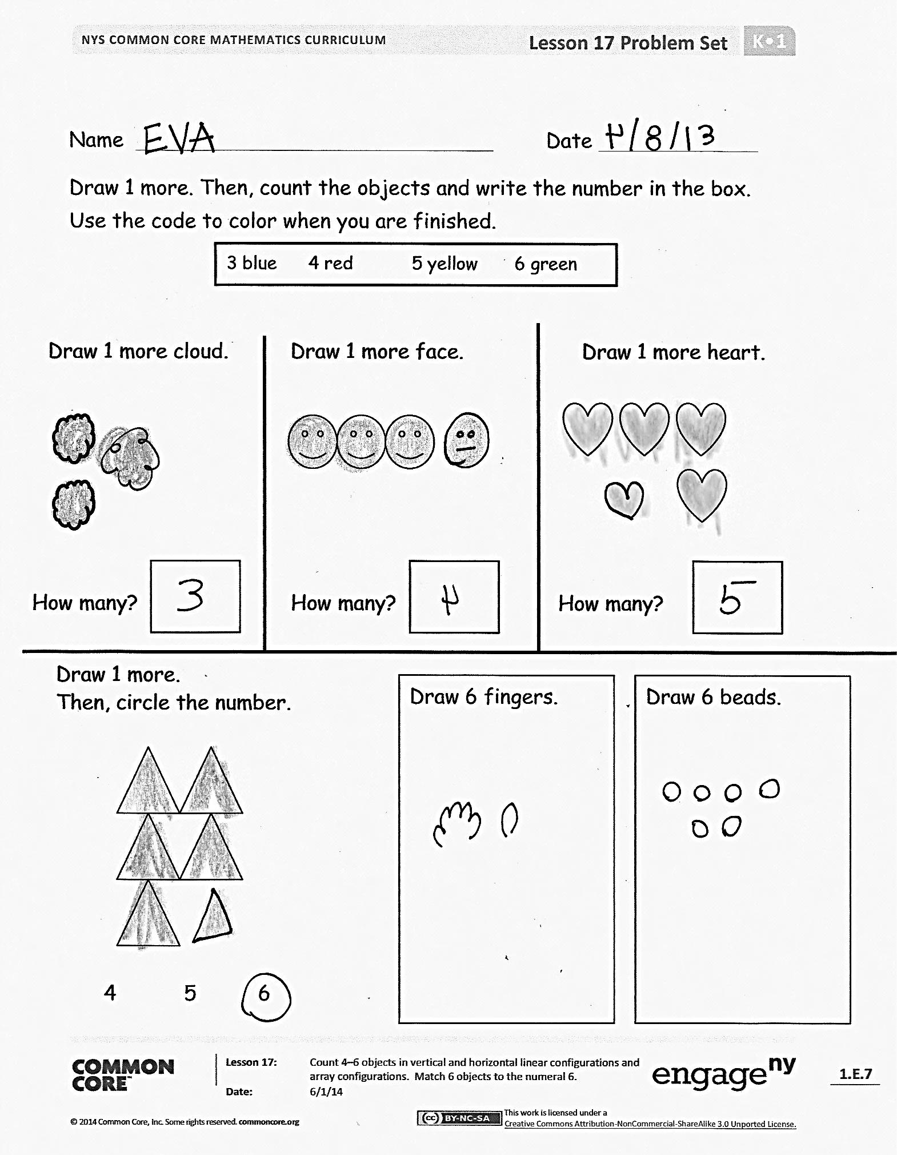T:  You are right!  Six is 1 more than 5.  Where should we put our extra cube? (Wait for responses, and then guide students to see that they need to use the other 5-group.  Circulate to ensure proper placement of the sixth cube.)  We have 5 cubes on one five and 1 on the other five. How many cubes do you have on your 5-group mat?

S: 6.

T:  Yes! Five and 1 more is 6. I am going to write the number 6 on the board.  (Demonstrate.)  Look through your number cards to find the number that looks like mine. How many cubes do you have?  Hold the number card up and say the number.

S: 6.

T:  Great counting!  Please put your materials away, and get ready for your Problem Set.

Problem Set (8 minutes)

Students should do their personal best to complete the Problem Set within the allotted time.

Extension: On the back of the Problem Set, have students draw 2 (3, 4, 5, 6) in as many different ways as they can.

Student Debrief (7 minutes)

**Lesson Objective:** Count 4–6 objects in vertical and horizontal linear configurations and array configurations. Match 6 objects to the numeral 6.

The Student Debrief is intended to invite reflection and active processing of the total lesson experience.

Invite students to review their solutions for the Problem Set. They should check work by comparing answers with a partner before going over answers as a class. Look for misconceptions or misunderstandings that can be addressed in the Debrief. Guide students in a conversation to debrief the Problem Set and process the lesson.

|  |  |
| --- | --- |
|  | NOTES ON  MULTIPLE MEANS  OF ENGAGEMENT: |
| Have students take turns being the leader of a pair during their partner share. Allow students with special needs to show their meaning by pointing to visuals set up around the room to help them explain their thinking. | |

You may choose to use any combination of the questions below to lead the discussion.

* Show us where you drew your objects in a line. Who did it a different way? Show us where you drew **rows**. Show us where you drew **columns**.
* How does the **5-group** help us count?
* Share with a partner how you counted and why.
* Have students discuss the different configurations.
* Look at the configurations you made when you drew 6. How is it similar to or different from your partner’s?

Exit Ticket (3 minutes)

After the Student Debrief, instruct students to complete the Exit Ticket. A review of their work will help you assess the students’ understanding of the concepts that were presented in the lesson today and plan more effectively for future lessons. You may read the questions aloud to the students.

Name Date

Draw 1 more. Then, count the objects and write the number in the box. Use the code to color when you are finished.

3 blue 4 red 5 yellow 6 green

How many?

Draw 1 more cloud.

How many?

Draw 1 more face.

How many?

Draw 1 more heart.

Draw 6 beads.

Draw 6 fingers.

Draw 1 more.

Then, circle the number.

4 5 6

Name Date

Fill in the missing numbers on the cards.

5

0

1

3

6

Count. Write how many in the box.

Name Date

Color 4.

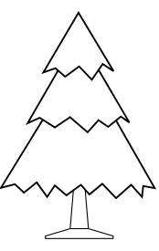

Color 5.

Color 6***.***



Connect the boxes with the same number.



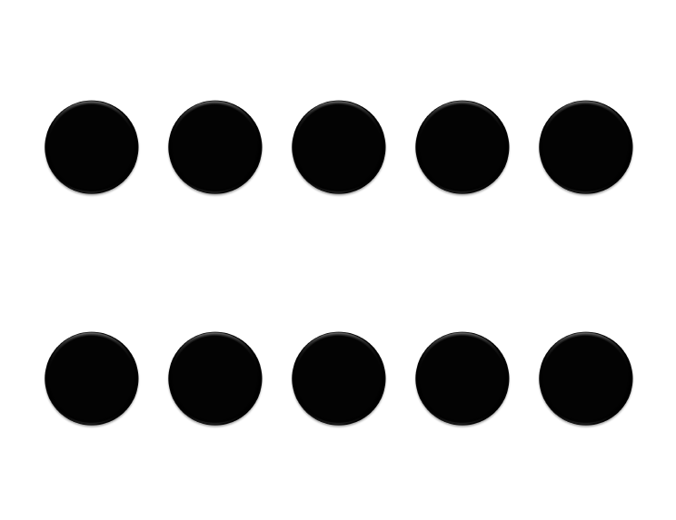

[1]

1. 5-group mat