Lesson 16
Objective: Write numerals 1–5 in order. Answer and make drawings of decompositions with totals of 4 and 5 without equations.

Suggested Lesson Structure
 Fluency Practice (15 minutes)
 Application Problem (5 minutes)
 Concept Development (25 minutes)
 Student Debrief (5 minutes)
Total Time (50 minutes)
Fluency Practice (15 minutes)
- Make 4 with Squares and Beans K.CC.4a (6 minutes)
- 5-Frames: Counting Dots and Spaces K.CC.4a (4 minutes)
- Take the Cake K.CC.4a (5 minutes)
Make 4 with Squares and Beans (6 minutes)
Materials: (S) 4 beans, paper or foam squares
T: Touch and count the corners of the square.
S: 1, 2, 3, 4.
T: Touch and count your beans.
S: 1, 2, 3, 4.
T: Our job is to make 4. Put your 3 beans on the corners of your square. Keep the other one in your hand. How many beans on your square?
S: 3.
T: How many beans in your hand?
S: 1.
T: We can tell how to make 4 like this: 3 and 1 make 4. Echo me, please.
S: 3 and 1 make 4.
T: Show me 2 beans on your square. Keep the rest in your hand. How many beans on your square?
S: 2.
T: How many beans in your hand?
S: 2.
T: Raise your hand when you can say the sentence. (Wait until all hands are raised and then give the signal.)
S: 2 and 2 make 4.
Continue with placing 1 bean on the square, then 4, and finally 0, to work through all of the number combinations.
5-Frames: Counting Dots and Spaces (4 minutes)
Materials: (T) 5-frame cards (Lesson 10 Fluency Template)
Conduct the activity as outlined in Lesson 10. After counting dots and spaces, have students describe the compositions of 5. For example, students count 3 dots and 2 spaces, so 3 and 2 make 5.
Take the Cake (5 minutes)
Materials: (S) Birthday cake number order cards per pair (Lesson 15 Fluency Template)
Working with a partner, have students put the birthday cake cards in order from the baby’s cake to the six-year-old’s cake.
1. Partner A closes his eyes.
2. Partner B takes one of the cards (or turns it over).
3. Partner A opens his eyes, and counts to determine which card is missing.
4. Switch roles, and play again.
Application Problem (5 minutes)
Draw 4 cups and 5 straws. Write the number of each. Circle the number that is more.
Note: This Application Problem continues to focus on groups, counting objects in a group, and number writing. This problem connects learning throughout the module.
Concept Development (25 minutes)
Materials: (T) Personal white board, 5 magnetic shapes or pictures (divided by a line down the middle)
(S) 5-group cards 1–5, shuffled (Lesson 7 template, numeral side); bag of 5 loose linking cubes
T: We are going to play a game called Mix and Fix. Each of you has a bag of cards in front of you. The cards have numerals 1 to 5 on them. Take your cards out, and check to see that you have all of your cards.
S: (Check cards, providing a quick review of the numbers.)
MP.1
T: Mix up your cards and turn them over so that you can’t see the numbers. On the count of three, turn your cards over and put them in order starting with 1 and going up to 5. You will want your cards to say 1, 2, 3, 4, and 5.
T: Are you ready? Set. GO!

NOTES ON
MULTIPLE MEANS
OF REPRESENTATION:
Have a number path or chart available as a reference for students who are still are unsure about their counting.
A simple 1–5 number path might be sufficient.

S: (Race to place their cards in order.)
T: (Circulate to ensure accuracy.) Point to the numbers and count your cards.
S: 1, 2, 3, 4, 5. (Repeat exercise, putting cards in decreasing order.)
T: Put your cards away and take out your linking cubes. Please make a tower of 4. You will use the tower while we do some work together on the board. I will be looking for some really focused mathematicians to help me! (Show students four of the shapes in a line on the board and call for a volunteer.)
T: (Select a volunteer.) How many shapes are on the board?
S: 4.
T: Put some on one side of the line and put the rest on the other.

NOTES ON
MULTIPLE MEANS
FOR ENGAGEMENT:
As an extension, have the more capable students experiment with making towers of 6 and 7. Have them find different combinations. If possible, make a sheet that shows all of these combinations.

S: (Arranges shapes on board, for example, two on one side and two on the other.)
T: Thank you. You may sit down now. Did she pick up any new shapes? Did she drop any shapes?
S: No.
T: How many shapes are still on the board?
S: 4.
T: Look at how many shapes are on each side of the line. She chose to use her 4 shapes to make groups of 2. Take your tower of 4 and break it into groups of 2. Show me your new towers.
S: (Hold up towers.)
T: We can talk about this the special math way! Repeat after me: 4 is the same as 2 and 2.
S: 4 is the same as 2 and 2.
T: Put your towers together again. Can anyone arrange our 4 shapes a different way? (Repeat the exercise with another volunteer, making sure that a different decomposition of 4 is represented. Have the students model the new situation with their cubes.)
T: Let’s try this with 5 shapes! Put another cube on your tower to make 5. (Repeat exercise, this time decomposing five objects on the board two different ways and having the students model each situation with their cubes.)
T: Put your linking cubes away. We are going to do some more work with groups of 4 and 5 on our Problem Sets.

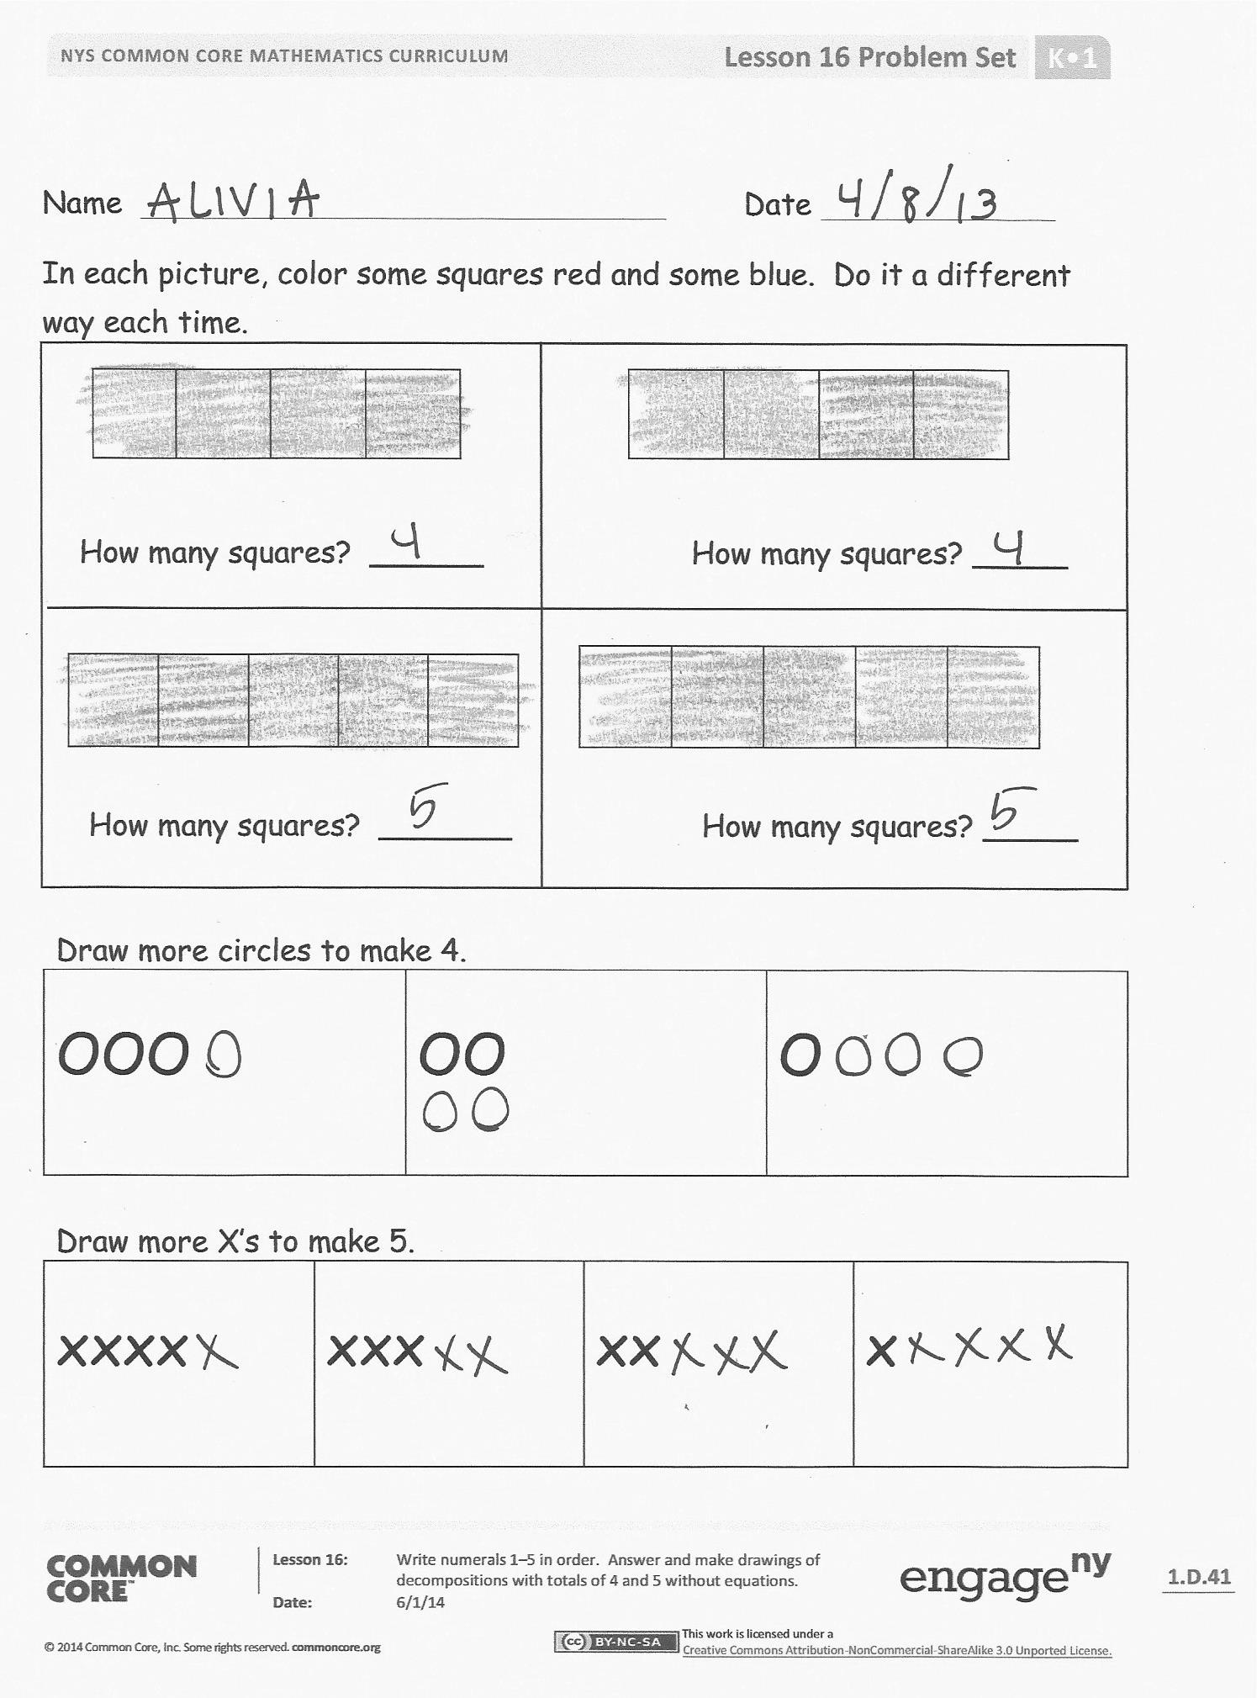
Problem Set (10 minutes)
Students should do their personal best to complete the Problem Set within the allotted time.
Student Debrief (5 minutes)
Lesson Objective: Write numerals 1–5 in order. Answer and make drawings of decompositions with totals of 4 and 5 without equations.
The Student Debrief is intended to invite reflection and active processing of the total lesson experience.
Invite students to review their solutions for the Problem Set. They should check work by comparing answers with a partner before going over answers as a class. Look for misconceptions or misunderstandings that can be addressed in the Debrief. Guide students in a conversation to debrief the Problem Set and process the lesson.
You may choose to use any combination of the questions below to lead the discussion.
- How many did you color red? How many blue? Why did you choose to do it that way?
- Did the way you colored it change the whole number of squares?
- Did we change the whole amount when we broke our towers or our groups into smaller ones?
- When we put them back together, did we change our whole amount?
Exit Ticket (3 minutes)
After the Student Debrief, instruct students to complete the Exit Ticket. A review of their work will help you assess the students’ understanding of the concepts that were presented in the lesson today and plan more effectively for future lessons. You may read the questions aloud to the students.

Name Date
In each picture, color some squares red and some blue. Do it a different way each time.

How many squares? ______ How many squares? _____

How many squares? _______ How many squares? _____

Draw more circles to make 4.
OOO |  | OO |  | O
Draw more X’s to make 5.
xxxx | xxx |  | xx |  | x

Name Date

How many ? _________ How many ? __________

How many altogether? ____________

How many ? _________ How many ? __________
How many altogether? ____________

Name Date
Write the missing numbers:
1, 2, ___, 4, ___ 5, ___, 3, 2, ___
___, 3, 2, 1, ___ ___, 1, 2, ___, 4
Draw 3 red fish and 1 green fish.

How many fish are there in all? There are _________ fish.
3 fish and 1 fish make _____ fish. 4 is the same as ____ and ____.

Make 2 happy faces and 3 sad faces.

How many faces are there in all? There are _______ faces.
2 faces and 3 faces make __________ faces.
5 is the same as _______ and _______.

