Lesson 14

Objective: Write numerals 1–3. Represent decompositions with materials, drawings, and equations, 3 = 2 + 1 and 3 = 1 + 2.

Suggested Lesson Structure

 Fluency Practice (13 minutes)

 Application Problem (5 minutes)

 Concept Development (27 minutes)

 Student Debrief (5 minutes)

**Total Time (50 minutes)**

Fluency Practice (13 minutes)

* Making 3 with Triangles and Beans **K.CC.4a** (5 minutes)
* Making Three-Finger Combinations **K.CC.4a** (4 minutes)
* Hide and See (3 as the Total) **K.CC.4a**  (4 minutes)

Making 3 with Triangles and Beans (5 minutes)

Materials: (S) 3 beans, paper or foam triangle

Repeat Triangles and Beans from Lesson 11, but include 0 and 3.

Making Three-Finger Combinations (4 minutes)

Conduct as outlined in Lesson 11, but include 0 and 3. Variation: Students can say the expressions.

Hide and See (3 as the Total) (4 minutes)

Conduct the activity as outlined in Lesson 11, but include 0 and 3, with 3 as the total. Variation: Students can say the expressions as they put the cubes together. This game can also be played with a partner.

Application Problem (5 minutes)

How many ears do you have? Write the number. How many heads do you have? Write the number. How many feet do you have? Write the number. How many wings do you have? Write the number. Stand with 2 friends. How many noses are in your group? Write the number. Draw something that has 1 ear, 2 heads, and 3 feet. Show your friend your picture.

Note: This Application Problem provides students with practice counting and writing numbers 0–3.

Concept Development (27 minutes)

Materials: (S) Bag of 3 loose linking cubes

T: Please take your linking cubes out of the bag, and put them in front of you. Pick up a cube. How many linking cubes are in your hand?

|  |  |
| --- | --- |
|  | NOTES ON  MULTIPLE MEANS  OF REPRESENTATION: |
| Many youngsters are visual learners. Take a linking cube and put a piece of sticky-sided magnetic tape on it. Do this with about two or three dozens of cubes. Take a metal cookie sheet and use the magnetic cubes to make towers and show that the towers can be broken into different combinations. Use a different cookie sheet for each numeral. | |

S: 1.

T: Write 1 in the air. (Demonstrate.) Pick up another cube and join it to your first one. (Repeat these steps until the students have a tower of 3 cubes.) How many cubes do you have now?

S: 3.

T: Write 3 in the air. (Demonstrate.) Watch how I take my tower apart. (Break off one cube.) How many cubes do I have in my hands?

S: 1 in that hand. 2 in the other hand.

T: Did I pick up any more cubes?

S: No.

T: Did I drop some?

S: No.

T: So, I still have 3 cubes in my hands, but I made my 3 tower into a 1 tower and a 2 tower. Take your tower of 3 and show me how you can break it into a 1 tower and a 2 tower.

|  |  |
| --- | --- |
|  | NOTES ON  MULTIPLE MEANS  OF ACTION AND EXPRESSION: |
| Some students benefit from having a work mat to help them focus with their manipulatives. This work mat might show templates for towers of 3 (or 4 or 5). Depending on student needs, use the 2 and 1 combination and the 1 and 2 combination, etc. | |

S: (Break the whole tower into the two parts.)

T: Watch me put my parts together to make a tower of 3 again. There is a special math way to write what I just did. (Write 3 = 1 + 2.) We call this a **number sentence**. (Repeat the decomposition exercise to show that   
3 = 2 + 1.)

T: Put your cubes back in the bag. I’m going to draw some cubes on the board. (Draw a rectangle divided into 3 squares to look like a linking cube tower.) I will color 2 squares red. I will color the rest blue. How many cubes are in my tower?

**MP.3**

S: 3.

T: How many red?

S: 2.

T: How many blue?

S: 1.

T: I will write it the math way. Here is our number sentence. (Write 3 = 2 + 1.)

T: Can we do this with other things? (Draw a group of three balls on the board. Draw stripes on one of them.) How many balls are there?

S: 3.

T: How many have stripes?

S: 1.

T: How many do not have stripes?

S: 2.

T: 3 is the same as 1 and 2. I will write the number sentence: 3 = 1 + 2.

T: Now, we will practice finding the parts of three and writing the number sentences on our Problem Sets.

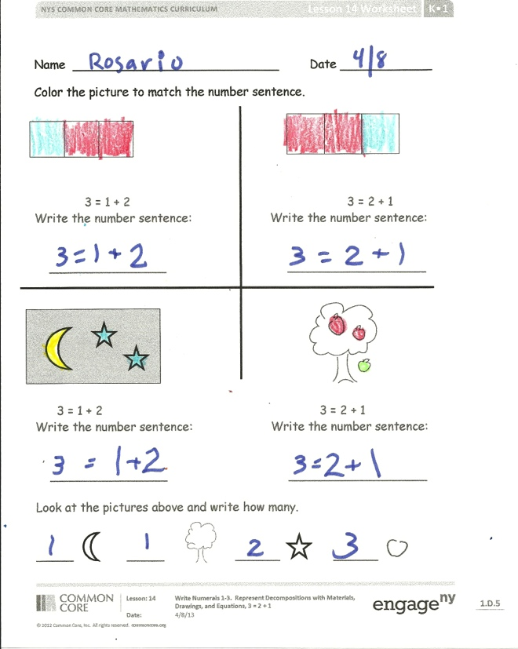Problem Set (10 minutes)

Students should do their personal best to complete the Problem Set within the allotted time.

Have students color the picture to match the number sentence. Allow students to choose their own color combinations in order to informally assess their understanding of decomposition.

Student Debrief (5 minutes)

**Lesson Objective:** Write numerals 1–3. Represent decompositions with materials, drawings, and equations,   
3 = 2 + 1 and 3 = 1 + 2.

The Student Debrief is intended to invite reflection and active processing of the total lesson experience.

Invite students to review their solutions for the Problem Set. They should check work by comparing answers with a partner before going over answers as a class. Look for misconceptions or misunderstandings that can be addressed in the Debrief. Guide students in a conversation to debrief the Problem Set and process the lesson.

You may choose to use any combination of the questions below to lead the discussion.

* How many are in your tower all together?
* What are the parts of your tower?
* How would we say that as a **number** **sentence**? 3 is the same as ______ and _______.
* Could we break bigger towers into parts and make number sentences to match?
* When have you taken something whole and broken it into two parts? (Sand castles, papers, cakes, etc.)
* If you put the parts together again, do you get something whole again?

Exit Ticket (3 minutes)

After the Student Debrief, instruct students to complete the Exit Ticket. A review of their work will help you assess the students’ understanding of the concepts that were presented in the lesson today and plan more effectively for future lessons. You may read the questions aloud to the students.

Name Date

|  |  |  |
| --- | --- | --- |
|  |  |  |

Color the picture to match the number sentence.

|  |  |  |
| --- | --- | --- |
|  |  |  |

3 = 1 + 2 3 = 2 + 1

Write the number sentence: Write the number sentence:

_________

3 = 1 + 2 3 = 2 + 1

Write the number sentence: Write the number sentence:

Look at the pictures above and write how many.

_____ _____ ______ ______

Name Date

Color the apples to show that 3 = 2 + 1.

C:\Users\store64\AppData\Local\Microsoft\Windows\Temporary Internet Files\Content.IE5\8VYBS75V\MC900437671[1].wmf

C:\Users\store64\AppData\Local\Microsoft\Windows\Temporary Internet Files\Content.IE5\8VYBS75V\MC900437671[1].wmf

C:\Users\store64\AppData\Local\Microsoft\Windows\Temporary Internet Files\Content.IE5\8VYBS75V\MC900437671[1].wmf

How many apples are there altogether? ___________

3 is the same as ______ and _______.

3 apples = _____ apples + ______ apple

Name Date

C:\Users\store64\AppData\Local\Microsoft\Windows\Temporary Internet Files\Content.IE5\DX4S01PJ\MC900013595[1].wmf C:\Users\store64\AppData\Local\Microsoft\Windows\Temporary Internet Files\Content.IE5\DX4S01PJ\MC900013595[1].wmf C:\Users\store64\AppData\Local\Microsoft\Windows\Temporary Internet Files\Content.IE5\DX4S01PJ\MC900013595[1].wmf

Color the shirts so that 1 is red and 2 are green. There are _________ shirts. **_______ = 1 + _______**

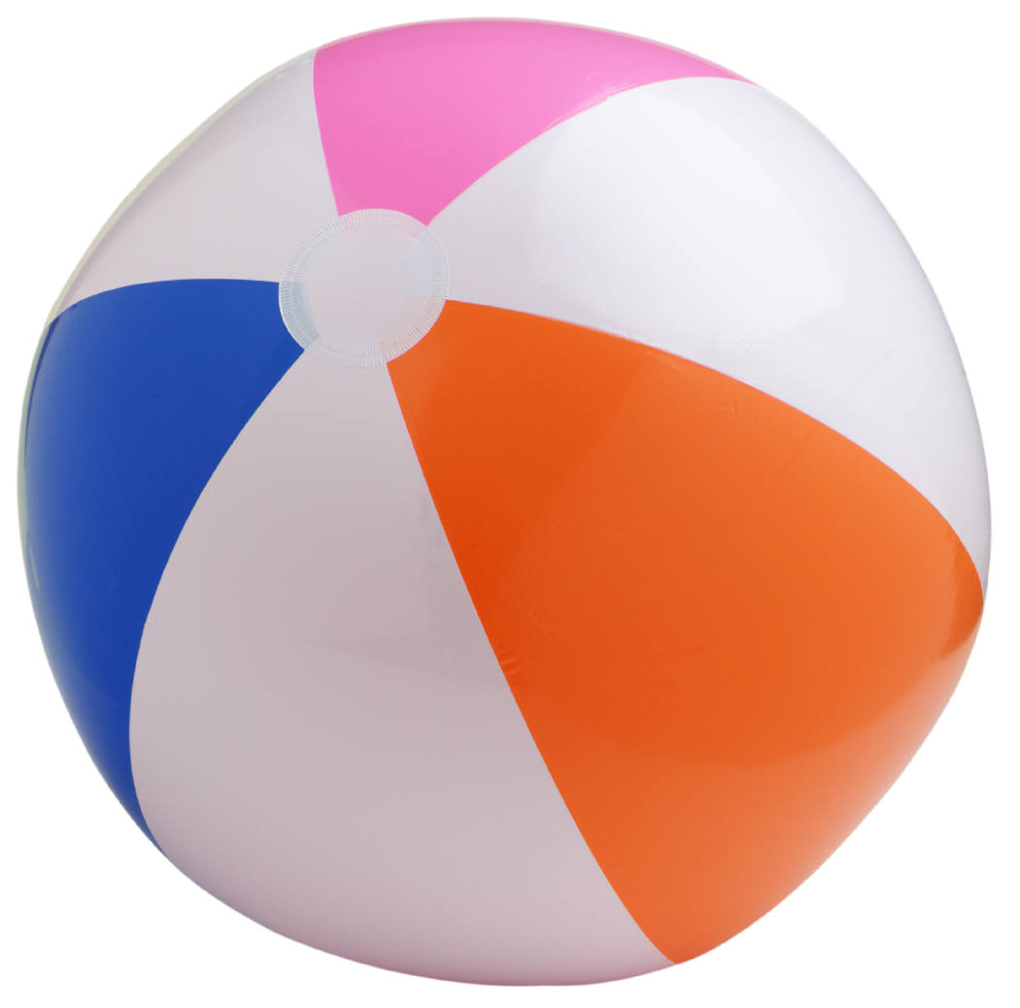  

Color the balls so that 2 are yellow and 1 is blue. There are ________ balls. **_________ = 2 + ________**

Choose two of your favorite types of fruit. Draw some of each on the plate to show that 3 = 2 + 1.

_____ fruits = ______ fruits + _______ fruit

________ = ________ + _________