Lesson 12

Objective: Understand the meaning of zero. Write the numeral 0.

Suggested Lesson Structure

 Fluency Practice (12 minutes)

 Application Problem (5 minutes)

 Concept Development (30 minutes)

 Student Debrief (3 minutes)

**Total Time (50 minutes)**

Fluency Practice (12 minutes)

* Birthday Candles **K.CC.4a** (6 minutes)
* Finger Counting **K.CC.2** (3 minutes)
* Sunrise/Sunset Counting to 5 **K.CC.2** (3 minutes)

Birthday Candles (6 minutes)

Materials: (S) 1 die, birthday cake (Lesson 5 Fluency Template), crayons

Conduct the activity as outlined in Lesson 5.

This is the second time this activity appears in the module. Be especially cognizant of and ready to support students who must recount each time, rather than take off or put on more crayons, to represent the new number.

Finger Counting (3 minutes)

Conduct the activity as outlined in Lesson 8.

As students grow more capable in complicated sequences, consider introducing 6. Focus on the transition between 5 and 6. Repetition will be valuable in seeing 5 as a unit.

Sunrise/Sunset Counting to 5 (3 minutes)

Conduct the activity as outlined in Lesson 7.

If students exhibit mastery, consider counting higher.

Application Problem (5 minutes)

Draw a group of 4 apples. Make some red and some green. Tell your friend how many are red and how many are green. Did you and your friend have the same number of red apples?

Concept Development (30 minutes)

Materials: (S) Bag of 5 loose linking cubes (varied colors), personal white board, numeral formation practice sheet 0 (Lesson 12 Practice Sheet)

T: Please put all of your cubes in front of you. Pick up a cube. How many cubes are you holding now?

S: 1.

T: Pick up 1 more cube, and connect it to your first cube. How high is your tower now?

|  |  |
| --- | --- |
|  | NOTES ON  MULTIPLE MEANS  FOR ENGAGEMENT: |
| As an extension of this activity, ask students when they have a 3 tower, “How many cubes do I have to take off to have 0?” “Let’s check and see if that is correct. 4 tower to 0? 5 tower to 0?” | |

S: 2 cubes.

T: (Repeat with the remaining cubes to make a tower of 5.) Hold your tower high! Now, we will take it apart. Take off one of your cubes and put it on the table. How many cubes are left in your tower?

S: 4.

T: Let’s take off another one. (Repeat and ask the number left each time until the students are holding only one cube.) How many cubes are left in your tower?

S: 1.

T: Please put down the last cube. How many cubes are left in your tower?

S: None!

|  |  |
| --- | --- |
|  | NOTES ON  MULTIPLE MEANS  OF REPRESENTATION: |
| Make a poster with the zero (in fancy letters). Post the chart and ask the students what it says. Ask the children what else is on the poster. What does zero mean? | |

T: The math word for *none* is **zero**. Repeat after me: There are zero cubes left in my tower.

S: There are zero cubes left in my tower.

T: (Repeat the finger counting from fluency, starting from 1 going up to 5 and from 5 down to zero as a fist.) Our numeral for zero looks like the outline of our fist. (Trace a zero around the outside of your fist, and then write 0 on the board.)

T: Please put all of your cubes back in the bag. Let’s practice writing a zero. Make it with your finger in the air as I draw it on the board.

T: We start at the top middle of the writing frame and then make a big curved line that just touches each side as we go along. We end up back at the top.   
(Demonstrate and say, “Curve from the top; be a hero! Close the loop and make a zero.”)

T: Let’s practice zero a few more times together. Use your fingers on your table (or the carpet) while I write on the board. (Demonstrate and repeat the rhyme with the students a few more times.)

T: Now, you may practice making zeroes on your own.

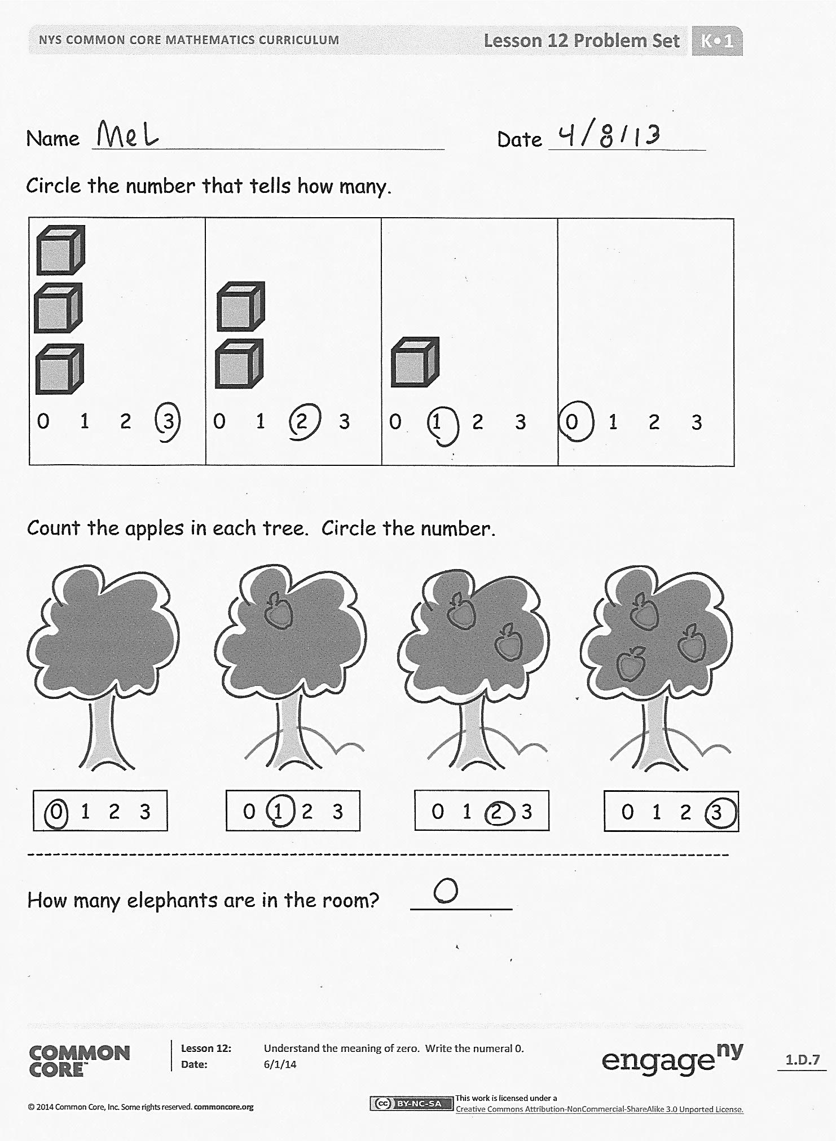Distribute personal white boards with numeral formation practice sheet inserts to students. Have students begin at the dot. Begin with finger tracing if necessary. With dry erase markers, practice the number formation. When students demonstrate fluency, remove the inserts and have them write the zeros directly on the sheets with pencil. They may then complete the counting Problem Set.

Problem Set (5 minutes)

Students should do their personal best to complete the Problem Set within the allotted time.

Student Debrief (3 minutes)

**Lesson Objective:** Understand the meaning of zero. Write the numeral 0.

The Student Debrief is intended to invite reflection and active processing of the total lesson experience.

Invite students to review their solutions for the Problem Set. They should check work by comparing answers with a partner before going over answers as a class. Look for misconceptions or misunderstandings that can be addressed in the Debrief. Guide students in a conversation to debrief the Problem Set and process the lesson.

You may choose to use any combination of the questions below to lead the discussion.

* How many eyes (noses, fingers, or feet) do you have?
* How many tails do you have?
* Use this frame to tell about more things we have none of: *We have* ***zero*** *______ in our classroom*. Have fun with this. Get them to talk to a partner after generating some ideas (elephants, zebras, spaceships, or bank robbers).

**MP.7**

* What is the math word for none? Let’s say our rhyme one more time! (Repeat the rhyme and write the numeral zero in the air together.)

Exit Ticket (3 minutes)

After the Student Debrief, instruct students to complete the Exit Ticket. A review of their work will help you assess the students’ understanding of the concepts that were presented in the lesson today and plan more effectively for future lessons. You may read the questions aloud to the students.

Name Date

Circle the number that tells how many.

|  |  |  |  |
| --- | --- | --- | --- |
| 0 1 2 3 | 0 1 2 3 | 0 1 2 3 | 0 1 2 3 |

Count the apples in each tree. Circle the number.

C:\Users\Mario and Mel\AppData\Local\Microsoft\Windows\Temporary Internet Files\Content.IE5\V75JAROW\MC900391406[1].wmf

0 1 2 3

0 1 2 3

0 1 2 3

0 1 2 3

-----------------------------------------------------------------------------------

How many elephants are in the room? ________

Name Date_______________

C:\Users\Mario and Mel\AppData\Local\Microsoft\Windows\Temporary Internet Files\Content.IE5\0218AVXP\MC900013073[1].wmfColor in the blocks to show how many girls, boys, and aliens are at your table. Don’t forget to count yourself!

|  |  |  |
| --- | --- | --- |
|  |  |  |
|  |  |  |
|  |  |  |
|  |  |  |
|  |  |  |



Name Date_______________

How many? Draw a line between each picture and its number.

0

C:\Users\store64\AppData\Local\Microsoft\Windows\Temporary Internet Files\Content.IE5\R9K9X7SA\MC900383846[1].wmf C:\Users\store64\AppData\Local\Microsoft\Windows\Temporary Internet Files\Content.IE5\R9K9X7SA\MC900383846[1].wmf C:\Users\store64\AppData\Local\Microsoft\Windows\Temporary Internet Files\Content.IE5\R9K9X7SA\MC900383846[1].wmf

1

C:\Users\store64\AppData\Local\Microsoft\Windows\Temporary Internet Files\Content.IE5\SYWK2P42\MC900371088[1].wmf

2

C:\Users\store64\AppData\Local\Microsoft\Windows\Temporary Internet Files\Content.IE5\R9K9X7SA\MC900413628[1].wmf

C:\Users\store64\AppData\Local\Microsoft\Windows\Temporary Internet Files\Content.IE5\R9K9X7SA\MC900413628[1].wmf

3

Write the numbers in the blanks.

___ , 1, 2, 3

0, ___ , 2, 3

Name Date

Insert the template into your personal white board. Practice with your dry erase marker. When you are ready, write in pencil on the paper.

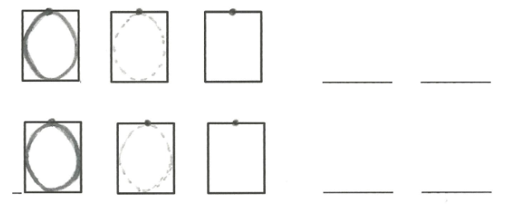[1]

1. numeral formation practice sheet 0