Grade 5: Module 2B: Unit 3: Lesson 14
Creating a Graphic Novelette and Peer Critique: Section 1

Long-Term Targets Addressed (Based on NYSP12 ELA CCLS)
I can write narratives to develop real experiences using effective technique, descriptive details, and clear event sequence. (W.5.3)
  - I can orient the reader by establishing a situation and introducing characters.
  - I can use narrative techniques such as dialogue to develop experiences and events.
With guidance and support from peers and adults, I can develop and strengthen writing as needed by planning, revising, editing, rewriting, or trying a new approach. (W.5.5)
I can use technology, including the Internet, to produce and publish writing as well as to interact and collaborate with others. (W.5.6)
I can follow our class norms when I participate in a conversation. (SL.5.1)

Supporting Learning Targets | Ongoing Assessment
- I can create and label pages for my graphic novelette.  - I can plan Section 1 of my graphic novelette based on criteria from the Graphic Novelette rubric.  - I can follow our group norms when working with partners to give and receive feedback. | - Graphic Novelette: Section 1  - Peer Critique based on Graphic Novelette: Section 1

Agenda | Teaching Notes
- Opening  - Homework Review and Engaging the Writer (5 minutes)  - Work Time  - Creating Pages for a Graphic Novelette (20 minutes)  - Planning Section 1 of a Graphic Novelette (20 minutes)  - Peer Critique and Revision (10 minutes)  - Closing and Assessment  - Debrief and Review of Learning Targets (5 minutes)  - Homework  - Complete graphic novelette Section 1 revisions and paste/add text and/or visual elements.  - Read Section 1 aloud to someone at home or in front of a mirror to practice fluency skills in preparation for performance task presentations. | - In this lesson, students begin creating their graphic novelettes. There are two options for them to create text and images for their novelettes: Option A requires the use of technology, and Option B does not. Review the supporting materials and determine which option is most feasible. Also note, there is a series of five short instructional videos, which are appropriate for both teachers and/or students to use, to learn how to use Word to create each piece for the graphic novelette, including frames and panels with text and images, as well as thought and speech bubbles (see “Graphic Novelette Video 1-5” http://usny.nysed.gov/rttt/docs/curriculum/grade-5-ela-module-2b-graphic-novel-video.html)  - Students begin by creating the pages they will use for each section of their graphic novelettes. There are a series of visual representations of each step with directions at the top of each visual (see the supporting materials). These can be displayed throughout the lesson to help students see what their novelette pages should look like. It would also be beneficial to model or complete each step with students.  - During Work Time B, students create Section 1 of their graphic novelettes. They first review the Graphic Novelette Rubric: Section 1 to become familiar with product criteria. Then they refer to their revised end of unit Storyboard, Section 1 to create frames with text (caption, speech and thought bubbles), a section title, and images for Section 1 of their novelettes. Once again, there are visuals in the supporting materials, with a technology option (Option A) and nontechnology option (Option B) to support students’ work.  - During Work Time C, students have a brief opportunity to share their thinking with peers to receive feedback based on the Graphic Novelette rubric. This allows them to receive feedback and revise before gluing down the pieces for Section 1 of their novelettes for homework.  - In advance:  - Review and organize visuals and directions from the supporting materials.  - If using Option A, make sure technology is in working order and students have access to the Internet and printers.  - Collect and organize the materials students will need to complete Section 1 of their novelettes.  - Post: Group Norms anchor chart directions for the Peer Critique protocol and learning targets.

Lesson Vocabulary | Materials
label, graphic novelette, criteria, rubric, norms, feedback | - 11-by-17 paper (three pieces per student)  - Document camera  - Creating Pages: Step 1 (one to display)  - Sticky notes (seven per student)  - Scissors (one pair per student)  - Glue (one per student)  - Numbers strip (one per student)  - Ruler (one per student)  - Creating Pages: Step 2 (one to display)  - Mark the Binding (one to display)  - Creating Pages: Step 3 (one to display)  - Creating Pages: Step 4 (one to display)  - Creating Pages: Step 5 (one to display)  - Glossary and Citations Pages (one to display)  - Graphic Novelette Rubric: Section 1 (one per student and one to display)  - End of Unit 3 Assessment: Storyboard, Section 1 (from Lesson 9; one per student)  - Computers (one per student; optional; see Option A)  - Colored pencils, markers, crayons (for each student; optional; see Option B)  - Section 1: Text and Images, Option A or Option B (one to display)  - Group Norms anchor chart (begun in Unit 1, Lesson 1)  - Peer Critique protocol (from Lesson 12)  - Arranging Pieces and Peer Critique (one to display)  - Folder, large manila envelope, or large zip-top bag (one per student)

Opening | Meeting Students’ Needs
A. Homework Review and Engaging the Writer (5 minutes)  - Ask students to take out the storyboard revisions they completed for homework and then locate a partner who is not a member of their regular triad.  - Once students are partnered, ask them to discuss:  - “How were you able to use the criteria for success to help you further revise your storyboards?”  - “Which do you think is the most effective revision you made and why?”  - After 2 or 3 minutes, focus students whole group. Invite a few of them to share their thinking with the class.  - Ask students to take their revised storyboards and join their regular triads in preparation for Work Time.  - Say something like:  - “Today you are going to start creating the graphic novelettes you will present during the final performance task in Lesson 17. We will begin by creating and labeling each page so you can keep track of where each section begins and ends, and you can focus on adding relevant text and visual elements to each section. Then you will transfer information and ideas for visual elements from your storyboard draft of Section 1 to create Section 1 of your graphic novelette.” | - Display each question for student reference during the discussion.

Work Time | Meeting Students’ Needs
A. Creating Pages for a Graphic Novelette (20 minutes)  - Focus students’ attention on the learning targets and read the first one aloud:  - “I can create and label pages for my graphic novelette.”  - Point out the words label and graphic novelette. Ask students to briefly discuss what it means to label something.  - Cold call a few students to share out. Listen for:  - “Label means to tag something, name it, identify it.”  - Tell students that today they are going to begin creating their graphic novelettes, but first it’s important to prepare their materials. Therefore, they will begin by creating each page and labeling it with a sticky note and page numbers.  - Distribute three pieces of 11-by-17 paper to each student, then use a document camera to display Creating Pages: Step 1.  - Give students 1 or 2 minutes to fold their pages.  - Distribute seven sticky notes, scissors, glue, a numbers strip, and a ruler to each student.  - Display and read each step of the directions for Creating Pages: Step 2. Pause in between for students to complete each step.  - Once students complete Step 2, display the Mark the Binding page. Read the directions aloud and clarify as needed. Explain that marking half an inch from the crease will make sure there is space for them to bind the pages and novelette cover together later without affecting their images or text. Model if necessary.  - After students mark space for the binding, display and read the directions for Creating Pages: Step 3. Clarify and model as needed.  - When students complete labeling Section 2, display and read aloud directions for Creating Pages: Step 4. Provide clarification and model as necessary.  - Once students complete Step 4, display and read aloud the directions for Creating Pages: Step 5. Clarify and model as needed.  - After students finish Step 5, display and read the directions for the final step, Glossary and Citations Pages. Offer support and guidance as necessary.  - When students have all the pages for their graphic novelette created and labeled, tell them they are ready to begin creating Section 1. | - Consider printing and distributing directions for each step so students may refer to directions and check off each step as they complete it.

Work Time (continued) | Meeting Students’ Needs
B. Planning Section 1 of a Graphic Novelette (20 minutes)  - Direct students’ attention to and read the second learning target aloud:  - “I can plan Section 1 of my graphic novelette based on criteria from the Graphic Novelette rubric.”  - Remind students that they have used rubrics in previous lessons and units to help guide their work. Ask them to think about and briefly discuss in triads how they could restate this target in their own words.  - After 1 minute, cold call a few students to share out with the class.  - Display the Graphic Novelette Rubric: Section 1. Ask students to follow along silently as you read each criteria and descriptor aloud.  - Ask students to take out their revised End of Unit 3 Assessment: Storyboard, Section 1.  - If students are using technology, distribute or ask them to go to their computers. If they are not using technology, distribute colored pencils, markers, crayons, and other materials they need to write and draw each piece of Section 1.  - When students are ready to begin, display the directions for either Section 1: Text and Images (Option A) or (Option B). Read each step aloud and clarify as needed.  - Give students 12 to 15 minutes to create their text and images for Section 1 of their novelettes. Circulate to offer guidance and support as needed.  - If students finish early, they may begin to cut out the pieces they created for their novelettes. Do not allow them to glue any of their pieces into the Section 1 novelette pages until they complete the peer critique in Work Time C. When students are ready, ask them to start arranging their pieces without gluing them down yet. | - Consider chunking directions so students complete only two or three steps at a time.  - For students who struggle with writing or typing text, consider allowing them to dictate their ideas to an aide or other adult to scribe for them.

Work Time (continued) | Meeting Students’ Needs
C. Peer Critique and Revision (10 minutes)  - Ask students to read the third learning target aloud with you:  - “I can follow our group norms when working with partners to give and receive feedback.”  - Refer students to the Group Norms anchor chart and remind them of the Peer Critique protocol.  - Tell them they will now cut out and arrange the graphic novelette pieces they just created, and then they will receive feedback about the arrangement from a triad peer based on the Graphic Novelette rubric, Section 1.  - Distribute a Graphic Novelette rubric, Section 1 to each student, for him or her to use for scoring and commenting on a triad member’s work.  - Display and read aloud directions from Arranging Pieces and Peer Critique.  - Allow students 7 or 8 minutes to complete their arrangements and peer critique.  - Let them know if they were unable to glue all their pieces into Section 1 that they will be able to complete that step for homework.  - Distribute folders, large manila envelopes, or large zip-top bags for students to place their graphic novelette pages and pieces into. | - Display the Peer Critique protocol directions for student reference.  - Provide sentence frames to support group conversations and feedback: “You definitely met the criteria ____ because you ____.”

Closing and Assessment | Meeting Students’ Needs
A. Debrief and Review of Learning Targets (5 minutes)  - Bring students together whole group, then ask them to discuss with a classmate who is not a member of their triad:  - “How did referring to criteria from the Graphic Novelette rubric help you understand how to create Section 1 of your graphic novelette?”  - After 2 minutes, invite a few students to share their ideas with the class.  - Read each of the learning targets aloud and ask students to show a thumbs-up or thumbs-down to demonstrate how successfully they feel they met each target. Note those who show a thumbs-down, as they may need extra time and/or more support to complete Section 1 of their graphic novelettes. | - Provide a sentence starter to allow all students access to the conversation: “Referring to the rubric criteria helped me understand that I needed to _____.”
Homework | Meeting Students’ Needs
- Complete graphic novelette Section 1 revisions and paste/add text and/or visual elements.  - Read Section 1 of your graphic novelette aloud to someone at home or in front of a mirror to practice fluency skills in preparation for performance task presentations. | - For students who struggle to complete tasks independently, consider finding another time during the day to help them complete their work or allow someone at home to help.

Grade 5: Module 2B: Unit 3: Lesson 14
Supporting Materials

Creating Pages:
Step 1

Fold each page in half.

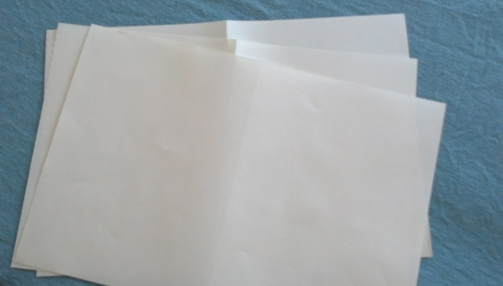

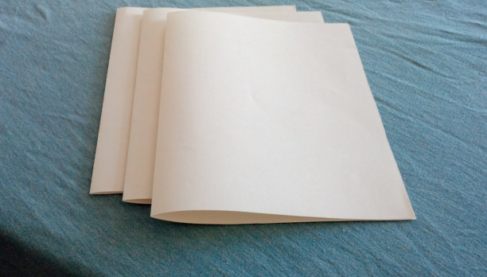

1
Numbers strip
2

3

4

5

6

7

8

9

10

Creating Pages:
Step 2

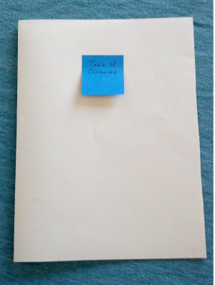 | On one of your sticky notes, write “Table of Contents,” then put the note on the front of one of your folded pages.

Cut out numbers 1–10 from your numbers strip and set aside or throw away the unused numbers (make sure you have only one of each number, 1–10).

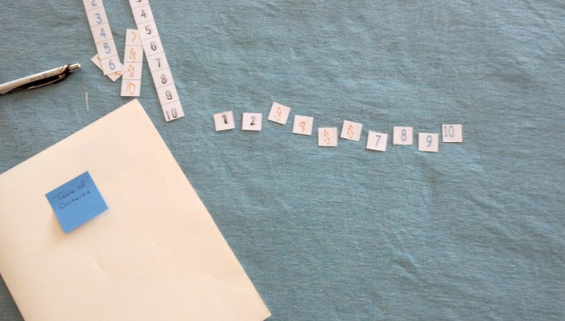

Creating Pages:
Step 2 (Continued)

Open (unfold the page) and write “Section 1” on one of your sticky notes. Place the sticky note on the left side of the page. Then, glue the “1” in the lower left corner of the page, and glue “2” in the lower right corner of the page.

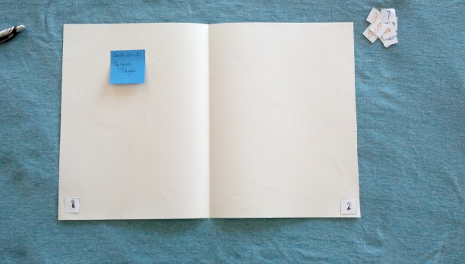

Mark the Binding

Use your ruler to measure half an inch from the right of your crease. Mark with a pencil. Repeat to make a mark half an inch from the left side of the crease as well.

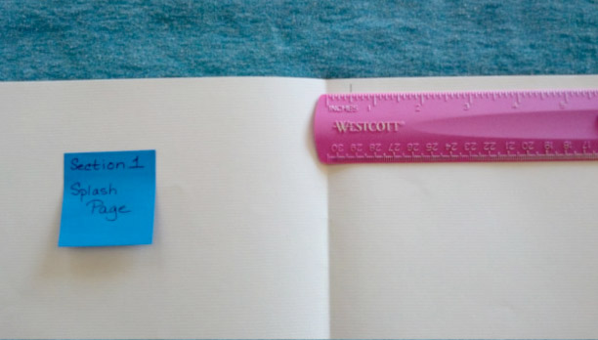

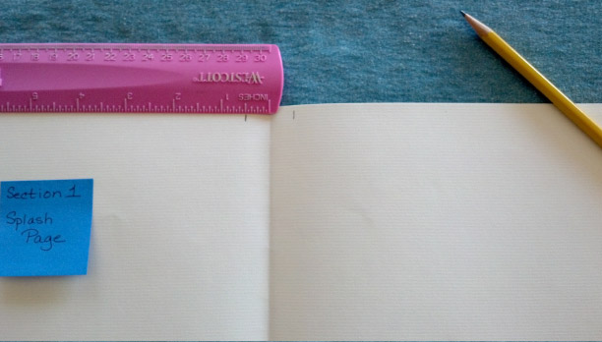

Mark the Binding

Line your ruler up vertically, using the mark you made on each side of the crease. Use your pencil to lightly draw a line to the left, then the right of the crease.

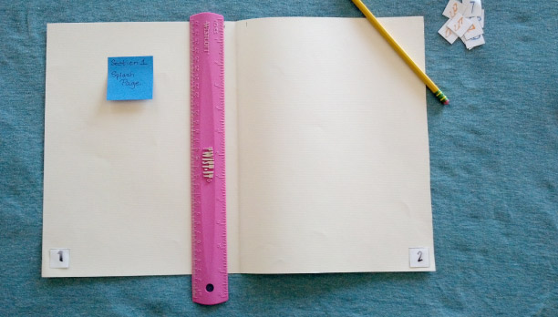

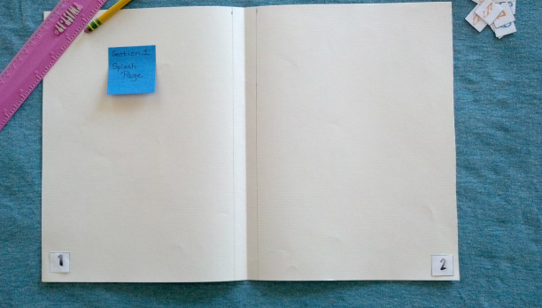
Creating Pages:
Step 3

Fold your “Section 1” paper to the left, so the blank side is showing. Set another one of your folded pieces of paper right next to it, so it looks like two pages with a crease in the center.

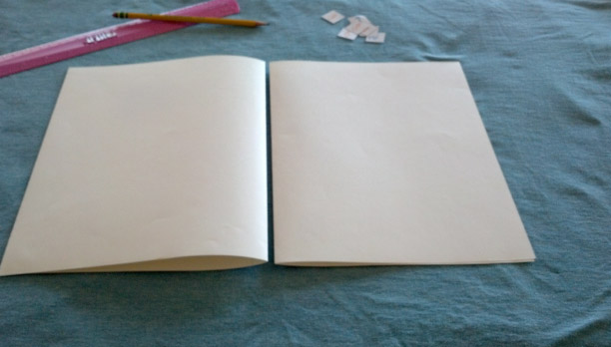

Write “Section 2” on another one of your sticky notes, then place on the left-side page. Glue a “3” onto the lower left page and a “4” on the lower right page. Then, use your ruler to make half-inch marks to either side of the crease (gap) and use your ruler and pencil to make lines that indicate space for the binding.

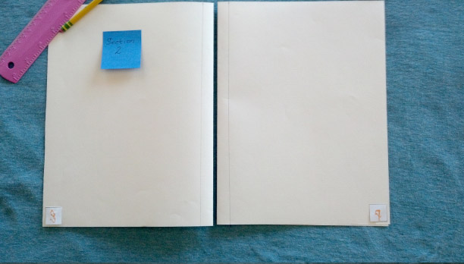
Creating Pages:
Step 4

Fold the right page of “Section 2” to the left, so there are two blank pages with a crease in the center.

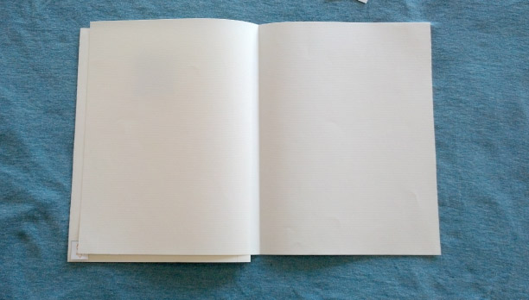

Write “Section 3” on another one of your sticky notes and place it on the left blank page. Glue a “5” onto the lower left and a “6” on the lower right. Then use your ruler to make half-inch marks to either side of the crease and use your ruler and pencil to make lines that indicate space for the binding.

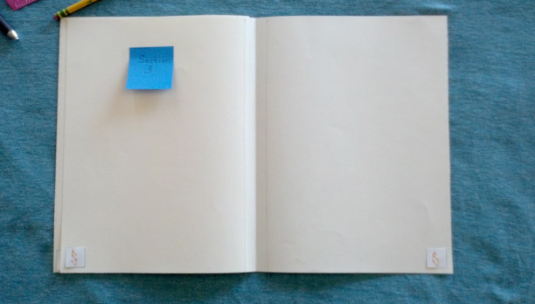
Creating Pages:
Step 5

Fold your “Section 3” paper to the left so the blank side is showing. Set your last folded piece of paper right next to it, so it looks like two pages with a crease in the center.

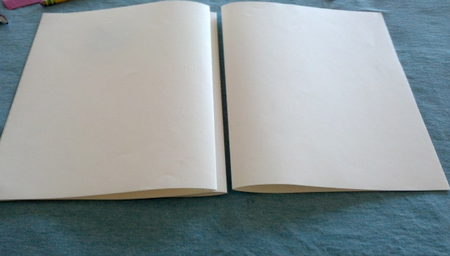

Write “Section 4” on another one of your sticky notes and place it on the left page. Glue a “7” on the lower left page and an “8” on the lower right page. Then, use your ruler to make half-inch marks to either side of the crease (gap) and use your ruler and pencil to make lines that indicate space for the binding.

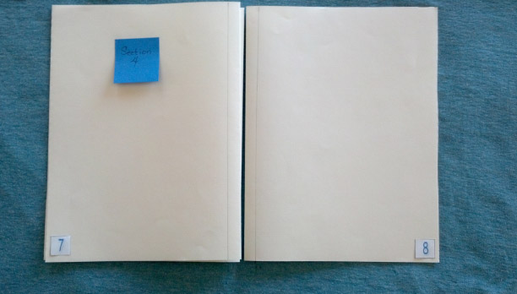
Glossary and Citations Pages

Fold the right page of “Section 4” to the left so there are two blank pages with a crease in the center.

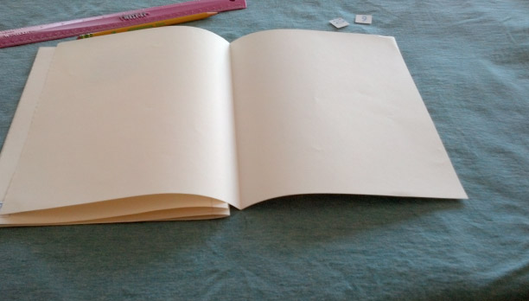

Write “Glossary” on another one of your sticky notes and place it on the left blank page. Write “Citations” on your last sticky note and place on the right blank page. Glue a “9” on the lower left and a “10” on the lower right. Then, use your ruler to make half-inch marks to either side of the crease and use your ruler and pencil to make lines that indicate space for the binding.

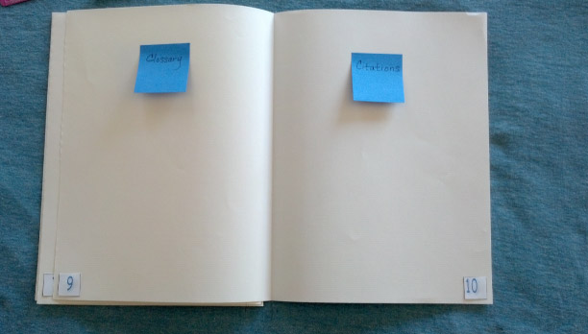

Graphic Novelette Rubric:
Section 1

 | 4 | 3 | 2 | 1
Section 1, Splash Page | _ Includes a title related to the content of this section  _ Includes a three- to five-sentence informational caption that explains what people needed or wanted  _ Thought bubble is a complete sentence that helps the reader understand what people wanted or needed  _Speech bubble is a complete sentence that helps the reader understand how people’s needs were met, and by whom  _Includes at least two frames/panels with images of an important person, place, thing, or idea inside; frames/panels separated by gutters  Includes at least one of these visual elements:  _ Close-up image  _ Definition box (scientific)  _ Definition box (academic)  _ Diagram  _ Ambient noise | Missing one or two of the criteria listed for a score of 4 | Missing three of the criteria listed for a score of 4 | Missing four or more criteria listed for a score of 4

Score
Reviewer comments:
Section 1:
Text and Images (Option A)

- Open a blank word document.
- Use “autoshapes” to create a rectangular frame for your caption, then add a text box to the caption frame. In the text box, type the best version of your three- to five-sentence summary from your end of unit storyboard draft for Section 1.
- Use “wordart” or font to create a title for Section 1. You may use the one provided on your end of unit Section 1 draft, or you may create a new title.
- Create a thought bubble using “autoshapes,” then add a text box to the thought bubble. In the text box, type the best version of text from the thought bubble on your storyboard draft.
- Create a speech bubble using “autoshapes,” then add a text box to the speech bubble. In the text box, type the best version of text from the speech bubble on your storyboard draft.
- Create two frames. Add an image to each frame.
- Add another visual element to Section 1 (see choices on rubric).
- Refer back to the rubric to help you determine whether you have created each piece to meet the criteria. Revise and/or create additional pieces as necessary.
- Print the caption, title, speech and thought bubbles, frames with images, and additional visual element.
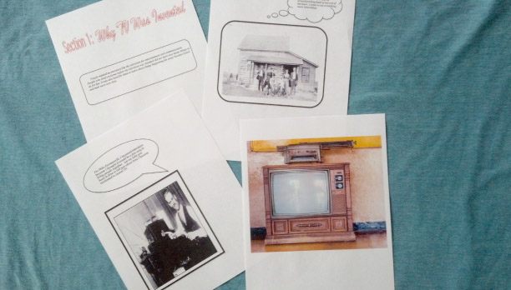
Section 1:
Text and Images (Option B)

- Gather two or three sheets of plain white paper.
- Draw a rectangular frame for your caption. In the frame, write the best version of your three- to five-sentence summary from your end of unit storyboard draft for Section 1.
- Neatly and in large print, write a title for Section 1. You may use the one provided on your end of unit Section 1 draft, or you may create a new title.
- Draw a thought bubble. Inside, write the best version of text from the thought bubble on your end 0f unit storyboard draft.
- Draw a speech bubble. Inside, write the best version of text from the speech bubble on your end of unit storyboard draft.
- Draw two frames. Draw an image in each frame.
- Create another visual element to add to Section 1 (see choices on rubric).
- Refer back to the rubric to help you determine whether you have created each piece to meet the criteria. Revise and/or create additional pieces as necessary.

Arranging Pieces and Peer Critique

- Neatly cut out each piece for Section 1 of your novelette: caption, title, thought and speech bubbles, frames with images, additional visual element.
- Arrange all the pieces onto pages 1 and 2 of your novelette. Do not glue them down yet!
- Show your arrangement to a member of your triad and ask her or him to refer to the rubric criteria to provide feedback (score and comments.)
- Rearrange, revise and/or create additional pieces as necessary, based on feedback.
- Show the changes to your peer reviewer for feedback regarding whether you addressed the concerns.
- As time allows, glue pieces onto pages 1 and 2 of your novelette. Make sure not to glue anything past the binding lines!



