Lesson 10
Objective: Within circular and scattered dot configurations of numbers 3, 4, and 5, find hidden partners.

Suggested Lesson Structure
 Fluency Practice (10 minutes)
 Application Problem (8 minutes)
 Concept Development (27 minutes)
 Student Debrief (5 minutes)
Total Time (50 minutes)
Fluency Practice (10 minutes)
- Line Up, Sprinkle, Circle K.CC.5 (4 minutes)
- 5-Frames: Counting Dots and Spaces K.CC.4a (4 minutes)
- Finger Counting K.CC.2 (2 minutes)
Line Up, Sprinkle, Circle (4 minutes)
Materials: (S) Bag of beans, piece of construction paper or foam as a work mat, small plastic cup
Note: This fluency activity requires students to recount the beans, which not only gives more opportunities for one-to-one matching, but also develops the concept of conservation.
T: Take three beans out of your bag, and put them in your cup. (Wait for students to do this.) Spill them onto your mat, and put them in a straight line. Touch and count.
S: 1, 2, 3.
T: Are there still 3?
S: Yes!
T: Put them back in your cup. Spill them onto your mat, and sprinkle them around. Touch and count.
S: 1, 2, 3.
T: Are there still 3?
S: Yes!
Repeat with 4 and 5, including an additional last step to put the beans in a circular formation. Allow students to experiment with other formations.

5-Frames: Counting Dots and Spaces (4 minutes)
Materials: (T) Large 5-frame cards (Lesson 10 Fluency Template)
T: We’re going to practice listen, think, raise your hand, wait. Raise your hand when you have counted the dots, then wait for the snap to say the number. Ready? (Show the 4 dot card. Wait until all hands are raised, and then give the signal.)
S: 4.
T: How many spaces? (Wait until all hands are raised, and then give the signal.)
S: 1.
T: How many dots? (Show the 3 dot card. Wait until all hands are raised, and then give the signal.)
S: 3.
T: How many spaces?
S: 2.
T: How many dots? (Show the 1 dot card. Wait until all hands are raised, and then give the signal.)
S: 1.
T: How many spaces?
S: 4.
As students begin to demonstrate mastery, deviate from a predictable pattern, and challenge them to recognize the groups of dots more quickly.
Finger Counting (2 minutes)

NOTES ON
MULTIPLE MEANS
OF ACTION AND EXPRESSION:
To help English language learners understand that they will practice listen, think, raise your hand, and wait, use gestures to illustrate these actions. For example, cup hands to the ear to illustrate listen, or point to temple when saying think.

Conduct the activity as outlined in Lesson 8.
Application Problem (8 minutes)
Draw 5 dogs playing. Draw a fence that keeps exactly 3 of them inside.
Note: This Application Problem links previous lessons of creating a group of objects of a certain count and leads into today’s lesson of hidden partners within a number.
Concept Development (27 minutes)
Materials: (T/S) 5 counting bears (1 large red, 2 large yellow, 2 small yellow), 1 paper clip

Part 1: Circular Count
Begin lesson with the five counting bears in a line on the rug.
T: Some bears went to the park. They wanted to play on the merry-go-round. (Place the plate down, and put the bears in a circle around or on the plate.)
T: Let’s count the bears. (Count with students, but do not stop when you get back to the first bear counted.)
S: 1, 2, 3, 4, 5, 6…. You didn’t stop counting after you counted them all.
T: What can I do so I know when to stop counting when my things are in a circle?
S: Pick up each bear as you count. Put a marker so that you know where you started.
T: Okay! I am going to put a marker so I can count in a circle correctly. (Place the paper clip at the start of the count.) Count with me.
S: 1, 2, 3, 4, 5.
T: What if I put my marker at a different bear to start? Will the count be the same? (Try it to verify.)
T: There are 5 bears. Yesterday, we found hidden partners inside of our big tower. Can we see groups of different bears inside this bigger group?
S: I see 3 big bears and 2 little bears.
T: Do you see any other small groups of friends?
S: I see 1 red bear and 4 yellow bears.
T: Inside our circle count, we saw hidden partners, too.
T: Now, you find small groups of bears inside your larger group.
Pass out a bag of five bears to each student. Direct them to put their cup on their mat and place their bear friends around the cup in a circle. Circulate and encourage them to both count in a circle correctly by placing their marker and look for small groups inside the large group.
Part 2: Scatter Count
Hold five bears in your hand.

NOTES ON
MULTIPLE MEANS
OF ENGAGEMENT:
Scaffold the lesson for students performing below grade level by having them pair up and take turns putting their bears in a circle and counting them. Students can then check their solutions with each other.

T: The bears were going so fast on the merry-go-round that they fell off. (Dump them onto the floor so they scatter.) Oh, no! Let’s count to see if all our bear friends are okay. How can I count them?
S: Touch each bear as you count. Pick up each bear as you count.
T: Show me a counting path. Where should I start?
S: With the big red one!
T: Next?
S: The little yellow one right next to it.
Continue the count. Once finished, go back and recount more quickly but use the exact same counting path through the five bears. After that, go back and find a different pathway through the count.
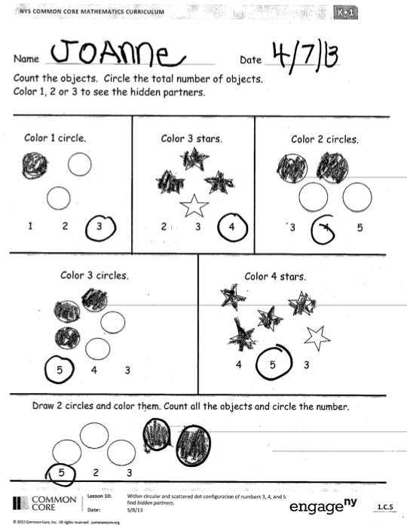
Problem Set (5 minutes)
Students should do their personal best to complete the Problem Set within the allotted time.
Have students count the objects in each circle. Then, have students color the correct number of objects.
Student Debrief (5 minutes)
Lesson Objective: Within circular and scattered dot configurations of numbers 3, 4, and 5, find hidden partners.
The Student Debrief is intended to invite reflection and active processing of the total lesson experience.
Invite students to review their solutions for the Problem Set. They should check work by comparing answers with
a partner before going over answers as a class. Look for misconceptions or misunderstandings that can be addressed in the Debrief. Guide students in a conversation to debrief the Problem Set and process the lesson.
You may choose to use any combination of the questions below to lead the discussion.
- Create stories to go along with problems. (For example, I have 3 gumballs. Two gumballs are white, and 1 gumball is _________.)
- Discuss what hidden partners were found inside the configuration.
- Circle the hidden partners and discuss.
- Talk about the strategies used for counting things that are in a circle and things that are scattered.
- Did you follow the same counting path as your friends?
Exit Ticket (3 minutes)
After the Student Debrief, instruct students to complete the Exit Ticket. A review of their work will help you assess the students’ understanding of the concepts that were presented in the lesson today and plan more effectively for future lessons. You may read the questions aloud to the students.
Note: Depending on your class, Exit Tickets with multi-step directions can be done in parts. “First let’s count the dots and circle the number.” Assess. “Now, let’s find the hidden group of 3. Circle a group of 3 in each box.” Assess again.

Name Date
Count the objects. Circle the total number of objects.
Color 1, 2, or 3 to see the hidden partners.

Color 1 circle.
1 2 3
3 4 5
Color 2 circles.
Color 3 stars.
2 3 4

Color 4 stars.
4 5 3
Color 3 circles.
5 4 3
5 2 3
Draw 2 circles and color them. Count all the objects, and circle the number.
Name Date
Count how many. Draw a box around that number. Then, circle a group of 3 dots in each box.
3 4 5 | 3 4 5
3 4 5 | 3 4 5
3 4 5 | 3 4 5

Name Date
Count how many. Draw a box around that number. Then, color 3 of the circles in each group.
3 4 5 |  | 3 4 5
3 4 5 | 3 4 5
3 4 5 | 3 4 5
Talk to an adult at home about the hidden partners you found.

large 5-frame cards

