Lesson 8

Objective: Answer *how many* questions to 5 in linear configurations   
(5-group), with 4 in an array configuration. Compare ways to count five fingers.

Suggested Lesson Structure

 Fluency Practice (12 minutes)

 Application Problem (8 minutes)

 Concept Development (25 minutes)

 Student Debrief (5 minutes)

**Total Time (50 minutes)**

Fluency Practice (12 minutes)

* How Many Dots? **K.CC.4a**  (5 minutes)
* Show Me Another Way **K.CC.4a** (4 minutes)
* Finger Counting **K.CC.2** (3 minutes)

How Many Dots? (5 minutes)

Materials: (T) Large 5-group cards 1–5 (Lesson 8 Fluency Template)

T: We’re going to practice *listen, think, raise your hand, wait.* I’m going to show you some dots. Raise your hand when you have counted the dots, then wait for the snap to say the number. Ready? (Show the 1 dot card. Wait until all hands are raised, and then give the signal.)

|  |  |
| --- | --- |
|  | NOTES ON  MULTIPLE MEANS  OF ENGAGEMENT: |
| Use hand signals to introduce a procedure for answering choral response questions: listen (cup hand around ear), think (finger to temple), raise your hand (raise your own hand to remind them to raise theirs), and wait for the snap. Practice with general knowledge questions until students are accustomed to the procedure. | |

S: 1.

T: (Show the 2 dot card. Wait until all hands are raised, and then give the signal.)

S: 2.

As students begin to demonstrate mastery, deviate from a predictable pattern and challenge them to recognize the groups of dots more quickly.

Show Me Another Way (4 minutes)

Conduct the activity as outlined in Lesson 6.

Have students try all of the different combinations. It might be necessary to indicate to students that they may use both hands to show the number. Continue the process to 5.

Finger Counting (3 minutes)

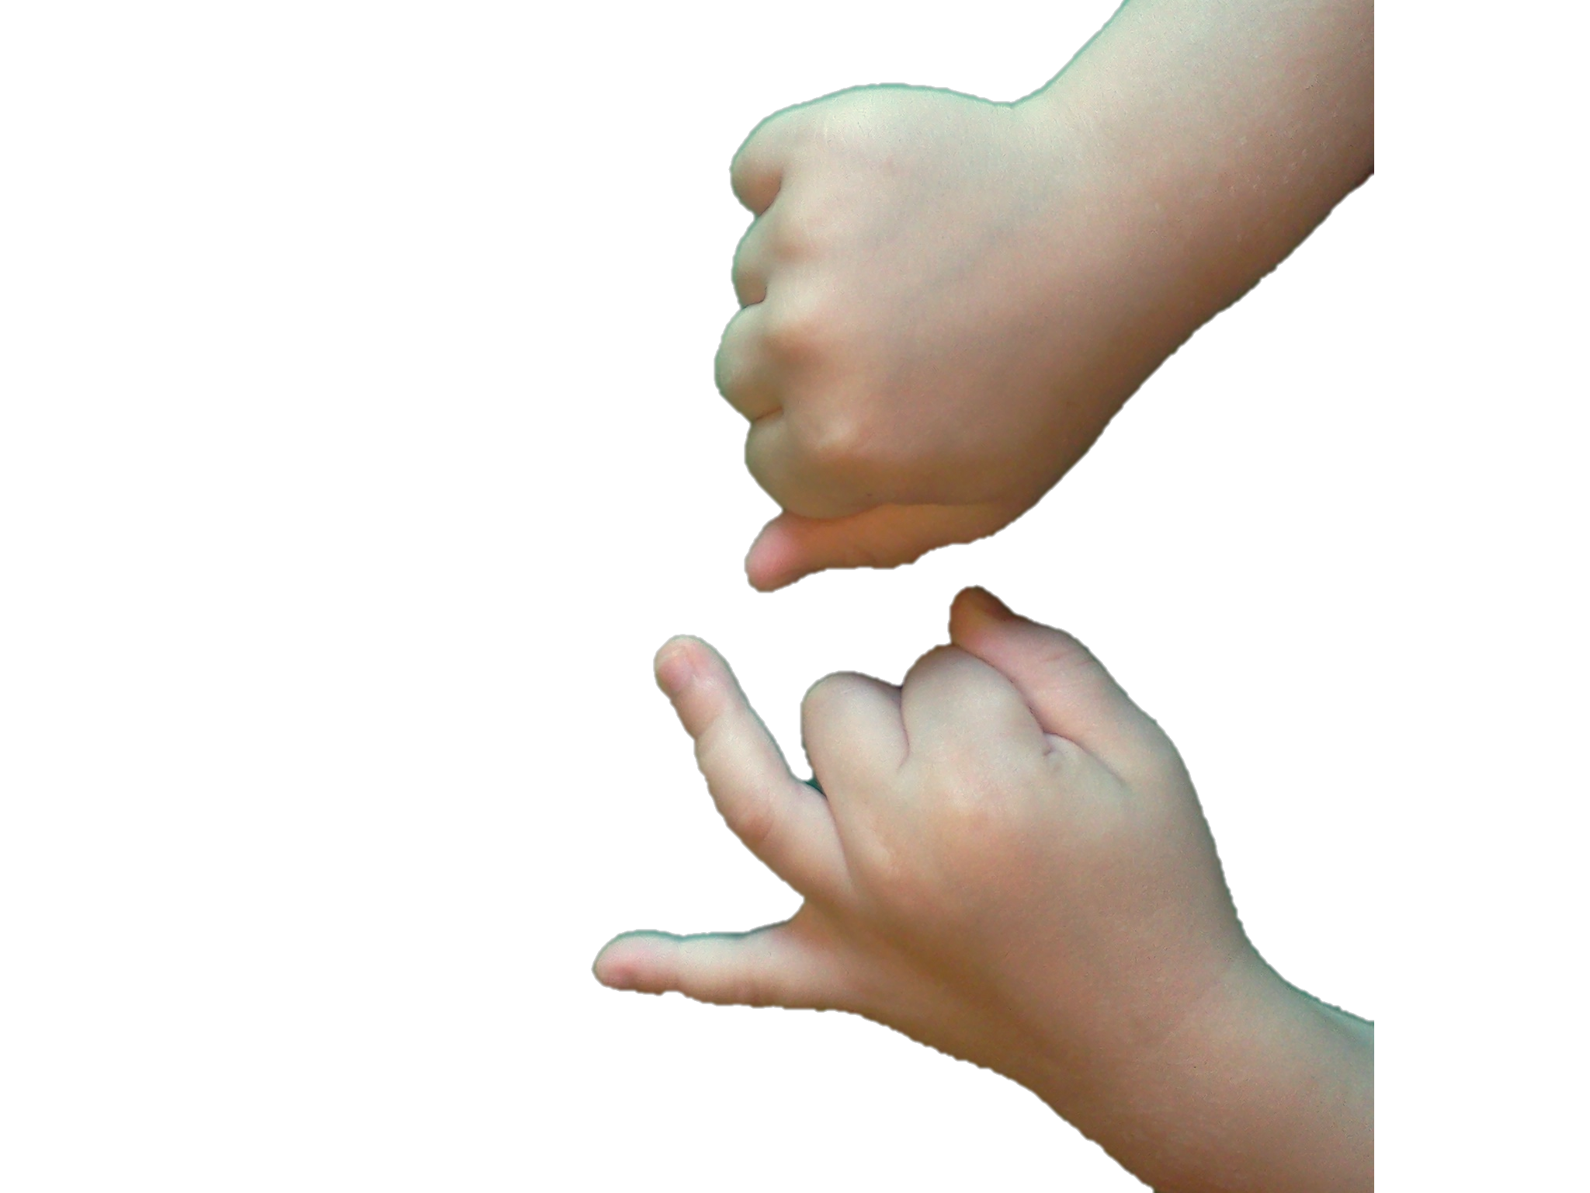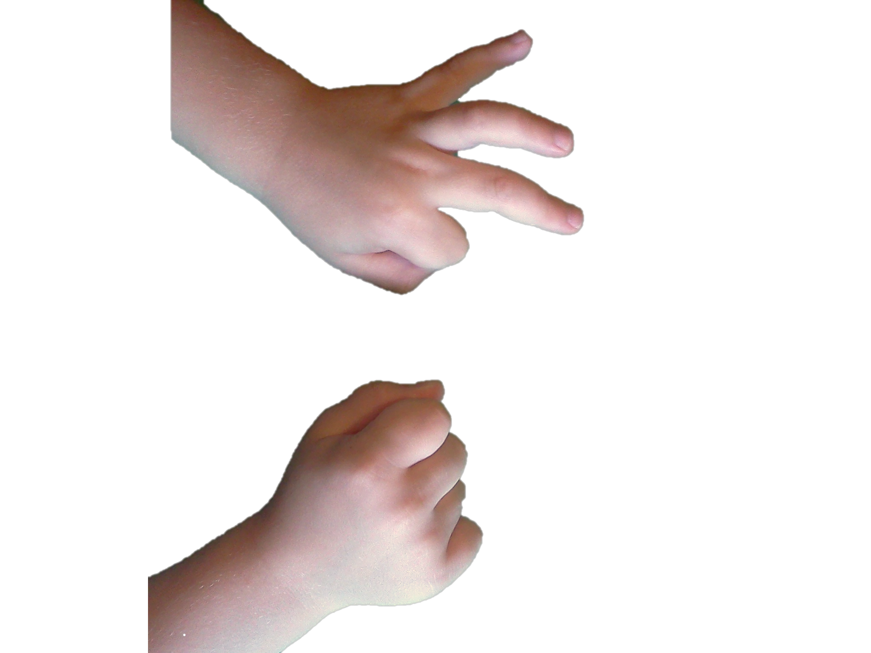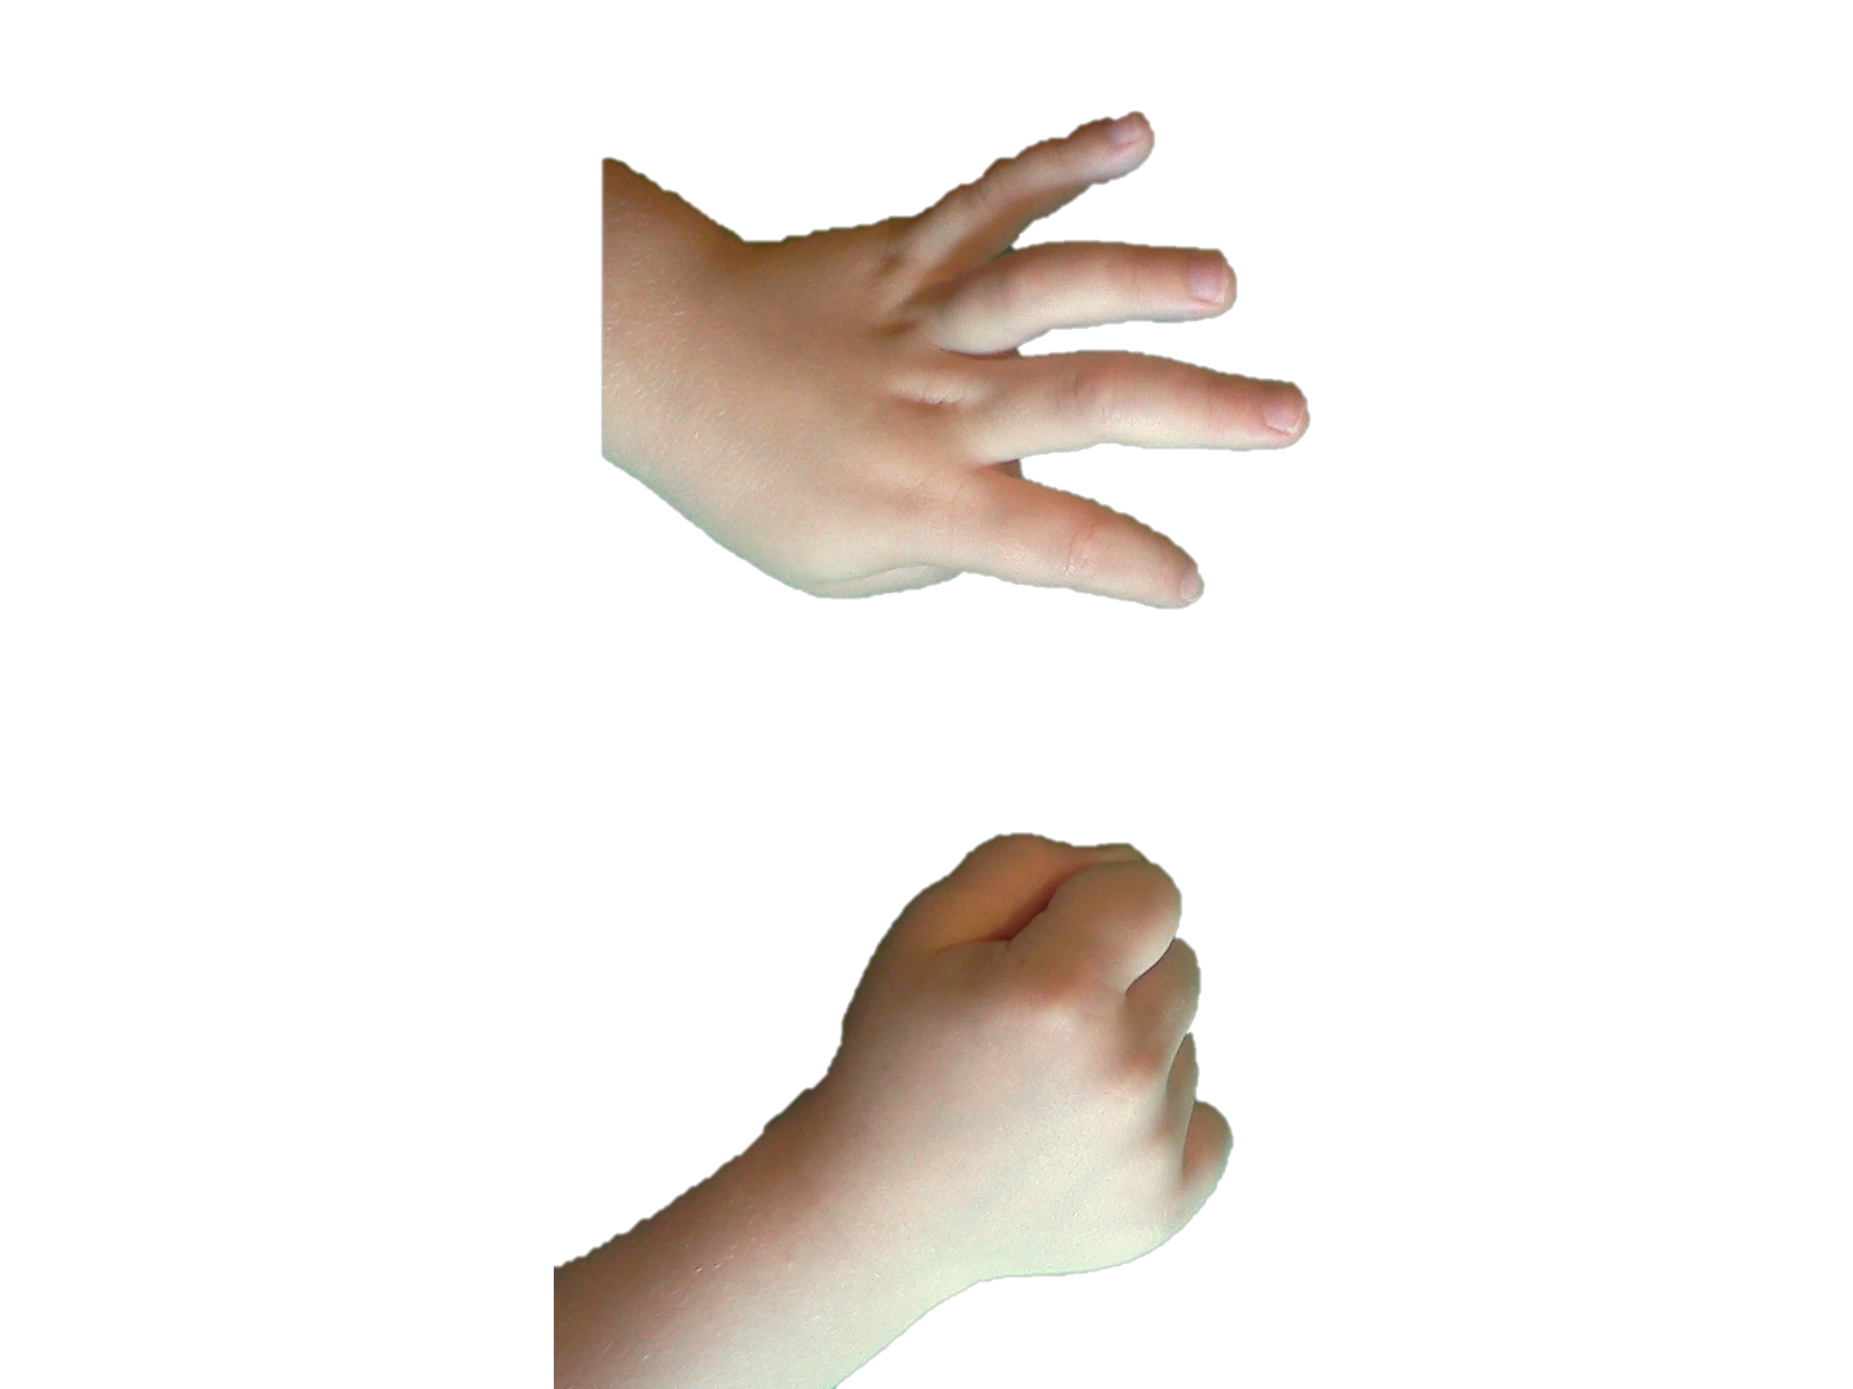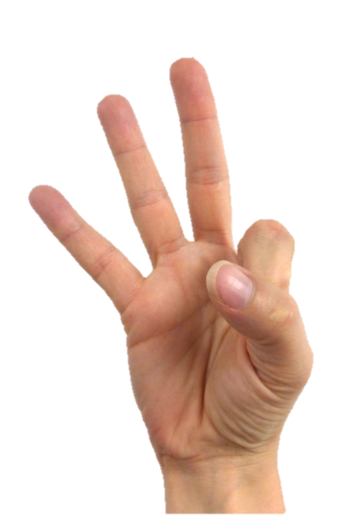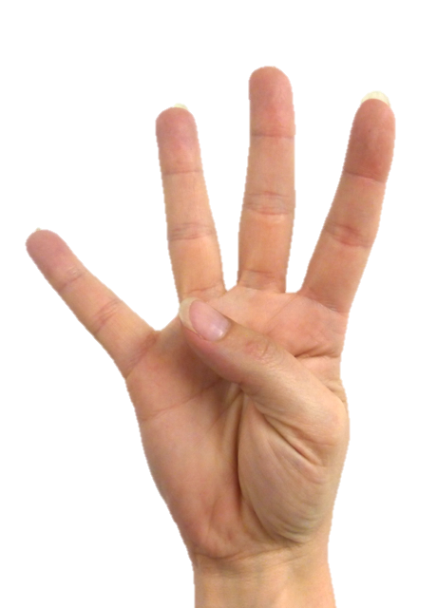

*Student view of teacher’s hand.*

*Student view of student’s hand.*

Note: Notice that the teacher does not say the numbers with the students, but rather listens intently for hesitations or errors. Return to a simpler sequence (within 3) if students begin to struggle.

T: Count with me. Ready? (Show pinky on the right hand.)

S: 1. (Show pinky on the left hand.)

T: (Show pinky and ring fingers on the right hand.)

S: 2. (Show pinky and ring fingers on the left hand.)

T: (Show pinky on the right hand.)

S: 3. (Show pinky, ring, and middle fingers on the left hand.)

T: (Show pinky and ring fingers on the right hand.)

Remain consistent in finger counting, moving from pinky to thumb, so that students can see their hands as a number line from left to right. (The teacher begins on the right so that the students do not see the reverse.)

Here is a recommended sequence: 1, 2, 1, 2, 3, 2, 3, 2, 3, 4, 3, 4, 3, 4, 5.

Application Problem (8 minutes)

Materials: (S) Counters in a bag

Put 4 counters in a row going across. (Wait for students do so.) Put 4 counters in a column going up and down. (Wait for students do so.) Draw your counters on your paper.

Note: Students are beginning to learn and experience that the total count is not changed when objects are arranged in different orientations.

Concept Development (25 minutes)

Materials: (T) 5 markers (S) Bag with 5 cotton balls, personal white board

T: (Begin on the carpet with four markers scattered.) How can I find out **how many** markers I have?

S: Count them.

T: Count with me.

S: 1, 2, 3, 4.

T: What is another way to organize them?

S: Move them into a line. 🡪 Line them up. 🡪 Put them in a row.

T: (Move them.) Let’s count again.

S: 1, 2, 3, 4.

T: It’s the same! (Put the four markers into a 2 × 2 array.)

T: How would I count these without putting them in a line?

S: Point to each one and count.

T: When I touch and count, I am going to go from left to right. Touch and count with me.

Give each student a bag with five cotton balls in it. Have them take out four, put them in a line, move them into an array, and move them back to a line, counting each time. Be sure they line their array up correctly, two above two.

Have the students take out the last cotton ball.

T: We are going to make magic pets. When I call out a number, I want you to put that many cotton balls in a line to make a caterpillar.

T: 5. (Put the cotton balls into a line.)

T: Now, change your magic pet into a fuzzy sleeping kitten; push the cotton balls together.

T: Put one cotton ball away. Put your cotton balls in a line to make a caterpillar.

T: Now, change your magic pet into a fuzzy sleeping puppy; push the cotton balls together.

T: Now, change your magic pet into two caterpillars that are exactly the same.

Have students take out their personal boards.

T: Draw four circles in a line to show your caterpillar. (Model the first few if needed.) Touch and count your circles.

S: 1, 2, 3, 4.

T: Erase. Now, draw a circle in each corner. Touch and count.

S: 1, 2, 3, 4.

T: Is that the same number?

Continue this procedure with 4 and 5 in linear and array configurations. Have them touch and count as needed each time so that they realize for themselves the conservation of the number.

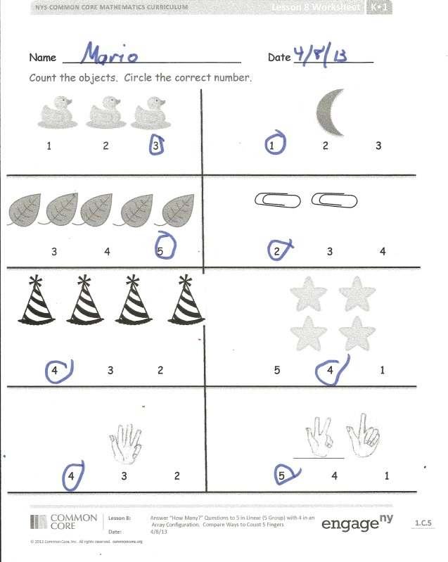Problem Set (5 minutes)

Students should do their personal best to complete the Problem Set within the allotted time.

Have students count the objects and circle the correct number.

Student Debrief (5 minutes)

**Lesson Objective:** Answer *how many* questions to 5 in linear configurations (5-group), with 4 in an array configuration. Compare ways to count five fingers.

The Student Debrief is intended to invite reflection and active processing of the total lesson experience.

Invite students to review their solutions for the Problem Set. They should check work by comparing answers with a partner before going over answers as a class. Look for misconceptions or misunderstandings that can be addressed in the Debrief. Guide students in a conversation to debrief the Problem Set and process the lesson.

You may choose to use any combination of the questions below to lead the discussion.

* How did you know how many ducks there were? (Have students model how they counted.)
* Turn and talk to your neighbor about how you counted the stars (array).
* Draw stars in an array on a dry erase board, and have students count the stars as you model.
* Discuss the answers students put on the hand pictures. Ask if they can show other ways to make that number.

**MP.3**

* Engage the students in a discussion about how the number stays the same even though the positioning of the objects changes.
* Do we have to touch and count to know the number is the same?
* Do we have to touch and count to count?

Exit Ticket (3 minutes)

After the Student Debrief, instruct students to complete the Exit Ticket. A review of their work will help you assess the students’ understanding of the concepts that were presented in the lesson today and plan more effectively for future lessons. You may read the questions aloud to the students.

Name Date

Count the objects. Circle the correct number.

1 2 3



1 2 3



2 3 4



3 4 5

4 3 2



5 4 1



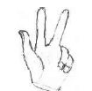

4 3 2

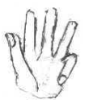

5 4 1

Name Date

Count. Circle the number that tells how many.

|  |  |
| --- | --- |
|  | 1 2 3 4 5 |
|  | 1 2 3 4 5 |
|  | 1 2 3 4 5 |
|  | 1 2 3 4 5 |
|  | 1 2 3 4 5 |
|  | 1 2 3 4 5 |

Name Date

Count. Circle the number that tells how many.

|  |  |
| --- | --- |
|  | 4 5 |
|  | 4 5 |
|  | 4 5 |
|  | 4 5 |
|  | 4 5 |
|  | 4 5 |
|  | 4 5 |

|  |
| --- |
|  |
|  |

[1]

|  |
| --- |
|  |
|  |

[2]

|  |
| --- |
|  |
|  |

[3] [4]

|  |
| --- |
|  |
|  |
|  |
|  |

[5]

1. large 5-group cards (Copy on card stock, and cut. Use cards 1–5 in today’s Fluency Practice. Save full set.)
2. large 5-group cards (Copy on card stock, and cut. Use cards 1–5 in today’s Fluency Practice. Save full set.)
3. large 5-group cards (Copy on card stock, and cut. Use cards 1–5 in today’s Fluency Practice. Save full set.)
4. large 5-group cards (Copy on card stock, and cut. Use cards 1–5 in today’s Fluency Practice. Save full set.)
5. large 5-group cards (Copy on card stock, and cut. Use cards 1–5 in today’s Fluency Practice. Save full set.)