Lesson 7
Objective: Sort by count in vertical columns and horizontal rows (linear configurations to 5). Match to numerals on cards.

Suggested Lesson Structure
 Fluency Practice (12 minutes)
 Application Problem (7 minutes)
 Concept Development (23 minutes)
 Student Debrief (8 minutes)
Total Time (50 minutes)
Fluency Practice (12 minutes)
- Sunrise/Sunset Counting to 5 K.CC.2 (3 minutes)
- Roll, Grab, Count K.CC.4a (5 minutes)
- Rekenrek Roller Coaster K.CC.4a (4 minutes)
Sunrise/Sunset Counting to 5 (3 minutes)
T: Hold your arms out in a great big circle. Pretend you are the sun! It’s morning, and the sun is coming up. Let me see your sunrise (model how to gradually rise up from a crouching position to standing on tip-toes).
S: (Act out the sunrise movement.)
T: Stay there. What does the sun do at night?
S: It goes down.
T: Show me your sunset (return to crouching position).
S: (Act out the sunset movement.)
T: Now, we’ll count as we make the sun rise. (Begin with 1 at the lowest position and count up to 5, reaching the highest position.)
S: 1, 2, 3, 4, 5 (make a circle with their arms and rise up on their toes).
T: Now, sunset.
S: 5, 4, 3, 2, 1 (return down to crouching position).
Repeat a few more times, but circulate to be sure students can do this independently. As always, listen closely for hesitations or errors.
Roll, Grab, Count (5 minutes)

NOTES ON
MULTIPLE MEANS
OF ENGAGEMENT:
Consider assigning a buddy for English language learners or special needs students to clarify the directions for the activity. Another possibility is to allow students to do this activity in pairs so that English language learners and special needs students can be more successful.

Materials: (S) Blank 5-frame (Lesson 7 Fluency Template), bag of 5 cubes, die (cover 6-dot side or replace 6 with a number less than 5)
Note: During this activity, circulate to see which students must recount each time, and which ones simply take off or put on more cubes to represent the new number.
1. Roll the die.
2. Touch and count the dots.
3. Put that many cubes on the 5-frame.
4. Roll again. Add or remove cubes to match the new number rolled.
After a few minutes, have students turn the 5-frame so that they can see both linear configurations, horizontal and vertical.
Rekenrek Roller Coaster (4 minutes)
Materials: (T) 20-bead Rekenrek
Direct students to gradually raise their hands as the numbers increase and lower their hands as the numbers decrease, mimicking the motion of a wave. Count up and down. Change directions after short sequences.
A suggested sequence is 1, 2, 3, 2, 3, 4, 3, 4, 5, 4, 3, etc.
Application Problem (7 minutes)
Find two things in this room that we use during math. Show a friend the things you found. How many things did you and your friend find all together? Did you find some of the same things? If so, put them together and count them.
Note: Application Problems continue to focus on counting and sorting. Students define groups and begin to learn that groups can be represented by the last number said when counting.
Concept Development (23 minutes)
Materials: (T/S) Bag of 15 linking cubes with 5 different colors such that each color configuration includes quantities to 5 (e.g., 1 blue, 2 red, 3 yellow, 4 green, and 5 brown), 5-group cards 1–5 (Lesson 7 Template)
T: (Hold up the 5-group card with the numeral 1). What number is this?
S: 1.
T: Can someone find something in our room that we have 1 of? (Wait as students look around and hands are raised.)
S: We have 1 teddy bear in our reading corner!
T: Sarah, go get the teddy bear and put it by our 1 card.
Continue finding objects in the classroom to match to each numeral to 5 (e.g., 2 pencils or 3 balls).
T: Good counting and finding everyone! (Hold up a bag of non-connected cubes.) Look at these cubes! I want to count how many I have of each color cube but they are all mixed up! What should I do?
S: Let’s dump them out and put the cubes that are the same color together.
T: Good idea! (As a whole group, work together to connect the same colored cubes. Position the sticks of connected cubes vertically.)
T: Now we can count how many of each color cube we have. Let’s count the blue cubes.

NOTES ON
MULTIPLE MEANS
OF ENGAGEMENT:
Below grade level students as well as English language learners and special needs students will benefit from seeing a chart representing the numeral with a corresponding object, e.g., 1 with one straw, 2 with two coins, etc.

S: There’s only 1 blue cube.
T: Yes. What card can we put under the blue cube to show that there is only one blue cube?
S: The number 1! (Call on a student to choose the correct card and place it beneath the blue cube.)
Continue until all of the 5-group cards are placed under a stick of cubes.
MP.8
T: (Turn the 5-cube stick horizontal.) Do we have to change the digit card for this stick of cubes? (Provide wait time, and call on several students. Be sure to ask the reason why or why not.)
S: No, because there are still 5 cubes so the 5 card is still good.
T: Should we count the cubes again? (Provide wait time, and elicit several opinions. Be sure to ask the reason why or why not.)
S: Yes, we should, just to make sure. No, we don’t have to because you didn’t put any more cubes on or take any off; you just turned the stick.
T: Ok. You are ready to try this at your desk. (Distribute materials. Monitor how each student organizes her cubes and digit cards, horizontally, vertically, or both horizontally and vertically.)

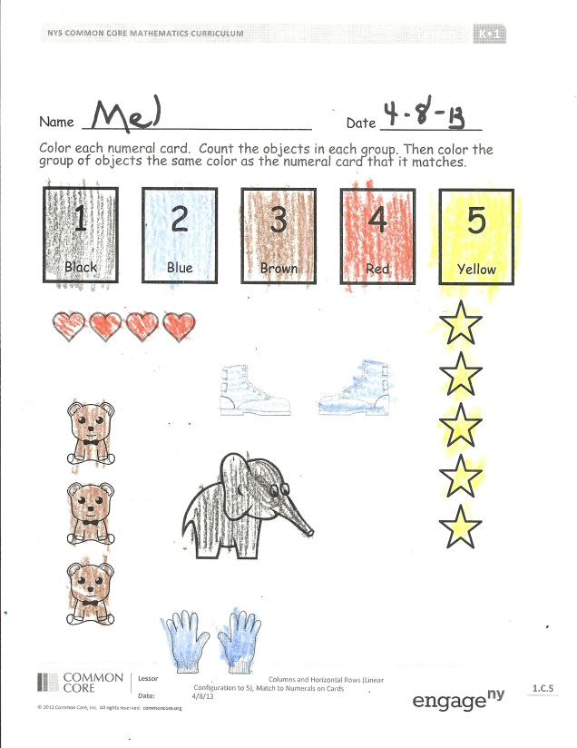
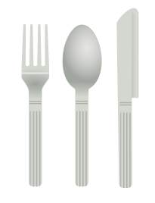
Problem Set (5 minutes)
Students should do their personal best to complete the Problem Set within the allotted time.
Color the numeral cards on the Problem Set together to support non-readers. Then let the students count and color independently.
Student Debrief (8 minutes)
Lesson Objective: Sort by count in vertical columns and horizontal rows (linear configurations to 5). Match to numerals on cards.
The Student Debrief is intended to invite reflection and active processing of the total lesson experience.
Invite students to review their solutions for the Problem Set. They should check work by comparing answers with a partner before going over answers as a class. Look for misconceptions or misunderstandings that can be addressed in the Debrief. Guide students in a conversation to debrief the Problem Set and process the lesson.
You may choose to use any combination of the questions below to lead the discussion.
- Why are the teddy bears and the silverware both colored brown? (Focus on the fact that even though both sets of objects look different, there are three bears and three pieces of silverware. Draw the same attention to the boots and the gloves.)
- (Draw five stars on the board horizontally.) Count the stars on your paper and on the board. How are they the same? How are they different?
Exit Ticket (3 minutes)
After the Student Debrief, instruct students to complete the Exit Ticket. A review of their work will help you assess the students’ understanding of the concepts that were presented in the lesson today and plan more effectively for future lessons. You may read the questions aloud to the students.

Name Date
Color each numeral card as directed. Count the objects in each group. Then, color the group of objects the same color as the numeral card that it matches.
5
Yellow
2
Blue
4
Red
3
Brown
1
Black

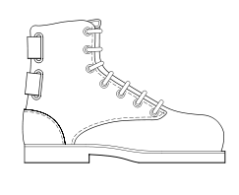

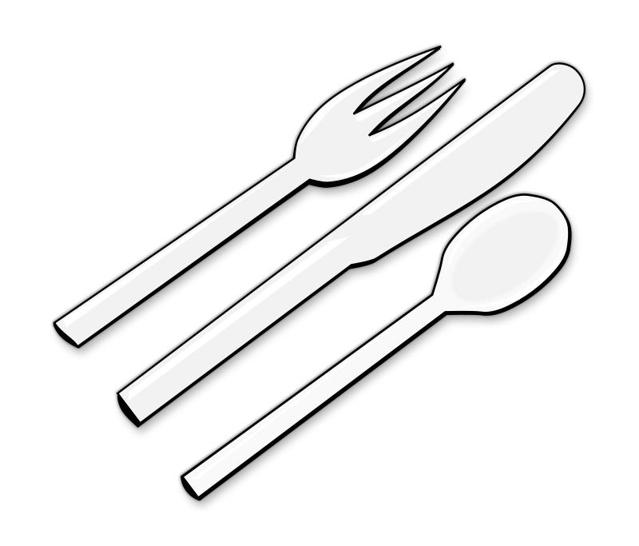
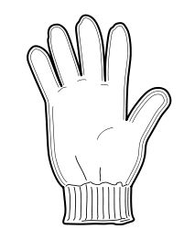

Name Date
Count the shapes. Color in the box that tells how many there are.

3

Name Date
5

4

Color each numeral card as directed. Count the objects in each group. Then, color the group of objects the same color as the numeral card that it matches.
1
Black
3
Brown
5
Yellow
4
Red
2
Blue

Cut out one 5-frame for each student.

0 | 1 | 2 | 3
4 | 5 | 5 | 6
7 | 8 | 9 | 10

Note: Only cards 1–5 are used in this lesson. Save the full set for use in future lessons. Consider copying on different color card stock for ease of organization.

5-frames
5-group cards (numeral side) (Copy double-sided with 5-groups on card stock, and cut.)
5-group cards (5-group side) (Copy double-sided with numerals on card stock, and cut.)

