Grade 4: Module 2B: Unit 1: Lesson 2
Building Background Knowledge: Launching Research of Animal Defense Mechanisms

Long-Term Targets Addressed (Based on NYSP12 ELA CCLS)
I can paraphrase portions of a text that are read aloud to me. (SL.4.2)
I can explain what a text says using specific details from the text. (RI.4.1)
I can infer what a text says using specific details from the text. (RI.4.1)
I can interpret information presented through charts or graphs. I can explain how that information helps me understand the text around it. (RI.4.7)
Supporting Learning Targets | Ongoing Assessment
- I can explain what it means to be a researcher.  - I can paraphrase information presented in a read-aloud on animal defense mechanisms.  - I can infer about a text by examining its visuals. | - Animal Defense research journals pages 2 and 3: Listening Closely and Examining Visuals note-catchers  - Observations from participation in Animal Defense Mechanisms: KWL chart construction

Agenda | Teaching Notes
- Opening  - Reviewing Learning Targets (5 minutes)  - Beginning the Research Process: What Does It Mean to Research? (15 minutes)  - Work Time  - Read-aloud and Paraphrasing Venom (15 minutes)  - Reading for the Gist and Examining Visuals—“Award-Winning Survival Skills” (20 minutes)  - Closing and Assessment  - KWL: Animal Defense Mechanisms (5 minutes)  - Homework  - “Award-Winning Survival Skills” Vocabulary | - This is the first of four lessons where students read the article Award-Winning Survival Skills. This article allows students to build background knowledge on the topic of animal defense mechanisms while at the same time practicing the key reading skills they will have to use independently later in this unit and Unit 2. In this lesson, students preview the visuals, then read the full article for the gist. For homework, students then reread the opening and circle challenging vocabulary. Then, in Lesson 3, students use vocabulary strategies as the reread three sections of the text. Finally, in Lesson 4, students reread these same sections to identify the main idea and supporting details.  - Note that over the course of these lessons, students do not read the “Hands-on Science: Master of Disguise” box on the last page of the article. You may invite students to read it on their own during independent reading or another time over the course of the module.  - Students use the Back-to-Back and Face-to-Face protocol in this lesson. Consider having students practice using this protocol prior to this lesson using topics that are of personal interest to them so when they use it with content, the protocol enhances the conversation and the focus is on the content.  - As in Lesson 1, students hear a portion of the book Venom read aloud. The Listening Closely note-catcher is introduced, and will be used and expanded upon in later lessons. This supports students in meeting the target: “I can paraphrase portions of a text that is read aloud to me.” Since this lesson is students’ first use of this note-catcher, its use is modeled during Opening Part A. If it’s difficult to read the text aloud and model using the organizer at the same time, consider inviting a “guest reader” to the class for the read-aloud of Venom; this guest reader might be the principal, another teacher, or a parent volunteer.  - During Lessons 2–4, students should work with a reading partner. Strategically partner students so they can support one another well as they read this complex text.  - Consider whether or not to have students use sticky notes to write their gist statements for each section of the text, or if students should write in the margins or on a separate sheet of paper.  - For homework, students reread the article and identify any challenging vocabulary words. These words will be used in Lesson 3 as a way to start the discussion about determining the meaning of unknown words when reading an informational text.  - In advance: Arrange for a guest reader for the read-aloud of Venom. Practice Back-to-Back and Face-to-Face protocol with questions/topics of personal interest to students

Agenda | Teaching Notes (continued)
- Review: Back-to-Back and Face-to-Face protocol, as well as Fist to Five in Checking for Understanding techniques (see Appendix).
- Locate the Close Readers Do These Things anchor chart (from Module 1, Unit 1, Lesson 3) or recreate this chart to display. See Work Time B.
- Post: Learning targets.

Lesson Vocabulary | Materials
paraphrase, animal defense mechanisms, research, infer, visuals; contorts, impersonate, mimic | - Equity sticks  - Performance Task anchor chart (from Lesson 1; teacher-created)  - Venom (book; for teacher read-aloud, cover and pages 16–17)  - Animal Defenses research journal (from Lesson 1)  - Listening Closely note-catcher (page 2 of Animal Defenses research journal; from Lesson 1; one per student and one to display)  - Listening Closely note-catcher (completed, for teacher reference)  - Document camera  - Close Readers Do These Things anchor chart (from Module 1, Unit 1, Lesson 3)  - “Award-Winning Survival Skills” (article; one per student and one to display)  - Examining Visuals note-catcher (page 3 of Animal Defenses research journal; from Lesson 1; one per student and one to display)  - Examining Visuals note-catcher (completed, for teacher reference)  - Sticky notes (optional; five per student)  - Animal Defense Mechanisms: KWL chart (page 1 of Animal Defenses research journal; from Lesson 1; one per student and one to display)

Opening | Meeting Students’ Needs
A. Reviewing Learning Targets (5 minutes)  - Use equity sticks to call on a student to read the first learning target:  - “I can explain what it means to be a researcher.”  - Tell students that in this lesson, they will learn what it means to be a researcher or someone who deeply studies a topic.  - Use equity sticks to call on a student to read the next learning target:  - “I can paraphrase information presented in a read-aloud on animal defense mechanisms.”  - Point to the word paraphrase and explain that to understand this learning target, students need to know the meaning of this word. Show them that it can be broken into its parts: para-, meaning to come from, and phrase, meaning a series of words. Taken together, “to come from words” should give them a clue about the word’s meaning.  - Ask students to reread the learning target with this in mind, then turn to a partner and explain what they think it means to paraphrase information from a read-aloud. Give students a few minutes to think and share; then use the equity sticks to call on a few pairs to share their explanations.  - Confirm that paraphrasing information means explaining something you have read or heard in your own words. If necessary, give an example.  - Read the last learning target:  - “I can infer about a text by examining its visuals.”  - Underline the word visuals. Tell students that understanding the word visuals is important to understanding this learning target. Ask students to think about other words that sound like visual (such as vision or visible/invisible).  - Ask students to turn to a partner and share what they think this word means. Remind students to use their knowledge of similar words like vision or visible/invisible and other clues from the sentence (something found in the text) to determine the meaning of this word.  - Listen for responses like: “Visuals are something you can see, like a picture or drawing.” Confirm the meaning of this word and that students understand the learning target. | - Discussing and clarifying the language of learning targets helps build academic vocabulary.

Opening (continued) | Meeting Students’ Needs
B. Beginning the Research Process: What Does It Mean to Research? (15 minutes)  - Display the Performance Task anchor chart and reread the performance task prompt. Remind students that they will be working towards writing a choose-your-own-adventure narrative during this module.  - Tell students to think and talk about the performance task with a partner using the Back-to-Back, Face-to-Face protocol. Explain the protocol to students:  - When you hear me say, “Back-to-back,” get back-to-back with a partner.  - Listen for a question prompt, then think about your response to the question.  - When you hear me say, “Face-to-face,” turn to face your partner.  - Decide which partner will share first, and then take turns listening carefully while your partner is speaking.  - When you hear me say, “Back-to-back,” thank your partner and silently go back-to-back again.  - If necessary, briefly have two students model.  - Invite students to stand up and place themselves back-to-back with the person next to them. Ask them to think about what it means to research. Then say, “Face-to-face!” and repeat the prompt: “What does it mean to research?”  - Listen for responses like: “It means to study or collect information about a new topic.” Clarify the meaning of research if necessary.  - After students have shared, say, “Back-to-back” again to get students ready for a new question. Continue to use the protocol for students to discuss the following questions:  - “Why is it important for writers to research?” Listen for responses like: “They need to know a lot about what they are going to write about, so that it will be interesting.”  - “What are different ways writers might conduct, or do, research?” Listen for responses like: “They read about the topic,” or “They look online to learn about what they are going to write about.” | - Examining the performance task closely provides motivation for student engagement in the topic, and gives purpose to reading a text closely.  - Whole class discussions encourage respectful and active listening, as well as social construction of knowledge.  - Consider posting the Back-to-Back, Face-to-Face questions for struggling students to see, or writing the questions down and giving these students an opportunity to preview the questions before this discussion.

Opening (continued) | Meeting Students’ Needs
- Gather students whole group and explain that writers often have to conduct research to learn about a topic they will write about. Preview the sequence of the three units in this module so students are oriented.
  - Under the performance task prompt, write: “Unit 1—Research: Animal Defense Mechanisms.” Explain that in this unit, they will learn about general animal defense mechanisms, and then do a deeper study of the defense mechanisms of the millipede. Next, write: “Unit 2—Research and Write: Build Expertise on a Selected Animal.” Tell students that in Unit 2, they will research in expert groups on different animals, and that this animal will be the main character in their narratives. However, before they can write their narrative, they have to research and write an informational piece about their animal and its defense mechanism.
  - Finally, write: “Unit 3—Write Narratives.” Explain that in this unit, students will read and examine a choose-your-own-adventure story to learn about this format and then plan and write their own narratives using the animal they researched as the main character.
  - Ask students to give you a thumbs-up if they have a general understanding of why they will become researchers on the topic of animal defense mechanisms, thumbs–sideways if they have a question, or a thumbs-down if they would like to meet for a one-on-one explanation of the task.

Work Time | Meeting Students’ Needs
A. Read-aloud and Paraphrasing Venom (15 minutes)  - If you invited a guest reader to model this lesson, introduce that person to the students, sharing that s/he will be helping with the read-aloud of Venom today as you model how a listener can take notes and then paraphrase a text.  - Display the cover of Venom so all students can see. Open to pages 4 and 5 and ask:  - “What did we learn about animal defense mechanisms when we read aloud Venom yesterday?”  - Listen for responses like: “Some animals use venom to protect themselves.” Validate responses and explain to students that they will listen to another section of Venom today.  - Ask students to get out their Animal Defenses research journal and turn to the Listening Closely note-catcher on page 2. Using a document camera, display a blank copy of the note-catcher. Explain to students that they will use this note-catcher to record information heard during the read-aloud.  - Explain to students there is a guest reader for today’s read-aloud so you can model how to use the note-catcher while he or she reads the text.  - Use equity sticks to call on a student to read the directions and headings of the table in the note-catcher. Answer any clarifying questions students have about the directions or the headings.  - Tell students that they will listen to the text read aloud several times. The first time they hear it, they should simply listen for the gist. The second time they hear it, they should begin to fill in the table.  - Invite the guest reader to read aloud pages 16 and 17 in Venom.  - Invite students to Think-Pair-Share. Ask:  - “What was the gist of this text?”  - Use equity sticks to call on a student to share his or her partner’s response. Listen for responses like: “It was about how bees sting and how they sting,” or “It was about the defense mechanisms of bees.”  - Tell students that they will now hear page 17 read aloud a second time, and that you will model how to fill in the table while listening to the text read aloud. Explain that they do not need to write anything on their note-catchers at this time.  - Invite the guest reader to reread page 16. Ask students:  - “After hearing this section of the text read again, what notes can we take, and in which box in our note-catcher would we put them?” | - Reading the complex text aloud slowly, fluently, and without interruption or explanation promotes fluency for students by allowing them to hear a strong reader read with accuracy and expression.

Work Time (continued) | Meeting Students’ Needs
- Listen for students to name various facts about bees from this section of the text. Listen for students to explain or point out that these are interesting facts about bees, but not related to their defense mechanisms and survival.
- Model recording a fact in the box headed “Other Facts about Bees and Wasps” and give students a few minutes to record any facts they found interesting in this section of the note-catcher.
- Next, invite the guest reader to reread page 17. Ask students:
  - “After hearing this section of the text read again, what did you hear that we can we record in our note-catchers?”
- Listen for students to suggest items that can be recorded in the “Examples of How Bees and Wasps Protect Themselves” and “How This Helps Bees and Wasps Survive” columns of the table. For example: “Bees produce a chemical signal” could be recorded in the first column and “This warns other bees of danger” could be recorded in the second column.
- Model taking notes for these pages of the text in the top row of the note-catcher (for pages 16–17) and ask students to record their notes along with you.
- Finally, ask students to reread their notes; then give students the following instructions for a Think-Pair-Share:
  - Reread your notes from today’s reading of Venom.
  - Think about how we could paraphrase what we heard today.
  - Share with your partner how you would explain what this section of the text is about.
- Use equity sticks to call on several pairs to share how they would paraphrase the text. This allows students to hear the text paraphrased in a variety of ways. Listen for students to say something similar to: “This section of Venom was about bees, where they live, what they eat. It talked about how they use chemical signals and stingers with venom to protect their hives. And it explained that some people are allergic to bee venom and how this can be dangerous.”
- Point out to students that when paraphrasing, they should include the big ideas of what they listened to, but they don’t have to include every detail. Point out that rereading their notes will help them remember the big ideas of the text.
- Tell students that tomorrow they will continue reading more from this section and continue to practice paraphrasing. Encourage students to thank the guest reader.

Work Time (continued) | Meeting Students’ Needs
B. Reading for the Gist and Examining Visuals—“Award-Winning Survival Skills” (20 minutes)  - Place students with a partner for reading and explain that the class will continue to research animal defense mechanisms by reading an article closely for the next few lessons.  - Post and review the Close Readers Do These Things anchor chart (from Module 1, Unit 1, Lesson 3).  - Read small chunks of text slowly and think about the gist.  - Reread each passage one sentence at a time.  - Underline things that you understand or know about.  - Circle or underline words that you do not know.  - Talk with your partners about all of your good ideas.  - State the gist or message of the paragraph in the margin.  - Listen to the questions.  - Go back to the text to find answers to questions.  - Talk with your partners about the answers you find.  - Tell students that the article they will read is challenging and may have unfamiliar words. Reassure them that just like when they read the Great Law of Peace, they are not expected to understand it fully the first time. Remind them that one key to being a strong reader of difficult text is being willing to struggle.  - Display and distribute “Award-Winning Survival Skills” to students. Build up the excitement; this text will be the first text they read and examine closely for their research.  - Invite students to look through the article, thinking about what they notice and wonder. Have students Think-Pair-Share these observations and questions. Use equity sticks to call on students to share with his or her peers what they noticed or wondered about the text. If no students point out the visuals in the article, say something like: “I notice visuals on each page of this article.”  - Ask:  - “How do visuals help you, the reader, to understand an informational text?” Listen for responses like: “Visuals help me to picture what the author is writing about,” or “Captions and labels on visuals explain the pictures in more detail, so I can better understand what I’m looking at.” | - Graphic organizers and recording forms engage students more actively and provide the necessary scaffolding that is especially critical for learners with lower levels of language proficiency and/or learning. For students needing additional support, you may want to provide a partially filled-in graphic organizer.  - Provide ELLs with a sentence starter or frame to aid in language production. For example: In the visual I see …

Work Time (continued) | Meeting Students’ Needs
- Display Examining Visuals note-catcher and invite students to open it to page 3 in their Animal Defenses research journals. Tell students that looking at visuals before reading a text can help them think more deeply about the text. Say something like: “Readers make inferences when looking at visuals just like when they read a text. After they examine a visual closely, they read the text, looking for details that support their inferences.”
- Explain that they will be using this note-catcher to record information and inferences about a visual in “Award-Winning Survival Skills.” Use equity sticks to call on a student to read the Steps 1–3 on the note-catcher and the headings of the first and middle columns (“Details from the Visual” and “My Inferences”). Clarify that students will complete the only first two columns prior to reading the text. Call on a student to read Steps 4 and 5 and the heading of the last column (“Details in the Text That Support My Inferences”). Clarify that students will read the article and then complete the last column.
- Invite students to look at page 2 of “Award-Winning Survival Skills” and display for students. Remind students that first they will look at the visual on the page and jot down notes about what they see in the visual in the “Details from the Visual” column.
- Notice details in the visual in a manner similar to the following: “The first big thing I notice is that this visual is broken into two parts—the top part and the bottom part. In the top part, I see a big photograph and a smaller photograph in a circle, and a caption. I see the same format in the bottom part—a big photograph and a smaller one in a circle, and another caption.”
- Next, ask the students to look closely at the visual and read along as you read the captions aloud.
- Explain the meaning of the word contorts, to bend in a way that seems impossible. Tell students that the words impersonate and mimic have similar meanings. Ask students to reread each caption with their partner and see if they can figure out the meanings of these words from the words in the sentence and the visuals.
- Ask a few pairs to share and listen for students to say these words mean “copy.” Prompt students to explain what clues they used in the captions or pictures to help them figure out the meaning of these words.
- Next, ask students to suggest notes that you can record in the first column of the note-catcher, “Details from the Visual.” Accept only details that can be found explicitly in the visual, “two pictures with a circle in each.” If students offer up an inference based on the visual, explain that you will record those next.
- Explain that now you would like them to infer about the visual. Remind students that in order to infer they must use both evidence that they see and what they know. Then, ask students to discuss the following question with their partner:
  - “What can you infer about the mimic octopus based on this visual?”

Work Time (continued) | Meeting Students’ Needs
- Listen for students to say: “It copies other animals so it looks poisonous.” Prompt them to explain what evidence they used from the visual to make this inference. Record inferences in the second column.  - Next ask students to examine the remaining visuals in the text with their partners. Remind them that they should not yet fill out the third column of their note-catchers. Give students 10 minutes to examine the remaining visuals.  - Use equity sticks to call on students to share an inference. Tell students to use the sentence frame: “We infer _______ because the visual/caption shows/says _______.” Record what students share in the “My Inferences” column on the graphic organizer.  - Ask students to close their research journals. Tell them that the class will come back to the Examining Visuals note-catcher after a few days, when they have a deeper understanding of the text, to confirm what they inferred about the visuals.  - Distribute five sticky notes per student (optional; see Teaching Notes). Next, tell students that now you are going to read text aloud to them and that you would like them to read along silently and listen for the gist, or what it is mostly about.  - Read the text aloud and pause after each section of the text (once you reach a new heading) and ask students to turn to their partner to discuss the following question:  - “What was that section of the text mostly about?”  - Use equity sticks to call on various pairs. As a class, agree on a gist statement for the section, and ask students to record a gist statement in the margin of their text, or on a sticky note.  - After the first read of the text is complete, ask for a final gist statement:  - “Overall, what is this text about?”  - Listen for students to say something similar to: “Different animals and how they defend themselves.” | - Hearing a complex text read slowly, fluently, and without interruption or explanation promotes fluency for students; they are hearing a strong reader read the text aloud with accuracy and expression, and are simultaneously looking at and thinking about the words on the printed page. Set clear expectations that students read along silently in their heads as you read the text aloud.

Closing and Assessment | Meeting Students’ Needs
A. KWL: Animal Defense Mechanisms (5 minutes)  - Remind students that good researchers always reflect on and record what they’ve learned. Display your copy of the Animal Defense Mechanisms: KWL chart and invite students to turn to their chart on page 1 of their research journals.  - Invite students to Think-Pair-Share. Ask:  - “Were any of your questions answered in the text that you read today?”  - “What new information did you learn from this article?”  - Invite students to write the answers to any questions they had in the W column under the “I Learned” column, in the “Information” section. Include the name of the article in the “Source” column.  - Tell students to also add one new piece of information they learned from the article in the “I Learned” column.  - Post and preview the homework. If necessary, indicate which section of the text they will be rereading. | - Consider adding visuals or symbols to the chart to support students.
Homework | Meeting Students’ Needs
- Reread the opening section of the “Award-Winning Survival Skills” read in today’s lesson. While you read, circle words that you do not know the meaning of. Choose one word you circled and try to figure out the meaning of it. Write down how you figured out what the word meant as well. | - Asking students to identify challenging vocabulary helps them monitor their understanding of a complex text. When students annotate the text by circling these words, it can also provide a formative assessment for the teacher.  - For students who struggle to read complex text independently, consider allowing them to reread and circle unfamiliar vocabulary with a partner during guided and independent reading time.

Grade 4: Module 2B: Unit 1: Lesson 2
Supporting Materials

Animal Defenses Research Journal:
Listening Closely Note-Catcher
(For Teacher Reference)
Source: Venom pages 16–17 and 19–20

Directions: Listen as Venom is read aloud. Use the table below to record your notes.

Examples of How Bees and Wasps Protect Themselves | How This Helps Bees and Wasps Survive
Venom pages 16–17
Completed in Lesson 2  - Bees have chemical signals called pheromones  - Bees have barbed stingers that stick into the victim | Completed in Lesson 2  - Helps to warn their hive of danger  - The venom from the sting is really painful to scare away predators
Venom pages 19–20 Completed in Lesson 3
Completed in Lesson 3  - Wasps sting  - The velvet wasp runs from enemies  - Most wasps and bees have yellow and black stripes | Completed in Lesson 3  - The sting hurts and scares attackers away  - The wasp won’t get caught and eaten or killed  - The colors and stripes warn other animals that bees and wasps are venomous
Other Facts about Bees and Wasps
Completed in Lessons 2 and 3
- There are lots of different kinds of bees
- Bees live in a colony and have different jobs
- Most bees eat nectar and pollen
- There are many kinds of wasps
- Most wasps use their venom to eat other bugs
Animal Defenses Research Journal:
Listening Closely Note-Catcher
(For Teacher Reference)

Explain what this section of Venom was about?

This section of Venom was about bees and wasps and how they sting. It explained the different kinds of bees and wasps and how they live and what they eat. It explained that bees use their stingers and venom to protect their hive and wasps mostly use their venom to kill and eat bugs, but they will sting in self-defense, too. Most bees and wasps have yellow and black stripes and this warns that they are venomous.

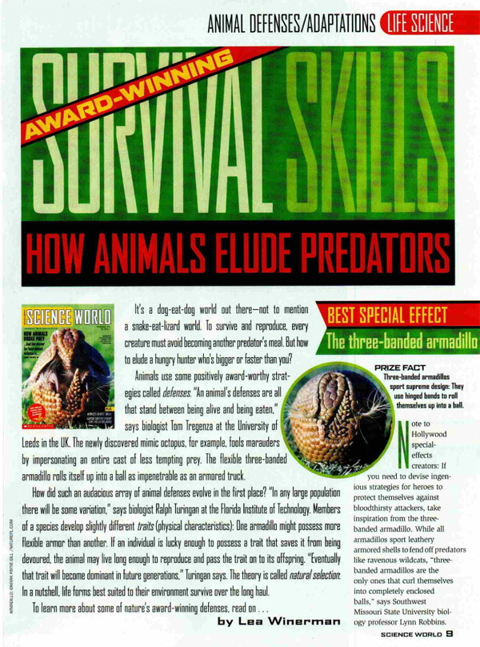
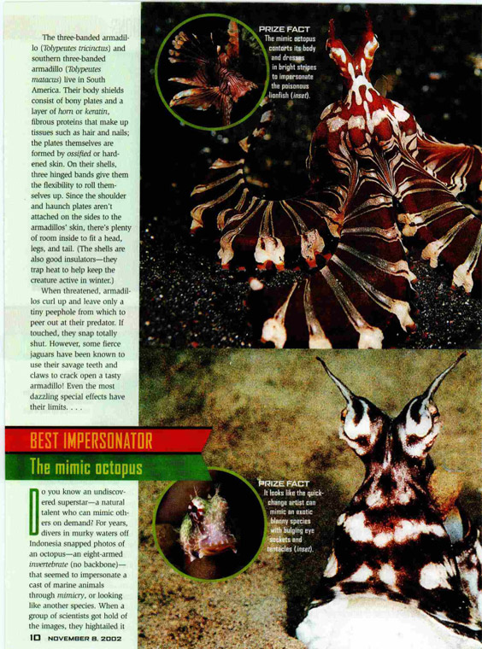
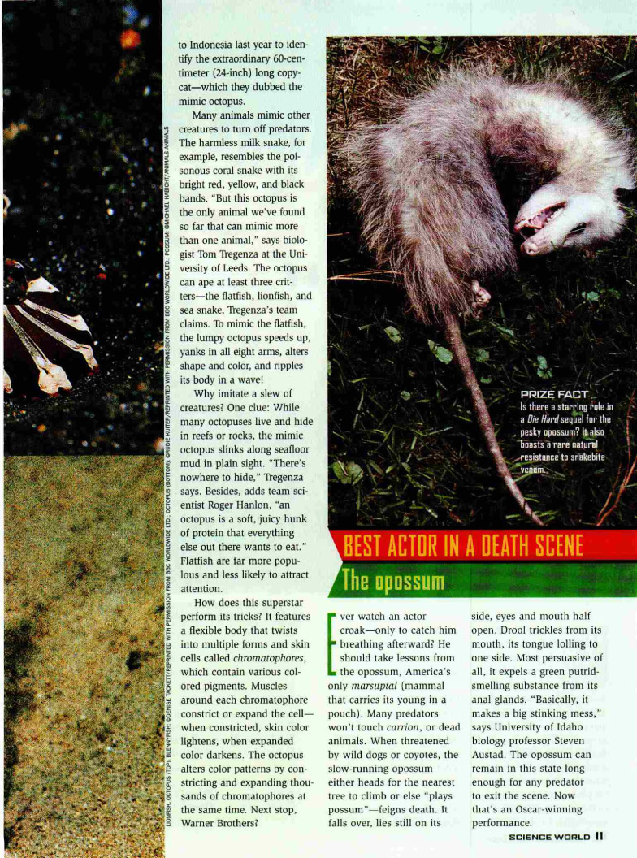
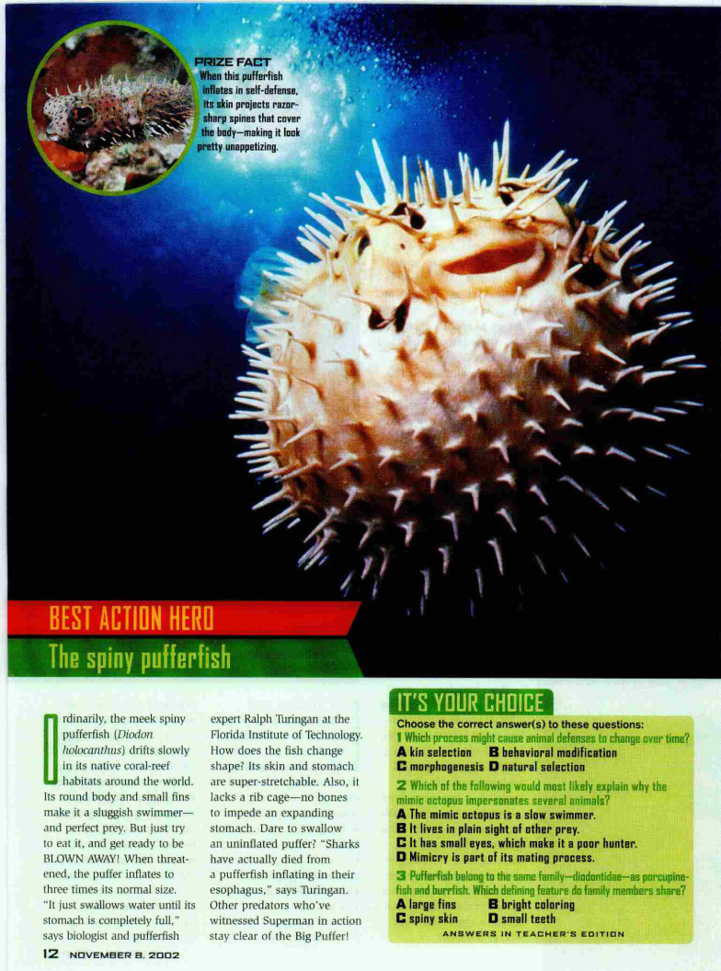
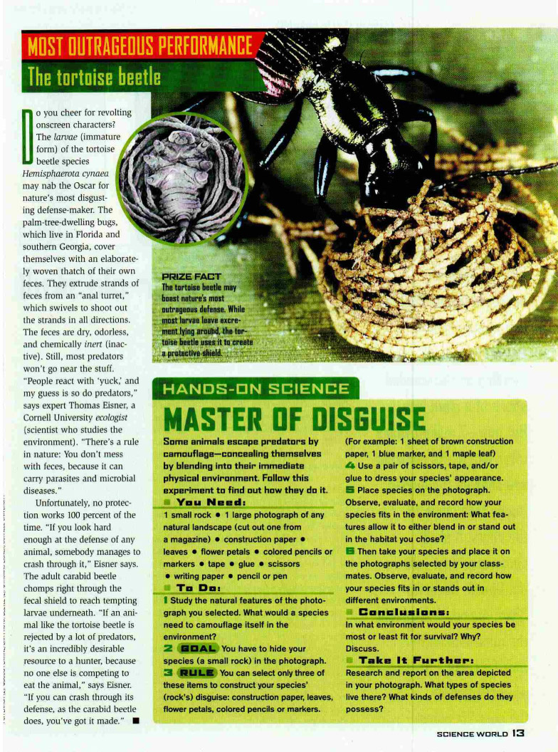
From Science World, November 8, 2002. Copyright © 2002 by Scholastic Inc. Reprinted with permission of Scholastic Inc.
Animal Defense Mechanisms: Examining Visuals
(For Teacher Reference)

- Look at the visual on page 2 of “Award-Winning Survival Skills: How Animals Elude Prey.”
- In the first column of the graphic organizer below, record three details you see in the visual.
- In the second column of the graphic organizer, record the inferences you make based on these details.

**NOTE: Do NOT complete the right-hand column of the graphic organizer yet!

- Read the article.
- In the right-hand column of the graphic organizer, record details from the text that support your inferences in the middle column.
Details from the Visual  (explicit information) | My Inferences  (what I infer about this animal) | Details in the Text That Support My Inferences  (confirmed with explicit information)
- Underwater  - Mimic octopus  - Orangeish-red stripes  - Stripes look like a lionfish  - Can bulge eye sockets and tentacles and looks like a blenny species | - The mimic octopus tricks other animals into thinking it’s a lionfish. Lionfish are poisonous, so other animals probably know this and stay away from them. Since the mimic octopus looks like the lionfish, other animals probably stay away from them, too, because they think the octopus is a lionfish and will poison them.  - The mimic octopus tricks other animals into thinking it’s a blenny species by bulging its eye sockets. | REMINDER TO TEACHERS: This column will not be completed with students until Lesson 4.  “Many animals mimic other creatures to turn off predators.” (page 3)  “But this octopus is the only animal we’ve found that can mimic more than one animal.” (page 3)  “The octopus can ape at least three critters—the flatfish, lionfish, and sea snake, Tregenza’s team claims.” (page 3)

