Grade 3: Module 2B: Unit 2: Lesson 16
End of Unit 2 Assessment: Reading and Writing about a New Informational Text: Exploring Countries: France

Long-Term Targets Addressed (Based on NYSP12 ELA CCLS)
I can write an informative text that has a clear topic. (W.3.2)
I can develop the topic with facts, definitions, and details. (W.3.2)
I can construct a closing statement on the topic of an informative text. (W.3.2)
I can use text features to locate information efficiently. (RI.3.5)
I can answer questions using specific details from informational text. (RI.3.1)
I can determine the main idea of an informational text. (RI.3.2)
I can retell key ideas from an informational text. (RI.3.2)
I can document what I learn about a topic by taking notes. (W.3.8)
I can sort evidence into provided categories. (W.3.8)
Supporting Learning Targets | Ongoing Assessment
- I can answer questions about the culture of France by reading excerpts from an informational text closely.  - I can identify the main idea of a paragraph in Exploring Countries: France by reading closely.  - I can identify key details that support the main idea in a paragraph from Exploring Countries: France.  - I can use text features to help me answer questions about the text.  - I can record evidence I find of customs and traditions in France.  - I can write an informative paragraph about some of the customs and traditions in France. | - End of Unit 2 Assessment  - Tracking My Progress, End of Unit 2 recording form

Agenda | Teaching Notes
- Opening  - Engaging the Reader: Things Close Readers Do (5 minutes)  - Work Time  - End of Unit 2 Assessment: Close Reading on My Own (35 minutes)  - Tracking My Progress (5 minutes)  - Things I Want to Know (10 minutes)  - Closing and Assessment  - Debrief (5 minutes)  - Homework  - None. | - In the Opening of this lesson, students are reminded of the things close readers do using the Things Close Readers Do anchor chart. This will help give them confidence to complete today’s work, as they realize that they have been practicing all of these skills throughout this module.  - For the bulk of this lesson, students independently apply the close reading skills they have been building throughout the module to complete the End of Unit 2 Assessment. Because this is a reading assessment, the text should not be read aloud.  - If students finish the assessment before their classmates, they should read their independent reading book, reread the excerpts from Exploring Countries: France, or complete another task that you designate ahead of time.  - After the End of Unit 2 Assessment, students have a chance to formally assess their learning using the Tracking My Progress recording form. Remind them of the importance of “checking in” with themselves, so they can see where they’ve been, where they are, and where they would like to go with their learning. This self-awareness is a powerful learning tool.  - The writing portion of the End of Unit 2 Assessment should be assessed using the New York State Grade 3 Expository Writing Evaluation Rubric (see the supporting materials). Note that the New York State Grade 3 Writing Evaluation Rubric includes language that states: “Essays at this level.…” For this assessment, students will not be crafting an essay. Rather, they will craft full paragraphs. But the criteria for quality as identified in the rubric remains the same for both essays and paragraphs.

Lesson Vocabulary | Materials
France, facts, main idea, details, informative | - Things Close Readers Do anchor chart (begun in Module 1, Unit 1, Lesson 2)  - Exploring Countries: France excerpt (assessment text; one per student)  - End of Unit 2 Assessment: Reading and Writing about a New Informational Text: Exploring France excerpts (one per student)  - End of Unit 2 Assessment: Reading and Writing about a New Informational Text: Exploring France excerpts (answers, for teacher reference)  - Tracking My Progress, End of Unit 2 recording form (one per student)  - Index cards (one per student)  - New York State Grade 3 Expository Writing Evaluation Rubric (for teacher reference)

Opening | Meeting Students’ Needs
A. Engaging the Reader: Things Close Readers Do (5 minutes)  - Gather students in a circle.  - Tell them that today they are going to “show what they know” about reading closely. Tell them they will read a new informational text about a new country: France. They will also be asked to take the same kind of notes they have been taking in previous lessons on their recording forms.  - Direct students’ attention to the Things Close Readers Do anchor chart. Ask for volunteers to read the items on the anchor chart aloud.  - Ask:  - “What have we been learning about how to read closely?”  - “What specifically have we been learning about how to read informational text to build expertise on a topic?”  - Listen for them to offer comments that illuminate today’s learning targets.  - Point out this connection to students. Probe as needed, emphasizing the importance of rereading, asking questions, looking in the text for answers, finding the main idea, finding details to support the main idea, using text features, and recording your new learning on a recording form.  - Tell students that these are exactly the skills they will demonstrate on today’s end of unit 2 assessment. | - When unpacking the learning targets, consider using visuals to support the meaning of key words in the target.

Work Time | Meeting Students’ Needs
A. End of Unit 2 Assessment: Close Reading on My Own (35 minutes)  - Distribute Exploring Countries: France excerpt and the End of Unit 2 Assessment: Reading and Writing about a New Informational Text: Exploring France excerpts.  - Read the directions on the End of Unit 2 Assessment. Point out that students will record information. They need to find four examples of customs and traditions in France. They will take notes about these, and they should feel confident in this task, as they have been practicing this skill in class.  - Remind students that they should read the text multiple times:  - First for gist  - Then to identify unfamiliar words  - Then to think about the main idea and details  - One last time to answer the questions  - Answer any clarifying questions.  - Give students 30 minutes to complete the assessment. If they finish early, they should read their independent reading book or reread Exploring Countries: France to generate questions they have about France (see Work Time C).  - Collect students’ End of Unit 2 Assessments. | - Consider previewing the text excerpts with struggling readers as an extra support.  - If students are reading below grade level and having trouble decoding, consider pulling them into a small group and reading the text aloud.
B. Tracking My Progress (5 minutes)
- Remind students that they now have a chance to self-assess their learning as researchers. Tell them that this time, they will reflect on the guiding questions for the module, rather than on their progress toward specific learning targets.
- Distribute the Tracking My Progress, End of Unit 2 recording form. Ask students to complete it independently. Remind them that they have been self-assessing in various ways throughout this unit.

Work Time (continued) | Meeting Students’ Needs
C. Things I Want to Know (10 minutes)
Note: Do this activity as time permits, being sure to save 5 minutes for the debrief.
- Distribute one index card to each student.
- Invite students to skim back through the text excerpts of Exploring Countries: France. Ask them to record any facts or words they found particularly interesting on one side of the card. On the other side, students should write a question about what they want to know about this fact or word. For example, on one side a student may write “ratatouille,” and on the other side, “Why is this called ratatouille?”
- Ask students to complete this step.
- Once they have written on their cards, give these instructions:
  - When you say “Go,” they will:
  - Stand up and find a partner.
  - Read a word or fact from one side of their card.
  - Invite their partner to tell what he/she thinks the word means or what it makes him/her wonder about.
  - Read their question and explain what they were wondering about it.
  - Trade, so that the other person can share.
- Ask students to find a new partner and repeat as time allows.
- Collect students’ index cards.

Closing and Assessment | Meeting Students’ Needs
A. Debrief (5 minutes)  - Invite students to form a circle in the middle of the room.  - Ask them to turn to their neighbor and complete these sentence stems:  - “I used to think _____________, but now I ________.” (For example, “I used to think that France had lots of french fries, but now I know that France has many different foods, including breads and cheeses.”) | - Consider providing a sentence frame, sentence starter, or cloze sentence to assist with language production and the structure required.
Homework | Meeting Students’ Needs
- None.

Grade 3: Module 2B: Unit 2: Lesson 16
Supporting Materials

Exploring Countries: France
Excerpts
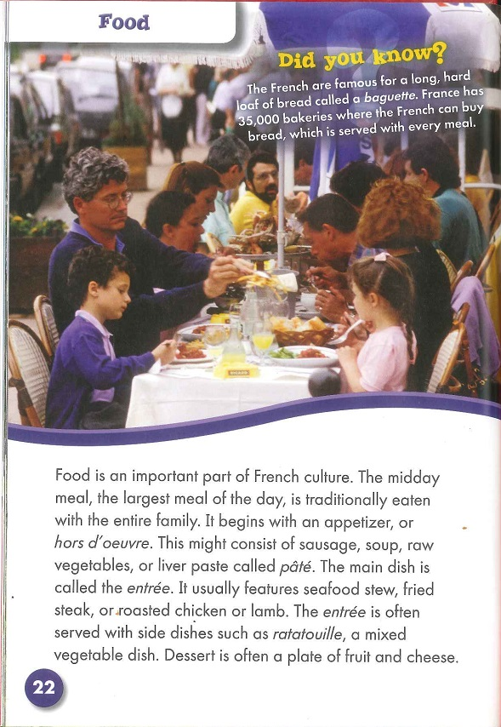
Exploring Countries: France
Excerpts

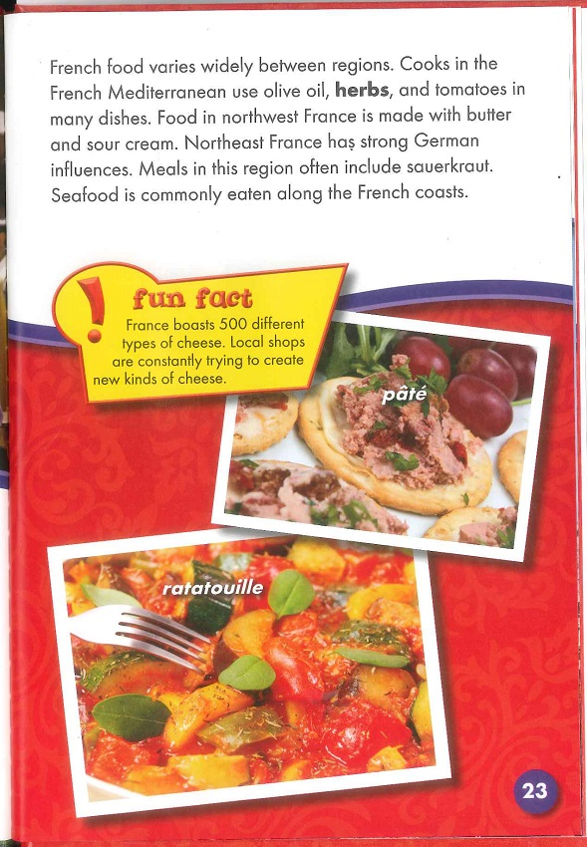
Exploring Countries: France
Excerpts
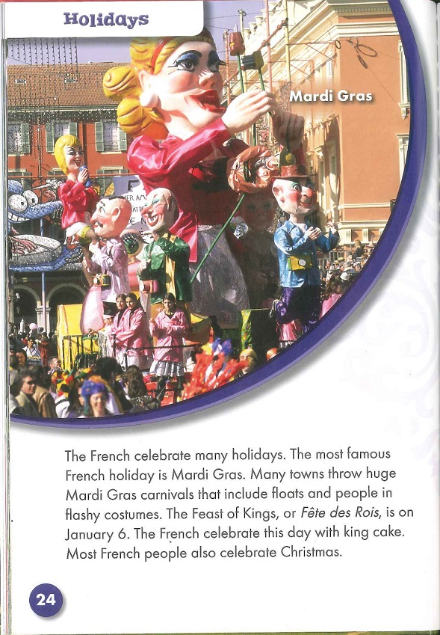
Exploring Countries: France
Excerpts
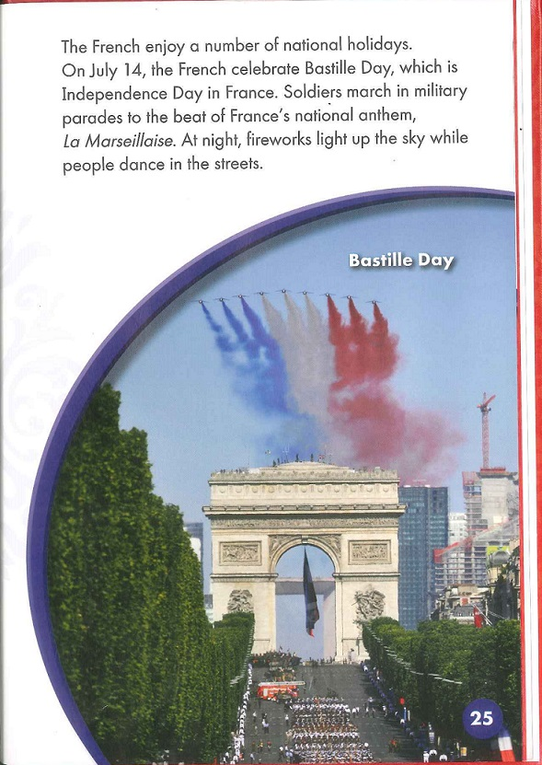

Grack, Rachel. "Exploring Countries: France." Blastoff! Readers, Bellweather Media. 8 Aug. 2010: 22-25. Print.
End of Unit 2 Assessment:
Reading and Writing about a New Informational Text: Exploring France excerpts

Name:
Date:

Part A: Reading Closely to Gather Information

Directions:
1. Read the text excerpts from Exploring Countries: France.
2. Reread the same excerpts and find four examples of French customs and traditions.
3. Take notes on this recording form, just as you have been doing in class.

Complete after reading text excerpts.

Category | Facts  What facts did you find in the text about this part of culture? | Page Number
Customs and Traditions |  | 1.  p._____
Customs and Traditions |  | 2.  p.____
Customs and Traditions |  | 3.  p.______
Customs and Traditions |  | 4.  p.______

End of Unit 2 Assessment:
Reading and Writing about a New Informational Text: Exploring France excerpts

Part B: Questions from the Text

1. What does hors d’oeuvre mean?
a. mean
b. appetizer
c. sausage
d. liver paste

2. Which text feature in the excerpt helps you understand how many different types of cheese are in France?
a. “Did you know?” fact
b. photograph
c. “Fun Fact” box
d. caption

3. Reread the first paragraph on page 24. Which sentence best expresses the main idea of this paragraph?
a. The French people like to have parades.
b. The French people are good at making balloons.
c. The French people celebrate many traditional holidays.
d. The French people like many colors.

4. Which of the details below does the author use to support this main idea?
a. A famous holiday is Mardi Gras.
b. There are floats.
c. People dress in flashy costumes.
d. They have cake.

End of Unit 2 Assessment:
Reading and Writing about a New Informational Text: Exploring France excerpts

Part C: Writing a Research-Based Informational Paragraph
You have learned a lot about using informational text to help you better understand the culture of a country. Use the graphic organizer you just completed to write a paragraph about some of the customs and traditions of France.

Write an informational paragraph describing two customs or traditions in France. Use details from the text to support your response.

In your response, be sure to:
- introduce the topic
- use specific facts and examples from both texts to describe each custom or tradition
- choose words that express your ideas in an interesting and clear way
- end with a concluding statement

Be sure to check your writing for correct spelling, grammar, capitalization, and punctuation.

End of Unit 2 Assessment:
Reading and Writing about a New Informational Text: Exploring France excerpts
(Answers, for Teacher Reference)

Part A: Reading Closely to Gather Information

Directions:
1. Read the text excerpts from Exploring Countries: France.
2. Reread the same excerpts and find four examples of French customs and traditions.
3. Take notes on this recording form, just as you have been doing in class.

Complete after reading text excerpts.

Category | Facts  What facts did you find in the text about this part of culture? | Page Number
Customs and Traditions | 1. Midday meal is eaten with the entire family. | 1.  p.__22__
Customs and Traditions | 2. Midday meal has an appetizer, entrée, and dessert. | 2.  p._22_
Customs and Traditions | 3. Famous holiday is Mardi Gras. | 3.  p.__24_
Customs and Traditions | 4. The Feast of Kings is celebrated every January 6 with king cake. | 4.  p._24__

End of Unit 2 Assessment:
Reading and Writing about a New Informational Text: Exploring France excerpts
(Answers, for Teacher Reference)

Part B: Questions from the Text

1. What does hors d’oeuvre mean?
a. mean
b. appetizer
c. sausage
d. liver paste

2. Which text feature in the excerpt helps you understand how many different types of cheese are in France?
a. “Did you know?” fact
b. photograph
c. “Fun Fact” box
d. caption

3. Reread the first paragraph on page 24. Which sentence best expresses the main idea of this paragraph?
a. The French people like to have parades.
b. The French people are good at making balloons.
c. The French people celebrate many traditional holidays.
d. The French people like many colors.

4. Which of the details below does the author use to support this main idea?
a. A famous holiday is Mardi Gras.
b. There are floats.
c. People dress in flashy costumes.
d. They have cake.

End of Unit 2 Assessment:
Reading and Writing about a New Informational Text: Exploring France excerpts
(Answers, for Teacher Reference)

Part C: Writing a Research-Based Informational Paragraph
You have learned a lot about using informational text to help you better understand the culture of a country. Use the graphic organizer you just completed to write a paragraph about some of the customs and traditions of France.

Write an informational paragraph describing two customs or traditions in France. Use details from the text to support your response.

In your response, be sure to:
- introduce the topic
- use specific facts and examples from both texts to describe each custom or tradition
- choose words that express your ideas in an interesting and clear way
- end with a concluding statement

Be sure to check your writing for correct spelling, grammar, capitalization, and punctuation.

France is a country that enjoys food and holidays. In France, an important meal is the midday meal. This meal has many parts, including appetizers. One unique appetizer is liver paste. France also has many traditional holidays. One famous holiday is Mardi Gras. Mardi Gras is when people dress up in costumes. The floats in the parade are very large. France is a country that enjoys lots of customs and traditions. These are just two examples.
Tracking My Progress, End of Unit 2
Name:
Date:

1. What defines culture?

2. How am I doing? Circle one.

I need more help to learn this
I am on my way!
I understand some of this




3.The evidence to support my self-assessment is:

New York State Grade 3 Expository Writing Evaluation Rubric

Note to teachers: The New York State rubric includes the language “Essays at this level….” Students are not required to draft complete essays. They will draft complete paragraphs, but the criteria for quality remain the same.

CRITERIA | CCLS | 4  Essays at this level: | 3  Essays at this level: | 2  Essays at this level: | 1  Essays at this level: | 0  Essays at this level:
CONTENT AND ANALYSIS: the extent to which the essay conveys ideas and information clearly and accurately in order to support analysis of topics or text | W.2,  R.1–9 | —clearly introduce a topic in a manner that follows logically from the task and purpose  —demonstrate comprehension and analysis of the text | —clearly introduce a topic in a manner that follows from the task and purpose  —demonstrate grade-appropriate comprehension of the text | —introduce a topic in a manner that follows generally from the task and purpose  —demonstrate a confused comprehension of the text | —introduce a topic in a manner that does not logically follow from the task and purpose  —demonstrate little understanding of the text | —demonstrate a lack of comprehension of the text or task
COMMAND OF EVIDENCE:  the extent to which the essay presents evidence from the provided text to support analysis and reflection | W.2  R.1–8 | —develop the topic with relevant, well-chosen facts, definitions, and details throughout the essay | —develop the topic with relevant facts, definitions, and details throughout the essay | —partially develop the topic of the essay with the use of some textual evidence, some of which may be irrelevant | —demonstrate an attempt to use evidence, but only develop ideas with minimal, occasional evidence that is generally invalid or irrelevant | —provide no evidence or provide evidence that is completely irrelevant
New York State Grade 3 Expository Writing Evaluation Rubric

CRITERIA | CCLS | 4  Essays at this level: | 3  Essays at this level: | 2  Essays at this level: | 1  Essays at this level: | 0  Essays at this level:
COHERENCE,  ORGANIZATION, AND  STYLE: the extent to which  the essay logically organizes  complex ideas, concepts, and  information using formal  style and precise language | W.2  L.3  L.6 | —clearly and consistently group related information together  —skillfully connect ideas  within categories of information using linking words and phrases  —provide a concluding statement that follows clearly from the topic and information presented | —generally group related information together  —connect ideas within  categories of information using linking words and phrases  —provide a concluding statement that follows from the topic and information presented | —exhibit some attempt to group related information together  —inconsistently connect ideas using some linking words and phrases  —provide a concluding statement that follows generally from the topic and information presented | —exhibit little attempt at  organization  —lack the use of linking words and phrases  —provide a concluding statement that is illogical or unrelated to the topic and information presented | —exhibit no evidence of organization  —do not provide a concluding statement

New York State Grade 3 Expository Writing Evaluation Rubric

CRITERIA | CCLS | 4  Essays at this level: | 3  Essays at this level: | 2  Essays at this level: | 1  Essays at this level: | 0  Essays at this level:
CONTROL OF  CONVENTIONS: the extent to which the essay demonstrates command of the conventions of standard  English grammar, usage, capitalization, punctuation, and spelling | W.2  L.1  L.2 | —demonstrate grade-appropriate command of conventions, with few errors | —demonstrate grade-appropriate command of conventions, with occasional errors that do not hinder comprehension | —demonstrate emerging command of conventions, with some errors that may hinder comprehension | —demonstrate a lack of command of conventions, with frequent errors that hinder comprehension | —are minimal, making assessment of conventions unreliable

- If the student writes only a personal response and makes no reference to the text(s), the response can be scored no higher than a 1.
- Responses totally unrelated to the topic, illegible, incoherent, or blank should be given a 0.
- A response totally copied from the text(s) with no original student writing should be scored a 0.

