Lesson 6

Objective: Sort categories by count. Identify categories with 2, 3, and 4 within a given scenario.

Suggested Lesson Structure

 Fluency Practice (12 minutes)

 Application Problem (6 minutes)

 Concept Development (25 minutes)

 Student Debrief (7 minutes)

**Total Time (50 minutes)**

Fluency Practice (12 minutes)

* Show Me Another Way **K.CC.4a** (4 minutes)
* Happy Counting Within 5 **K.CC.2** (3 minutes)
* Counting Around the Circle to 5 **K.CC.4a** (5 minutes)

Show Me Another Way (4 minutes)

T: Remember how you learned to count on your fingers? (Provide a brief demonstration from previous lessons’ finger counting exercises as needed.) That’s called counting the Math Way. First, I’ll ask you to show me fingers the Math Way. Then, I’ll ask you to show me the number another way. Show me 2!

S: (Hold up the pinky and ring fingers of the left hand.)

T: Now, show me another way to make 2.

S: (Responses vary.)

T: How we can be sure that we’re still showing 2?

S: Count.

Have students try all of the different combinations. It may be necessary to indicate to students that they may use both hands to show the number. Continue the process to 5.

Happy Counting Within 5 (3 minutes)

T: Let’s play Happy Counting! When I hold my hand like this (point two fingers up), I want you to count up. If I put my hand like this (point two fingers down), I want you to count down. If I do this (close fist), that means stop, but try hard to remember the last number you said. Ready? (Point fingers up.)

S/T: 1, 2, 3, 4, 5. (Close fist; point fingers up.) 4, 3, 2, 1. (Close fist; point fingers up). 2, 3 (Close fist; point fingers down). 2, 1 (Close fist; point fingers up). 2, 3, 4, 5….

Counting Around the Circle to 5 (5 minutes)

T: Come and stand on the edges of the rug. We’re going to play a fast counting game. We’ll count around the circle. Each person says the next two numbers. So, if I say 1, 2, what would you say?

S: 3, 4.

T: Right. Now, here’s a change. The next person only says 5, and since we’re only counting to 5, they will also sit down. Should you be sad if you have to sit?

S: No.

T: By the end of the game everyone will be sitting down anyway. It’s part of the fun! So, let’s get started.

S: 1, 2.

S: 3, 4.

S: 5. (Sits down.)

S: 1, 2.

S: 3, 4.

S: 5. (Sits down.)

Continue playing until all students are sitting down. A variation is to count down, and have the students sit when they say 1.

Application Problem (6 minutes)

Draw one thing that you would wear in the summer. Draw one thing that you would wear in the winter. Tell a friend how you chose those items.

Concept Development (25 minutes)

Materials: (T) 3 sheets of chart paper positioned in a row on the bottom of the wall decorated to look like treasure chests—one labeled with a large 2, one with a large 3, and one with large 4; several bundled sets of classroom objects in groups of 2, 3, and 4 stored in a large opaque bag

Suggested items: a bundle of 3 pencils, a baggie of 2 erasers, a tower of 4 linking cubes, etc. The teacher may want to add outliers such as a tower of 5 linking cubes or something in a quantity of 1 to stimulate discussion and encourage precision.

T: We are going on a treasure hunt! I have a lot of treasures in my bag. When we find the treasures, we are going to sort them into groups. The numbers of our groups are on our treasure chest posters. What numbers do you see on the treasure chests?

|  |  |
| --- | --- |
|  | NOTES ON  MULTIPLE MEANS  OF ENGAGEMENT: |
| After selecting the treasure, the student could choose the next volunteer and then guide the class discussion about categorizing the next set. | |

S: 2, 3, 4.

T: (Call on a volunteer.) Mary, would you please come up to choose a treasure from our bag?

S: (Selects one set of objects from the bag, and displays it to the class.)

T: What treasure chest should we put this into?

S: 3.

T: How did you decide?

S: I counted 3 pencils in the group.

T: Thumbs up if you agree with Mary! (Check for understanding.) Please put it on the floor under our 3 treasure chest. (Repeat with other volunteers with remaining sets.)

T: How many sets of things did we find to put into our 2 treasure chest?

S: (Count sets in 2 category.)

T: What is special about the last number you said when you were counting the sets?

|  |  |
| --- | --- |
|  | NOTES ON  MULTIPLE MEANS  OF ACTION AND EXPRESSION: |
| Have each student draw a treasure chest, write a number on it, and draw something that would belong inside. | |

S: It tells the number of sets!

T: (Repeat counting exercise with 3 and 4 categories.)

T: Did we have any sets that didn’t fit into one of our treasure chests?

S: Yes, the big linking cube tower.

T: Why?

S: Because there were too many cubes.

T: You are good treasure hunters! Let’s do some more counting on our Problem Set.

Problem Set (5 minutes)

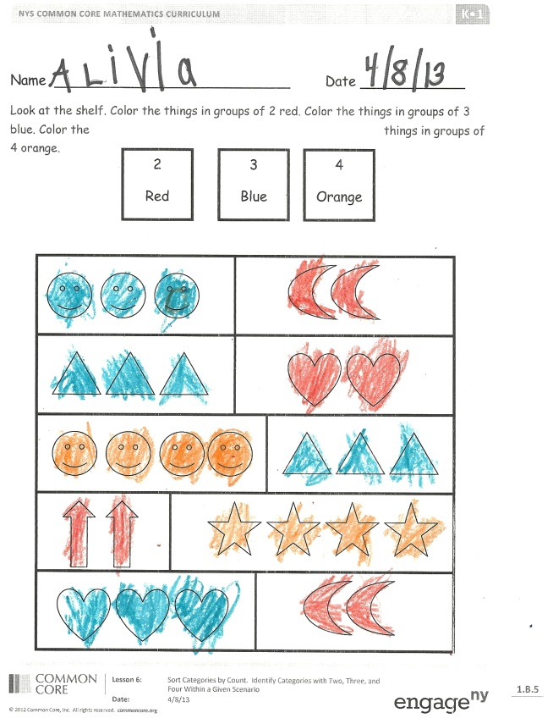Students should do their personal best to complete the Problem Set within the allotted time.

Color the number boxes at the top of the Problem Set together. Then, guide students to color groups of objects the same color according to their count. Watch for students who mistakenly color groups of similar objects the same color rather than coloring according to the count of each object.

Student Debrief (7 minutes)

**Lesson Objective:** Sort categories by count. Identify categories with 2, 3, and 4 within a given scenario.

The Student Debrief is intended to invite reflection and active processing of the total lesson experience.

Invite students to review their solutions for the Problem Set. They should check work by comparing answers with a partner before going over answers as a class. Look for misconceptions or misunderstandings that can be addressed in the Debrief. Guide students in a conversation to debrief the Problem Set and process the lesson.

You may choose to use any combination of the questions below to lead the discussion.

* Why did you color both sets of triangles blue but the sets of happy faces different colors?
* With a partner, point to all the objects that are in groups of 2.
* Look around our room. Can you find anything in a group of 2? Group of 3? Group of 4?
* Can you think of something at home that would fit into one of those groups?

Exit Ticket (3 minutes)

After the Student Debrief, instruct students to complete the Exit Ticket. A review of their work will help you assess the students’ understanding of the concepts that were presented in the lesson today and plan more effectively for future lessons. You may read the questions aloud to the students.

Name Date

Look at the shelf. Color the things in groups of 2 red. Color the things in groups of 3 blue. Color the things in groups of 4 orange.

3

Blue

4

Orange

2

Red

Name Date

Match the groups that have the same number.

C:\Users\store64\AppData\Local\Microsoft\Windows\Temporary Internet Files\Content.IE5\ZA32B5B8\MC900034169[1].wmf C:\Users\store64\AppData\Local\Microsoft\Windows\Temporary Internet Files\Content.IE5\ZA32B5B8\MC900034169[1].wmf





C:\Users\store64\AppData\Local\Microsoft\Windows\Temporary Internet Files\Content.IE5\4HNJXDX3\MC900280903[1].wmfC:\Users\store64\AppData\Local\Microsoft\Windows\Temporary Internet Files\Content.IE5\4HNJXDX3\MC900280903[1].wmf C:\Users\store64\AppData\Local\Microsoft\Windows\Temporary Internet Files\Content.IE5\4HNJXDX3\MC900280903[1].wmf

C:\Users\store64\AppData\Local\Microsoft\Windows\Temporary Internet Files\Content.IE5\4HNJXDX3\MC900232246[1].wmf

C:\Users\store64\AppData\Local\Microsoft\Windows\Temporary Internet Files\Content.IE5\4HNJXDX3\MC900232246[1].wmf

C:\Users\store64\AppData\Local\Microsoft\Windows\Temporary Internet Files\Content.IE5\4HNJXDX3\MC900232246[1].wmf

C:\Users\store64\AppData\Local\Microsoft\Windows\Temporary Internet Files\Content.IE5\4HNJXDX3\MC900232246[1].wmf



C:\Users\store64\AppData\Local\Microsoft\Windows\Temporary Internet Files\Content.IE5\4HNJXDX3\MC900326476[1].wmf C:\Users\store64\AppData\Local\Microsoft\Windows\Temporary Internet Files\Content.IE5\4HNJXDX3\MC900326476[1].wmf C:\Users\store64\AppData\Local\Microsoft\Windows\Temporary Internet Files\Content.IE5\4HNJXDX3\MC900326476[1].wmf

Name Date

Draw lines to put the treasures in the boxes.



C:\Users\store64\AppData\Local\Microsoft\Windows\Temporary Internet Files\Content.IE5\Q11W2AUA\MC900280927[1].wmf

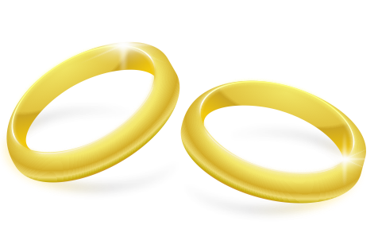



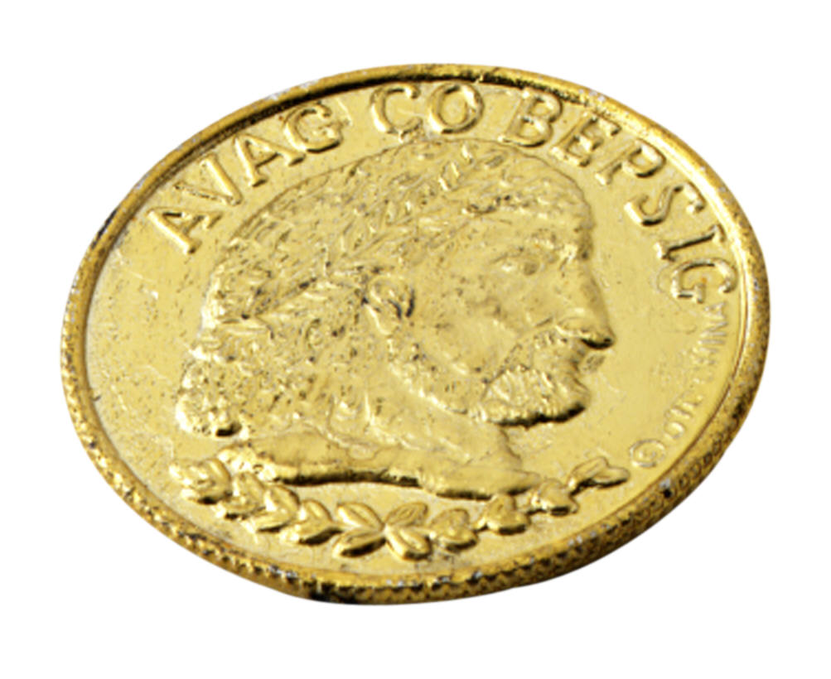





2

3

C:\Users\store64\AppData\Local\Microsoft\Windows\Temporary Internet Files\Content.IE5\Q11W2AUA\MC900280927[1].wmf

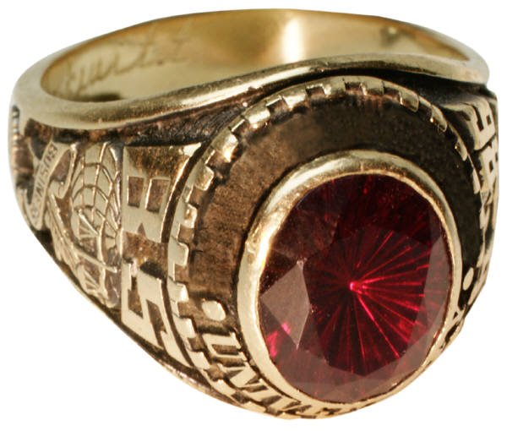

C:\Users\store64\AppData\Local\Microsoft\Windows\Temporary Internet Files\Content.IE5\ZA32B5B8\MC900019118[1].wmfC:\Users\store64\AppData\Local\Microsoft\Windows\Temporary Internet Files\Content.IE5\ZA32B5B8\MC900019118[1].wmf

4

C:\Users\store64\AppData\Local\Microsoft\Windows\Temporary Internet Files\Content.IE5\Q11W2AUA\MC900280927[1].wmf