Lesson 5

Objective: Classify items into three categories, determine the count in each, and reason about how the last number named determines the total.

Suggested Lesson Structure

 Fluency Practice (13 minutes)

 Application Problem (6 minutes)

 Concept Development (25 minutes)

 Student Debrief (6 minutes)

**Total Time (50 minutes)**

Fluency Practice (13 minutes)

* Green Light, Red Light **K.CC.2** (3 minutes)
* Pop Up Number **K.CC.4a** (5 minutes)
* Birthday Candles **K.CC.4a** (5 minutes)

Green Light, Red Light (3 minutes)

On the board, draw a green dot and write 1 underneath it, and then draw a red dot and write 3 underneath it. Explain to students that they will start and stop counting using the number indicated by the color code.

T: Look at your numbers (point to the number 1 written below the green dot and 3 below the red dot). Think! Ready? Green light!

S: 1, 2, 3.

T: Very good! (Erase numbers 1 and 3, and write the new numbers.) Here are the new numbers (green is 1, red is 5). Look. Think! Ready? Green light!

S: 1, 2, 3, 4, 5.

A recommended sequence is (2, 3); (2, 3, 4); (3, 4); (3, 4, 5); (3, 2, 1); (5, 4, 3, 2, 1); (5, 4); (5, 4, 3); (4, 3); (4, 3, 2).

Pop Up Number (5 minutes)

T: Come and sit in a circle on the rug. We’re going to play Pop Up Number! The Pop Up Number is 3. What is the number?

S: 3.

T: We’ll count around the circle to 5. If you say the Pop Up Number, you have to…

S: Pop up! (Stand up.)

T: Let’s begin. 1.

S: 2.

S: 3. (Stands up.)

S: 4.

S: 5.

The next student begins again at 1. Continue until several or all students are standing. For variation, try counting down from 5.

Birthday Candles (5 minutes)

Materials: (S) 1 die, birthday cake (Lesson 5 Fluency Template), crayons

Note: At the end of each person’s turn, the number of candles on the cake should match the die. The second player does not add the total rolled to the first player’s candles, but simply adjusts the candles to match his roll. Circulate to see which students must recount each time, and which ones simply take off or put on more crayons to represent the new number.

|  |  |
| --- | --- |
|  | NOTES ON  MULTIPLE MEANS  OF ACTION AND EXPRESSION: |
| To differentiate, cover the 6-dot side of the die with a small piece of mailing label. Leave it blank to indicate 0, or draw a different number of dots. Similarly, provide a pair of dice for students who are ready to work with larger numbers. | |

Assign partners, and remind students to take turns. If needed, model how to play the game with one student beforehand.

1. Roll the die.

2. Touch and count the dots.

3. Put that many “candles” (crayons) on the birthday cake.

**MP.5**

4. Without removing the crayons, the next person rolls the die and then adjusts the “candles” to match the roll.

Application Problem (6 minutes)

With a partner, talk about how we could sort the class into two groups. For example, students who are wearing pants, and students who are wearing shorts.

Note: Share a few partner discussions with the whole class. Use the Application Problem to continue to link the previous day’s lesson with today’s lesson.

Concept Development (25 minutes)

Materials: (T) Large pictures for the board depicting the sun, raindrops, and snowflakes; smaller pictures in an opaque bag or envelope depicting items corresponding to each of the weather types

Materials Note: Sunny weather items could be sunglasses, sun hats, sandals, bathing suit, popsicles, or beach buckets and shovels. Rainy weather items might include an umbrellas, raincoats, boots, rain hats, puddles, or soup. Hats, scarves, boots, snow shovels, mittens, skis, or hot cocoa could be used for winter weather items. To stimulate discussion, consider including some ambiguous items such as popcorn, books, or ice cream. There should be at least five of each type, but the numbers in each category need not be equal.

T: Do you remember some of the ways you sorted items yesterday?

S: By their size. 🡪 By their shape. 🡪 By their color.

T: Today, we are going to do another sorting activity, but this time we are going to look for three

different groups to sort things into. What do you see on the board?

S: The sun. 🡪 Some raindrops! 🡪 I see a snowflake.

T: What are some things you like to do on sunny days? (Allow a brief time for students to share ideas.)

T: We’re going to play a game called Where Do I Belong? I will call one of you up to choose a picture from this bag, while the rest of us whisper-count together to 10. (The counting keeps the lesson moving along and speed the students’ decision times.) You decide if your picture belongs with the sun, the rain, or the snow. After you tell us why you made that choice, we will put it on the board underneath its weather type.

S: (Take turns choosing pictures from the teacher’s bag and categorizing them.

T: (Assist the students in placing the pictures in the appropriate column underneaththe weather symbols on the board. Continue until all of the pictures have been used.)

T: Great job! I wonder how many sunny pictures we found? Let’s count them. (Number each picture as it is counted.) How many sunny pictures?

|  |  |
| --- | --- |
|  | NOTES ON  MULTIPLE MEANS  OF ENGAGEMENT: |

Students who would benefit from an extension of this lesson could play the role of teacher. The new teacher puts pictures in the appropriate column, but one is incorrect.

The teacher asks how many are in the column, and then asks if the pictures are correct. “Do you agree with me?” Have children explain their reasoning.

S: 5.

T: What number did I write beside the last picture?

S: 5.

Repeat with the rainy and snowy categories. As an extension, students might talk about which category had the most pictures. Lead them to notice that the last number they counted in each category corresponds to the largest written numeral in that category.

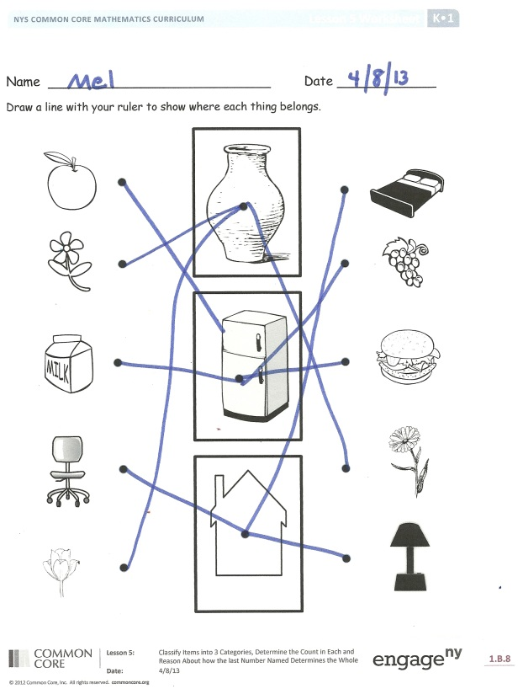Problem Set (5 minutes)

Students should do their personal best to complete the Problem Set within the allotted time.

On this Problem Set students draw a line with a ruler to show where each thing belongs. For homework, provide glue sticks and safety scissors for those students who might not have these items at home.

Student Debrief (6 minutes)

**Lesson Objective:** Classify items into three categories, determine the count in each, and reason about how the last number named determines the total.

The Student Debrief is intended to invite reflection and active processing of the total lesson experience.

Invite students to review their solutions for the Problem Set. They should check work by comparing answers with a partner before going over answers as a class. Look for misconceptions or misunderstandings that can be addressed in the Debrief. Guide students in a conversation to debrief the Problem Set and process the lesson.

You may choose to use any combination of the questions below to lead the discussion.

* How did you decide where to put your picture?
* Why didn’t it fit into one of the other groups?
* Are there some things at home that you would have put into one of the weather groups?

Exit Ticket (3 minutes)

|  |  |
| --- | --- |
|  | NOTES ON  INFORMAL ASSESSMENT OPPORTUNITY: |
| * This Exit Ticket would provide an excellent opportunity for an informal assessment. * Circulate to interview students for a quick snapshot of individual student’s reasoning. Responses may vary, as there is more than one correct response in each row. * Consider using this Exit Ticket to open tomorrow’s lesson. | |

After the Student Debrief, instruct students to complete the Exit Ticket. A review of their work will help you assess the students’ understanding of the concepts that were presented in the lesson today and plan more effectively for future lessons. You may read the questions aloud to the students.

Name Date

Draw a line with your ruler to show where each thing belongs.



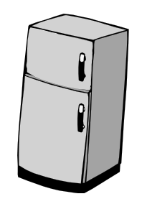











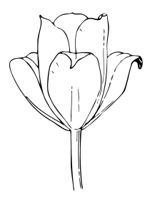

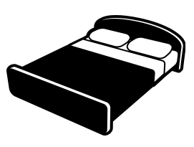



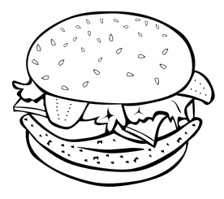

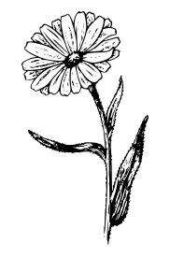



Name Date

[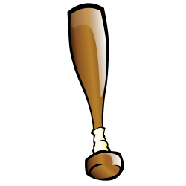](http://openclipart.org/people/pianoBrad/Baseball_Bat_Sports2010.svg)[](http://openclipart.org/detail/75919/baseball-by-pianobrad)[](http://openclipart.org/detail/75925/basketball-by-pianobrad)[](http://openclipart.org/detail/75913/baseball-helmet-by-pianobrad)Cross out what doesn’t belong. How many are left? (Students may cross out more than 1 item in each row. Students explain the group left to a friend or teacher.)

Cross out what doesn’t belong. How many are left?

[](http://openclipart.org/detail/75919/baseball-by-pianobrad)[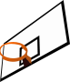](http://openclipart.org/detail/5451/basketball-rim-by-gioppino)[](http://openclipart.org/detail/153373/basketball-by-gnokii)

Cross out what doesn’t belong. How many are left?

[](http://openclipart.org/people/pianoBrad/Baseball_Bat_Sports2010.svg)C:\Users\Nuhad\AppData\Local\Microsoft\Windows\Temporary Internet Files\Content.IE5\WC6PVK7W\MC900320770[1].wmf[](http://openclipart.org/detail/32563/football-helmet-by-salahuddin66)[](http://openclipart.org/detail/91027/-by-feraliminal)

Name Date

Cut and glue where each belongs. Write how many.

|  |  |  |
| --- | --- | --- |
| # |  | C:\Users\Nuhad\AppData\Local\Microsoft\Windows\Temporary Internet Files\Content.IE5\0N2VFSA9\MC900355321[1].wmf |
|  | C:\Users\Nuhad\AppData\Local\Microsoft\Windows\Temporary Internet Files\Content.IE5\WC6PVK7W\MC900412392[1].wmf |  |
| C:\Users\Nuhad\AppData\Local\Microsoft\Windows\Temporary Internet Files\Content.IE5\0N2VFSA9\MC900251695[1].wmf | C:\Users\Nuhad\AppData\Local\Microsoft\Windows\Temporary Internet Files\Content.IE5\0N2VFSA9\MC900232760[1].wmf | C:\Users\Nuhad\AppData\Local\Microsoft\Windows\Temporary Internet Files\Content.IE5\7BDQ7RZA\MC900433840[1].png |

School

C:\Users\Nuhad\AppData\Local\Microsoft\Windows\Temporary Internet Files\Content.IE5\7BDQ7RZA\MC900290671[1].wmfNumber:_______

Library

C:\Users\Nuhad\AppData\Local\Microsoft\Windows\Temporary Internet Files\Content.IE5\WC6PVK7W\MC900056795[1].wmf Number:_______

Grocery Store

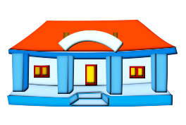 Number:_______

The Birthday Cake

[1]

The Birthday Cake

1. birthday cake