Lesson 4
Objective: Classify items into two pre-determined categories.
Suggested Lesson Structure
 Fluency Practice (12 minutes)
 Application Problem (6 minutes)
 Concept Development (26 minutes)
 Student Debrief (6 minutes)
Total Time (50 minutes)
Fluency Practice (12 minutes)
- Hands Number Line to 5 K.CC.4a (5 minutes)
- Show Me Fingers to 5 K.CC.5 (2 minutes)
- Finger Flashes to 5 K.CC.5 (2 minutes)
- Rekenrek to 5 K.CC.5 (3 minutes)
Hands Number Line to 5 (5 minutes)
Materials: (S) Left hand mat (Lesson 1 Fluency Template), bag of beans or small counters
Conduct the activity as outlined in Lesson 2.
Continue the process to 5. Then, guide students to recognize the group of 5 on one hand. Ask questions such as, “Are you showing me all of your fingers on one hand? How many is that? So then, how many fingers do you have on the other hand?”
Show Me Fingers to 5 (2 minutes)
Conduct the activity as outlined in Lesson 2.
A possible sequence is 1, 2, 3, 2, 3, 4, 3, 4, 5, 4, 3. As students approach mastery, say numbers randomly. Focus especially on 5. The goal is to have students just open one hand to show 5 without having to count.
Finger Flashes to 5 (2 minutes)
Conduct the activity as outlined in Lesson 2.
Concentrate heavily on 5. Use a similar sequence, but interject 5 frequently and repetitiously. Students will be delighted at their ability to instantly recognize the group of 5.
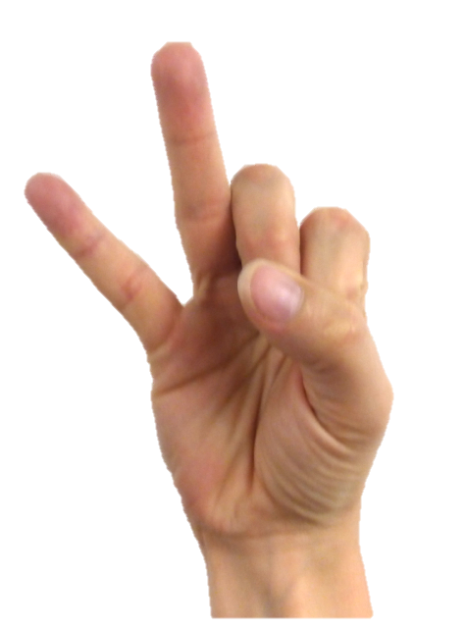
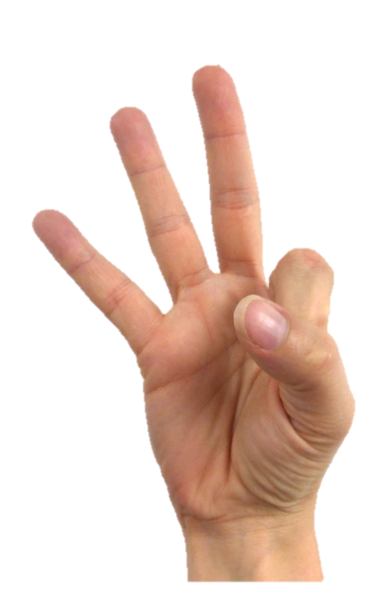
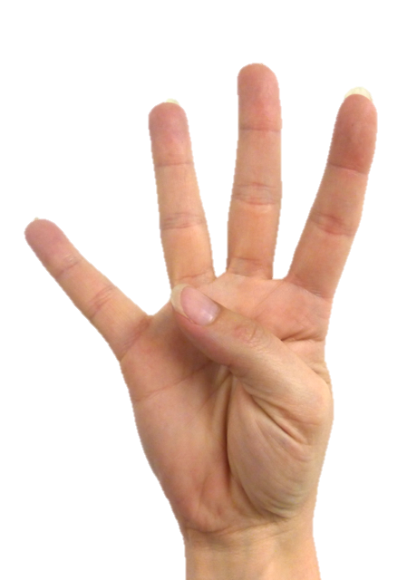
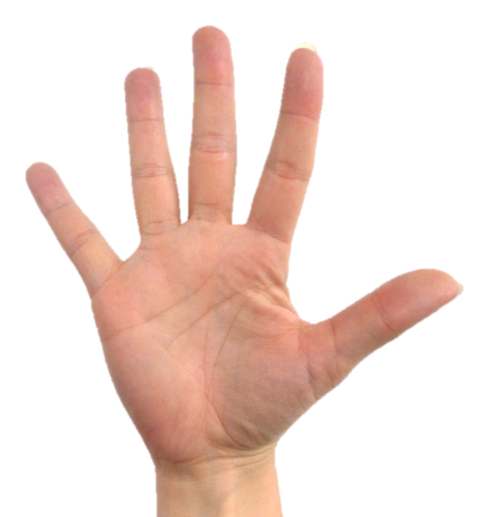
Again, be conscious of the students’ viewing perspective. Begin with the pinky finger of the right hand and end with the thumb at 5 so that students see the number line progressing from left to right.

Rekenrek to 5 (3 minutes)
Conduct the activity as outlined in Lesson 2.
A suggested sequence is counting up, counting down, then in short sequences: 1, 2, 3, 2, 3, 4, 3, 4, 5, 4, 3, etc.
Application Problem (6 minutes)
Color these pictures so that they are exactly the same. Tell a friend how you know that they are exactly the same.
Note: Copy two of the same pictures (bears, flowers, cups, etc.) side by side on one piece of paper. Instruct students to color each picture so they look exactly like each other.
Concept Development (26 minutes)
Materials: (T) Assortment of classroom toys with a wide range of attributes and obvious differences to facilitate sorting, two plastic trays

NOTES ON
MULTIPLE MEANS
OF ENGAGEMENT:
Provide students who catch on quickly with a collection of objects to sort. Have the other students in the class try to guess how the objects were sorted.

T: Watch how I sort these toys into two groups—big and small. (Place one big toy on one tray, and one small toy on the other.) Point to the tray that has the big toy.
S: (Point.)
T: Yes. Now, point to the tray that has the small toy.
S: (Point.)
T: Do you see any other toys that belong in the small toys group?
S: (Place a small toy on the tray.)
T: How can you tell that it belongs on that tray?
S: Because it is small, like the rest of the toys in that group.
Continue until remaining toys have been sorted. Also, show a few non-examples and discuss why they do not belong.
Next, sort the same toys into two groups, one with soft toys, and one with hard toys. See if the students can figure out the attribute with a partner.
T: (Remove all of the toys from the trays, and display them in the center of the rug.) Can you think of other ways we could sort these toys?
Sort again according to students’ suggestions.
T: Now, let’s play a game where we sort ourselves! If your shoes have laces, please stand near the window. If your shoes do not have laces, please stand near the door. Everyone, point to the laces group.
S: (Point.)
T: Now, point to the no laces group.
S: (Point.)
T: Come back to your seats. This time, I will sort you into two groups another way. (Call students to come and stand in a teacher-selected group without telling them how they have been grouped.) What is the same about all of the students in this group?
S: They are all wearing blue uniform shirts.
T: That’s right, and this group?
S: White shirts.
T: What are some other ways we could sort ourselves?
Problem Set (10 minutes)

NOTES ON
MULTIPLE MEANS
OF REPRESENTATION:
Make a chart of this Problem Set, and have students think of what they put into their book bag or trunk.
Some responses might be a lunch, snack, game, or baseball mitt.
Write the words or draw pictures to illustrate their answers. Leave the chart up for a few days in case they think of other ideas to add.

Students should do their personal best to complete the Problem Set within the allotted time.
Have students glue pictures to show where to keep each item.

Student Debrief (6 minutes)
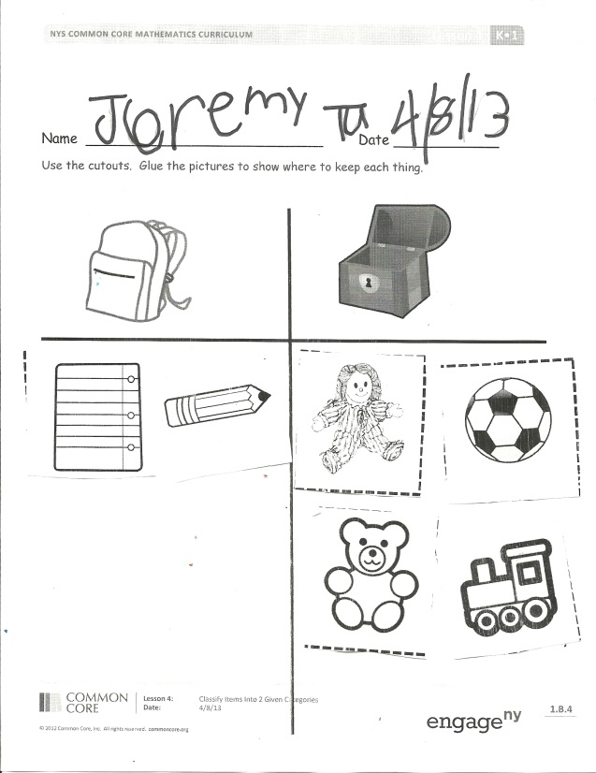
Lesson Objective: Classify items into two pre-determined categories.
Have students bring their Problem Sets to the carpet and discuss with a partner how they decided to sort the pictures.
The Student Debrief is intended to invite reflection and active processing of the total lesson experience.
Invite students to review their solutions for the Problem Set. They should check work by comparing answers with a partner before going over answers as a class. Look for misconceptions or misunderstandings that can be addressed in the Debrief. Guide students in a conversation to debrief the Problem Set and process the lesson.
You may choose to use any combination of the questions below to lead the discussion.
- What is the new math word we used today?
- What does it mean to sort into groups?
- Can you think of other times when it is important to sort things? (Elicit real life examples from home or school.)
Exit Ticket (3 minutes)
After the Student Debrief, instruct students to complete the Exit Ticket. A review of their work will help you assess the students’ understanding of the concepts that were presented in the lesson today and plan more effectively for future lessons. You may read the questions aloud to the students.

Name Date
Use the cutouts. Glue the pictures to show where to keep each thing.
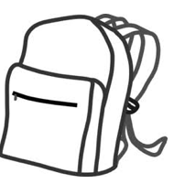

Name Date
Cutouts for the Problem Set

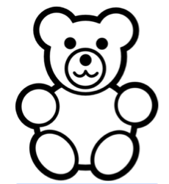
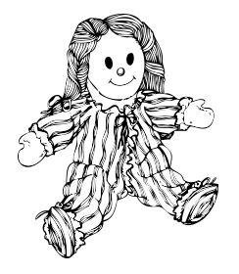

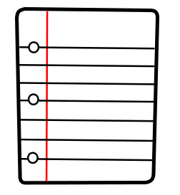

Name Date
Circle the animals that belong to one group, and underline the animals that belong to the other group.
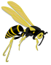
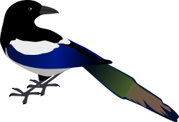

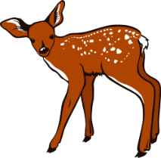
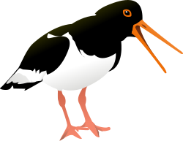

What is the same about the animals in each group? (Discuss with a friend.) (Teacher circulates, listening to conversations and making informal assessments.)

Name Date
Circle the things that belong to one group, and underline the things that belong to the other group. Tell an adult why the items in each group belong together.

