Lesson 3

Objective: Classify to find two objects that share a visual pattern, color, and use.

Suggested Lesson Structure

 Fluency Practice (11 minutes)

 Application Problem (4 minutes)

 Concept Development (30 minutes)

 Student Debrief (5 minutes)

**Total Time (50 minutes)**

Fluency Practice (11 minutes)

* Counting Beans and Fingers to 5 **K.CC.4a** (5 minutes)
* Show Me Beans to 5 **K.CC.4a** (3 minutes)
* Counting with the Number Glove to 5 **K.CC.5**  (3 minutes)

Counting Beans and Fingers to 5 (5 minutes)

Materials: (S) Left hand mat (Lesson 1 Fluency Template), bag of beans or small counters

Note: This fluency activity was selected in anticipation of future lessons. Although they will not be working with numbers in this lesson, students will need to develop fluency for upcoming lessons in which they will work with numbers in depth.

Conduct the activity as outlined in Lesson 1.

Continue to 5 moving from pinky finger to thumb. Give time for students to touch and count, but take notice of which students must recount each time another bean is added.

Show Me Beans to 5 (3 minutes)

Materials: (S) Left hand mat (Lesson 1 Fluency Template), bag of beans or small counters

Note: This fluency activity was selected in anticipation of future lessons. Although they will not be working with numbers in this lesson, students will need to develop fluency for upcoming lessons in which they will work with numbers in depth.

Conduct the activity as outlined in Lesson 1.

Continue the wave sequence to 5, then randomly, as students demonstrate mastery. Take notice of which students need to recount.

Counting with the Number Glove to 5 (3 minutes)

Note: This fluency activity was selected in anticipation of future lessons. Although they will not be working with numbers in this lesson, students will need to develop fluency for upcoming lessons in which they will work with numbers in depth.

Conduct the activity as outlined in Lesson 1.

A recommended sequence is 1, 2, 3, 2, 3, 4, 3, 4, 5, 4…. Listen for hesitation as students count, rather than count along with them. Return to sequences within 3 if they have difficulty, then build up to 5.

Application Problem (4 minutes)

Draw two circles that are the same but a different color.

Note: Linking drawing and math is important to instill in students from the beginning of their formal math learning. By drawing circles, they are representing their understanding and learning how drawing can be a tool to aid in that understanding.

Concept Development (30 minutes)

Part 1

|  |  |
| --- | --- |
|  | NOTES ON  MULTIPLE MEANS  OF ACTION AND EXPRESSION: |

Children who are visually impaired or who tend to be more kinesthetic learners may benefit from sets that have texture. For example, glue the rim of the cup and then dip it in sand. The plate could be glued around the edges and sprinkled with sand. Another option is to glue rickrack around a cup and a plate to give it texture.

Materials: (S) Sets of plates, cups, bowls, etc., in a variety of patterns; bin or basket; stuffed animals

Plastic dinnerware sets can be purchased, or the teacher can create her own from disposable products with a variety of colors and patterns drawn with permanent marker. Although time-consuming, a teacher-created set will allow for greater control of the complexities of the concepts and yield richer discussion. For example, this plate has blue stripes, and this bowl has red stripes. Even though they are different colors, they match because the pattern is the same.

Invite students to the rug to sit in a circle. Have them pass the objects around and talk about them. Guide them to discuss and compare attributes of each. Collect the items after discussion.

T: Let’s have a teddy bear tea party! This is Teddy’s plate. (Place a plate in front of the stuffed animal.) What do we see on Teddy’s plate?

|  |  |
| --- | --- |
|  | NOTES ON  MULTIPLE MEANS  OF REPRESENTATION: |

Continue to stress the importance of clear, concise language from students. Let students share their answers with a partner first, and then share with the class. Watch for students who have expressive language issues, or are English language learners, and help them along.

S: Stripes.

T: Yes, what color are the stripes?

S: Blue.

T: Good. Teddy wants a cup that has the same striped pattern. Let’s find a cup that **matches** Teddy’s plate.

S: The one with red stripes!

T: Yes! Are they the same color?

**MP.7**

S: No.

T: How are they a match?

S: They both have stripes.

Continue with other patterns and colors until students are able to consistently identify a match. Consider showing a few non-examples, and have students determine why the objects do not match.

Distribute a bin and stuffed animals to each group or table. Have them set the table so that each stuffed animal (not each table) has a matching set of dinnerware. Place the items back into the bin, and rotate so that students can practice with several different sets. Circulate and foster dialogue about the attributes of the objects.

Part 2

Materials: (S) Bags of objects or pictures of objects that are used together

T: How are these used together? (Hold up a plate and a fork from the previous activity.)

S: To eat with.

T: Yes. Let’s say it in a sentence like this: “I use a fork and plate for eating.” Ready?

S: I use a fork and plate for eating.

T: Raise your hand when you can say the sentence about these two items. (Show a paper and pencil.) Ready?

S: I use a pencil and paper for writing.

T: Very good. When you go back to your seat you’ll get a bag. First, make a match. Then, tell how they are used together. Remember to say the whole sentence, just like we practiced.

Circulate to ensure that students are using the sentence frame to describe each match. Rotate bags of objects among tables or groups so that students have the opportunity to see a variety of items.

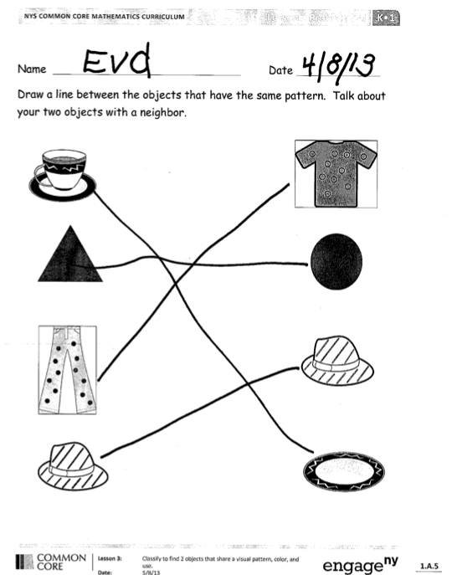Problem Set (7 minutes)

Students should do their personal best to complete the Problem Set within the allotted time.

Student Debrief (5 minutes)

**Lesson Objective:**  Classify to find two objects that share a visual pattern, color, and use.

The Student Debrief is intended to invite reflection and active processing of the total lesson experience.

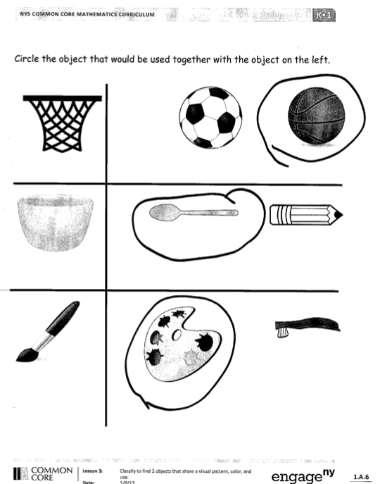Invite students to review their solutions for the Problem Set. They should check work by comparing answers with a partner before going over answers as a class. Look for misconceptions or misunderstandings that can be addressed in the Debrief. Guide students in a conversation to debrief the Problem Set and process the lesson.

You may choose to use any combination of the questions below to lead the discussion.

* What are some ways that we made a **match** today?
* How can you tell if two items **match**?
* Can you think of things at home that are used together?
* What are some things at home that are not used together?

Exit Ticket (3 minutes)

After the Student Debrief, instruct students to complete the Exit Ticket. A quick review of their work will help you assess the students’ understanding of the concepts that were presented in the lesson today. Students have two minutes to complete the Exit Ticket. You may read the questions aloud to the students.

Name Date

Draw a line between the objects that have the same pattern. Talk with a neighbor about the objects that match.



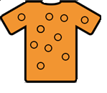



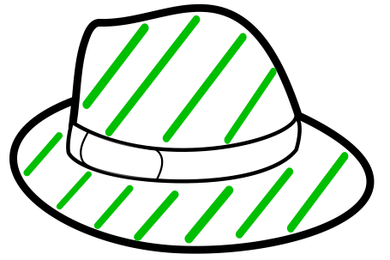

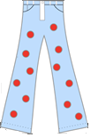

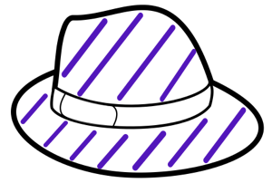

Circle the object that would be used together with the object on the left.

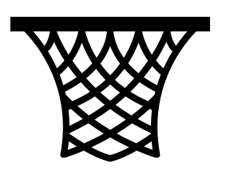

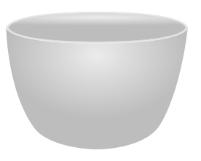







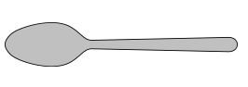

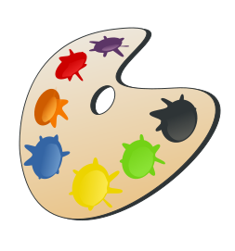

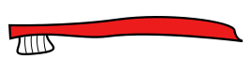

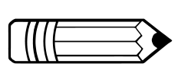

Name Date

Draw a connecting line between shapes with the same pattern.

Circle the things that are used together. Explain your choice.

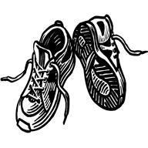



Name Date

Draw something that you would use with each. Tell why.



C:\Users\store64\AppData\Local\Microsoft\Windows\Temporary Internet Files\Content.IE5\8VYBS75V\MC900353075[1].wmf

Make a picture of 2 things you use together. Tell why.