Lesson 2
Objective: Analyze to find two similar objects—these are the same but….

Suggested Lesson Structure
 Fluency Practice (12 minutes)
 Application Problem (3 minutes)
 Concept Development (25 minutes)
 Student Debrief (10 minutes)
Total Time (50 minutes)
Fluency Practice (12 minutes)
- Hands Number Line to 3 K.CC.4a (5 minutes)
- Show Me Fingers to 3 K.CC.5 (2 minutes)
- Finger Flashes to 3 K.CC.5 (2 minutes)
- Rekenrek to 3 K.CC.5 (3 minutes)
Hands Number Line to 3 (5 minutes)

NOTES ON
MULTIPLE MEANS
OF REPRESENTATION:
Enlarge a copy of the left hand mat and hang it in the room where students will see it and reflect on how they have used it. Make a few copies so that children can use them at a center where they can practice counting.
For learners who like to touch and feel, or for students with fine motor challenges, consider finding inexpensive gloves and letting students put the beans on the gloves.

Materials: (S) Left hand mat (Lesson 1 Fluency Template), bag of beans or small counters
Note: This fluency activity was selected in anticipation of future lessons. Although they will not be working with numbers in this lesson, students will need to develop fluency for upcoming lessons in which they will work with numbers in depth.
T: How many hands do you see on your mat?
S: 1.
T: How many real hands do you have?
S: 2.
T: Put 1 of your real hands down on the mat so that it matches the picture of the hand on your mat exactly. Make sure to line up all of your fingers.
T: Take 1 bean out of your bag, and put it on the pinky fingernail on your mat. How many fingers have a bean?
S: 1.
T: Which finger is it?
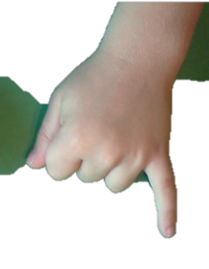
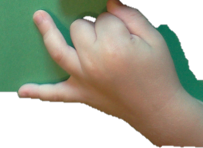
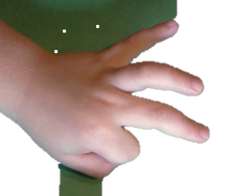
S: Pinky.
T: Show me your real pinky finger. This is the finger we’ll start counting with. (Demonstrate.)
S: 1. (Hold up the pinky finger of the left hand, palm facing away from students.)
T: Put another bean on the very next finger. How many fingers have beans on them now?
S: 2.
T: Show me which fingers have beans. Use your mat to help you. (Circulate and support.) Let’s count on fingers from 1 to 2. Ready?
S: 1 (hold up the pinky finger of the left hand), 2 (hold up pinky and ring finger, palm out).
T: Put another bean on the very next finger. How many fingers have beans on them now?
S: 3.
MP.5
T: Show me which fingers have beans. Use your mat to help you. (Circulate and support.) Let’s count on fingers from 1 to 3. Ready?
S: 1 (hold up the pinky finger of the left hand), 2 (hold up pinky and ring finger, palm out), 3 (hold up pinky, ring finger, and middle finger, palm out).
T: Very good! See if you can do it without looking at the mat. Close it up (show closed fist). Ready?
S: 1, 2, 3 (show fingers).
T: Stay here at 3. Now, count back down to 1. Ready?
S: 3, 2, 1.
Continue practicing so that students get more comfortable with this way of finger counting.
Show Me Fingers to 3 (2 minutes)
Note: This fluency activity was selected in anticipation of future lessons. Although they will not be working with numbers in this lesson, students will need to develop fluency for upcoming lessons in which they will work with numbers in depth.
T: Let’s play Show Me Fingers. I’ll say a number, and you show me that many fingers, the same way as before. Remember to start on the pinky, and don’t skip any fingers! Ready? Show me 1!
S: (Hold up the pinky finger.)
T: Quick… show me 2!
S: (Hold up the pinky finger and the ring finger.)
A possible sequence is 1, 2, 1, 2, 3, 2, 3, 2, 3, 2, 1. As students approach mastery, say numbers randomly.

Finger Flashes to 3 (2 minutes)
Note: This fluency activity was selected in anticipation of future lessons. Although they will not be working with numbers in this lesson, students will need to develop fluency for upcoming lessons in which they will work with numbers in depth.
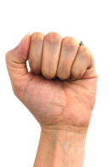
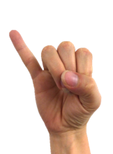
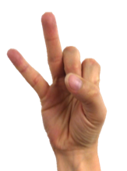
T: This time, I’ll show you my fingers, and you say how many you see. Ready?
Student View
Use a similar sequence as before. Realize that the teacher will need to show the reverse, starting with the pinky finger of the right hand. It is important that students see the number line progressing from left to right from one finger to the next.
Rekenrek to 3 (3 minutes)
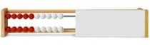
Materials: (T) 20-bead Rekenrek
20-Bead Rekenrek
Note: This fluency activity was selected in anticipation of future lessons. Although they will not be working with numbers in this lesson, students will need to develop fluency for upcoming lessons in which they will work with numbers in depth.
T: Let’s practice counting with the Rekenrek. (Show students the 20-bead Rekenrek with the side panel attached.) Say how many you see. (Slide the red beads students will count completely to one side).
A suggested sequence is counting up, counting down, then in short sequences, 1, 2, 1, 2, 3, 2, 3, etc.
Application Problem (3 minutes)
Jeremy has 3 marbles. Draw his marbles.
Note: Students can debrief this problem by comparing their drawing to that of their partner. The sooner they see that there are different ways to draw solutions, the better. Ask, “How are our drawings exactly the same? How are our drawings not exactly the same?”
Concept Development (25 minutes)
Materials: (T) Pairs of similar items that are different in one aspect (e.g., two tennis balls, one white and one yellow; two identical cups, one with a straw and one empty; two squares, one turned to be a kite and one parallel to the floor; two identical pencil boxes, each labeled with a different student’s name; two identical pencils, one new and one used) (S) Two of the same flowers (or leaves, twigs, etc.)

T: What am I holding?
S: Balls. 2 things. 2 balls. A yellow ball and a white ball. 2 tennis balls.
T: Are they exactly the same, or are they not exactly the same?
S: They are not exactly the same.
T: They are the same but….
S: One is yellow and one is white. They are same, but they are different colors. One is fuzzier than the other one.
T: So many good ideas! Repeat one of them after me. They are the same, but one is yellow and one is white.

NOTES ON
MULTIPLE MEANS
FOR ACTION AND EXPRESSION:
Have students bring an object to add to the materials from the lesson (e.g., balls, cups, pencils). Set up an area where children can explore those items and reflect back on the lesson.
After a day or two, consider adding some other items (e.g., colored styrofoam egg cartons, large and small books, colored buttons). Children can apply their learning about exactly the same, but… to the new pieces.
To further extend this activity, consider making some colored geometric shapes (or attribute blocks) in varied sizes so students can tell how they are exactly the same, but different.

S: They are the same, but one is yellow and one is white.
T: What am I holding now?
S: Pencils. 2 things. 2 pencils. A short pencil and a long pencil.
T: Are they exactly the same, or are they not exactly the same?
S: They are not exactly the same.
T: They are the same but….
S: One is shorter, and one is longer. They are the same, but one is sharpened and one is not sharpened. One is new and one is not.
T: Repeat one of your ideas after me. They are the same, but one is shorter and one is longer.
S: They are the same, but one is shorter and one is longer.
T: What am I holding now?
S: Cups. 2 things. 2 cups. 2 plastic cups.
T: Are they exactly the same, or are they not exactly the same?
S: They are exactly the same.
Repeat the process with other pairs. Encourage students to take control of the questioning, asking their partners, “Are they exactly the same, or are they not exactly the same?” Have them talk to their partners using their words, “They are the same but….” Once they have finished with one pair of items, have them try with another.
Problem Set (5 minutes)

NOTES ON
MULTIPLE MEANS
OF ENGAGEMENT:
Cut out the eight pictures on the Problem Set, and let students who have coordination challenges match them by pairing.

Students should do their personal best to complete the Problem Set within the allotted time.

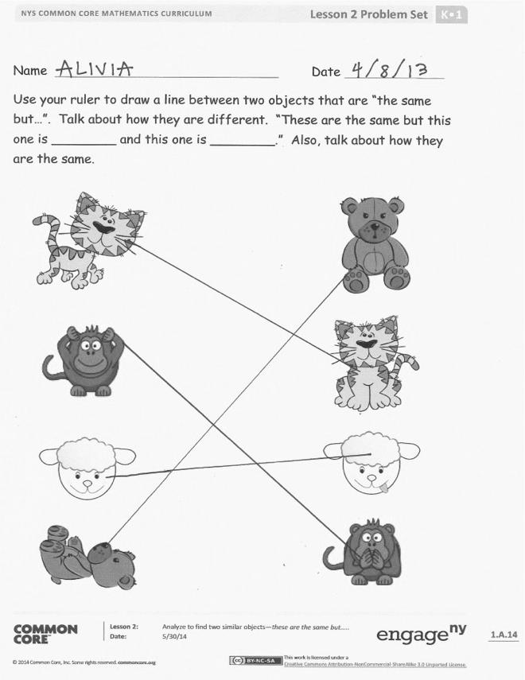
Student Debrief (10 minutes)
The Student Debrief is intended to invite reflection and active processing of the total lesson experience.
Invite students to review their solutions for the Problem Set. They should check work by comparing answers with a partner before going over answers as a class. Look for misconceptions or misunderstandings that can be addressed in the Debrief. Guide students in a conversation to debrief the Problem Set and process the lesson.
You may choose to use any combination of the questions below to lead the discussion.
- What were your favorite objects?
- Who can make a sentence about the cats using they are the same but…? (Repeat with each of the animals.)
- How could we change one of the cats to make it exactly the same as the other? (Repeat with each of the animals.)
Exit Ticket (3 minutes)
After the Student Debrief, instruct students to complete the Exit Ticket. A review of their work will help you assess the students’ understanding of the concepts that were presented in the lesson today and plan more effectively for future lessons. You may read the questions aloud to the students.

Name Date
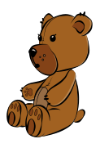
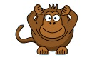
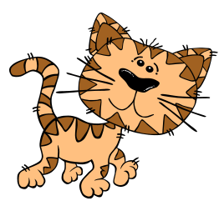
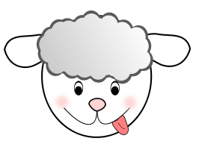
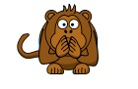
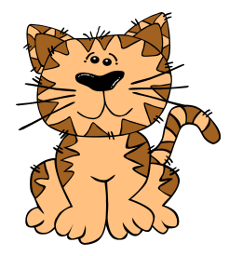
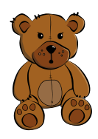
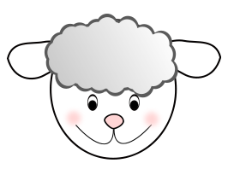
Use your ruler to draw a line between two objects that are “the same but….” Talk about how they are different. “These are the same, but this one is ________ and this one is ________.” Also, talk about how they are the same.

Name Date
Circle the shapes that are the same in each row. Talk to a friend about how you made your choice.

Name Date
Are they the same? Circle your answer, and explain it to an adult or friend.

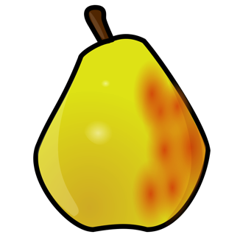
Are these the same? YES NO

Are these the same? YES NO

Are these the same? YES NO

