Lesson 8
Objective: Use the area model and multiplication to show the equivalence of two fractions.

Suggested Lesson Structure
 Fluency Practice (12 minutes)
 Application Problem (4 minutes)
 Concept Development (34 minutes)
 Student Debrief (10 minutes)
Total Time (60 minutes)
Fluency Practice (12 minutes)
- Multiply Mentally 4.OA.4 (4 minutes)
- Count by Equivalent Fractions 3.NF.3 (4 minutes)
- Draw Equivalent Fractions 4.NF.1 (4 minutes)
Multiply Mentally (4 minutes)
Materials: (S) Personal white board
Note: This fluency activity reviews Module 3 content.
T: (Write 32 $\text{×}$ 3 = .) Say the multiplication sentence.
S: 32 $\text{×}$ 3 = 96.
T: (Write 32 $\text{×}$ 3 = 96. Below it, write 32 $\text{×}$ 20 = .) Say the multiplication sentence.
S: 32 $\text{×}$ 20 = 640.
T: (Write 32 $\text{×}$ 20 = 640. Below it, write 32 $\text{×}$ 23 = .) On your personal white board, solve 32 $\text{×}$ 23.
S: (Write 32 $\text{×}$ 23 = 736.)
Continue with the following possible sequence: 42 $\text{×}$ 2, 42 $\text{×}$ 20, 42 $\text{×}$ 22 and 21 $\text{×}$ 4, 21 $\text{×}$ 40, 21 $\text{×}$ 44.
Count by Equivalent Fractions (4 minutes)
Note: This fluency activity reviews Lesson 4.
T: Count by twos to 12. Start at 0.
S: 0, 2, 4, 6, 8, 10, 12.
T: Count by 2 thirds to 12 thirds. Start at 0 thirds. (Write as students count.)
S: $\frac{\text{0}}{\text{3}}\text{,}\frac{\text{2}}{\text{3}}\text{,}\frac{\text{4}}{\text{3}}\text{,}\frac{\text{6}}{\text{3}}\text{,}\frac{\text{8}}{\text{3}}\text{,}\frac{\text{10}}{\text{3}}\text{,}\frac{\text{12}}{\text{3}}\text{.}$
$\frac{\text{0}}{\text{3}} \frac{\text{2}}{\text{3}} \frac{\text{4}}{\text{3}} \frac{\text{6}}{\text{3}} \frac{\text{8}}{\text{3}} \frac{\text{10}}{\text{3}} \frac{\text{12}}{\text{3}}$
$\text{0 }\frac{\text{2}}{\text{3}} \frac{\text{4}}{\text{3}}\text{ 2 } \frac{\text{8}}{\text{3}} \frac{\text{10}}{\text{3}} \text{4}$
T: 1 is the same as how many thirds?
S: 3 thirds.
T: 2 is the same as how many thirds?
S: 6 thirds.
T: (Beneath $\frac{\text{6}}{\text{3}}$ , write 2.) 3 is the same as how many thirds?
S: 9 thirds.
T: 4 is the same as how many thirds?
S: 12 thirds.
T: (Beneath $\frac{\text{12}}{\text{3}}$, write 4.) Count by 2 thirds again. This time, say the whole numbers when you arrive at them.
S: $\text{0, }\frac{\text{2}}{\text{3}}\text{, }\frac{\text{4}}{\text{3}}\text{,} \text{2}\text{,}\frac{\text{8}}{\text{3}}\text{,}\frac{\text{10}}{\text{3}}\text{,} \text{4}$.
Repeat the process, counting by 2 sixths to 18 sixths.
Draw Equivalent Fractions (4 minutes)
Materials: (S) Personal white board
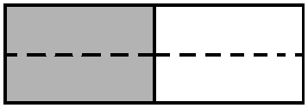
Note: This fluency activity reviews Lesson 7.
T: (Write $\frac{\text{1}}{\text{2}}$.) Say the fraction.
S: 1 half.
T: On your personal white board, draw a model to show $\frac{\text{1}}{\text{2}}$.
S: (Draw a model partitioned into 2 equal units. Shade 1 unit.)
T: (Write $\frac{\text{1}}{\text{2}}\text{= }\frac{}{}\frac{\text{×}}{\text{×}}\frac{}{}\text{=}$ $\frac{}{\text{4}}$.) Draw a dotted horizontal line to find the equivalent fraction. Then, complete the number sentence.
S: (Draw a dotted horizontal line, breaking 2 units into 4 smaller units. Write $\frac{\text{1}}{\text{2}}$ = $\frac{\text{1 ×} \text{2}}{\text{2 × 2}}$= $\frac{\text{2}}{\text{4}}$.)
Continue with the following possible sequence: $\frac{\text{1}}{\text{2}}$ = $\frac{}{\text{8}}$, $\frac{\text{1}}{\text{3}}$ = $\frac{}{\text{9}}$, $\frac{\text{1}}{\text{4}}$ = $\frac{}{\text{8}}$, $\frac{\text{1}}{\text{5}}$ = $\frac{}{\text{15}}$, and $\frac{\text{1}}{\text{7}}$ = $\frac{}{\text{14}}$.

Application Problem (4 minutes)
Saisha gives some of her chocolate bar, pictured below, to her younger brother Lucas. He says, “Thanks for
$\frac{\text{3}}{\text{12}}$ of the bar.” Saisha responds, “No, I gave you $\frac{\text{1}}{\text{4}}$ of the bar.” Explain why both Lucas and Saisha are correct.
CHOCOLATE
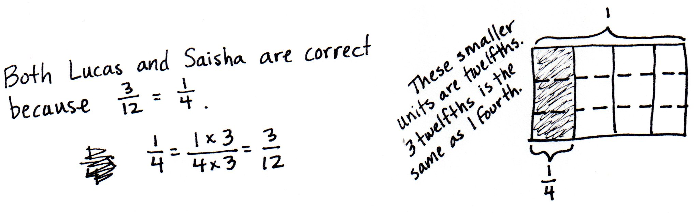
Note: This Application Problem reviews content from Lesson 7. This bridges into today’s lesson, where students will determine equivalent fractions of non-unit fractions. Revisit this problem in the Debrief by asking students to write the remaining portion as two equivalent fractions.
Concept Development (34 minutes)
Materials: (S) Personal white board
Problem 1: Determine that multiplying both the numerator and denominator by n results in an equivalent fraction.
T: Draw an area model to represent 2 thirds. Draw three horizontal lines across the area model.
MP.7
S: (Draw and partition the model.)
T: What happened to the size of the fractional units?
S: The units are 4 times as small because we divided each unit into
4 smaller units.
T: What happened to the number of units?
S: There were 3, and now there are 12. There are 4 times as many units.
T: What happened to the number of selected units?
S: There were 2 units selected; now, there are 8 units selected.
T: Discuss with your partner how to represent the equivalence of $\frac{\text{2}}{\text{3}}$ and $\frac{\text{8}}{\text{12}}$ using multiplication.
S: We can multiply the numerator and denominator by 4.
We can write $\frac{\text{2}}{\text{3}}\text{=}\frac{\text{2} \text{×} \text{4}}{\text{ 3} \text{×} \text{4 }}\text{=}\frac{\text{8}}{\text{12}}$.
T: How do you know the fraction is still representing the same amount?
S: I know it’s the same size because I didn’t change how much is selected. There are more smaller units instead of fewer bigger units, but the area of the selected fraction is still the same. The fractions are equivalent.
MP.7
T: What was different about this problem than the ones we did yesterday?
S: The fraction that we are starting with doesn’t have 1 as the numerator.
T: We know any fraction can be decomposed into the sum of unit fractions. Yesterday, we saw that
1 third equals 4 twelfths. Today, we see that 2 thirds equals 4 twelfths plus 4 twelfths, or 8 twelfths.
T: Draw an area model to represent $\frac{\text{5}}{\text{6}}$. Find an equivalent fraction with the denominator of 12. Explain to a partner how this is done.
S: We partition each of the 6 units into 2 parts so that we have 12 units. We double the number of units to make twelfths. There are twice as many units in the whole and twice as many units selected, but the parts are only half as big. $\frac{\text{5}}{\text{6}}\text{=}\frac{\text{5} \text{×} \text{2}}{\text{ 6} \text{×} \text{2 }}\text{=}\frac{\text{10}}{\text{12}}\text{.}$
T: What have we discovered about finding equivalent fractions?
S: The area of the fraction stays the same, but the number and size of the units change. The number of units increases. The size of the unit fraction decreases.
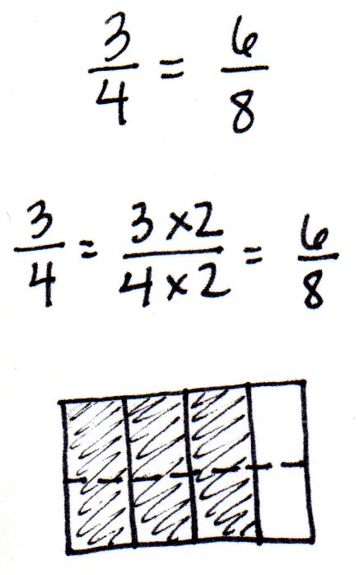
Problem 2: Determine that two fractions are equivalent using an area model and a number sentence.
T: (Project $\frac{\text{3}}{\text{4}}\text{=}\frac{\text{6}}{\text{8}}$.) If the whole is the same, is this statement true or false?
S: 3 times 2 is 6, and 4 times 2 is 8. Yes, it’s true. If we multiply both the numerator and denominator by 2, we get $\frac{\text{6}}{\text{8}}$. Doubling the selected units and the number of units in the whole has the same area as $\frac{\text{3}}{\text{4}}$.
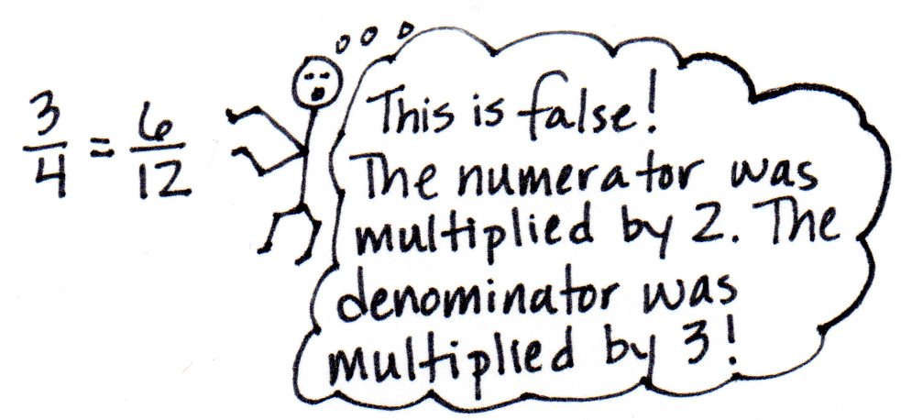
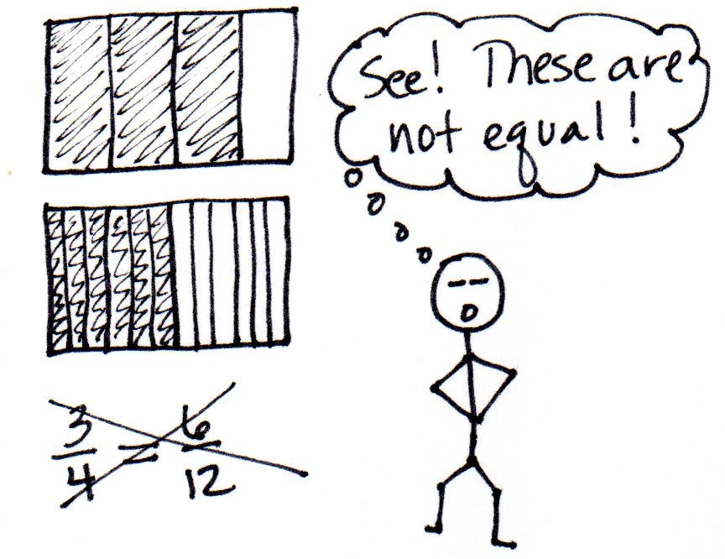
T: Represent the equivalence in a number sentence using multiplication, and draw an area model to show the equivalence.
S: (Do so as pictured to the right.)
T: (Project $\frac{\text{3}}{\text{4}}\text{=}\frac{\text{6}}{\text{12}}$.) If the wholes are the same, is this statement true or false? How do you know? Discuss with your partner.
S: Three times 2 is 6, and 4 times 3 is 12. It’s false. We didn’t multiply by the same number. This is false. I drew a model for$\frac{\text{3}}{\text{4}}$ and then decomposed it into twelfths. There are 9 units shaded, not 6. The numerator is being multiplied by 2, and the denominator is being multiplied by 3. They are not equivalent fractions.
T: With your partner, revise the right side of the equation to make a true number sentence.
S: We could change $\frac{\text{6}}{\text{12}}$ to$\frac{\text{9}}{\text{12}}$. Or we could change $\frac{\text{6}}{\text{12}}$ to $\frac{\text{6}}{\text{8}}$ because both the numerator and denominator would be multiplied by 2.
Problem 3: Write a number sentence using multiplication to show the equivalence of two fractions. Draw the corresponding area model.
T: Find an equivalent fraction without drawing an area model first. Write
$\frac{\text{3}}{\text{5}}$ on your personal white board. How have we found equivalent fractions?
S: We’ve doubled, tripled, or quadrupled the numerator and denominator.
We multiply the numerator and denominator by the same number.
T: Find an equivalent fraction to $\frac{\text{3}}{\text{5}}$ using multiplication.
S: When I multiply the numerator and denominator by 2, I get $\frac{\text{6}}{\text{10}}$.
T: Use an area model to confirm your number sentence.

NOTES ON
MULTIPLE MEANS
OF ENGAGEMENT
Invite students working above grade level and others to test their discoveries about multiplying fractions by partitioning shapes other than rectangles, such as circles and hexagons. This work may best be supported by means of concrete or virtual manipulatives.

S: (Do so, correcting any errors as necessary. Answers may vary.)
Problem Set (10 minutes)
Students should do their personal best to complete the Problem Set within the allotted 10 minutes. For some classes, it may be appropriate to modify the assignment by specifying which problems they work on first. Some problems do not specify a method for solving. Students should solve these problems using the RDW approach used for Application Problems.
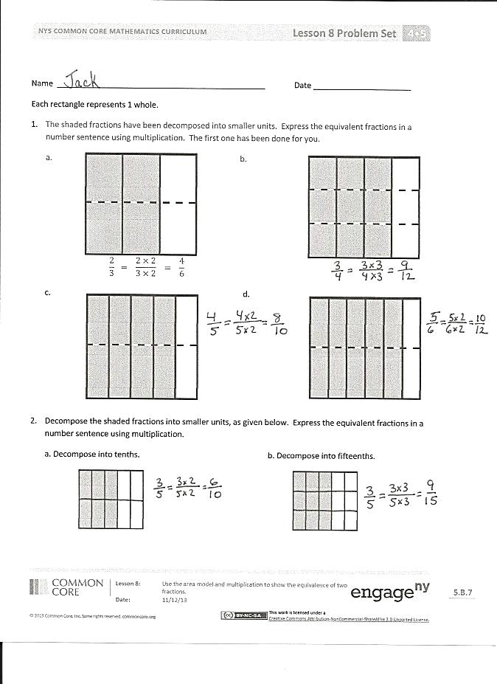
Student Debrief (10 minutes)
Lesson Objective: Use the area model and multiplication to show the equivalence of two fractions.
The Student Debrief is intended to invite reflection and active processing of the total lesson experience.
Invite students to review their solutions for the Problem Set. They should check work by comparing answers with a partner before going over answers as a class. Look for misconceptions or misunderstandings that can be addressed in the Debrief. Guide students in a conversation to debrief the Problem Set and process the lesson.
Any combination of the questions below may be used to lead the discussion.
- For Problem 3(a–d), how did you determine the number of horizontal lines to draw in each area model?
- For Problem 5(c), did you and your partner have the same answer? Explain why you might have different answers.
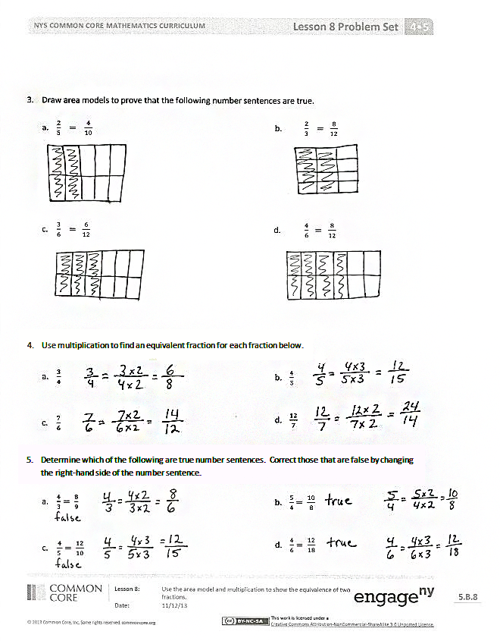
- Explain when someone might need to use equivalent fractions in daily life.
- How are we able to show equivalence without having to draw an area model?
- Think back to the Application Problem. What fraction of the bar did Saisha receive?
Exit Ticket (3 minutes)
After the Student Debrief, instruct students to complete the Exit Ticket. A review of their work will help with assessing students’ understanding of the concepts that were presented in today’s lesson and planning more effectively for future lessons. The questions may be read aloud to the students.

Name Date
Each rectangle represents 1.
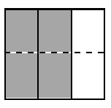
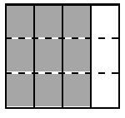
- The shaded fractions have been decomposed into smaller units. Express the equivalent fractions in a number sentence using multiplication. The first one has been done for you.
$$\frac{\text{2}}{\text{3}}\text{ = }\frac{\text{2} \text{×} \text{2}}{\text{3} \text{×} \text{2}}\text{ = }\frac{\text{4}}{\text{6}}$$
a. b.

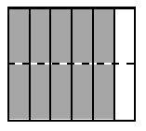
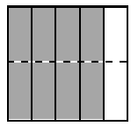
c. d.

- Decompose the shaded fractions into smaller units, as given below. Express the equivalent fractions in a number sentence using multiplication.
- Decompose into tenths. b. Decompose into fifteenths.
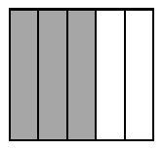

- Draw area models to prove that the following number sentences are true.

  - $\frac{\text{2}}{\text{5}}\text{ = }\frac{\text{4}}{\text{10}}$
  - $\frac{\text{2}}{\text{3}}\text{ = }\frac{\text{8}}{\text{12}}$

  - $\frac{\text{3}}{\text{6}}\text{ = }\frac{\text{6}}{\text{12}}$
  - $\frac{\text{4}}{\text{6}}\text{ = }\frac{\text{8}}{\text{12}}$

- Use multiplication to find an equivalent fraction for each fraction below.

- $\frac{\text{3}}{\text{4}}$

- $\frac{\text{7}}{\text{6}}$
- $\frac{\text{4}}{\text{5}}$

- $\frac{\text{12}}{\text{7}}$

- Determine which of the following are true number sentences. Correct those that are false by changing the right-hand side of the number sentence.

- $\frac{\text{4}}{\text{3}} \text{= }\frac{\text{8}}{\text{9}}$

- $\frac{\text{4}}{\text{5}} \text{= }\frac{\text{12}}{\text{10}}$

- $\frac{\text{5}}{\text{4}} \text{= }\frac{\text{10}}{\text{8}}$

- $\frac{\text{4}}{\text{6}} \text{= }\frac{\text{12}}{\text{18}}$

Name Date
- Use multiplication to create an equivalent fraction for the fraction below.

$$\frac{\text{2}}{\text{5}}$$

- Determine if the following is a true number sentence. If needed, correct the statement by changing the right-hand side of the number sentence.

$$\frac{\text{3}}{\text{4}} \text{=} \frac{\text{9}}{\text{8}}$$

Name Date
Each rectangle represents 1.
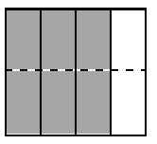
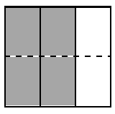
- The shaded fractions have been decomposed into smaller units. Express the equivalent fractions in a number sentence using multiplication. The first one has been done for you.
a. b.

$$\frac{\text{2}}{\text{3}} \text{=} \frac{\text{2} \text{×} \text{2}}{\text{3} \text{×} \text{2}} \text{=} \frac{\text{4}}{\text{6}}$$

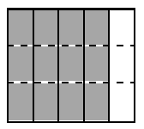
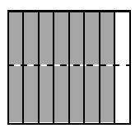
c. d.

- Decompose both shaded fractions into twelfths. Express the equivalent fractions in a number sentence using multiplication.
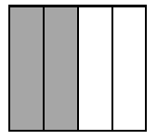
- b.

- Draw area models to prove that the following number sentences are true.
a. $\frac{1}{3}= \frac{2}{6}$ b. $\frac{2}{5}= \frac{4}{10}$

c. $\frac{5}{7}= \frac{10}{14}$ d. $\frac{3}{6}= \frac{9}{18}$

- Use multiplication to create an equivalent fraction for each fraction below.
a. $\frac{2}{3}$ b. $\frac{5}{6}$

c. $\frac{6}{5}$ d. $\frac{10}{8}$

- Determine which of the following are true number sentences. Correct those that are false by changing the right-hand side of the number sentence.
a. $\frac{2}{3}= \frac{4}{9}$ b. $\frac{5}{6}= \frac{10}{12}$

c. $\frac{3}{5}= \frac{6}{15}$ d. $\frac{7}{4}= \frac{21}{12}$

