Lesson 7
Objective: Use the area model and multiplication to show the equivalence of two fractions.

Suggested Lesson Structure
 Fluency Practice (12 minutes)
 Application Problem (4 minutes)
 Concept Development (34 minutes)
 Student Debrief (10 minutes)
Total Time (60 minutes)
Fluency Practice (12 minutes)
- Break Apart Fractions 4.NF.3 (4 minutes)
- Count by Equivalent Fractions 3.NF.3 (4 minutes)
- Draw Equivalent Fractions 4.NF.1 (4 minutes)
Break Apart Fractions (4 minutes)
Materials: (S) Personal white board
Note: This fluency activity reviews Lessons 1─3.
T: (Project a tape diagram of 3 fifths with the whole labeled as 1.) Name the fraction that’s shaded.
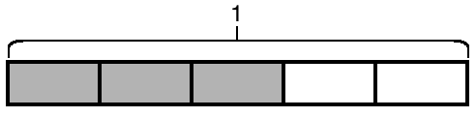
S: $\frac{\text{3}}{\text{5}}$.
T: (Write $\frac{\text{3}}{\text{5}}$ = __.) Say the fraction.
S: 3 fifths.
T: On your personal white board, write $\frac{\text{3}}{\text{5}}$ as a repeated addition sentence using unit fractions.
S: (Write $\frac{\text{3}}{\text{5}}$ $\text{=}$ $\frac{\text{1}}{\text{5}}$ $\text{+}$ $\frac{\text{1}}{\text{5}}$ + $\frac{\text{1}}{\text{5}}$.)
T: (Write $\frac{\text{3}}{\text{5}}$ = $\frac{\text{1}}{\text{5}}$ + $\frac{\text{1}}{\text{5}}$ + $\frac{\text{1}}{\text{5}}$ = __ $\text{×}$ $\frac{\text{1}}{\text{5}}$.) On your board, complete the number sentence.
S: (Write $\frac{\text{3}}{\text{5}}$ = $\frac{\text{1}}{\text{5}}$ + $\frac{\text{1}}{\text{5}}$ + $\frac{\text{1}}{\text{5}}$ = 3 $\text{×}$ $\frac{\text{1}}{\text{5}}.$)
Continue with the following possible sequence: $\frac{\text{5}}{\text{6}}$ = $\frac{\text{1}}{\text{6}}$ + $\frac{\text{1}}{\text{6}}$ + $\frac{\text{1}}{\text{6}}$ + $\frac{\text{1}}{\text{6}}$ + $\frac{\text{1}}{\text{6}}$ = 5 $\text{×}$ $\frac{\text{1}}{\text{6}}$ and $\frac{\text{5}}{\text{8}}$ = $\frac{\text{1}}{\text{8}}$ + $\frac{\text{1}}{\text{8}}$ + $\frac{\text{1}}{\text{8}}$ + $\frac{\text{1}}{\text{8}}$ + $\frac{\text{1}}{\text{8}}$ = 5 $\text{×}\frac{\text{1}}{\text{8}}$.

Count by Equivalent Fractions (4 minutes)
Materials: (S) Personal white board
Note: This fluency activity prepares students for lessons throughout this module.
T: Count from 0 to 10 by ones. Start at 0.
S: 0, 1, 2, 3, 4, 5, 6, 7, 8, 9, 10.
T: Count by 1 fourths to 10 fourths. Start at 0 fourths. (Write as students count.)
$\frac{\text{0}}{\text{4}}$ $\frac{\text{1}}{\text{4}}$ $\frac{\text{2}}{\text{4}}$ $\frac{\text{3}}{\text{4}}$ $\frac{\text{4}}{\text{4}}$ $\frac{\text{5}}{\text{4}}$ $\frac{\text{6}}{\text{4}}$ $\frac{\text{7}}{\text{4}}$ $\frac{\text{8}}{\text{4}}$ $\frac{\text{9}}{\text{4}}$ $\frac{\text{10}}{\text{4}}$
0 $\frac{\text{1}}{\text{4}}$ $\frac{\text{2}}{\text{4}}$ $\frac{\text{3}}{\text{4}}$ 1 $\frac{\text{5}}{\text{4}}$ $\frac{\text{6}}{\text{4}}$ $\frac{\text{7}}{\text{4}}$ 2 $\frac{\text{9}}{\text{4}}$ $\frac{\text{10}}{\text{4}}$

S: $\frac{\text{0}}{\text{4}}\text{,}\frac{\text{1}}{\text{4}}$ , $\frac{\text{2}}{\text{4}}$ , $\frac{\text{3}}{\text{4}}$ , $\frac{\text{4}}{\text{4}}$ , $\frac{\text{5}}{\text{4}}$ , $\frac{\text{6}}{\text{4}}$ , $\frac{\text{7}}{\text{4}}$ , $\frac{\text{8}}{\text{4}}$ ,$\frac{\text{9}}{\text{4}}$ , $\frac{\text{10}}{\text{4}}$.
T: 4 fourths is the same as 1 of what unit?
S: 1 one.
T: (Beneath 4 fourths, write 1.) 2 ones is the same as how many fourths?
S: 8 fourths.
T: (Beneath $\frac{\text{8}}{\text{4}}$ , write 2.) Let’s count to 10 fourths again, but this time, say the whole numbers when you come to a whole number. Start at 0.
S: 0, $\frac{\text{1}}{\text{4}}$ , $\frac{\text{2}}{\text{4}}$ , $\frac{\text{3}}{\text{4}}$ , 1, $\frac{\text{5}}{\text{4}}$, $\frac{\text{6}}{\text{4}}$ , $\frac{\text{7}}{\text{4}}$ , 2,$\frac{\text{9}}{\text{4}}$ , $\frac{\text{10}}{\text{4}}$.
Repeat the process, counting by thirds to 10 thirds.
Draw Equivalent Fractions (4 minutes)
Materials: (S) Personal white board
Note: This fluency activity reviews Lesson 6.
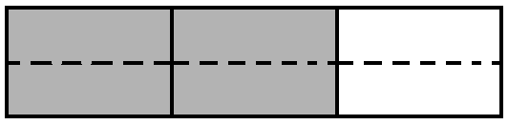
T: (Write $\frac{\text{2}}{\text{3}}\text{.}$) Say the fraction.
S: 2 thirds.
T: On your personal white board, draw an area model to show $\frac{\text{2}}{\text{3}}$.
S: (Draw a model partitioned into 3 equal units. Shade 2 units.)
T: (Write $\frac{\text{2}}{\text{3}}$ = $\frac{\text{4}}{}\text{.}$) Draw a dotted horizontal line to find the equivalent fraction.
$\frac{\text{2}}{\text{3}}$ = $\frac{\text{4}}{\text{6}}$
S: (Draw a dotted horizontal line, breaking 3 units into 6 smaller units. Write $\frac{\text{2}}{\text{3}}$ = $\frac{\text{4}}{\text{6}}\text{.}$)
Continue with the following possible sequence: $\frac{\text{2}}{\text{3}}$ = $\frac{\text{6}}{}$ , $\frac{\text{3}}{\text{4}}$ = $\frac{\text{6}}{}$, $\frac{\text{2}}{\text{5}}$ = $\frac{\text{4}}{}$ , and $\frac{\text{4}}{\text{5}}$ = $\frac{\text{12}}{}$.
Application Problem (4 minutes)
Model an equivalent fraction for $\frac{\text{4}}{\text{7}}$ using an area model.

NOTES ON
MULTIPLE MEANS
OF REPRESENTATION:
Students working below grade level and others may benefit from explicit instruction as they decompose unit fractions. When doubling the number of units, instruct students to draw one horizontal dotted line. When tripling, draw two lines, and so forth.

Note: This Application Problem reviews Lesson 6 and leads into today’s lesson as students find equivalent fractions using multiplication.
Concept Development (34 minutes)
Materials: (S) Personal white board
Problem 1: Determine that multiplying the numerator and denominator by n results in an equivalent fraction.
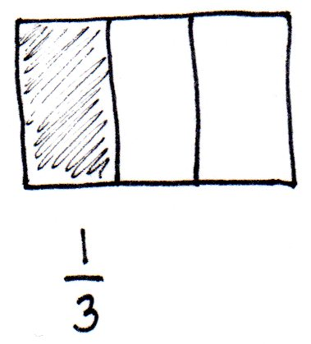
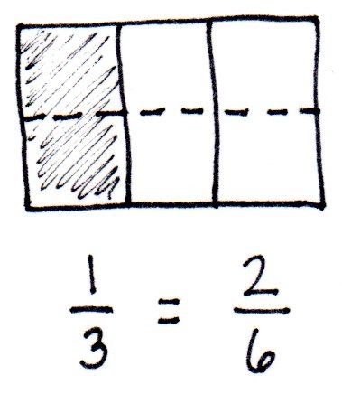
T: Draw an area model representing 1 whole partitioned into thirds. Shade and record $\frac{\text{1}}{\text{3}}$ below the area model. Draw 1 horizontal line across the area model.
S: (Draw, partition, and shade an area model.)
T: What happened to the size of the fractional units?
S: The units got smaller. The unit became half the size.
T: What happened to the number of units in the whole?
MP.7
S: There were 3; now, there are 6. We doubled the total number of units.
T: What happened to the number of selected units when we drew the dotted line?
S: There was 1 unit selected, and now there are 2. It doubled, too!
T: That’s right. We can record the doubling of units with multiplication: $\frac{\text{1}}{\text{3}}\text{=}\frac{\text{1} \text{×} \text{2}}{\text{3} \text{×} \text{2}}\text{=}\frac{\text{2}}{\text{6}}$.
S: Hey, I remember from third grade that $\frac{\text{1}}{\text{3}}$ is the same as $\frac{\text{2}}{\text{6}}$.
T: Yes, they are equivalent fractions.
T: Why didn’t doubling the number of selected units make the fraction larger?
S: We didn’t change the amount of the fraction, just the size of the units. Yeah, so the size of the units became half as big.
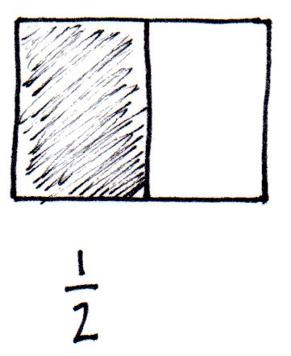
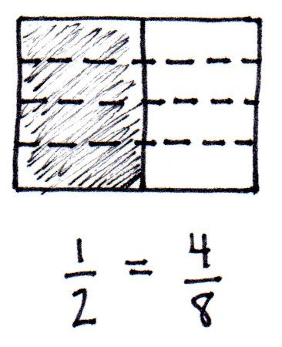
T: Draw an area model representing 1 partitioned with a vertical line into 2 halves.
T: Shade and record $\frac{\text{1}}{\text{2}}$ below the area model. If we want to rewrite $\frac{\text{1}}{\text{2}}$ using 4 times as many units, what should we do?
S: Draw horizontal dotted lines—three of them. Then, we can write a number sentence using multiplication. This time, it’s 4 times as many, so we will multiply the top number and bottom number by 4.
T: Show me. (Allow time for students to partition the area model.) What happened to the size of the fractional unit?
S: The size of the fractional unit got smaller.
MP.7
T: What happened to the number of units in the whole?
S: There are 4 times as many. They quadrupled.
T: What happened to the number of selected units?
S: There was 1, and now there are 4. The number of selected units quadrupled!
T: Has the size of the selected units changed?
S: There are more smaller unit fractions instead of one bigger unit fraction, but the area is still the same.
T: What can you conclude about $\frac{\text{1}}{\text{2}}$ and $\frac{\text{4}}{\text{8}}?$
S: They are equal!
T: Let’s show that using multiplication: $\frac{\text{1}}{\text{2}}\text{=}\frac{\text{1} \text{×} \text{4}}{\text{ 2} \text{×} \text{4 }}\text{=}\frac{\text{4}}{\text{8}}$. $\left(\frac{\text{4 }\text{times as many selected units}}{\text{4 }\text{times as many units in the whole}}\right)$
T: When we quadrupled the number of units, the number of selected units quadrupled. When we doubled the number of units, the number of selected units doubled. What do you predict would happen to the shaded fraction if we tripled the units?
S: The number of units within the shaded fraction would triple, too.
Problem 2: Given an area model, determine an equivalent fraction for the area selected.
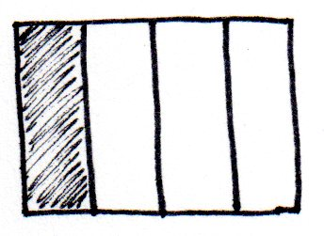
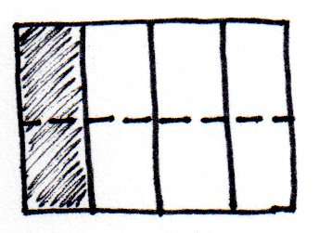
T: (Display area model showing $\frac{\text{1}}{\text{4}}$.) Work with your partner to determine an equivalent fraction to $\frac{\text{1}}{\text{4}}$.
S: Let’s draw one horizontal line. That will double the number of units. We can draw two horizontal lines. That will triple the number of units and make them smaller, too. If we multiply the top and bottom numbers by 4, we could quadruple the number of units. Each one will be a quarter of the size, too.
Circulate to listen for student understanding and monitor their work. Reconvene to examine one or more equivalent fractions.
T: Some groups drew one horizontal line. (Demonstrate.) Tell your partner what happened to the size of the units.
S: The units got smaller.
T: Tell your partner what happened to the number of units.
S: There are twice as many units.
T: Let’s record that: $\frac{\text{1}}{\text{4}}\text{=}\frac{\text{1} \text{×} \text{2}}{\text{ 4} \text{×} \text{2 }}\text{=}\frac{\text{2}}{\text{8}}$.
T: What is the relationship of the denominators, the fractional units, in the equivalent fractions?
S: The denominator in $\frac{\text{2}}{\text{8}}$ is double the denominator in $\frac{\text{1}}{\text{4}}$ because we doubled the number of units.
Since the size of the units is half as big, we doubled the denominator.
T: What is the relationship of the numerators, the number of fractional units selected, in the equivalent fractions?
S: The numerator in $\frac{\text{2}}{\text{8}}$ is double the numerator in $\frac{\text{1}}{\text{4}}$ because we doubled the number of selected units. Since the size of the selected units is half as big, we doubled the numerator.
Problem 3: Express an equivalent fraction using multiplication, and verify by drawing an area model.
T: Discuss with your partner how to find another way to name $\frac{\text{1}}{\text{3}}$ without drawing an area model first.
S: Let’s triple the number of units in the whole. So, we have to multiply the numerator and denominator by 3. Or we could triple the numerator and denominator.
T: Now, verify that the fraction you found is equivalent by drawing an area model.
S: (Work.)
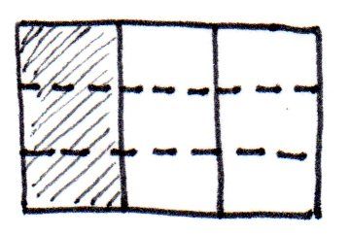
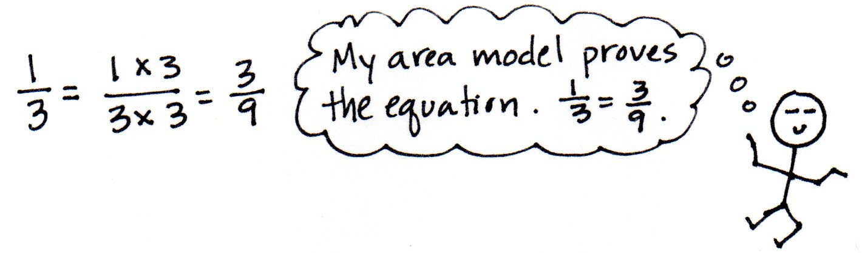

Problem Set (10 minutes)
Students should do their personal best to complete the Problem Set within the allotted 10 minutes. For some classes, it may be appropriate to modify the assignment by specifying which problems they work on first. Some problems do not specify a method for solving. Students should solve these problems using the RDW approach used for Application Problems.

Student Debrief (10 minutes)
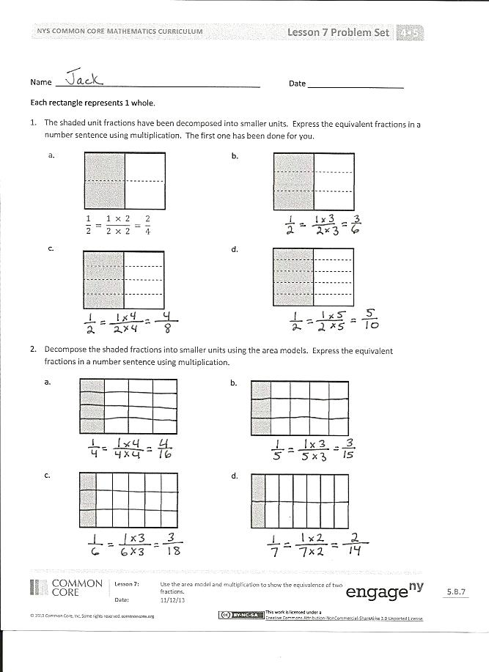
Lesson Objective: Use the area model and multiplication to show the equivalence of two fractions.
The Student Debrief is intended to invite reflection and active processing of the total lesson experience.
Invite students to review their solutions for the Problem Set. They should check work by comparing answers with a partner before going over answers as a class. Look for misconceptions or misunderstandings that can be addressed in the Debrief. Guide students in a conversation to debrief the Problem Set and process the lesson.
Any combination of the questions below may be used to lead the discussion.
- What pattern did you notice for Problem 1(a–d)?
- Discuss and compare with your partner your answers to Problems 2(e) and 2(f).
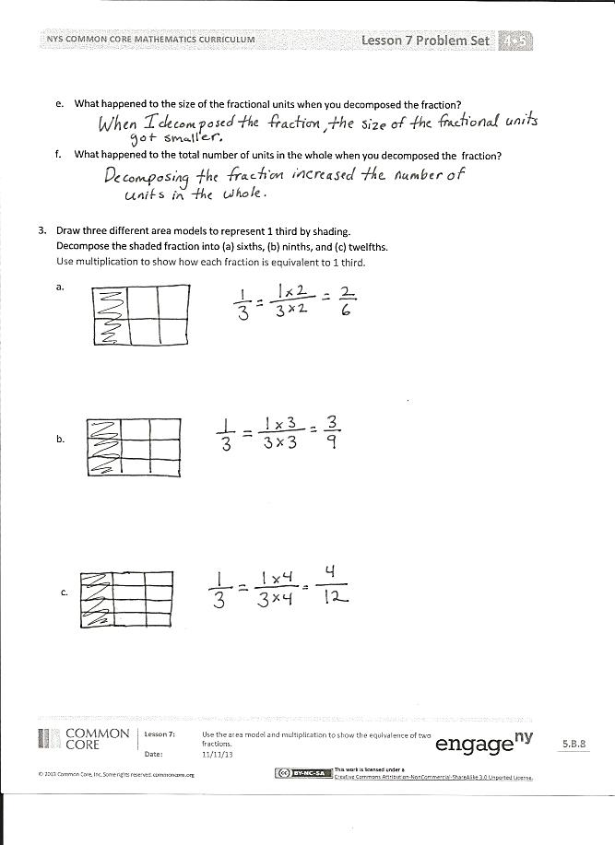
- In Problem 2, the unit fractions have different denominators. Discuss with your partner how the size of a unit fraction is related to the denominator.
- The numerator identifies the number of units selected. Can the numerator be larger than the denominator?
Exit Ticket (3 minutes)
After the Student Debrief, instruct students to complete the Exit Ticket. A review of their work will help with assessing students’ understanding of the concepts that were presented in today’s lesson and planning more effectively for future lessons. The questions may be read aloud to the students.

Name Date
Each rectangle represents 1.
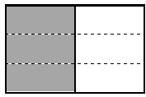
- The shaded unit fractions have been decomposed into smaller units. Express the equivalent fractions in a number sentence using multiplication. The first one has been done for you.
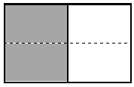
a. b.

$$\frac{\text{1}}{\text{2}}\text{ = }\frac{\text{1 × 2}}{\text{2 × 2}}\text{ = }\frac{\text{2}}{\text{4}}$$

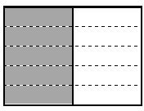
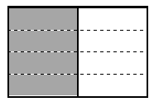
c. d.

- Decompose the shaded fractions into smaller units using the area models. Express the equivalent fractions in a number sentence using multiplication.
a. b.

c. d.

e. What happened to the size of the fractional units when you decomposed the fraction?

f. What happened to the total number of units in the whole when you decomposed the fraction?

- Draw three different area models to represent 1 third by shading.
Decompose the shaded fraction into (a) sixths, (b) ninths, and (c) twelfths.
Use multiplication to show how each fraction is equivalent to 1 third.
a.

b.

c.

Name Date
Draw two different area models to represent 1 fourth by shading.
Decompose the shaded fraction into (a) eighths and (b) twelfths.
Use multiplication to show how each fraction is equivalent to 1 fourth.

b.

Name Date
Each rectangle represents 1.
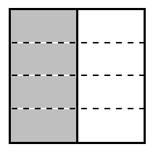
- The shaded unit fractions have been decomposed into smaller units. Express the equivalent fractions in a number sentence using multiplication. The first one has been done for you.
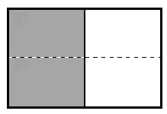
- b.
$$\frac{\text{1}}{\text{2}}\text{ = }\frac{\text{1 × 2}}{\text{2 × 2}}\text{ = }\frac{\text{2}}{\text{4}}$$

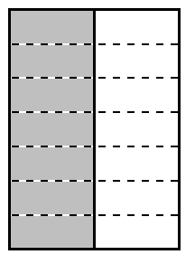
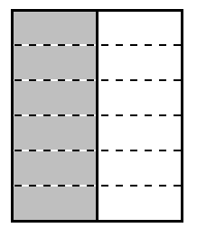
c. d.

- Decompose the shaded fractions into smaller units using the area models. Express the equivalent fractions in a number sentence using multiplication.
a. b.

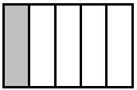
c. d. d.

- Draw three different area models to represent 1 fourth by shading.
Decompose the shaded fraction into (a) eighths, (b) twelfths, and (c) sixteenths.
Use multiplication to show how each fraction is equivalent to 1 fourth.
a.

b.

c.

