Lesson 6
Objective: Decompose fractions using area models to show equivalence.

Suggested Lesson Structure
 Fluency Practice (12 minutes)
 Application Problem (8 minutes)
 Concept Development (30 minutes)
 Student Debrief (10 minutes)
Total Time (60 minutes)
Fluency Practice (12 minutes)
- Sprint: Multiply Whole Numbers Times Fractions 4.NF.4 (9 minutes)
- Find Equivalent Fractions 4.NF.1 (3 minutes)
Sprint: Multiply Whole Numbers Times Fractions (9 minutes)
Materials: (S) Multiply Whole Numbers Times Fractions Sprint
Note: This fluency activity reviews Lesson 3.
Find Equivalent Fractions (3 minutes)
Materials: (S) Personal white board
Note: This fluency activity reviews Lesson 5.
T: (Write $\frac{\text{1}}{\text{3}}.$) Say the fraction.
S: 1 third.
T: On your personal white boards, draw a model to show $\frac{\text{1}}{\text{3}}$.
S: (Draw a model partitioned into 3 equal units. Shade 1 unit.)
T: (Write $\frac{\text{1}}{\text{3}}$ = $\frac{\text{2}}{}.$) Draw a dotted horizontal line to decompose 1 third into an equivalent fraction.
S: (Draw a dotted horizontal line, breaking 3 units into 6 smaller units. Write $\frac{\text{1}}{\text{3}}$ = $\frac{\text{2}}{\text{6}}.$)
Continue with the following possible sequence: $\frac{\text{1}}{\text{3}}$ = $\frac{\text{3}}{\text{9}}$ , $\frac{\text{1}}{\text{2}}$ = $\frac{\text{2}}{\text{4}}$ , $\frac{\text{1}}{\text{2}}$ = $\frac{\text{4}}{\text{8}}$ , $\frac{\text{1}}{\text{4}}$ = $\frac{\text{2}}{\text{8}}$, and $\frac{\text{1}}{\text{5}}$ = $\frac{\text{3}}{\text{15}}$.
Application Problem (8 minutes)
Use area models to prove that $\frac{\text{1}}{\text{2}} \text{=} \frac{\text{2}}{\text{4}} \text{=} \frac{\text{4}}{\text{8}}$ , $\frac{\text{1}}{\text{2}} \text{=} \frac{\text{3}}{\text{6}} \text{=} \frac{\text{6}}{\text{12}} ,$and $\frac{\text{1}}{\text{2}} \text{=} \frac{\text{5}}{\text{10}}.$ What conclusion can you make about
$\frac{\text{4}}{\text{8}},\frac{\text{6}}{\text{12}} ,$ and $\frac{\text{5}}{\text{10}}?$ Explain.

Note: This Application Problem builds from Lesson 5, where students decomposed unit fractions using area models to show equivalence. Consider leading a discussion with a question, such as, “Why can you show
$\frac{\text{1}}{\text{2}}$ = $\frac{\text{2}}{\text{4}}$ = $\frac{\text{4}}{\text{8}}$ on one model, $\frac{1}{2}$ = $\frac{\text{3}}{\text{6}}$ = $\frac{\text{6}}{\text{12}}$ on another, and $\frac{\text{1}}{\text{2}}$ = $\frac{\text{5}}{\text{10}}$ on another?” Or perhaps lead with a question, such as, “Why can’t you show $\frac{\text{1}}{\text{2}}$ = $\frac{\text{2}}{\text{4}}$ = $\frac{\text{5}}{\text{10}}$ on the same area model?”
Concept Development (30 minutes)
Materials: (S) Personal white board
Problem 1: Use an area model to show that $\frac{\text{3}}{\text{4}} \text{=} \frac{\text{6}}{\text{8}}$.
T: Draw an area model representing 1, and then shade $\frac{\text{3}}{\text{4}}$.
T: Discuss with a partner how you can use this model to show the decomposition of 3 fourths into eighths.
S: We could draw a line so that each of the fourths is split into
2 equal parts. That would give us eighths. Drawing a line will make each unit into 2 smaller units, which would be eighths.
T: How many eighths are shaded?
S: 6 eighths.
T: Work with a partner to write an addition and a multiplication sentence to describe the decomposition.
S: $\frac{\text{3}}{\text{4}} \text{=} \left(\frac{\text{1}}{\text{8}} \text{+}\frac{\text{1}}{\text{8}}\right)\text{+}\left(\frac{\text{1}}{\text{8}} \text{+} \frac{\text{1}}{\text{8}}\right)\text{+}\left(\frac{\text{1}}{\text{8}} \text{+} \frac{\text{1}}{\text{8}}\right)\text{=} \frac{\text{6}}{\text{8}}.$ $\frac{\text{3}}{\text{4}} \text{=} \text{3 ×} \frac{\text{2}}{\text{8}} \text{= 6 ×} \frac{\text{1}}{\text{8}} \text{= }\frac{\text{6}}{\text{8}}.$ $\frac{\text{3}}{\text{4}}$is equal to $\frac{\text{6}}{\text{8}}.$
T: What do these addition and multiplication sentences tell you?
S: The shaded area didn’t change. It’s still the same amount. The number of pieces increased, but the size of the pieces got smaller. Adding together all of the smaller units equals the total of the larger units shaded. Multiplying also equals the total of the larger units shaded and is easier to write out!
Problem 2: Draw an area model to represent the equivalence of two fractions, and express the equivalence as the sum and product of unit fractions.
T: Let’s draw an area model to show that $\frac{\text{2}}{\text{3}} \text{=} \frac{\text{8}}{\text{12}}$. What fraction will you model first, and why? Discuss with a partner.
S: I will represent $\frac{\text{2}}{\text{3}}$ first since thirds are the larger pieces. I can draw 1 divided into thirds and then shade 2 of them. Then, it’s easy to split the thirds into parts to make twelfths. We have to draw the larger units first and then decompose them into smaller ones, don’t we?
T: Draw an area model representing 2 thirds.
T: How can we show that $\frac{\text{2}}{\text{3}} \text{=} \frac{\text{8}}{\text{12}}$? Discuss.
S: We can split the thirds into parts until we have 12 of them. Yes, but we need to make sure that they are equal parts. We might have to erase our lines and then redraw to make them look equal. We can draw three lines across the thirds. This will make 12 groups. When I do that, the eight pieces are already shaded!
T: Express the equivalence as an addition sentence.
S: $\frac{2}{3}=\frac{1}{3}+\frac{1}{3}=\left(\frac{1}{12}+\frac{1}{12}+\frac{1}{12}+\frac{1}{12}\right)+\left(\frac{1}{12}+\frac{1}{12}+\frac{1}{12}+\frac{1}{12}\right)=\frac{8}{12}$.
T: Express the equivalence as a multiplication sentence.
S: $\frac{\text{2}}{\text{3}} \text{=} \left(\text{8 ×} \frac{\text{1}}{\text{12}}\right) \text{=} \frac{\text{8}}{\text{12}}$. $\frac{\text{2}}{\text{3}} \text{=} \left(\text{4 ×} \frac{\text{1}}{\text{12}}\right) \text{+} \left(\text{4 ×} \frac{\text{1}}{\text{12}}\right) \text{=} \frac{\text{8}}{\text{12}}.$
Problem 3: Decompose to create equivalent fractions by drawing an area model and then dividing the area model into smaller parts.
T: Let’s use what we know to model equivalent fractions.
- Draw an area model. The entire figure is 1.
- Choose a fraction, and partition the whole using vertical lines.
- Shade your fraction.
- Switch papers with a partner. Write down the fraction that your partner has represented.
- Draw one to three horizontal lines. What equivalent fraction have you modeled?
T: How could we model 5 thirds?
S: We can draw an area model and partition it into 5 parts. Each part is 1 third. We have to label 1 after 3 units.
T: Draw one horizontal line to model an equivalent fraction. How many units are in 1?

NOTES ON
MULTIPLE MEANS
OF ENGAGEMENT:
Scaffold Problem 2 on the Problem Set for students working below grade level and others by providing number sentence frames such as the following:
$$\left(\frac{1}{}+\frac{1}{}\right)+\left(\frac{1}{}+\frac{1}{}\right)= \\ \left({}_{ }×\frac{}{}\right)+\left( {}_{ }×\frac{}{}\right)=\frac{}{}.$$

S: 6.
T: What fraction is represented?
S: $\frac{\text{10}}{\text{6}}.$
Problem Set (10 minutes)
Students should do their personal best to complete the Problem Set within the allotted 10 minutes. For some classes, it may be appropriate to modify the assignment by specifying which problems they work on first. Some problems do not specify a method for solving. Students should solve these problems using the RDW approach used for Application Problems.
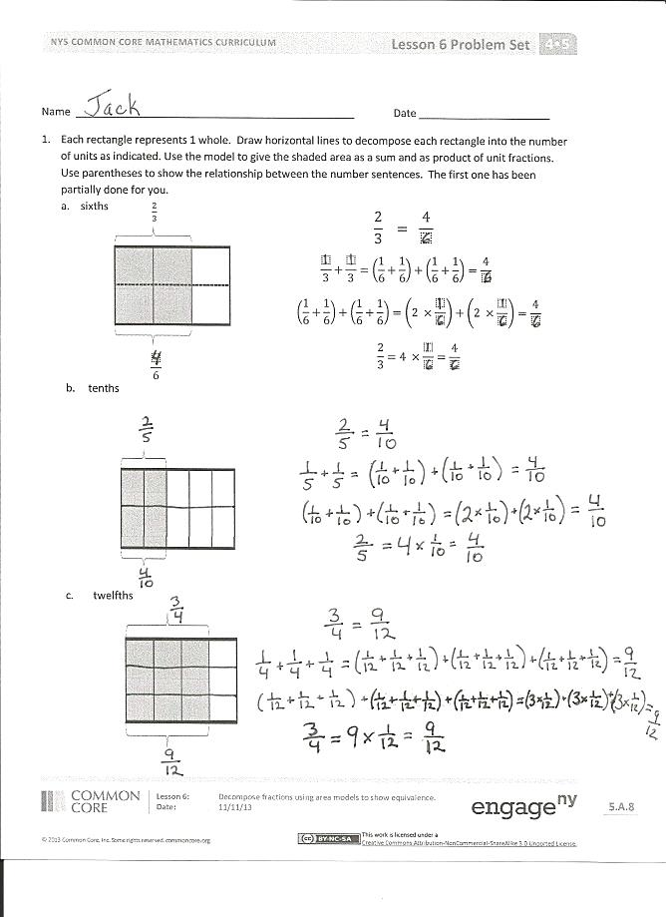
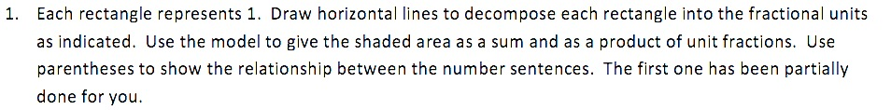
Student Debrief (10 minutes)
Lesson Objective: Decompose fractions using area models to show equivalence.
The Student Debrief is intended to invite reflection and active processing of the total lesson experience.
Invite students to review their solutions for the Problem Set. They should check work by comparing answers with a partner before going over answers as a class. Look for misconceptions or misunderstandings that can be addressed in the Debrief. Guide students in a conversation to debrief the Problem Set and process the lesson.
Any combination of the questions below may be used to lead the discussion.
- Look at Problems 1(c) and 2(b). Compare the two problems. How can $\frac{\text{3}}{\text{4}}$ be equivalent to both fractions?
- Why do we use parentheses? What does it help show?
- In Problem 2 of the Concept Development, could you represent $\frac{\text{8}}{\text{12}}$ first and then show the equivalence to $\frac{\text{2}}{\text{3}}$? How would you show it?
- How can two different fractions represent the same portion of a whole?
- How did the Application Problem connect to today’s lesson?
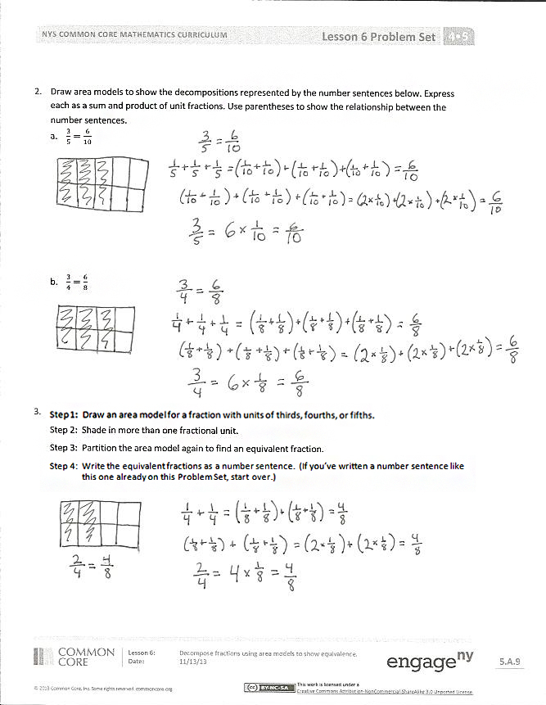
Exit Ticket (3 minutes)
After the Student Debrief, instruct students to complete the Exit Ticket. A review of their work will help with assessing students’ understanding of the concepts that were presented in today’s lesson and planning more effectively for future lessons. The questions may be read aloud to the students.

Number Correct: _______
A
Multiply Whole Numbers Times Fractions
 | $\frac{\text{ 1 }}{\text{3}} \text{+} \frac{\text{ 1 }}{\text{3}} \text{=}$ |  |  |  | $\frac{\text{ 1 }}{\text{3}} \text{+} \frac{\text{ 1 }}{\text{3}} \text{+} \frac{\text{ 1 }}{\text{3}} \text{+} \frac{\text{ 1 }}{\text{3}} \text{=}$
 | $\text{2 ×} \frac{\text{ 1 }}{\text{ 3 }} \text{=}$ |  |  |  | $\text{4 ×} \frac{\text{ 1 }}{\text{ 3 }} \text{=}$
 | $\frac{\text{ 1 }}{\text{4}} \text{+} \frac{\text{ 1 }}{\text{4}} \text{+} \frac{\text{ 1 }}{\text{4}} \text{=}$ |  |  |  | $\frac{\text{5}}{\text{6}} \text{=}$ | $\text{___ ×} \frac{\text{ 1 }}{\text{ 6 }}$
 | $\text{3 ×} \frac{\text{ 1 }}{\text{ 4 }} \text{=}$ |  |  |  | $\frac{\text{5}}{\text{6}} \text{=}$ | $\text{5 ×} \frac{}{}$
 | $\frac{\text{ 1 }}{\text{5}} \text{+} \frac{\text{ 1 }}{\text{5}} \text{=}$ |  |  |  | $\frac{\text{5}}{\text{8}} \text{=}$ | $\text{5 ×} \frac{}{}$
 | $\text{2 ×} \frac{\text{ 1 }}{\text{ 5 }} \text{=}$ |  |  |  | $\frac{\text{5}}{\text{8}} \text{=}$ | $\text{___ ×} \frac{\text{ 1 }}{\text{ 8 }}$
 | $\frac{\text{ 1 }}{\text{5}} \text{+} \frac{\text{ 1 }}{\text{5}} \text{+} \frac{\text{ 1 }}{\text{5}} \text{=}$ |  |  |  | $\frac{\text{7}}{\text{8}} \text{=}$ | $\text{7 ×} \frac{}{}$
 | $\text{3 ×} \frac{\text{ 1 }}{\text{ 5 }} \text{=}$ |  |  |  | $\frac{\text{7}}{\text{10}} \text{=}$ | $\text{7 ×} \frac{}{}$
 | $\frac{\text{ 1 }}{\text{5}} \text{+} \frac{\text{ 1 }}{\text{5}} \text{+} \frac{\text{ 1 }}{\text{5}} \text{+} \frac{\text{ 1 }}{\text{5}} \text{=}$ |  |  |  | $\frac{\text{7}}{\text{8}} \text{=}$ | $\text{___ ×} \frac{\text{ 1 }}{\text{ 8 }}$
 | $\text{4 ×} \frac{\text{ 1 }}{\text{ 5 }} \text{=}$ |  |  |  | $\frac{\text{7}}{\text{10}} \text{=}$ | $\text{___ ×} \frac{\text{ 1 }}{\text{10 }}$
 | $\frac{\text{ 1 }}{\text{10}} \text{+} \frac{\text{ 1 }}{\text{10}} \text{+} \frac{\text{ 1 }}{\text{10}} \text{=}$ |  |  |  | $\frac{\text{6}}{\text{6}} \text{=}$ | $\text{6 ×} \frac{}{}$
 | $\text{3 ×} \frac{\text{ 1 }}{\text{ 10 }} \text{=}$ |  |  |  | $\text{1 }\text{=}$ | $\text{6 ×} \frac{}{}$
 | $\frac{\text{ 1 }}{\text{8}} \text{+} \frac{\text{ 1 }}{\text{8}} \text{+} \frac{\text{ 1 }}{\text{8}} \text{=}$ |  |  |  | $\frac{\text{8}}{\text{8}} \text{=}$ | $\text{___ ×} \frac{\text{ 1 }}{\text{ 8 }}$
 | $\text{3 ×} \frac{\text{ 1 }}{\text{ 8 }} \text{=}$ |  |  |  | $\text{1 }\text{=}$ | $\text{___ ×} \frac{\text{ 1 }}{\text{ 8 }}$
 | $\frac{\text{ 1 }}{\text{2}} \text{+} \frac{\text{ 1 }}{\text{2}} \text{=}$ |  |  |  | $\text{9 ×} \frac{\text{ 1 }}{\text{ 10 }} \text{=}$
 | $\text{2 ×} \frac{\text{ 1 }}{\text{ 2 }} \text{=}$ |  |  |  | $\text{7 ×} \frac{\text{ 1 }}{\text{ 5 }} \text{=}$
 | $\frac{\text{ 1 }}{\text{3}} \text{+} \frac{\text{ 1 }}{\text{3}} \text{+} \frac{\text{ 1 }}{\text{3}} \text{=}$ |  |  |  | $\text{1 }\text{=}$ | $\text{3 ×} \frac{}{}$
 | $\text{3 ×} \frac{\text{ 1 }}{\text{ 3 }} \text{=}$ |  |  |  | $\text{7 ×} \frac{\text{ 1 }}{\text{ 12 }} \text{=}$
 | $\frac{\text{ 1 }}{\text{4}} \text{+} \frac{\text{ 1 }}{\text{4}} \text{+} \frac{\text{ 1 }}{\text{4}} \text{+} \frac{\text{ 1 }}{\text{4}} \text{=}$ |  |  |  | $\text{1 }\text{=}$ | $\text{___ ×} \frac{\text{ 1 }}{\text{ 5 }}$
 | $\text{4 ×} \frac{\text{ 1 }}{\text{ 4 }} \text{=}$ |  |  |  | $\frac{\text{3}}{\text{5}} \text{=}$ | $\frac{\text{ 1 }}{\text{5}} \text{+} \frac{\text{ 1 }}{\text{5}}\text{+} \frac{}{}$
 | $\frac{\text{ 1 }}{\text{2}} \text{+} \frac{\text{ 1 }}{\text{2}} \text{+} \frac{\text{ 1 }}{\text{2}} \text{=}$ |  |  |  | $\text{3 ×} \frac{\text{ 1 }}{\text{ 4 }} \text{=}$ | $\frac{}{} \text{+} \frac{\text{ 1 }}{\text{4}}\text{+} \frac{\text{ 1 }}{\text{4}}$
 | $\text{3 ×} \frac{\text{ 1 }}{\text{ 2 }} \text{=}$ |  |  |  | $\text{1 }\text{=}$ | $\frac{}{}\text{+} \frac{}{}\text{+} \frac{}{}$
B
[KEY]

Number Correct: _______
Improvement: _______
Multiply Whole Numbers Times Fractions
 | $\frac{\text{ 1 }}{\text{5}} \text{+} \frac{\text{ 1 }}{\text{5}} \text{=}$ |  |  |  | $\frac{\text{ 1 }}{\text{2}} \text{+} \frac{\text{ 1 }}{\text{2}} \text{+} \frac{\text{ 1 }}{\text{2}} \text{=}$
 | $\text{2 ×} \frac{\text{ 1 }}{\text{ 5 }} \text{=}$ |  |  |  | $\text{3 ×} \frac{\text{ 1 }}{\text{ 2 }} \text{=}$
 | $\frac{\text{ 1 }}{\text{3}} \text{+} \frac{\text{ 1 }}{\text{3}} \text{=}$ |  |  |  | $\frac{\text{5}}{\text{6}} \text{=}$ | $\text{___ ×} \frac{\text{ 1 }}{\text{ 6 }}$
 | $\text{2 ×} \frac{\text{ 1 }}{\text{ 3 }} \text{=}$ |  |  |  | $\frac{\text{5}}{\text{6}} \text{=}$ | $\text{5 ×} \frac{}{}$
 | $\frac{\text{ 1 }}{\text{4}} \text{+} \frac{\text{ 1 }}{\text{4}} \text{+} \frac{\text{ 1 }}{\text{4}} \text{=}$ |  |  |  | $\frac{\text{5}}{\text{8}} \text{=}$ | $\text{5 ×} \frac{}{}$
 | $\text{3 ×} \frac{\text{ 1 }}{\text{ 4 }} \text{=}$ |  |  |  | $\frac{\text{5}}{\text{8}} \text{=}$ | $\text{___ ×} \frac{\text{ 1 }}{\text{ 8 }}$
 | $\frac{\text{ 1 }}{\text{5}} \text{+} \frac{\text{ 1 }}{\text{5}} \text{+} \frac{\text{ 1 }}{\text{5}} \text{=}$ |  |  |  | $\frac{\text{7}}{\text{8}} \text{=}$ | $\text{7 ×} \frac{}{}$
 | $\text{3 ×} \frac{\text{ 1 }}{\text{ 5 }} \text{=}$ |  |  |  | $\frac{\text{7}}{\text{10}} \text{=}$ | $\text{7 ×} \frac{}{}$
 | $\frac{\text{ 1 }}{\text{5}} \text{+} \frac{\text{ 1 }}{\text{5}} \text{+} \frac{\text{ 1 }}{\text{5}} \text{+} \frac{\text{ 1 }}{\text{5}} \text{=}$ |  |  |  | $\frac{\text{7}}{\text{8}} \text{=}$ | $\text{___ ×} \frac{\text{ 1 }}{\text{ 8 }}$
 | $\text{4 ×} \frac{\text{ 1 }}{\text{ 5 }} \text{=}$ |  |  |  | $\frac{\text{7}}{\text{10}} \text{=}$ | $\text{___ ×} \frac{\text{ 1 }}{\text{10 }}$
 | $\frac{\text{ 1 }}{\text{8}} \text{+} \frac{\text{ 1 }}{\text{8}} \text{+} \frac{\text{ 1 }}{\text{8}} \text{=}$ |  |  |  | $\frac{\text{8}}{\text{8}} \text{=}$ | $\text{8 ×} \frac{}{}$
 | $\text{3 ×} \frac{\text{ 1 }}{\text{ 8 }} \text{=}$ |  |  |  | $\text{1 }\text{=}$ | $\text{8 ×} \frac{}{}$
 | $\frac{\text{ 1 }}{\text{10}} \text{+} \frac{\text{ 1 }}{\text{10}} \text{+} \frac{\text{ 1 }}{\text{10}} \text{=}$ |  |  |  | $\frac{\text{6}}{\text{6}} \text{=}$ | $\text{___ ×} \frac{\text{ 1 }}{\text{ 6 }}$
 | $\text{3 ×} \frac{\text{ 1 }}{\text{ 10 }} \text{=}$ |  |  |  | $\text{1 }\text{=}$ | $\text{___ ×} \frac{\text{ 1 }}{\text{ 6 }}$
 | $\frac{\text{ 1 }}{\text{3}} \text{+} \frac{\text{ 1 }}{\text{3}} \text{+} \frac{\text{ 1 }}{\text{3}} \text{=}$ |  |  |  | $\text{5 ×} \frac{\text{ 1 }}{\text{ 12 }} \text{=}$
 | $\text{3 ×} \frac{\text{ 1 }}{\text{ 3 }} \text{=}$ |  |  |  | $\text{6 ×} \frac{\text{ 1 }}{\text{ 5 }} \text{=}$
 | $\frac{\text{ 1 }}{\text{4}} \text{+} \frac{\text{ 1 }}{\text{4}} \text{+} \frac{\text{ 1 }}{\text{4}} \text{+} \frac{\text{ 1 }}{\text{4}} \text{=}$ |  |  |  | $\text{1 }\text{=}$ | $\text{4 ×} \frac{}{}$
 | $\text{4 ×} \frac{\text{ 1 }}{\text{ 4 }} \text{=}$ |  |  |  | $\text{9 ×} \frac{\text{ 1 }}{\text{ 10 }} \text{=}$
 | $\frac{\text{ 1 }}{\text{2}} \text{+} \frac{\text{ 1 }}{\text{2}} \text{=}$ |  |  |  | $\text{1 }\text{=}$ | $\text{___ ×} \frac{\text{ 1 }}{\text{ 3 }}$
 | $\text{2 ×} \frac{\text{ 1 }}{\text{ 2 }} \text{=}$ |  |  |  | $\frac{\text{3}}{\text{4}} \text{=}$ | $\frac{\text{ 1 }}{\text{4}} \text{+} \frac{\text{ 1 }}{\text{4}}\text{+} \frac{}{}$
 | $\frac{\text{ 1 }}{\text{3}} \text{+} \frac{\text{ 1 }}{\text{3}} \text{+} \frac{\text{ 1 }}{\text{3}} \text{+} \frac{\text{ 1 }}{\text{3}} \text{=}$ |  |  |  | $\text{3 ×} \frac{\text{ 1 }}{\text{ 5 }} \text{=}$ | $\frac{}{} \text{+} \frac{\text{ 1 }}{\text{5}}\text{+} \frac{\text{ 1 }}{\text{5}}$
 | $\text{4 ×} \frac{\text{ 1 }}{\text{ 3 }} \text{=}$ |  |  |  | $\text{1 }\text{=}$ | $\frac{}{}\text{+} \frac{}{}\text{+} \frac{}{}\text{+} \frac{}{}$
Name Date
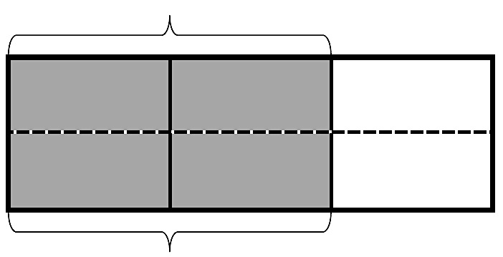
- Each rectangle represents 1. Draw horizontal lines to decompose each rectangle into the fractional units as indicated. Use the model to give the shaded area as a sum and as a product of unit fractions. Use parentheses to show the relationship between the number sentences. The first one has been partially done for you.
$\frac{2}{3}$
$\frac{ }{6}$
- Sixths
$$\frac{2}{3} = \frac{4}{ }$$
$$\frac{ }{3}+\frac{ }{3}=\left(\frac{1}{6}+\frac{1}{6}\right)+\left(\frac{1}{6}+\frac{1}{6}\right)=\frac{4}{ }$$
$$\left(\frac{1}{6}+\frac{1}{6}\right)+\left(\frac{1}{6}+\frac{1}{6}\right)=\left(2 ×\frac{ }{ }\right)+\left(2 ×\frac{ }{ }\right)=\frac{4}{ }$$
$$\frac{2}{3}=4 ×\frac{ }{ }=\frac{4}{ }$$

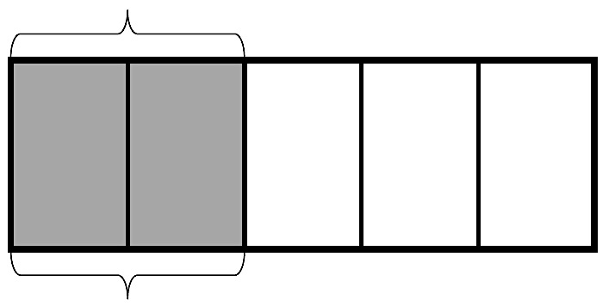
- Tenths

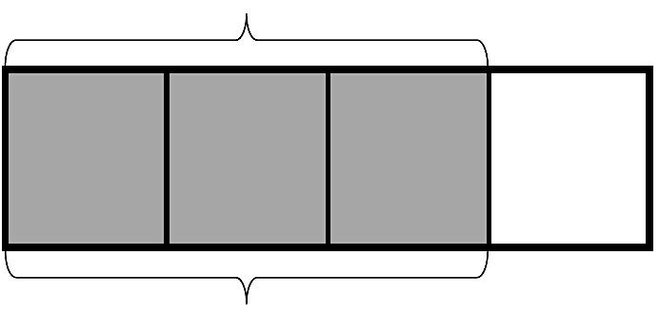
- Twelfths

- Draw area models to show the decompositions represented by the number sentences below. Express each as a sum and product of unit fractions. Use parentheses to show the relationship between the number sentences.

- $\frac{3}{5}=\frac{6}{10}$

- $\frac{3}{4}=\frac{6}{8}$

- Step 1: Draw an area model for a fraction with units of thirds, fourths, or fifths.
Step 2: Shade in more than one fractional unit.
Step 3: Partition the area model again to find an equivalent fraction.
Step 4: Write the equivalent fractions as a number sentence. (If you’ve written a number sentence like this one already on this Problem Set, start over.)

Name Date
- The rectangle below represents 1. Draw horizontal lines to decompose the rectangle into eighths. Use the model to give the shaded area as a sum and as a product of unit fractions. Use parentheses to show the relationship between the number sentences.

- Draw an area model to show the decomposition represented by the number sentence below.

$$\frac{4}{5}=\frac{8}{10}$$

Name Date
- Each rectangle represents 1. Draw horizontal lines to decompose each rectangle into the fractional units as indicated. Use the model to give the shaded area as a sum and as a product of unit fractions. Use parentheses to show the relationship between the number sentences. The first one has been partially done for you.
- Tenths
$$\frac{2}{5}$$
$$\frac{ }{10}$$
$$\frac{2}{5} = \frac{4}{ }$$
$$\frac{ }{5}+\frac{ }{5}=\left(\frac{1}{10}+\frac{1}{10}\right)+\left(\frac{1}{10}+\frac{1}{10}\right)=\frac{4}{ }$$
$$\left(\frac{1}{10}+\frac{1}{10}\right)+\left(\frac{1}{10}+\frac{1}{10}\right)=\left(2 × \frac{ }{ }\right)+\left( 2 × \frac{ }{ }\right)=\frac{4}{ }$$

$$\frac{2}{5}=4 × \frac{ }{ }=\frac{4}{ }$$

- Eighths

- Fifteenths

- Draw area models to show the decompositions represented by the number sentences below. Express each as a sum and product of unit fractions. Use parentheses to show the relationship between the number sentences.
- $\frac{2}{3}=\frac{4}{6}$

- $\frac{4}{5}=\frac{8}{10}$

- Step 1: Draw an area model for a fraction with units of thirds, fourths, or fifths.
Step 2: Shade in more than one fractional unit.
Step 3: Partition the area model again to find an equivalent fraction.
Step 4: Write the equivalent fractions as a number sentence. (If you have written a number sentence like this one already in this homework, start over.)

