Lesson 5

Objective: Decompose unit fractions using area models to show equivalence.

Suggested Lesson Structure

 Fluency Practice (12 minutes)

 Application Problem (8 minutes)

 Concept Development (30 minutes)

 Student Debrief (10 minutes)

**Total Time (60 minutes)**

Fluency Practice (12 minutes)

* Count by Equivalent Fractions  **3.NF.3** (4 minutes)
* Add Fractions **4.NF.3** (4 minutes)
* Break Apart the Unit Fraction **4.NF.3** (4 minutes)

Count by Equivalent Fractions (4 minutes)

Note: This fluency activity reviews Lesson 4.

T: Count from 0 fourths to 4 fourths by 1 fourths. (Write as students count.)

S: .

0 1

T: 4 fourths is the same as one of what unit?

S: 1 one.

T: (Beneath , write 1.) Count by fourths again. This time, say *1* when you arrive at 4 fourths. Start at zero.

S: 1.

T: Let’s count by halves to 4 halves. (Write as students count.)

0 1 2

S: .

T: How many halves are equal to 1?

S: 2 halves.

T: (Beneath write 1.) How many halves are equal to 2?

S: 4 halves.

T: (Beneath write 2.) Let’s count by halves again. This time, when you arrive at 2 halves and 4 halves, say the whole number.

S: .

Repeat the process, counting by fourths to 12 fourths.

Add Fractions (4 minutes)

Materials: (S) Personal white board

Note: This fluency activity reviews Lesson 2.

T: (Write .) Say the fraction.

S: 4 fifths.

T: On your personal white boards, draw a tape diagram representing 4 fifths.

S: (Draw a tape diagram partitioned into 5 equal units. Shade 4 units.)

T: (Write = __ + __ + ___ + __.) On your boards, fill in the unknown fractions.

S: (Write = + + + )

T: (Write = + + + . Beneath it, write = __ × ) Fill in the unknown factor.

S: (Write = 4 × )

Continue the process with and .

Break Apart the Unit Fraction (4 minutes)

Materials: (S) Personal white board

Note: This fluency activity reviews Lesson 4.

T: (Project a tape diagram partitioned into 2 equal units. Shade 1 unit.) Name the fraction of the diagram that is shaded.

S: 1 half.

T: (Write above the shaded unit. Decompose the shaded unit into 3 equal units.)

T: What fraction of the tape diagram is each smaller unit?

S: 1 sixth.

T: (Write = + + ) On your personal white boards, complete the number sentence.

S: (Write = + + )

Repeat the process with .

T: (Write ) On your boards, draw and shade a tape diagram to show .

T: Decompose each third into 3 equal parts on your model with an addition sentence. (Pause.)   
Each third is the same as 3 of what unit?

S: 3 ninths.

T: (Write = ) 2 thirds is the same as how many ninths? Write the answer on your boards.

S: (Write = )

Continue with the following possible sequence: = , = , = , and = .

Application Problem (8 minutes)

A loaf of bread was cut into 6 equal slices. Each of the 6 slices was cut in half to make thinner slices for sandwiches.

Mr. Beach used 4 slices. His daughter said, “Wow, you used of the loaf!” His son said, “No, he used .” Work with a partner to explain who was correct using a tape diagram.

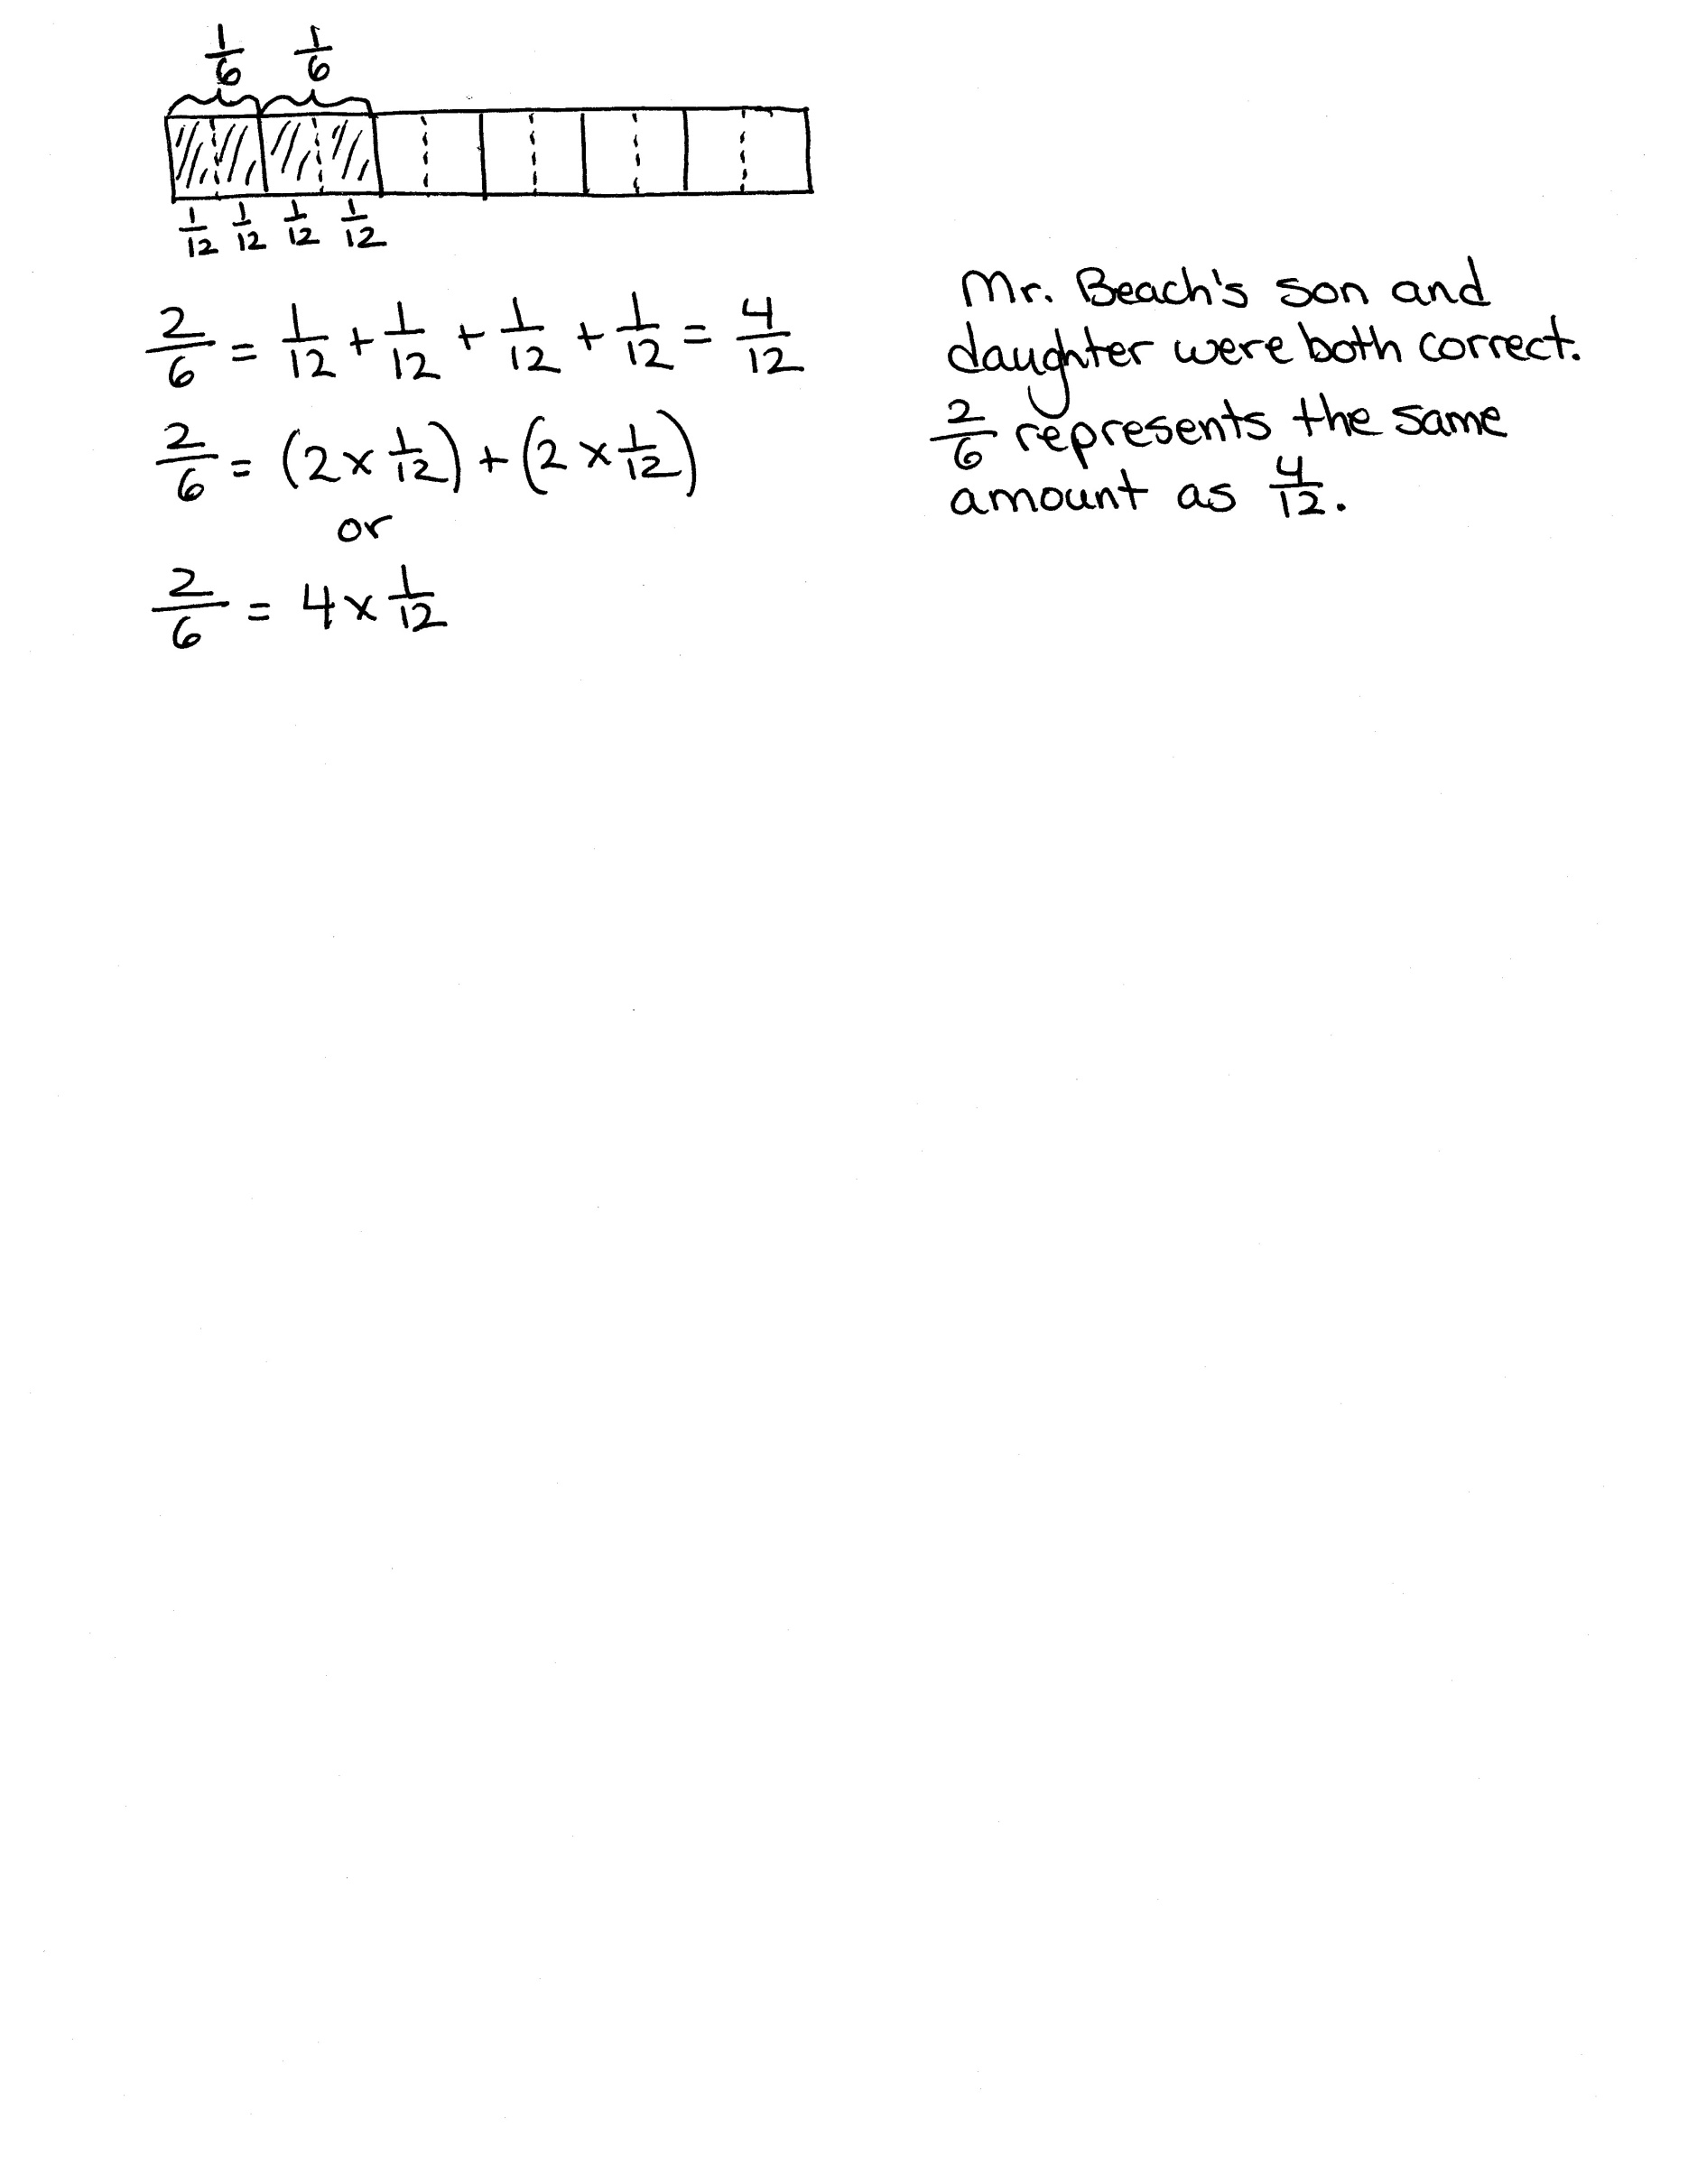

Note: This Application Problem builds on Lesson 4’s objective of decomposing a fraction as the sum of smaller fractions. It also bridges to today’s lesson where students will use the area model as another way to show both decomposition and equivalence.

Concept Development (30 minutes)

|  |  |
| --- | --- |
|  | NOTES ON  MULTIPLE MEANS  OF ACTION AND EXPRESSION: |

Drawing an area model representing fifths or other odd numbers may be challenging for some students. Slip grid paper into personal white boards to assist them, if beneficial. Students who find it easier may continue using folded paper strips to model fractions.



Materials: (S) Personal white board

Problem 1: Draw an area model to illustrate that is equal to .

T: Draw an area model that is partitioned into 5 equal parts. Shade 1 of them. If the entire figure represents 1, what fractional part is shaded?

S: 1 fifth.

T: Draw a horizontal dotted line to decompose the whole into two equal rows. (Demonstrate.) What happened? Discuss with your partner.

S: There were 5 pieces, but now, there are 10. 🡪 We had fifths, but now, we have tenths. 🡪 We doubled the number of original units (fifths) to make a new unit (tenths). 🡪 We cut each fifth into   
2 equal pieces to make tenths. 🡪 There are more parts, but they are smaller, so 2 times 1 tenth is the same as 1 fifth.

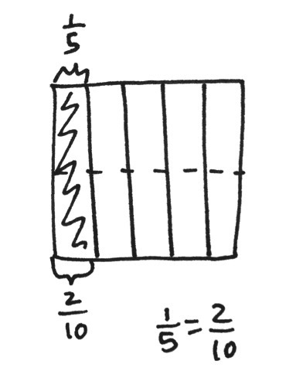

T: How many tenths are shaded?

S: 2 tenths.

T: Even though the parts changed, did the area covered by the shaded region change?

S: No.

T: What relationship does this show between and ? Say your answer as an addition sentence.

S: . 1 fifth equals 2 tenths.

Problem 2: Decompose as represented in an area model and as the sum and product of unit fractions.

T: Draw an area model that is partitioned into 3 equal parts. Shade 1 of them. If the entire figure represents 1, what fraction is shaded?

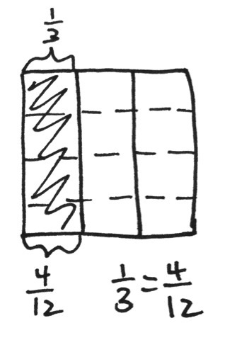

S: 1 third.

T: Discuss with your partner how to draw horizontal dotted lines to decompose 1 third to demonstrate that .

**MP.2**

S: We can draw a horizontal line. 🡪 One line won’t be enough. That will make sixths. Two lines will make ninths. Three lines!

T: How many parts do we have now?

S: 12.

T: How many twelfths are shaded?

S: .

T: Represent the decomposition of as the sum of unit fractions.

S:

**MP.2**

T: Now, like in the last lesson, represent this decomposition of using a multiplication sentence.

S: . 🡪 .

Problem 3: Model and represent the decomposition as the sum and product of unit fractions.

T: (Display .) Discuss with your partner how to represent this equivalence using an area model.

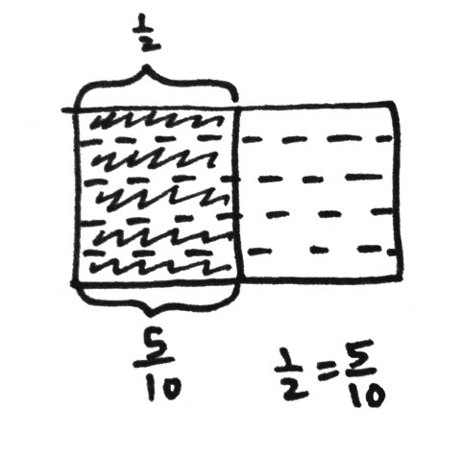

S: We can partition an area model in half. We can draw lines across so that they make equal parts. 🡪 We need 10 parts. Since there are 2 halves, that would be 5 on each side.

T: Work with your partner to draw the model, and write a number sentence to represent the decomposition.

S: 🡪

Problem Set (10 minutes)

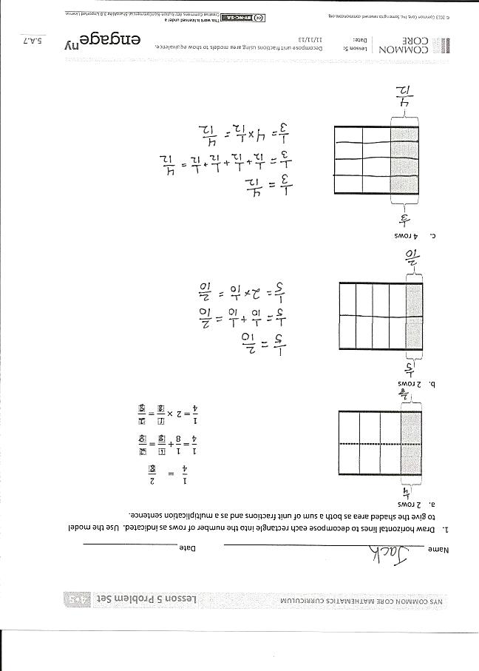Students should do their personal best to complete the Problem Set within the allotted 10 minutes. For some classes, it may be appropriate to modify the assignment by specifying which problems they work on first. Some problems do not specify a method for solving. Students should solve these problems using the RDW approach used for Application Problems.

Student Debrief (10 minutes)

**Lesson Objective:** Decompose unit fractions using area models to show equivalence.

The Student Debrief is intended to invite reflection and active processing of the total lesson experience.

Invite students to review their solutions for the Problem Set. They should check work by comparing answers with a partner before going over answers as a class. Look for misconceptions or misunderstandings that can be addressed in the Debrief. Guide students in a conversation to debrief the Problem Set and process the lesson.

Any combination of the questions below may be used to lead the discussion.

* In Problem 1, why do you think the directions tell you how many rows to draw?
* How is Problem 2 more difficult than Problem 1?

|  |  |
| --- | --- |
|  | NOTES ON  MULTIPLE MEANS  OF REPRESENTATION: |
| While discussing sixths, eighths, tenths, and other fractional units that end in  *–th*, check that English language learners are able to hear and say the ending digraph /th/. Help them distinguish the meaning and pronunciation of, for example, the whole number *six* and fraction *sixths*. | |

* Problems 2(a), 2(b), and 2(c) all start with an area of   
  1 half. What does that tell you about the fractions   
  3 sixths, 4 eighths, and 5 tenths? What happens to the size and number of units as 1 half is decomposed into sixths, eighths, and tenths?
* Explain to your partner how you determined the answer for Problem 3.
* In Grade 3, we used tape diagrams to show equivalent fractions. In Grade 4, we are using area models, and we are including addition and multiplication statements. Why are these statements important?
* How did the Application Problem connect to today’s lesson?

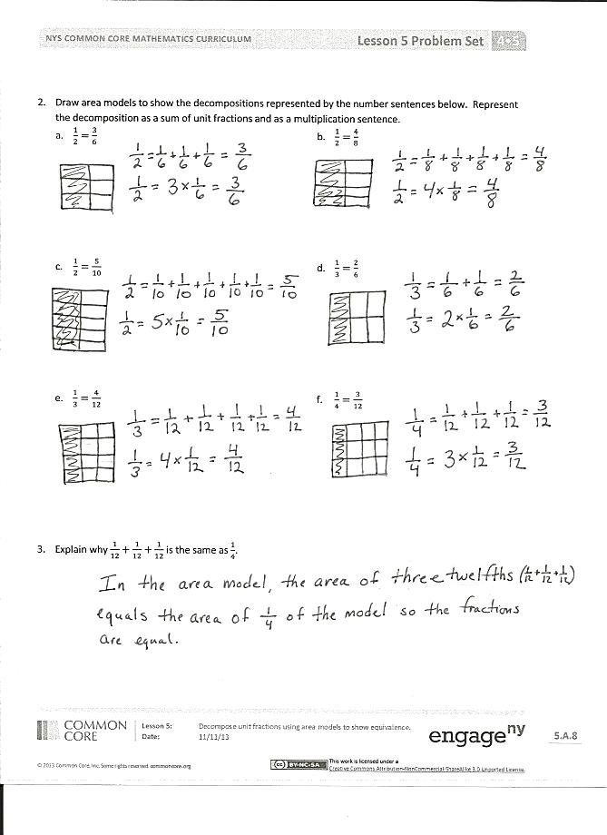Exit Ticket (3 minutes)

After the Student Debrief, instruct students to complete the Exit Ticket. A review of their work will help with assessing students’ understanding of the concepts that were presented in today’s lesson and planning more effectively for future lessons. The questions may be read aloud to the students.

Name Date

1. Draw horizontal lines to decompose each rectangle into the number of rows as indicated. Use the model to give the shaded area as both a sum of unit fractions and as a multiplication sentence.  
   1. 2 rows

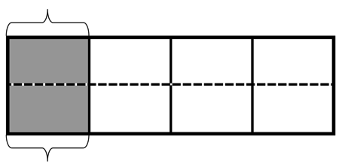

* 1. 2 rows

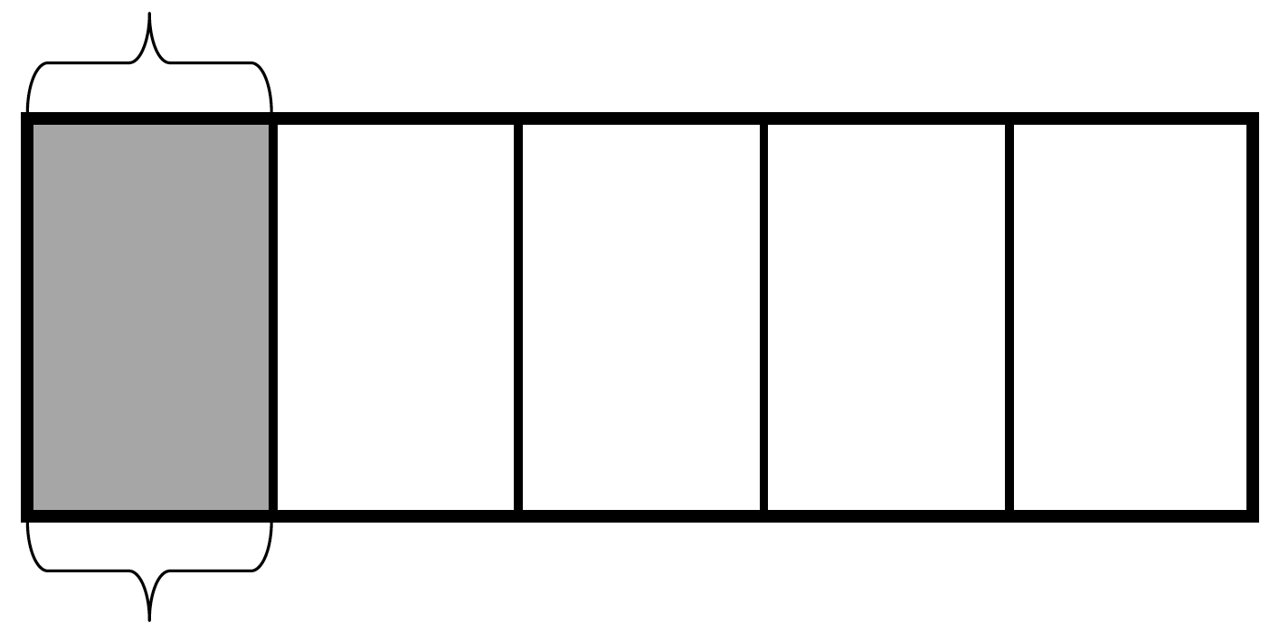

* 1. 4 rows

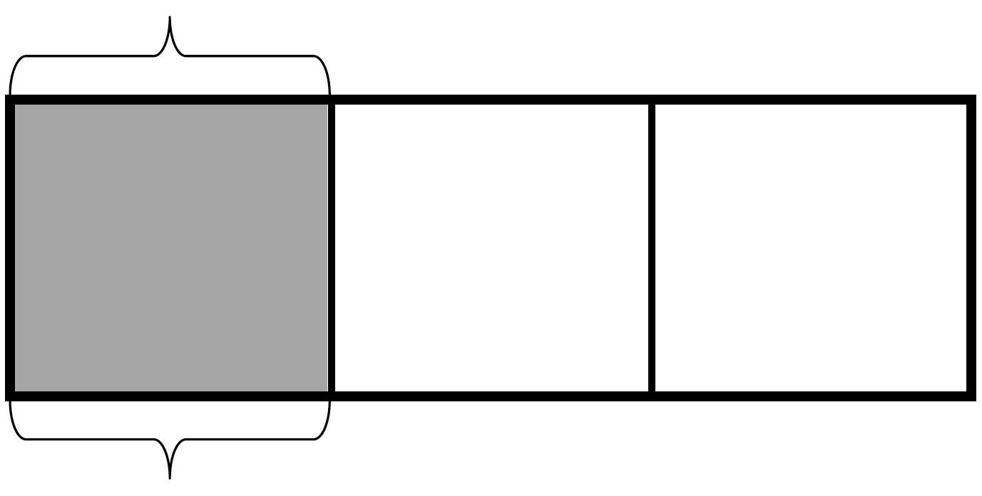

1. Draw area models to show the decompositions represented by the number sentences below. Represent the decomposition as a sum of unit fractions and as a multiplication sentence.
2. Explain why is the same as .

Name Date

1. Draw horizontal lines to decompose each rectangle into the number of rows as indicated. Use the model to give the shaded area as both a sum of unit fractions and as a multiplication sentence.  
   1. 2 rows

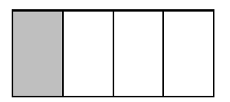

1. 3 rows

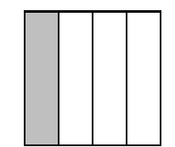

1. Draw an area model to show the decomposition represented by the number sentence below. Represent the decomposition as a sum of unit fractions and as a multiplication sentence.

Name Date

1. Draw horizontal lines to decompose each rectangle into the number of rows as indicated. Use the model to give the shaded area as both a sum of unit fractions and as a multiplication sentence.
   1. 3 rows

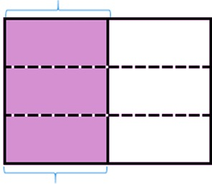

1. 2 rows

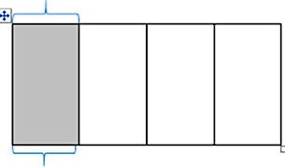

1. 4 rows



1. Draw area models to show the decompositions represented by the number sentences below. Represent the decomposition as a sum of unit fractions and as a multiplication sentence.

b.

d.

f.

1. Explain why is the same as