Lesson 4

Objective: Decompose fractions into sums of smaller unit fractions using tape diagrams.

Suggested Lesson Structure

 Fluency Practice (12 minutes)

 Application Problem (4 minutes)

 Concept Development (34 minutes)

 Student Debrief (10 minutes)

**Total Time (60 minutes)**

Fluency Practice (12 minutes)

* Break Apart Fractions **4.NF.3** (7 minutes)
* Count by Equivalent Fractions **3.NF.3** (5 minutes)

Break Apart Fractions (7 minutes)

Materials: (S) Personal white board

Note: This fluency activity reviews Lesson 3.

T: (Project a tape diagram partitioned into 3 equal units. Write 1 above it. Shade 2 units.) How many equal parts does this 1 have?

S: 3 parts.

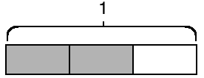T: Say the value of 1 unit.

S: 1 third.

T: What fraction of 1 is shaded?

S: 2 thirds.

T: On your personal white board, write the value of the shaded part as a sum of unit fractions.

S: (Write = + )

T: (Write __ × = ) On your board, complete the number sentence.

S: (Write 2 × = )

Continue with the following possible sequence: , , and .

T: (Write ) Say the fraction.

S: 3 fourths.

T: On your board, draw a tape diagram of 3 fourths.

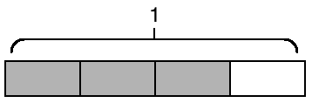S: (Draw a tape diagram partitioned into 4 equal units. Shade 3 units.)

T: What’s the value of each unit?

S: 1 fourth.

T: Express 3 fourths as a repeated addition sentence.

S: (Write = + + )

T: (Write = __ × ) Fill in the unknown number.

S: (Write = 3 × )

Continue with the following possible sequence: , , and .

Count by Equivalent Fractions (5 minutes)

Note: This fluency activity prepares students for Lesson 4.

T: Count by ones to 6.

S: 1, 2, 3, 4, 5, 6.

T: Count by sixths to 6 sixths. Start at 0 sixths. (Write as students count.)

S:

T: 6 sixths is the same as one of what unit?

S: 1 one.

T: (Beneath , write 1.) Count by sixths again. This time, say 1 one when you arrive at 6 sixths. Start at zero.

S: .

T: Let’s count by thirds to 6 thirds. Start at 0 thirds. (Write as students count.)

S: .

T: How many thirds are in 1?

S: 3 thirds.

T: (Beneath , write 1.) How many thirds are in 2?

S: 6 thirds.

T: (Beneath , write 2.) Let’s count by thirds again. This time, when you arrive at 3 thirds and 6 thirds, say the whole number. Start at zero.

S: .

Continue, counting by halves to 6 halves.

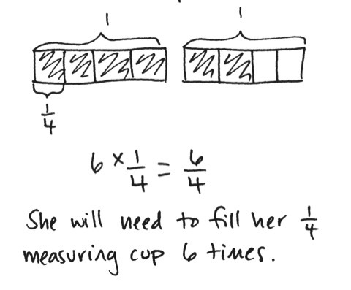Application Problem (4 minutes)

A recipe calls for cup of milk. Saisha only has a cup measuring cup. If she doubles the recipe, how many times will she need to fill the cup with milk? Draw a tape diagram and record as a multiplication sentence.

Note: This Application Problem reviews students’ knowledge of fractions from Lesson 3 and prepares them for today’s objective of decomposing unit fractions into sums of smaller unit fractions.

Concept Development (34 minutes)

|  |  |
| --- | --- |
|  | NOTES ON  MULTIPLE MEANS  OF ACTION AND EXPRESSION: |
| Cuisenaire rods can be used to model  1 whole (brown), 2 halves (pink),  4 fourths (red), and 8 eighths (white). If concrete Cuisenaire rods are unavailable or otherwise challenging, virtual rods can be found at the link below:  <http://nrich.maths.org/4348>. | |

Materials: (S) Personal white board

Problem 1: Use tape diagrams to represent the decomposition of as the sum of unit fractions.

T: Draw a tape diagram that represents 1, and shade 1 third. Decompose each of the thirds in half. How many parts are there now?

S: 6.

T: What fraction of 1 does each part represent?

S: 1 sixth.

T: How many sixths are shaded?

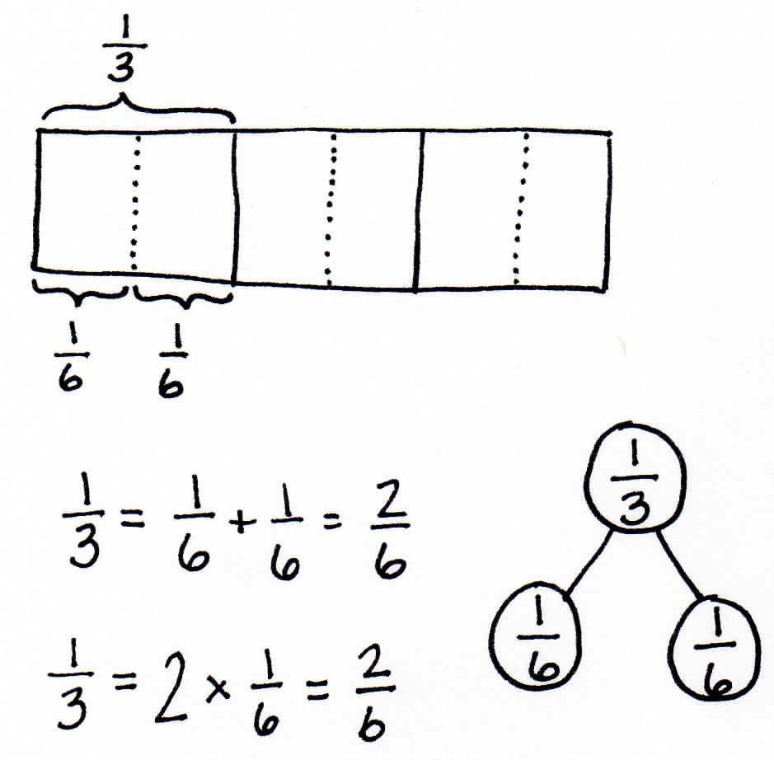S: 2 sixths.

**MP.2**

T: What can we say about 1 third and 2 sixths?

S: They are the same.

T: How can you tell?

S: They both take up the same amount of space.

T: Let’s write that as a number sentence: = + = .

T: Now, decompose each sixth into 2 equal parts on your tape diagram. How many parts are in 1 now?

S: 12.

T: What fractional part of 1 does each piece represent?

S: 1 twelfth.

T: How many twelfths equal ?

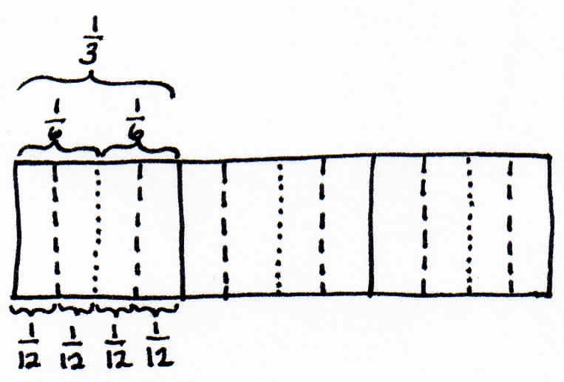S: equals .

T: Work with your partner to write a number sentence for how many twelfths equal .

S: (Write = + = + .)

T: We can put parentheses around two groups of 1 twelfth to show that each combines to make .

**MP.2**

T: How can we represent this using multiplication?

S: (Write = + 🡪 = 4 × .)

Problem 2: Use tape diagrams to represent the decomposition of and as the sum of smaller unit fractions.

T: Draw a tape diagram and shade . Decompose each of the fifths into 3 equal parts. How many parts are there now?

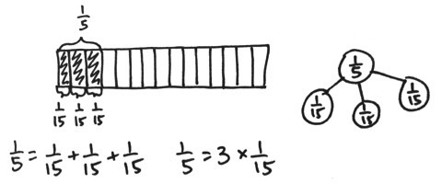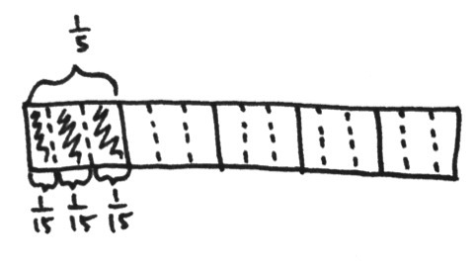

S: There are 15 parts.

T: What fraction does each part represent?

S: .

T: Write an addition sentence to show how many fifteenths it takes to make 1 fifth.

S: (Write = + + = )

T: What can we say about one-fifth and three-fifteenths?

S: They are equal.

T: With your partner, write a number sentence that represents .

S: (Write = + = 🡪 = + = . 🡪 = 2 × = 2 × = .)

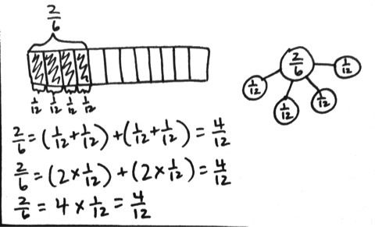Problem 3: Draw a tape diagram and use addition to show that is the sum of 4 twelfths.

T: (Project .) Using what you just learned, how can you model to show that  
 is equal to ?

S: We can draw a tape diagram and shade . Then, we can decompose it into twelfths.

T: How many twelfths are shaded?

S: 4.

T: We have seen that 1 third is equal to 2 sixths. We have seen 1 sixth is equal to 2 twelfths. So, how many twelfths equal 1 third?

S: 4 twelfths!

T: So, 2 thirds is how many twelfths? Explain to your partner how you know using your diagrams.

S: 1 third is 4 twelfths, so 2 thirds is 8 twelfths. 🡪 It’s just double. 🡪 It’s twice the area on the tape diagram. 🡪 It’s the same as 4 sixths. 1 third is 2 sixths. 2 thirds is 4 sixths. 1 sixth is the same as 2 twelfths, so 4 times 2 is 8. 8 twelfths.

Problem Set (10 minutes)

Students should do their personal best to complete the Problem Set within the allotted 10 minutes. For some classes, it may be appropriate to modify the assignment by specifying which problems they work on first. Some problems do not specify a method for solving. Students should solve these problems using the RDW approach used for Application Problems.

Student Debrief (10 minutes)

**Lesson Objective:** Decompose fractions into sums of smaller unit fractions using tape diagrams.

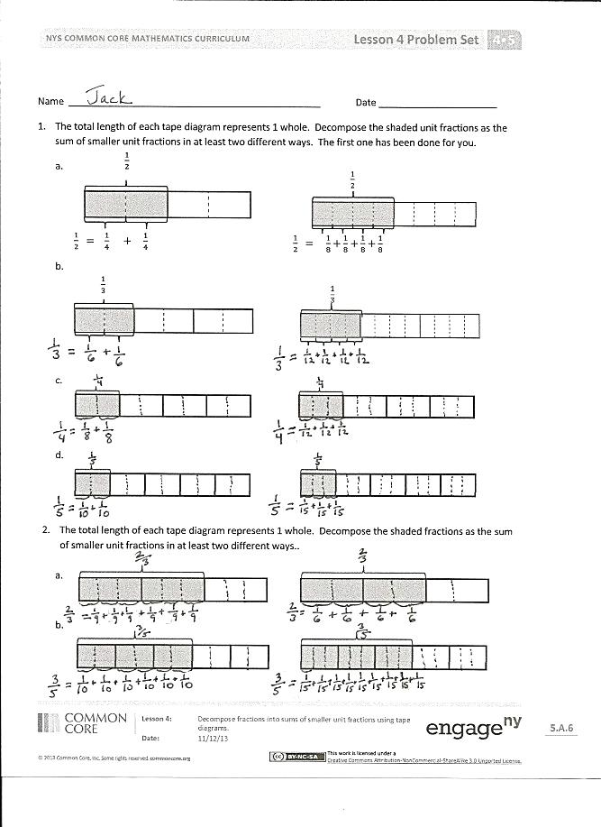

The Student Debrief is intended to invite reflection and active processing of the total lesson experience.

Invite students to review their solutions for the Problem Set. They should check work by comparing answers with a partner before going over answers as a class. Look for misconceptions or misunderstandings that can be addressed in the Debrief. Guide students in a conversation to debrief the Problem Set and process the lesson.

Any combination of the questions below may be used to lead the discussion.

* For Problem 1(a–d), what were some different ways that you decomposed the unit fraction?
* What is different about Problems 3(c) and 3(d)? Explain how fourths can be decomposed into both eighths and twelfths.
* For Problems 4, 5, and 6, explain the process you used to show equivalent fractions.
* Without using a tape diagram, what strategy would you use for decomposing a unit fraction?
* How did the Application Problem connect to today’s lesson?

Exit Ticket (3 minutes)

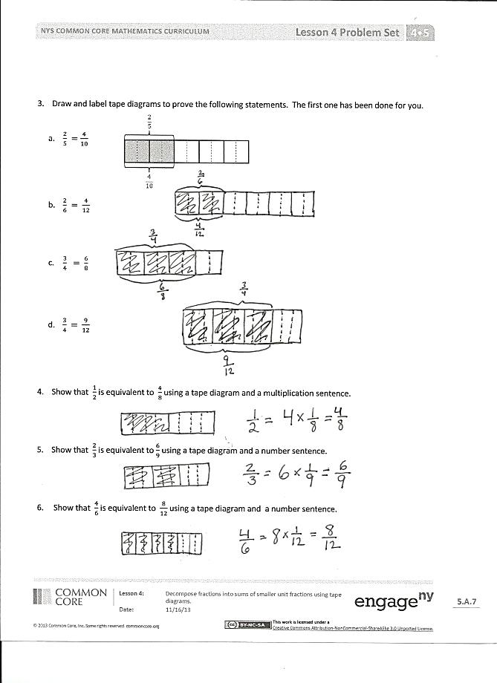

After the Student Debrief, instruct students to complete the Exit Ticket. A review of their work will help with assessing students’ understanding of the concepts that were presented in today’s lesson and planning more effectively for future lessons. The questions may be read aloud to the students.

Name Date

1. The total length of each tape diagram represents 1. Decompose the shaded unit fractions as the sum of smaller unit fractions in at least two different ways. The first one has been done for you.

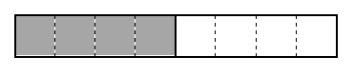







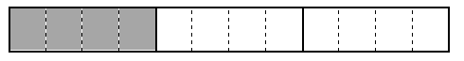

1. 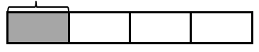

1. 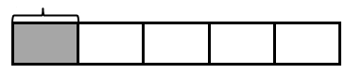

1. The total length of each tape diagram represents 1. Decompose the shaded fractions as the sum of smaller unit fractions in at least two different ways.

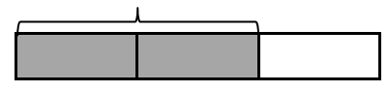

1. 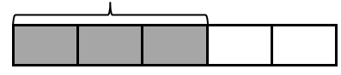



1. 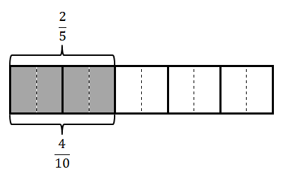Draw and label tape diagrams to prove the following statements. The first one has been done for you.
2. Show that is equivalent to using a tape diagram and a number sentence.
3. Show that is equivalent to using a tape diagram and a number sentence.
4. Show that is equivalent to using a tape diagram and a number sentence.

Name Date

1. The total length of the tape diagram represents 1. Decompose the shaded unit fraction as the sum of smaller unit fractions in at least two different ways.

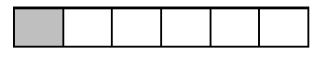

1. Draw a tape diagram to prove the following statement.

Name Date

1. The total length of each tape diagram represents 1. Decompose the shaded unit fractions as the sum of smaller unit fractions in at least two different ways. The first one has been done for you.

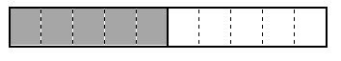



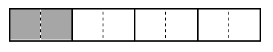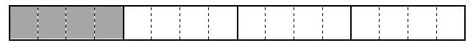

1. The total length of each tape diagram represents 1. Decompose the shaded fractions as the sum of smaller unit fractions in at least two different ways.





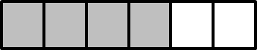

1. Draw tape diagrams to prove the following statements. The first one has been done for you.

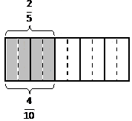

1. Show that is equivalent to using a tape diagram and a number sentence.
2. Show that is equivalent to using a tape diagram and a number sentence.
3. Show that is equivalent to using a tape diagram and a number sentence.