Lesson 2
Objective: Decompose fractions as a sum of unit fractions using tape diagrams.

Suggested Lesson Structure
 Fluency Practice (10 minutes)
 Application Problem (6 minutes)
 Concept Development (34 minutes)
 Student Debrief (10 minutes)
Total Time (60 minutes)
Fluency Practice (10 minutes)
- Read Tape Diagrams 3.OA.3 (4 minutes)
- Break Apart Fractions 4.NF.3 (6 minutes)
Read Tape Diagrams (4 minutes)
Materials: (S) Personal white board
Note: This fluency activity prepares students for today’s lesson.
T: (Project a tape diagram partitioned into 3 equal parts. Write 15 at the top.) Say the value of the whole.
S: 15.
T: Write the value of 1 unit as a division problem.
S: (Write 15 ÷ 3 = 5.)
T: (Write 5 in each unit.) Write the whole as a repeated addition sentence.
S: (Write 5 + 5 + 5 = 15.)
T: (Write 3 fives = 5 + 5 + 5 = 3 × __.) Write the whole as a multiplication equation.
S: (Write 3 × 5 = 15.)
Continue with the following possible sequence: 8 ÷ 2, 20 ÷ 5, 12 ÷ 2, 8 ÷ 4, 21 ÷ 3, and 32 ÷ 4.
Break Apart Fractions (6 minutes)
Materials: (S) Personal white board
Note: This fluency activity reviews Lesson 1.
T: (Project a circle partitioned into 4 equal parts with 3 parts shaded.) How many circles do you see?
S: 1 circle.
T: How many equal parts does the circle have?
S: 4.
T: What fraction of the circle is shaded?
S: 3 fourths.
T: How many fourths are in 3 fourths?
S: 3.
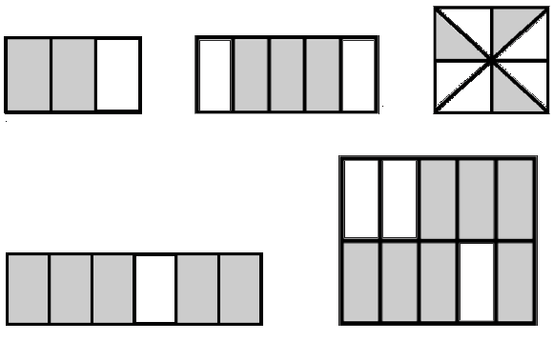
T: (Write $\frac{\text{3}}{\text{4}}$ = __ + __ + __.) On your personal white board, write $\frac{\text{3}}{\text{4}}$ as a repeated addition sentence.
S: (Write $\frac{\text{3}}{\text{4}}$ = $\frac{\text{1}}{\text{4}}$ + $\frac{\text{1}}{\text{4}}$ + $\frac{\text{1}}{\text{4}}$.)
T: (Write $\frac{\text{3}}{\text{4}}$ = $\frac{\text{1}}{\text{4}}$ + $\frac{\text{1}}{\text{4}}$ + $\frac{\text{1}}{\text{4}}$. Beneath it, write $\frac{\text{3}}{\text{4}}$ = $\frac{\text{2}}{\text{4}}$ + __.)
Fill in the unknown fraction.
S: (Write $\frac{\text{3}}{\text{4}}$ = $\frac{\text{2}}{\text{4}}$ + $\frac{\text{1}}{\text{4}}.$)
Continue with the fraction graphics pictured to the right:
Application Problem (6 minutes)
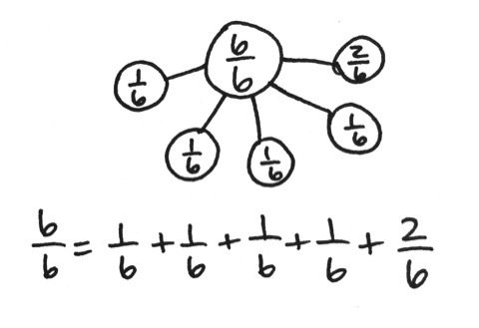
Mrs. Salcido cut a small birthday cake into 6 equal pieces for 6 children. One child was not hungry, so she gave the birthday boy the extra piece. Draw a tape diagram to show how much cake each of the five children received.
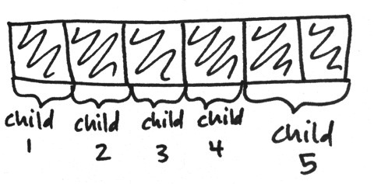
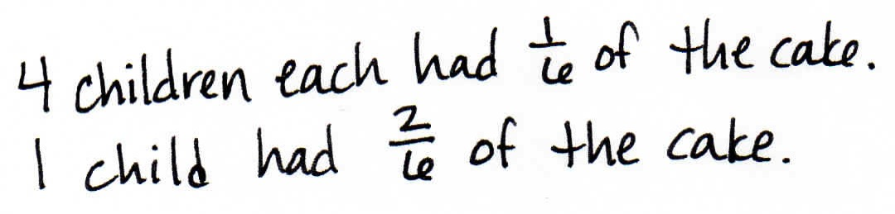

Note: This Application Problem is a review of the material presented in Lesson 1 and prepares students for the more advanced portion of this lesson objective that they will encounter in today’s lesson.
Concept Development (34 minutes)
Materials: (T) 2 strips of paper, markers (S) 2 strips of paper, markers or colored pencils, personal white board
Problem 1: Use a number bond to show how 1 can be decomposed into fourths and how fourths can be composed to make 1.
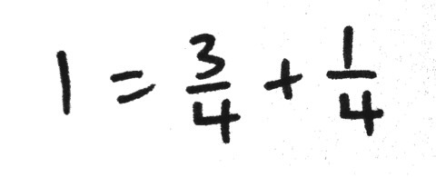
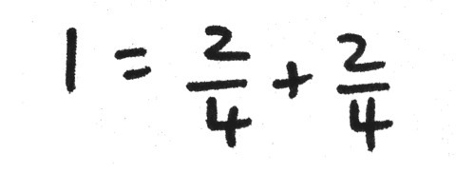
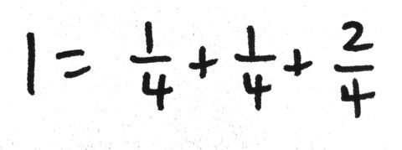
T: (Display a number bond to show 1 decomposed into 4 units of 1 fourth.) What does the number bond show?
S: 1 is the whole. The four 1 fourths are the parts. 4 fourths make 1.
T: Let’s say it as an addition sentence starting with “1 equals…”
S: 1 = $\frac{\text{1}}{\text{4}}$ + $\frac{\text{1}}{\text{4}}$ + $\frac{\text{1}}{\text{4}}$ + $\frac{\text{1}}{\text{4}}.$
T: Fold a strip of paper to represent the same parts that our number bond shows. Work with a partner to see if there are any different number sentences we could create for decomposing 1 into fourths. Draw number bonds, and then write number sentences.
T: What number sentences did you create?
S: 1 = $\frac{\text{3}}{\text{4}}$ + $\frac{\text{1}}{\text{4}}.$ $1=\frac{2}{4}+\frac{2}{4}$. We could write 1 = $\frac{\text{1}}{\text{4}}$ + $\frac{\text{1}}{\text{4}}$ + $\frac{\text{2}}{\text{4}}.$
They both equal 1.
Problem 2: Fold a piece of paper to create eighths. Decompose fractions in different ways.
T: Turn over your strip of paper. The length of this strip of paper represents 1. Fold this paper to create 8 equal parts. (Demonstrate folding vertically.) Shade 7 of your 8 parts.
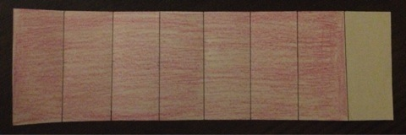
T: Give me one number sentence that shows the decomposition of 7 eighths into unit fractions.
S: (Write the sum of 7 units of 1 eighth.)
T: Use parentheses to decompose your sum of unit fractions into two parts.

NOTES ON
MULTIPLE MEANS
OF ACTION AND EXPRESSION:
If paper strip eighths are difficult to color and manipulate in Problem 2 of the Concept Development, use concrete manipulatives such as fraction strips, Cuisenaire rods, or linking cubes. Alternatively, use larger fraction strips or tape diagram drawings.

S: (Write a possible answer such as
$\frac{7}{8}$ = $\left(\frac{\text{1}}{\text{8}}\text{+}\frac{\text{1}}{\text{8}}\text{+}\frac{\text{1}}{\text{8}}\right)$ + $\left(\frac{\text{1}}{\text{8}}\text{+}\frac{\text{1}}{\text{8}}\text{+}\frac{\text{1}}{\text{8}}\text{+}\frac{\text{1}}{\text{8}}\right).$)
T: On your boards, record your decomposition of
7 eighths with 2 parts, and then look for other ways to decompose with 2 or more parts.
S: $\frac{\text{7}}{\text{8}}$ = $\frac{\text{3}}{\text{8}}$ + $\frac{\text{4}}{\text{8}}.$ $\frac{\text{7}}{\text{8}}$ = $\frac{\text{7}}{\text{8}}$ + 0. $\frac{\text{7}}{\text{8}}$ = $\frac{\text{2}}{\text{8}}$ + $\frac{\text{2}}{\text{8}}$ + $\frac{\text{3}}{\text{8}}.$
T: What do all of the number sentences have in common? Discuss with a partner.
S: They all add up to $\frac{\text{7}}{\text{8}}$. The parts are eighths in all of them.
Problem 3: Write number sentences to decompose $\frac{\text{5}}{\text{6}}$as a sum of fractions with the same denominator.
T: Form groups of three. Work on your personal white boards. Each of you should write a number bond and sentence showing a decomposition of 5 sixths. If you have the same decomposition as someone else in your group, one of you must change your work. (Allow time for students to work.)
MP.3
T: Let’s share. What number bonds did you create? (Record number sentences.)
S: $\frac{\text{5}}{\text{6}}$ = $\frac{\text{1}}{\text{6}}$ + $\frac{\text{1}}{\text{6}}$ + $\frac{\text{1}}{\text{6}}$ + $\frac{\text{1}}{\text{6}}$ +$\frac{\text{1}}{\text{6}}.$ $\frac{\text{5}}{\text{6}}$ = $\frac{\text{3}}{\text{6}}$ + $\frac{\text{2}}{\text{6}}.$ $\frac{\text{5}}{\text{6}}$ = $\frac{\text{4}}{\text{6}}$ + $\frac{\text{1}}{\text{6}}$. (Other various answers.)
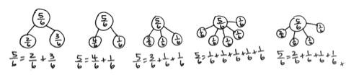

T: Now, on your boards, instead of drawing number bonds, draw tape diagrams to show three
different ways of decomposing the fraction $\frac{\text{5}}{\text{4}}.$ Write the number sentence describing each tape diagram you drew next to the tape diagrams. What number sentences did you write?
S: $\frac{\text{5}}{\text{4}}$ = $\frac{\text{4}}{\text{4}}$ + $\frac{\text{1}}{\text{4}}.$ $\frac{\text{5}}{\text{4}}$ = $\frac{\text{2}}{\text{4}}$ + $\frac{\text{1}}{\text{4}}$ + $\frac{\text{2}}{\text{4}}.$ $\frac{\text{5}}{\text{4}}$ = 1 + $\frac{\text{1}}{\text{4}}$.

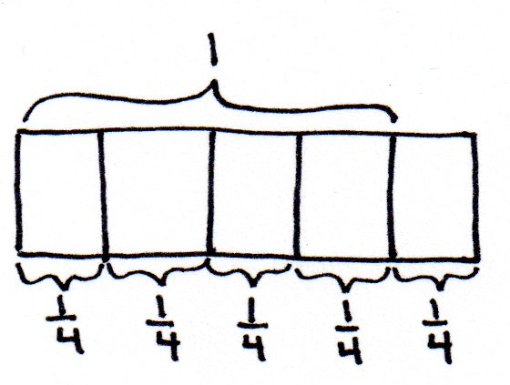
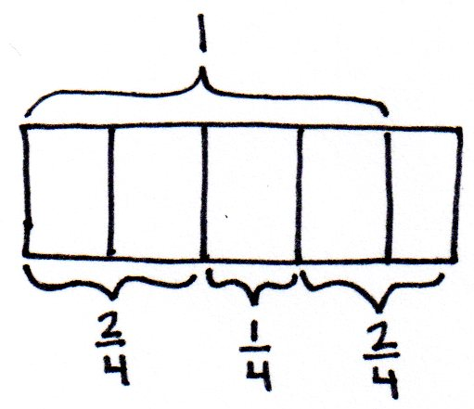
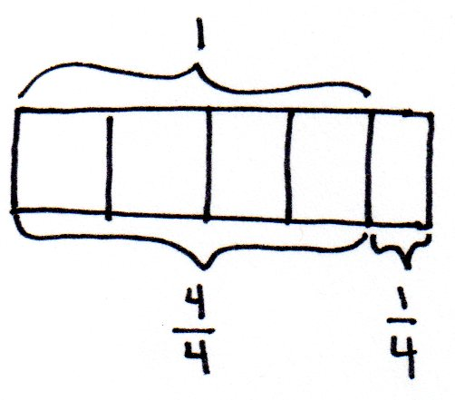

NOTES ON
MULTIPLE MEANS
OF REPRESENTATION:
Check that English language learners and others understand that they are to represent 5 fourths, not 5 fifths, with a tape diagram. Provide guidance as students model this improper fraction as a tape diagram. Ask, “What is the unit? How many units to make 1? How do you show 1 on your tape diagram?”

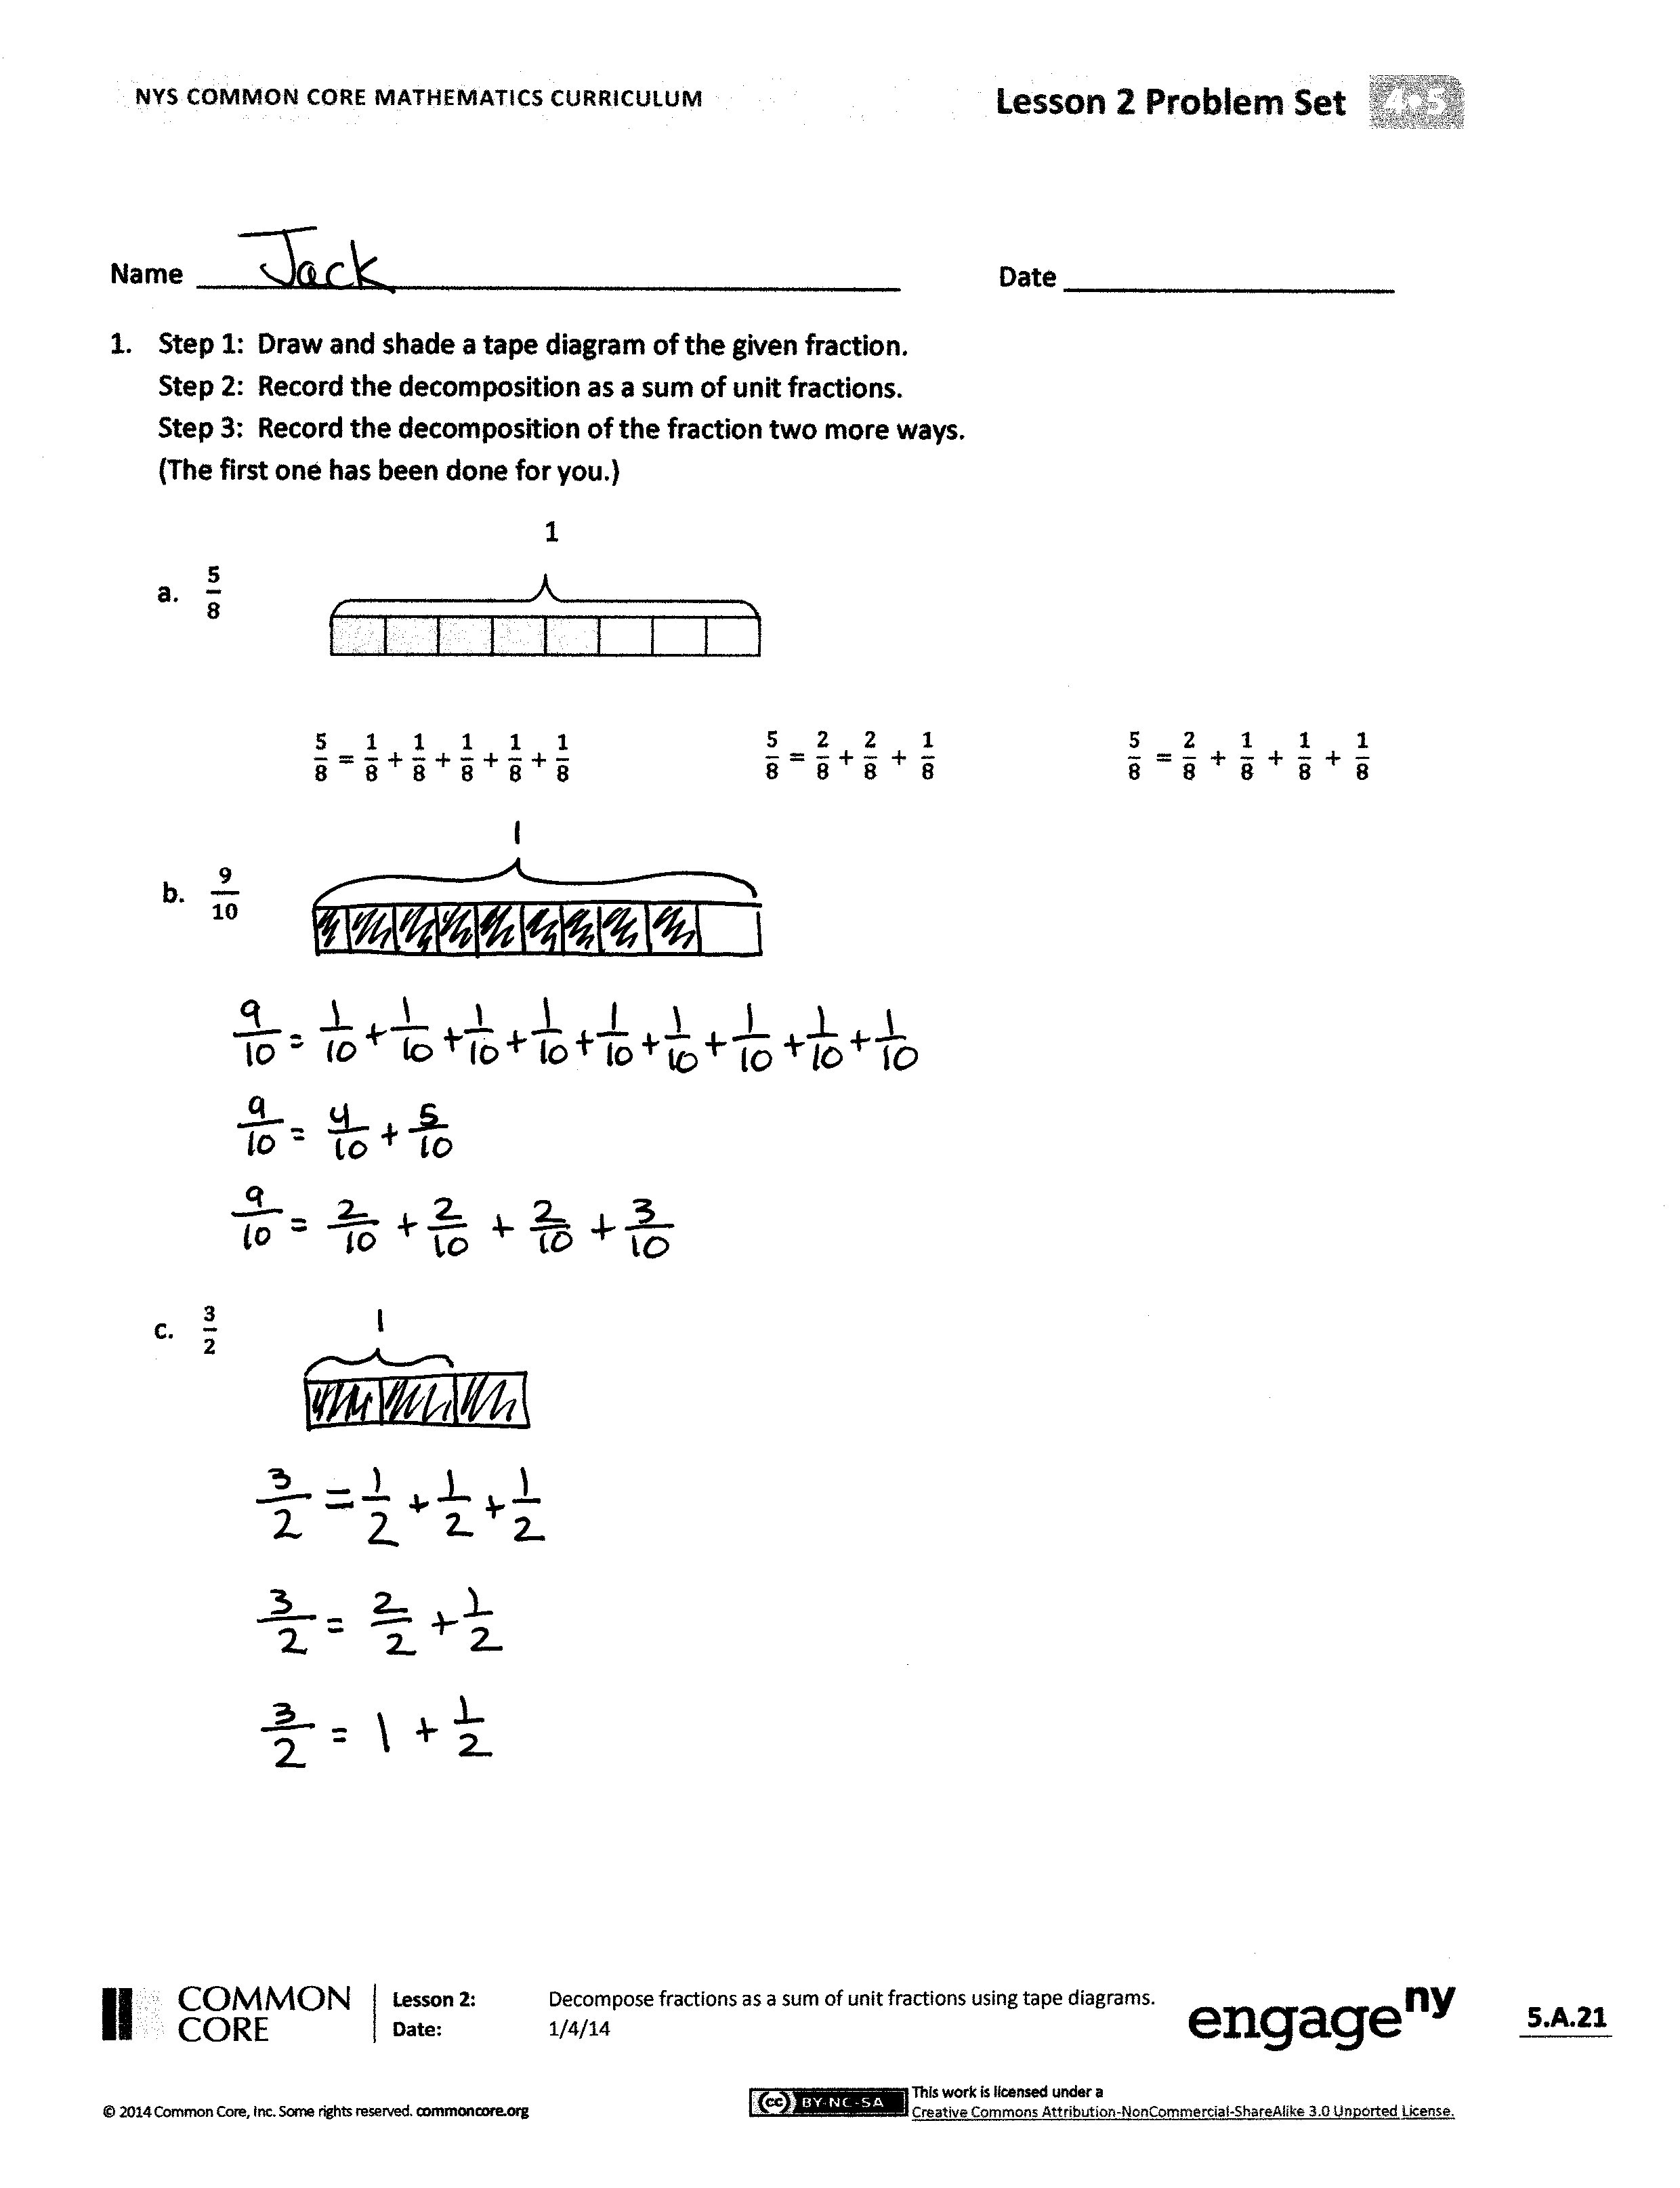
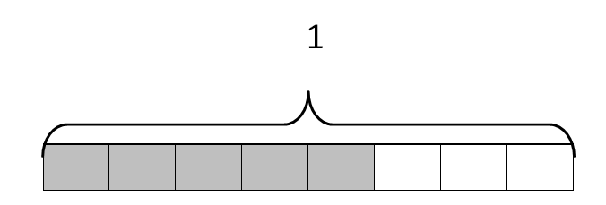
Problem Set (10 minutes)
Students should do their personal best to complete the Problem Set within the allotted 10 minutes. For some classes, it may be appropriate to modify the assignment by specifying which problems they work on first. Some problems do not specify a method for solving. Students should solve these problems using the RDW approach used for Application Problems.
Student Debrief (10 minutes)
Lesson Objective: Decompose fractions as a sum of unit fractions using tape diagrams.
The Student Debrief is intended to invite reflection and active processing of the total lesson experience.
Invite students to review their solutions for the Problem Set. They should check work by comparing answers with a partner before going over answers as a class. Look for misconceptions or misunderstandings that can be addressed in the Debrief. Guide students in a conversation to debrief the Problem Set and process the lesson.
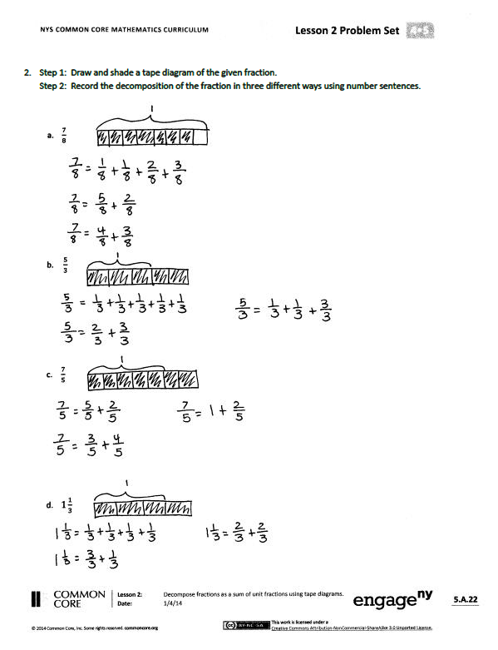
Any combination of the questions below may be used to lead the discussion.
- Look at your answers for Problems 1(b) and 1(c). Problem 1(c) is a fraction greater than 1, but it has fewer ways to be decomposed. Why is that?
- In Problem 1(a), which was completed for you, the first number sentence was decomposed into the sum of unit fractions. The second number sentence bonded some of these unit fractions. Which ones? ($\frac{\text{2}}{\text{8}}$ bonded $\frac{\text{1}}{\text{8}}$ + $\frac{\text{1}}{\text{8}}$.) Draw parentheses around the unit fractions in the first number sentence that match the second number sentence. Do the same for Problems 1(b) and 1(c). (Answers will vary.)
$\frac{\text{5}}{\text{8}}$ = $\left(\frac{\text{1}}{\text{8}}\text{+}\frac{\text{1}}{\text{8}}\right)$ + $\left(\frac{\text{1}}{\text{8}}\text{+}\frac{\text{1}}{\text{8}}\right)$ + $\frac{\text{1}}{\text{8}}\text{.}$ $\frac{\text{5}}{\text{8}}$ = $\frac{\text{2}}{\text{8}}$ + $\frac{\text{2}}{\text{8}}$ + $\frac{\text{1}}{\text{8}}$.
- Give examples of when you decomposed numbers in earlier grades.
- How did the Application Problem connect to today’s lesson?
Exit Ticket (3 minutes)
After the Student Debrief, instruct students to complete the Exit Ticket. A review of their work will help with assessing students’ understanding of the concepts that were presented in today’s lesson and planning more effectively for future lessons. The questions may be read aloud to the students.
Name Date
- Step 1: Draw and shade a tape diagram of the given fraction.
Step 2: Record the decomposition as a sum of unit fractions.
Step 3: Record the decomposition of the fraction two more ways.
(The first one has been done for you.)
1
$$\frac{5}{8} = \frac{1}{8} + \frac{1}{8} + \frac{1}{8} + \frac{1}{8} + \frac{1}{8}$$
- $\frac{5}{8}$
$$\frac{5}{8} = \frac{2}{8} + \frac{1}{8} + \frac{1}{8} + \frac{1}{8}$$
$$\frac{5}{8} = \frac{2}{8} + \frac{2}{8} + \frac{1}{8}$$

- $\frac{9}{10}$

- $\frac{3}{2}$

- Step 1: Draw and shade a tape diagram of the given fraction.
Step 2: Record the decomposition of the fraction in three different ways using number sentences.

- $\frac{7}{8}$

- $\frac{5}{3}$

- $\frac{7}{5}$

- $1\frac{1}{3}$

Name Date
Step 1: Draw and shade a tape diagram of the given fraction.
Step 2: Record the decomposition of the fraction in three different ways using number sentences.
$\frac{4}{7}$

Name Date
- Step 1: Draw and shade a tape diagram of the given fraction.
Step 2: Record the decomposition as a sum of unit fractions.
Step 3: Record the decomposition of the fraction two more ways.
(The first one has been done for you.)

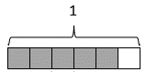
  - $\frac{5}{6}$

$\frac{\text{5}}{\text{6}} \text{=} \frac{\text{1}}{\text{6}} \text{+} \frac{\text{4}}{\text{6}}$

$$\frac{\text{5}}{\text{6}}\text{ = }\frac{\text{2}}{\text{6}}\text{ + }\frac{\text{2}}{\text{6}}\text{ + }\frac{\text{1}}{\text{6}}$$

$\frac{\text{5}}{\text{6}} \text{=} \frac{\text{1}}{\text{6}} \text{+} \frac{\text{1}}{\text{6}} \text{+} \frac{\text{1}}{\text{6}} \text{+} \frac{\text{1}}{\text{6}} \text{+} \frac{\text{1}}{\text{6}}$

  - $\frac{6}{8}$

  - $\frac{7}{10}$

- Step 1: Draw and shade a tape diagram of the given fraction.
Step 2: Record the decomposition of the fraction in three different ways using number sentences.

- $\frac{10}{12}$

- $\frac{5}{4}$

- $\frac{6}{5}$

- $1\frac{1}{4}$

