Lesson 1

Objective: Decompose fractions as a sum of unit fractions using tape diagrams.

Suggested Lesson Structure

 Fluency Practice (9 minutes)

 Application Problem (8 minutes)

 Concept Development (33 minutes)

 Student Debrief (10 minutes)

**Total Time (60 minutes)**

Fluency Practice (9 minutes)

* Read Tape Diagrams  **3.OA.3** (5 minutes)
* Addition of Fractions in Unit Form **3.NF.1** (4 minutes)

Read Tape Diagrams (5 minutes)

Materials: (S) Personal white board

Note: This fluency activity prepares students for Lesson 1.

T: (Project a tape diagram partitioned into 2 equal parts. Write 10 at the top.) Say the value of the whole.



10

S: 10.

T: Write the value of one unit as a division problem.

S: (Write 10 ÷ 2 = 5.)

T: (Write 5 in both units.) Write the whole as a repeated addition sentence.

S: (Write 5 + 5 = 10.)

Continue with the following possible sequence: 6 ÷ 2, 15 ÷ 3, 6 ÷ 3, 12 ÷ 4, and 24 ÷ 4.

Addition of Fractions in Unit Form (4 minutes)

Materials: (S) Personal white board

Note: This fluency activity prepares students for Lesson 1.

T: (Project a circle partitioned into 2 equal parts with 1 part shaded.) How many circles do you see?

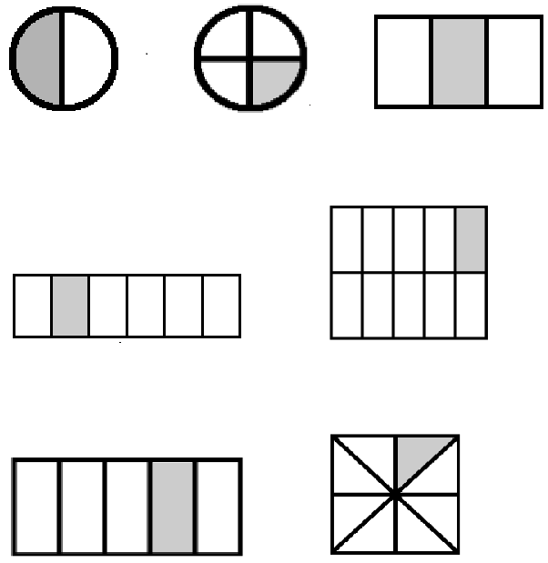S: 1.

T: How many equal parts are in the circle?

S: 2.

T: What fraction of the circle is shaded?

S: .

T: (Write *1 half + 1 half = 2 halves = 1*.) True or false?

S: True.

T: Explain why it is true to your partner.

S: 1 + 1 is 2. That’s kindergarten. 🡪 Two halves is the same as 1. 🡪 Half an apple + half an apple is 1 apple.

T: (Project a circle partitioned into 4 equal parts with 1 part shaded.) How many circles do you see?

S: 1.

T: How many equal parts does this circle have?

S: 4.

T: Write the fraction that is represented by the shaded part.

S: (Write .)

T: (Write *1 fourth + 1 fourth + 1 fourth + 1 fourth = 4 fourths = 1*.) True or false?

S: True.

Continue with the following possible fraction graphics:

Application Problem (8 minutes)

Materials: (S) 1 index card with diagonals drawn, pair of scissors (1 per pair of students)

1. Discuss with your partner what you notice about the rectangle.
2. Use your scissors to cut your rectangle on the diagonal lines. Prove that you have cut the rectangle into 4 fourths. Include a drawing in your explanation.

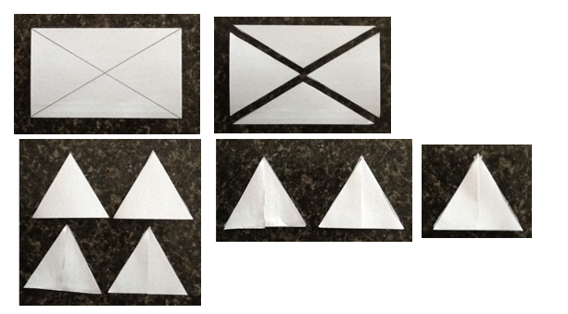

Note: This Application Problem reviews and reinforces the concept that fractional parts have the same area. Many students may say that the diagonal lines do not create fourths because the triangles created by the diagonals do not look alike. Exploration will help students see that the areas are, in fact, equal and prepare them for the work with tape diagrams that is done in this lesson.

Concept Development (33 minutes)

|  |  |
| --- | --- |
|  | NOTES ON  MULTIPLE MEANS  OF ACTION AND EXPRESSION: |
| Folding paper strips into thirds may be challenging for some students. Offer the following guidance:   * Roll the paper strip into a loose tube. Lightly flatten the middle and adjust so that the three parts are all approximately the same size. Align the edges of the paper strip. Then, flatten the tube. * Provide prefolded strips. * Depending on paper thickness, it may be desirable to score or line the paper to guide folds. | |

Materials: (T) 3 strips of paper, markers (S) 3 strips of paper, colored markers or colored pencils, personal white board

Problem 1: Fold a strip of paper to create thirds and sixths. Record the decompositions represented by the folded paper with addition.

T: The area of this strip of paper is my whole. What number represents this strip of paper?

S: 1.

T: Fold to decompose the whole into 3 equal parts. (Demonstrate.)

T: Draw lines on the creases you made. (Demonstrate.) Draw a number bond to represent the whole decomposed into 3 units of…?

S: 1 third.

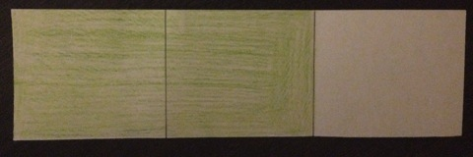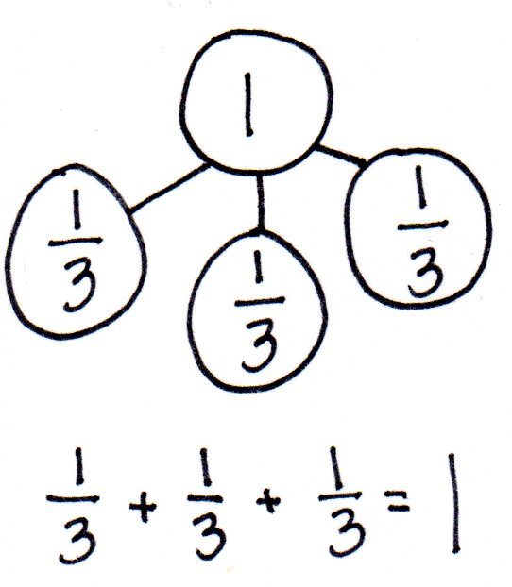

T: (Allow students time to draw.) Tell me an addition number sentence to describe this decomposition, starting with “1 equals…” (Record the sentence as students speak.)

S: 1 = + + .

T: Let’s show this decomposition in another way. (Shade 2 thirds of the paper strip.)

T: (Insert parentheses.) 1 = + . Tell me a new addition sentence that matches the new groups starting with “1 equals…”

S: 1 = + .

T: Decompose 5 sixths into 5 units of 1 sixth with a number bond. (Allow students time to work.)

T: Give me an addition sentence representing this decomposition, starting with “5 sixths equals…” (Record the sentence as students speak.)

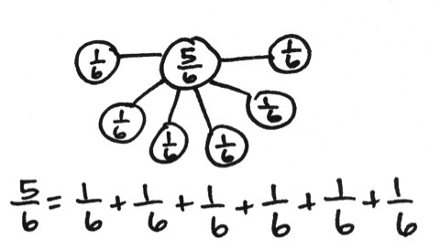

S: = + + + + .

T: Let’s double the number of units in our whole. Fold your strip on the creases. Fold one more time in half. Open up your strip. Into how many parts have we now decomposed the whole?

S: 6.

T: On the other side that has no lines, draw lines on the creases you made and shade 5 sixths.

T: Show this decomposition in another way.

T: (Insert parentheses.) = + Tell me a new addition sentence that matches this new decomposition, starting with “5 sixths equals…” (Record the sentence as students speak.)

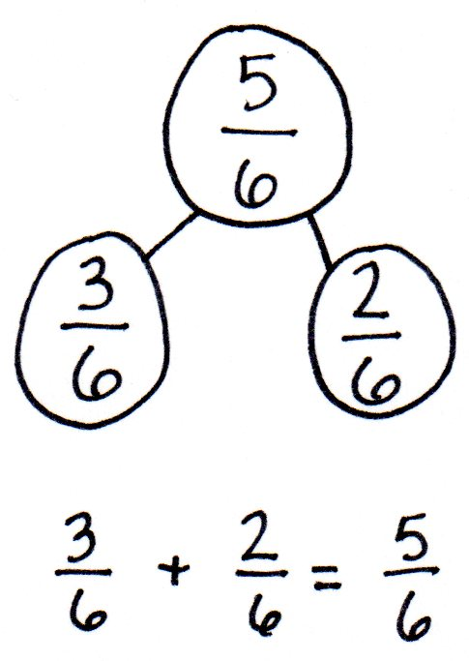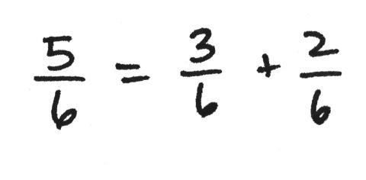

S: = + .

T: Draw a number bond and addition sentence to match.

S: (Draw a number bond and addition sentence.)

T: Use your paper strip to show your partner the units that match each part.

S: = + .

Problem 2: Fold two strips of paper into fourths. Shade Write the number sentence created.

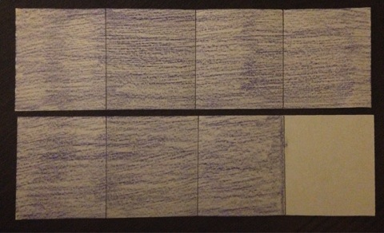

T: Take a new strip of paper. The area of this strip of paper is the whole. Fold this paper to create 4 equal parts. (Demonstrate creating fourths vertically.) Shade all 4 of the parts. Take one more strip of paper, fold it, and shade 3 of the 4 parts. How much is shaded?

S: The first strip of paper represents . On the second strip of paper, we shaded = + .

T: Draw a number bond to represent the 2 parts and their sum.

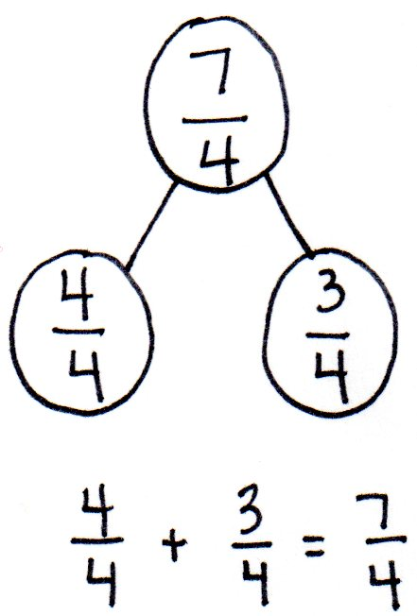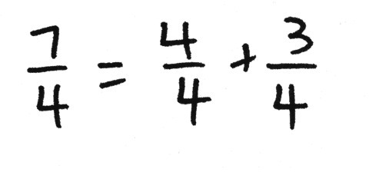

S: (Draw.)

T: Can be renamed?

S: Yes, is equal to 1.

T: Draw another number bond to rename with 1.

S: (Draw.)

T: Write a number sentence that represents this number bond.

S: (Write = 1 + )

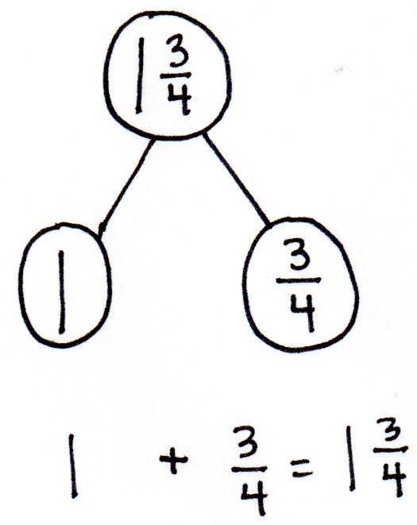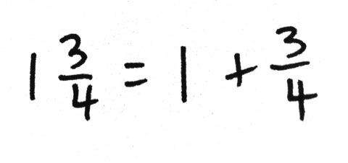

T: With a **fraction greater than 1**, like , we can rename it. We say this is one and three-fourths. is another way to record the decomposition of as and Compare and contrast to .

S: One has a whole number. The other has just a fraction. 🡪 They both represent the same area, so they are equivalent. 🡪 So, when a fraction is greater than 1, we can write it using a whole number and a fraction.

Problem 3: Write decompositions of fractions represented by tape diagrams as number sentences.

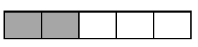

1

Display the following tape diagram:

T: The rectangle represents 1. Name the unit fraction.

S: 1 fifth.

T: (Label underneath both shaded unit fractions.) Name the shaded fraction.

S: 2 fifths.

T: Decompose into unit fractions

S: = + .

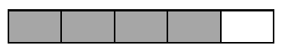

1

Display the tape diagram pictured to the right.

T: What is the unit fraction?

S: 1 fifth.

T: Use the model to write an addition sentence for the tape diagram showing the decomposition of   
4 fifths indicated by the brackets

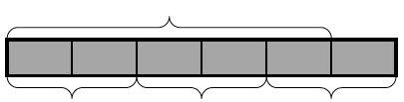

1

S: (Write = + + .)

Display the tape diagram pictured to the right.

T: What is the unit fraction?

|  |  |
| --- | --- |
|  | NOTES ON  MULTIPLE MEANS  OF ENGAGEMENT: |
| Challenge students working above grade level to use parentheses and what they understand about repeated addition to write as many number sentences as they can for the tape diagram of = + + | |

S: 1 sixth. 🡪 1 fifth.

T: How do you know it is not 1 sixth?

S: This tape diagram shows 5 equal parts shaded as being 1. Then, there’s another unit after that. 🡪 This tape diagram represents a number greater than 1.   
🡪 This tape diagram is showing a whole number and a fraction.

T: Tell your partner the number this tape diagram represents.

S: 🡪

T: On your personal white boards, write the number sentence for the tape diagram showing a sum equal to 6 fifths.

S: = + + 🡪 = + . 🡪 = + . 🡪 = 1 +

Problem 4: Draw decompositions of fractions with tape diagrams from number sentences.

Display the number sentence = + + .

T: Discuss with your partner how this number sentence can be modeled as a tape diagram.

S: Well, the sum is 1 because it is equal to . 🡪 The unit fraction is 1 sixth, so we should partition the tape diagram into 6 equally sized pieces. 🡪 We can use brackets to label the sum and addends.

**MP.3**

Allow partners to draw a tape diagram and share. Repeat with = + .

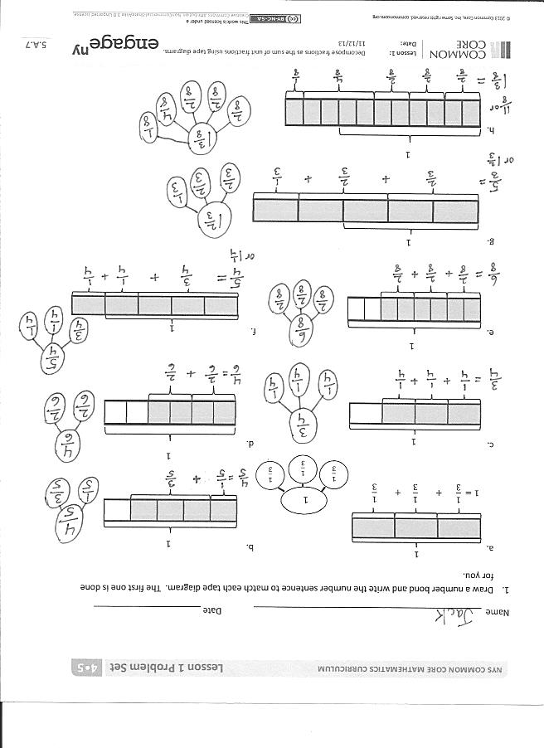Problem Set (10 minutes)

Students should do their personal best to complete the Problem Set within the allotted 10 minutes. Some problems do not specify a method for solving. This is an intentional reduction of scaffolding that invokes MP.5, Use Appropriate Tools Strategically. Students should solve these problems using the RDW approach used for Application Problems.

For some classes, it may be appropriate to modify the assignment by specifying which problems students should work on first. With this option, let the purposeful sequencing of the Problem Set guide the selections so that problems continue to be scaffolded. Balance word problems with other problem types to ensure a range of practice. Consider assigning incomplete problems for homework or at another time during the day.

Student Debrief (10 minutes)

**Lesson Objective:** Decompose fractions as a sum of unit fractions using tape diagrams.

The Student Debrief is intended to invite reflection and active processing of the total lesson experience.

Invite students to review their solutions for the Problem Set. They should check work by comparing answers with a partner before going over answers as a class. Look for misconceptions or misunderstandings that can be addressed in the Debrief. Guide students in a conversation to debrief the Problem Set and process the lesson.

Any combination of the questions below may be used to lead the discussion.

* How do Problems 1(f), 1(g), and 1(h) differ from Problems 1(a─e)? How do the tape diagrams model a **fraction greater than 1**?
* Compare the size of the shaded fractions in Problems 1(c) and 1(e). Assume the wholes are equal. What can you inter about the two number sentences?
* 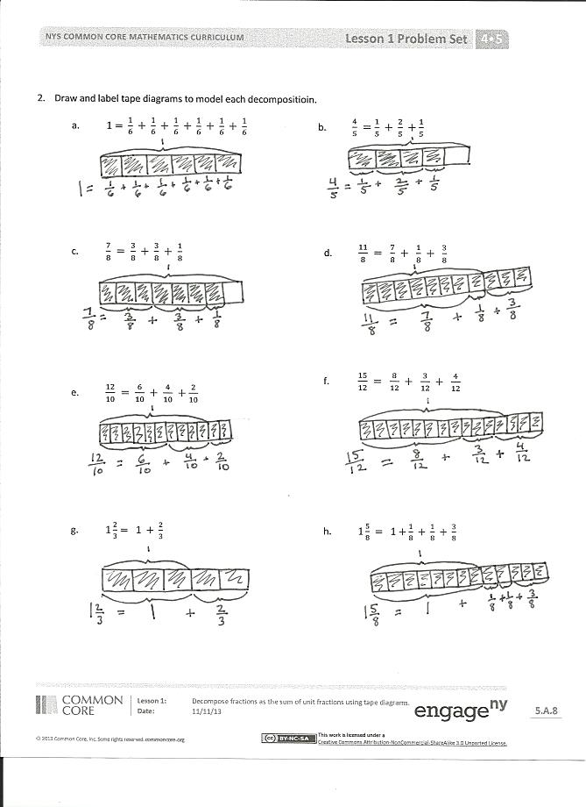How do the number bonds connect to the number sentences?
* How did using the paper strips during our lesson help you visualize the tape diagrams you had to draw in Problem 2?
* What relationship does the unit fraction have with the number of units in a whole?
* How did the Application Problem connect to today’s lesson?

Exit Ticket (3 minutes)

After the Student Debrief, instruct students to complete the Exit Ticket. A review of their work will help with assessing students’ understanding of the concepts that were presented in today’s lesson and planning more effectively for future lessons. The questions may be read aloud to the students.

Name Date

1. Draw a number bond and write the number sentence to match each tape diagram. The first one is done for you.



1



1

a. b.

1



1



1

c. d.



1



1

e. f.



1

g.



1

h.

1. Draw and label tape diagrams to model each decomposition.

a.

b.

c.

d.

e.

f.

g.

h.

Name Date

1. Draw a number bond and write the number sentence to match the tape diagram.

1



1

1. Draw and label tape diagrams to model each number sentence.

Name Date

1. Draw a number bond and write the number sentence to match each tape diagram. The first one is done for you.

|  |  |
| --- | --- |
|  | b. |
| c. | d. |
| e. | f. |
| g. | h. |

1. Draw and label tape diagrams to match each number sentence.