Name Date
- Label each graph with the function it represents; choose from those listed below.
$$f\left(x\right)=3\sqrt{x}$$ | $$g\left(x\right)=\frac{1}{2}\sqrt[3]{x}$$ | $$h\left(x\right)=-5x^{2}$$
$$k\left(x\right)=\sqrt{x+2}-1$$ | $$m\left(x\right)=\sqrt[3]{x}+2$$ | $$n\left(x\right)={\left(x-3\right)}^{2}-1$$

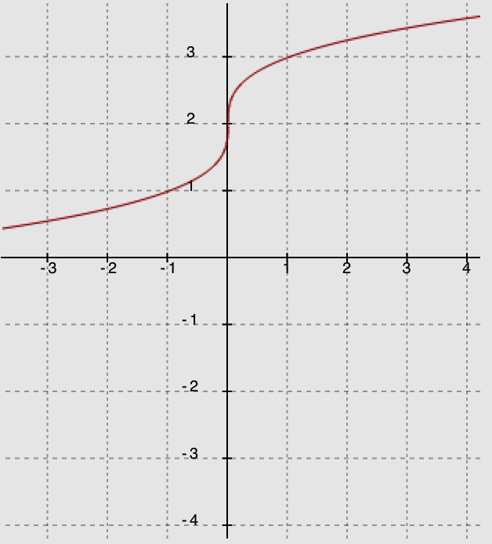 | 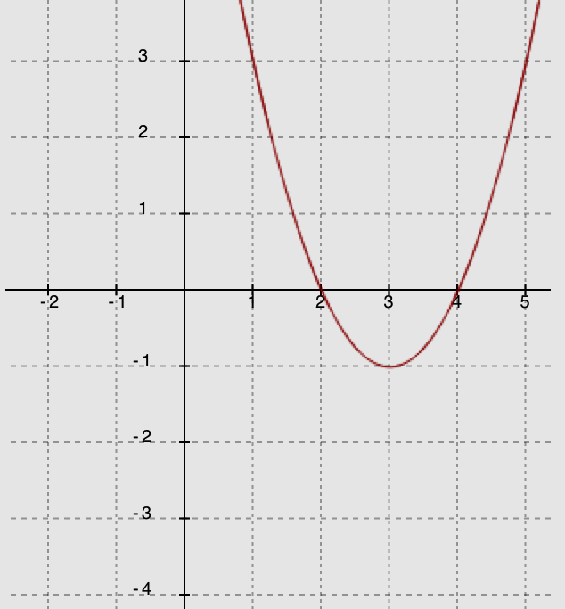 | 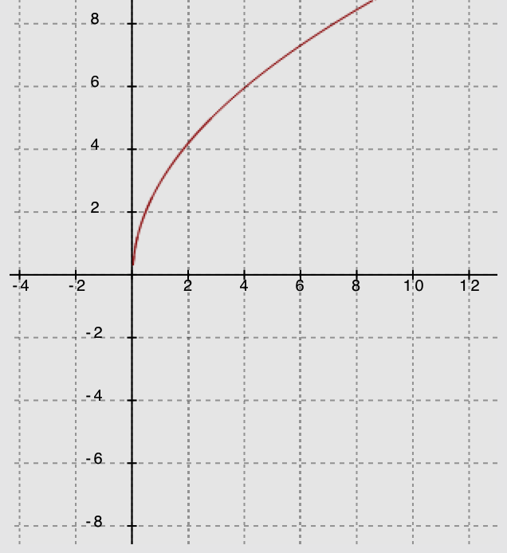
Function _______________ | Function _______________ | Function _______________
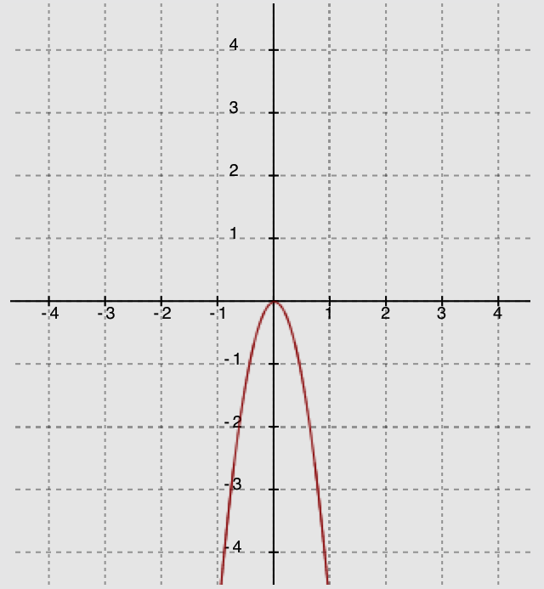 | 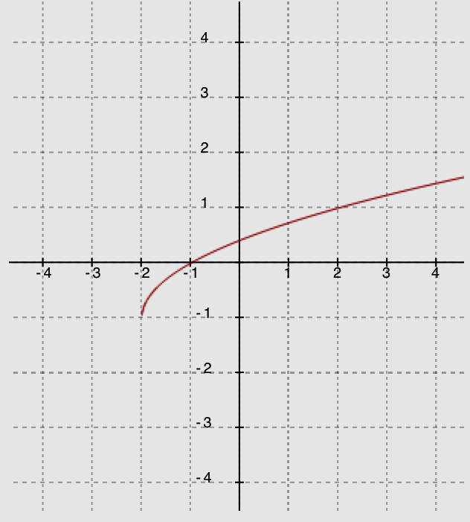 | 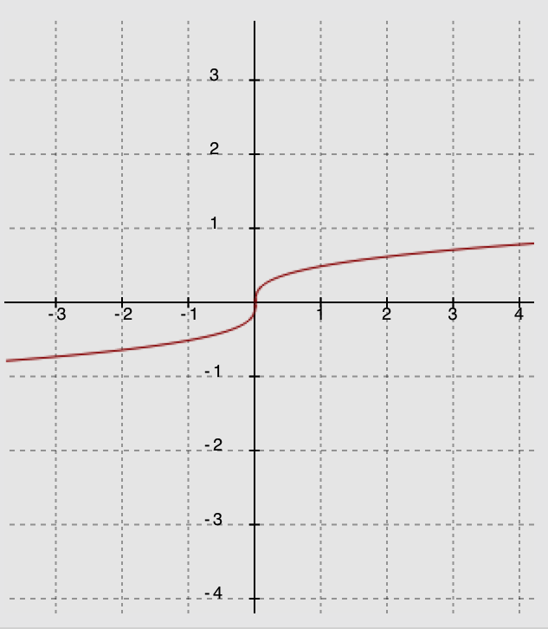
Function _______________ | Function _______________ | Function _______________

- Compare the following three functions.
    - A function $f$ is represented by the graph below.
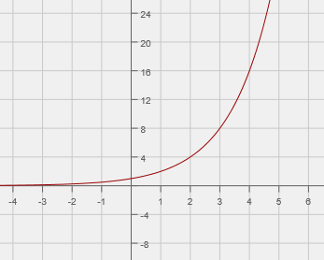

    - A function $g$ is represented by the following equation.

$$g\left(x\right)={\left(x-6\right)}^{2}-36$$

    - A linear function $h$ is represented by the following table.
$$x$$ | $$-1$$ | $$1$$ | $$3$$ | $$5$$ | $$7$$
$$h(x)$$ | $$10$$ | $$14$$ | $$18$$ | $$22$$ | $$26$$

For each of the following, evaluate the three expressions given, and identify which expression has the largest value and which has the smallest value. Show your work.

  - $f(0), g(0), h(0)$

  - $\frac{f\left(4\right) - f\left(2\right)}{4 - 2}$, $\frac{g\left(4\right) - g(2)}{4 - 2}$, $\frac{h\left(4\right) - h(2)}{4 - 2}$

  - $f(1000), g(1000), h(1000)$

- An arrow is shot into the air. A function representing the relationship between the number of seconds it is in the air, $t$, and the height of the arrow in meters, $h$, is given by

$h\left(t\right)=-4.9t^{2}+29.4t+2.5$.

  - Complete the square for this function. Show all work.

  - What is the maximum height of the arrow? Explain how you know.

  - How long does it take the arrow to reach its maximum height? Explain how you know.

  - What is the average rate of change for the interval from $t=1$ to $t=2$ seconds? Compare your answer to the average rate of change for the interval from $t=2$ to $t=3$ seconds, and explain the difference in the context of the problem.

  - How long does it take the arrow to hit the ground? Show your work, or explain your answer.

  - What does the constant term in the original equation tell you about the arrow’s flight?

  - What do the coefficients on the second- and first-degree terms in the original equation tell you about the arrow’s flight?

- Rewrite each expression below in expanded (standard) form:
- ${\left(x+\sqrt{3}\right)}^{2}$ | - $\left(x-2\sqrt{5}\right)\left(x-3\sqrt{5}\right)$

  - Explain why, in these two examples, the coefficients of the linear terms are irrational and the constants are rational.

Factor each expression below by treating it as the difference of squares:
- $q^{2}-8$ | - $t-16$

- Solve the following equations for $r$. Show your method and work. If no solution is possible, explain how you know.
- $r^{2}+12r+18=7$ | - $r^{2}+2r-3=4$ | - $r^{2}+18r+73=-9$

- Consider the equation $x^{2}-2x-6=y+2x+15$ and the function $f\left(x\right)=4x^{2}-16x-84$ in the following questions:

  - Show that the graph of the equation $x^{2}-2x-6=y+2x+15$ has $x$-intercepts at $x=-3$ and $7$.

  - Show that the zeros of the function $f\left(x\right)=4x^{2}-16x-84$ are the same as the $x$-values of the $x$-intercepts for the graph of the equation in part (a) (i.e., $x=-3$ and $7$).

  - Explain how this function is different from the equation in part (a).

  - Identify the vertex of the graphs of each by rewriting the equation and function in the completed-square form, $a{(x-h)}^{2}+k$. Show your work. What is the same about the two vertices? How are they different? Explain why there is a difference.

  - Write a new quadratic function with the same zeros but with a maximum rather than a minimum. Sketch a graph of your function, indicating the scale on the axes and the key features of the graph.

A Progression Toward Mastery
Assessment  Task Item |  | STEP 1  Missing or incorrect answer and little evidence of reasoning or application of mathematics to solve the problem. | STEP 2  Missing or incorrect answer but evidence of some reasoning or application of mathematics to solve the problem. | STEP 3  A correct answer with some evidence of reasoning or application of mathematics to solve the problem, or an incorrect answer with substantial evidence of solid reasoning or application of mathematics to solve the problem. | STEP 4  A correct answer supported by substantial evidence of solid reasoning or application of mathematics to solve the problem.
1 | F-IC.C.7a  F.IF.C.7b  F-BF.B.3 | Student matches two or fewer of the six graphs and functions accurately. | Student matches three of the six graphs and functions accurately. | Student matches four or five of the six graphs and functions accurately. | Student matches all six graphs and functions accurately.
2 | a–c  F-IF.B.6  F-IF.C.9 | Student marks each part separately, using the same scoring criteria for each. Student does not order the function values for each part correctly, and there is no evidence to show an understanding of the three representations as being exponential, quadratic, and linear or of how to determine the functions’ values at the indicated $x$-values. | Student marks each part separately, using the same scoring criteria for each. Student provides work that shows an understanding of the graphic representation as being exponential, the tabular as linear, and the symbolic as quadratic. Only one of the three function values is correctly determined for the indicated values of $x,$ but the function values are not ordered correctly. | Student marks each part separately, using the same scoring criteria for each. Student provides work that shows an understanding of the graphic representation as being exponential, the tabular as linear, and the symbolic as quadratic. The values for $x$ are substituted correctly, but there are one or more errors in calculating the values of the expressions. The function values are not ordered correctly. | Student marks each part separately, using the same scoring criteria for each. Student provides work that shows an understanding of the graphic representation as being exponential, the tabular as linear, and the symbolic as quadratic. The values for $x$ are substituted correctly, and the expressions are ordered correctly.
3 | a  A-SSE.A.2  F-IF.B.8a | Student shows little or no understanding of the process required to complete the square. | Student attempts to rewrite the function in completed-square form, using a correct process. However, there are errors in calculations and steps missing in the process. | Student writes the function in completed- square form, but critical steps in the work are missing, or there are errors in the calculations. | Student correctly writes the function in completed-square form, and the correct steps for the process are included.
 | b–g  A-SSE.A.1  A-SSE.B.3b  F-IF.B.4 | Student shows little evidence of interpreting the function.  OR  Student makes little or no attempt to answer the question. | Student uses the function form found in part (a) but shows only some understanding of interpreting the key features of the function. Errors are made in calculations, and there is limited explanation. | Student provides an explanation that indicates an understanding of the key features of the function. Student uses the function form found in part (a) but incorrectly interprets the function or makes minor errors in calculation. Student explains the process but leaves gaps in the explanation. | Student provides an explanation that indicates an understanding of the key features of the function. Student uses the function form found in part (a) and correctly interprets the function features. Student provides evidence of the process and gives an accurate explanation of the reasoning used.
4 | a–b  A-SSE.A.2 | Student shows little evidence of understanding multiplication of binomials that include radicals.  OR  Student makes little or no attempt to rewrite the expression in standard form. | Student shows some evidence of understanding multiplication of binomials that include radicals. There are errors in the calculations and work. | Student shows evidence of understanding multiplication of binomials that include radicals. There are no errors in the calculations, but radical calculations are left unfinished, such as ${(\sqrt{3})}^{2}$ or $-3\sqrt{5}-2\sqrt{5}$. | Student performs expansions accurately. The terms are in simplest radical form, and the work supports the solutions.
 | c  N-RN.B.3 | Student makes no attempt to provide an explanation. | Student shows little evidence of understanding the properties of irrational numbers. The explanation uses numerical examples for both questions but provides no further explanation, or an explanation is provided for only one part of the question. | Student shows some evidence of understanding the properties of irrational numbers in the explanation. The explanation is partially correct and is attempted for both parts of the question but is missing one or more aspects. | Student clearly shows an understanding of the properties of irrational numbers based on the explanation.
 | d–e  A-SSE.A.2 | Student shows no evidence of understanding factoring the difference of squares.  OR  Student makes little or no attempt to factor the expression. | Student shows some evidence of understanding factoring the difference of squares. There are errors in the calculations that lead to incorrect solutions. | Student shows strong evidence of understanding factoring the difference of squares. There are no errors in the calculations, but the radical is left off (e.g., $\sqrt{t}$), or irrational calculations are left unfinished (e.g., $\sqrt{16}$). | Student provides accurate factors, the terms are in simplest radical form, and the work supports the solutions.  (Note: In part (d), full credit is given for either form of the radical: $\sqrt{8}$ or $2\sqrt{2}$. However, in part (e), $\sqrt{16}$ must be changed to $4$.)
5 | a–b  A-REI.B.4  A-REI.B.4a  A-REI.4b | Student shows no evidence of understanding the process of solving a quadratic equation.  OR  Student makes little or no attempt to solve the equation. | Student shows some evidence of understanding the process of solving a quadratic equation in the work shown. There are errors in calculations, and an incorrect method is used to find the solutions, or the process is aborted before completion. | Student completes the equation solving process using an appropriate method for each part. There are errors in calculations (e.g., factored incorrectly) or the equation is set up incorrectly (e.g., student fails to set the expression equal to $0$), or there is only one solution found. | Student correctly solves the equations using an efficient method with accurate and supportive work shown.
 | c  A-REI.B.4  A-REI.B.4a  A-REI.4b | Student shows no evidence of understanding the process of solving a quadratic equation.  OR  Student makes little or no attempt to solve the equation. | Student shows some evidence of understanding the process of solving a quadratic equation. There are errors in calculations, and an incorrect method is used to find the solutions, or the process is aborted before completion. | Student understands the nature of this quadratic equation as having no real solutions. However, the explanation does not include using the discriminant or a graphic representation to justify the reasoning. | Student correctly sets up the equation for solution. The discriminant value shows there are no real solutions. Accurate explanation is included. (Note: The explanation may include references to the graphic representation.)
6 | a–b  A-APR.B.3 | Student shows no evidence of understanding the concept of verifying the zeros of a function.  OR  Student makes little or no attempt to answer the question. | Student attempts to determine whether $x=-3$ and $7$ are $x$-intercepts for the function. Errors are made in method selection or in calculations that lead to an inconsistency. | Student uses a valid method to show that the function has $x$-intercepts at $x=-3$ and $7$ and includes an explanation to “show” the solutions are correct. Errors are made in the calculations that do not affect the final result. | Student uses a valid method to show that the function has $x$-intercepts at $x=-3$ and $7$ and includes an explanation to “show” the solutions are correct.
 | c  A-SSE.B.3a  A-SSE.B.3b | Student shows no evidence of understanding the relationship between the function and the equation and how that relationship is manifested in the graphs. | Student shows an understanding of how the graphs relate but does not mention how the expression used for the formula for $f$ is $4$ times the expression that defines $y$ based on the given equation. | Student shows an understanding of how the graphs relate and of how the expression used for the formula for $f$ is $4$ times the expression that defines $y$based on the given equation, but there are minor errors or misuse of vocabulary. | Student shows an understanding of how the graphs relate and of how the expression used for the formula for $f$ is $4$ times the expression that defines $y$ based on the given equation. The ideas are communicated with accurate use of vocabulary.
 | d  A-CED.A.2  A-SSE.B.3a  A-SSE.B.3b | Student shows no evidence of understanding the process of completing the square.  OR  Student makes little or no attempt to solve the problem. | Student shows some evidence of understanding the process of completing the square, but the attempt contains errors that lead to incorrect solutions. A valid explanation of the difference between the two vertices is not included. | Student shows evidence of understanding the process of completing the square. The attempt contains errors that lead to incorrect coordinates for the vertices. However, the explanation of the differences is based on the vertices found and is logical. | Student accurately performs the process of completing the square; the coordinates of the vertices are correct, and the explanation of their differences is accurate and logical.
 | e  A-CED.A.2  A-APR.B.3 | Student shows little evidence of understanding the concept of creating an equation with a maximum.  OR  Student makes little or no attempt to create the equation or sketch its graph. | Student shows evidence of understanding that the leading coefficient for the function must be negative. However, the function does not have the same zeros as those in parts (a) and (b), and the graph does not match the function created. The scale is not indicated on the graph, and the key features are not identified. | Student shows evidence of understanding that the leading coefficient for the function must be negative. However, the function does not have the same zeros as those in parts (a) and (b), or the graph does not match the function created. The scale is not indicated on the graph, or the key features are not identified. | Student shows evidence of understanding that the leading coefficient for the function must be negative. The function created has the same zeros as those in parts (a) and (b), and the graph matches the function created. The scale is indicated on the graph, and the key features are identified.

Name Date

- Label each graph with the function it represents; choose from those listed below.
$$f\left(x\right)=3\sqrt{x}$$ | $$g\left(x\right)=\frac{1}{2}\sqrt[3]{x}$$ | $$h\left(x\right)=-5x^{2}$$
$$k\left(x\right)=\sqrt{x+2}-1$$ | $$m\left(x\right)=\sqrt[3]{x}+2$$ | $$n\left(x\right)={\left(x-3\right)}^{2}-1$$

Function ______ m_________ | Function ______ n_______ | Function ______ f_________
Function ______ h_________ | Function _____ k________ | Function ______ g_________

- Compare the following three functions.
    - A function f is represented by the graph below.

Note: f(x) = 2^{x}

    - Function $g$ is represented by the following equation.
$g\left(x\right)={\left(x-6\right)}^{2}-36$
Note: h(x) = 2x +12

    - Linear function $h$ is represented by the following table.
$$x$$ | $$-1$$ | $$1$$ | $$3$$ | $$5$$ | $$7$$
$$h(x)$$ | $$10$$ | $$14$$ | $$18$$ | $$22$$ | $$26$$

For each of the following, evaluate the three expressions given, and identify which expression has the largest value and which has the smallest value. Show your work.
  - $f(0), g(0), h(0)$
f(0) =1, g(0) = 0, h(0) = 12, so
g(0) has the smallest value, and h(0) has the largest value.

  - $\frac{f\left(4\right) - f(2)}{4 - 2}$, $\frac{g\left(4\right) - g(2)}{4 - 2}$, $\frac{h\left(4\right) - h(2)}{4 - 2}$
f(4) = 16 f(2)= 4 : g(4) = –32 g(2) = –20 : h(4) = 20 h(2) = 16
So, the values for the average rate of change over the interval [2, 4] for each function are as follows:
f: 6 g: –6 h: 2
The rate of change of g has the smallest value, -6, meaning it is decreasing relatively quickly; the rate of change of f has the largest value, 6; f is increasing at the same rate that g is decreasing; the rate of change of h is slowest.

  - $f(1000), g(1000), h(1000)$
f(1000) = 2¹⁰⁰⁰ = 1.1 x 10³⁰¹; g(1000) = 994² – 36 = 988,000; h(1000) = 2012
h(1000) has the smallest value, and f(1000) has the largest value.

- An arrow is shot into the air. A function representing the relationship between the number of seconds it is in the air, $t,$ and the height of the arrow in meters, $h$, is given by

$h\left(t\right)=-4.9t^{2}+29.4t+2.5$.

  - Complete the square for this function. Show all work.
h(t) = -4.9t² + 29.4t + 2.5 = –4.9(t² + 6t + ) + 2.5 (factoring out the –4.9 from the two t terms and leaving the constant outside the parentheses)
= –4.9(t² – 6t + 9) + 2.5 + 44.1 (completing the square inside the parentheses)
= –4.9(t – 3)² + 46.6

  - What is the maximum height of the arrow? Explain how you know.
46.6 m—this is the value of the function at its vertex, so it is the highest the arrow will reach before it begins its descent.

  - How long does it take the arrow to reach its maximum height? Explain how you know.
3 sec., because that is the t-value (time in seconds) at which the arrow reached its highest point.

  - What is the average rate of change for the interval from $t=1$ to $t=2$ seconds? Compare your answer to the average rate of change for the interval from $t=2$ to $t=3$ seconds, and explain the difference in the context of the problem.
h(2) = –4.9(4) + 29.4(2) + 2.5 = 41.7
h(1) = –4.9(1) + 29.4(1) + 2.5 = 27
The average rate of change for the interval [1, 2] is $\frac{\text{41.7 – 27}}{\text{2 – 1}}\text{= 14.7}$ meters per second.
h(2) = 41.7
h(3) = –4.9(9) + 29.4(3) + 2.5 = 46.6
The average rate of change for the interval [2, 3] is $\frac{\text{46.6 – 41.7}}{\text{3 – 2}}\text{= 4.9}$ meters per second.
The average rate of change for [1, 2] shows that the arrow is moving faster in the first interval than during the second (from 2 to 3 sec.). As the arrow moves upward, the rate slows until it finally turns and begins its downward motion.

  - How long does it take the arrow to hit the ground? Show your work, or explain your answer.
Since the zeros for the function are at –0.08 and 6.08 seconds, the arrow was in flight from 0–6.08 seconds.

  - What does the constant term in the original equation tell you about the arrow’s flight?

The constant (2.5) represents the height when t = 0 or h(0). That is the initial height of the arrow when it was shot, 2.5 m. (Note: 2.5 m is approximately 8 ft. 2 in. Since a bow and arrow at the ready is held a full arm’s length above the head, this would suggest that the person shooting the arrow was around 6 ft. tall.)

  - What do the coefficients on the second and first degree terms in the original equation tell you about the arrow’s flight?
–4.9: This is half of the local gravitational constant, -9.8 m/s².
29.4: The initial velocity of the arrow as it was shot upward was 29.4 m/s (approximately 66 mph).

- Rewrite each expression below in expanded (standard) form:

- ${\left(x+\sqrt{3}\right)}^{2}$  $${\text{x}}^{\text{2}}\text{ + 2}\sqrt{\text{3}}\text{ x +} {\text{(}\sqrt{\text{3}}\text{)}}^{\text{2}}$$  $${\text{=x}}^{\text{2}}\text{ + 2}\sqrt{\text{3}}\text{ x + 3}$$ | - $\left(x-2\sqrt{5}\right)\left(x-3\sqrt{5}\right)$  $${\text{x}}^{\text{2}}\text{- 3}\sqrt{\text{5}}\text{ x- 2}\sqrt{\text{5}}\text{ x+}\left(\text{2}\sqrt{\text{5}}\right)\left(\text{3}\sqrt{\text{5}}\right)$$  $${\text{=x}}^{\text{2}}\text{- 5}\sqrt{\text{5}}\text{ x + 30}$$

  - Explain why, in these two examples, the coefficients of the linear terms are irrational and the constants are rational.
When two irrational numbers are added (unless they are additive inverses), the result is irrational. Therefore, the linear term will be irrational in both of these cases. When a square root is squared or multiplied by itself, the result is rational.

Factor each expression below by treating it as the difference of squares:

- $q^{2}-8$ | - $t-16$
($\sqrt{\text{t}}\text{+4}$)($\sqrt{\text{t}}\text{-4}$) or
($\text{-}\sqrt{\text{t}}\text{+4}$)($\text{-}\sqrt{\text{t}}\text{-4}$)
(q + $\sqrt{\text{8}}$)(q – $\sqrt{\text{8}}$)
(q + $\text{2}\sqrt{\text{2}}$)(q – $\text{2}\sqrt{\text{2}}$)

- Solve the following equations for r. Show your method and work. If no solution is possible, explain how you know.
- $r^{2}+12r+18=7$  $$\text{r}\text{2}\text{ + 12r + 18 }\text{= 7} \\ \text{r}\text{2}\text{ + 12r + 11 }\text{= 0} \\ \text{(r + 1)(r + 11) }\text{= 0} \\ \text{r }\text{= –1 or –11}$$ | - $r^{2}+2r-3=4$  r² + 2r – 3 = 4  r² + 2r – 7 = 0  Completing the square:  $$\text{r}\text{2}\text{ + 2r +} \text{1 }\text{= 7 + 1} \\ \text{(r + 1)}\text{2} \text{= 8} \\ \text{r +1 }\text{= ± 2√2} \\ \text{r }\text{= -1 ± 2√2}$$  Note: Students may opt to use the quadratic formula to solve this equation. | - $r^{2}+18r+73=-9$  r² + 18r + 73 = –9  r² + 18r + 82 = 0  Discriminant:  $$\text{18}\text{2}\text{ – 4(1)(82) }\text{= } \\ \text{324 – 328 }\text{= –4}$$  There are no real solutions since the discriminant is negative.

- Consider the equation $x^{2}- 2x-6=y+2x+15$ and the function $f\left(x\right)=4x^{2}-16x-84$ in the following questions:

  - Show that the graph of the equation $x^{2}- 2x-6=y+2x+15$ has $x$-intercepts at $x=-3$ and $7$.
Substituting 7 for x and 0 for y:
49 – 14 – 6 = 0 + 14 + 15
29 = 29
This true statement shows that
(7, 0) is an x-intercept on the graph of this equation.
Substituting –3 for x and 0 for y:
9 + 6 – 6 = 0 – 6 + 15
9 = 9
This true statement shows that
(–3, 0) is an x-intercept on the graph of this equation.

  - Show that the zeros of the function $f\left(x\right)= 4x^{2}-16x-84$ are the same as the $x$-values of the
$x$-intercepts for the graph of the equation in part (a) (i.e., $x = -3$ and $7$).
Substituting x = –3 and f(x) = 0:
$$\text{4(9) – 16(–3) – 84 }\text{= 0} \\ \text{ 36 + 48 – 84 }\text{= 0} \\ \text{ 0 }\text{= 0}$$
Substituting x = 7 and f(x) = 0:
$$\text{4(49) – 16(7) – 84 }\text{= 0} \\ \text{ 196 – 112 – 84 }\text{= 0} \\ \text{ 0 }\text{= 0}$$
  - Explain how this function is different from the equation in part (a).
The graph of the function would be a vertical stretch, with a scale factor of 4, of the graph of the equation. Or, you could say that the graph of the equation is a vertical shrink, with a scale factor of $\frac{\text{1}}{\text{4}}$ of the graph of f. You know this because the formula for the function f is related to the equation. Solving the equation for y, you get y = x² – 4x – 21. So, y = $\frac{\text{1}}{\text{4}}$ f(x).

  - Identify the vertex of the graphs of each by rewriting the equation and function in the completed-square form, $a{(x-h)}^{2}+ k$. Show your work. What is the same about the two vertices? How are they different? Explain why there is a difference.
$$\text{x}\text{2}\text{ – 2x – 6 }\text{= y + 2x + 15} \\ \text{y }\text{= x}\text{2}\text{ – 4x – 21 } \\ \text{y }\text{= (x}\text{2}\text{ – 4x + 4 ) – 21 – 4 } \\ \text{y }\text{= (x – 2)}\text{2}\text{ – 25}$$
Vertex (2, –25)
$$\text{4x}\text{2 }\text{– 16x – 84 }\text{= f(x)} \\ \text{f(x) }\text{= 4(x}\text{2 }\text{– 4x + 4 ) – 84 – 16} \\ \text{f(x) }\text{= 4(x – 2)}\text{2} \text{–}\text{ 100}$$
Vertex (2, –100)
The two vertices have the same x-coordinate (the same axis of symmetry), but the y-coordinate for the vertex of the graph of the function is 4 times the y-coordinate of the vertex of the graph of the two-variable equation because the graph of the function would be a vertical stretch (with a scale factor of 4) of the graph of the equation.

  - Write a new quadratic function with the same zeros but with a maximum rather than a minimum. Sketch a graph of your function, indicating the scale on the axes and the key features of the graph.
(-3,0)
(2,25)
(7,0)
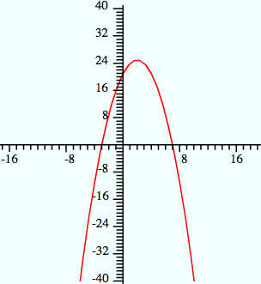
Notes: Factored form is easiest to use with the zeros as the given information. We just need to have a negative leading coefficient. Any negative number will work. This example uses a = –1:
f(x) = - (x + 3)(x – 7).
To graph this function, plot the zeros/intercepts (–3, 0) and (7, 0). The vertex will be on the axis of symmetry (x = 2). Evaluate the equation for x = 2 to find the vertex, (2, 25), and sketch.
Results for the graphs may be wider or narrower, and the vertex may be higher or lower. However, all should open down, pass through the points (–3, 0) and (7, 0), and have 2 as the x-coordinate for the vertex.

