Table of Contents
GRADE 4 • MODULE 6
Decimal Fractions

Module Overview i

Topic A: Exploration of Tenths 6.A.1

Topic B: Tenths and Hundredths 6.B.1

Topic C: Decimal Comparison 6.C.1

Topic D: Addition with Tenths and Hundredths 6.D.1

Topic E: Money Amounts as Decimal Numbers 6.E.1

Module Assessments 6.S.1

Grade 4 • Module 6
Decimal Fractions
OVERVIEW
This 20-day module gives students their first opportunity to explore decimal numbers via their relationship to decimal fractions, expressing a given quantity in both fraction and decimal forms. Utilizing the understanding of fractions developed throughout Module 5, students apply the same reasoning to decimal numbers, building a solid foundation for Grade 5 work with decimal operations. Previously referred to as whole numbers, all numbers written in the base ten number system with place value units that are powers of 10 are henceforth referred to as decimal numbers, a set which now includes tenths and hundredths, e.g., 1, 15, 248, 0.3, 3.02, and 24.345.
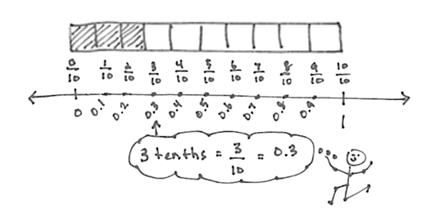
In Topic A, students use their understanding of fractions to explore tenths. At the opening of the topic, they use metric measurement to see tenths in relation to different whole units: centimeters, meters, kilograms, and liters. Students explore, creating and identifying tenths of various wholes, as they draw lines of specified length, identify the weight of objects, and read the level of liquid measurements. Students connect these concrete experiences pictorially as tenths are represented on the number line and with tape diagrams as pictured to the right. Students express tenths as decimal fractions and are introduced to decimal notation. They write statements of equivalence in unit, fraction, and decimal forms, e.g., 3 tenths = $\frac{3}{10}$ = 0.3 (4.NF.6). Next, students return to the use of metric measurement to investigate decimal fractions greater than 1. Using a centimeter ruler, they draw lines that measure, for example, $\text{2}\frac{4}{10}$ or $\text{6}\frac{8}{10}$ centimeters. Using the area model, students see that numbers containing a whole number and fractional part, i.e., mixed numbers, can also be expressed using decimal notation provided that the fractional part can be converted to a decimal number (4.NF.6). Students use place value disks to represent the value of each digit in a decimal number. Just as they wrote whole numbers in expanded form using multiplication, students write the value of a decimal number in expanded form using fractions and decimals, e.g., 2 ones 4 tenths = $\text{2}\frac{4}{10}$ = (2 $\text{×}$ 1) + (4 $\text{×}$ $\frac{1}{10}\text{)}$ and 2.4 = (2 $\text{×}$ 1) + (4 $\text{×}$ 0.1). Additionally, students plot decimal numbers on the number line.
Students decompose tenths into 10 equal parts to create hundredths in Topic B. Through the decomposition of a meter, students identify 1 centimeter as 1 hundredth of a meter. As students count up by hundredths, they realize the equivalence of 10 hundredths and 1 tenth and go on to represent them as both decimal fractions and as decimal numbers (4.NF.5). Students use area models, tape diagrams, and number disks on a place value chart to see and model the equivalence of numbers involving units of tenths and hundredths. They express the value of the number in both decimal and fraction expanded forms.
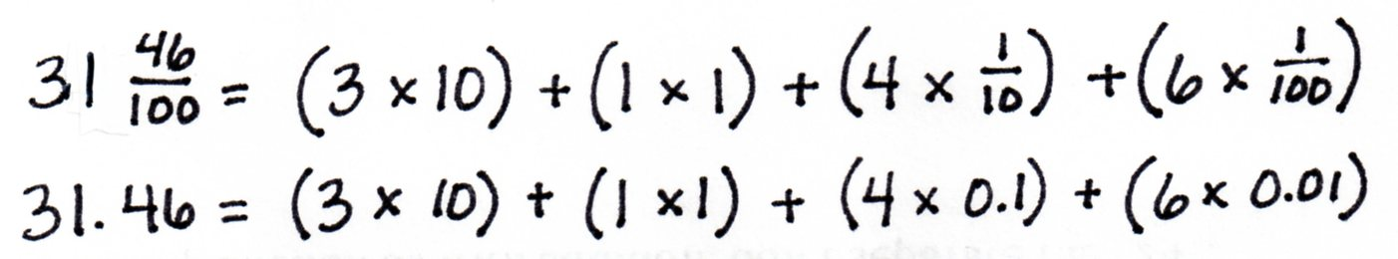

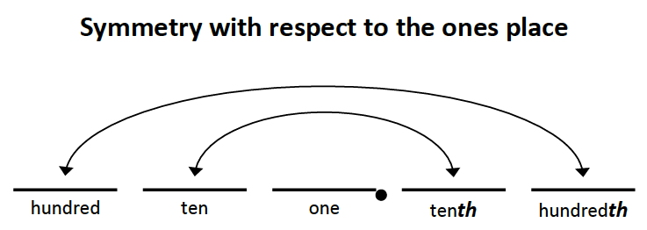
Close work with the place value chart helps students see that place value units are not symmetric about the decimal point—a common misconception that often leads students to mistakenly believe there is a oneths place. They explore the placement of decimal numbers to hundredths and recognize that the place value chart is symmetric about the ones column. This understanding helps students recognize that, even as we move to the units on the right side of the decimal on the place value chart, a column continues to represent a unit 10 times as large as that of the column to its right. This understanding builds on the place value work done in Module 1 and enables students to understand that 3.2, for example, might be modeled as 3 ones 2 tenths, 32 tenths, or 320 hundredths. Topic B concludes with students using their knowledge of fraction equivalence to work with decimal numbers expressed in unit form, fraction form, and decimal form (4.NF.6).
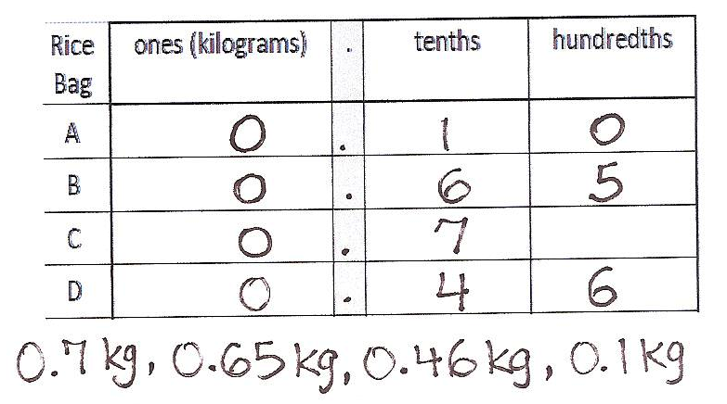
The focus of Topic C is comparison of decimal numbers (4.NF.7). To begin, students work with concrete representations of measurements. They see measurement of length on meter sticks, of mass using a scale, and of volume using graduated cylinders. In each case, students record the measurements on a place value chart and then compare them. They use their understanding of metric measurement and decimals to answer questions, such as, “Which is greater? Less? Which is longer? Shorter? Which is heavier? Lighter?” Comparing the decimals in the context of measurement supports students’ justification of their comparisons and grounds their reasoning, while at the same time setting them up for work with decimal comparison at a more concrete level. Next, students use area models and number lines to compare decimal numbers and use the <, >, and = symbols to record their comparisons. All of their work with comparisons at the pictorial level helps to eradicate the common misconception that is often made when students assume a greater number of hundredths must be greater than a lesser number of tenths. For example, when comparing 7 tenths and 27 hundredths, students recognize that 7 tenths is greater than 27 hundredths because, as in any comparison, one must consider the size of the units. Students go on to arrange mixed groups of decimal fractions in unit, fraction, and decimal forms in order from greatest to least, or least to greatest. They use their understanding of different ways of expressing equivalent values to arrange a set of decimal fractions as pictured below.
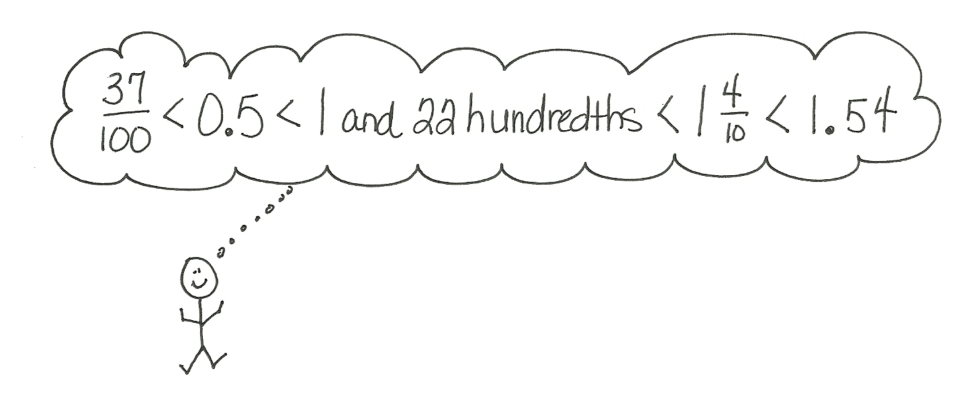
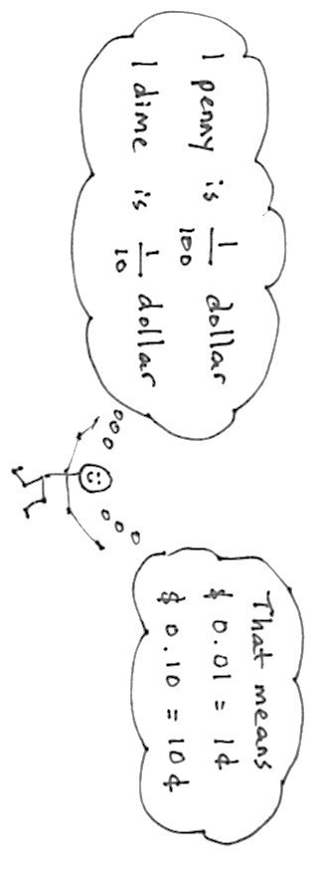
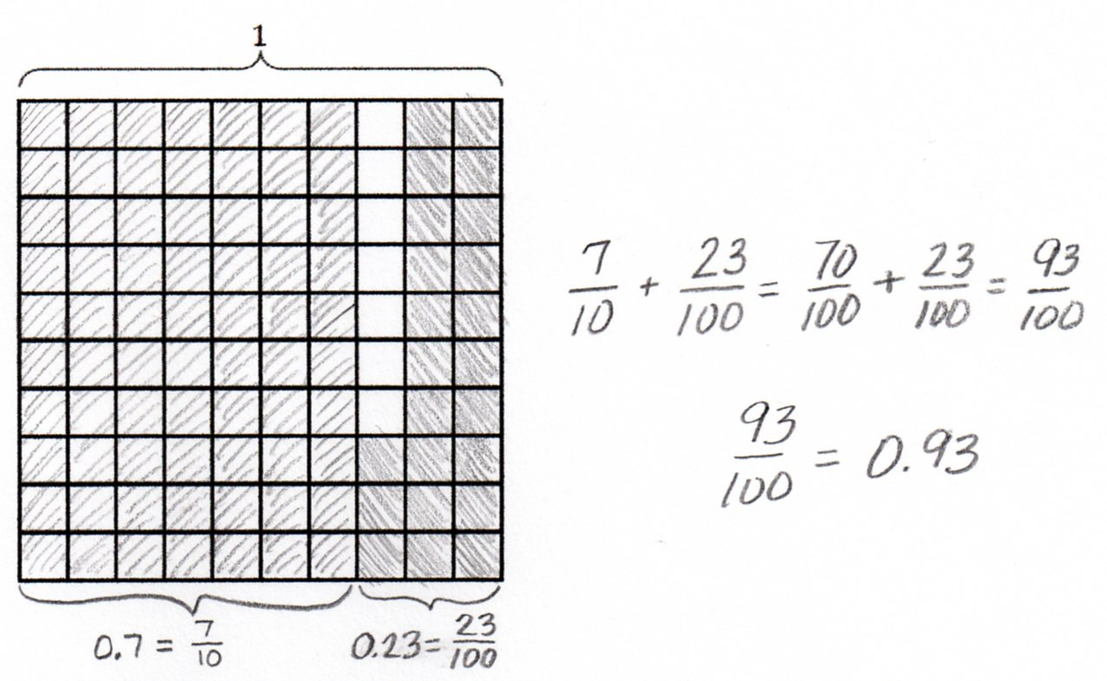
Topic D introduces the addition of decimals by way of finding equivalent decimal fractions and adding fractions. Students add tenths and hundredths, recognizing that they must convert the addends to the same units (4.NF.5). The sum is then converted back into a decimal (4.NF.6). They use their knowledge of like denominators and understanding of fraction equivalence to do so. Students use the same process to add and subtract mixed numbers involving decimal units. They then apply their new knowledge to solve word problems involving metric measurements.
Students conclude their work with decimal fractions in Topic E by applying their knowledge to the real world context of money. They recognize 1 penny as $\frac{1}{100}$ dollar, 1 dime as $\frac{1}{10}$ dollar, and 1 quarter as $\frac{25}{100}$ dollar. They apply their understanding of tenths and hundredths to write given amounts of money in both fraction and decimal forms. To do this, students decompose a given amount of money into dollars, quarters, dimes, and pennies and express the amount as a decimal fraction and decimal number. Students then add various numbers of coins and dollars using Grade 2 knowledge of the equivalence of 100 cents to 1 dollar. Addition and subtraction word problems are solved using unit form, adding dollars and cents. Multiplication and division word problems are solved using cents as the unit (4.MD.2). The final answer in each word problem is converted from cents into a decimal using a dollar symbol for the unit. For example, Jack has 2 quarters and 7 dimes. Jim has 1 dollar, 3 quarters, and 6 pennies. How much money do they have together? Write your answer as a decimal.
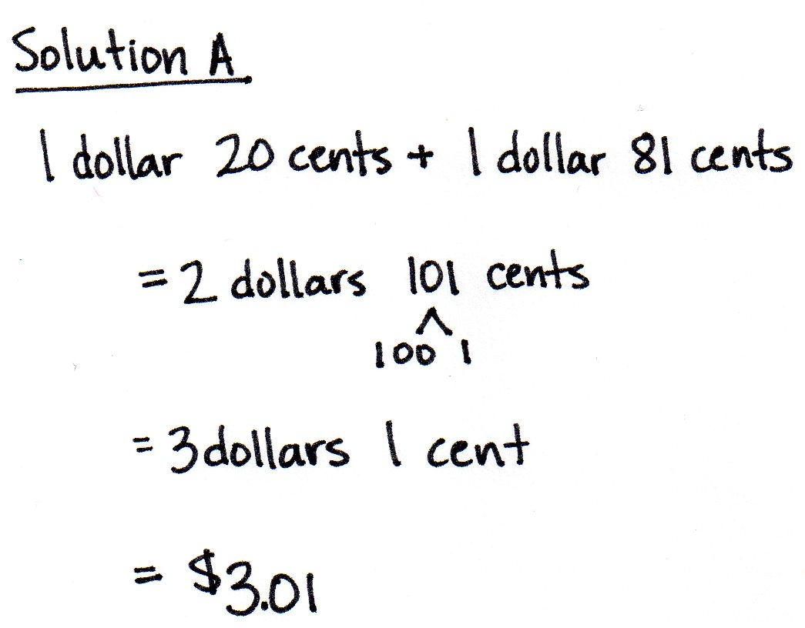

Focus Grade Level Standards
Understand decimal notation for fractions, and compare decimal fractions.
4.NF.5 Express a fraction with denominator 10 as an equivalent fraction with denominator 100, and use this technique to add two fractions with respective denominators 10 and 100. For example, express 3/10 as 30/100, and add 3/10 + 4/100 = 34/100. (Students who can generate equivalent fractions can develop strategies for adding fractions with unlike denominators in general. But addition and subtraction with unlike denominators in general is not a requirement at this grade.)
4.NF.6 Use decimal notation for fractions with denominators 10 or 100. For example, rewrite 0.62 as 62/100; describe a length as 0.62 meters; locate 0.62 on a number line diagram.
4.NF.7 Compare two decimals to hundredths by reasoning about their size. Recognize that comparisons are valid only when the two decimals refer to the same whole. Record the results of comparisons with the symbols >, =, or <, and justify the conclusions, e.g., by using a visual model.

Solve problems involving measurement and conversion of measurements from a larger unit to a smaller unit.
4.MD.2 Use the four operations to solve word problems involving distances, intervals of time, liquid volumes, masses of objects, and money, including problems involving simple fractions or decimals, and problems that require expressing measurements given in a larger unit in terms of a smaller unit. Represent measurement quantities using diagrams such as number line diagrams that feature a measurement scale.
Foundational Standards
2. MD.8 Solve word problems involving dollar bills, quarters, dimes, nickels, and pennies, using $ and ¢ symbols appropriately. Example: If you have 2 dimes and 3 pennies, how many cents do you have?
3. NBT.3 Multiply one-digit whole numbers by multiples of 10 in the range 10–90 (e.g., 9 × 80, 5 × 60) using strategies based on place value and properties of operations.
3. NF.1 Understand a fraction 1/b as the quantity formed by 1 part when a whole is partitioned into b equal parts; understand a fraction a/b as the quantity formed by a parts of size 1/b.
3. NF.2 Understand a fraction as a number on the number line; represent fractions on a number line diagram.
- Represent a fraction a/b on a number line diagram by marking off a lengths 1/b from 0. Recognize that the resulting interval has size a/b and that its endpoint locates the number a/b on the number line.
3. NF.3 Explain equivalence of fractions in special cases, and compare fractions by reasoning about their size.
b. Recognize and generate simple equivalent fractions, (e.g., 1/2 = 2/4, 4/6 = 2/3). Explain why the fractions are equivalent, e.g., by using a visual fraction model.
d. Compare two fractions with the same numerator or the same denominator by reasoning about their size. Recognize that comparisons are valid only when the two fractions refer to the same whole. Record the results of comparisons with the symbols >, =, or <, and justify the conclusions, e.g., by using a visual fraction model.
3. MD.2 Measure and estimate liquid volumes and masses of objects using standard units of grams (g), kilograms (kg), and liters (l). (Excludes compound units such as cm³ and finding the geometric volume of a container.) Add, subtract, multiply, or divide to solve one-step word problems involving masses or volumes that are given in the same units, e.g., by using drawings (such as a beaker with a measurement scale) to represent the problem. (Excludes multiplicative comparison problems [problems involving notions of “times as much”; see CCSS Glossary, Table 2]).
Focus Standards for Mathematical Practice
MP.2 Reason abstractly and quantitatively. Throughout this module, students use area models, tape diagrams, number disks, and number lines to represent decimal quantities. When determining the equivalence of a decimal fraction and a fraction, students consider the units that are involved and attend to the meaning of the quantities of each. Further, students use metric measurement and money amounts to build an understanding of the decomposition of a whole into tenths and hundredths.
MP.4 Model with mathematics. Students represent decimals with various models throughout this module, including expanded form. Each of the models helps students to build understanding and to analyze the relationship and role of decimals within the number system. Students use a tape diagram to represent tenths and then to decompose one-tenth into hundredths. They use number disks and a place value chart to extend their understanding of place value to include decimal fractions. Further, students use a place value chart along with the area model to compare decimals. A number line models decimal numbers to the hundredths.
MP.6 Attend to precision. Students attend to precision as they decompose a whole into tenths and tenths into hundredths. They also make statements such as 5 ones and 3 tenths equals 53 tenths. Focusing on the units of decimals, students examine equivalence, recognize that the place value chart is symmetric around 1, and compare decimal numbers. In comparing decimal numbers, students are required to consider the units involved. Students communicate their knowledge of decimals through discussion and then apply their learning to add decimals, recognizing the need to convert to like units when necessary.
MP.8 Look for and express regularity in repeated reasoning. As they progress through this module, students have multiple opportunities to explore the relationships between and among units of ones, tenths, and hundredths. Relationships between adjacent place values, for example, are the same on the right side of the decimal point as they are on the left side, and students investigate this fact working with tenths and hundredths. Further, adding tenths and hundredths requires finding like units just as it does with whole numbers, such as when adding centimeters and meters. Students come to understand equivalence, conversions, comparisons, and addition involving decimal fractions.

Overview of Module Topics and Lesson Objectives
Standards | Topics and Objectives |  | Days
4.NF.6  4.NBT.1  4.MD.1 | A | Exploration of Tenths  Lesson 1: Use metric measurement to model the decomposition of one whole into tenths.  Lesson 2: Use metric measurement and area models to represent tenths as fractions greater than 1 and decimal numbers.  Lesson 3: Represent mixed numbers with units of tens, ones, and tenths with number disks, on the number line, and in expanded form. | 3
4.NF.5  4.NF.6  4.NBT.1  4.NF.1  4.NF.7  4.MD.1 | B | Tenths and Hundredths  Lesson 4: Use meters to model the decomposition of one whole into hundredths. Represent and count hundredths.  Lesson 5: Model the equivalence of tenths and hundredths using the area model and number disks.  Lesson 6: Use the area model and number line to represent mixed numbers with units of ones, tenths, and hundredths in fraction and decimal forms.  Lesson 7: Model mixed numbers with units of hundreds, tens, ones, tenths, and hundredths in expanded form and on the place value chart.  Lesson 8: Use understanding of fraction equivalence to investigate decimal numbers on the place value chart expressed in different units. | 5
 |  | Mid-Module Assessment: Topics A–B (assessment 1 day, return ½ day, remediation or further applications ½ day) | 2
4.NF.7  4.MD.1  4.MD.2 | C | Decimal Comparison  Lesson 9: Use the place value chart and metric measurement to compare decimals and answer comparison questions.  Lesson 10: Use area models and the number line to compare decimal numbers, and record comparisons using <, >, and =.  Lesson 11: Compare and order mixed numbers in various forms. | 3
4.NF.5  4.NF.6  4.NF.3c  4.MD.1 | D | Addition with Tenths and Hundredths  Lesson 12: Apply understanding of fraction equivalence to add tenths and hundredths.  Lesson 13: Add decimal numbers by converting to fraction form.  Lesson 14: Solve word problems involving the addition of measurements in decimal form. | 3
4.MD.2  4.NF.5  4.NF.6 | E | Money Amounts as Decimal Numbers  Lesson 15: Express money amounts given in various forms as decimal numbers.  Lesson 16: Solve word problems involving money. | 2
 |  | End-of-Module Assessment: Topics A–E (assessment 1 day, return ½ day, remediation or further applications ½ day) | 2
Total Number of Instructional Days |  |  | 20
Terminology
New or Recently Introduced Terms
- Decimal expanded form (e.g., ($\text{2} \text{×} \text{10)} \text{+} \left(\text{4} \text{×} \text{1}\right) \text{+} \left(\text{5} \text{×} \text{0.1}\right) \text{+} \left(\text{9} \text{×} \text{0.01}\right) \text{=} \text{24}\text{.}\text{59}$)
- Decimal fraction (fraction with a denominator of 10, 100, 1,000, etc.)
- Decimal number (number written using place value units that are powers of 10)
- Decimal point (period used to separate the whole number part from the fractional part of a decimal number)
- Fraction expanded form (e.g., ($\text{2} \text{×} \text{10)} \text{+} \left(\text{4} \text{×} \text{1}\right) \text{+}\left(\text{5} \text{×}\frac{\text{1}}{\text{10}}\right)\text{+}\left(\text{9} \text{×}\frac{\text{1}}{\text{100}}\right)\text{=} \text{24}\frac{\text{59}}{\text{100}}$)
- Hundredth (place value unit such that 100 hundredths equals 1 one)
- Tenth (place value unit such that 10 tenths equals 1 one)
Familiar Terms and Symbols
- Expanded form (e.g., 100 + 30 + 5 = 135)
- Fraction (numerical quantity that is not a whole number, e.g., $\frac{1}{3}$)

Suggested Tools and Representations
- 1-liter container with milliliter marks
- Area model
- Centimeter ruler
- Decimal place value disks (tenths and hundredths)
- Digital scale
- Meter stick
- Number line
- Place value chart with decimals to hundredths
- Tape diagram
- Whole number place value disks (hundreds, tens, and ones)
Scaffolds
The scaffolds integrated into A Story of Units give alternatives for how students access information as well as express and demonstrate their learning. Strategically placed margin notes are provided within each lesson elaborating on the use of specific scaffolds at applicable times. They address many needs presented by English language learners, students with disabilities, students performing above grade level, and students performing below grade level. Many of the suggestions are organized by Universal Design for Learning (UDL) principles and are applicable to more than one population. To read more about the approach to differentiated instruction in A Story of Units, please refer to “How to Implement A Story of Units.”
Assessment Summary
Type | Administered | Format | Standards Addressed
Mid-Module Assessment Task | After Topic B | Constructed response with rubric | 4.NF.5  4.NF.6
End-of-Module Assessment Task | After Topic E | Constructed response with rubric | 4.NF.5  4.NF.6  4.NF.7  4.MD.2

4.MD.1 is addressed in Modules 2 and 7; 4.MD.3 is addressed in Module 3.
These are terms and symbols students have seen previously.
Students with disabilities may require Braille, large print, audio, or special digital files. Please visit the website www.p12.nysed.gov/specialed/aim for specific information on how to obtain student materials that satisfy the National Instructional Materials Accessibility Standard (NIMAS) format.

