Name Date
- Write the following fractions as equivalent decimals. Then, model each decimal with the given representation.

- $\frac{2}{10}$ = _______
- $\frac{3}{100}$ = _______

- $\frac{4}{10}$ = _______

- $\frac{46}{100}$= _______

- $\text{7}\frac{6}{10}$ = _______
7
8
- $3\frac{64}{100}$= _______
3.7
3.6

- $\text{4}\frac{7}{10}$ = _____
- $\text{5}\frac{72}{100}=_____$
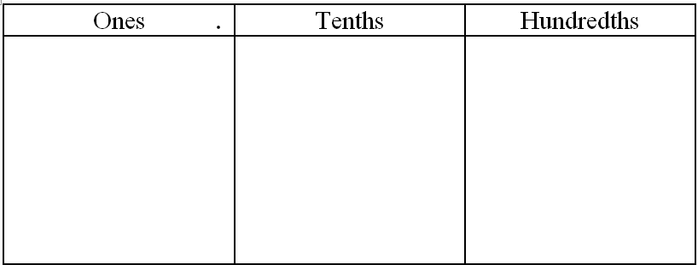

- Decompose tenths into hundredths using the area model. Express the equivalence of tenths and hundredths with fractions and with decimals.

  - 3 tenths b. 1 and 7 tenths

- Use number bonds to complete Parts (a) and (b) below:

  - Decompose 3.24 by units. b. Compose 0.03, 0.5, and 2 as one decimal number.

- Model the following equivalence on the place value chart using number disks.
20 hundredths = 2 tenths
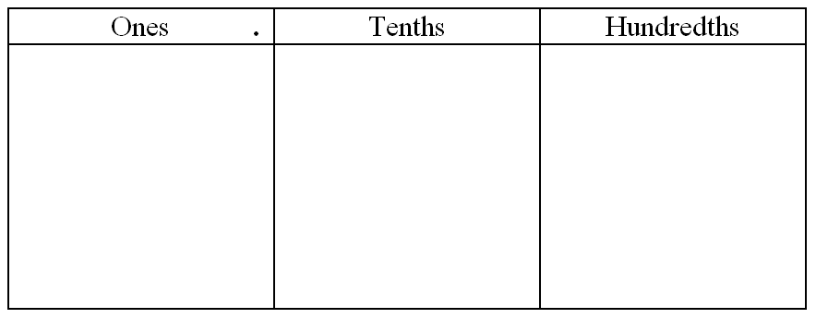

- Complete the following chart.

 | Unit Form | Fraction | Fraction Expanded Form | Decimal Expanded Form | Decimal
a. | 1 tenth  6 hundredths
b. |  | $$2\frac{7}{10}$$
c. |  |  |  |  | 6.34
d. |  |  |  | (1$\text{×}$10) + (6$\text{×}$1) + (5$\text{×}$0.01)
e. |  |  | $\text{(2} \text{×} \text{10)} \text{+} \text{(3} \text{×} \text{1)} \text{+}\left(\text{7} \text{×}\frac{1}{10}\right)\text{+}\left(\text{8} \text{×}\frac{1}{100}\right)$

- Maya puts groceries into bags. The items and their weights in kilograms are given below.

 | 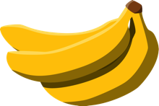 | 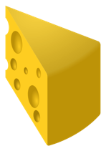 | 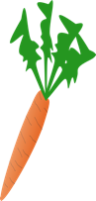 | 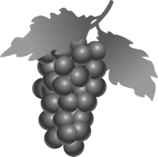 | 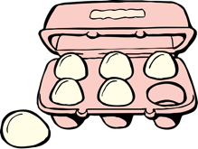
Bread | Bananas | Cheese | Carrots | Grapes | Eggs
$$0.25$$ | $$0.34$$ | $$0.56$$ | $$\frac{25}{100}$$ | $$\frac{56}{100}$$ | $$\frac{34}{100}$$
- Plot the weight of each item on the number line below.

0
1

- Write a number sentence using decimals to record the weight of the bananas in expanded form.

- Write a number sentence using fractions to record the weight of the grapes in expanded form.

Maya packs the eggs and cheese into one of the bags. Together, these items weigh $\frac{90}{100}$ kilogram.
- Use the area model to show that $\frac{90}{100}$ can be renamed as tenths.
=

- Use division to show how $\frac{90}{100}$ can be renamed as tenths.

Maya places the bread into the bag with the eggs and cheese. Together, all three items weigh 1 and 15 hundredths kilograms.
- Use a model and words to explain how 1 and 15 hundredths can be written as a decimal and as a fraction.

Maya put the rest of the groceries in a second bag. The items in both bags weigh a total of $\text{2}\frac{30}{100}$ kilograms.
- Using a model and words, explain how many tenths are in $\text{2}\frac{30}{100}$.

Mid-Module Assessment Task Topics A–B
Standards Addressed
Understand decimal notation for fractions, and compare decimal fractions.
4.NF.5 Express a fraction with denominator 10 as an equivalent fraction with denominator 100, and use this technique to add two fractions with respective denominators 10 and 100. For example, express 3/10 as 30/100, and add 3/10 + 4/100 = 34/100. (Students who can generate equivalent fractions can develop strategies for adding fractions with unlike denominators in general. But addition and subtraction with unlike denominators in general is not a requirement at this grade.)
4.NF.6 Use decimal notation for fractions with denominators 10 or 100. For example, rewrite 0.62 as 62/100; describe a length as 0.62 meters; locate 0.62 on a number line diagram.

Evaluating Student Learning Outcomes
A Progression Toward Mastery is provided to describe steps that illuminate the gradually increasing understandings that students develop on their way to proficiency. In this chart, this progress is presented from left (Step 1) to right (Step 4). The learning goal for students is to achieve Step 4 mastery. These steps are meant to help teachers and students identify and celebrate what the students CAN do now and what they need to work on next.

A Progression Toward Mastery
Assessment  Task Item  and  Standards Assessed | STEP 1  Little evidence of reasoning without a correct answer.  (1 Point) | STEP 2  Evidence of some reasoning without a correct answer.  (2 Points) | STEP 3  Evidence of some reasoning with a correct answer or evidence of solid reasoning with an incorrect answer.  (3 Points) | STEP 4  Evidence of solid reasoning with a correct answer.  (4 Points)
1  4.NF.6 | The student correctly completes three or fewer parts of the question with little to no modeling. | The student correctly solves at least four parts of the question, providing evidence of some reasoning. | The student correctly solves six or seven of the eight parts of the question.  OR  The student correctly answers all eight parts but incorrectly models on no more than two parts. | The student correctly writes the equivalent fractions and correctly models using the given representation:  - 0.2  - 0.03  - 0.4  - 0.46  - 7.6  - 3.64  - 4.7  - 5.72
2  4.NF.5  4.NF.6 | The student is unable to correctly answer any of the parts. | The student answers one part correctly. | The student correctly represents the decomposition or correctly writes an equivalent equation in one of the questions. OR  The student correctly writes equivalent statements for all parts but incorrectly decomposes in just one part. | The student correctly:  - Decomposes the models into hundredths, shading the correct amount.  - Expresses the equivalence using fractions and decimals:  - $\frac{3}{10}$ = $\frac{30}{100}$  and 0.3 = 0.30.  - $1\frac{7}{10}$ = $1\frac{70}{100}$  and 1.7 = 1.70.
3  4.NF.6 | The student is unable to correctly compose or decompose. | The student answers one part correctly. | The student decomposes 3.24 into just two bonds (3, 0.24) and answers Part (b) correctly. | The student correctly:  - Decomposes 3.24 into number bonds: 3, 0.2, 0.04.  - Composes 2.53.
4  4.NF.5 | The student shows little understanding of the number disks and equivalence. | The student models equivalence but does not use number disks. | The student shows some understanding of the number disks and supplements with a written explanation. | The student correctly uses number disks to show the equivalence of 20 hundredths and 2 tenths in the place value chart.
5  4.NF.5  4.NF.6 | The student correctly answers fewer than 10 of the expressions in the chart. | The student correctly answers 10 to 14 of the expressions in the chart. | The student correctly answers 15 to 19 of the expressions in the chart. | The student correctly answers each expression.  (Note: Unit form may have more than one correct answer.)  - 1 tenth 6 hundredths; $\frac{16}{100}$; $(1 \text{×}\frac{1}{10}$ ) + (6 × $\frac{1}{100})$;  (1 × 0.1) + (6 × 0.01); 0.16.  - 2 ones 7 tenths; 2 $\frac{7}{10}$; (2 × 1) + (7 × $\frac{1}{10})$; (2 × 1) + (7 × 0.1); 2.7.  - 6 ones 3 tenths 4 hundredths; 6 $\frac{34}{100}$; (6 × 1) + (3 × $\frac{1}{10})$ + (4 × $\frac{1}{100})$; (6 × 1) + (3 × 0.1) + (4 × 0.01); 6.34.  - 1 ten 6 ones 5 hundredths; 16$\frac{5}{100};$ (1 × 10) + (6 × 1) + (5 × $\frac{1}{100})$; (1 × 10) + (6 × 1) + (5 × 0.01); 16.05.  - 2 tens 3 ones 7 tenths 8 hundredths; 23$\frac{78}{100}$; (2 × 10) + (3 × 1) + (7 × $\frac{1}{10})$ + (8 × $\frac{1}{100})$; (2 × 10) + (3 × 1) + (7 × 0.1) + (8 × 0.01); 23.78.
6  4.NF.5  4.NF.6 | The student correctly answers fewer than three problems. | The student correctly answers three or four of the seven problems, providing evidence of some reasoning. | The student correctly answers five or six of the seven problems. OR  The student answers all parts correctly but without solid evidence or reasoning on fewer than two problems. | The student correctly:  - Plots each item on the number line.  - Responds 0.3 + 0.04 = 0.34 or (3$×$0.1) + (4$×$0.01) = 0.34.  - Responds $\frac{5}{10}$+ $\frac{6}{100}$= $\frac{56}{100}$ or $\left(\text{5} \text{×}\frac{1}{10}\right)\text{+}\left(\text{6} \text{×}\frac{1}{100}\right) = \text{=}\frac{56}{100}$.  - Represents $\frac{90}{100}$=$\frac{9}{10}$ in the area models.  - Responds $\frac{90}{100}\text{=}\frac{90 ÷ 10}{100 ÷10}$ = $\frac{9}{10}$.  - Models and explains that 1 and 15 hundredths equals $\text{1}\frac{15}{100}$and 1.15.  - Models and explains that there are 23 tenths in $\text{2}\frac{30}{100}$.

