Name Date
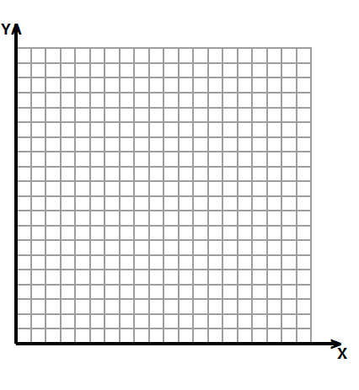
0 $\frac{1}{2}$ 1 1$\frac{1}{2}$ 2 2$\frac{1}{2}$ 3 3$\frac{1}{2}$ 4 4$\frac{1}{2}$ 5
$\frac{1}{2}$
1
1$\frac{1}{2}$
2
2$\frac{1}{2}$
3
3$\frac{1}{2}$
4$\frac{1}{2}$
4
5
- Follow the directions.

- Draw a ray that starts at point $L$ at ($\text{1}\frac{1}{2}$, 3) and includes point $K$ at (5, 3). Label points $K$ and $L$.

- Give the coordinates of three other points on the ray.

- Draw a second ray with the same initial point and containing point $M$ with coordinates ($\text{3}\frac{1}{2}, \text{4}\frac{1}{4}$). Label point $M$.

0 $\frac{1}{2}$ 1 1$\frac{1}{2}$ 2 2$\frac{1}{2}$
$\frac{1}{2}$
1
1$\frac{1}{2}$
2
2$\frac{1}{2}$
- David draws a line segment from point $Q$ ($\frac{1}{4}$, $\frac{7}{8}$) to point $R$ ($\frac{5}{8}$,$\frac{1}{2}$). He then draws a line perpendicular to the first segment that intersects segment $\overline{QR}$and includes point $S$ ($\frac{3}{4}$, 1).

- Draw $\overline{QR}$and label the endpoints on the grid.

- Draw the perpendicular line and label point $S.$

- Name another point that lies on the perpendicular line whose$x$-coordinate is between 1 and $\text{1}\frac{1}{2}$.

- Complete the table for the rule multiply by 2 then add 2 for the values of $x$ from 0 to 4. Then use the coordinate plane to answer the questions.

$$x$$ | $$y$$ | ($x,y$)
0
1
2
3
4
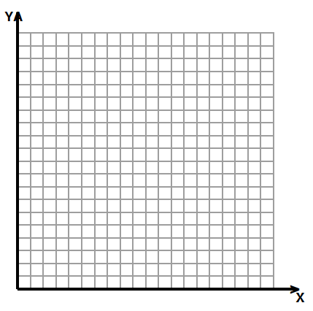
0 1 2 3 4 5 6 7 8 9 10 11 12 13 14 15 16 17 18 19 20

20
19
18
17
16
15
14
13
12
11
10
9
8
7
6
5
4
3
2
1

$$a$$
$$b$$
$$c$$
$$d$$

- Which line shows the rule in the table?

- Give the coordinates for the intersection of lines $b$ and $c$.

- Draw a line on the graph such that any point on the line has a $y$-coordinate of 2. Label your line as $e$.

- Which coordinate is 2 for any point on line $c$?

- Write a rule that that tells how to find the $y$-coordinate when the $x$-coordinate is given for the points on line $b$.

- Kim and Lacy want to draw a line on the coordinate plane that is parallel to line $a$. Kim uses the rule, multiply by 4 and add 2 to generate her $y$-coordinates. Lacy uses the rule multiply by 2 and add 4 to generate her y-coordinates. Which girl’s line will be parallel to line $a$? Without graphing the lines, explain how you know.

- An airplane is descending into an airport. When its altitude is 5 miles, it is 275 miles from the airport. When its altitude is 4 miles, it is 200 miles from the airport. At 3 miles, it is 125 miles from the airport.

Altitude
2 mi

3 mi

4 mi

5 mi

1 mi

50 100 150 200 250
Miles from Airport



- If the pilot follows the same pattern, what will the plane’s altitude be at 50 miles from the airport?

- For the plane to land at the airport, the altitude will need to be 0 and the distance from the airport will need to be 0. Should the pilot continue this pattern? Why or why not?

End-of-Module Assessment Topics A–D
Standards Addressed
Write and interpret numerical expressions.
5.OA.2 Write simple expressions that record calculations with numbers, and interpret numerical expressions without evaluating them. For example, express the calculation “add 8 and 7, then multiply by 2” as 2 × (8 + 7). Recognize that 3 × (18932 + 921) is three times as large as 18932 + 921, without having to calculate the indicated sum or product.
Analyze patterns and relationships.
5.OA.3 Generate two numerical patterns using two given rules. Identify apparent relationships between corresponding terms. Form ordered pairs consisting of corresponding terms from the two patterns, and graph the ordered pairs on a coordinate plane. For example, given the rule “Add 3” and the starting number 0, and given the rule “Add 6” and the starting number 0, generate terms in the resulting sequences, and observe that the terms in one sequence are twice the corresponding terms in the other sequence. Explain informally why this is so.
Graph points on the coordinate plane to solve real-world and mathematical problems.
5.G.1 Use a pair of perpendicular number lines, called axes, to define a coordinate system, with the intersection of the lines (the origin) arranged to coincide with the 0 on each line and a given point in the plane located by using an ordered pair of numbers, called its coordinates. Understand that the first number indicates how far to travel from the origin in the direction of one axis, and the second number indicates how far to travel in the direction of the second axis, with the convention that the names of the two axes and the coordinates correspond (e.g., $x$-axis and $x$-coordinate, $y$-axis and $y$-coordinate).
5.G.2 Represent real world and mathematical problems by graphing points in the first quadrant of the coordinate plane, and interpret coordinate values of points in the context of the situation.

Evaluating Student Learning Outcomes
A Progression Toward Mastery is provided to describe steps that illuminate the gradually increasing understandings that students develop on their way to proficiency. In this chart, this progress is presented from left (Step 1) to right (Step 4). The learning goal for each student is to achieve Step 4 mastery. These steps are meant to help teachers and students identify and celebrate what the student CAN do now and what they need to work on next.

A Progression Toward Mastery
Assessment  Task Item  and  Standards Assessed | STEP 1  Little evidence of reasoning without a correct answer.  (1 Point) | STEP 2  Evidence of some reasoning without a correct answer.  (2 Points) | STEP 3  Evidence of some reasoning with a correct answer or evidence of solid reasoning with an incorrect answer.  (3 Points) | STEP 4  Evidence of solid reasoning with a correct answer.  (4 Points)
1  5.G.1 | The student accurately completes at least three of the tasks embedded in the question. | The student accurately completes at least four of the tasks embedded in the question. | The student accurately completes at least five of the tasks embedded in the question. | The student accurately completes each task embedded in the question.  - Draws a ray with points at coordinates ($\text{1}\frac{1}{2}$, 3) and (5, 3).  - Labels point$L$.  - Labels point $K$.  - Gives the coordinates of three other points on the ray. (Correct answers are any two coordinates with the $y$-coordinate of 3.)  - Draws a second ray with one point at the coordinates ($\text{1}\frac{1}{2}$, 3) and point $M$ at ($\text{3}\frac{1}{2}$, $\text{4}\frac{1}{4}$).  - Labels point $M$.
2  5.G.1  5.G.2 | The student accurately completes at least two of the tasks embedded in the question. | The student accurately completes at least three of the tasks embedded in the question. | The student accurately completes at least four of the tasks embedded in the question. | The student accurately completes all of the tasks embedded in the question:  - Draws $\overline{QR}$.  - Labels $\overline{QR}$.  - Draws a line perpendicular to $\overline{QR}$.  - Labels point $S.$  - Names one of the following coordinates:  $1\frac{1}{8}, 1\frac{3}{8}$  $1\frac{1}{4},1\frac{1}{2}$ or equivalent  $1\frac{3}{8}, 1\frac{5}{8}$.
3  5.G.1  5.OA.2  5.OA.3 | The student accurately completes at least two of the tasks embedded in the question. The table counts as one task. | The student accurately completes at least three of the tasks embedded in the question. The table counts as one task. | The student accurately completes at least five of the tasks embedded in the question. The table counts as one task. | The student accurately completes all of the tasks embedded in the question and gives correct responses.  - Completes the table:  $$x$$ $$y$$ ($x,y$)  0 2 (0,2)  1 4 (1,4)  2 6 (2,6)  3 8 (3,8)  4 10 (4,10)  - Line $a$.  - (2, 6).  - Draws and labels line $e$ parallel to the $x$-axis, $y$ coordinate 2.  - The $x$-coordinate.  - Add 4 or plus 4.  - Lacy’s rule will make a line parallel to line $a$. The rule for line $a$ is multiply $x$ by 2, add 2$.$ The rule for Lacy’s line is multiply $x$-coordinate by 2 and add 4.  Lacy’s line is parallel because the steepness of the line is the same. (That is, the multiplication part of the rule is the same.) The adding part of the rule will make the $y$-coordinates two more than those in line $a$.)
4  5.G.1  5.G.2  5.OA.3 | The student has no correct answers for either Part (a) or Part (b). | The student has correctly answered either Part (a) or Part (b), but may not have a clear answer of why for Part (b). | The student has correctly answered both Part (a) and Part (b), but lacks a clear answer of why for Part (b). | The student has accurately completed Part (a) and Part (b), including a clear explanation of why for Part (b).  - The plane’s altitude will be 2 miles.  - No, the pilot should not continue this pattern. If he continues this pattern, his plane will have 0 altitude between 1 and 2 miles past the airport (or other correct response).

