Table of Contents
GRADE 3 • MODULE 7
Geometry and Measurement Word Problems

Module Overview i

Topic A: Solving Word Problems 7.A.1

Topic B: Attributes of Two-Dimensional Figures 7.B.1

Topic C: Problem Solving with Perimeter 7.C.1

Topic D: Recording Perimeter and Area Data on Line Plots 7.D.1

Topic E: Problem Solving with Perimeter and Area 7.E.1

Topic F: Year in Review 7.F.1

Module Assessments 7.S.1

NOTE: Student sheets should be printed at 100% scale to preserve the intended size of figures for accurate measurements. Adjust your copier or printer settings to actual size and set page scaling to none.

Grade 3 • Module 7
Geometry and Measurement Word Problems

OVERVIEW
The final module of the year offers students intensive practice with word problems, as well as hands-on investigation experiences with geometry and perimeter.
Topic A begins with solving one- and two-step word problems based on a variety of topics studied throughout the year, using all four operations (3.OA.8). The lessons emphasize modeling and reasoning to develop solution paths. They incorporate teacher facilitated problem solving, opportunities for students to independently make sense of problems and persevere in solving them, and time for students to share solutions and critique peer strategies.
Topic B introduces an exploration of geometry. Students build on Grade 2 ideas about polygons and their properties, specifically developing and expanding their knowledge of quadrilaterals. They explore the attributes of quadrilaterals and classify examples into various categories, including recognizing the characteristics of polygons (3.G.1). Students draw polygons based on their attributes, producing sketches from descriptions like, “This shape has two long sides that are parallel, two short sides, and no right angles.”
Tangram Puzzle
Students next use tangrams and tetrominoes (see examples to the right) to compose and decompose shapes. They reason about the relationships between shapes and between attributes. For example, students understand that quadrilaterals can be decomposed into triangles, and recognize that the two smallest triangles in a tangram puzzle can be put together to form a parallelogram, a square, and a medium triangle.

Tetrominoes
Students tessellate to bridge geometry experience with the study of perimeter in Topic C. They first decompose a quadrilateral and then rearrange the parts. They use the new shape to tile. Students then define perimeter in two distinct ways: (1) as the boundary of a planar region and (2) as the length of the boundary curve. Students see varied examples from the tiles used to tessellate.
or
Cut on the line. Then slide the piece to the opposite side or rotate it to an adjacent side to make a new shape.

As they learn about perimeter as an attribute of plane figures, students apply their knowledge to real world situations through problem solving (3.MD.8). They measure side lengths of shapes in whole number units to determine perimeter and solve problems where side lengths are given. They use string and rulers to measure the length around circles of different sizes. This variation prompts students to think more flexibly about perimeter, and to understand that it can be the boundary of any shape and that its measurements are not limited to whole numbers. The topic ends with problems in which some measurements around the perimeter of a polygon are missing but can be determined by reasoning. Students consider the efficiency of their strategies and identify tools for solving; for example, they use multiplication as a tool when measurements are repeated.
Topic D utilizes the line plot, familiar from Module 6, to help students draw conclusions about perimeter and area measurements (3.MD.4). Early in the topic, students find different possible perimeters or areas for rectangles based on information given about the rectangles. For example, using knowledge of factors from experience with multiplication, students determine the following:
- Different perimeters of rectangles comprised of a given number of unit squares (3.MD.8).
  - For example, given a rectangle composed of 24 unit squares, students find four possible perimeters: 50, 28, 22, and 20 length units.
- Different areas of rectangles comprised of unit squares with a given perimeter.
  - For example, students use unit squares to build rectangles with a perimeter of 12 units and determine that they can do so using 5, 8, or 9 unit squares.
(Rectangles are formed with unit squares, and as a result they have whole number side lengths.)
Students then draw their rectangles on grid paper and reason about their findings, noticing, for example, that for rectangles of a given area, those with side lengths that are equal or almost equal (more square-like) have smaller perimeters than those whose side lengths are very different (a long and narrow shape). They use line plots to show the number of rectangles they were able to construct for each set of given information. The line plots are a tool that students use to help them reason and draw conclusions about their data.
As they move through the lessons in this topic, students notice and compare differences in the strategies for finding area when given a perimeter and for finding perimeter given an area. By the end of the topic they are able to conclude that there is no direct relationship between area and perimeter, meaning that if an area is given there is no way of knowing a shape’s corresponding perimeter.
In Topic E, students solve problems involving area and perimeter. After an initial lesson problem solving with perimeter, students apply this knowledge to create a robot composed of rectangles. Given specific perimeter measurements, they reason about the different side lengths that may be produced. Students compare and analyze their work, discussing how different choices for side lengths can affect area while conforming to the criteria for perimeter. Students synthesize their learning in the final lessons through solving word problems involving area and perimeter using all four operations (3.OA.8).

Topic F concludes the school year with a set of engaging lessons that briefly review the fundamental Grade 3 concepts of fractions, multiplication, and division. This topic comes after the End-of-Module Assessment. It begins with a pair of lessons on fractions, engaging students in analyzing and creating unusual representations of one-half such as those shown to the right. Students analyze and discuss these representations, using their knowledge of fractions to justify their constructions and critique the work of others to make adjustments as necessary. The final lessons in this topic are fluency based and engage students in games that provide practice to solidify their automaticity with Grade 3 skills. Using simple origami techniques they create booklets of these games. The booklets go home and become resources for summer practice.
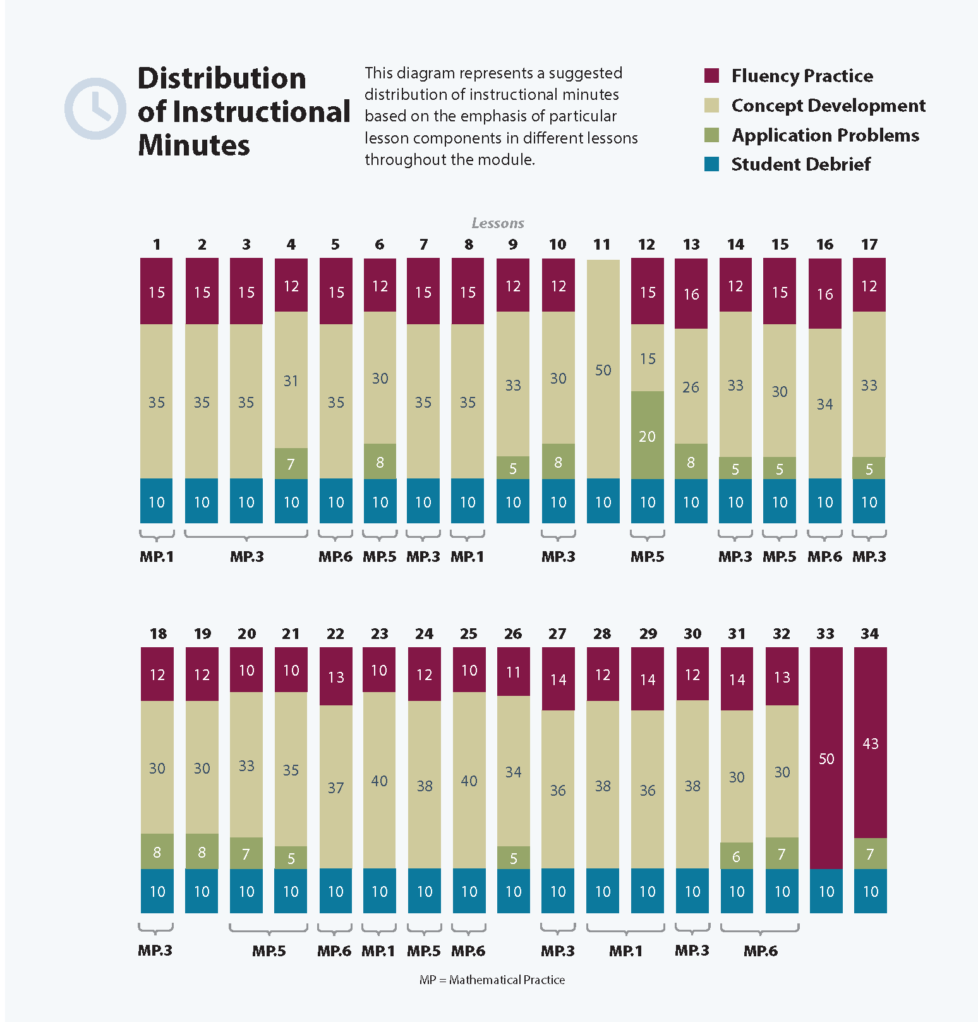
Focus Grade Level Standards
Solve problems involving the four operations, and identify and explain patterns in arithmetic.
3.OA.8 Solve two-step word problems using the four operations. Represent these problems using equations with a letter standing for the unknown quantity. Assess the reasonableness of answers using mental computation and estimation strategies including rounding. (This standard is limited to problems posed with whole numbers and having whole-number answers; students should know how to perform operations in the conventional order when there are no parentheses to specify a particular order [Order of Operations].)
Represent and interpret data.
3.MD.4 Generate measurement data by measuring lengths using rulers marked with halves and fourths of an inch. Show the data by making a line plot, where the horizontal scale is marked off in appropriate units—whole numbers, halves, or quarters.
Geometric measurement: recognize perimeter as an attribute of plane figures and distinguish between linear and area measures.
3.MD.8 Solve real world and mathematical problems involving perimeters of polygons, including finding the perimeter given the side lengths, finding an unknown side length, and exhibiting rectangles with the same perimeter and different areas or with the same area and different perimeters.
Reason with shapes and their attributes.
3.G.1 Understand that shapes in different categories (e.g., rhombuses, rectangles, and others) may share attributes (e.g., having four sides), and that the shared attributes can define a larger category (e.g., quadrilaterals). Recognize rhombuses, rectangles, and squares as examples of quadrilaterals, and draw examples of quadrilaterals that do not belong to any of these subcategories.

Foundational Standards
2.MD.1 Measure the length of an object by selecting and using appropriate tools such as rulers, yardsticks, meter sticks, and measuring tapes.
2.MD.6 Represent whole numbers as lengths from 0 on a number line diagram with equally spaced points corresponding to the numbers 0, 1, 2, ..., and represent whole-number sums and differences within 100 on a number line diagram.
2.G.1 Recognize and draw shapes having specified attributes, such as a given number of angles or a given number of equal faces. Identify triangles, quadrilaterals, pentagons, hexagons, and cubes. (Sizes are compared directly or visually, not compared by measuring.)
3.MD.5 Recognize area as an attribute of plane figures and understand concepts of area measurement:
a. A square with side length 1 unit, called “a unit square,” is said to have “one square unit” of area, and can be used to measure area.
b. A plane figure which can be covered without gaps or overlaps by n unit squares is said to have an area of n square units.
3.MD.6 Measure areas by counting unit squares (square cm, square m, square in, square ft, and improvised units).
3.MD.7 Relate area to the operations of multiplication and addition.
a. Find the area of a rectangle with whole-number side lengths by tiling it, and show that the area is the same as would be found by multiplying the side lengths.
b. Multiply side lengths to find areas of rectangles with whole-number side lengths in the context of solving real world and mathematical problems, and represent whole-number products as rectangular areas in mathematical reasoning.
c. Use tiling to show in a concrete case that the area of a rectangle with whole-number side lengths a and b + c is the sum of a × b and a × c. Use area models to represent the distributive property in mathematical reasoning.
d. Recognize area as additive. Find the areas of rectilinear figures by decomposing them into non-overlapping rectangles and adding the areas of the non-overlapping parts, applying this technique to solve real world problems.

Focus Standards for Mathematical Practice
MP.1 Make sense of problems and persevere in solving them. This module concentrates on word problems, with an emphasis on modeling and reasoning to develop solution paths for complex problems. Students have the opportunity to work independently and in small groups to develop the solutions to two-step problems involving all four operations. Additionally, students make conjectures about the properties of polygons, test their thinking, and refine their ideas as they make new discoveries.
MP.3 Construct viable arguments and critique the reasoning of others. The focus on problem solving in Module 7 provides opportunities for students to present their strategies, engage in peer critique, and discuss how to improve their solution pathways. Two lessons explicitly focus on these skills. In addition to engaging in this practice through word problems, students also justify why certain shapes belong in certain categories based on their shared attributes.
MP.5 Use appropriate tools strategically. When solving perimeter problems, students recognize that using multiplication strategies, when appropriate, is more efficient than addition.
MP.6 Attend to precision. Students learn to precisely define terms based on their observations of properties of quadrilaterals. They accurately draw shapes using descriptions of properties and straight-edge tools.
Overview of Module Topics and Lesson Objectives
Standards | Topics and Objectives |  | Days
3.OA.8 | A | Solving Word Problems  Lessons 1–2: Solve word problems in varied contexts using a letter to represent the unknown.  Lesson 3: Share and critique peer solution strategies to varied word problems. | 3
3.G.1 | B | Attributes of Two-Dimensional Figures  Lesson 4: Compare and classify quadrilaterals.  Lesson 5: Compare and classify other polygons.  Lesson 6: Draw polygons with specified attributes to solve problems.  Lesson 7: Reason about composing and decomposing polygons using tetrominoes.  Lesson 8: Create a tangram puzzle and observe relationships among the shapes.  Lesson 9: Reason about composing and decomposing polygons using tangrams. | 6
3.MD.8  3.G.1 | C | Problem Solving with Perimeter  Lesson 10: Decompose quadrilaterals to understand perimeter as the boundary of a shape.  Lesson 11: Tessellate to understand perimeter as the boundary of a shape. (Optional.)  Lesson 12: Measure side lengths in whole number units to determine the perimeter of polygons.  Lesson 13: Explore perimeter as an attribute of plane figures and solve problems.  Lesson 14: Determine the perimeter of regular polygons and rectangles when whole number measurements are missing.  Lesson 15: Solve word problems to determine perimeter with given side lengths.  Lesson 16: Use string to measure the perimeter of various circles to the nearest quarter inch.  Lesson 17: Use all four operations to solve problems involving perimeter and missing measurements. | 8
 |  | Mid-Module Assessment: Topics A–C (assessment 1 day, return 1 day, remediation or further applications 1 day) | 3
3.MD.4  3.MD.8  3.G.1 | D | Recording Perimeter and Area Data on Line Plots  Lesson 18: Construct rectangles from a given number of unit squares and determine the perimeters.  Lesson 19: Use a line plot to record the number of rectangles constructed from a given number of unit squares.  Lessons 20–21: Construct rectangles with a given perimeter using unit squares and determine their areas.  Lesson 22: Use a line plot to record the number of rectangles constructed in Lessons 20 and 21. | 5
3.MD.8  3.G.1 | E | Problem Solving with Perimeter and Area  Lesson 23: Solve a variety of word problems with perimeter.  Lessons 24–27: Use rectangles to draw a robot with specified perimeter measurements, and reason about the different areas that may be produced.  Lessons 28–29: Solve a variety of word problems involving area and perimeter using all four operations.  Lesson 30: Share and critique peer strategies for problem solving. | 8
 |  | End-of-Module Assessment: Topics A–E (assessment 1 day, return 1 day, remediation or further applications 1 day) | 3
 | F | Year in Review  Lessons 31–32: Explore and create unconventional representations of one-half.  Lesson 33: Solidify fluency with Grade 3 skills.  Lesson 34: Create resource booklets to support fluency with Grade 3 skills. | 4
Total Number of Instructional Days |  |  | 40

Terminology
New or Recently Introduced Terms
- Attribute (any characteristic of a shape, including properties and other defining characteristics, e.g., straight sides, and non-defining characteristics, e.g., blue)
- Diagonal (e.g., the line drawn between opposite corners of a quadrilateral)
- Perimeter (boundary or length of the boundary of a two-dimensional shape)
- Property (e.g., having all sides equal in length)
- Regular polygon (polygon whose side lengths and interior angles are all equal)
- Tessellate (to tile a plane without gaps or overlaps)
- Tetrominoes (four squares arranged to form a shape so that every square shares at least one side with another square)
Familiar Terms and Symbols
- Area (the measurement of two-dimensional space in a bounded region)
- Compose (put two or more objects or numbers together)
- Decompose (break an object or number into smaller parts)
- Heptagon (flat figure enclosed by seven straight sides and seven angles)
- Hexagon (flat figure enclosed by six straight sides and six angles)
- Octagon (flat figure enclosed by eight straight sides and eight angles)
- Parallel (lines that do not intersect, even when extended in both directions)*
- Parallelogram (a quadrilateral with both pairs of opposite sides parallel)
- Pentagon (flat figure enclosed by five straight sides and five angles)
- Polygon (a closed figure with three or more straight sides, e.g., triangle, quadrilateral, pentagon, hexagon)*
- Quadrilaterals (a four-sided polygon, e.g., square, rhombus, rectangle, parallelogram, trapezoid)*
- Rectangle (flat figure enclosed by four straight sides, having four right angles)
- Rhombus (flat figure enclosed by four straight sides of the same length)
- Right angle (e.g., a square corner)*
- Square (rectangle with four sides of the same length)
- Tangram (special set of puzzle pieces with five triangles and two quadrilaterals that compose a square)
- Trapezoid (quadrilateral with at least one pair of parallel sides)*
- Triangle (flat figure enclosed by three straight sides and three angles)
Suggested Tools and Representations
- Cardstock (for making student copies of templates)
- Grid paper
- Pattern Blocks
- Rulers (measuring to the nearest quarter inch, constructed by students in Module 6)
- String
- Tangrams (see example illustrated in overview narrative)
- Tetrominoes (see example illustrated in overview narrative)
Scaffolds
The scaffolds integrated into A Story of Units give alternatives for how students access information as well as express and demonstrate their learning. Strategically placed margin notes are provided within each lesson elaborating on the use of specific scaffolds at applicable times. They address many needs presented by English language learners, students with disabilities, students performing above grade level, and students performing below grade level. Many of the suggestions are organized by Universal Design for Learning (UDL) principles and are applicable to more than one population. To read more about the approach to differentiated instruction in A Story of Units, please refer to “How to Implement A Story of Units.”
Assessment Summary
Type | Administered | Format | Standards Addressed
Mid-Module Assessment Task | After Topic C | Constructed response with rubric | 3.OA.8  3.MD.8  3.G.1
End-of-Module Assessment Task | After Topic E | Constructed response with rubric | 3.OA.8  3.MD.4  3.MD.8  3.G.1

3.OA.9 is addressed in Module 3.
3.MD.3 is addressed in Module 6.
3.G.2 is addressed in Module 5.
These are terms and symbols students have seen previously. Each of the asterisked terms in this section was introduced in Grade 2, Module 8. However, given the importance of their specific definitions to this module and the amount of time elapsed between G2–M8 and G3–M7, they are bolded at first use in the lessons.
Students with disabilities may require Braille, large print, audio, or special digital files. Please visit the website, www.p12.nysed.gov/specialed/aim, for specific information on how to obtain student materials that satisfy the National Instructional Materials Accessibility Standard (NIMAS) format.

