Name Date

- Complete the chart. Use the word bank below to identify the name of each shape. Not all of the names will be used.
a. | b. | c. | d.
__________ sides | __________ sides | __________ sides | __________ sides
__________ angles | __________ angles | __________ angles | __________ angles
Name of shape: | Name of shape: | Name of shape: | Name of shape:

Word Bank

hexagon cube square triangle pentagon quadrilateral

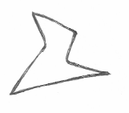
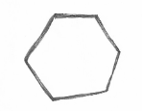
Sarah and Henry were asked to draw a hexagon. Sarah believes that only her drawing is correct. Explain why both shapes are hexagons.
Sarah’s Hexagon
Henry’s Hexagon

  - Draw a shape with three sides. Make one of the angles of the shape a right angle. Which shape in Problem 1 has the same number of angles?

  - Draw a shape with 4 right angles. Which shape in Problem 1 has the same number of angles?

- Solve the following problems.
- Draw the shape that is one face of a cube.

- How many faces are on a cube? ________________
- How many corners are on a cube? ______________
- How many edges are on a cube? ________________

- Complete each statement by circling the correct answer based on the figure below.

  - One small triangle is what portion of the figure?
1 fourth 1 half 1 third
  - One square is what portion of the figure?
1 fourth 1 half 1 whole
- One rectangle that is not a square is what portion of the figure?
1 half 1 fourth 1 whole
Mid-Module Assessment Task Topics A–B
Standards Addressed
Reason with shapes and their attributes.
2.G.1 Recognize and draw shapes having specific attributes, such as a given number of angles or a given number of equal faces. Identify triangles, quadrilaterals, pentagon, hexagons, and cubes. (Sizes are compared directly or visually, not compared by measuring.)
2.G.3 Partition circles and rectangles into two, three, or four equal shares, describe the shares using the words halves, thirds, half of, a third of, etc., and describe the whole as two halves, three thirds, four fourths. Recognize that equal shares of identical wholes need not have the same shape.

Evaluating Student Learning Outcomes
A Progression Toward Mastery is provided to describe steps that illuminate the gradually increasing understandings that students develop on their way to proficiency. In this chart, this progress is presented from left (Step 1) to right (Step 4). The learning goal for each student is to achieve Step 4 mastery. These steps are meant to help teachers and students identify and celebrate what the student CAN do now and what they need to work on next.

A Progression Toward Mastery
Assessment  Task Item  and  Standards Assessed | STEP 1  Little evidence of reasoning without a correct answer.  (1 Point) | STEP 2  Evidence of some reasoning without a correct answer.  (2 Points) | STEP 3  Evidence of some reasoning with a correct answer or evidence of solid reasoning with an incorrect answer.  (3 Points) | STEP 4  Evidence of solid reasoning with a correct answer.  (4 Points)
1  2.G.1 | The student answers one out of five parts correctly. | The student answers two out of five parts correctly. | The student answers three to four out of five parts correctly. | The student correctly answers:  - 4, 4, quadrilateral.  - 5, 5, pentagon.  - 3, 3, triangle.  - 6, 6, hexagon.  - That both images have 6 sides and/or 6 angles.
2  2.G.1 | The student answers one out of four parts correctly. | The student answers two out of four parts correctly. | The student answers three out of four parts correctly. | The student draws appropriate shapes and correctly answers:  - Triangle.  - Quadrilateral.
3  2.G.1 | The student answers one out of four parts correctly. | The student answers two out of four parts correctly. | The student answers three out of four parts correctly. | The student correctly:  - Draws a square.  - Answers 6.  - Answers 8.  - Answers 12.
4  2.G.3 | The student is unable to answer any of the questions. | The student answers one out of three parts correctly. | The student answers two out of three parts correctly. | The student correctly circles:  - 1 fourth.  - 1 half.  - 1 whole.
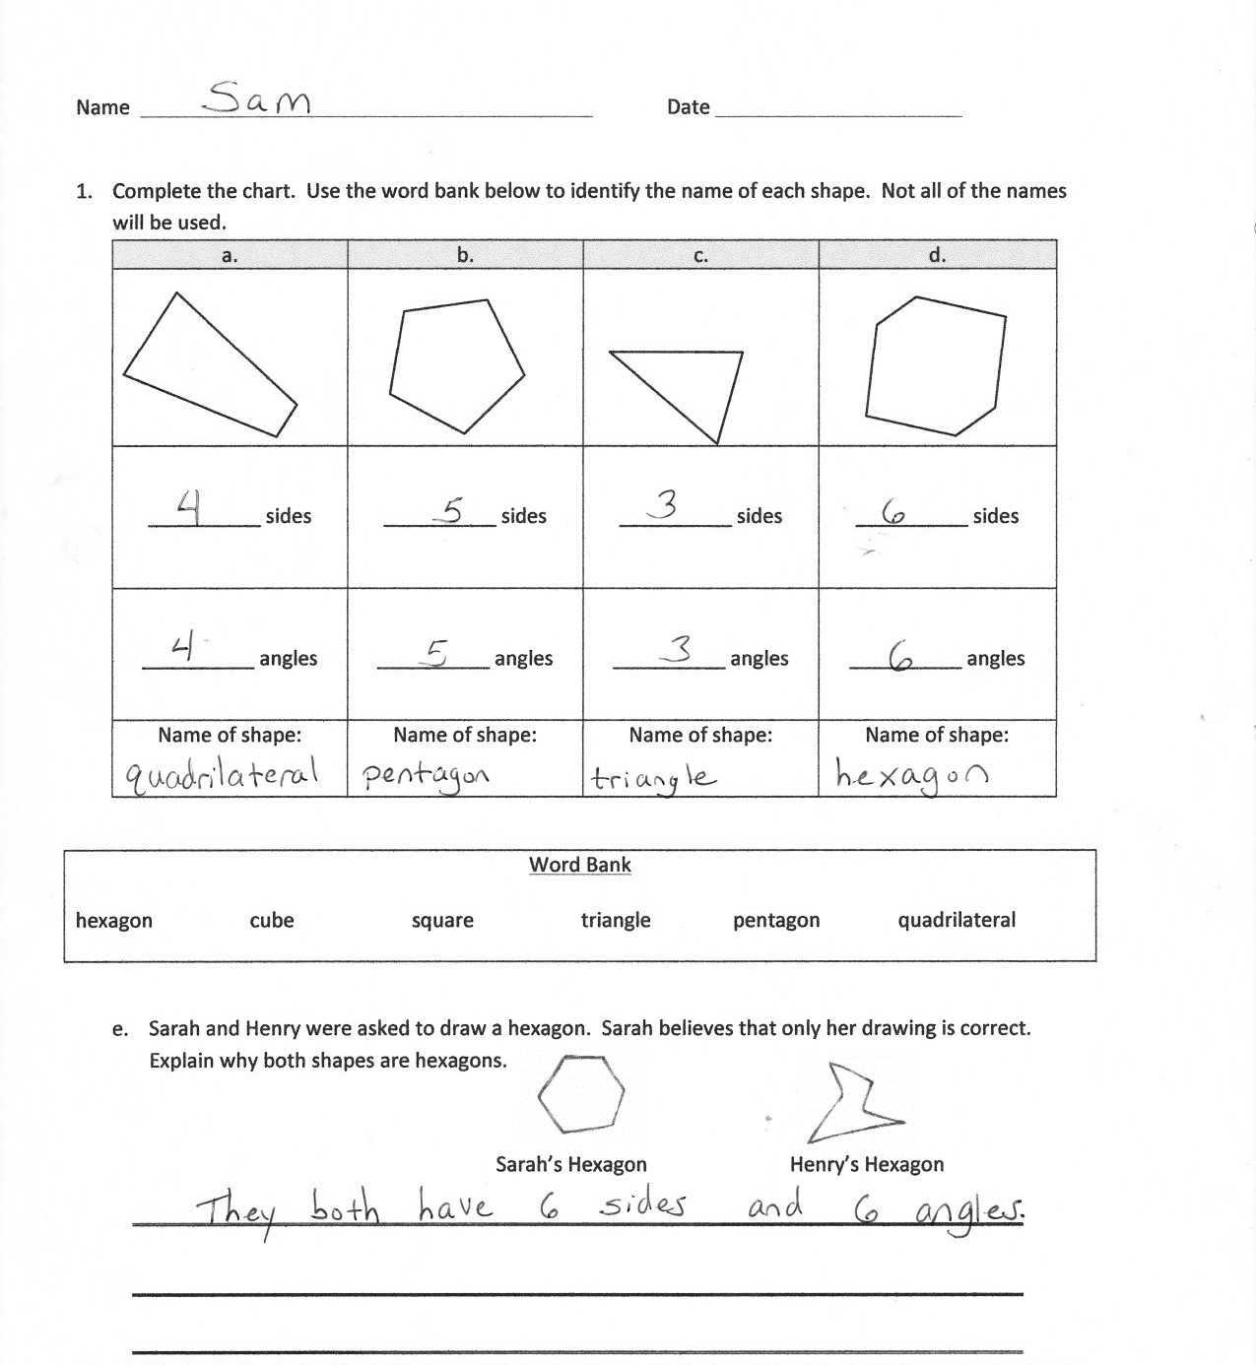
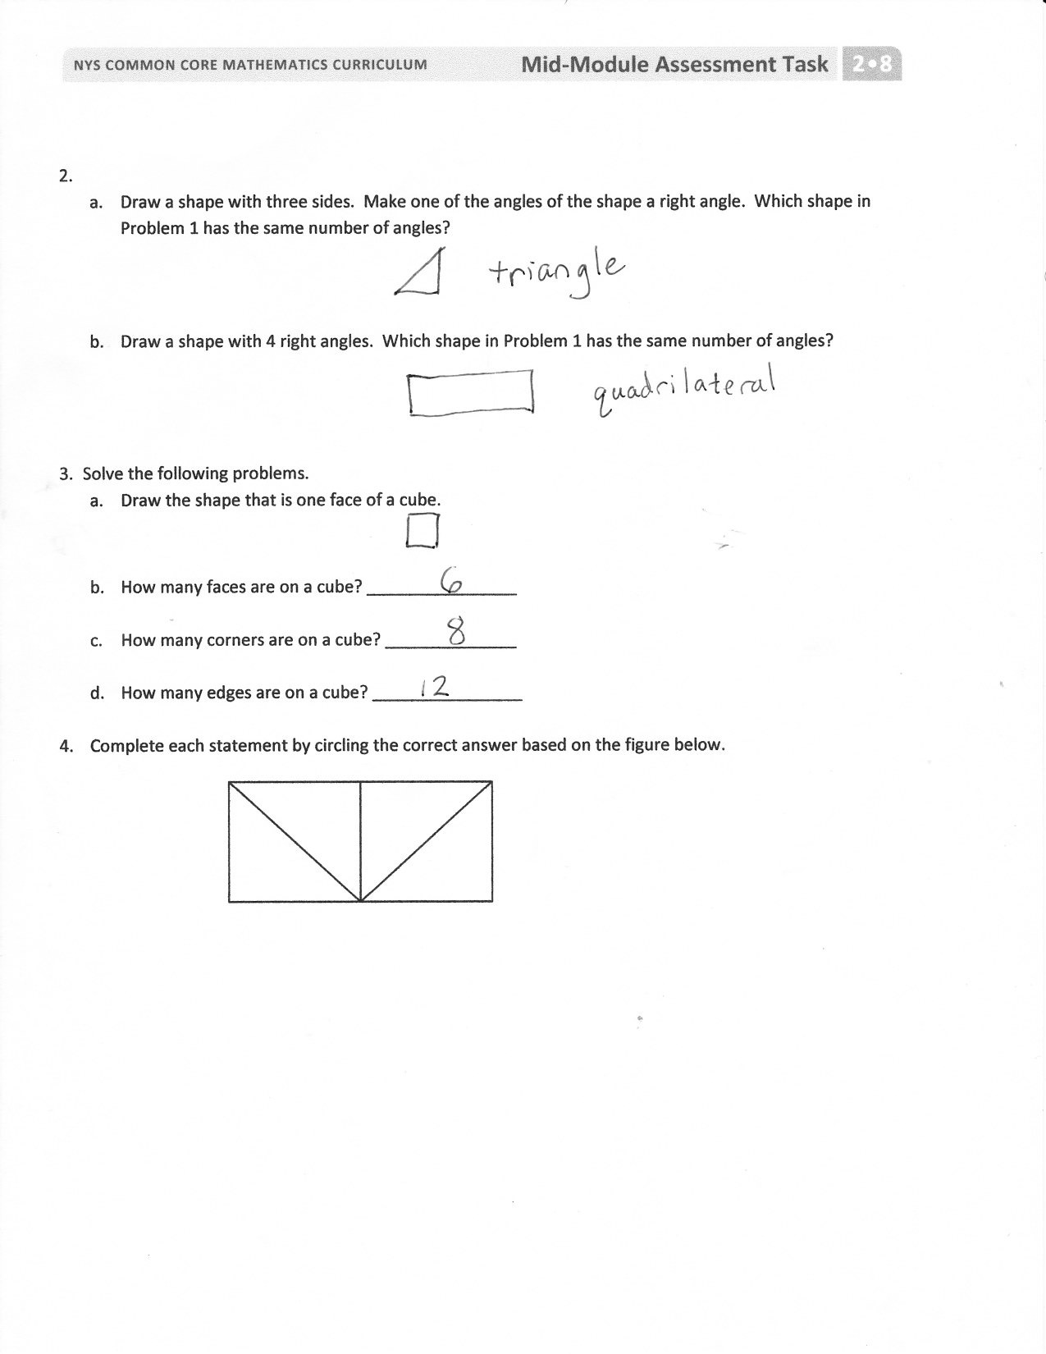

Time is revisited using an analog clock as part of the work with 2.G.3. Clock faces provide an excellent application of partitioning the whole into halves, etc., and to the corresponding angle sizes.

