Name Date

- Match each description to the correct shape name by drawing a line. Draw an example for each shape to the right.
triangle
quadrilateral
hexagon
pentagon
cube
five angles

three sides

four angles

six square faces

six sides

- Partition each whole circle into equal shares of 2 halves, 3 thirds, and 4 fourths.

2 halves 3 thirds 4 fourths

- Solve.
- 1 whole = _____ halves 1 whole = ______ thirds _______ fourths = 1 whole

A
- Use vertical lines to partition rectangle:
A into halves.
B into thirds.
C into fourths.
B

C

- Use horizontal lines to partition rectangle:
D into halves.
D
E into thirds.
F into fourths.
E

F

- Circle all of the rectangles that are partitioned into fourths, and cross out any rectangle that is not partitioned into fourths.

- Draw the hands on the analog clock to match the time shown on the digital clock. Then, circle a.m. or p.m. based on the description given.
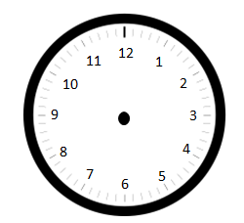
a. Time to go to school.

8:10 a.m. or p.m.

b. Time for lunch.

12:25 a.m. or p.m.

c. Time for dinner.
5:45 a.m. or p.m.

- Write the time shown on each analog clock.

___________________

____________________

____________________
End-of-Module Assessment Task Topics A–D
Standards Addressed
Work with time and money.
2.MD.7 Tell and write time from analog and digital clocks to the nearest five minutes, using a.m. and p.m.
Reason with shapes and their attributes.
2.G.1 Recognize and draw shapes having specified attributes, such as a given number of angles or a given number of equal faces. Identify triangles, quadrilaterals, pentagons, hexagons, and cubes. (Sizes are compared directly or visually, not compared by measuring.)
2.G.3 Partition circles and rectangles into two, three, or four equal shares, describe the shares using the words halves, thirds, half of, a third of, etc., and describe the whole as two halves, three thirds, four fourths. Recognize that equal shares of identical wholes need not have the same shape.

Evaluating Student Learning Outcomes
A Progression Toward Mastery is provided to describe steps that illuminate the gradually increasing understandings that students develop on their way to proficiency. In this chart, this progress is presented from left (Step 1) to right (Step 4). The learning goal for each student is to achieve Step 4 mastery. These steps are meant to help teachers and students identify and celebrate what the student CAN do now and what they need to work on next.
A Progression Toward Mastery
Assessment  Task Item  and  Standards Assessed | STEP 1  Little evidence of reasoning without a correct answer.  (1 Point) | STEP 2  Evidence of some reasoning without a correct answer.  (2 Points) | STEP 3  Evidence of some reasoning with a correct answer or evidence of solid reasoning with an incorrect answer.  (3 Points) | STEP 4  Evidence of solid reasoning with a correct answer.  (4 Points)
1  2.G.1 | The student correctly answers one out of five parts correctly. | The student correctly answers two out of five parts correctly. | The student correctly answers three to four out of five parts correctly. | The student correctly:  - Matches triangle to three sides and draws a triangle.  - Matches quadrilateral to four angles and draws a quadrilateral.  - Matches hexagon to six sides and draws a hexagon.  - Matches pentagon to five angles and draws a pentagon.  - Matches cube to six squares and draws a cube.
2  2.G.3 | The student is unable to answer any parts correctly. | The student correctly answers one out of three parts correctly. | The student correctly answers two out of three parts correctly. | The student correctly:  - Partitions the first circles into halves.  - Partitions the middle circle into thirds.  - Partitions the last  circle into fourths.
3  2.G.3 | The student correctly answers one out of four parts correctly. | The student correctly answers two out of four parts correctly. | The student correctly answers three out of four parts correctly. | The student correctly:  - Solves 2, 3, 4.  - Using vertical lines, partitions rectangle A into halves, B into thirds, and C into fourths.  - Using horizontal lines, partitions rectangle D into halves, E into thirds, and F into fourths.  - Circles the first, second, and fourth rectangles, and crosses out the third rectangle.
4  2.MD.7 | The student is unable to answer any of the parts correctly. | The student correctly answers one out of three parts correctly. | The student correctly answers two out of three parts correctly. | The student correctly draws clock hands and circles:  - a.m.  - p.m.  - p.m.
5  2.MD.7 | The student is unable to answer any of the parts correctly. | The student correctly answers one out of three parts correctly. | The student correctly answers two out of three parts correctly. | The student correctly answers:  - 7:25  - 2:45  - 12:55

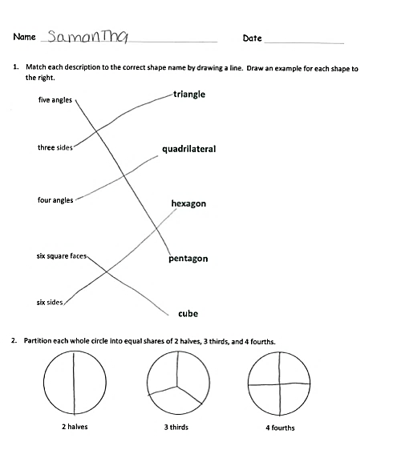
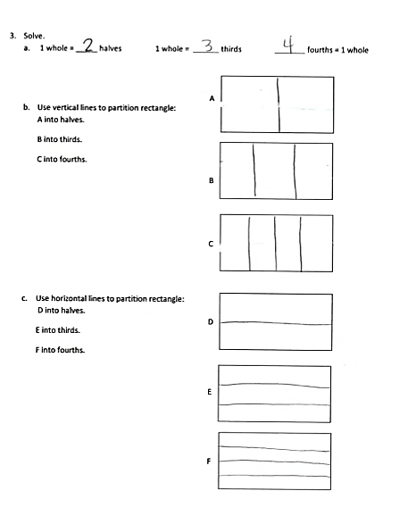
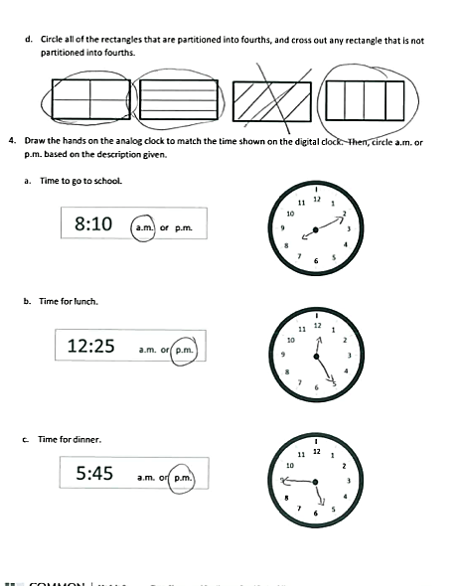
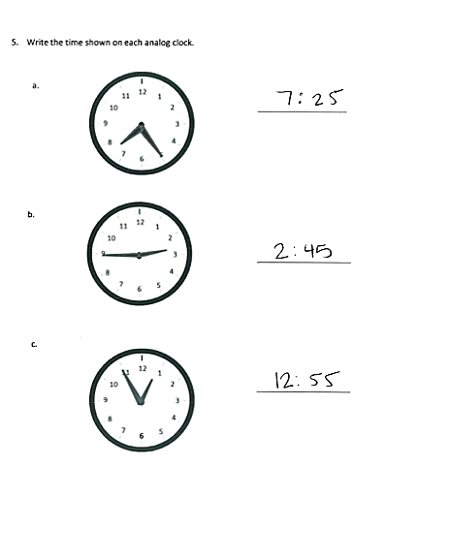

Time is revisited using an analog clock as part of the work with 2.G.3. Clock faces provide an excellent application of partitioning the whole into halves, etc., and to the corresponding angle sizes.

