Name Date
- Hank emptied his pockets and found these coins.
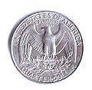
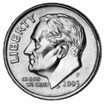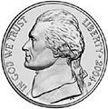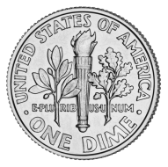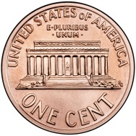
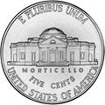
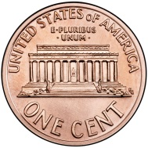

  - How much money does Hank have? Write the answer using the $ or ¢ symbol. Explain your thinking using pictures, numbers, or words.

- Hank gave his brother Luke a quarter and some more coins. Now, Luke has 57 cents. Draw and label one possible picture of Luke’s coins.

- Hank’s sister Maria found a dollar bill under her bed and used it to buy an iced tea for 45 cents. How much change will Maria get back? Write the answer using the $ or ¢ symbol. Explain your thinking using pictures, numbers, or words.

- Karen has 1 twenty-dollar bill, 2 ten-dollar bills, 4 five-dollar bills, and 8 one-dollar bills.
- How much money does Karen have? Write the answer using the $ or ¢ symbol. Explain your thinking using pictures, numbers, or words.

- Karen buys a book for 12 dollars and a fruit smoothie for 4 dollars. Karen gives the cashier the twenty dollar bill. How much change will she receive? Write the answer using the $ or ¢ symbol. Explain your thinking using pictures, numbers, or words.

- Alex sorted the fruits in his shopping basket. The table below shows what he bought.
Oranges | Lemons | Bananas | Pears
2 | 5 | 3 | 4

- Draw and label a picture graph to represent the fruits in Alex’s shopping basket.

Title ________________________________

Legend: _______________________________________

- Draw and label a bar graph to represent the fruits in Alex’s shopping basket.

Title: _________________________________

0 __ __ __ __ __ __ __ __ __ __ __ __ __ __

- How many pieces of fruit did Alex buy in all?

- How many more lemons and pears does Alex have than oranges and bananas? Explain your thinking using pictures, numbers, or words.

- Denise found 4 nickels in the car, 32 cents in her room, and 21 pennies and 1 quarter in her desk drawer.
- How much money did Denise find in all? Write the answer using the $ or ¢ symbol.

- Denise spent 42 cents on one banana and lost 19 cents. How much money does Denise have left? Write the answer using the $ or ¢ symbol. Explain your thinking using pictures, numbers, or words.

Mid-Module Assessment Task Topics A–B
Standards Addressed
Use place value understanding and properties of operations to add and subtract.
2.NBT.5 Fluently add and subtract within 100 using strategies based on place value, properties of operations, and/or the relationship between addition and subtraction.
Work with time and money.
2.MD.8 Solve word problems involving dollar bills, quarters, dimes, nickels, and pennies, using $ and ¢ symbols appropriately. Example: If you have 2 dimes and 3 pennies, how many cents do you have?
Represent and interpret data.
2.MD.10 Draw a picture graph and a bar graph (with single-unit scale) to represent a data set with up to four categories. Solve simple put-together, take-apart, and compare problems using information presented in a bar graph.

Evaluating Student Learning Outcomes
A Progression Toward Mastery is provided to describe steps that illuminate the gradually increasing understandings that students develop on their way to proficiency. In this chart, this progress is presented from left (Step 1) to right (Step 4). The learning goal for students is to achieve Step 4 mastery. These steps are meant to help teachers and students identify and celebrate what the students CAN do now and what they need to work on next.
A Progression Toward Mastery
Assessment  Task Item  and  Standards Assessed | STEP 1  Little evidence of reasoning without a correct answer.  (1 Point) | STEP 2  Evidence of some reasoning without a correct answer.  (2 Points) | STEP 3  Evidence of some reasoning with a correct answer or evidence of solid reasoning with an incorrect answer.  (3 Points) | STEP 4  Evidence of solid reasoning with a correct answer.  (4 Points)
1  2.NBT.5  2.MD.8 | The student solves one out of five parts correctly. | The student solves two or three out of five parts correctly. | The student solves four out of five parts correctly. | The student correctly:  - Answers 78¢ and explains using pictures, numbers, or words.  - Draws and labels a coin combination that totals 57 cents, such as QDDDPP or QDDNNPP.  - Answers 55¢ and explains using pictures, numbers, or words.
2  2.NBT.5  2.MD.8 | The student solves one out of four parts correctly. | The student solves two out of four parts correctly. | The student solves three out of four parts correctly. | The student correctly:  - Answers $68 and explains using pictures, numbers, or words.  - Answers $4 change and explains using pictures, numbers, or words.
3  2.MD.10 | The student solves fewer than three out of seven parts correctly. | The student solves three to four out of seven parts correctly. | The student solves five to six out of seven parts correctly. | The student correctly:  - Draws and labels the picture graph to show 2 oranges, 5 lemons, 3 bananas, and 4 pears.  - Draws and labels the bar graph to show 2 oranges, 5 lemons, 3 bananas, and 4 pears.  - Answers 14 pieces of fruit.  - Answers 4 more lemons and pears and explains using pictures, numbers, or words.
4  2.NBT.5  2.MD.8 | The student solves zero out of three parts correctly. | The student solves one out of three parts correctly. | The student solves two out of three parts correctly. | The student correctly:  - Answers 98¢.  - Answers 37¢ and explains using pictures, numbers, or words.

