Name Date

- David is the groundskeeper at Triangle Park, shown below.

$$50 yd.$$
$$300 yd.$$

  - David needs to cut the grass four times a month. How many square yards of grass will he cut altogether each month?

  - During the winter, the triangular park and adjacent square parking lot are flooded with water and allowed to freeze so that people can go ice skating. What is the area of the ice?

$$50 yd.$$
$300 yd.$ $50 yd.$

- Marika is looking for a new computer table. Part (b) presents a sketch of two computer tables she likes when looking at them from above. All measurements are in feet.
  - If Marika needs to choose the one with the greater area, which one should she choose? Justify your answer with evidence, using coordinates to determine side lengths.

  - If Marika needs to choose the one with the greater perimeter, which one should she choose? Justify your answer with evidence, using coordinates to determine side lengths.
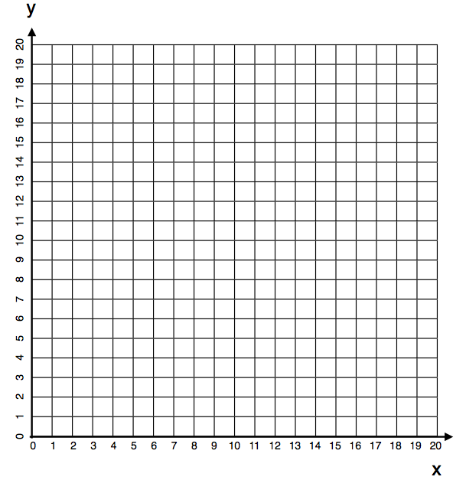

Table A
Table B

- Find the area of the triangular region.

$$6 in.$$
$$5 in.$$
$$13 in.$$

- The grid below shows a birds-eye view of a middle school.
Point | Coordinates |  | Segment | Length (m)
$$A$$ |  |  | $$\overline{AB}$$
$$B$$ |  |  | $$\overline{BC}$$
$$C$$ |  |  | $$\overline{CD}$$
$$D$$ |  |  | $$\overline{DE}$$
$$E$$ |  |  | $$\overline{EF}$$
$$F$$ |  |  | $$\overline{FG}$$
$$G$$ |  |  | $$\overline{GH}$$
$$H$$ |  |  | $$\overline{HA}$$
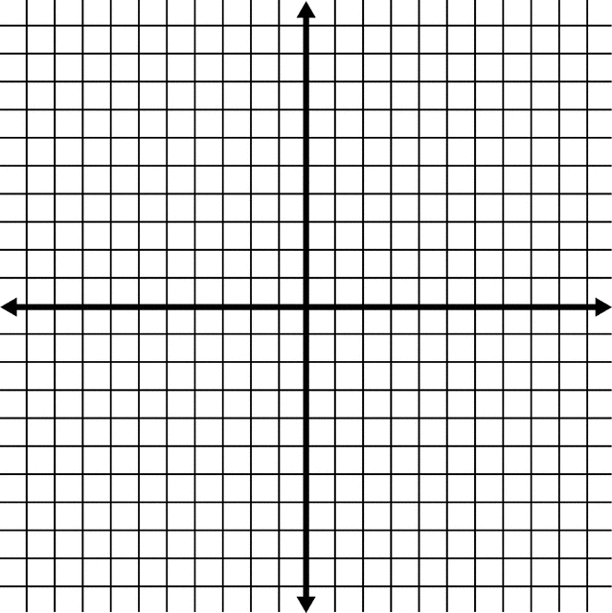
C

  - Write the coordinates of each point in the table.

  - Each space on the grid stands for $10$ meters. Find the length of each wall of the school.

  - Find the area of the entire building. Show your work.

A Progression Toward Mastery
Assessment  Task Item |  | STEP 1  Missing or incorrect answer and little evidence of reasoning or application of mathematics to solve the problem | STEP 2  Missing or incorrect answer but evidence of some reasoning or application of mathematics to solve the problem | STEP 3  A correct answer with some evidence of reasoning or application of mathematics to solve the problem, or an incorrect answer with substantial evidence of solid reasoning or application of mathematics to solve the problem | STEP 4  A correct answer supported by substantial evidence of solid reasoning or application of mathematics to solve the problem
1 | a  6.G.A.1 | Student response is incorrect and shows no application of the triangle area formula. | Student uses the triangle area formula but answers incorrectly, perhaps by only calculating the area of the triangle ($7,500 {yd}^{2}$). | Student uses the triangle area formula, correctly finds the area of the park, $7,500 {yd}^{2}$, and multiplies that area by $4$. In the final answer, an arithmetic mistake might be made, or the units are either missing or are in yards instead of square yards. | Student uses the triangle area formula, correctly finds the area of the park, $7,500 {yd}^{2}$, and multiplies that area by $4$. Student response is correct, both in number and in units ($30,000 {yd}^{2}$).
 | b  6.G.A.1 | Student response is incorrect and shows no application of area formulas. | Student uses the triangle area formula and/or rectangle area formula but response is incorrect because of arithmetic errors. Units are not correct. | Student uses the triangle area formula, and correctly finds the area of the grass, $7,500 {yd}^{2}$, or correctly finds the area of the parking lot,  $2,500 {yd}^{2}$. | Student uses area formulas and correctly finds the area of the grass, $7,500 {yd}^{2}$, and parking lot, $2,500 {yd}^{2}$, and adds them correctly, totaling $10,000 {yd}^{2}$. Units are correct in the final answer.
2 | a  6.G.A.3 | Student response is incorrect and shows no application of area formulas. Perimeter calculations may have been made. | Student incorrectly calculates the area of both tables. The student chooses the greater of the two areas calculated, regardless of the mistake. Units are incorrectly identified. | Student correctly calculates the area of one table, either Table A is $39 {ft}^{2}$ or Table B is $37 {ft}^{2}$. The student chooses the greater of the two areas calculated, regardless of the mistake. Units are correctly identified. | Student correctly calculates the area of both tables, Table A is $39 {ft}^{2}$ and Table B is $37 {ft}^{2}$, and concludes Table A has a larger area. Units are correctly identified, and coordinates are appropriately used in order to determine side lengths.
 | b  6.G.A.3 | Student incorrectly calculates the perimeter of both tables. Units are incorrectly identified. Area calculations may have been made. | Student incorrectly calculates the perimeter of both tables. The student chooses the greater of the two calculated perimeters, regardless of the mistake. Units are incorrectly identified. | Student correctly calculates the perimeter of one table, either Table A is $32 ft.$ or Table B is $36 ft.$, and concludes Table B has a longer perimeter. Units are correctly identified. | Student correctly calculates the perimeter of both tables, Table A is $32 ft.$ and Table B is $36 ft.$, and concludes Table B has a longer perimeter. Units are correctly identified, and coordinates are appropriately used in order to determine side lengths.
3 | 6.G.A.1 | Student does not calculate the altitude of the triangle to be $7 in.$, and the final response is incorrect. | Student correctly calculates the altitude of the triangle to be  $7 in.$, but the final area of the triangle is incorrect. | Student correctly calculates the altitude and area of the triangle, but the units are incorrectly identified. | Student correctly calculates the area of the triangle as $17.5 {in}^{2}$.
4 | a  6.G.A.3 | Student correctly identifies fewer than $2$of the $8$ points. | Student correctly identifies at least $4$ of the $8$ points. | Student correctly identifies at least $6$ of the $8$ points. | Point Coordinates  $$A$$ $$(-4, 4)$$  $$B$$ $$(6, 4)$$  $$C$$ $$(6, -6)$$  $$D$$ $$(4, -6)$$  $$E$$ $$(4, -2)$$  $$F$$ $$(-1, -2)$$  $$G$$ $$(-1, -7)$$  $$H$$ $$(-4, -7)$$  Student correctly identifies all $8$ points.
 | b  6.G.A.3 | Student correctly identifies fewer than $2$ of the $8$ lengths. | Student correctly identifies at least $4$ of the $8$ lengths; alternatively, the response ignores the scale factor and finds $6$ of the $8$ lengths to be one-tenth of the correct answers. | Student correctly identifies at least 6 of the $8$ lengths; alternatively, the response ignores the scale factor and finds all $8$ lengths to be one-tenth of the correct answers. | Segment Length (m)  $$\overline{AB}$$ $$100$$  $$\overline{BC}$$ $$100$$  $$\overline{CD}$$ $$20$$  $$\overline{DE}$$ $$40$$  $$\overline{EF}$$ $$50$$  $$\overline{FG}$$ $$50$$  $$\overline{GH}$$ $$30$$  $$\overline{HA}$$ $$110$$  Student correctly identifies all $8$ lengths correctly.
 | c  6.G.A.3 | Student response is incorrect in both number and units. | Student ignores the scale and incorrectly calculates the area of the building as $83 m^{2}$. Units can be correct, incorrect, or missing. | Student incorrectly calculates the area of the building to be something other than $8300 m^{2}$ due to an arithmetic error. Units are correct. | Student correctly calculates the area of the building: $8300 m^{2}$. Both the number and units are correct.
Name Date

- David is the groundskeeper at Triangle Park, scale shown below.

$$50 yd.$$
$$300 yd.$$

  - David needs to cut the grass four times a month. How many square yards of grass will he cut altogether each month?
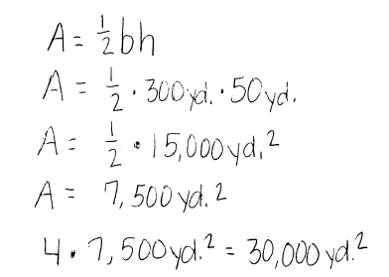

  - During the winter, the triangular park and adjacent square parking lot are flooded with water and allowed to freeze so that people can go ice skating. What is the area of the ice?

$$50 yd.$$
$300 yd.$ $50 yd.$

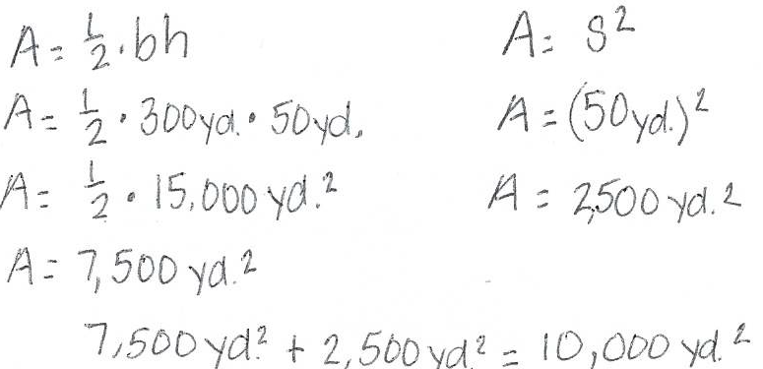

- Marika is looking for a new computer table. Below is a sketch of two computer tables she likes when looking at them from above. All measurements are in feet.
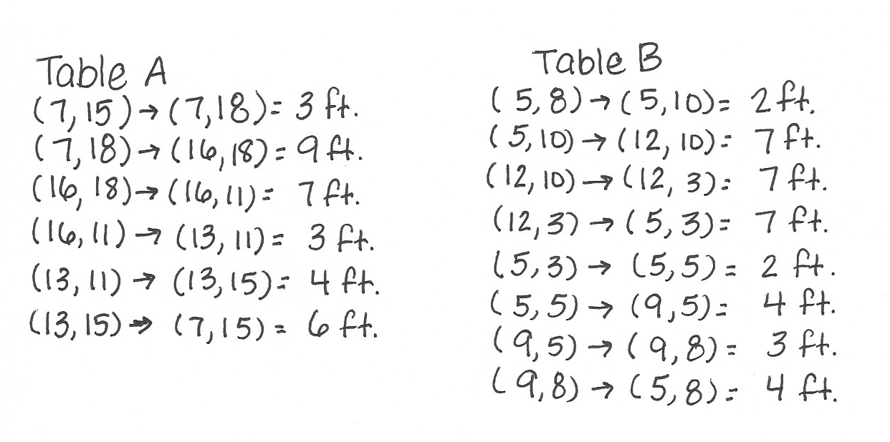
  - If Marika needs to choose the one with the greater area, which one should she choose? Justify your answer with evidence, using coordinates to determine side lengths.

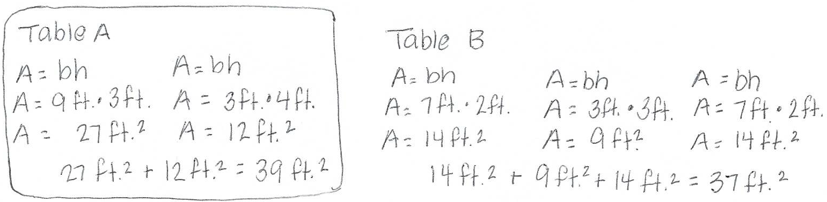

  - If Marika needs to choose the one with the greater perimeter, which one should she choose? Justify your answer with evidence, using coordinates to determine side lengths.
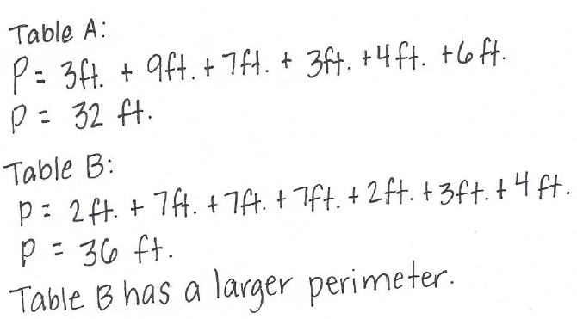
Table A
Table B

- Find the area of the triangular region.
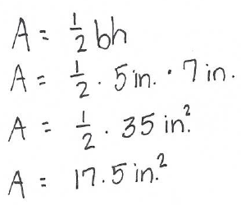

$$6 in.$$
$$5 in.$$
$$13 in.$$

- The grid below shows a birds-eye view of a middle school.
AA
BB
C
DD
EE
FF
GG
HH

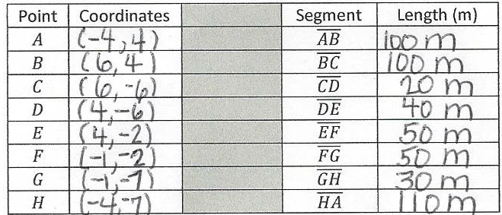

  - Write the coordinates of each point in the table.

  - Each space on the grid stands for $10$ meters. Find the length of each wall of the school.

  - Find the area of the entire building. Show your work.
