Name Date
- The juice box pictured below is $4$inches high, $3$inches long, and $2$inches wide.

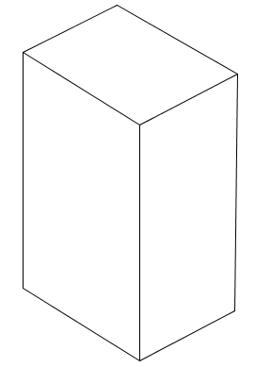

  - In the grid above, the distance between grid lines represents one inch. Use the grid paper to sketch the net of the juice box.

  - Find the surface area of the juice box. Show your work.

  - Find the volume of the juice box. Show your work.

- The Cubic Crystal Company has a new Crystal Cube they want to sell. The packaging manager insists that the cubes be arranged to form a rectangular prism and that the package be designed to hold the Crystal Cubes exactly, with no leftover packaging. Each Crystal Cube measures $1 in\text{.}×1 in\text{.}×1 in$. There are $24$ Crystal Cubes to be sold in a box.

  - What are the dimensions of the possible box designs in inches?

Height | Width | Length

  - Which Crystal Cube box design will use the least amount of cardboard for packaging? Justify your answer as completely as you can.

Height | Width | Length | Surface Area

  - Another type of cube is the Mini Crystal Cube, which has an edge length of $\frac{3}{4}$ inch. What is the volume in cubic inches of one Mini Crystal Cube? Show your work.

- Which of these nets can be folded to form a cube?

A
C
B
D

- Which box below has the larger surface area?

$$3 in.$$
$$3 in.$$
$$2 in.$$
$$5 in.$$
$$1 in.$$
$$10 in.$$

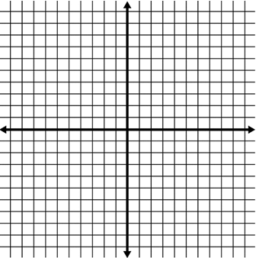
- a. Draw a polygon in the coordinate plane using the given
coordinates.
$$(4, -4)$$
$$(6, -2)$$
$$(8, -6)$$

  - Calculate the area of the polygon.

- Eaglecrest Elementary School is creating a vegetable garden at the school.
$$25 ft.$$
$$8 ft.$$
$$6 ft.$$

  - What is the area of the garden?

  - After more discussion, Eaglecrest decided to change the location of the garden so that the vegetables can get more sunlight. Below is the new garden.
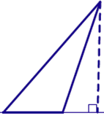
$$7 ft.$$
$$28 ft.$$

In which garden can the students of Eaglecrest plant more vegetables? Explain your reasoning.

A Progression Toward Mastery
Assessment  Task Item |  | STEP 1  Missing or incorrect answer and little evidence of reasoning or application of mathematics to solve the problem | STEP 2  Missing or incorrect answer but evidence of some reasoning or application of mathematics to solve the problem | STEP 3  A correct answer with some evidence of reasoning or application of mathematics to solve the problem, or an incorrect answer with substantial evidence of solid reasoning or application of mathematics to solve the problem | STEP 4  A correct answer supported by substantial evidence of solid reasoning or application of mathematics to solve the problem
1 | a  6.G.A.4 | Student sketch does not contain $6$ rectangles. | Student sketch contains $6$ rectangles but not $3$ different sizes (two each of $2×3$, $2×4$, and $3×4$); they are arranged in a way that will not fold into a rectangular solid. | Student sketch contains $6$rectangles of $3$ different sizes (two each of $2×3$, $2×4$, and $3×4$); however, they are arranged in a way that will not fold into a rectangular solid. | Student sketch is one of many nets of a $2×3×4$ rectangular solid. Here is one example:  3x4  3x4  2x4  2x4  2x3  2x3  Critical performance indicators: the net must have $6$ rectangles of $3$ different sizes (two each of $2×3$, $2×4$, and $3×4$), similar rectangles must not be adjacent to one another, and the net must fold to a $2×3×4$ rectangular solid.
 | b  6.G.A.4 | Student response does not include the use of a formula and is incorrect ($52 {in}^{2}$). | Student uses a formula other than $SA=2(l·w+l·h+w·h)$, or equivalent, to make the calculation. Alternatively, the volume may have been calculated. | Student uses the formula $SA=2(l·w+l·h+w·h)$, or equivalent, to make the calculation, but an arithmetic error results in an incorrect final answer. Alternatively, the correct number is calculated, and the units (${in}^{2}$) are incorrect. | Student uses the formula $SA=2(l·w+l·h+w·h)$, or equivalent, to make the calculation, and the surface area of the box is correctly found ($52 {in}^{2}$). Both number and units are correct.
 | c  6.G.A.2 | Student response does not include the use of a formula and is incorrect ($24 {in}^{3}$). | Student uses a formula other than  $V=l·w·h,$or equivalent, to make the calculation. Alternatively, the surface area may have been calculated. | Student uses the formula $V=l·w·h,$ or equivalent, to make the calculation, but an arithmetic error results in an incorrect final answer. Alternatively, the correct number is calculated, and the units (${in}^{3}$) are incorrect. | Student uses the formula $V=l·w·h,$ or equivalent, to make the calculation, and the volume of the box is correctly found ($24 {in}^{3}$). Both number and units are correct.
2 | a  6.G.A.2 | Student response includes none or only one of the six possible configurations of the box. | Student response includes at least two of the six possible configurations of the box. | Student response includes at least four of the six possible configurations of the box. | Student response includes all six possible configurations of the box (all measurements in inches): $1×1×24$, $1×2×12$, $1×3×8$, $1×4×6$, $2×2×6$, and $2×3×4$.  L W H  $$1 in.$$ $$1 in.$$ $$1 in.$$ $$1 in.$$ $$2 in.$$ $$2 in.$$ $$1 in.$$ $$2 in.$$ $$3 in.$$ $$4 in.$$ $$2 in.$$ $$3 in.$$ $$24 in.$$ $$12 in.$$ $$8 in.$$ $$6 in.$$ $$6 in.$$ $$4 in.$$
 | b  6.G.A.4 | Student response does not include a calculation for the surface area of any of the box designs. | Student response includes calculations for at least two of the six possible configurations of the box. The smallest number of these calculations is chosen as the box needing the least amount of cardboard. | Student response includes calculations for at least four of the six possible configurations of the box. The smallest number of these calculations is chosen as the box needing the least amount of cardboard. | Student calculates the surface area of all six boxes correctly:  L W H SA  $$1 in.$$ $$1 in.$$ $$1 in.$$ $$1 in.$$ $$2 in.$$ $$2 in.$$ $$1 in.$$ $$2 in.$$ $$3 in.$$ $$4 in.$$ $$2 in.$$ $$3 in.$$ $$24 in.$$ $$12 in.$$ $$8 in.$$ $$6 in.$$ $$6 in.$$ $$4 in.$$ $$98 {in}^{2}$$ $$76 {in}^{2}$$ $$70 {in}^{2}$$ $$68 {in}^{2}$$ $$56 {in}^{2}$$ $$52 {in}^{2}$$  Student concludes that the minimum surface area is found to be on the $2 in. ×3 in. ×4 in.$ box. That box needs the least amount of cardboard.
 | c  6.G.A.2 | Student response does not include a length, width, and height of a Crystal Cube. | Student response includes length, width, and height dimensions other than  $\frac{3}{4} in\text{.}×\frac{3}{4} in\text{.}×\frac{3}{4} in.$ | Student response includes $\frac{3}{4} in\text{.}×\frac{3}{4} in\text{.}×\frac{3}{4} in.$ but is calculated incorrectly. | Student correctly calculates the volume of a single Crystal Cube:  $\frac{3}{4} in\text{.}×\frac{3}{4} in\text{.}×\frac{3}{4} in\text{.}=\frac{27}{64}{ in}^{3}$.
3 | 6.G.A.4 | Student response does not include choice D. | Student response includes choice D and two or three other (incorrect) choices. | Student response includes choice D and one other (incorrect) choice. | Student response is choice D only.
4 | 6.G.A.4 | Student is not able to calculate the surface area of either rectangular prism. | Student is able to calculate the surface area, but calculations may have mathematical errors. | Student calculates the surface area of one prism correctly but one incorrectly.  OR  Student calculates both surface areas correctly but does not answer the question. | Student finds the surface area of the prisms to be $86 {in}^{2}$ and $62 {in}^{2}$. The student also states that the prism with dimensions  $10 in\text{.}×1 in\text{.}×3 in.$ has the larger surface area.
5 | a  6.G.A.3 | Student does not plot any of the points correctly. | Student plots the points backwards. For example, student may have plotted the points $(-4, 4)$, $(-2, 6)$, and $(-6, 8)$. | Student plots two of the three points correctly. | Student plots all three points correctly.
 | b  6.G.A.3 | Student does not calculate the area. | Student counts the squares inside the shape by estimating the parts of squares that are part of the area. | Student uses the area of rectangles and/or triangles to calculate the area of the shape but does so incorrectly. | Student uses the area of rectangles and/or triangles to calculate the area of the shape and correctly calculates $6$ square units as the area.
6 | a  6.G.A.1 | Student does not calculate the area. | Student calculates the area incorrectly, perhaps using the wrong dimensions. | Student calculates the area correctly but does not label the answer. | Student calculates the area correctly and labels accurately $150 {ft}^{2}$.
 | b  6.G.A.1 | Student does not calculate the area. | Student calculates the area of the new garden but does not divide by $2$. | Student calculates the area of both shapes correctly but does not answer the question. | Student calculates the area of both shapes correctly and explains that the original garden has a larger area because $150 {ft}^{2}$ is larger than  $98 {ft}^{2}$; therefore, students can plant more vegetables in the original garden.

Name Date
- The juice box pictured below is $4 inches$ high, $3 inches$ long, and $2 inches$ wide.

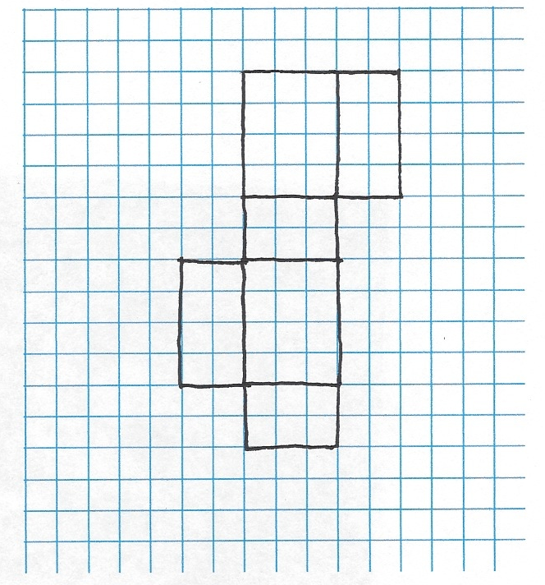

  - In the grid above, the distance between grid lines represents one inch. Use the grid paper to sketch the net of the juice box.

  - Find the surface area of the juice box. Show your work.
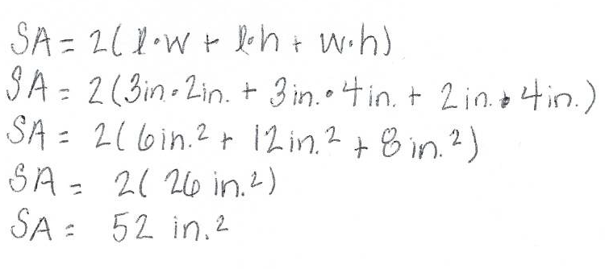

  - Find the volume of the juice box. Show your work.

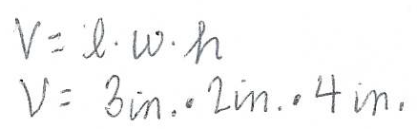
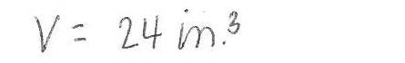
- The Cubic Crystal Company has a new Crystal Cube they want to sell. The packaging manager insists that the cubes be arranged to form a rectangular prism and that the package be designed to hold the Crystal Cubes exactly, with no leftover packaging. Each Crystal Cube measures $1 in\text{.}×1 in\text{.}×1 in$. There are $24$ Crystal Cubes to be sold in a box.

  - What are the dimensions of the possible box designs in inches?
  - Which Crystal Cube box design will use the least amount of cardboard for packaging? Justify your answer as completely as you can.

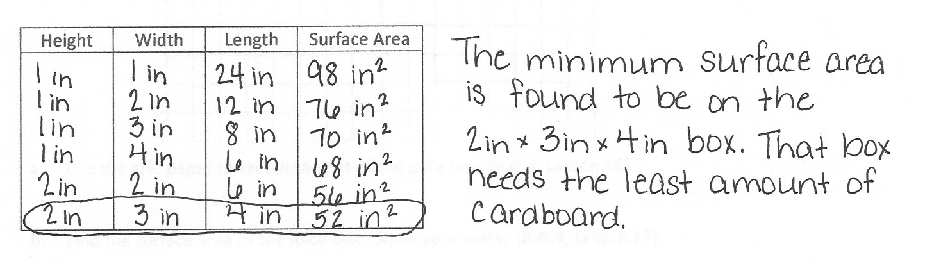
  - Another type of cube is the Mini Crystal Cube, which has an edge length of $\frac{3}{4}$ inch. What is the volume in cubic inches of one Mini Crystal Cube? Show your work.

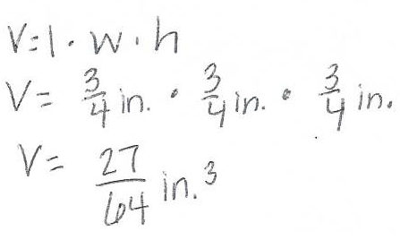

- Which of these nets can be folded to form a cube?
A
C
B
D

- Which box below has the larger surface area?

$$3 in.$$
$$3 in.$$
$$2 in.$$
$$5 in.$$
$$1 in.$$
$$10 in.$$

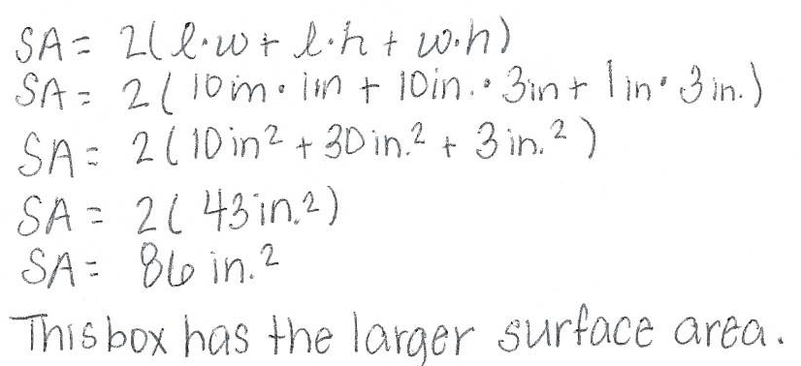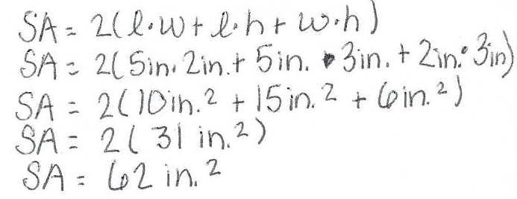
- a. Draw a polygon in the coordinate plane using the given coordinates.
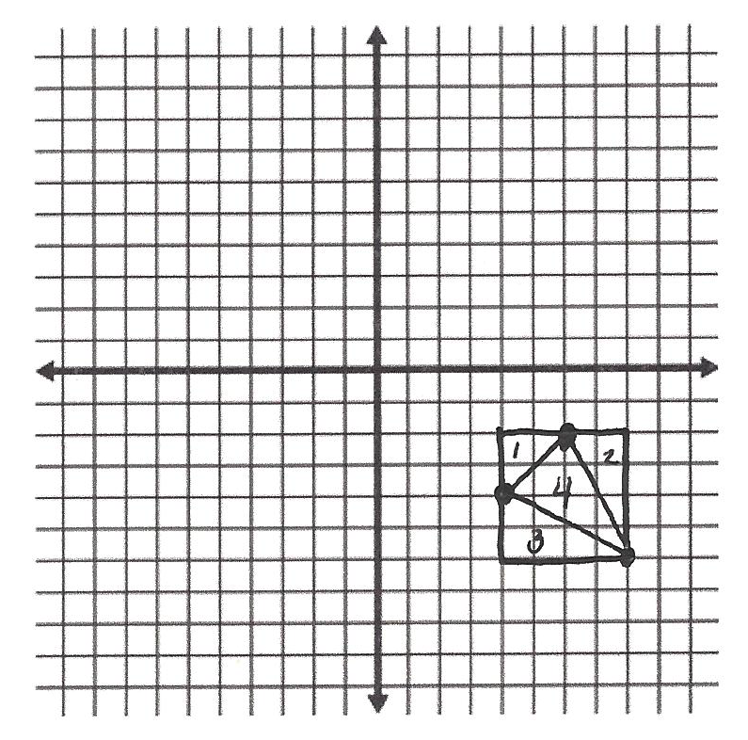
$(4, -4)$
$\left(6, -2\right)$
$(8, -6)$

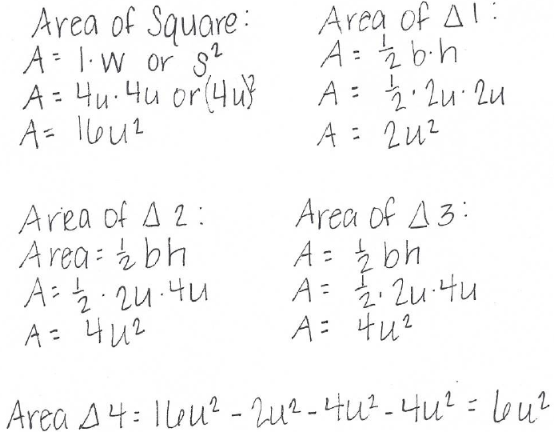
  - Calculate the area of the polygon.

- Eaglecrest Elementary School is creating a vegetable garden at the school.

$$25 ft.$$
$$8 ft.$$
$$6 ft.$$

  - What is the area of the garden?
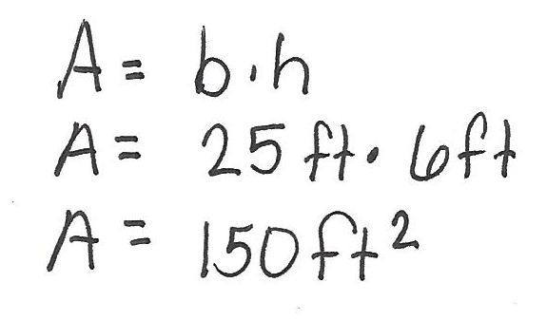

  - After more discussion, Eaglecrest decided to change the location of the garden so that the vegetables can get more sunlight. Below is the new garden.
$$7 ft.$$
$$28 ft.$$

In which garden can the students of Eaglecrest plant more vegetables? Explain your reasoning.
