Name Date
- Solve. Show your mental math strategy.

35 + 25 = _______ | b.  _______ = 27 + 46 | c.  _______ – 19 = 73
d.  89 – 52 = _______ | e.  61 – ______ = 32 | f.  75 – _______ = 29
g.  +1 +_____  32 $⟶$ _______ $⟶$ 43 | h.  –_____ –______  60 $⟶$ _______ $⟶$ 49 | i.  +10 +1  ____ $⟶$ ____ $⟶$ 73

- Solve and show your work with a model.

a.  116 + 74 = ________  Model: | b.  147 + 28 = _________  Model:
c.  84 – 59 = ________  Model: | d.  62 – 45 = _________  Model:

- Label each as true or false. Use a place value strategy to show how you know.

- 23 – 14 = 14 + 23 _________________

- 45 – 19 = 22 + 4 _________________

- 93 – 56 = 84 – 37 __________________

- 8 ones + 5 tens = 85 __________________

- Sarah solved the word problem below.
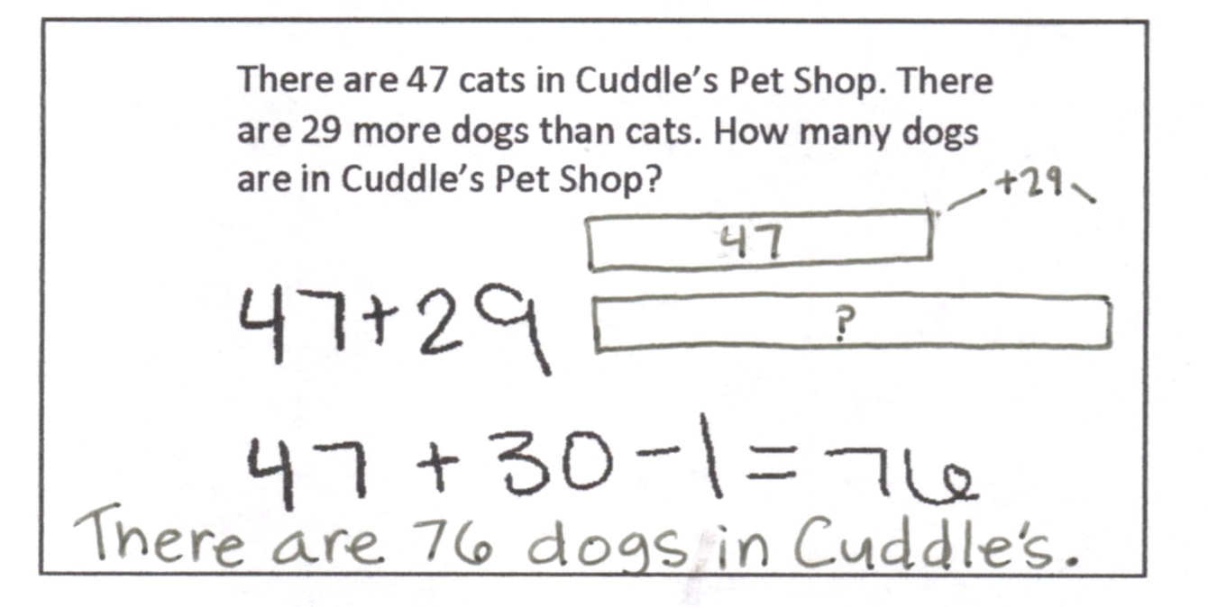
There are 47 cats in Cuddle’s Pet Shop. There are 29 more dogs than cats. How many dogs are in Cuddle’s Pet Shop?

  - Explain why Sarah’s addition strategy worked.

  - There are 18 fewer cats than birds. How many birds are in Cuddle’s Pet Shop? Use another place value strategy to find the answer. Show your work.

Mid-Module Assessment Task  Standards Addressed | Topics A–C
Represent and solve problems involving addition and subtraction.
2.OA.1 Use addition and subtraction within 100 to solve one- and two-step problems involving situations of adding to, taking from, putting together, taking apart, and comparing, with unknowns in all positions, e.g., by using drawings and equations with a symbol for the unknown number to represent the problem.
Use place value understanding and properties of operations to add and subtract.
2.NBT.5 Fluently add and subtract within 100 using strategies based on place value, properties of operations, and/or the relationship between addition and subtraction.
2.NBT.7 Add and subtract within 1000, using concrete models or drawings and strategies based on place value, properties of operations, and/or the relationship between addition and subtraction; relate the strategy to a written method. Understand that in adding or subtracting three-digit numbers, one adds or subtracts hundreds and hundreds, tens and tens, ones and ones; and sometimes it is necessary to compose or decompose tens or hundreds.
2.NBT.8 Mentally add 10 or 100 to a given number 100–900, and mentally subtract 10 or 100 from a given number 100–900.
2.NBT.9 Explain why addition and subtraction strategies work, using place value and the properties of operations. (Explanations may be supported by drawings or objects.)
Evaluating Student Learning Outcomes
A Progression Toward Mastery is provided to describe steps that illuminate the gradually increasing understandings that students develop on their way to proficiency. In this chart, this progress is presented from left (Step 1) to right (Step 4). The learning goal for each student is to achieve Step 4 mastery. These steps are meant to help teachers and students identify and celebrate what the student CAN do now and what they need to work on next.

A Progression Toward Mastery
Assessment  Task Item  and  Standards Assessed | STEP 1  Little evidence of reasoning without a correct answer.  (1 Point) | STEP 2  Evidence of some reasoning without a correct answer.  (2 Points) | STEP 3  Evidence of some reasoning with a correct answer or evidence of solid reasoning with an incorrect answer.  (3 Points) | STEP 4  Evidence of solid reasoning with a correct answer.  (4 Points)
1  2.NBT.5  2.NBT.8 | The student solves one or two of the nine problems correctly and models mental strategies fewer than three times. | The student solves three to five of the nine problems correctly and models mental strategies at least three times. | The student solves six to eight of the nine problems correctly and models mental strategies at least six times. | The student correctly solves to find:  - 60  - 73  - 92  - 37  - 29  - 46  - 33, +10  - -10, 50, -1 or  -1, 59, -10  - 62, 72  The student correctly uses and models a place value strategy such as arrow notation, adding the same amount to the subtrahend as to the minuend to make a multiple of ten, adding or subtracting a multiple of 10 and adjusting the solution as necessary, or other strategies as noted in the Module Overview.
2  2.NBT.7  2.NBT.8 | The student answers one or two of eight parts correctly. | The student answers three to five of eight parts correctly. | The student answers six or seven of eight parts (one part being the equation and one part being the model) correctly. | Student shows accurate models and finds:  - 190  - 175  - 25  - 17
3  2.NBT.5 | The student answers one of four problems correctly and models mental strategies fewer than two times. | The student answers two of four problems correctly and models mental strategies at least twice. | The student answers three or four problems correctly and models mental strategies at least three times. | The student correctly:  - Answers  - False  - True  - False  - False  - Uses and models a mental strategy such as arrow notation, adding the same amount to the subtrahend as to the minuend to make a multiple of ten, adding or subtracting a multiple of 10 and adjusting the solution as necessary, or other strategies as noted in the Module Overview.
4  2.OA.1  2.NBT.5  2.NBT.9 | The student answers both parts correctly. | Student answers one of the parts correctly. | Student answers Parts (a) and (b) correctly but does not show work in Part (b), or answers one part incorrectly but shows correct work in Part (b). | The student correctly:  - Demonstrates an understanding of the role of place value and the arithmetic properties in Sarah’s strategy.  - Uses an alternate place value strategy to solve Part (b), e.g., 47 + 18 = 45 + 20 = 65

