Name Date

- Solve mentally:
a.  72 + 10 = _______ | b.  _______ = 73 – 10 | c.  _______ + 10 = 174
d.  83 + 100 = _______ | e.  _______ = 182 – 100 | f.  _______ – 100 = 81
g.  65 + 40 = _______ | h.  _______ = 166 – 40 | i.  127 + _______ = 167
j.  85 + 42 = _______ | k.  _______ = 186 – 41 | l.  189 – 47 = _______

- Solve:
- Find the solution and model how you found your answer.
87 + 56 = | Model:
38 + 68 + 71 + 12 = | Model:

- Solve and explain your answer using place value.

91 – 24 = | 154 + 27 =
105 – 42 = | 86 + 45 =

- Susan and James solved 125 + 32 in different ways. Explain why both ways are correct.

Susan’s Way:  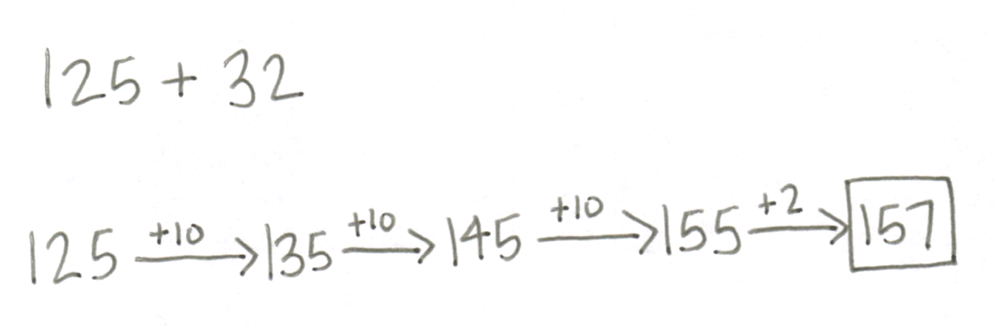 | 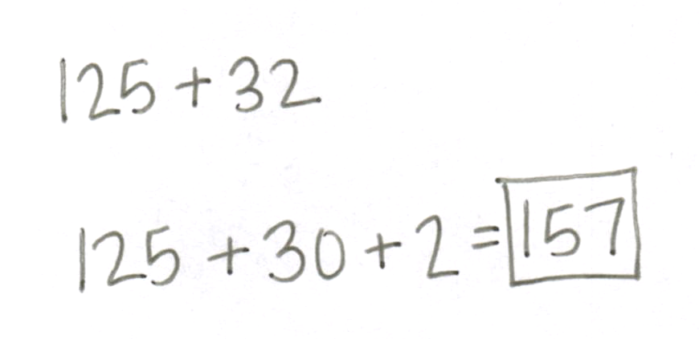  James’ Way:
Explanation: | Explanation:

- Find the missing numbers to make each statement true. Show your mental math strategy.
+___
+10
- 98 $⟶$_____ $⟶$ 109

- 6 tens + 4 ones = 70 – _________

- 25 + 75 = ________ + 30

- 39 + ___________ = 82

- 100 – _________ = 45 + 15 + 32

- Sally went shopping. She spent $86 on groceries and $39 on clothing.
  - How much more did Sally spend on groceries than on clothing? Show your work.

  - After Sally’s shopping trip she had $12 left. How much money did she have to begin with? Show your work.

c. If Sally hadn’t purchased the clothing would she have been able to afford a $55 necklace? Explain your answer.

d. How much money would Sally need to buy the groceries, clothing, and the necklace? Show your work with a model.

End-of-Module Assessment Task Topics A–F
Standards Addressed
Represent and solve problems involving addition and subtraction.
2.OA.1 Use addition and subtraction within 100 to solve one- and two-step problems involving
situations of adding to, taking from, putting together, taking apart, and comparing, with unknowns in all positions, e.g., by using drawings and equations with a symbol for the unknown number to represent the problem.
Use place value understanding and properties of operations to add and subtract.
2.NBT.5 Fluently add and subtract within 100 using strategies based on place value, properties of operations, and/or the relationship between addition and subtraction.
2.NBT.6 Add up to four two-digit numbers using strategies based on place value and properties of operations.
2.NBT.7 Add and subtract within 1000, using concrete models or drawings and strategies based on place value, properties of operations, and/or the relationship between addition and subtraction; relate the strategy to a written method. Understand that in adding or subtracting three-digit numbers, one adds or subtracts hundreds and hundreds, tens and tens, ones and ones; and sometimes it is necessary to compose or decompose tens or hundreds.
2.NBT.8 Mentally add 10 or 100 to a given number 100–900, and mentally subtract 10 or 100 from a given number 100–900.
2.NBT.9 Explain why addition and subtraction strategies work, using place value and the properties of operations. (Explanations may be supported by drawings or objects.)

Evaluating Student Learning Outcomes
A Progression Toward Mastery is provided to describe steps that illuminate the gradually increasing understandings that students develop on their way to proficiency. In this chart, this progress is presented from left (Step 1) to right (Step 4). The learning goal for each student is to achieve Step 4 mastery. These steps are meant to help teachers and students identify and celebrate what the student CAN do now and what they need to work on next.

A Progression Toward Mastery
Assessment  Task Item  and  Standards Assessed | STEP 1  Little evidence of reasoning without a correct answer.  (1 Point) | STEP 2  Evidence of some reasoning without a correct answer.  (2 Points) | STEP 3  Evidence of some reasoning with a correct answer or evidence of solid reasoning with an incorrect answer.  (3 Points) | STEP 4  Evidence of solid reasoning with a correct answer.  (4 Points)
1  2.NBT.8  2.NBT.7 | The student solves one to three of twelve parts correctly. | The student solves four to seven of twelve parts correctly. | The student solves eight to eleven of the twelve parts correctly. | The student correctly solves to find:  - 82  - 63  - 164  - 183  - 82  - 181  - 105  - 126  - 40  - 127  - 145  - 142
2  2.NBT.6  2.NBT.7  2.NBT.9 | The student solves one to four of fourteen parts correctly. | The student solves five to nine of fourteen parts correctly. | The student solves ten to thirteen of the fourteen parts correctly. | For Part (a) the student correctly:  - Solves to find 143.  - Shows an accurate model for 87 + 56.  - Solves to find 189.  - Shows an accurate model for 38 + 68 + 71 + 12.  - Uses and models place value strategies such as arrow notation, adding the same amount to the subtrahend as to the minuend to make a multiple of ten, adding or subtracting a multiple of 10 and adjusting the solution as necessary, or other strategies as noted in the Module Overview.  For Part (b) the student correctly:  - Solves to find 67, 181, 63, and 131.  - Shows an accurate explanation for each problem.  For Part (c) the student correctly:  - Explains why both Susan and James’ strategies are correct.
3  2.NBT.5  2.NBT.6  2.NBT.8 | The student solves one of five problems correctly and models fewer than two mental math strategies. | The student solves two of five problems correctly and models at least two mental math strategies. | The student solves three to four of the five problems correctly and models at least four mental math strategies. | The student correctly:  - Solves to find  - 108, + 1  - 6  - 70  - 43  - 8  - Uses and models place value strategies such as arrow notation, adding the same amount to the subtrahend as to the minuend to make a multiple of ten, adding or subtracting a multiple of 10 and adjusting the solution as necessary, or other strategies as noted in the Module Overview.
4  2.OA.1  2.NBT.5  2.NBT.6  2.NBT.7 | The student solves one of the six parts correctly. | The student solves two or three of the six parts correctly. | The student solves four or five of the six parts correctly. | The student correctly answers:  - $47  - $137  - “No,” and provides an accurate explanation.  - $180.00 with an accurate model

