Table of Contents

GRADE K • MODULE 4

Number Pairs, Addition and Subtraction to 10

Module Overview i

Topic A: Compositions and Decompositions of 2, 3, 4, and 5 4.A.1

Topic B: Decompositions of 6, 7, and 8 into Number Pairs 4.B.1

Topic C: Addition with Totals of 6, 7, and 8 4.C.1

Topic D: Subtraction from Numbers to 8 4.D.1

Topic E: Decompositions of 9 and 10 into Number Pairs 4.E.1

Topic F: Addition with Totals of 9 and 10 4.F.1

Topic G: Subtraction from 9 and 10 4.G.1

Topic H: Patterns with Adding 0 and 1 and Making 10 4.H.1

Module Assessments 4.S.1

Grade K • Module 4
Number Pairs, Addition and Subtraction to 10

OVERVIEW
Module 4 marks the next exciting step in math for kindergartners—addition and subtraction! Students begin to harness their practiced counting abilities, knowledge of the value of numbers, and work with embedded numbers to reason about and solve addition and subtraction expressions and equations (K.OA.1, K.OA.2).
In Topic A, decompositions and compositions of numbers to 5 are revisited to reinforce how a whole can be broken into two parts and how two parts can be joined to make a whole. Decomposition and composition are taught simultaneously using the number bond model so students begin to understand the relationship between parts and wholes before adding and subtracting, formally addressed in Topics C and D.
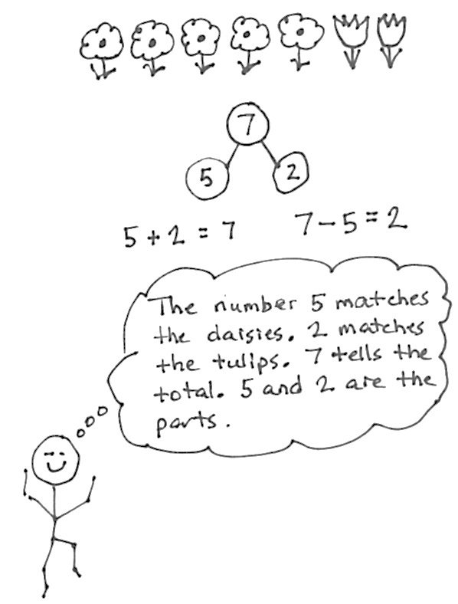
Topic B continues with decomposing and composing 6, 7, and 8 using the number bond model. Students systematically work with each quantity, finding all possible number pairs using story situations, objects, sets, arrays, 5 + n patterns, and numerals (K.OA.3).
Topic C introduces addition to totals of 6, 7, and 8 within concrete and pictorial settings, first generating number sentences without unknowns (e.g., 5 + 2 = 7) to develop an understanding of the addition symbol and the referent of each number within the equation. Next, students graduate to working within the addition word problem types taught in kindergarten: add to with result unknown (A + B = ___), put together with total unknown (A + B = ___), and both addends unknown (C = ___ + ___) (K.OA.2). Students draw a box around the total to track the unknown.
Topic D introduces subtraction with 6, 7, and 8 with no unknown. The lessons in Topic D build from the concrete level of students acting out, crossing out objects in a set, and breaking and hiding parts, to more formal representations of decomposition recorded as or matched to equations (C – B = ___).
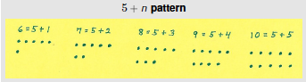
Topics E, F, and G parallel the first half of the module with the numbers 9 and 10. Topic E explores composition, decomposition, and number pairs using the number bond model (K.OA.3). It is essential that students build deep understanding and skill with identifying the number pairs of 6 through 10 because this is foundational to Grade 1’s fluency with sums and differences within 10, as well as Grade 2’s fluency with sums and differences to 20. Topics F and G deal with addition and subtraction, respectively. Students are refocused on representing larger numbers by drawing the 5 + n pattern to bridge efficiently from seeing the embedded five to representing that as addition.
After addition and subtraction have been introduced, Topic H explores the behavior of zero: the additive identity. Students learn that adding or subtracting zero does not change the original quantity. Students also begin to see patterns when adding 1 more and the inverse relationship between addition and subtraction
(8 + 2 = 10 and 10 – 2 = 8). Finally, students begin to formally study and explore partners to 10 (K.OA.4), though this essential work has been supported throughout Module 4 during Fluency Practice.
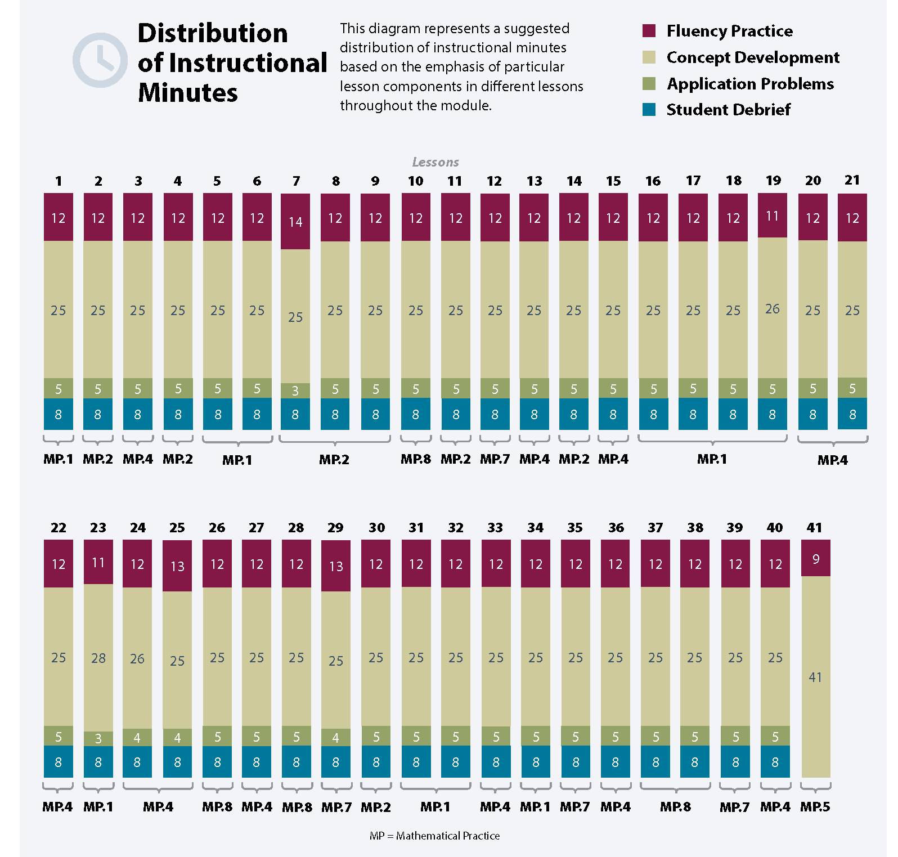
The culminating task of this module asks students to demonstrate their understanding of addition as putting together, adding to and subtraction as taking apart, or taking from. Students use mathematical models and equations to teach a small group of students, administrators, family members, or community partners about a decomposition of 10.

Focus Grade Level Standards
Understand addition as putting together and adding to, and understand subtraction as taking apart and taking from.
K.OA.1 Represent addition and subtraction with objects, fingers, mental images, drawings, sounds (e.g., claps), acting out situations, verbal explanations, expressions, or equations. (Drawings need not show details, but should show the mathematics in the problem. This applies wherever drawings are mentioned in the Standards.)
K.OA.2 Solve addition and subtraction word problems, and add and subtract within 10, e.g., by using objects or drawings to represent the problem.
K.OA.3 Decompose numbers less than or equal to 10 into pairs in more than one way, e.g., by using objects or drawings, and record each decomposition by a drawing or equation (e.g., 5 = 2 + 3 and 5 = 4 + 1).
K.OA.4 For any number from 1 to 9, find the number that makes 10 when added to the given number, e.g., by using objects or drawings, and record the answer with a drawing or equation.
K.OA.5 Fluently add and subtract within 5.

Foundational Standards
PK.OA.1 Demonstrate an understanding of addition and subtraction by using objects, fingers, and responding to practical situations (e.g., If we have 3 apples and add two more, how many apples do we have all together?).
PK.OA.2 Duplicate and extend (e.g., What comes next?) simple patterns using concrete objects.

Focus Standards for Mathematical Practice
MP.1 Make sense of problems and persevere in solving them. Students identify story problems as addition or subtraction situations and find the unknown. Students demonstrate with drawings and verbal explanations the referent of each number in a given problem type.
MP.2 Reason abstractly and quantitatively. Students reason about the relationships between numbers in composition and decomposition situations. For example, they can use the number bond mat to show and explain that 6 and 4 make 10, and that 10 can be broken into 6 and 4.
MP.4 Model with mathematics. Students use number bonds and addition and subtraction equations to model composition and decomposition. Students tell story problems using drawings, numbers, and symbols.
MP.5 Use appropriate tools strategically. Students select and use tools such as drawings, number bonds, and the number path to solve problems.
MP.7 Look for and make use of structure. Students draw the 5 + n pattern to reason about numbers within 10.
MP.8 Look for and express regularity in repeated reasoning. Students add and subtract 0 to get the same number. They also use linking cubes to add and subtract 1 to reason about 1 more and 1 less than with numbers to 10.

Overview of Module Topics and Lesson Objectives
Standards | Topics and Objectives |  | Days
K.OA.1  K.OA.3  K.OA.5 | A | Compositions and Decompositions of 2, 3, 4, and 5  Lesson 1: Model composition and decomposition of numbers to 5 using actions, objects, and drawings.  Lesson 2: Model composition and decomposition of numbers to 5 using fingers and linking cube sticks.  Lesson 3: Represent composition story situations with drawings using numeric number bonds.  Lesson 4: Represent decomposition story situations with drawings using numeric number bonds.  Lesson 5: Represent composition and decomposition of numbers to 5 using pictorial and numeric number bonds.  Lesson 6: Represent number bonds with composition and decomposition story situations. | 6
K.OA.3  K.OA.1  K.OA.4 | B | Decompositions of 6, 7, and 8 into Number Pairs  Lesson 7: Model decompositions of 6 using a story situation, objects, and number bonds.  Lesson 8: Model decompositions of 7 using a story situation, sets, and number bonds.  Lesson 9: Model decompositions of 8 using a story situation, arrays, and number bonds.  Lesson 10: Model decompositions of 6–8 using linking cube sticks to see patterns.  Lesson 11: Represent decompositions for 6–8 using horizontal and vertical number bonds.  Lesson 12: Use 5-groups to represent the 5 + n pattern to 8. | 6
K.OA.1  K.OA.2  K.OA.3  K.OA.4 | C | Addition with Totals of 6, 7, and 8  Lesson 13: Represent decomposition and composition addition stories to 6 with drawings and equations with no unknown.  Lesson 14: Represent decomposition and composition addition stories to 7 with drawings and equations with no unknown.  Lesson 15: Represent decomposition and composition addition stories to 8 with drawings and equations with no unknown.  Lesson 16: Solve add to with result unknown word problems to 8 with equations. Box the unknown.  Lesson 17: Solve put together with total unknown word problems to 8 using objects and drawings.  Lesson 18: Solve both addends unknown word problems to 8 to find addition patterns in number pairs. | 6
K.OA.1  K.OA.2  K.OA.3 | D | Subtraction from Numbers to 8  Lesson 19: Use objects and drawings to find how many are left.  Lesson 20: Solve take from with result unknown expressions and equations using the minus sign with no unknown.  Lesson 21: Represent subtraction story problems using objects, drawings, expressions, and equations.  Lesson 22: Decompose the number 6 using 5-group drawings by breaking off or removing a part, and record each decomposition with a drawing and subtraction equation.  Lesson 23: Decompose the number 7 using 5-group drawings by hiding a part, and record each decomposition with a drawing and subtraction equation.  Lesson 24: Decompose the number 8 using 5-group drawings and crossing off a part, and record each decomposition with a drawing and subtraction equation. | 6
 |  | Mid-Module Assessment: Topics A–D | 3
K.OA.3 | E | Decompositions of 9 and 10 into Number Pairs  Lesson 25: Model decompositions of 9 using a story situation, objects, and number bonds.  Lesson 26: Model decompositions of 9 using fingers, linking cubes, and number bonds.  Lesson 27: Model decompositions of 10 using a story situation, objects, and number bonds.  Lesson 28: Model decompositions of 10 using fingers, sets, linking cubes, and number bonds. | 4

Standards |  | Topics and Objectives | Days
K.OA.2 | F | Addition with Totals of 9 and 10  Lesson 29: Represent pictorial decomposition and composition addition stories to 9 with 5-group drawings and equations with no unknown.  Lesson 30: Represent pictorial decomposition and composition addition stories to 10 with 5-group drawings and equations with no unknown.  Lesson 31: Solve add to with total unknown and put together with total unknown problems with totals of 9 and 10.  Lesson 32: Solve both addends unknown word problems with totals of 9 and 10 using 5-group drawings. | 4
K.OA.1  K.OA.2  K.OA.3 | G | Subtraction from 9 and 10  Lesson 33: Solve take from equations with no unknown using numbers to 10.  Lesson 34: Represent subtraction story problems by breaking off, crossing out, and hiding a part.  Lesson 35: Decompose the number 9 using 5-group drawings, and record each decomposition with a subtraction equation.  Lesson 36: Decompose the number 10 using 5-group drawings, and record each decomposition with a subtraction equation. | 4
K.OA.1  K.OA.2  K.OA.4 | H | Patterns with Adding 0 and 1 and Making 10  Lesson 37: Add or subtract 0 to get the same number and relate to word problems wherein the same quantity that joins a set, separates.  Lesson 38: Add 1 to numbers 1–9 to see the pattern of the next number using 5-group drawings and equations.  Lesson 39: Find the number that makes 10 for numbers 1–9, and record each with a 5-group drawing.  Lesson 40: Find the number that makes 10 for numbers 1–9, and record each with an addition equation.  Lesson 41: Culminating task—choose tools strategically to model and represent a stick of 10 cubes broken into two parts. | 5
 |  | End-of-Module Assessment: Topics E–H | 3
Total Number of Instructional Days |  |  | 47

Terminology

New or Recently Introduced Terms
- Addition (specifically using add to with result unknown, put together with total unknown, put together with both addends unknown)
- Addition and subtraction sentences (equations)
- Make 10 (combine two numbers from 1 to 9 that add up to 10)
Number Bond
- Minus (–)
- Number bond (mathematical model)
- Number pairs or partners (embedded numbers)
- Part (addend or embedded number)
- Put together (add)
- Subtraction (specifically using take from with result unknown)
- Take apart (decompose)
- Take away (subtract)
- Whole (total)

Familiar Terms and Symbols
- 5-group
- Equals (=)
- Hidden partners (embedded numbers)
5-groups highlight the 5 + n pattern
- Number sentence (3 = 2 + 1)
- Number story (stories with add to or take from situations)
- Numbers 0–10
- Plus (+)

Suggested Tools and Representations
- 5-group dot cards
- Hula hoops
1 | 2 | 3 | 4 | 5 | 6 | 7 | 8 | 9 | 10
- Linking cubes
- Number bonds
- Number path
Number Path
- Number towers
- Sets of objects
- Showing fingers the Math Way

Scaffolds
The scaffolds integrated into A Story of Units give alternatives for how students access information as well as express and demonstrate their learning. Strategically placed margin notes are provided within each lesson elaborating on the use of specific scaffolds at applicable times. They address many needs presented by English language learners, students with disabilities, students performing above grade level, and students performing below grade level. Many of the suggestions are organized by Universal Design for Learning (UDL) principles and are applicable to more than one population. To read more about the approach to differentiated instruction in A Story of Units, please refer to “How to Implement A Story of Units.”

Assessment Summary
Type | Administered | Format | Standards Addressed
Mid-Module Assessment Task | After Topic D | Constructed response with rubric | K.OA.1  K.OA.2  K.OA.3  K.OA.5
End-of-Module Assessment Task | After Topic H | Constructed response with rubric | K.OA.1  K.OA.2  K.OA.3  K.OA.4
Culminating Task | Lesson 41 | Choose tools strategically to model and represent a stick of 10 cubes broken into two parts. | K.OA.1  K.OA.2  K.OA.4

Operations and Algebraic Thinking progression document, p. 10.
These are terms and symbols students have seen previously.
Students with disabilities may require Braille, large print, audio, or special digital files. Please visit the website www.p12.nysed.gov/specialed/aim for specific information on how to obtain student materials that satisfy the National Instructional Materials Accessibility Standard (NIMAS) format.

