|  |  |  |  |
| --- | --- | --- | --- |
|  | **Date 1** | **Date 2** | **Date 3** |
| **Topic E** |  |  |  |
| **Topic F** |  |  |  |
| **Topic G** |  |  |  |
| **Topic H** |  |  |  |

Student Name _________________________   
  
Topic E: Decompositions of 9 and 10 into Number Pairs

Rubric Score: Time Elapsed:

Materials: (S) Personal white board, number bond mat, 10 loose cubes, 2 pieces of construction paper

T: (Put the number bond mat in the personal white board, and write 10 in the whole’s place.) Use your marker to complete this number bond.

T: Anya’s friends brought her 9 presents. They put some of the presents on one table and the rest on the other table. (Place the two pieces of construction paper in front of the student to represent each table.) Use the cubes to show me how Anya’s presents could look. Now, draw a number bond about Anya’s presents.

|  |  |
| --- | --- |
| What did the student do? | What did the student say? |
| 1.  2. |  |

Topic F: Addition with Totals of 9 and 10

Rubric Score: ___________ Time Elapsed: ____________

Materials: (S) Personal white board, 9 dots (Template 1), cars (Template 2), flowers (Template 3), 10 linking cubes

T: (Show Template 1 to the student, and write 9 = ____ + ____ on the personal white board.) Look at the 5-group dots. How can the dots help you fill in the blanks of the equation? Fill in the blanks.

T: (Place Template 2 in front of the student.) Listen to my story, and use the cubes to help you remember the numbers. There were 6 orange cars in the parking lot. 4 green cars drove in. How many cars are in the parking lot now? (Write ___ + ___ = ___ on the board.) Write the numbers in the addition sentence to match the story.

T: (Place Template 3 in front of the student.) Listen to my story, and use the cubes to help you remember the numbers. There were 10 flowers. 8 of them were red, and 2 of them were blue. Write an addition sentence that matches this story.

|  |  |
| --- | --- |
| What did the student do? | What did the student say? |
| 1.  2.  3. |  |

Topic G: Subtraction from 9 and 10

Rubric Score: ___________ Time Elapsed: ____________

Materials: (S) 10 linking cube stick (5 cubes one color, 5 cubes a different color), 9 crayons, brown paper bag, personal white board, paper, and pencil

T: (Give the student a piece of paper and a pencil.) Listen to my story, and watch what I do. When I’m finished, you are going to record what you hear and see on your paper. You can use a drawing or a subtraction sentence. I have 9 crayons. I’m going to put 1 in this paper bag. How many crayons are left?

T: (Give the student the 10-stick of linking cubes.) How many cubes? Break off some cubes, and put them on the table. How many did you break off? How many are still in your hand? (As the student tells you how many cubes, write ___ – ___ = ___ on the personal white board.) Write the numbers in the blanks that tell what you did with the linking cubes.

T: (Connect the cubes, and erase the board. Place both items in front of the student.) Break off a different number this time, and record your work by writing a subtraction sentence.

|  |  |
| --- | --- |
| What did the student do? | What did the student say? |
| 1.  2.  3. |  |

**Topic H: Patterns with Adding 0 and 1 and Making 10**

Rubric Score: ___________ Time Elapsed: ____________

Materials: (S) 9 dots (Template 1), number sentences (Template 4), linking cubes, personal white board

T: (Place 5 loose linking cubes of the same color in front of the student.) Count and put the cubes together. How many cubes are there? Take zero cubes away. How many cubes are left? Put zero cubes on your stick. How many cubes are there in all?

T: (Student is still holding his 5-stick from the previous question. Put 5 loose linking cubes of different colors in front of the student.) Put 1 more cube on your stick. How many cubes are there? Put 1 more cube on your stick. How many cubes now?

T: (Place Template 4 in front of the student.) Listen to my story. Hold up the equation that matches my story. 5 fish were swimming in a pond. Then, 3 frogs jumped in the pond. Now, there are 8 animals in the pond. Which equation matches my story?

Listen to some more. There were 8 animals in the pond. The 3 frogs jumped out and went home. Now, there are 5 animals in the pond. Which equation matches my story?

T: (Put Template 1 in front of the student.) How many more does 9 need to be 10? Write an equation that shows how many 9 needs to make 10.

T: (Give the student the personal white board and marker.) Draw the number 7 using a 5-group. How many more does 7 need to make 10? Write an equation that shows how many 7 needs to make 10.

|  |  |
| --- | --- |
| What did the student do? | What did the student say? |
| 1.  2.  3.  4.  5. |  |

|  |  |
| --- | --- |
| End-of-Module Assessment Task  Standards Addressed | Topics E–H |
| Understand addition as putting together and adding to, and understand subtraction as taking apart and taking from.  K.OA.1 Represent addition and subtraction with objects, fingers, mental images, drawings, sounds (e.g., claps), acting out situations, verbal explanations, expressions, or equations. (Drawings need not show details, but should show the mathematics in the problem. This applies wherever drawings are mentioned in the Standards.)  K.OA.2 Solve addition and subtraction word problems, and add and subtract within 10, e.g., by using objects or drawings to represent the problem.  K.OA.3 Decompose numbers less than or equal to 10 into pairs in more than one way, e.g., by using objects or drawings, and record each decomposition by a drawing or equation (e.g., 5 = 2 + 3 and 5 = 4 + 1).  K.OA.4 For any number from 1 to 9, find the number that makes 10 when added to the given number, e.g., by using objects or drawings, and record the answer with a drawing or equation. | |

Evaluating Student Learning Outcomes

A Progression Toward Mastery is provided to describe and quantify steps that illuminate the gradually increasing understanding that students develop *on their way to proficiency.* In this chart, this progress is presented from left (Step 1) to right (Step 4). The learning goal for students is to achieve Step 4 mastery. These steps are meant to help teachers and students identify and celebrate what the students CAN do now and what they need to work on next.

| A Progression Toward Mastery | | | | |
| --- | --- | --- | --- | --- |
| Assessment  Task Item  and  Standards Assessed | STEP 1  Little evidence of reasoning without a correct answer.  (1 Point) | STEP 2  Evidence of some reasoning without a correct answer.  (2 Points) | STEP 3  Evidence of some reasoning with a correct answer or evidence of solid reasoning with an incorrect answer.  (3 Points) | STEP 4  Evidence of solid reasoning with a correct answer.  (4 Points) |
| **Topic E**  K.OA.3 | The student:   * Writes random or no numbers in the number bond. * Is unable to represent the story using cubes or number bond. | The student:   * Writes two numbers that are close but an incorrect number pair for 10 in the number bond. * Represents the story incorrectly with cubes and the number bond.   OR  The student performs one of the tasks correctly with some teacher support. | The student:   * Writes a correct number pair for 10 in the number bond.   OR   * Represents the story correctly using cubes or a number bond. | The student correctly:   * Writes a number pair for 10 in the number bond. * Represents the story using cubes and a number bond. |
| **Topic F**  K.OA.2 | The student shows little evidence of understanding addition sentences and is unable to complete most of the tasks. | The student:   * Writes an incorrect number pair for 9. * Writes random numbers in the addition sentence and shows little understanding of the story. * Is unable to write an addition sentence, or the addition sentence is not understandable.   OR  The student performs one or more of the tasks correctly with some teacher support. | The student:   * Identifies and writes 5 for the dark dots and 4 for the light dots in the equation, or writes a different, correct number pair for 9. * Writes correct numbers in the addition sentence, with some confusion about parts and whole. * Writes an addition sentence that matches the story, with some confusion about parts and whole. | The student correctly:   * Identifies and writes 5 for the dark dots and 4 for the light dots in the equation, or writes a different, correct number pair for 9. * Writes all the correct numbers in the addition sentence:  6 + 4 = 10 or  4 + 6 = 10. * Writes a correct addition sentence that matches the story: 10 = 8 + 2 or  8 + 2 = 10. |
| **Topic G**  K.OA.1  K.OA.2  K.OA.3 | The student shows little evidence of understanding subtraction sentences and is unable to complete most of the tasks. | The student:   * Represents the story using pictures, numbers, or symbols that are not related to the story. * Orally answers the questions incorrectly and writes random numbers in the blanks of the subtraction sentence. * Is unable to break off a different amount of cubes, and writes random numbers in the equation or is not able to write an equation.   OR  The student performs one or more of the tasks correctly with some teacher support. | The student:   * Represents the story using pictures, numbers, or symbols that are incorrectly related to the story (e.g., 9 + 1 = 8 or showing 9 pencils with one more added). * Orally answers the questions being asked, counts all the cubes when asked the questions, and writes incorrect numbers in the blanks of the subtraction sentence  (e.g., 8 – 1 = 9). * Breaks off a different number of cubes and records work with an equation but may get numbers mixed up in the equation. | The student correctly:   * Represents and records 9 – 1 = 8 clearly using a drawing and/or equation. * Orally answers the questions being asked and writes numbers in the blanks of the subtraction sentence that represent what happened with the cubes. * Breaks off a different number of cubes and records work with an equation. |
| **Topic H**  K.OA.1  K.OA.2  K.OA.4 | The student shows little evidence of understanding zero, 1 more, and the relationship between numbers and addition and subtraction. He is unable to complete most of the tasks. | The student:   * Counts one-to-one incorrectly or is confused about zero. * Adds more than 1 or takes cubes off the stick, and is confused about how many cubes after adding, stating an incorrect number of cubes. * Selects incorrect equations and is clearly guessing. * May answer 1 orally but is unable to write a related equation. * Draws 7 dots but not in a 5-group, or draws a different number of dots, and provides the wrong answer, and/or has difficulty writing the equation. | The student:   * Counts 5 cubes correctly but has some confusion about zero. * Answers 6 and 7 as she puts 1 more cube on the 5-stick (must count all of the cubes every time). * Selects the correct equation for only one part of the story. * Answers 1 but may write the numbers or symbols incorrectly. * Correctly draws 7 dots in a 5-group pattern or answers 3 orally and writes 7 + 3 = 10, but may have some difficulty with the drawing or writing the equation. | The student correctly:   * Counts 5 cubes and answers 5 to each of the questions about zero. * Answers 6 and 7 as she puts 1 more cube on the 5-stick. * Selects the correct equation for both parts of the story:  5 + 3 = 8 and  8 – 3 = 5. * Answers 1 and writes 9 + 1 = 10. * Correctly draws 7 dots in a 5-group pattern, and answers 3 orally and writes 7 + 3 = 10. |

| Class Record Sheet of Rubric Scores: Module 4 | | | | | |
| --- | --- | --- | --- | --- | --- |
| Student Names: | Topic E:  Decompositions of 9 and 10 into Number Pairs | Topic F:  Addition with Totals of 9 and 10 | Topic G:  Subtraction from 9 and 10 | Topic H:  Patterns with Adding 0 and 1 and Making 10 | Next Steps: |
|  |  |  |  |  |  |
|  |  |  |  |  |  |
|  |  |  |  |  |  |
|  |  |  |  |  |  |
|  |  |  |  |  |  |
|  |  |  |  |  |  |



[1]

Template 1

Template 2





Template 3





Template 4

5 + 3 = 8

8 - 3 = 5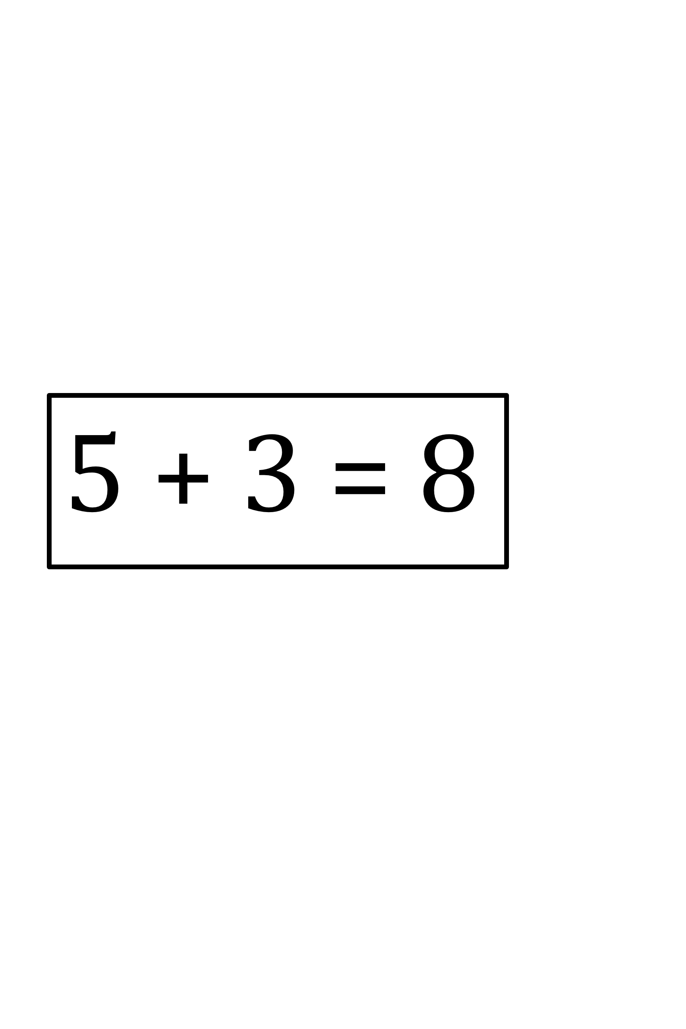

5 - 3 = 2

1. number bond mat