Table of Contents
GRADE 5 • MODULE 4
Multiplication and Division of Fractions and Decimal Fractions

Module Overview i

Topic A: Line Plots of Fraction Measurements 4.A.1

Topic B: Fractions as Division 4.B.1

Topic C: Multiplication of a Whole Number by a Fraction 4.C.1

Topic D: Fraction Expressions and Word Problems 4.D.1

Topic E: Multiplication of a Fraction by a Fraction 4.E.1

Topic F: Multiplication with Fractions and Decimals as Scaling and Word Problems…………………………………………………………………………………………....... 4.F.1

Topic G: Division of Fractions and Decimal Fractions 4.G.1

Topic H: Interpretation of Numerical Expressions 4.H.1

Module Assessments 4.S.1

Grade 5 • Module 4
Multiplication and Division of Fractions and Decimal Fractions

OVERVIEW
In Module 4, students learn to multiply fractions and decimal fractions, and begin working with fraction division. Topic A opens the 38-day module with an exploration of fractional measurement. Students construct line plots by measuring the same objects using three different rulers accurate to $\frac{1}{2}$, $\frac{1}{4}$, and $\frac{1}{8}$ of an inch (5.MD.2).
Students compare the line plots and explain how changing the accuracy of the unit of measure affects the distribution of points. This is foundational to the understanding that measurement is inherently imprecise because it is limited by the accuracy of the tool at hand. Students use their knowledge of fraction operations to explore questions that arise from the plotted data. The interpretation of a fraction as division is inherent in this exploration. For measuring to the quarter inch, one inch must be divided into four equal parts, or
1 ÷ 4. This reminder of the meaning of a fraction as a point on a number line, coupled with the embedded, informal exploration of fractions as division, provides a bridge to Topic B’s more formal treatment of fractions as division.
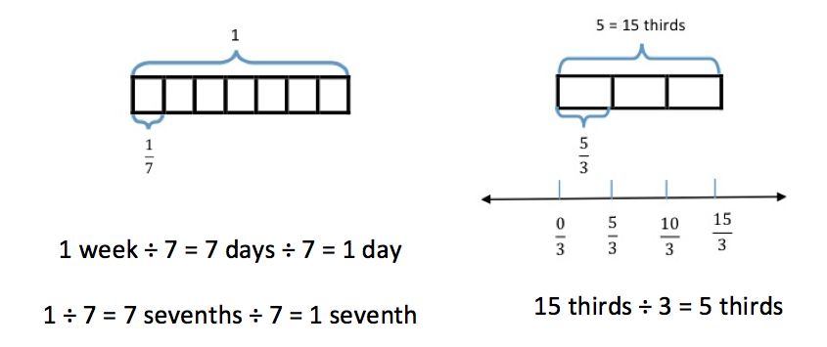
Topic B focuses on interpreting fractions as division. Equal sharing with area models (both concrete and pictorial) provides students with an opportunity to understand division of whole numbers with answers in the form of fractions or mixed numbers (e.g., seven brownies shared by three girls, three pizzas shared by four people). Discussion also includes an interpretation of remainders as a fraction (5.NF.3). Tape diagrams provide a linear model of these problems. Moreover, students see that, by renaming larger units in terms of smaller units, division resulting in a fraction is similar to whole number division.

Topic B continues as students solve real world problems (5.NF.3) and generate story contexts for visual models. The topic concludes with students making connections between models and equations while reasoning about their results (e.g., between what two whole numbers does the answer lie?).
1 $÷$ 7 = $\frac{7}{7}$ $÷$ 7 = $\frac{1}{7}$ 5 $÷$ 3 = $\frac{5}{3}$
In Topic C, students interpret finding a fraction of a set ($\frac{3}{4}$ of 24) as multiplication of a whole number by a fraction ($\frac{3}{4}$ × 24) and use tape diagrams to support their understandings (5.NF.4a). This, in turn, leads students to see division by a whole number as being equivalent to multiplication by its reciprocal. That is, division by 2, for example, is the same as multiplication by $\frac{1}{2}$. Students also use the commutative property to relate a fraction of a set to the Grade 4 repeated addition interpretation of multiplication by a fraction. This offers opportunities for students to reason about various strategies for multiplying fractions and whole numbers. Students apply their knowledge of a fraction of a set and previous conversion experiences (with scaffolding from a conversion chart, if necessary) to find a fraction of a measurement, thus converting a larger unit to an equivalent smaller unit (e.g., $\frac{1}{3}$ min = 20 seconds and 2 $\frac{1}{4}$ feet = 27 inches).
Interpreting numerical expressions opens Topic D as students learn to evaluate expressions with parentheses, such as 3 × ($\frac{2}{3}-\frac{1}{5}$ ) or $\frac{2}{3}$ × (7 + 9) (5.OA.1). They then learn to interpret numerical expressions, such as 3 times the difference between $\frac{2}{3}$ and $\frac{1}{5}$ or two-thirds the sum of 7 and 9 (5.OA.2). Students generate word problems that lead to the same calculation (5.NF.4a) such as, “Kelly combined 7 ounces of carrot juice and 5 ounces of orange juice in a glass. Jack drank $\frac{2}{3}$ of the mixture. How much did Jack drink?” Solving word problems (5.NF.6) allows students to apply new knowledge of fraction multiplication in context, and tape diagrams are used to model multi-step problems requiring the use of addition, subtraction, and multiplication of fractions.
Topic E introduces students to multiplication of fractions by fractions—both in fraction and decimal form (5.NF.4a, 5.NBT.7). The topic starts with multiplying a unit fraction by a unit fraction, and progresses to multiplying two non-unit fractions. Students use area models, rectangular arrays, and tape diagrams to model the multiplication. These familiar models help students draw parallels between whole number and fraction multiplication, as well as solve word problems. This intensive work with fractions positions students to extend their previous work with decimal-by-whole number multiplication to decimal-by-decimal multiplication. Just as students used unit form to multiply fractional units by wholes in Module 2
(e.g., 3.5 × 2 = 35 tenths × 2 ones = 70 tenths), they will connect fraction-by-fraction multiplication to multiply fractional units‐by-fractional units (3.5 × 0.2 = 35 tenths × 2 tenths = 70 hundredths).
$\frac{3}{4}$ of a foot = $\frac{3}{4}$ × 12 inches
1 foot = 12 inches
$\frac{3}{4}$ × 12
Express $\text{5}\frac{3}{4}$ ft as inches.
$\text{5}\frac{3}{4}$ ft = (5 × 12) inches + ($\frac{3}{4}$ × 12) inches
= 60 + 9 inches
= 69 inches

Reasoning about decimal placement is an integral part of these lessons. Finding fractional parts of customary measurements and measurement conversion (5.MD.1) concludes Topic E. Students convert smaller units to fractions of a larger unit (e.g., 6 inches = $\frac{1}{2}$ ft). The inclusion of customary units provides a meaningful context for many common fractions ($\frac{1}{2}$ pint = 1 cup, $\frac{1}{3}$ yard = 1 foot, $\frac{1}{4}$ gallon = 1 quart, etc.). This topic, together with the fraction concepts and skills learned in Module 3, opens the door to a wide variety of application word problems (5.NF.6).
Students interpret multiplication in Grade 3 as equal groups, and in Grade 4 students begin understanding multiplication as comparison. Here, in Topic F, students once again extend their understanding of multiplication to include scaling (5.NF.5). Students compare the product to the size of one factor, given the size of the other factor (5.NF.5a) without calculation (e.g., 486 × 1,327.45 is twice as large as 243 × 1,327.45 because 486 = 2 × 243). This reasoning, along with the other work of this module, sets the stage for students to reason about the size of products when quantities are multiplied by numbers larger than 1 and smaller than 1. Students relate their previous work with equivalent fractions to interpreting multiplication by $\frac{n}{n}$ as multiplication by 1 (5.NF.5b). Students build on their new understanding of fraction equivalence as multiplication by $\frac{n}{n}$ to convert fractions to decimals and decimals to fractions. For example, $\frac{3}{25}$ is easily renamed in hundredths as $\frac{12}{100}$ using multiplication of $\frac{4}{4}$. The word form of twelve hundredths will then be used to notate this quantity as a decimal. Conversions between fractional forms will be limited to fractions whose denominators are factors of 10, 100, or 1,000. Students will apply the concepts of the topic to real world, multi‐step problems (5.NF.6).
Topic G begins the work of division with both fractions and decimal fractions. Students use tape diagrams and number lines to reason about the division of a whole number by a unit fraction and a unit fraction by a whole number (5.NF.7). Using the same thinking developed in Module 2 to divide whole numbers, students reason about how many fourths are in 5 when considering such cases as 5 ÷ $\frac{1}{4}$. They also reason about the size of the unit when $\frac{1}{4}$ is partitioned into 5 equal parts: $\frac{1}{4}$ ÷ 5. Using this thinking as a backdrop, students are introduced to decimal fraction divisors and use equivalent fraction and place value thinking to reason about the size of quotients, calculate quotients, and sensibly place the decimal in quotients (5.NBT.7).
The module concludes with Topic H, in which numerical expressions involving fraction-by-fraction multiplication are interpreted and evaluated (5.OA.1, 5.OA.2). Students create and solve word problems involving both multiplication and division of fractions and decimal fractions.
The Mid-Module Assessment is administered after Topic D, and the End-of-Module Assessment follows
Topic H.

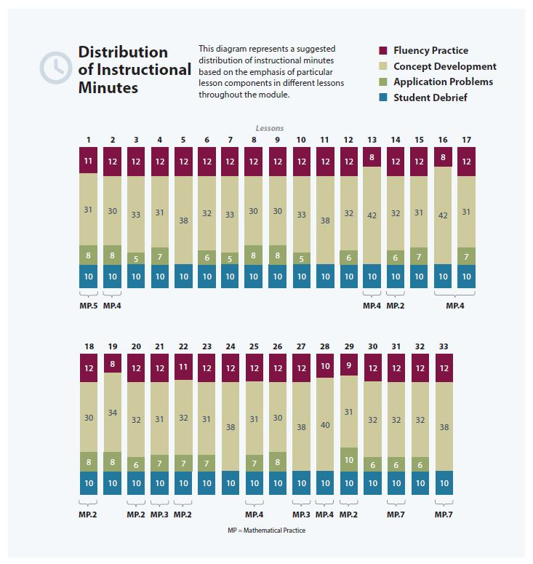

Focus Grade Level Standards
Write and interpret numerical expressions.
5.OA.1 Use parentheses, brackets, or braces in numerical expressions, and evaluate expressions with these symbols.
5.OA.2 Write simple expressions that record calculations with numbers, and interpret numerical expressions without evaluating them. For example, express the calculation “add 8 and 7, then multiply by 2” as 2 × (8 +7). Recognize that 3 × (18932 + 921) is three times as large as 18932 + 921, without having to calculate the indicated sum or product.
Perform operations with multi-digit whole numbers and with decimals to hundredths.
5.NBT.7 Add, subtract, multiply, and divide decimals to hundredths, using concrete models or drawings and strategies based on place value, properties of operations, and/or the relationship between addition and subtraction; relate the strategy to a written method and explain the reasoning used.
Apply and extend previous understandings of multiplication and division to multiply and divide fractions.
5.NF.3 Interpret a fraction as division of the numerator by the denominator (a/b = a ÷ b). Solve word problems involving division of whole numbers leading to answers in the form of fractions or mixed numbers, e.g., by using visual fraction models or equations to represent the problem. For example, interpret 3/4 as the result of dividing 3 by 4, noting that 3/4 multiplied by 4 equals 3, and that when 3 wholes are shared equally among 4 people each person has a share of size 3/4. If 9 people want to share a 50‐pound sack of rice equally by weight, how many pounds of rice should each person get? Between what two whole numbers does your answer lie?
5.NF.4 Apply and extend previous understandings of multiplication to multiply a fraction or whole number by a fraction.
a. Interpret the product of (a/b) × q as a parts of a partition of q into b equal parts; equivalently, as the result of a sequence of operations a × q ÷ b. For example, use a visual fraction model to show (2/3 × 4 = 8/3, and create a story context for this equation. Do the same with (2/3) × (4/5) = 8/15. (In general, (a/b) × (c/d) = ac/bd.)
5.NF.5 Interpret multiplication as scaling (resizing), by:
a. Comparing the size of a product to the size of one factor on the basis of the size of the other factor, without performing the indicated multiplication.
b. Explaining why multiplying a given number by a fraction greater than 1 results in a product greater than the given number (recognizing multiplication by whole numbers greater than 1 as a familiar case); explaining why multiplying a given number by a fraction less than 1 results in a product smaller than the given number; and relating the principle of fraction equivalence a/b = (n×a)/(n×b) to the effect of multiplying a/b by 1.
5.NF.6 Solve real world problems involving multiplication of fractions and mixed numbers, e.g., by using visual fraction models or equations to represent the problem.
5.NF.7 Apply and extend previous understandings of division to divide unit fractions by whole numbers and whole numbers by unit fractions. (Students capable of multiplying fractions can generally develop strategies to divide fractions by reasoning about the relationship between multiplication and division. However, division of a fraction by a fraction is not a requirement at this grade level.)
a. Interpret division of a unit fraction by a non-zero whole number, and compute such quotients. For example, create a story context for (1/3) ÷ 4, and use a visual fraction model to show the quotient. Use the relationship between multiplication and division to explain that (1/3) ÷ 4 = 1/12 because (1/12) × 4 = 1/3.
b. Interpret division of a whole number by a unit fraction, and compute such quotients. For example, create a story context for 4 ÷ (1/5), and use a visual fraction model to show the quotient. Use the relationship between multiplication and division to explain that 4 ÷ (1/5) = 20 because 20 × (1/5) = 4.
c. Solve real world problems involving division of unit fractions by non‐zero whole numbers and division of whole numbers by unit fractions, e.g., by using visual fraction models and equations to represent the problem. For example, how much chocolate will each person get if 3 people share 1/2 lb of chocolate equally? How many 1/3-cup servings are in 2 cups of raisins?
Convert like measurement units within a given measurement system.
5.MD.1 Convert among different-sized standard measurement units within a given measurement system (e.g., convert 5 cm to 0.05 m), and use these conversions in solving multi-step, real world problems.
Represent and interpret data.
5.MD.2 Make a line plot to display a data set of measurements in fractions of a unit (1/2, 1/4, 1/8). Use operations on fractions for this grade to solve problems involving information presented in line plots. For example, given different measurements of liquid in identical beakers, find the amount of liquid each beaker would contain if the total amount in all the beakers were redistributed equally.

Foundational Standards
4.NF.1 Explain why a fraction a/b is equivalent to a fraction (n × a)/(n × b) by using visual fraction models, with attention to how the number and size of the parts differ even though the two fractions themselves are the same size. Use this principle to recognize and generate equivalent fractions.
4.NF.2 Compare two fractions with different numerators and different denominators, e.g., by creating common denominators or numerators, or by comparing to a benchmark fraction such as 1/2. Recognize that comparisons are valid only when the two fractions refer to the same whole. Record the results of comparisons with symbols >, =, or <, and justify the conclusions, e.g., by using a visual fraction model.
4.NF.3 Understand a fraction a/b with a > 1 as a sum of fractions 1/b.
a. Understand addition and subtraction of fractions as joining and separating parts referring to the same whole.
b. Decompose a fraction into a sum of fractions with the same denominator in more than one way, recording each decomposition by an equation. Justify decompositions, e.g., by using a visual fraction model. Examples: 3/8 = 1/8 + 1/8 + 1/8 ; 3/8 = 1/8 + 2/8 ; 2 1/8 = 1 + 1 + 1/8 = 8/8 + 8/8 + 1/8.
4.NF.4 Apply and extend previous understandings of multiplication to multiply a fraction by a whole number.
a. Understand a fraction a/b as a multiple of 1/b. For example, use a visual fraction model to represent 5/4 as the product 5 × (1/4), recording the conclusion by the equation 5/4 = 5 × (1/4).
b. Understand a multiple of a/b as a multiple of 1/b, and use this understanding to multiply a fraction by a whole number. For example, use a visual fraction model to express 3 × (2/5) as 6 × (1/5), recognizing this product as 6/5. (In general, n × (a/b) = (n × a)/b.)
c. Solve word problems involving multiplication of a fraction by a whole number, e.g., by using visual fraction models and equations to represent the problem. For example, if each person at a party will eat 3/8 of a pound of roast beef, and there will be 5 people at the party, how many pounds of roast beef will be needed? Between what two whole numbers does your answer lie?
4.NF.5 Express a fraction with denominator 10 as an equivalent fraction with denominator 100, and use this technique to add two fractions with respective denominators 10 and 100. (Students capable of generating equivalent fractions can generally develop strategies for adding fractions with unlike denominators. However, addition and subtraction with unlike denominators generally is not a requirement at this grade.) For example, express 3/10 as 30/100, and add 3/10 + 4/100 = 34/100.
4.NF.6 Use decimal notation for fractions with denominators 10 or 100. For example, rewrite 0.62 as 62/100; describe a length as 0.62 meters; locate 0.62 on a number line diagram.
Focus Standards for Mathematical Practice
MP.2 Reason abstractly and quantitatively. Students reason abstractly and quantitatively as they interpret the size of a product in relation to the size of a factor, as well as interpret terms in a multiplication sentence as a quantity and scaling factor. Then, students create a coherent representation of the problem at hand while attending to the meaning of the quantities.
MP.4 Model with mathematics. Students model with mathematics as they solve word problems involving multiplication and division of fractions and decimals, as well as identify important quantities in a practical situation and map their relationships using diagrams. Students use a line plot to model measurement data and interpret their results with respect to context of the situation, reflecting on whether results make sense, and possibly improve the model if it has not served its purpose.
MP.5 Use appropriate tools strategically. Students use rulers to measure objects to the $\frac{1}{2}$, $\frac{1}{4}$ and $\frac{1}{8}$ inch increments, recognizing both the insight to be gained and limitations of this tool as they learn that the actual object may not match the mathematical model precisely.
Overview of Module Topics and Lesson Objectives
Standards | Topics and Objectives |  | Days
5.MD.2 | A | Line Plots of Fraction Measurements  Lesson 1: Measure and compare pencil lengths to the nearest $\frac{1}{2}$, $\frac{1}{4}$, and $\frac{1}{8}$ of an inch, and analyze the data through line plots. | 1
5.NF.3 | B | Fractions as Division  Lessons 2–3: Interpret a fraction as division.  Lesson 4: Use tape diagrams to model fractions as division.  Lesson 5: Solve word problems involving the division of whole numbers with answers in the form of fractions or whole numbers. | 4
5.NF.4a | C | Multiplication of a Whole Number by a Fraction  Lesson 6: Relate fractions as division to fraction of a set.  Lesson 7: Multiply any whole number by a fraction using tape diagrams.  Lesson 8: Relate a fraction of a set to the repeated addition interpretation of fraction multiplication.  Lesson 9: Find a fraction of a measurement, and solve word problems. | 4

Standards |  | Topics and Objectives |  | Days
5.OA.1  5.OA.2  5.NF.4a  5.NF.6 |  | D | Fraction Expressions and Word Problems  Lesson 10: Compare and evaluate expressions with parentheses.  Lesson 11–12: Solve and create fraction word problems involving addition, subtraction, and multiplication. | 3
 |  |  | Mid-Module Assessment: Topics A–D (assessment ½ day, return ½ day, remediation or further applications 1 day) | 2
5.NBT.7  5.NF.4a  5.NF.6  5.MD.1  5.NF.4b |  | E | Multiplication of a Fraction by a Fraction  Lesson 13: Multiply unit fractions by unit fractions.  Lesson 14: Multiply unit fractions by non-unit fractions.  Lesson 15: Multiply non-unit fractions by non-unit fractions.  Lesson 16: Solve word problems using tape diagrams and fraction-by-fraction multiplication.  Lessons 17–18: Relate decimal and fraction multiplication.  Lesson 19: Convert measures involving whole numbers, and solve multi-step word problems.  Lesson 20: Convert mixed unit measurements, and solve multi-step word problems. | 8
5.NF.5  5.NF.6 |  | F | Multiplication with Fractions and Decimals as Scaling and Word Problems  Lesson 21: Explain the size of the product, and relate fraction and decimal equivalence to multiplying a fraction by 1.  Lessons 22–23: Compare the size of the product to the size of the factors.  Lesson 24: Solve word problems using fraction and decimal multiplication. | 4
5.OA.1  5.NBT.7  5.NF.7 |  | G | Division of Fractions and Decimal Fractions  Lesson 25: Divide a whole number by a unit fraction.  Lesson 26: Divide a unit fraction by a whole number.  Lesson 27: Solve problems involving fraction division.  Lesson 28: Write equations and word problems corresponding to tape and number line diagrams.  Lessons 29: Connect division by a unit fraction to division by 1 tenth and 1 hundredth.  Lessons 30–31: Divide decimal dividends by non‐unit decimal divisors. | 7
Standards |  | Topics and Objectives |  | Days
5.OA.1  5.OA.2 | H | Interpretation of Numerical Expressions  Lesson 32: Interpret and evaluate numerical expressions including the language of scaling and fraction division.  Lesson 33: Create story contexts for numerical expressions and tape diagrams, and solve word problems. |  | 2
 |  | End-of-Module Assessment: Topics A–H (assessment ½ day, return ½ day, remediation or further applications 2 days) |  | 3
Total Number of Instructional Days |  |  |  | 38
Terminology
New or Recently Introduced Terms
- Decimal divisor (the number that divides the whole and has units of tenths, hundredths, thousandths, etc.)
- Simplify (using the largest fractional unit possible to express an equivalent fraction)
Familiar Terms and Symbols
- Conversion factor
- Commutative property (e.g., 4 × $\frac{1}{2}$ = $\frac{1}{2}$× 4)
- Decimal fraction
- Denominator (denotes the fractional unit, e.g., fifths in 3 fifths, which is abbreviated to the 5 in $\frac{3}{5}$)
- Distribute (with reference to the distributive property, e.g., in $\text{1}\frac{2}{5}$ × 15 = (1 × 15) + ($\frac{2}{5}$ × 15))
- Divide, division (partitioning a total into equal groups to show how many units in a whole,
e.g., 5 ÷ $\frac{1}{5}$ = 25)
- Equation (a statement that two expressions are equal, e.g., 3 × 4 = 6 × 2)
- Equivalent fraction
- Expression
- Factors (numbers that are multiplied to obtain a product)
- Feet, mile, yard, inch, gallon, quart, pint, cup, pound, ounce, hour, minute, second
- Fraction greater than or equal to 1 (e.g., $\frac{7}{2}$, $\text{3}\frac{1}{2}$, an abbreviation for 3 + $\frac{1}{2}$)
- Fraction written in the largest possible unit (e.g., $\frac{3}{6}=\frac{1 × 3}{2 × 3}=\frac{1}{2}$ or 1 three out of 2 threes = $\frac{1}{2}$)
- Fractional unit (e.g., the fifth unit in 3 fifths denoted by the denominator 5 in $\frac{3}{5}$)
- Hundredth ($\frac{1}{100}$ or 0.01)
- Line plot
- Mixed number ($\text{3}\frac{1}{2}$, an abbreviation for 3 + $\frac{1}{2}$)
- Numerator (denotes the count of fractional units, e.g., 3 in 3 fifths or 3 in $\frac{3}{5}$)
- Parentheses (symbols ( ) used around a fact or numbers within an equation or expression)
- Quotient (the answer when one number is divided by another)
- Tape diagram (method for modeling problems)
- Tenth ($\frac{1}{10}$ or 0.1)
- Unit (one segment of a partitioned tape diagram)
- Unknown (the missing factor or quantity in multiplication or division)
- Whole unit (any unit partitioned into smaller, equally sized fractional units)
Suggested Tools and Representations
- Area models
- Number lines
- Tape diagrams
Scaffolds
The scaffolds integrated into A Story of Units give alternatives for how students access information as well as express and demonstrate their learning. Strategically placed margin notes are provided within each lesson elaborating on the use of specific scaffolds at applicable times. They address many needs presented by English language learners, students with disabilities, students performing above grade level, and students performing below grade level. Many of the suggestions are organized by Universal Design for Learning (UDL) principles and are applicable to more than one population. To read more about the approach to differentiated instruction in A Story of Units, please refer to “How to Implement A Story of Units.”

Assessment Summary
Type | Administered | Format | Standards Addressed
Mid-Module Assessment Task | After Topic D | Constructed response with rubric | 5.OA.1  5.OA.2  5.NF.3  5.NF.4a  5.NF.6  5.MD.1  5.MD.2
End-of-Module Assessment Task | After Topic H | Constructed response with rubric | 5.OA.1  5.OA.2  5.NBT.7  5.NF.3  5.NF.4a  5.NF.5  5.NF.6  5.NF.7  5.MD.1  5.MD.2

These are terms and symbols students have seen previously.
Students with disabilities may require Braille, large print, audio, or special digital files. Please visit the website, www.p12.nysed.gov/specialed/aim, for specific information on how to obtain student materials that satisfy the National Instructional Materials Accessibility Standard (NIMAS) format.

