Table of Contents
GRADE 4 • MODULE 5
Fraction Equivalence, Ordering, and Operations

Module Overview i

Topic A: Decomposition and Fraction Equivalence 5.A.1

Topic B: Fraction Equivalence Using Multiplication and Division 5.B.1

Topic C: Fraction Comparison 5.C.1

Topic D: Fraction Addition and Subtraction 5.D.1

Topic E: Extending Fraction Equivalence to Fractions Greater Than 1 5.E.1

Topic F: Addition and Subtraction of Fractions by Decomposition 5.F.1

Topic G: Repeated Addition of Fractions as Multiplication 5.G.1

Topic H: Exploring a Fraction Pattern 5.H.1

Module Assessments 5.S.1

Grade 4 • Module 5
Fraction Equivalence, Ordering, and Operations

OVERVIEW
In this 45-day module, students build on their Grade 3 work with unit fractions as they explore fraction equivalence and extend this understanding to mixed numbers. This leads to the comparison of fractions and mixed numbers and the representation of both in a variety of models. Benchmark fractions play an important part in students’ ability to generalize and reason about relative fraction and mixed number sizes. Students then have the opportunity to apply what they know to be true for whole number operations to the new concepts of fraction and mixed number operations.
Students begin Topic A by decomposing fractions and creating tape diagrams to represent them as sums of fractions with the same denominator in different ways (e.g., $\frac{\text{3}}{\text{5}} \text{=} \frac{\text{1}}{\text{5}} \text{+} \frac{\text{1}}{\text{5}} \text{+} \frac{\text{1}}{\text{5}} \text{=} \frac{\text{1}}{\text{5}} \text{+} \frac{\text{2}}{\text{5}}$ ) (4.NF.3b). They proceed to see that representing a fraction as the repeated addition of a unit fraction is the same as multiplying that unit fraction by a whole number. This is already a familiar fact in other contexts.
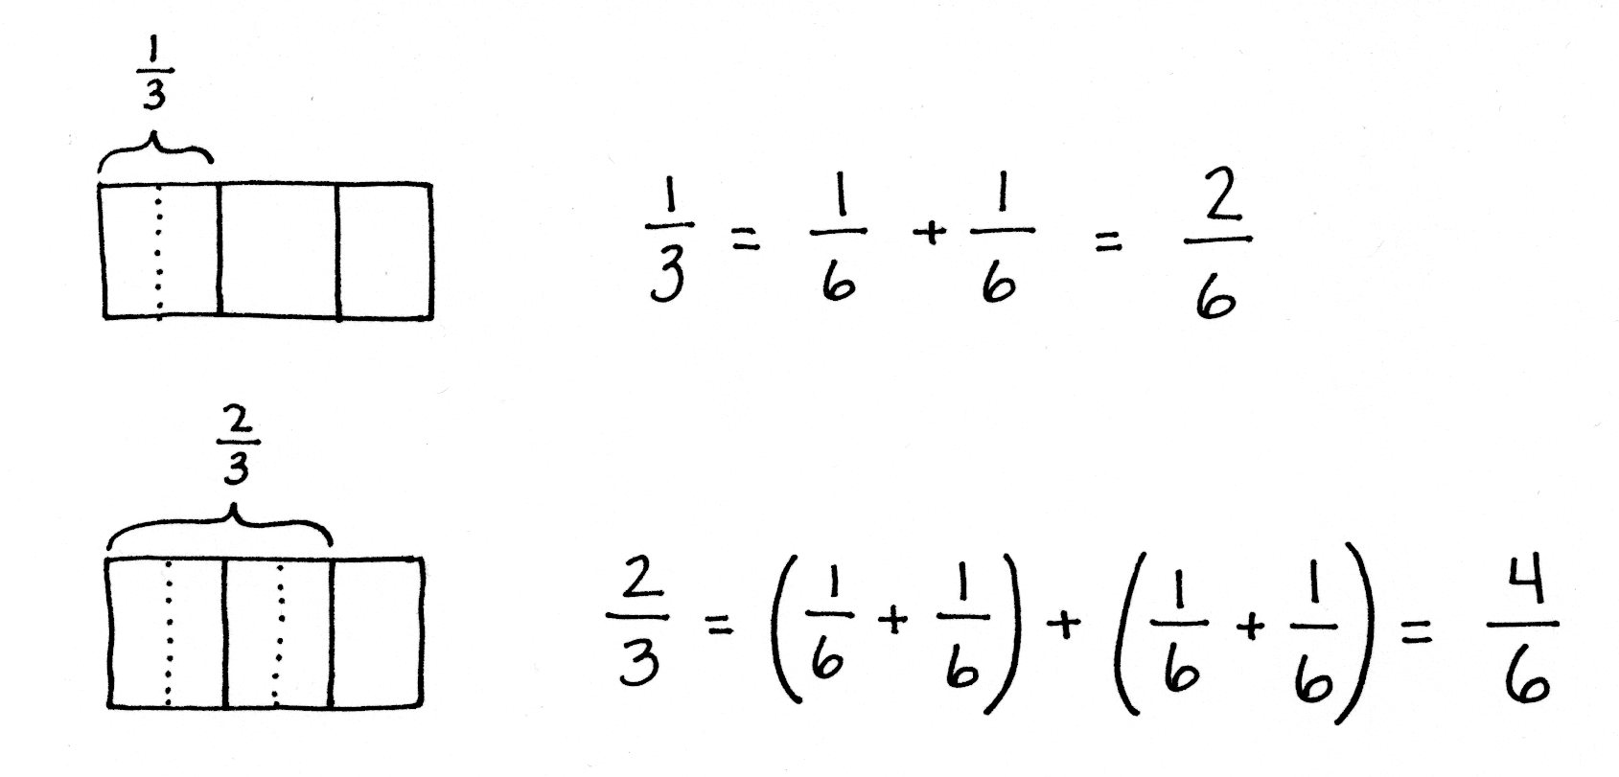
For example, just as 3 twos = 2 + 2 + 2 = 3 × 2, so does 3 fourths$\text{=} \frac{\text{1}}{\text{4}} \text{+} \frac{\text{1}}{\text{4}} \text{+} \frac{\text{1}}{\text{4}} \text{=} \text{3 ×} \frac{\text{1}}{\text{4}}$.
The introduction of multiplication as a record of the decomposition of a fraction (4.NF.4a) early in the module allows students to become familiar with the notation before they work with more complex problems. As students continue working with decomposition, they represent familiar unit fractions as the sum of smaller unit fractions. A folded paper activity allows them to see that, when the number of fractional parts in a whole increases, the size of the parts decreases. They proceed to investigate this concept with the use of tape diagrams and area models. Reasoning enables them to explain why two different fractions can represent the same portion of a whole (4.NF.1).
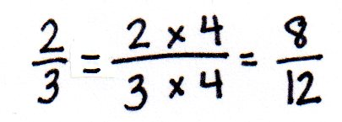
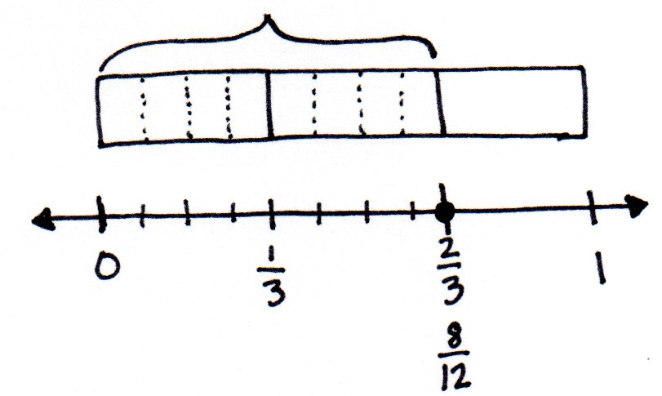
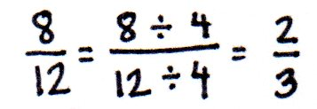
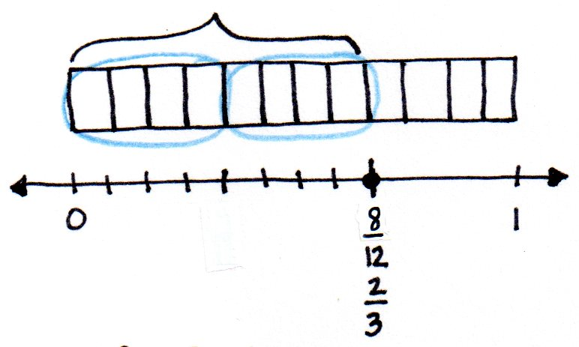
In Topic B, students use tape diagrams and area models to analyze their work from earlier in the module and begin using multiplication to create an equivalent fraction that comprises smaller units, e.g., $\frac{\text{2}}{\text{3}} \text{=} \frac{\text{2 × 4}}{\text{3 }\text{× }\text{4}} \text{=} \frac{\text{8}}{\text{12}}$ (4.NF.1). Based on the use of multiplication, they reason that division can be used to create a fraction that comprises larger units (or a single unit) equivalent to a given fraction (e.g., $\frac{\text{8}}{\text{12}} \text{=} \frac{\text{8 ÷ 4}}{\text{12 }\text{÷ }\text{4}} \text{=} \frac{\text{2}}{\text{3}}$). Their work is justified using area models and tape diagrams and, conversely, multiplication is used to test for and/or verify equivalence. Students use the tape diagram to transition to modeling equivalence on the number line. They see that, by multiplying, any unit fraction length can be partitioned into n equal lengths and that doing so multiplies both the total number of fractional units (the denominator) and number of selected units (the numerator) by n. They also see that there are times when fractional units can be grouped together, or divided, into larger fractional units. When that occurs, both the total number of fractional units and number of selected units are divided by the same number.

In Grade 3, students compared fractions using fraction strips and number lines with the same denominators. In Topic C, they expand on comparing fractions by reasoning about fractions with unlike denominators. Students use the relationship between the numerator and denominator of a fraction to compare to a known benchmark (e.g., 0, $\frac{\text{1}}{\text{2}}$ , or 1) on the number line. Alternatively, students compare using the same numerators. They find that the fraction with the greater denominator is the lesser fraction since the size of the fractional unit is smaller as the whole is decomposed into more equal parts (e.g., $\frac{\text{1}}{\text{5}}$ > $\frac{\text{1}}{\text{10}}$, therefore $\frac{\text{3}}{\text{5}}\text{ >}\frac{\text{3}}{\text{10}}$). Throughout the process, their reasoning is supported using tape diagrams and number lines in cases where one numerator or denominator is a factor of the other, such as $\frac{\text{1}}{\text{5}}$ and $\frac{\text{1}}{\text{10}}$ or $\frac{\text{2}}{\text{3}}$ and $\frac{\text{5}}{\text{6}}.$ When the units are unrelated, students use area models and multiplication, the general method pictured below to the left, whereby two fractions are expressed in terms of the same denominators. Students also reason that comparing fractions can only be done when referring to the same whole, and they record their comparisons using the comparison symbols <, >, and = (4.NF.2).
Comparison Using Like Numerators
Comparison Using Like Denominators

In Topic D, students apply their understanding of whole number addition (the combining of like units) and subtraction (finding an unknown part) to work with fractions (4.NF.3a). They see through visual models that, if the units are the same, computation can be performed immediately, e.g., 2 bananas + 3 bananas =
5 bananas and 2 eighths + 3 eighths = 5 eighths. They see that, when subtracting fractions from one whole, the whole is decomposed into the same units as the part being subtracted, e.g., 1 – $\frac{\text{3}}{\text{5}} \text{=} \frac{\text{5}}{\text{5}} \text{–} \frac{\text{3}}{\text{5}} \text{=} \frac{\text{2}}{\text{5}}\text{.}$ Students practice adding more than two fractions and model fractions in word problems using tape diagrams (4.NF.3d). As an extension of the Grade 4 standards, students apply their knowledge of decomposition from earlier topics to add fractions with related units using tape diagrams and area models to support their numerical work. To find the sum of $\frac{\text{1}}{\text{2}}$ and $\frac{\text{1}}{\text{4}}$, for example, one simply decomposes 1 half into 2 smaller equal units, fourths, just as in Topics A and B. Now, the addition can be completed: $\frac{\text{2}}{\text{4}} \text{+} \frac{\text{1}}{\text{4}} \text{=} \frac{\text{3}}{\text{4}}$. Though not assessed, this work is warranted because, in Module 6, students are asked to add tenths and hundredths when working with decimal fractions and decimal notation.
At the beginning of Topic E, students use decomposition and visual models to add and subtract fractions less than 1 to or from whole numbers, e.g., $\text{4} \text{+ }\frac{\text{3}}{\text{4}}\text{=} \text{4}\frac{\text{3}}{\text{4}}$and $\text{4 – }\frac{\text{3}}{\text{4}}\text{= }\left(\text{3 + 1}\right) \text{– }\frac{\text{3}}{\text{4}}$. They use addition and multiplication to build fractions greater than 1 and represent them on the number line.
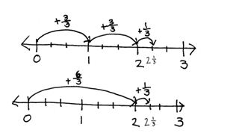

Students then use these visual models and decompositions to reason about the various forms in which a fraction greater than or equal to 1 may be presented, both as fractions and mixed numbers. They practice converting between these forms and begin understanding the usefulness of each form in different situations. Through this understanding, the common misconception that every improper fraction must be converted to a mixed number is avoided. Next, students compare fractions greater than 1, building on their rounding skills and using understanding of benchmarks to reason about which of two fractions is greater (4.NF.2). This activity continues to build understanding of the relationship between the numerator and denominator of a fraction. Students progress to finding and using like denominators or numerators to compare and order mixed numbers. They apply their skills of comparing numbers greater than 1 by solving word problems (4.NF.3d) requiring the interpretation of data presented in line plots (4.MD.4). Students use addition and subtraction strategies to solve the problems, as well as decomposition and modeling to compare numbers in the data sets.
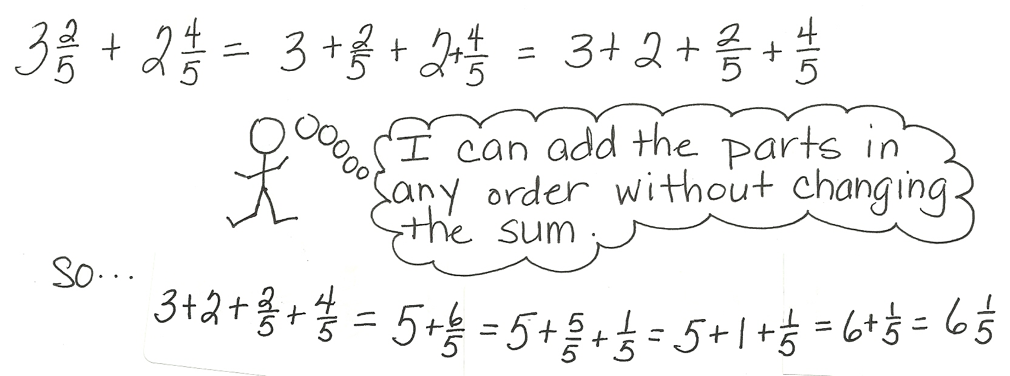
In Topic F, students estimate sums and differences of mixed numbers, rounding before performing the actual operation to determine what a reasonable outcome will be. They proceed to use decomposition to add and subtract mixed numbers (4.NF.3c). This work builds on their understanding of a mixed number being the sum of a whole number and fraction.
Using unit form, students add and subtract like units first (e.g., ones and ones, fourths and fourths). Students use decomposition, shown with number bonds, in mixed number addition to make one from fractional units before finding the sum. When subtracting, students learn to decompose the minuend or subtrahend when there are not enough fractional units from which to subtract. Alternatively, students can rename the subtrahend, giving more units to the fractional units, which connects to whole number subtraction when renaming 9 tens 2 ones as 8 tens 12 ones.
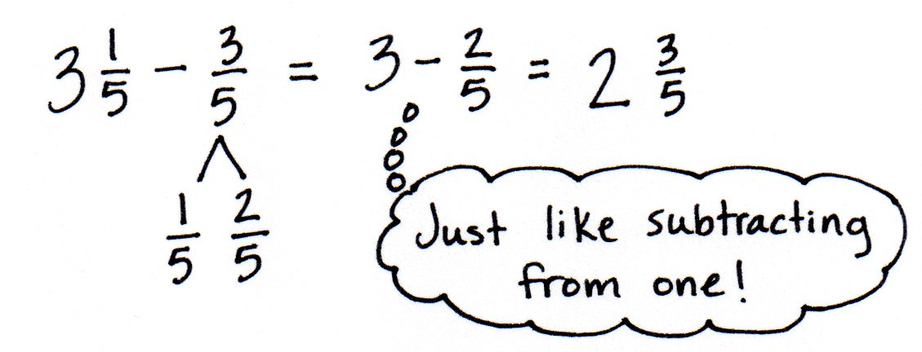
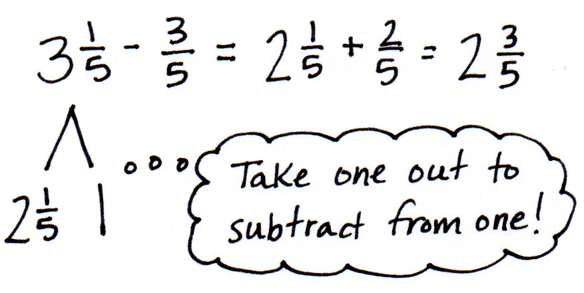
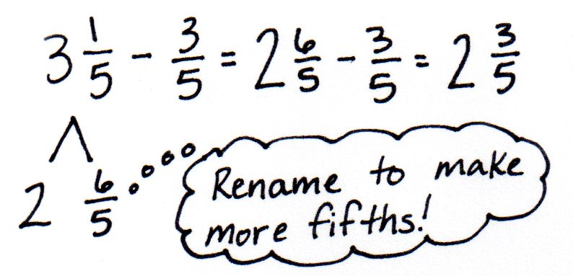
In Topic G, students build on the concept of representing repeated addition as multiplication, applying this familiar concept to work with fractions (4.NF.4a, 4.NF.4b). They use the associative property and their understanding of decomposition. Just as with whole numbers, the unit remains unchanged.

$$\text{4 × }\frac{\text{3}}{\text{5}}\text{ = 4 ×} \left(\text{3 × }\frac{\text{1}}{\text{5}}\right) \text{= }\left(\text{4 × 3}\right)\text{ × }\frac{\text{1}}{\text{5}}\text{ = }\frac{\text{4 × 3}}{\text{5}}\text{ = }\frac{\text{12}}{\text{5}}$$
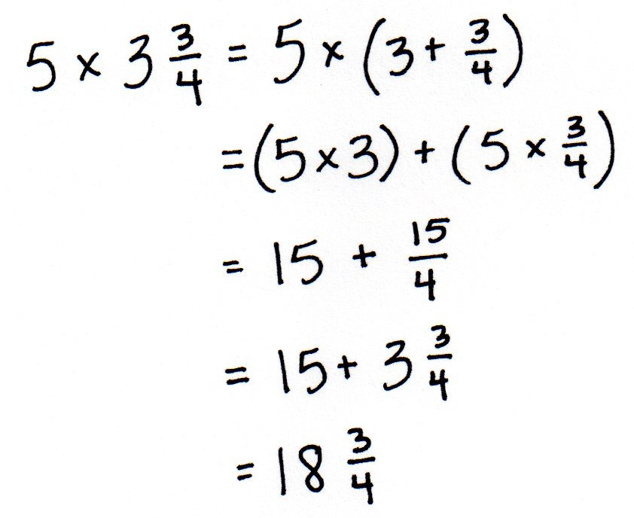
This understanding connects to students’ work with place value and whole numbers. Students proceed to explore the use of the distributive property to multiply a whole number by a mixed number. They recognize that they are multiplying each part of a mixed number by the whole number and use efficient strategies to do so. The topic closes with solving multiplicative comparison word problems involving fractions (4.NF.4c) as well as problems involving the interpretation of data presented on a line plot.
Topic H comprises an exploration lesson where students find the sum of all like denominators from $\frac{\text{0}}{\text{n}} \text{to} \frac{\text{n}}{\text{n}}$. Students first work in teams with fourths, sixths, eighths, and tenths. For example, they might find the sum of all sixths from $\frac{\text{0}}{\text{6}}$ to $\frac{\text{6}}{\text{6}}.$ Students discover that they can make pairs with a sum of 1 to add more efficiently, e.g., $\frac{\text{0}}{\text{6}}\text{ + }\frac{\text{6}}{\text{6}}\text{, }\frac{\text{1}}{\text{6}}\text{ + }\frac{\text{5}}{\text{6}}\text{, }\frac{\text{2}}{\text{6}}\text{ + }\frac{\text{4}}{\text{6}},$ and there will be one fraction, $\frac{3}{6},$ without a pair. They then extend this to similarly find sums of thirds, fifths, sevenths, and ninths, observing patterns when finding the sum of odd and even denominators (4.OA.5).
The Mid-Module Assessment follows Topic D, and the End-of-Module Assessment follows Topic H.
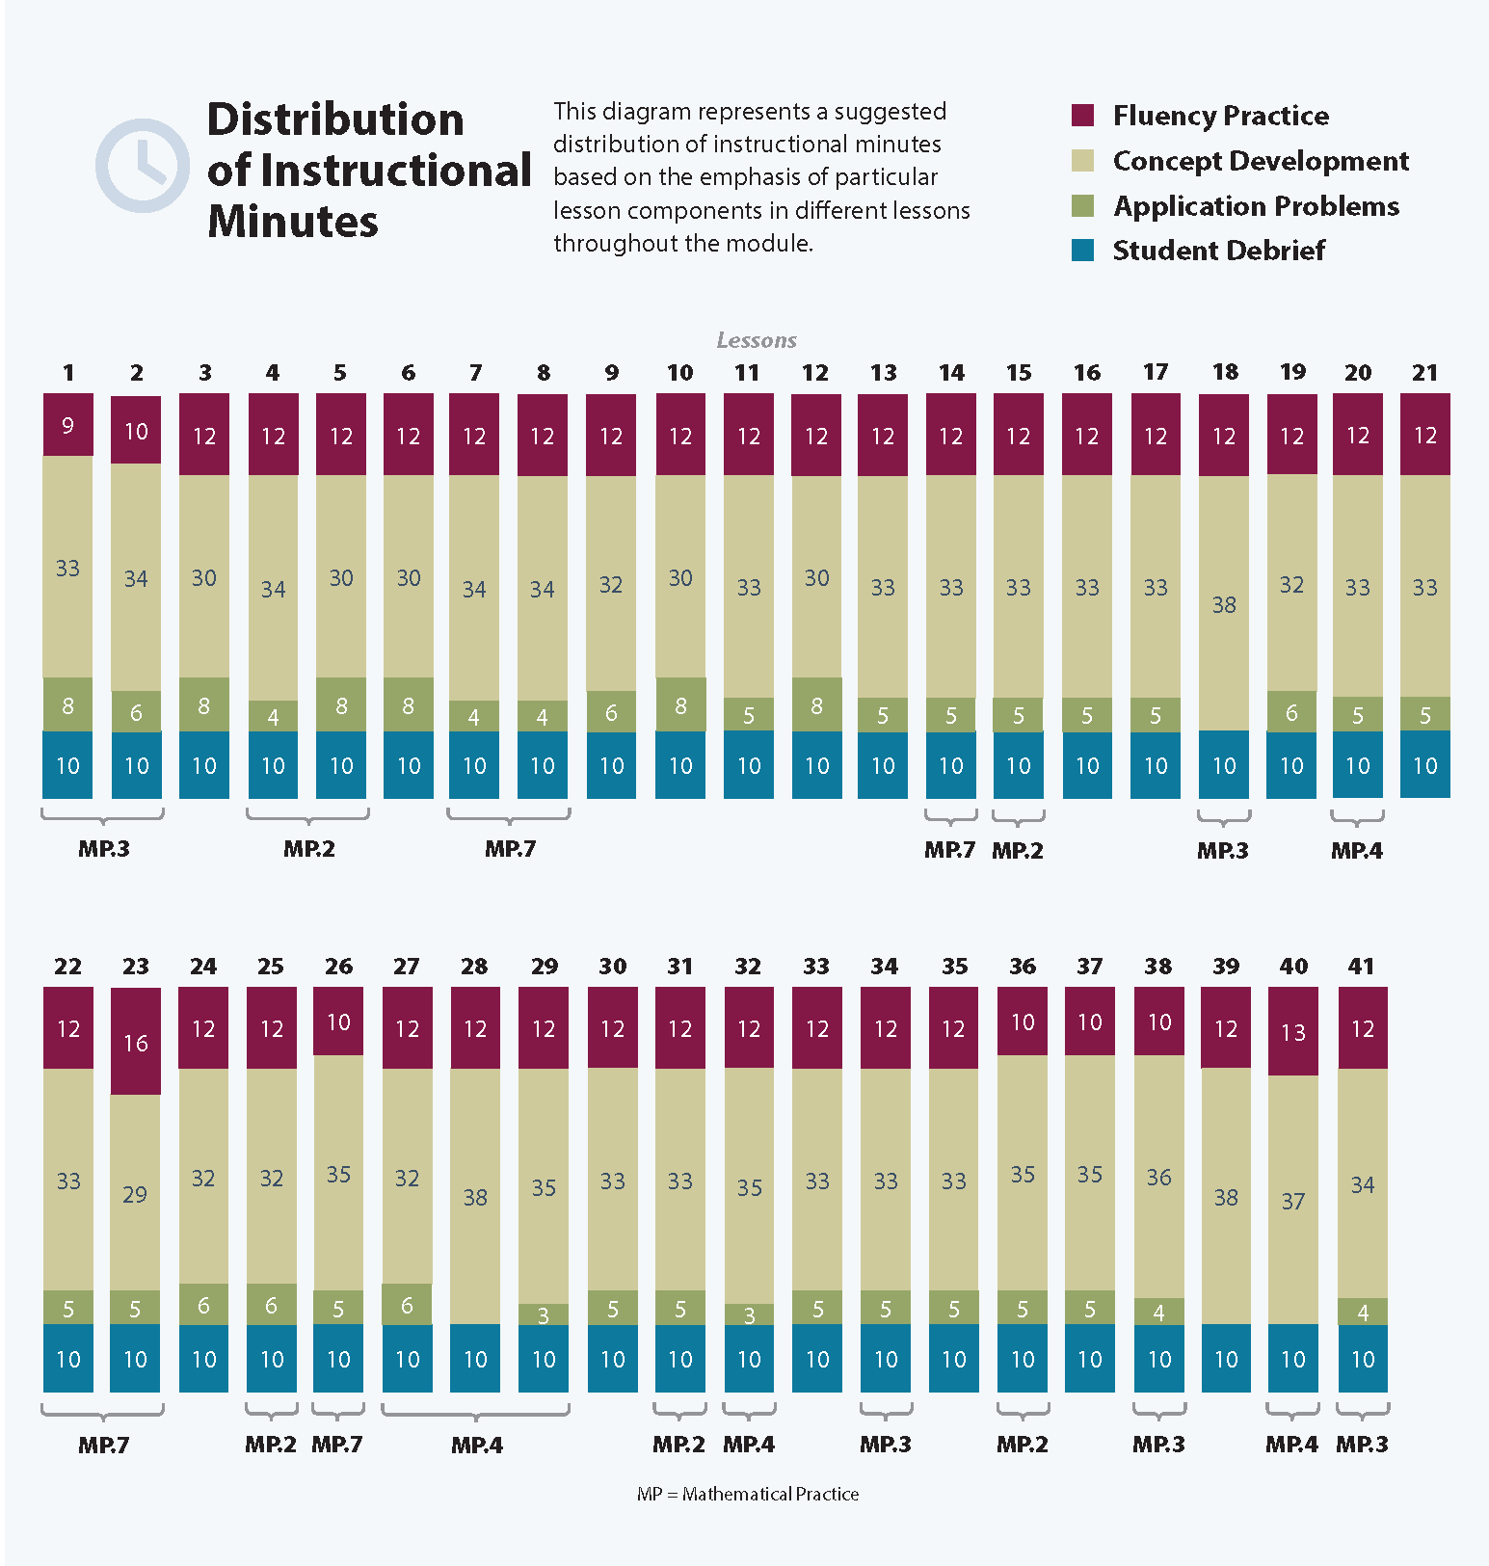

Focus Grade Level Standards
Generate and analyze patterns.
4.OA.5 Generate a number or shape pattern that follows a given rule. Identify apparent features of the pattern that were not explicit in the rule itself. For example, given the rule “Add 3” and the starting number 1, generate terms in the resulting sequence and observe that the terms appear to alternate between odd and even numbers. Explain informally why the numbers will continue to alternate in this way.
Extend understanding of fraction equivalence and ordering.
4.NF.1 Explain why a fraction a/b is equivalent to a fraction (n × a)/(n × b) by using visual fraction models, with attention to how the number and size of the parts differ even though the two fractions themselves are the same size. Use this principle to recognize and generate equivalent fractions.
4.NF.2 Compare two fractions with different numerators and different denominators, e.g., by creating common denominators or numerators, or by comparing to a benchmark fraction such as 1/2. Recognize that comparisons are valid only when the two fractions refer to the same whole. Record the results of comparisons with symbols >, =, or <, and justify the conclusions, e.g., by using a visual fraction model.
Build fractions from unit fractions by applying and extending previous understandings of operations on whole numbers.
4.NF.3 Understand a fraction a/b with a > 1 as a sum of fractions 1/b.
a. Understand addition and subtraction of fractions as joining and separating parts referring to the same whole.
b. Decompose a fraction into a sum of fractions with the same denominator in more than one way, recording each decomposition by an equation. Justify decompositions, e.g., by using a visual fraction model. Examples: 3/8 = 1/8 + 1/8 + 1/8; 3/8 = 1/8 + 2/8; 2 1/8 =
1 + 1 + 1/8 = 8/8 + 8/8 + 1/8.
c. Add and subtract mixed numbers with like denominators, e.g., by replacing each mixed number with an equivalent fraction, and/or by using properties of operations and the relationship between addition and subtraction.
d. Solve word problems involving addition and subtraction of fractions referring to the same whole and having like denominators, e.g., by using visual fraction models and equations to represent the problem.
4.NF.4 Apply and extend previous understandings of multiplication to multiply a fraction by a whole number.
a. Understand a fraction a/b as a multiple of 1/b. For example, use a visual fraction model to represent 5/4 as the product 5 × (1/4), recording the conclusion by the equation
5/4 = 5 × (1/4).
b. Understand a multiple of a/b as a multiple of 1/b, and use this understanding to multiply a fraction by a whole number. For example, use a visual fraction model to express 3 × (2/5) as 6 × (1/5), recognizing this product as 6/5. (In general, n × (a/b) = (n × a)/b.)
c. Solve word problems involving multiplication of a fraction by a whole number, e.g., by using visual fraction models and equations to represent the problem. For example, if each person at a party will eat 3/8 of a pound of roast beef, and there will be 5 people at the party, how many pounds of roast beef will be needed? Between what two whole numbers does your answer lie?
Represent and interpret data.
4.MD.4 Make a line plot to display a data set of measurements in fractions of a unit (1/2, 1/4, 1/8). Solve problems involving addition and subtraction of fractions by using information presented in line plots. For example, from a line plot find and interpret the difference in length between the longest and shortest specimens in an insect collection.
Foundational Standards
3.NF.1 Understand a fraction 1/b as the quantity formed by 1 part when a whole is partitioned into
b equal parts; understand a fraction a/b as the quantity formed by a parts of size 1/b.
3.NF.2 Understand a fraction as a number on the number line; represent fractions on a number line diagram.
a. Represent a fraction 1/b on a number line diagram by defining the interval from 0 to 1 as the whole and partitioning it into b equal parts. Recognize that each part has size 1/b and that the endpoint of the part based at 0 locates the number 1/b on the number line.
b. Represent a fraction a/b on a number line diagram by marking off a lengths 1/b from 0. Recognize that the resulting interval has size a/b and that its endpoint locates the number a/b on the number line.
3.NF.3 Explain equivalence of fractions in special cases, and compare fractions by reasoning about their size.
a. Understand two fractions as equivalent (equal) if they are the same size, or the same point on a number line.
b. Recognize and generate simple equivalent fractions, e.g., 1/2 = 2/4, 4/6 = 2/3. Explain why the fractions are equivalent, e.g., by using a visual fraction model.
c. Express whole numbers as fractions, and recognize fractions that are equivalent to whole numbers. Examples: Express 3 in the form 3 = 3/1; recognize that 6/1 = 6; locate 4/4 and 1 at the same point of a number line diagram.
d. Compare two fractions with the same numerator or the same denominator by reasoning about their size. Recognize that comparisons are valid only when the two fractions refer to the same whole. Record the results of comparisons with the symbols >, =, or <, and justify the conclusions, e.g., by using a visual fraction model.
3.MD.4 Generate measurement data by measuring lengths using rulers marked with halves and fourths of an inch. Show the data by making a line plot, where the horizontal scale is marked off in appropriate units—whole numbers, halves, or quarters.
3.G.2 Partition shapes into parts with equal areas. Express the area of each part as a unit fraction of the whole. For example, partition a shape into 4 parts with equal area, and describe the area of each part as 1/4 of the area of the shape.

Focus Standards for Mathematical Practice
MP.2 Reason abstractly and quantitatively. Students will reason both abstractly and quantitatively throughout this module. They will draw area models, number lines, and tape diagrams to represent fractional quantities, as well as word problems.
MP.3 Construct viable arguments and critique the reasoning of others. Much of the work in this module is centered on multiple ways to solve fraction and mixed number problems. Students explore various strategies and participate in many turn and talk and explain to your partner activities. By doing so, they construct arguments to defend their choice of strategy, as well as think about and critique the reasoning of others.
MP.4 Model with mathematics. Throughout this module, students represent fractions with various models. Area models are used to investigate and prove equivalence. The number line is used to compare and order fractions, as well as model addition and subtraction of fractions. Students also use models in problem solving as they create line plots to display given sets of fractional data and solve problems requiring the interpretation of data presented in line plots.
MP.7 Look for and make use of structure. As students progress through this fraction module, they search for and use patterns and connections that will help them build understanding of new concepts. They relate and apply what they know about operations with whole numbers to operations with fractions.
Overview of Module Topics and Lesson Objectives
Standards | Topics and Objectives |  | Days
4.NF.3b  4.NF.4a  4.NF.3a | A | Decomposition and Fraction Equivalence  Lessons 1–2: Decompose fractions as a sum of unit fractions using tape diagrams.  Lesson 3: Decompose non-unit fractions and represent them as a whole number times a unit fraction using tape diagrams.  Lesson 4: Decompose fractions into sums of smaller unit fractions using tape diagrams.  Lesson 5: Decompose unit fractions using area models to show equivalence.  Lesson 6: Decompose fractions using area models to show equivalence. | 6
4.NF.1  4.NF.3b | B | Fraction Equivalence Using Multiplication and Division  Lessons 7–8: Use the area model and multiplication to show the equivalence of two fractions.  Lessons 9–10: Use the area model and division to show the equivalence of two fractions.  Lesson 11: Explain fraction equivalence using a tape diagram and the number line, and relate that to the use of multiplication and division. | 5
4.NF.2 | C | Fraction Comparison  Lessons 12–13: Reason using benchmarks to compare two fractions on the number line.  Lessons 14–15: Find common units or number of units to compare two fractions. | 4
4.NF.3ad  4.NF.1  4.MD.2 | D | Fraction Addition and Subtraction  Lesson 16: Use visual models to add and subtract two fractions with the same units.  Lesson 17: Use visual models to add and subtract two fractions with the same units, including subtracting from one whole.  Lesson 18: Add and subtract more than two fractions.  Lesson 19: Solve word problems involving addition and subtraction of fractions.  Lessons 20–21: Use visual models to add two fractions with related units using the denominators 2, 3, 4, 5, 6, 8, 10, and 12. | 6
 |  | Mid-Module Assessment: Topics A–D (assessment ½ day, return ½ day, remediation or further applications 1 day) | 2
4.NF.2  4.NF.3  4.MD.4  4.NBT.6  4.NF.1  4.NF.4a | E | Extending Fraction Equivalence to Fractions Greater Than 1  Lesson 22: Add a fraction less than 1 to, or subtract a fraction less than 1 from, a whole number using decomposition and visual models.  Lesson 23: Add and multiply unit fractions to build fractions greater than 1 using visual models.  Lessons 24–25: Decompose and compose fractions greater than 1 to express them in various forms.  Lesson 26: Compare fractions greater than 1 by reasoning using benchmark fractions.  Lesson 27: Compare fractions greater than 1 by creating common numerators or denominators.  Lesson 28: Solve word problems with line plots. | 7
4.NF.3c  4.MD.2 | F | Addition and Subtraction of Fractions by Decomposition  Lesson 29: Estimate sums and differences using benchmark numbers.  Lesson 30: Add a mixed number and a fraction.  Lesson 31: Add mixed numbers.  Lesson 32: Subtract a fraction from a mixed number.  Lesson 33: Subtract a mixed number from a mixed number.  Lesson 34: Subtract mixed numbers. | 6
4.NF.4  4.OA.2  4.MD.2  4.MD.4 | G | Repeated Addition of Fractions as Multiplication  Lessons 35–36: Represent the multiplication of n times a/b as (n × a)/b using the associative property and visual models.  Lessons 37–38: Find the product of a whole number and a mixed number using the distributive property.  Lesson 39: Solve multiplicative comparison word problems involving fractions.  Lesson 40: Solve word problems involving the multiplication of a whole number and a fraction including those involving line plots. | 6
4.OA.5 | H | Exploring a Fraction Pattern  Lesson 41: Find and use a pattern to calculate the sum of all fractional parts between 0 and 1. Share and critique peer strategies. | 1
 |  | End-of-Module Assessment: Topics A–H (assessment ½ day, return ½ day, remediation or further applications 1 day) | 2
Total Number of Instructional Days |  |  | 45

Terminology
New or Recently Introduced Terms
- Benchmark (standard or reference point by which something is measured)
- Common denominator (when two or more fractions have the same denominator)
- Denominator (e.g., the 5 in $\frac{3}{5}$ names the fractional unit as fifths)
- Fraction greater than 1 (a fraction with a numerator that is greater than the denominator)
- Line plot (display of data on a number line, using an x or another mark to show frequency)
- Mixed number (number made up of a whole number and a fraction)
- Numerator (e.g., the 3 in $\frac{3}{5}$ indicates 3 fractional units are selected)
Familiar Terms and Symbols
- =, <, > (equal to, less than, greater than)
- Compose (change a smaller unit for an equivalent of a larger unit, e.g., 2 fourths = 1 half, 10 ones = 1 ten; combining 2 or more numbers, e.g., 1 fourth + 1 fourth = 2 fourths, 2 + 2 + 1 = 5)
- Decompose (change a larger unit for an equivalent of a smaller unit, e.g., 1 half = 2 fourths, 1 ten = 10 ones; partition a number into 2 or more parts, e.g., 2 fourths = 1 fourth + 1 fourth, 5 = 2 + 2 + 1)
- Equivalent fractions (fractions that name the same size or amount)
- Fraction (e.g., $\frac{1}{3}, \frac{2}{3}, \frac{3}{3}, \frac{4}{3}$)
- Fractional unit (e.g., half, third, fourth)
- Multiple (product of a given number and any other whole number)
- Non-unit fraction (fractions with numerators other than 1)
- Unit fraction (fractions with numerator 1)
- Unit interval (e.g., the interval from 0 to 1, measured by length)
- Whole (e.g., 2 halves, 3 thirds, 4 fourths)
Suggested Tools and Representations
- Area model
- Fraction strips (made from paper, folded, and used to model equivalent fractions)
- Line plot
- Number line
- Rulers
- Tape diagram
Scaffolds
The scaffolds integrated into A Story of Units give alternatives for how students access information as well as express and demonstrate their learning. Strategically placed margin notes are provided within each lesson elaborating on the use of specific scaffolds at applicable times. They address many needs presented by English language learners, students with disabilities, students performing above grade level, and students performing below grade level. Many of the suggestions are organized by Universal Design for Learning (UDL) principles and are applicable to more than one population. To read more about the approach to differentiated instruction in A Story of Units, please refer to “How to Implement A Story of Units.”
Assessment Summary
Type | Administered | Format | Standards Addressed
Mid-Module Assessment Task | After Topic D | Constructed response with rubric | 4.NF.1  4.NF.2  4.NF.3abd  4.NF.4a
End-of-Module Assessment Task | After Topic H | Constructed response with rubric | 4.OA.5  4.NF.1  4.NF.2  4.NF.3  4.NF.4  4.MD.4

These are terms and symbols students have seen previously.
Students with disabilities may require Braille, large print, audio, or special digital files. Please visit the website www.p12.nysed.gov/specialed/aim for specific information on how to obtain student materials that satisfy the National Instructional Materials Accessibility Standard (NIMAS) format.

