Name Date
- Follow the directions below to draw a figure in the box below. Use a straightedge.

  - Draw 2 points, A and B.

  - Draw $\overset{⃡}{\text{AB}}$.
  - Draw point D that is not on $\overset{⃡}{\text{AB}}$.
  - Draw $\overset{⃑}{\text{BD}}$.
  - Draw $\overline{\text{AD}}$.
  - Name an acute angle. ______________________________
  - Name an obtuse angle. You may have to draw and label another point.

______________________________

- Use your protractor to measure the angle indicated by the arc. Classify each angle as right, acute, or obtuse. Explain how you know each angle’s classification.

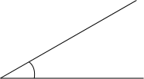

b.
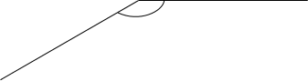

c.

- Use the following instructions to draw a figure in the box below.
- Using a straightedge, draw a line. Label it $\overset{⃡}{\text{KL}}$.
- Label a point A on $\overset{⃡}{\text{K}\text{L}}$.
- Using your protractor and ruler, draw a line perpendicular to $\overset{⃡}{\text{K}\text{L}}$ through point A.
- Label the perpendicular line $\overset{⃡}{\text{PQ}}$.
- Label a point $B$ on $\overset{⃡}{\text{PQ}}$, other than point A.
- Using your protractor and straightedge, draw a line, $\overset{⃡}{\text{S}\text{T}}$, perpendicular to $\overset{⃡}{\text{PQ}}$ through point B.

Which lines are parallel in your drawing? Explain why.

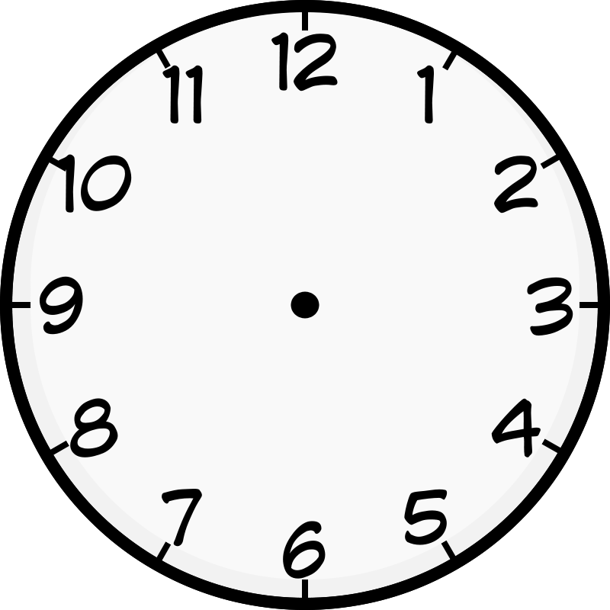
- Use the clock to answer the following:
  - Use a straightedge to draw the hands as they would appear at 3:00.

  - What kind of angle is formed by the clock hands at 3:00?

  - What time will it be when the minute hand has turned 180°?

  - How many 90° turns will the minute hand make between 3:00 and 4:00?

- Use the compass rose to answer the following:
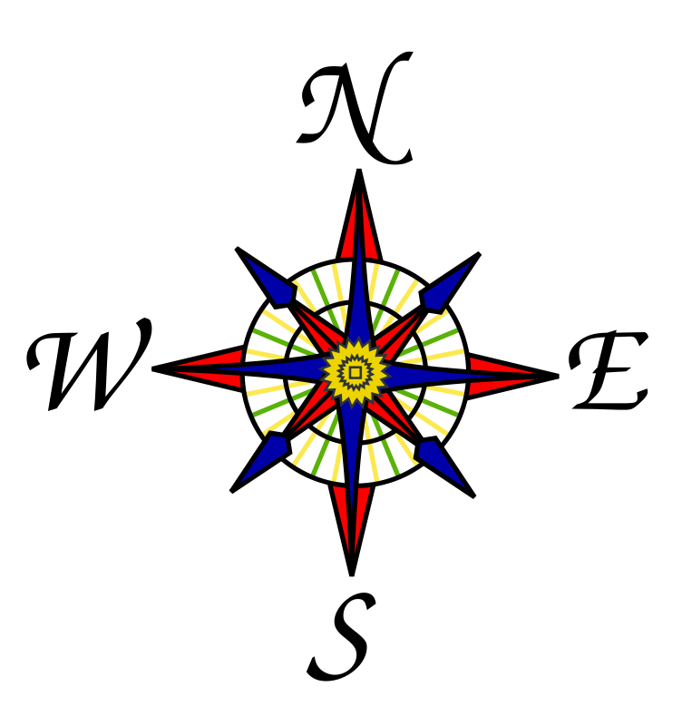

  - Maddy faced East. She turned to her right until she was facing North. How many degrees did she turn?

  - Quanisha was facing North. She turned toward her right until she faced East. Alisha was facing South. She turned toward her right until she faced West. What fraction of a full turn did each girl complete? Through how many degrees did each girl turn?

- The town of Seaford has a large rectangular park with a biking path around its perimeter and two straight-line biking paths that cut across it as shown in the diagram below.
138°
F
E
L
G
K
N
D
H
J

- Find the measure of the following angles using a protractor.

∠FGD:

∠DGK:

∠KGN:

- In the space below, use a protractor to draw an angle with the same measure as $∠\text{DGK}$.

- Below is a sign that bikers may encounter while riding in the park. Using the points in the figure below, identify a line segment, a right angle, an obtuse angle, a set of parallel lines, and a set of perpendicular lines. Write them in the table below.

L
K

STOP

E
A
B
C

Line Segment
Right Angle
Obtuse Angle
Parallel Lines
Perpendicular Lines
J
F
D

H
G

Mid-Module Assessment Task  Standards Addressed | Topics A–B
Geometric measurement: understand concepts of angle and measure angles.
4.MD.5 Recognize angles as geometric shapes that are formed wherever two rays share a common endpoint, and understand concepts of angle measurement:
a. An angle is measured with reference to a circle with its center at the common endpoint of the rays, by considering the fraction of the circular arc between the points where the two rays intersect the circle. An angle that turns through 1/360 of a circle is called a “one-degree angle,” and can be used to measure angles.
b. An angle that turns through n one-degree angles is said to have an angle measure of n degrees.
4.MD.6 Measure angles in whole-number degrees using a protractor. Sketch angles of specified measure.
Draw and identify lines and angles, and classify shapes by properties of their lines and angles.
4.G.1 Draw points, lines, line segments, rays, angles (right, acute, obtuse), and perpendicular and parallel lines. Identify these in two-dimensional figures.
Evaluating Student Learning Outcomes
A Progression Toward Mastery is provided to describe steps that illuminate the gradually increasing understandings that students develop on their way to proficiency. In this chart, this progress is presented from left (Step 1) to right (Step 4). The learning goal for each student is to achieve Step 4 mastery. These steps are meant to help teachers and students identify and celebrate what the students CAN do now and what they need to work on next.

A Progression Toward Mastery
Assessment  Task Item  and  Standards Assessed | STEP 1  Little evidence of reasoning without a correct answer.  (1 Point) | STEP 2  Evidence of some reasoning without a correct answer.  (2 Points) | STEP 3  Evidence of some reasoning with a correct answer or evidence of solid reasoning with an incorrect answer.  (3 Points) | STEP 4  Evidence of solid reasoning with a correct answer.  (4 Points)
1  4.G.1 | The student attempts to draw some points, lines, and rays for the figure, but does so incorrectly and without correctly identifying an obtuse or acute angle. | The student correctly draws the figure, but is unable to identify an obtuse or acute angle. | The student correctly draws the figure to match directions, but correctly identifies only one of the two angles. Or, the student follows directions to complete the figure incorrectly, but correctly identifies an acute and obtuse angle. | The student correctly draws all lines, line segments, and rays as stated. The student correctly identifies an acute and obtuse angle based on the figure drawn.  (Note: Drawings and angles may differ for each student.)
2  4.MD.6  4.G.1 | The student correctly measures and classifies fewer than two of the three angles. | The student correctly measures and classifies at least two of the three angles, providing some reasoning. | The student correctly measures at least two of the three angles and classifies them all correctly. Or, the student correctly measures all three angles, but does not provide solid reasoning for classifying angles. | The student correctly measures and classifies all angles and correctly explains the classifications:  - 30°; acute; the angle measures less than 90°.  - 147°; obtuse; the angle measures greater than 90°.  - 90°; right; the angle measures exactly 90°.

A Progression Toward Mastery
3  4.MD.6  4.G.1 | The student attempts to draw and identify lines, but does so incorrectly. | The student attempts to draw the diagram according to given directions, but is only able to create one set of perpendicular lines. There are no sets of parallel lines created and little reasoning about parallel lines. | The student correctly completes the drawing according to directions, identifying the parallel lines, but is unable to provide solid reasoning about why the lines are parallel. Or, the student correctly identifies parallel lines and provides solid reasoning as to why specific lines are parallel, but does not draw the figure as directed. | The student correctly draws and labels all points and lines, as well as identifies $\overset{⃡}{\text{ST}}$ as parallel to $\overset{⃡}{\text{KL}}$. The student correctly reasons that the lines are parallel because they are an equal distance apart from each other. (Drawings will vary, but must contain all required elements to be considered correct.)
4  4.MD.5 | The student is unable to complete any part or is able to complete only one part of the problem. | The student correctly completes Part (b) and one of the three remaining parts. | The student correctly completes Part (b) and two of the three remaining parts. | The student correctly completes all four parts:  - Clock hands depict 3:00.  - Possible correct responses include  90° angle, right angle, or 270° angle  - 3:30.  - Four turns.
5  4.MD.5 | The student is unable to complete either of the two parts. | The student correctly completes one of the two parts. | The student correctly answers Part (a), but only answers one question from Part (b) correctly. | The student correctly completes both parts of the problem:  - 270°.  - Each girl turned 90$°$. Each turned $\frac{1}{4}$ of a full turn.

A Progression Toward Mastery
6  4.MD.5  4.MD.6  4.G.1 | The student correctly completes four or fewer of the nine components. | The student correctly completes five or six of the nine components. | The student correctly completes seven or eight of the nine components. | The student correctly completes all nine components:  - $∠$FGD = 42°  $∠$DGK = 138°  $∠$KGN = 42°  (The measurements above are accurate; however, allow +/- 1 degree variance for student responses.)  - Sketch of a 138° angle, labeled with an arc and points.  - The student must include one of the following choices per part:  Segment:  $\overline{AB}, \overline{\text{AC}}$, $\overline{BC}, \overline{\text{BD}}$, $\overline{\text{EF}}$, $\overline{GH}$, $\overline{HJ}$, $\overline{KL}$.  Right angle: $∠$ABD, $∠$CBD.  Obtuse angle: $∠$GHJ.  Parallel lines: $\overline{KL} ∥ \overline{\text{GH}}$,  $\overline{\text{BD}}∥\overline{\text{EF}}$.  Perpendicular lines:  $\overline{\text{AC}}$ $⊥\overline{\text{BD}}$, $\overline{\text{AB}}$ $⊥\overline{\text{BD}}$, $\overline{\text{BC}}$ $⊥\overline{\text{BD}}$.

