Name Date

1. Given and .
   1. Describe how to obtain the graph of from the graph of using transformations.
   2. Describe how to obtain the graph of from the graph of using transformations.
   3. Sketch the graphs of and on the same coordinate plane.



* 1. Use your graphs to estimate the solutions to the equation:

Explain how you got your answer.

* 1. Were your estimations in part (d) correct? If yes, explain how you know. If not explain why not.

1. Let and be the functions given by and .
   1. Find , , and .
   2. What is the domain of ?
   3. What is the range of ?
   4. Evaluate .
   5. Compare and contrast and . How are they alike? How are they different?
   6. Is there a value of , such that ? If so, find . If not, explain why no such value exists.
   7. Is there a value of  such that ? If so, find . If not, explain why no such value exists.
2. A boy bought six guppies at the beginning of the month. One month later the number of guppies in his tank had doubled. His guppy population continued to grow in this same manner. His sister bought some tetras at the same time. The table below shows the number of tetras, , after months have passed since they bought the fish.

|  |  |  |  |  |
| --- | --- | --- | --- | --- |
| , months |  |  |  |  |
| , tetras |  |  |  |  |

* 1. Create a function to model the growth of the boy’s guppy population, where is the number of guppies at the beginning of each month and is the number of months that have passed since he bought the six guppies. What is a reasonable domain for in this situation?
  2. How many guppies will there be one year after he bought the six guppies?
  3. Create an equation that could be solved to determine how many months it will take for there to be guppies.



* 1. Use graphs or tables to approximate a solution to the equation from part (c). Explain how you arrived at your estimate.
  2. Create a function, , to model the growth of the sister’s tetra population, where is the number of tetras after months have passed since she bought the tetras.
  3. Compare the growth of the sister’s tetra population to the growth of the guppy population. Include a comparison of the average rate of change for the functions that model each population’s growth over time.
  4. Use graphs to estimate the number of months that will have passed when the population of guppies and tetras will be the same.



* 1. Use graphs or tables to explain why the guppy population will eventually exceed the tetra population even though there were more tetras to start with.
  2. Write the function in such a way that the percent increase in the number of guppies per month can be identified. Circle or underline the expression representing percent increase in number of guppies per month.

1. Regard the solid dark equilateral triangle as Figure 0. Then, the first figure in this sequence is the one composed of three dark triangles, the second figure is the one composed of nine dark triangles, and so on.

[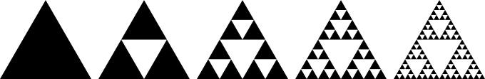](http://upload.wikimedia.org/wikipedia/commons/0/05/Sierpinski_triangle_evolution.svg)

**Figure 0**

**Figure 1**

**Figure 2**

**Figure 3**

**Figure 4**

* 1. How many dark triangles are in each figure? Make a table to show this data.

|  |  |  |  |  |  |
| --- | --- | --- | --- | --- | --- |
| (Figure Number) |  |  |  |  |  |
| (# of dark triangles) |  |  |  |  |  |

* 1. Given the number of dark triangles in a figure, describe in words how to determine the number of dark triangles in the next figure.
  2. Create a function that models this sequence. What is the domain of this function?
  3. Suppose the area of the solid dark triangle in Figure 0 is square meter. The areas of one dark triangle in each figure form a sequence. Create an explicit formula that gives the area of just one of the dark triangles in the th figure in the sequence.
  4. The sum of the areas of all the dark triangles in Figure 0 is ; there is only one triangle in this case. The sum of the areas of all the dark triangles in Figure 1 is. What is the sum of the areas of all the dark triangles in the th figure in the sequence? Is this total area increasing or decreasing as increases?
  5. Let be the sum of the perimeters of the all dark triangles in the th figure in the sequence of figures. There is a real number so that,

is true for each positive whole number . What is the value of ?

1. The graph of a piecewise function is shown to the right. The domain of is .
   1. Create an algebraic representation for . Assume that the graph of is composed of straight line segments.

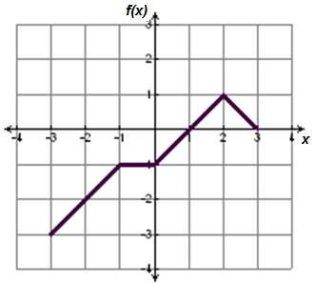

* 1. Sketch the graph of , and state the domain and range.

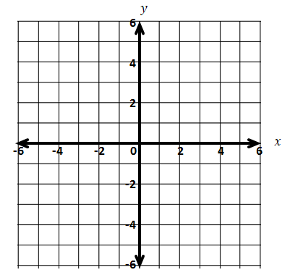

* 1. Sketch the graph of and state the domain and range.



* 1. How does the range ofcompare to the range of , where ?
  2. How does the domain ofcompare to the domain of , where ?

|  |  |  |  |  |  |
| --- | --- | --- | --- | --- | --- |
| A Progression Toward Mastery | | | | | |
| Assessment  Task Item | | STEP 1  Missing or incorrect answer and little evidence of reasoning or application of mathematics to solve the problem | STEP 2  Missing or incorrect answer but evidence of some reasoning or application of mathematics to solve the problem | STEP 3  A correct answer with some evidence of reasoning or application of mathematics to solve the problem OR an incorrect answer with substantial evidence of solid reasoning or application of mathematics to solve the problem | STEP 4  A correct answer supported by substantial evidence of solid reasoning or application of mathematics to solve the problem |
| **1** | **a–b**  F-BF.B.3 | Student answer is missing or entirely incorrect. | Student describes the transformations partially correctly. | Student describes the transformations correctly, but there may be some minor misuse or omission of appropriate vocabulary. | Student describes the transformations clearly and correctly and uses appropriate vocabulary. |
| **c–e**  A-REI.D.11  F-BF.B.3 | Student creates sketches that do not resemble absolute value functions.  OR  Student is unable to use the graphs to estimate the solutions to the equation. Student may or may not arrive at correct solutions of the equation via another method such as trial and error. | Student creates sketches that resemble the graph of an absolute value function but are inaccurate. Student shows evidence of using the intersection point of the graphs to find the solution but is unable to confirm his or her solution points; therefore, the conclusion in part (e) is inconsistent with the intersection points. | Student creates sketches that are accurate with no more than one minor error; the student shows evidence of using the intersection points to find the solutions to the equation. The conclusion in part (e) is consistent with the estimated solutions but may have one error. Student communication is clear but could include more appropriate use of vocabulary or more detail. | Student creates sketches that are accurate and solutions in part (d) match the -coordinates of the intersection points. The student’s explanation for part (d) reflects an understanding that the process is analogous to solving the system   and . The work shown in part (e) supports her conclusion that estimates were or were not solutions and includes supporting explanation using appropriate vocabulary. |
| **2** | **a**  F-IF.A.2 | Student provides no correct answers. | Student provides only one correct answer. | Student provides two correct answers. | Student provides correct answers for all three items. |
| **b–c**  F-IF.A.1 | Neither domain nor range is correct. | One of the two is identified correctly, or the student has reversed the ideas, giving the range of when asked for domain of and the domain of when asked for the range of . | Both domain and range are correct but notation may contain minor errors. | Both domain and range are correct and use appropriate notation. |
| **d**  F-IF.A.2 | Student makes a major error or omission in evaluating the expression (e.g., does not substitute into or ). | Student makes one or more errors in evaluating the expression. | Student evaluates the expression correctly but work to support the answer is limited, or there is one minor error present. | Student evaluates the expression correctly and shows the work to support the answer. |
| **e**  F-IF.A.1  F-IF.A.2  F-IF.C.7a | Student makes little or no attempt to compare the two functions. | Student comparison does not note the similarity of the two functions yielding identical outputs for positive inputs and opposite outputs for negative inputs; it may be limited to superficial features, such as one that involves squaring and the other that contains an absolute value. | Student recognizes that the two functions are equal for and positive -values but may not clearly articulate that the two functions are opposites when is negative. | Student clearly describes that the two functions yield identical outputs for positive inputs and for an input of and opposite outputs for negative inputs. |
| **f**  F-IF.A.1  F-IF.A.2 | Student provides an incorrect conclusion.  OR  Student makes little or no attempt to answer. | Student identifies that there is no solution but provides little or no supporting work or explanation. | Student identifies that there is no solution and provides an explanation, but the explanation is limited or contains minor inconsistencies or errors. | Student identifies that there is no solution and provides an explanation and/or work that clearly supports valid reasoning. |
| **g**  F-IF.A.1  F-IF.A.2 | Student provides an incorrect conclusion.  OR  Student makes little or no attempt to answer. | Student identifies that is a solution but provides little or no supporting work or explanation. | Student identifies that is a solution and provides an explanation, but the explanation is limited or contains minor inconsistencies/errors. | Student identifies that is a solution and provides an explanation and/or work that clearly supports valid reasoning. |
| **3** | **a**  A-CED.A.1  F-BF.A.1a  F-IF.B.5 | Student does not provide an exponential function.  OR  Student provides an exponential function that does not model the data, and the domain is incorrect or omitted. | Student provides a correct exponential function, but the domain is incorrect or omitted. OR  Student provides an exponential function that does not model the data but correctly identifies the domain in this situation. | Student has made only minor errors in providing an exponential function that models the data and a domain that fits the situation. | Student provides a correct exponential function and identifies the domain to fit the situation. |
| **b**  F-IF.A.2 | Student gives an incorrect answer with no supporting calculations. | Student gives an incorrect answer, but the answer is supported with the student’s function from part (a). | Student has a minor calculation error in arriving at the answer. Student provides supporting work. | Student provides a correct answer with proper supporting work. |
| **c**  F-BF.A.1a | Student provides no equation or gives an equation that does not demonstrate understanding of what is required to solve the problem described. | Student sets up an incorrect equation that demonstrates limited understanding of what is required to solve the problem described. | Student provides a correct answer but then simplifies it into an incorrect equation.  OR  Student has a minor error in the equation given but demonstrates substantial understanding of what is required to solve the problem. | Student provides a correct equation that demonstrates understanding of what is required to solve the problem. |
| **d**  F-IF.A.2 | Student provides an equation or graph that does not reflect the correct data.  OR  Student fails to provide an equation or graph. | Student provides a correct graph or table, but the answer to the question is either not given or incorrect. | Student provides a correct table or graph, but the answer is months with an explanation that the mark occurs during the th month. | Student provides a correct table or graph, and the answer is correct ( months) with a valid explanation. |
| **e**  F-BF.A.1a | Student does not provide a linear function. | Student provides a function that is linear but does not reflect data. | Student provides a correct linear function, but the function is either simplified incorrectly or does not use the notation, . | Student provides a correct linear function using the notation, . |
| **f**  A-CED.A.2  F-IF.B.6  F-LE.A.3 | Student does not demonstrate an ability to recognize and distinguish between linear and exponential growth or to compare growth rates or average rate of change of functions. | Student makes a partially correct but incomplete comparison of growth rates that does not include or incorrectly applies the concept of average rate of change. | Student makes a correct comparison of growth rates that includes an analysis of the rate of change of each function. However, student’s communication contains minor errors or misuse of mathematical terms. | Student identifies that the guppies’ population will increase at a faster rate and provides a valid explanation that includes an analysis of the rate of change of each function. |
| **g**  A-REI.D.11  F-IF.A.2  F-IF.C.9 | Student does not provide correct graphs of the functions and is unable to provide an answer that is based on reasoning. | Student provides correct graphs but is unable to arrive at a correct answer from the graphs. OR  Student’s graphs are incomplete or incorrect, but the student arrives at an answer based on sound reasoning. | Student provides graphs that contain minor imprecisions and therefore arrives at an answer that is supportable by the graphs but incorrect. | Student provides correct graphs and arrives at an answer that is supportable by the graphs and correct. |
| **h**  F-IF.B.6  F-LE.A.1  F-LE.A.3 | Student does not provide tables or graphs that are accurate enough to support an answer and shows little reasoning in an explanation. | Student provides tables or graphs that are correct but provides limited or incorrect explanation of results. | Student provides tables or graphs that are correct and gives an explanation that is predominantly correct but contains minor errors or omissions in the explanation. | Student provides tables or graphs that are correct and gives a complete explanation that uses mathematical vocabulary correctly. |
| **i**  A-SSE.B.3c | Student does not provide an exponential function that shows percent increase. | Student writes an exponential function that uses an incorrect version of the growth factor, such as , , , or . | Student creates a correct version of the function using a growth factor expressed as or expressed as with a note that is equivalent to . Student has a minor error in notation or in the domain or does not specify the domain. | Student creates a correct version of the function using a growth factor expressed as or expressed as with a note that is equivalent to . Student specifies the domain correctly. |
| **4** | **a–c**  F-BF.A.1a  F-IF.A.3  F-LE.A.1  F-LE.A.2 | Student does not fill in the table correctly and does not describe the relationship correctly. Student does not provide an exponential function. | Student completes the table correctly and describes the sequence correctly but gives an incorrect function. Student may or may not have given a correct domain. | Student completes the table correctly and describes the sequence correctly but has a minor error in either his or her function or domain. The function provided is exponential with a growth factor of . Description or notation may contain minor errors. | Student completes the table correctly, describes the sequence correctly, and provides a correct exponential function including the declaration of the domain. Student uses precise language and proper notation (either function or subscript notation) for the function. |
| **d**  F-BF.A.1a  F-LE.A.1  F-LE.A.2 | Student fails to provide an explicit exponential formula. | Student provides an explicit formula that is exponential but incorrect; supporting work is missing or reflects limited reasoning about the problem. | Student provides a correct explicit exponential formula. Notation or supporting work may contain minor errors. | Student provides a correct explicit exponential formula using function or subscript notation; formula and supporting work are free of errors. |
| **e**  F-BF.A.1a  F-LE.A.1  F-LE.A.2 | Student fails to provide an explicit exponential formula. | Student provides an explicit formula that is exponential but incorrect; supporting work is missing or reflects limited reasoning about the problem. | Student provides a correct explicit exponential formula. Notation or supporting work may contain minor errors. | Student provides a correct explicit exponential formula using function or subscript notation; formula and supporting work are free of errors. |

|  |  |  |  |  |  |
| --- | --- | --- | --- | --- | --- |
|  | **f**  F-BF.A.1a  F-LE.A.1 | Student provides little or no evidence of understanding how to determine the perimeter of the dark triangles nor how to recognize the common factor between two successive figures’ perimeter. | Student identifies an incorrect value of or the value is not provided, but solution shows some understanding of how to determine the perimeter of the dark triangles. | Student solution shows significant progress towards identifying that is but contains minor errors or is not complete.  OR  Student computes an incorrect value due to a minor error but otherwise demonstrates a way to determine either by recognizing that the given equation is a recursive form of a geometric sequence or by approaching the problem algebraically. | Student identifies the correct value of with enough supporting evidence of student thinking (correct table, graph, marking on diagram, or calculations) that shows how he arrived at the solution. |
| **5** | **a**  F-BF.A.1a | Student does not provide a piecewise definition of the function and/or more than two expressions in the answer are incorrect. | Student provides a piecewise function in which at least one of the expressions is correct; the solution may contain errors with the intervals or notation. | Student provides a piecewise function with correct expressions, but the answer may contain minor errors with the intervals or use of function notation.  OR  Student provides one incorrect expression, but provides correct intervals and correctly uses function notation. | Student provides a correctly defined piecewise function with correct intervals. |
| **b–c**  F-BF.B.3  F-IF.A.1 | Student provides graphs that contain major errors; domain and range are missing or are inconsistent with the graphs. | Student provides a graph for (b) that would be correct for (c) and vice versa.  OR  Student answers either part (b) or (c) correctly. Minor errors may exist in the domain and range. | Student provides graphs that contain one minor error. The domain and range are consistent with the graphs. | Student provides correct graphs for both parts (b) and (c) and provides a domain and range for each that are consistent with student graphs. |
| **d–e**  F-BF.B.3  F-IF.A.1 | Both explanations and solutions are incorrect or have major conceptual errors (e.g., confusing domain and range). | Student answers contain more than one minor error.  OR  Student answers only one of part (d) and (e) correctly. | Student answer only explains how the domain/range changes; it may contain one minor error. | Student answer not only explains how the domain/range changes but also explains how knowing aids in finding the new domain/ range. |

Name Date

1. Given and .
   1. Describe how to obtain the graph of from the graph of using transformations.

To obtain the graph of ***g***, reflect the graph of ***a*** about the x-axis, and translate this graph up 4 units.

* 1. Describe how to obtain the graph of from the graph of using transformations.

To obtain the graph of ***h***, translate the graph of ***a*** 2 units to the left and 3 units down.

* 1. Sketch the graphs of and on the same coordinate plane.

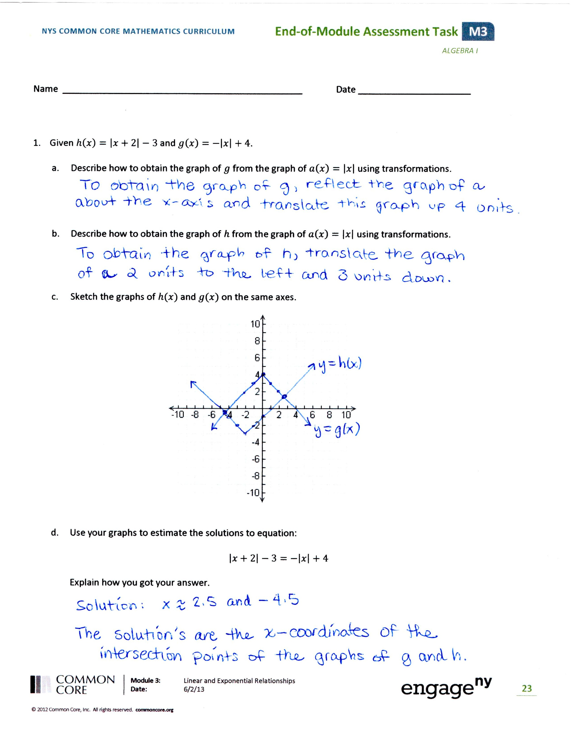

* 1. Use your graphs to estimate the solutions to the equation:

Explain how you got your answer.

Solution: x ≈ 2.5 or x ≈-4.5

The solutions are the x-coordinates of the intersection points of the graphs of ***g*** and ***h***.

* 1. Were your estimations in part (d) correct? If yes, explain how you know. If not explain why not.

Let x = 2.5 Let x = -4.5

Is |2.5 + 2|-3 = -|2.5| + 4 true? Is |-4.5 + 2| - 3 = - |4.5| + 4 true?

Yes, 4.5 – 3 = -2.5 + 4 is true. Yes, 2.5 – 3 = -4.5 + 4 is true.

Yes, the estimates are correct. They each make the equation true.

1. Let and be the functions given by and .
   1. Find , , and .

f(1/3) = 1/9, g(4) = 16, g(-) = -3

* 1. What is the domain of ?

D: all real numbers.

* 1. What is the range of ?

R: all real numbers.

* 1. Evaluate .

(-67)2 + -67|-67| = 0.

* 1. Compare and contrast and . How are they alike? How are they different?

When x is positive, both functions give the same value. But when x is negative, f gives the always positive value of x2, whereas g gives a value that is the opposite of what f gives.

* 1. Is there a value of , such that ? If so, find . If not, explain why no such value exists.

No, f and g are either both zero, giving a sum of zero, both positive, giving a positive sum, or the opposite of each other, giving a sum of zero. So, there is no way to get a negative sum.

* 1. Is there a value of  such that ? If so, find . If not, explain why no such value exists.

Yes, if x = 5, f(x) = g(x) = 25, thus f(x) + g(x) = 50.

1. A boy bought six guppies at the beginning of the month. One month later the number of guppies in his tank had doubled. His guppy population continued to grow in this same manner. His sister bought some tetras at the same time. The table below shows the number of tetras, , after months have passed since they bought the fish.

|  |  |  |  |  |
| --- | --- | --- | --- | --- |
| , months |  |  |  |  |
| , tetras |  |  |  |  |

* 1. Create a function to model the growth of the boy’s guppy population, where is the number of guppies at the beginning of each month and is the number of months that have passed since he bought the six guppies. What is a reasonable domain for in this situation?

g(n) = 6•2n Domain: n is a whole number.

* 1. How many guppies will there be one year after he bought the six guppies?

g(12) = 6•212 = 24,576 guppies

* 1. Create an equation that could be solved to determine how many months it will take for there to be guppies.

100 = 6•2n

* 1. 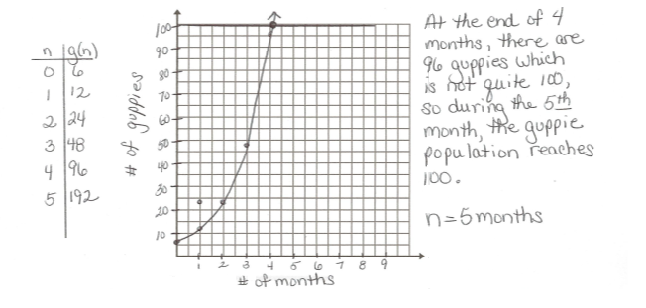Use graphs or tables to approximate a solution to the equation from part (c). Explain how you arrived at your estimate.
  2. Create a function, , to model the growth of the sister’s tetra population, where is the number of tetras after months have passed since she bought the tetras.

t(n) = 8(n+1), n is a whole number.

Or, t(n) = 8n + 8, n is a whole number.

* 1. Compare the growth of the sister’s tetra population to the growth of the guppy population. Include a comparison of the average rate of change for the functions that model each population’s growth over time.

The guppies’ population is increasing faster than the tetras’ population. Each month, the number of guppies doubles, while the number of tetra’s increases by 8. The rate of change for the tetras is constant, but the rate of change for the guppies is always increasing.

* 1. Use graphs to estimate the number of months that will have passed when the population of guppies and tetras will be the same.

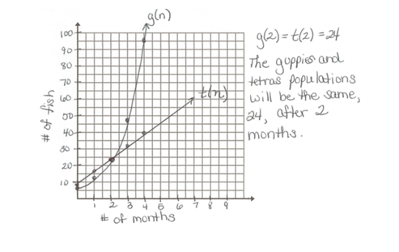

* 1. Use graphs or tables to explain why the guppy population will eventually exceed the tetra population even though there were more tetras to start with.

The guppy population’s growth is exponential, and the tetra populations’ growth is linear. The graph in part (g) shows how the population of the guppies eventually overtakes the population of the tetras. The table below shows that by the end of the 3rd month, there are more guppies than tetras.

|  |  |  |  |  |  |  |  |
| --- | --- | --- | --- | --- | --- | --- | --- |
| n | 0 | 1 | 2 | 3 | 4 | 5 |  |
| g(n) | 6 | 12 | 24 | 48 | 96 | 192 | The average rate of change is doubling. |
| t(n) | 8 | 16 | 24 | 32 | 40 | 48 | The rate of change is constant. |

* 1. Write the function in such a way that the percent increase in the number of guppies per month can be identified. Circle or underline the expression representing percent increase in number of guppies per month.

g(n) = 6(200%)n

1. Regard the solid dark equilateral triangle as Figure 0. Then, the first figure in this sequence is the one composed of three dark triangles, the second figure is the one composed of nine dark triangles, and so on.

[](http://upload.wikimedia.org/wikipedia/commons/0/05/Sierpinski_triangle_evolution.svg)

**Figure 0**

**Figure 1**

**Figure 2**

**Figure 3**

**Figure 4**

* 1. How many dark triangles are in each figure? Make a table to show this data.

0 1 2 3 4

1 3 9 27 81

|  |  |  |  |  |  |
| --- | --- | --- | --- | --- | --- |
| (Figure Number) |  |  |  |  |  |
| (# of dark triangles) |  |  |  |  |  |

* 1. Given the number of dark triangles in a figure, describe in words how to determine the number of dark triangles in the next figure.

The number of triangles in a figure is 3 times the number of triangles in the previous figure.

* 1. Create a function that models this sequence. What is the domain of this function?

T(n) = 3n, D: n is a whole number.

* 1. Suppose the area of the solid dark triangle in Figure 0 is square meter. The areas of one dark triangle in each figure form a sequence. Create an explicit formula that gives the area of just one of the dark triangles in the th figure in the sequence.

|  |  |
| --- | --- |
| Figure, n | Area of one dark triangle, A(n) |
| 0 | 1 |
| 1 | 1/4 |
| 2 | 1/16 |
| 3 | 1/64 |

A(n) =

* 1. The sum of the areas of all the dark triangles in Figure 0 is ; there is only one triangle in this case. The sum of the areas of all the dark triangles in Figure 1 is. What is the sum of the areas of all the dark triangles in the th figure in the sequence? Is this total area increasing or decreasing as increases?

|  |  |
| --- | --- |
| Figure | Area in m2 |
| 0 | 1 |
| 1 | 3/4 |
| 2 | 9/16 |
| 3 | 27/64 |

T(n) =

The total area is decreasing as n increases.

P is a geometric sequence and k is the ratio between any term and the previous term, so k= P(n+1)/P(n).

So, for example, for n = 0,

For n = 1,

K = 3/2

|  |  |
| --- | --- |
| Figure | P(n) |
| 0 |  |
| 1 |  |
| 2 |  |

Let x represent the number of meters long of one side of the triangle in Figure 0.

* 1. Let be the sum of the perimeters of the all dark triangles in the th figure in the sequence of figures. There is a real number so that,

is true for each positive whole number . What is the value of ?

1. The graph of a piecewise function is shown to the right. The domain of is .
   1. Create an algebraic representation for . Assume that the graph of is composed of straight line segments.



or

* 1. Sketch the graph of , and state the domain and range.

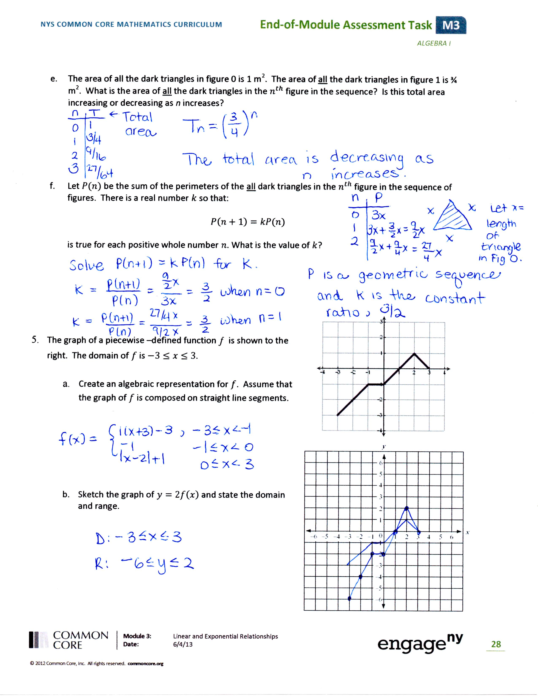

Domain: -3 ≤ x ≤ 3

Range: -6 ≤ y ≤ 2

* 1. Sketch the graph of and state the domain and range.

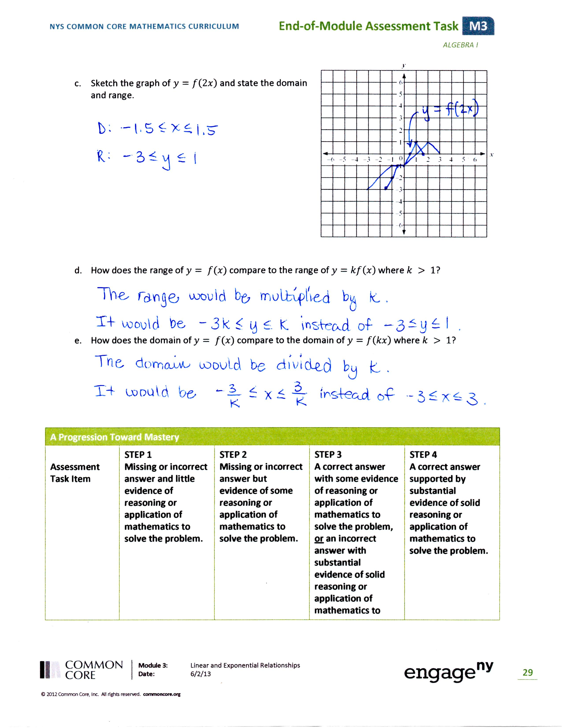

Domain: -1.5 ≤ x ≤ 1.5

Range: -3 ≤ y ≤ 1

* 1. How does the range ofcompare to the range of , where ?

Every value in the range of y = f(x) would be multiplied by k. Since k>1 we can represent this by multiplying the compound inequality that gives the range of y = f(x) by ***k***, giving -3k ≤ y ≤ k.

* 1. How does the domain ofcompare to the domain of , where ?

Every value in the domain of y = f(x) would be divided by k. Since k>1 we can represent this by multiplying the compound inequality that gives the domain of y = f(x) by 1/k, giving -3/k ≤ x ≤ 3/k.