Name Date
- Many computers come with a Solitaire card game. The player moves cards in certain ways to complete specific patterns. The goal is to finish the game in the shortest number of moves possible, and a player’s score is determined by the number of moves. A statistics teacher played the game $16$ times and recorded the number of moves and the final score after each game. The line represents the linear function that is used to determine the score from the number of moves.

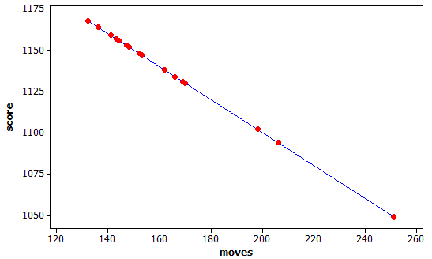

- Was this person’s average score closer to $1130$ or $1110$? Explain how you decided.

- The first two games she played took $169$ moves ($1131$ points) and $153$ moves ($1147$ points). Based on this information, determine the equation of the linear function used by the computer to calculate the score from the number of moves. Explain your work.

- Based on the linear function, each time the player makes a move, how many points does he or she lose?

- Based on the linear function, how many points does the player start with in this game? Explain your reasoning.

- To save money, drivers often try to increase their mileage, which is measured in miles per gallon (mpg). One theory is that speed traveled impacts miles per gallon. Suppose the following data are recorded for five different $300$-mile tests, with the car traveling at different speeds in miles per hour (mph) for each test.
Speed (mph) | Miles per gallon (mpg)
$$50$$ | $$32$$
$$60$$ | $$29$$
$$70$$ | $$24$$
$$80$$ | $$20$$
$$90$$ | $$17$$

- For the data in this table, is the association positive or negative? Explain how you decided.

- Construct a scatter plot of these data using the following coordinate grid. The vertical axis represents the miles per gallon (mpg), and the horizontal axis represents the speed in miles per hour (mph).
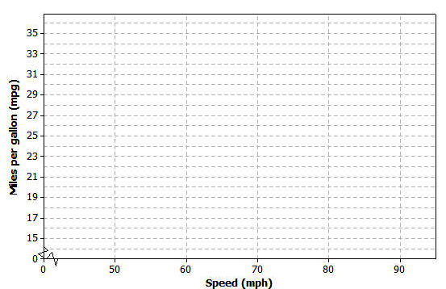

- Draw a line on your scatter plot that you think is a reasonable model for predicting the miles per gallon from the car speed.

- Estimate and interpret the slope of the line you found in part (c).

Suppose additional data were measured for three more tests. These results have been added to the previous tests, and the combined data are shown in the table below.
Speed (mph) | Miles per gallon (mpg)
$$20$$ | $$25$$
$$30$$ | $$27$$
$$40$$ | $$30$$
$$50$$ | $$32$$
$$60$$ | $$29$$
$$70$$ | $$24$$
$$80$$ | $$20$$
$$90$$ | $$17$$

- Does the association for these data appear to be linear? Why or why not?

- If your only concern was miles per gallon and you had no traffic constraints, what speed would you recommend traveling based on these data? Explain your choice.

A Progression Toward Mastery
Assessment  Task Item |  | STEP 1  Missing or incorrect answer and little evidence of reasoning or application of mathematics to solve the problem. | STEP 2  Missing or incorrect answer but evidence of some reasoning or application of mathematics to solve the problem. | STEP 3  A correct answer with some evidence of reasoning or application of mathematics to solve the problem.  OR  An incorrect answer with substantial evidence of solid reasoning or application of mathematics to solve the problem. | STEP 4  A correct answer supported by substantial evidence of solid reasoning or application of mathematics to solve the problem.
1 | a  8.SP.A.1 | Student makes no use of given data. | Student chooses $1110$ based solely on it being the midpoint of the $y$-axis values. | Student chooses $1130$, but reasoning is incomplete or missing. | Student chooses $1130$ based on the higher concentration of red dots around those $y$-values.
 | b  8.F.B.4 | Student cannot obtain a line. | Student attempts to estimate a line from the graph. | Student approach is reasonable, but student does not obtain the correct line, e.g., interchanges slope and intercept in equation, sets up inverse of slope equation, or shows insufficient work. | Student finds correct equation (or with minor errors) from slope $=\frac{\left(1131-1147\right)}{169-153}=-1,$ and intercept from $1131=a-169$, so $a=1300$. Equation:  $y=1300-x$, where $y=$ points and $x=$ number of moves.
 | c  8.F.B.4 | Student makes no use of given data. | Student does not recognize this as a question about slope. | Student estimates the slope from the graph. | Student reports slope ($-1$) found in part (b).
 | d  8.F.B.4 | Student makes no use of given data. | Student does not recognize this as a question about intercept. | Student estimates the intercept from the graph or solves the equation with moves $=0$ without recognizing a connection to the equation. | Student reports intercept ($1300$) found in part (b).

2 | a  8.F.B.4 | Student makes no use of given data. | Student bases answer solely on the content, e.g., faster cars will be less fuel-efficient. | Student refers to scatter plot in part (b) or makes a minor error, e.g., misspeaks and describes a negative association but appears to unintentionally call it a positive association. | Student notes that mpg values are decreasing while speeds (mph) are increasing and states that this is a negative association.  OR  Student solves for slope and notes sign of slope.
 | b  8.SP.A.1 | Student makes no use of given data. | Student does not construct a scatter plot with the correct number of dots. | Student constructs a scatter plot but reverses roles of speed and miles per gallon. | Student constructs a scatter plot that has five dots in correct locations.
 | c  8.SP.A.2 | Student does not answer the question. | Student does not draw a line but rather connects the dots. | Student draws a line that does not reasonably describe the behavior of the plotted data. | Student draws a line that reasonably describes the behavior of the plotted data.
 | d  8.F.B.4 | Student makes no use of given data. | Student uses the correct approach but makes major calculation errors such as using only values from the table or failing to interpret the slope. | Student uses the correct approach but makes minor errors in calculation or in interpretation. | Student estimates the coordinates for two locations and determines the change in $y$-values divided by the change in $x$-values, e.g., $(50, 33)$ and $(80, 20)$, which yields $\left(-\frac{13}{30}\right)≈-0.43\overline{3},$ and interprets this as the decrease in mpg per additional mph in speed.
 | e  8.F.B.5 | Student does not comment on the increasing or decreasing pattern in the values. | Student attempts to sketch a graph of the data and comments on the overall pattern but does not comment on the change in the direction of the association. | Student comments only on how the change in the miles per gallon is not constant without commenting on the change in sign of the differences. | Student comments on the increasing then decreasing behavior of the mpg column as the mph column steadily increases.
 | f  8.F.B.4 | Student does not answer the question. | Student recommends $55$ mph based only on anecdote and does not provide any reasoning. | Student recommends a reasonable speed but does not fully justify the choice. | Student recommends and gives justification for a speed between $40$ and $50$ mph, or at $50$ mph, based on the association “peaking” at $50$mph.

Name Date
- Many computers come with a Solitaire card game. The player moves cards in certain ways to complete specific patterns. The goal is to finish the game in the shortest number of moves possible, and a player’s score is determined by the number of moves. A statistics teacher played the game $16$ times and recorded the number of moves and the final score after each game. The line represents the linear function that is used to determine the score from the number of moves.

- Was this person’s average score closer to $1130$ or $1110$? Explain how you decided.

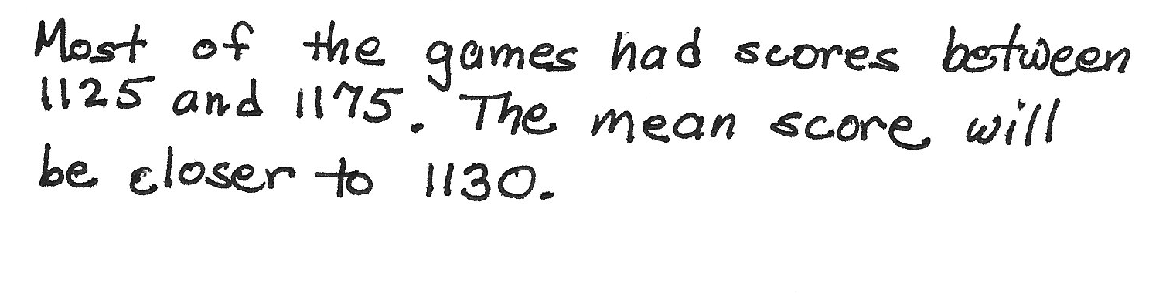
- The first two games she played took $169$ moves ($1131$ points) and $153$ moves ($1147$ points). Based on this information, determine the equation of the linear function used by the computer to calculate the score from the number of moves. Explain your work.

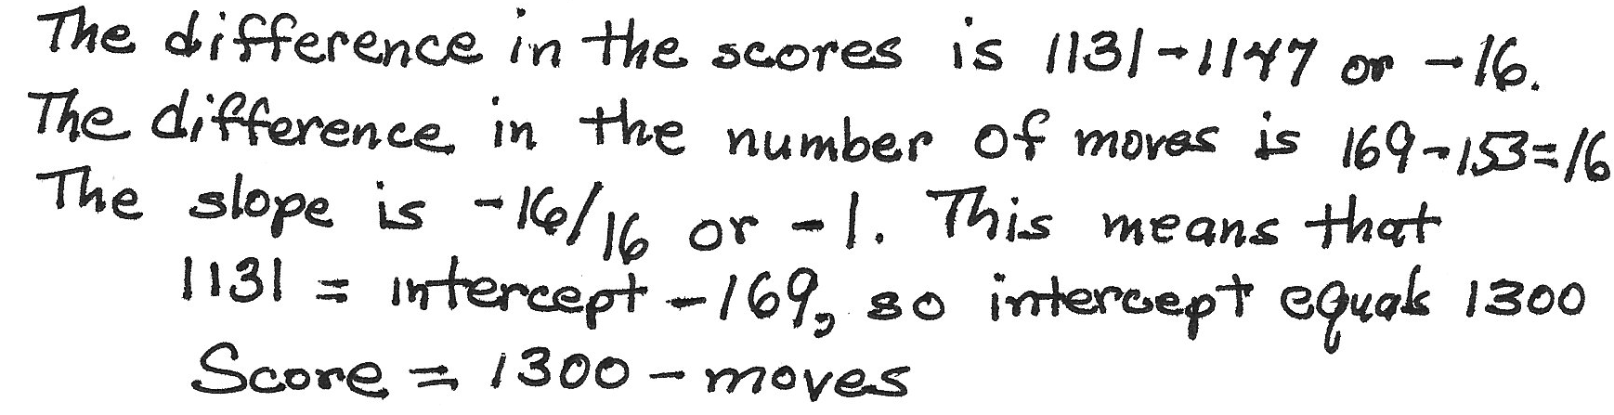
- Based on the linear function, each time the player makes a move, how many points does he or she lose?

- Based on the linear function, how many points does the player start with in this game? Explain your reasoning.
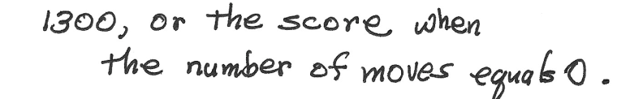

- To save money, drivers often try to increase their mileage, which is measured in miles per gallon (mpg). One theory is that speed traveled impacts miles per gallon. Suppose the following data are recorded for five different $300$-mile tests, with the car traveling at different speeds in miles per hour (mph) for each test.
Speed (mph) | Miles per gallon (mpg)
$$50$$ | $$32$$
$$60$$ | $$29$$
$$70$$ | $$24$$
$$80$$ | $$20$$
$$90$$ | $$17$$

- For the data in this table, is the association positive or negative? Explain how you decided.
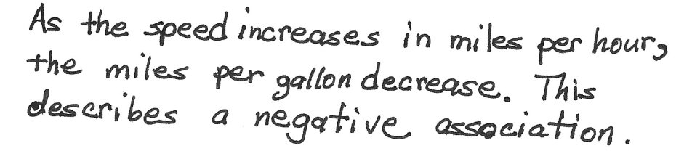

- Construct a scatter plot of these data using the following coordinate grid. The vertical axis represents the miles per gallon (mpg), and the horizontal axis represents the speed in miles per hour (mph).
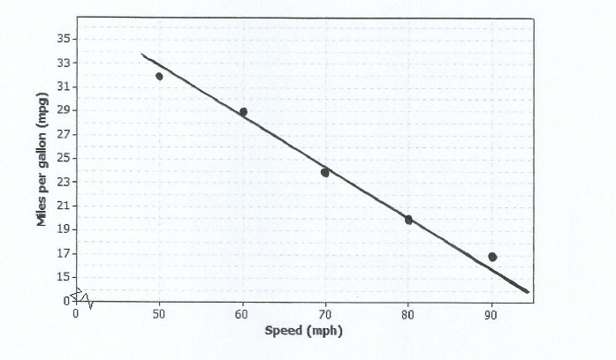

- Draw a line on your scatter plot that you think is a reasonable model for predicting the miles per gallon from the car speed.

- Estimate and interpret the slope of the line you found in part (c).
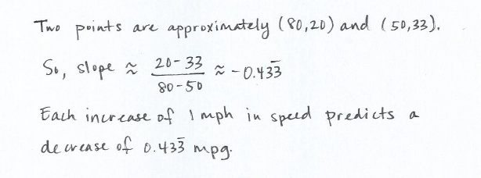

Suppose additional data were measured for three more tests. These results have been added to the previous tests, and the combined data are shown in the table below.
Speed (mph) | Miles per gallon (mpg)
$$20$$ | $$25$$
$$30$$ | $$27$$
$$40$$ | $$30$$
$$50$$ | $$32$$
$$60$$ | $$29$$
$$70$$ | $$24$$
$$80$$ | $$20$$
$$90$$ | $$17$$

  - Does the association for these data appear to be linear? Why or why not?
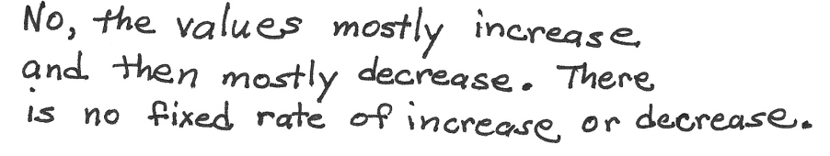

  - If your only concern was miles per gallon and you had no traffic constraints, what speed would you recommend traveling based on these data? Explain your choice.
