Name Date

* 1. We define as a year between 2008 and 2013, and as the total number of smartphones sold that year, in millions. The table shows values of and corresponding values.

|  |  |  |  |  |  |  |  |
| --- | --- | --- | --- | --- | --- | --- | --- |
| Year  () | 2008 | 2009 | 2010 | 2011 | 2012 | 2013 |  |
| Number of smartphones in millions () |  |  |  |  |  |  |  |

* + 1. How many smartphones were sold in 2009?
    2. In which year were million smartphones sold?
    3. Is a function of ? Explain why or why not.

* 1. Randy began completing the table below to represent a particular linear function. Write an equation to represent the function he used, and complete the table for him.

|  |  |  |  |  |  |  |  |
| --- | --- | --- | --- | --- | --- | --- | --- |
| Input  () |  |  |  |  |  |  |  |
| Output () |  |  |  |  |  |  |  |

* 1. Create the graph of the function in part (b).

Macintosh HD:Users:shassan:Desktop:gr.pdf

* 1. At NYU in 2013, the cost of the weekly meal plan options could be described as a function of the number of meals. Is the cost of the meal plan a linear or nonlinear function? Explain.

meals: /week

meals: /week

meals: /week

meals: /week

1. The cost to enter and go on rides at a local water park, Wally’s Water World, is shown in the graph below.

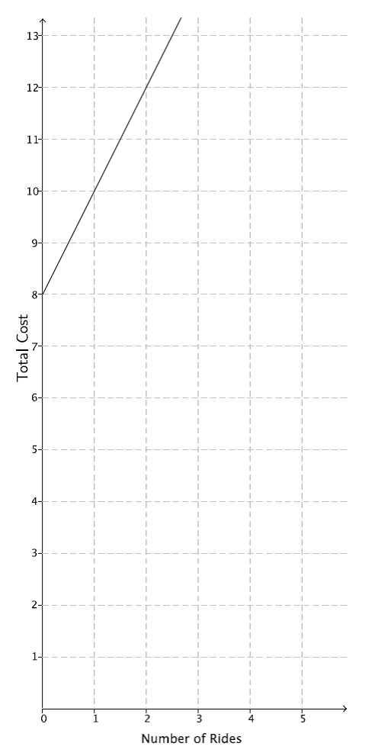

A new water park, Tony’s Tidal Takeover, just opened. You have not heard anything specific about how much it costs to go to this park, but some of your friends have told you what they spent. The information is organized in the table below.

|  |  |  |  |  |
| --- | --- | --- | --- | --- |
| Number of rides |  |  |  |  |
| Dollars spent |  |  |  |  |

Each park charges a different admission fee and a different fee per ride, but the cost of each ride remains the same.

* 1. If you only have to spend, which park would you attend (assume the rides are the same quality)? Explain.
  2. Another water park, Splash, opens, and they charge an admission fee of with no additional fee for rides. At what number of rides does it become more expensive to go to Wally’s Water World than Splash? At what number of rides does it become more expensive to go to Tony’s Tidal Takeover than Splash?
  3. For all three water parks, the cost is a function of the number of rides. Compare the functions for all three water parks in terms of their rate of change. Describe the impact it has on the total cost of attending each park.

1. For each part below, leave your answers in terms of
   1. Determine the volume for each three-dimensional figure shown below.

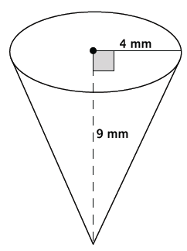 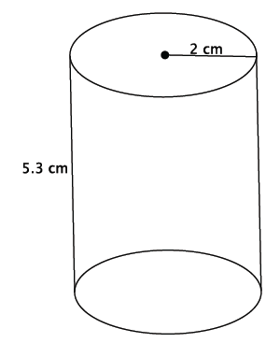 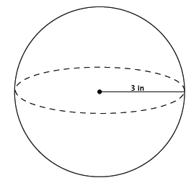

* 1. You want to fill the cylinder shown below with water. All you have is a container shaped like a cone with a radius of inches and a height of inches; you can use this cone-shaped container to take water from a faucet and fill the cylinder. How many cones will it take to fill the cylinder?

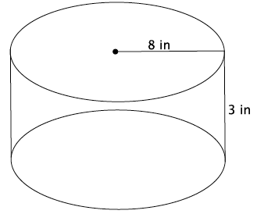

* 1. You have a cylinder with a diameter of inches and height of inches. What is the volume of the largest sphere that will fit inside of it?

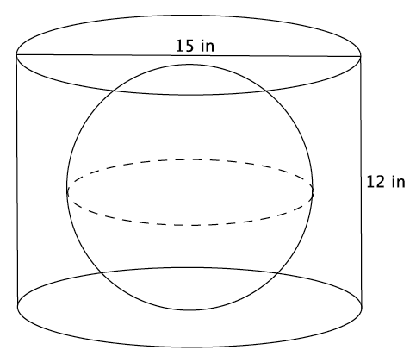

|  |  |  |  |  |  |
| --- | --- | --- | --- | --- | --- |
| A Progression Toward Mastery | | | | | |
| Assessment  Task Item | | STEP 1  Missing or incorrect answer and little evidence of reasoning or application of mathematics to solve the problem. | STEP 2  Missing or incorrect answer but evidence of some reasoning or application of mathematics to solve the problem. | STEP 3  A correct answer with some evidence of reasoning or application of mathematics to solve the problem, or an incorrect answer with substantial evidence of solid reasoning or application of mathematics to solve the problem. | STEP 4  A correct answer supported by substantial evidence of solid reasoning or application of mathematics to solve the problem. |
| **1** | **a**  8.F.A.1 | Student makes little or no attempt to solve the problem. | Student answers at least one of the three questions correctly as million, 2011, or yes. Student does not provide an explanation as to why is a function of | Student answers all three questions correctly as million, 2011, and yes. Student provides an explanation as to why is a function of . Student may not have used vocabulary related to functions. | Student answers all three questions correctly as million, 2011, and yes. Student provides a *compelling* explanation as to why is a function of and uses appropriate vocabulary related to functions (e.g., assignment, input*,* and output). |
| **b**  8.F.A.1 | Student makes little or no attempt to solve the problem.  Student does not write a function or equation.  The outputs may or may not be calculated correctly. | Student does not correctly write the equation to describe the function.  The outputs may be correct for the function described by the student.  The outputs may or may not be calculated correctly.  Student may have made calculation errors.  Two or more of the outputs are calculated correctly. | Student correctly writes the equation to describe the function as .  Three or more of the outputs are calculated correctly.  Student may have made calculation errors. | Student correctly writes the equation to describe the function as .  All four of the outputs are calculated correctly as when ,; when ,; when ,; and when , . |
| **c**  8.F.A.1 | Student makes little or no attempt to solve the problem.  Student may have graphed some or all of the input/outputs given. | Student graphs the input/outputs incorrectly (e.g., instead of ).  The input/outputs do not appear to be linear. | Student may or may not have graphed the input/outputs correctly (e.g., instead of ).  The input/outputs appear to be linear. | Student graphs the input/outputs correctly as .  The input/outputs appear to be linear. |
| **d**  8.F.A.3 | Student makes little or no attempt to solve the problem.  Student may or may not have made a choice.  Student does not give an explanation. | Student incorrectly determines that the meal plan is linear or correctly determines that it is nonlinear.  Student does not give an explanation, or the explanation does not include any mathematical reasoning. | Student correctly determines that the meal plan is nonlinear.  Explanation includes some mathematical reasoning.  Explanation may or may not include reference to the graph. | Student correctly determines that the meal plan is nonlinear.  Explanation includes substantial mathematical reasoning.  Explanation includes reference to the graph. |
| **2** | **a**  8.F.A.2 | Student makes little or no attempt to solve the problem.  Student may or may not have made a choice.  Student does not give an explanation. | Student identifies either choice.  Student makes significant calculation errors.  Student gives little or no explanation. | Student identifies either choice.  Student may have made calculation errors.  Explanation may or may not have included the calculation errors. | Student identifies Wally’s Water World as the better choice.  Student references that for he can ride three rides at Wally’s Water World but only two rides at Tony’s Tidal Takeover. |
| **b**  8.F.A.2 | Student makes little or no attempt to solve the problem.  Student does not give an explanation. | Student identifies the number of rides at both parks incorrectly.  Student may or may not identify functions to solve the problem. For example, student uses the table or counting method.  Student makes some attempt to find the function for one or both of the parks.  The functions used are incorrect. | Student identifies the number of rides at one of the parks correctly.  Student makes some attempt to identify the function for one or both of the parks.  Student may or may not identify functions to solve the problem. For example, student uses the table or counting method.  One function used is correct. | Student identifies that the th ride at Tony’s Tidal Takeover makes it more expensive than Splash. Student may have stated that he could ride rides for at Tony’s. Student identifies that the th ride at Wally’s Water World makes it more expensive than Splash. Student may have stated that he could ride rides for at Wally’s.  Student identifies functions to solve the problem (e.g., if is the number of rides, for the cost of Wally’s, and for the cost of Tony’s). |
| **c**  8.F.A.2 | Student makes little or no attempt to solve the problem. | Student may have identified the rate of change for each park, but does so incorrectly. Student may not have compared the rate of change for each park. Student may have described the impact of the rate of change on total cost for one or two of the parks, but draws incorrect conclusions. | Student correctly identifies the rate of change for each park. Student may or may not have compared the rate of change for each park. Student may have described the impact of the rate of change on total cost for all parks, but makes minor mistakes in the description. | Student correctly identifies the rate of change for each park: Wally’s is , Tony’s is , and Splash is . Student compares the rate of change for each park and identifies which park has the greatest rate of change (or least rate of change) as part of the comparison.  Student describes the impact of the rate of change on the total cost for each park. |
| **3** | **a**  8.G.C.9 | Student makes little or no attempt to solve the problem.  Student finds none or one of the volumes correctly.  Student may or may not have included correct units.  Student may have omitted from one or more of the volumes (i.e., the volume of the cone is ). | Student finds two out of three volumes correctly.  Student may or may not have included correct units.  Student may have omitted from one or more of the volumes (i.e., the volume of the cone is ). | Student finds all three of the volumes correctly.  Student does not include the correct units.  Student may have omitted from one or more of the volumes (i.e., the volume of the cone is ). | Student finds all three of the volumes correctly, that is, the volume of the cone is mm3, the volume of the cylinder is cm3, and the volume of the sphere is in3.  Student includes the correct units. |
| **b**  8.G.C.9 | Student makes little or no attempt to solve the problem. | Student does not correctly calculate the number of cones.  Student makes significant calculation errors.  Student may have used the wrong formula for volume of the cylinder or the cone.  Student may not have answered in a complete sentence. | Student may have correctly calculated the number of cones, but does not correctly calculate the volume of the cylinder or cone (e.g., volume of the cone is , omitting the ).  Student correctly calculates the volume of the cone at in3 or the volume of the cylinder at in3, but not both.  Student may have used incorrect units.  Student may have made minor calculation errors.  Student may not answer in a complete sentence. | Student correctly calculates that it will take cones to fill the cylinder.  Student correctly calculates the volume of the cone at in3 and the volume of the cylinder at in3.  Student answers in a complete sentence. |
| **c**  8.G.C.9 | Student makes little or no attempt to solve the problem. | Student does not correctly calculate the volume.  Student may have used the diameter instead of the radius for calculations.  Student may have made calculation errors.  Student may or may not have omitted  Student may or may not have included the units. | Student correctly calculates the volume, but does not include the units or includes incorrect units (e.g., in2).  Student uses the radius of to calculate the volume.  Student may have calculated the volume as (is omitted). | Student correctly calculates the volume as in3.  Student uses the radius of to calculate the volume.  Student includes correct units. |

Name Date

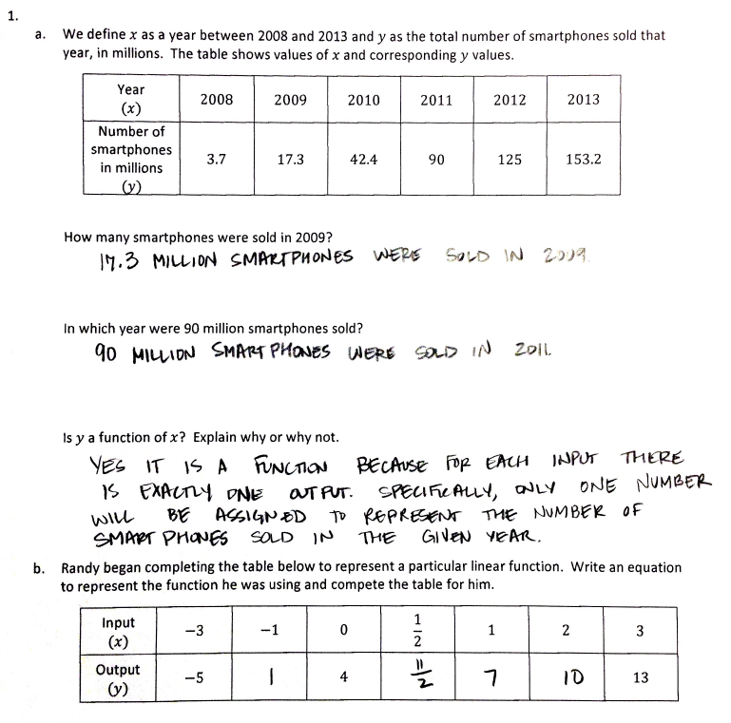

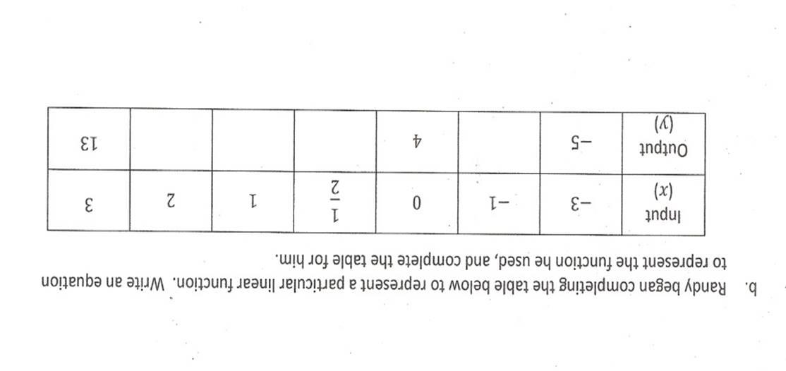

1

7

10

y = 3x + 4

