Table of Contents

GRADE 5 • MODULE 1

Place Value and Decimal Fractions

**Module Overview** i

Topic A: Multiplicative Patterns on the Place Value Chart 1.A.1

Topic B: Decimal Fractions and Place Value Patterns 1.B.1

Topic C: Place Value and Rounding Decimal Fractions 1.C.1

Topic D: Adding and Subtracting Decimals 1.D.1

Topic E: Multiplying Decimals 1.E.1

Topic F: Dividing Decimals 1.F.1

**Module Assessments** 1.S.1

NOTE: Student sheets should be printed at 100% scale to preserve the intended size of figures for accurate measurements. Adjust copier or printer settings to *actual size* and set page scaling to *none*.

Grade 5 • Module 1

Place Value and Decimal Fractions

OVERVIEW

In Module 1, students’ understandings of the patterns in the base ten system are extended from Grade 4’s work with place value to include decimals to the thousandths place. In Grade 5, students deepen their knowledge through a more generalized understanding of the relationships between and among adjacent places on the place value chart, e.g., 1 tenth times any digit on the place value chart moves the digit one place value to the right (**5.NBT.1**). Toward the module’s end, students apply these new understandings as they reason about and perform decimal operations through the hundredths place.

Topic A opens the module with a conceptual exploration of the multiplicative patterns of the base ten system using place value disks and a place value chart. Students notice that multiplying by 1,000 is the same as multiplying by 10 10 10. Since each factor of 10 shifts the digits one place to the left, multiplying by 10 10 10—which can be recorded in exponential form as 103 (**5.NBT.2**)—shifts the position of the digits to the left 3 places, thus changing the digits’ relationships to the decimal point (**5.NBT.2**). Application of these place value understandings to problem solving with metric conversions completes Topic A (**5.MD.1**).

Topic B moves into the naming of decimal fraction numbers in expanded, unit (e.g., 4.23 = 4 ones 2 tenths 3 hundredths), and word forms and concludes with using like units to compare decimal fractions. Now in Grade 5, students use exponents and the unit fraction to represent expanded form, e.g., 2 102 + 3 (1/10) + 4 (1/100) = 200.34 (**5.NBT.3**). Further, students reason about differences in the values of like place value units and express those comparisons with symbols (>, <, and =). Students generalize their knowledge of rounding whole numbers to round decimal numbers in Topic C, initially using a vertical number line to interpret the result as an approximation and then eventually moving away from the visual model (**5.NBT.4**).

In the latter topics of Module 1, students use the relationships of adjacent units and generalize whole number algorithms to decimal fraction operations (**5.NBT.7**). Topic D uses unit form to connect general methods for addition and subtraction with whole numbers to decimal addition and subtraction, e.g., 7 tens + 8 tens = 15 tens = 150 is analogous to 7 tenths + 8 tenths = 15 tenths = 1.5.

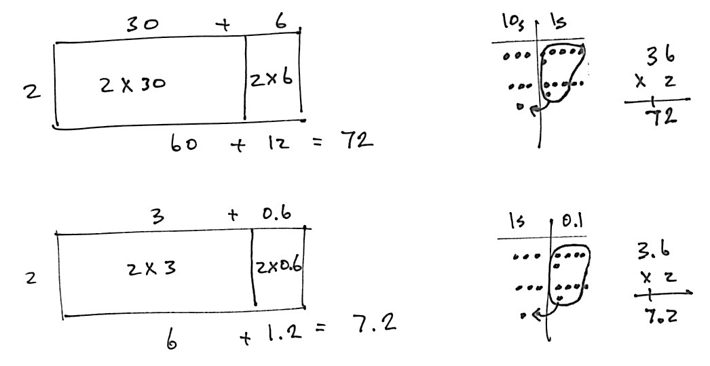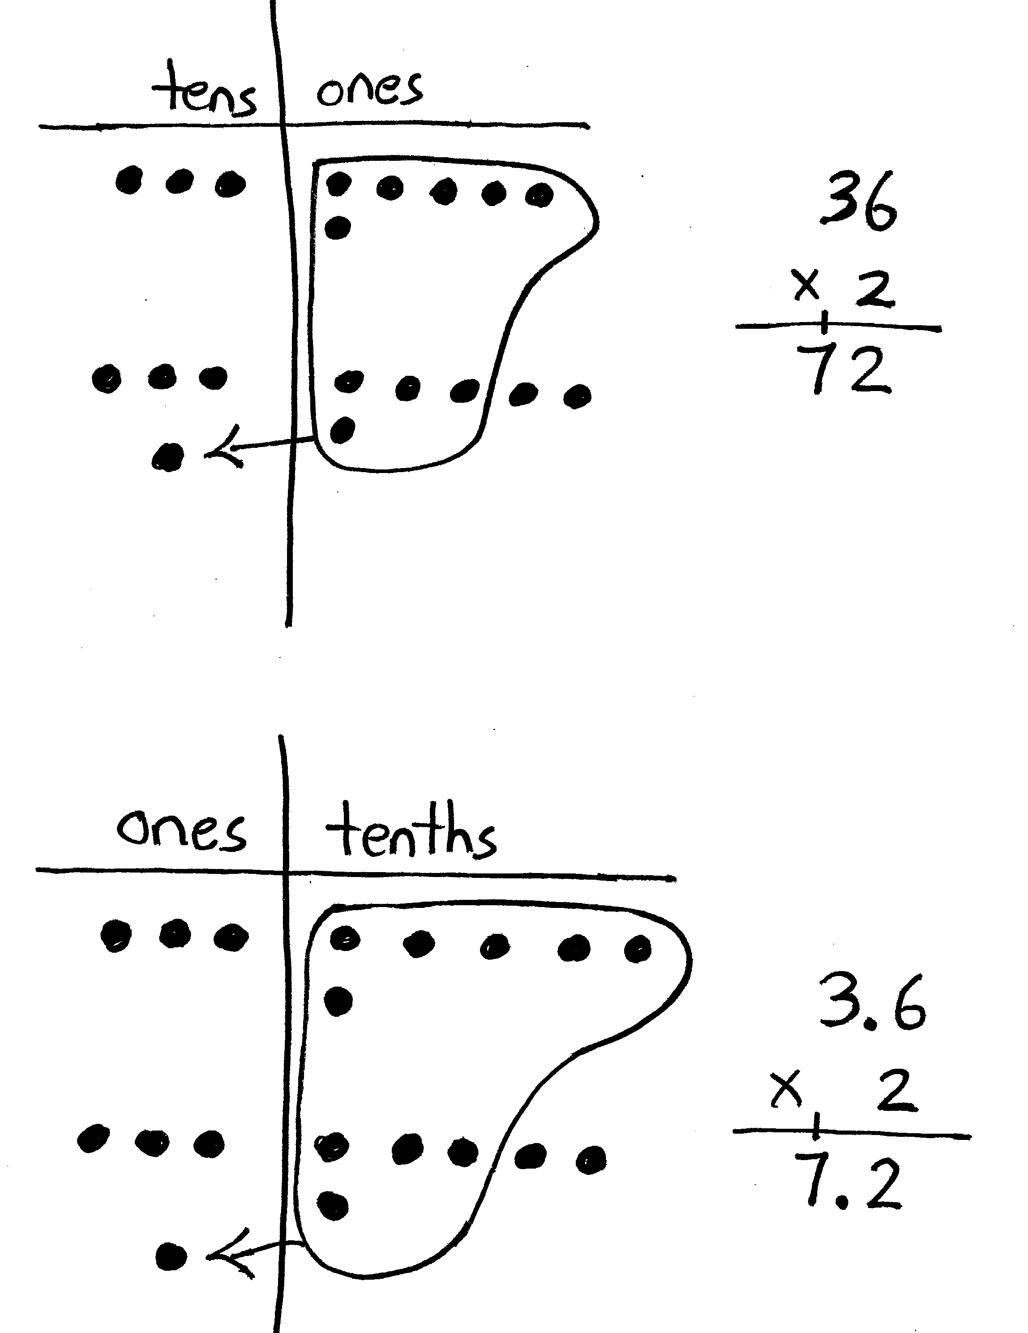

Topic E bridges the gap between Grade 4 work with multiplication and the standard algorithm by focusing on an intermediate step—reasoning about multiplying a decimal by a one-digit whole number. The area model, with which students have had extensive experience since Grade 3, is used as a scaffold for this work.

Topic F concludes Module 1 with a similar exploration of division of decimal numbers by one-digit whole number divisors. Students solidify their skills with an understanding of the algorithm before moving on to long division involving two-digit divisors in Module 2.

The Mid-Module Assessment follows Topic C. The End-of-Module Assessment follows Topic F.

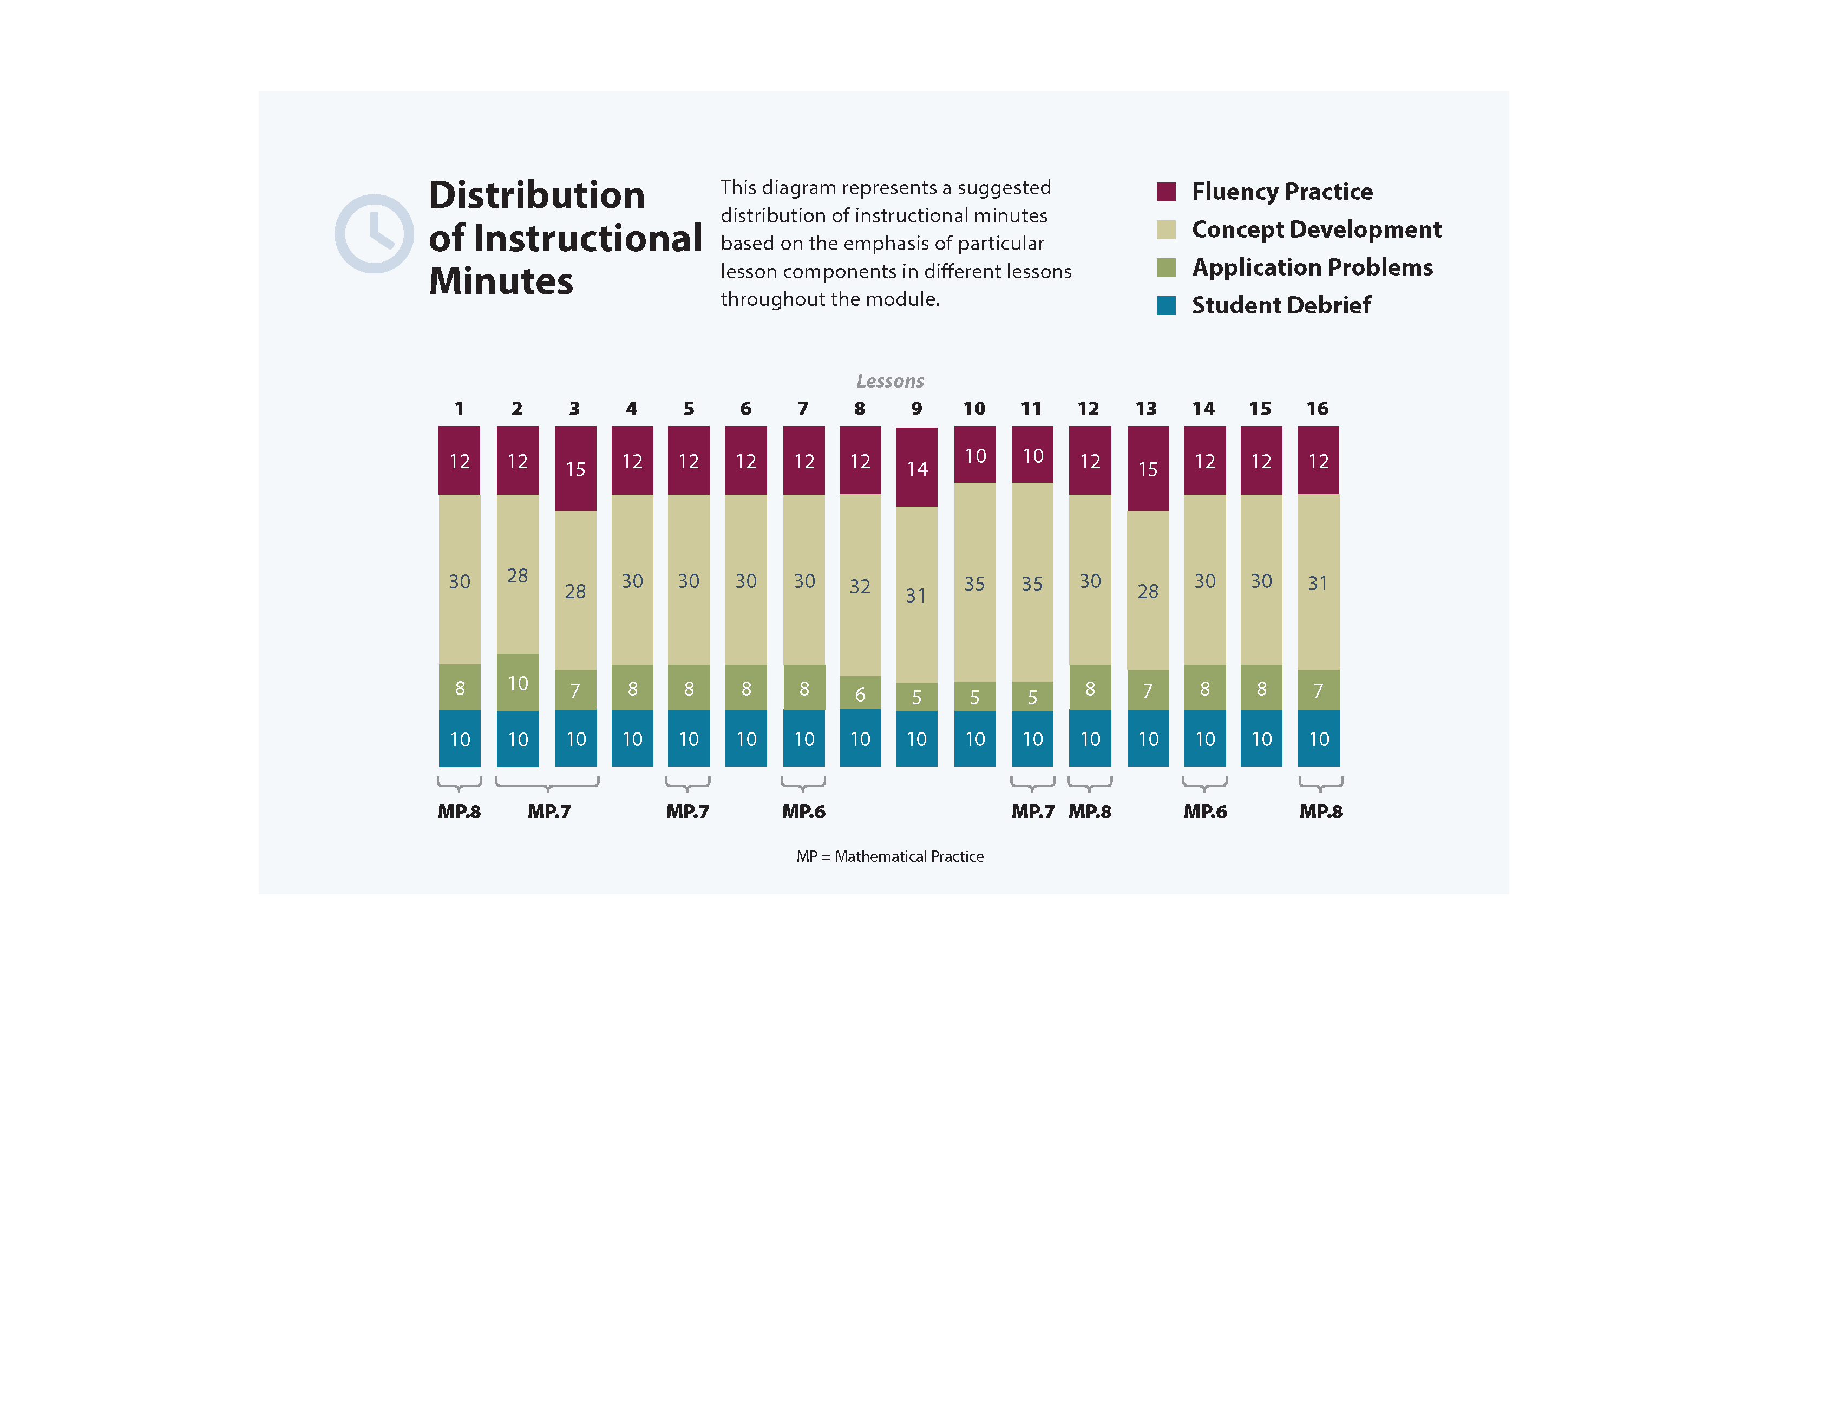

Focus Grade Level Standards

Understand the place value system.

5.NBT.1 Recognize that in a multi-digit number, a digit in one place represents 10 times as much as it represents in the place to its right and 1/10 of what it represents in the place to its left.

5.NBT.2  Explain patterns in the number of zeros of the product when multiplying a number by powers of 10, and explain patterns in the placement of the decimal point when a decimal is multiplied or divided by a power of 10. Use whole-number exponents to denote powers of 10.

5.NBT.3 Read, write, and compare decimals to thousandths.

a. Read and write decimals to thousandths using base-ten numerals, number names, and expanded form, e.g., 347.392 = 3 100 + 4 10 + 7 1 + 3 (1/10) + 9 (1/100) + 2 (1/1000).

b. Compare two decimals to thousandths based on meanings of the digits in each place, using >, =, and < symbols to record the results of comparisons.

5.NBT.4 Use place value understanding to round decimals to any place.



Perform operations with multi-digit whole numbers and with decimals to hundredths.[1]

**5.NBT.7** Add, subtract, multiply, and divide decimals to hundredths, using concrete models or drawings and strategies based on place value, properties of operations, and/or the relationship between addition and subtraction; relate the strategy to a written method and explain the reasoning used.

**Convert like measurement units within a given measurement system.**

**5.MD.1** Convert among different-sized standard measurement units within a given measurement system (e.g., convert 5 cm to 0.05 m), and use these conversions in solving multi-step, real world problems.[2]

Foundational Standards

4.NBT.1 Recognize that in a multi-digit whole number, a digit in one place represents ten times what it represents in the place to its right. *For example, recognize that 700 ÷ 70 = 10 by applying concepts of place value and division.*

4.NBT.3 Use place value understanding to round multi-digit whole numbers to any place.

4.NF.5 Express a fraction with denominator 10 as an equivalent fraction with denominator 100, and use this technique to add two fractions with respective denominators 10 and 100. (Students who can generate equivalent fractions can develop strategies for adding fractions with unlike denominators in general. But addition and subtraction with unlike denominators in general is not a requirement at this grade.) *For example, express 3/10 as 30/100, and add 3/10 + 4/100 = 34/100.*

4.NF.6 Use decimal notation for fractions with denominators 10 or 100. *For example, rewrite 0.62 as 62/100; describe a length as 0.62 meters; locate 0.62 on a number line diagram.*

4.NF.7 Compare two decimals to hundredths by reasoning about their size. Recognize that comparisons are valid only when the two decimals refer to the same whole. Record the results of comparisons with the symbols >, =, or <, and justify the conclusions, e.g., by using a visual model.

4.MD.1 Know relative sizes of measurement units within one system of units including km, m, cm; kg, g; lb, oz.; l, ml; hr, min, sec. Within a single system of measurement, express measurements in a larger unit in terms of a smaller unit. Record measurement equivalents in a two-column table. *For example, know that 1 ft is 12 times as long as 1 in. Express the length of a 4 ft snake as 48 in. Generate a conversion table for feet and inches listing the number pairs (1, 12), (2, 24), (3, 36), …*

4.MD.2 Use the four operations to solve word problems involving distances, intervals of time, liquid volumes, masses of objects, and money, including problems involving simple fractions or decimals, and problems that require expressing measurements given in a larger unit in terms of a smaller unit. Represent measurement quantities using diagrams such as number line diagrams that feature a measurement scale.

Focus Standards for Mathematical Practice

**MP.6 Attend to precision.** Students express the units of the base ten system as they work with decimal operations, expressing decompositions and compositions with understanding, e.g., “9 hundredths + 4 hundredths = 13 hundredths. I can change 10 hundredths to make 1 tenth.”

**MP.7 Look for and make use of structure.**  Students explore the multiplicative patterns of the base ten system when they use place value charts and disks to highlight the relationships between adjacent places. Students also use patterns to name decimal fraction numbers in expanded, unit, and word forms.

**MP.8 Look for and express regularity in repeated reasoning.**  Students express regularity in repeated reasoning when they look for and use whole number general methods to add and subtract decimals and when they multiply and divide decimals by whole numbers. Students also use powers of ten to explain patterns in the placement of the decimal point and generalize their knowledge of rounding whole numbers to round decimal numbers.

Overview of Module Topics and Lesson Objectives

|  |  |  |  |
| --- | --- | --- | --- |
| **Standards** | **Topics and Objectives** | | **Days** |
| **5.NBT.1**  **5.NBT.2**  **5.MD.1** | A | Multiplicative Patterns on the Place Value Chart  Lesson 1: Reason concretely and pictorially using place value understanding to relate adjacent base ten units from millions to thousandths.  Lesson 2: Reason abstractly using place value understanding to relate adjacent base ten units from millions to thousandths.  Lesson 3: Use exponents to name place value units and explain patterns in the placement of the decimal point.  Lesson 4: Use exponents to denote powers of 10 with application to metric conversions. | 4 |
| **5.NBT.3** | B | Decimal Fractions and Place Value Patterns  Lesson 5: Name decimal fractions in expanded, unit, and word forms by applying place value reasoning.  Lesson 6: Compare decimal fractions to the thousandths using like units, and express comparisons with >, <, =. | 2 |
| **5.NBT.4** | C | Place Value and Rounding Decimal Fractions  Lessons 7–8: Round a given decimal to any place using place value understanding and the vertical number line. | 2 |
|  |  | Mid-Module Assessment: Topics A–C (assessment ½ day, return ½ day, remediation or further applications 1 day) | 2 |
| **Standards** | **Topics and Objectives** | | **Days** |
| **5.NBT.2**  **5.NBT.3**  **5.NBT.7** | D | Adding and Subtracting Decimals  Lesson 9: Add decimals using place value strategies and relate those strategies to a written method.  Lesson 10: Subtract decimals using place value strategies and relate those strategies to a written method. | 2 |
| **5.NBT.2**  **5.NBT.3**  **5.NBT.7** | E | Multiplying Decimals  Lesson 11: Multiply a decimal fraction by single-digit whole numbers, relate to a written method through application of the area model and place value understanding, and explain the reasoning used.  Lesson 12: Multiply a decimal fraction by single-digit whole numbers, including using estimation to confirm the placement of the decimal point. | 2 |
| **5.NBT.3**  **5.NBT.7** | F | Dividing Decimals  Lesson 13: Divide decimals by single-digit whole numbers involving easily identifiable multiples using place value understanding and relate to a written method.  Lesson 14: Divide decimals with a remainder using place value understanding and relate to a written method.  Lesson 15: Divide decimals using place value understanding including remainders in the smallest unit.  Lesson 16: Solve word problems using decimal operations. | 4 |
|  |  | End-of-Module Assessment: Topics A–F (assessment ½ day, return ½ day, remediation or further applications 1 day) | 2 |
| **Total Number of Instructional Days** | | | **20** |

Terminology

|  |  |
| --- | --- |
|  | NOTES ON  *EXPRESSION*, *EQUATION*,  AND *NUMBER SENTENCE*: |
| Please note the descriptions for the following terms, which are frequently misused.   * + - **Expression:** A number, or any combination of sums, differences, products, or divisions of numbers that evaluates to a number (e.g., 3 + 4, 8 × 3, 15 ÷ 3 as distinct from an equation or number sentence). * **Equation:** A statement that two expressions are equal (e.g., 3 × ___ = 12, 5 × *b* =20, 3 + 2 = 5). * **Number sentence** (also addition, subtraction, multiplication, or division sentence)**:** An equation or inequality for which both expressions are numerical and can be evaluated to a single number (e.g., 4 + 3 = 6 + 1, 2 = 2, 21 > 7 × 2, 5 ÷ 5 =1). Number sentences are either true or false (e.g., 4 + 4 < 6 × 2 and 21 ÷ 7 = 4) and contain no unknowns. | |

New or Recently Introduced Terms

* Exponent (how many times a number is to be used in a multiplication sentence)
* Millimeter (a metric unit of length equal to   
  one-thousandth of a meter)
* Thousandths (related to place value)

Familiar Terms and Symbols[3]

* >, <, = (greater than, less than, equal to)
* Base ten units (place value units)
* Bundling, making, renaming, changing, regrouping, trading
* Centimeter (cm, a unit of measure equal to one-hundredth of a meter)
* Digit (any of the numbers 0 to 9; e.g., what is the value of the digit in the tens place?)
* Expanded form (e.g., 135 = 1 100 + 3 10 + 5 1)
* Hundredths (as related to place value)
* Number line (a line marked with numbers at evenly spaced intervals)
* Number sentence (e.g., 4 + 3 = 7)
* Place value (the numerical value that a digit has by virtue of its position in a number)
* Standard form (a number written in the format: 135)
* Tenths (as related to place value)
* Unbundling, breaking, renaming, changing, regrouping, trading
* Unit form (e.g., 3.21 = 3 ones 2 tenths 1 hundredth)
* Word form (e.g., one hundred thirty-five)

Suggested Tools and Representations

* Number lines (a variety of templates, including a large one for the back wall of the classroom)
* Place value charts (at least one per student for an insert in their personal board)
* Place value disks

Suggested Methods of Instructional Delivery

Directions for Administration of Sprints

Sprints are designed to develop fluency. They should be fun, adrenaline-rich activities that intentionally build energy and excitement. A fast pace is essential. During Sprint administration, teachers assume the role of athletic coaches. A rousing routine fuels students’ motivation to do their personal best. Student recognition of increasing success is critical, and so every improvement is celebrated.

One Sprint has two parts with closely related problems on each. Students complete the two parts of the Sprint in quick succession with the goal of improving on the second part, even if only by one more.

With practice, the following routine takes about 9 minutes.

Sprint A

Pass Sprint Aout quickly, face down on student desks with instructions to not look at the problems until the signal is given. (Some Sprints include words. If necessary, prior to starting the Sprint, quickly review the words so that reading difficulty does not slow students down.)

T: You will have 60 seconds to do as many problems as you can. I do not expect you to finish all of them. Just do as many as you can, your personal best. (If some students are likely to finish before time is up, assign a number to count by on the back.)

T: Take your mark! Get set! THINK!

Students immediately turn papers over and work furiously to finish as many problems as they can in 60 seconds. Time precisely.

T: Stop! Circle the last problem you did. I will read just the answers. If you got it right, call out “Yes!” If you made a mistake, circle it. Ready?

T: (Energetically, rapid-fire call the first answer.)

S: Yes!

T: (Energetically, rapid-fire call the second answer.)

S: Yes!

Repeat to the end of Sprint A or until no student has a correct answer. If needed, read the count-by answers in the same way you read Sprint answers. Each number counted-by on the back is considered a correct answer.

T: Fantastic! Now, write the number you got correct at the top of your page. This is your personal goal for Sprint B.

T: How many of you got one right? (All hands should go up.)

T: Keep your hand up until I say the number that is one more than the number you got correct. So, if you got 14 correct, when I say 15, your hand goes down. Ready?

T: (Continue quickly.) How many got two correct? Three? Four? Five? (Continue until all hands are down.)

If the class needs more practice with Sprint A, continue with the optional routine presented below.

T: I’ll give you one minute to do more problems on this half of the Sprint. If you finish, stand behind your chair.

As students work, the student who scored highest on Sprint A might pass out Sprint B.

T: Stop! I will read just the answers. If you got it right, call out “Yes!” If you made a mistake, circle it. Ready? (Read the answers to the first half again as students stand.)

Movement

To keep the energy and fun going, always do a stretch or a movement game in between Sprints A and B. For example, the class might do jumping jacks while skip-counting by 5 for about 1 minute. Feeling invigorated, students take their seats for Sprint B, ready to make every effort to complete more problems this time.

Sprint B

Pass Sprint Bout quickly, face down on student desks with instructions to not look at the problems until the signal is given. (Repeat the procedure for Sprint Aup through the show of hands for how many right.)

T: Stand up if you got more correct on the second Sprint than on the first.

S: (Stand.)

T: Keep standing until I say the number that tells how many more you got right on Sprint B. If you got three more right on Sprint B than you did on Sprint A, when I say *three,* you sit down. Ready? (Call out numbers starting with one. Students sit as the number by which they improved is called. Celebrate the students who improved most with a cheer.)

T: Well done! Now, take a moment to go back and correct your mistakes. Think about what patterns you noticed in today’s Sprint.

T: How did the patterns help you get better at solving the problems?

T: Rally Robin your thinking with your partner for 1 minute. Go!

Rally Robin is a style of sharing in which partners trade information back and forth, one statement at a time per person, for about 1 minute. This is an especially valuable part of the routine for students who benefit from their friends’ support to identify patterns and try new strategies.

Students may take Sprints home.

RDW or Read, Draw, Write (an Equation and a Statement)

Mathematicians and teachers suggest a simple process applicable to all grades:

1) Read.

2) Draw and Label.

3) Write an equation.

4) Write a word sentence (statement).

The more students participate in reasoning through problems with a systematic approach, the more they internalize those behaviors and thought processes.

* What do I see?
* Can I draw something?
* What conclusions can I make from my drawing?

|  |  |  |
| --- | --- | --- |
| **Modeling with Interactive Questioning** | **Guided Practice** | **Independent Practice** |
| The teacher models the whole process with interactive questioning, some choral response, and talk moves such as, “What did Monique say, everyone?” After completing the problem, students might reflect with a partner on the steps they used to solve the problem. “Students, think back on what we did to solve this problem. What did we do first?” Students might then be given the same or similar problem to solve for homework. | Each student has a copy of the question. Though guided by the teacher, they work indepen-dently at times and then come together again. Timing is important. Students might hear, “You have 2 minutes to do your drawing.” Or, “Put your pencils down. Time to work together again.” The Debrief might include selecting different student work to share. | The students are given a problem to solve and possibly a designated amount of time to solve it. The teacher circulates, supports, and is thinking about which student work to show to support the mathematical objectives of the lesson. When sharing student work, students are encouraged to think about the work with questions such as, “What do you notice about Jeremy’s work?”, “What is the same about Jeremy’s work and Sara’s work?”, “How did Jeremy show the 3/7 of the students?”, and “How did Sara show the 3/7 of the students?” |

Personal White Boards

Materials Needed for Personal White Boards

1 heavy duty clear sheet protector

1 piece of stiff red tag board 11" × 8 ¼"

1 piece of stiff white tag board 11" × 8 ¼"

1 3" × 3" piece of dark synthetic cloth for an eraser (e.g., felt)

1 low odor blue dry erase marker, fine point

Directions for Creating Personal White Boards

Cut your white and red tag to specifications. Slide into the sheet protector. Store your eraser on the red side. Store markers in a separate container to avoid stretching the sheet protector.

Frequently Asked Questions About Personal White Boards

*Why is one side red and one white?*

The white side of the board is the “paper.” Students generally write on it, and if working individually, turn the board over to signal to the teacher they have completed their work. The teacher then says, “Show me your boards,” when most of the class is ready.

*What are some of the benefits of a personal white board?*

* The teacher can respond quickly to a gap in student understandings and skills. “Let’s do some of these on our personal white boards until we have more mastery.”
* Students can erase quickly so that they do not have to suffer the evidence of their mistake.
* They are motivating. Students love both the drill and thrill capability and the chance to do story problems with an engaging medium.
* Checking work gives the teacher instant feedback about student understanding.

*What is the benefit of this personal white board over a commercially purchased dry erase board?*

* It is much less expensive.
* Templates such as place value charts, number bond mats, hundreds boards, and number lines can be stored between the two pieces of tag board for easy access and reuse.
* Worksheets, story problems, and other problem sets can be done without marking the paper so that students can work on the problems independently at another time.
* Strips with story problems, number lines, and arrays can be inserted and still have a full piece of paper on which to write.
* The red versus white side distinction clarifies your expectations. When working collaboratively, there is no need to use the red. When working independently, the students know how to keep their work private.
* The tag board can be removed so that student work can be projected on an overhead.

Scaffolds[4]

The scaffolds integrated into *A Story of Units* give alternatives for how students access information as well as express and demonstrate their learning. Strategically placed margin notes are provided within each lesson, elaborating on the use of specific scaffolds at applicable times. They address many needs presented by English language learners, students with disabilities, students performing above grade level, and students performing below grade level. Many of the suggestions are organized by Universal Design for Learning (UDL) principles and are applicable to more than one population. To read more about the approach to differentiated instruction in *A Story of Units*, please refer to “How to Implement *A Story of Units*.”

Assessment Summary

|  |  |  |  |
| --- | --- | --- | --- |
| **Type** | **Administered** | **Format** | **Standards Addressed** |
| Mid-Module Assessment Task | After Topic C | Constructed response with rubric | 5.NBT.1  5.NBT.2  5.NBT.3  5.NBT.4  5.MD.1 |
| End-of-Module Assessment Task | After Topic F | Constructed response with rubric | 5.NBT.1  5.NBT.2  5.NBT.3  5.NBT.4  5.NBT.7  5.MD.1 |

1. The balance of this cluster is addressed in Module 2.
2. The focus in this module is on the metric system to reinforce place value and writing measurements using mixed units. This standard is addressed again in later modules.
3. These are terms and symbols students have used or seen previously.
4. Students with disabilities may require Braille, large print, audio, or special digital files. Please visit the website,

   [www.p12.nysed.gov/specialed/aim](http://www.p12.nysed.gov/specialed/aim), for specific information on how to obtain student materials that satisfy the National Instructional Materials Accessibility Standard (NIMAS) format.