Table of Contents
GRADE 2 • MODULE 2
Addition and Subtraction of Length Units

Module Overview i

Topic A: Understand Concepts About the Ruler 2.A.1

Topic B: Measure and Estimate Length Using Different Measurement Tools 2.B.1

Topic C: Measure and Compare Lengths Using Different Length Units 2.C.1

Topic D: Relate Addition and Subtraction to Length 2.D.1

Module Assessments 2.S.1

NOTE: Student sheets should be printed at 100% scale to preserve the intended size of figures for accurate measurements. Adjust your copier or printer settings to actual size and set page scaling to none.

Grade 2 • Module 2
Addition and Subtraction of Length Units
OVERVIEW
In this 12-day Grade 2 module, students engage in activities designed to deepen their conceptual understanding of measurement and to relate addition and subtraction to length. Their work in Module 2 is exclusively with metric units in order to support place value concepts. Customary units are introduced in Module 7.
Topic A opens with students exploring concepts related to the centimeter ruler. In the first lesson, they are guided to connect measurement with physical units as they find the total number of unit lengths by laying multiple copies of centimeter cubes (physical units) end-to-end along various objects. Through this, students discover that to get an accurate measurement, there must be no gaps or overlaps between consecutive length units.
Next, students measure by iterating with one physical unit, using the mark and advance technique, also known as mark and move forward. Students then repeat the process by laying both multiple copies and a single cube along a centimeter ruler. This helps students create a mental benchmark for the centimeter. It also helps them realize that the distance between 0 and 1 on the ruler indicates the amount of space already covered. Hence 0, not 1, marks the beginning of the total length. Students use this understanding to create their own centimeter rulers using a centimeter cube and the mark and advance technique. Topic A ends with students using their unit rulers to measure lengths (2.MD.1), thereby connecting measurement with a ruler.
Students build skill in measuring using centimeter rulers and meter sticks in Topic B. They learn to see that a length unit is not a cube, or a portion of a ruler (which has width), but is a segment of a line. By measuring a variety of objects, students build a bank of known measurements or benchmark lengths, such as a doorknob being a meter from the floor, or the width of a finger being a centimeter. Then, students learn to estimate length using knowledge of previously measured objects and benchmarks. This enables students to internalize the mental rulers of a centimeter or meter, empowering them to mentally iterate units relevant to measuring a given length (2.MD.3). The knowledge and experience signal that students are determining which tool is appropriate to make certain measurements (2.MD.1).
In Topic C, students measure and compare to determine how much longer one object is than another (2.MD.4). They also measure objects twice using different length units, both standard and non-standard, thereby developing their understanding of how the total measurement relates to the size of the length unit (2.MD.2). Repeated experience and explicit comparisons help students recognize that the smaller the length unit, the larger the number of units, and the larger the length unit, the smaller the number of units.

The module culminates as students relate addition and subtraction to length. They apply their conceptual understanding to choose appropriate tools and strategies, such as the ruler as a number line, benchmarks for estimation, and tape diagrams for comparison, to solve word problems (2.MD.5, 2.MD.6). The problems progress from concrete (i.e., measuring objects and using the ruler as a number line to add and subtract) to abstract (i.e., representing lengths with tape diagrams to solve start unknown and two-step problems).

Focus Grade Level Standards
Measure and estimate lengths in standard units.
2.MD.1 Measure the length of an object by selecting and using appropriate tools such as rulers, yardsticks, meter sticks, and measuring tapes.
2.MD.2 Measure the length of an object twice, using length units of different lengths for the two measurements; describe how the two measurements relate to the size of the unit chosen.
2.MD.3 Estimate lengths using units of inches, feet, centimeters, and meters.
2.MD.4 Measure to determine how much longer one object is than another, expressing the length difference in terms of a standard length unit.
Relate addition and subtraction to length.
2.MD.5 Use addition and subtraction within 100 to solve word problems involving lengths that are given in the same units, e.g., by using drawings (such as drawings of rulers) and equations with a symbol for the unknown number to represent the problem.
2.MD.6 Represent whole numbers as lengths from 0 on a number line diagram with equally spaced points corresponding to the numbers 0, 1, 2, …, and represent whole-number sums and differences within 100 on a number line diagram.
Foundational Standards
1.MD.1 Order three objects by length; compare the lengths of two objects indirectly by using a third object.
1.MD.2 Express the length of an object as a whole number of length units, by laying multiple copies of a shorter object (the length unit) end to end; understand that the length measurement of an object is the number of same-size length units that span it with no gaps or overlaps. Limit to contexts where the object being measured is spanned by a whole number of length units with no gaps or overlaps.
Focus Standards for Mathematical Practice
MP.2 Reason abstractly and quantitatively. Students reason quantitatively when they measure and compare lengths. They reason abstractly when they use estimation strategies such as benchmarks and mental rulers and when they relate number line diagrams to measurement models.
MP.3 Construct viable arguments and critique the reasoning of others. Students reason to solve word problems involving length measurement using tape diagrams and analyze the reasonableness of the work of their peers.
MP.5 Use appropriate tools strategically. Students consider the object being measured and choose the appropriate measurement tool. They use the tape diagram as a tool to solve word problems.
MP.6 Attend to precision. Students accurately measure by laying physical units end-to-end with no gaps and by using a measurement tool. They correctly align the zero-point on a ruler as the beginning of the total length. They attend to precision when they verbally and in writing specify the length unit, when they use a ruler to measure or draw a straight line of a given length, and when they verify estimates by measuring.

Overview of Module Topics and Lesson Objectives
Standards | Topics and Objectives |  | Days
2.MD.1 | A | Understand Concepts About the Ruler  Lesson 1: Connect measurement with physical units by using multiple copies of the same physical unit to measure.  Lesson 2: Use iteration with one physical unit to measure.  Lesson 3: Apply concepts to create unit rulers and measure lengths using unit rulers. | 3
2.MD.1  2.MD.3 | B | Measure and Estimate Length Using Different Measurement Tools  Lesson 4: Measure various objects using centimeter rulers and meter sticks.  Lesson 5: Develop estimation strategies by applying prior knowledge  of length and using mental benchmarks. | 2
2.MD.1  2.MD.2  2.MD.4 | C | Measure and Compare Lengths Using Different Length Units  Lesson 6: Measure and compare lengths using centimeters and meters.  Lesson 7: Measure and compare lengths using standard metric length units and non-standard length units; relate measurement to unit size. | 2
2.MD.5  2.MD.6  2.MD.1  2.MD.3  2.MD.4 | D | Relate Addition and Subtraction to Length  Lesson 8: Solve addition and subtraction word problems using the ruler as a number line.  Lesson 9: Measure lengths of string using measurement tools, and use tape diagrams to represent and compare the lengths.  Lesson 10: Apply conceptual understanding of measurement by solving two-step word problems | 3
 |  | End-of-Module Assessment: Topics A–D (assessment ½ day, return ½ day, remediation or further applications 1 day) | 2
Total Number of Instructional Days |  |  | 12

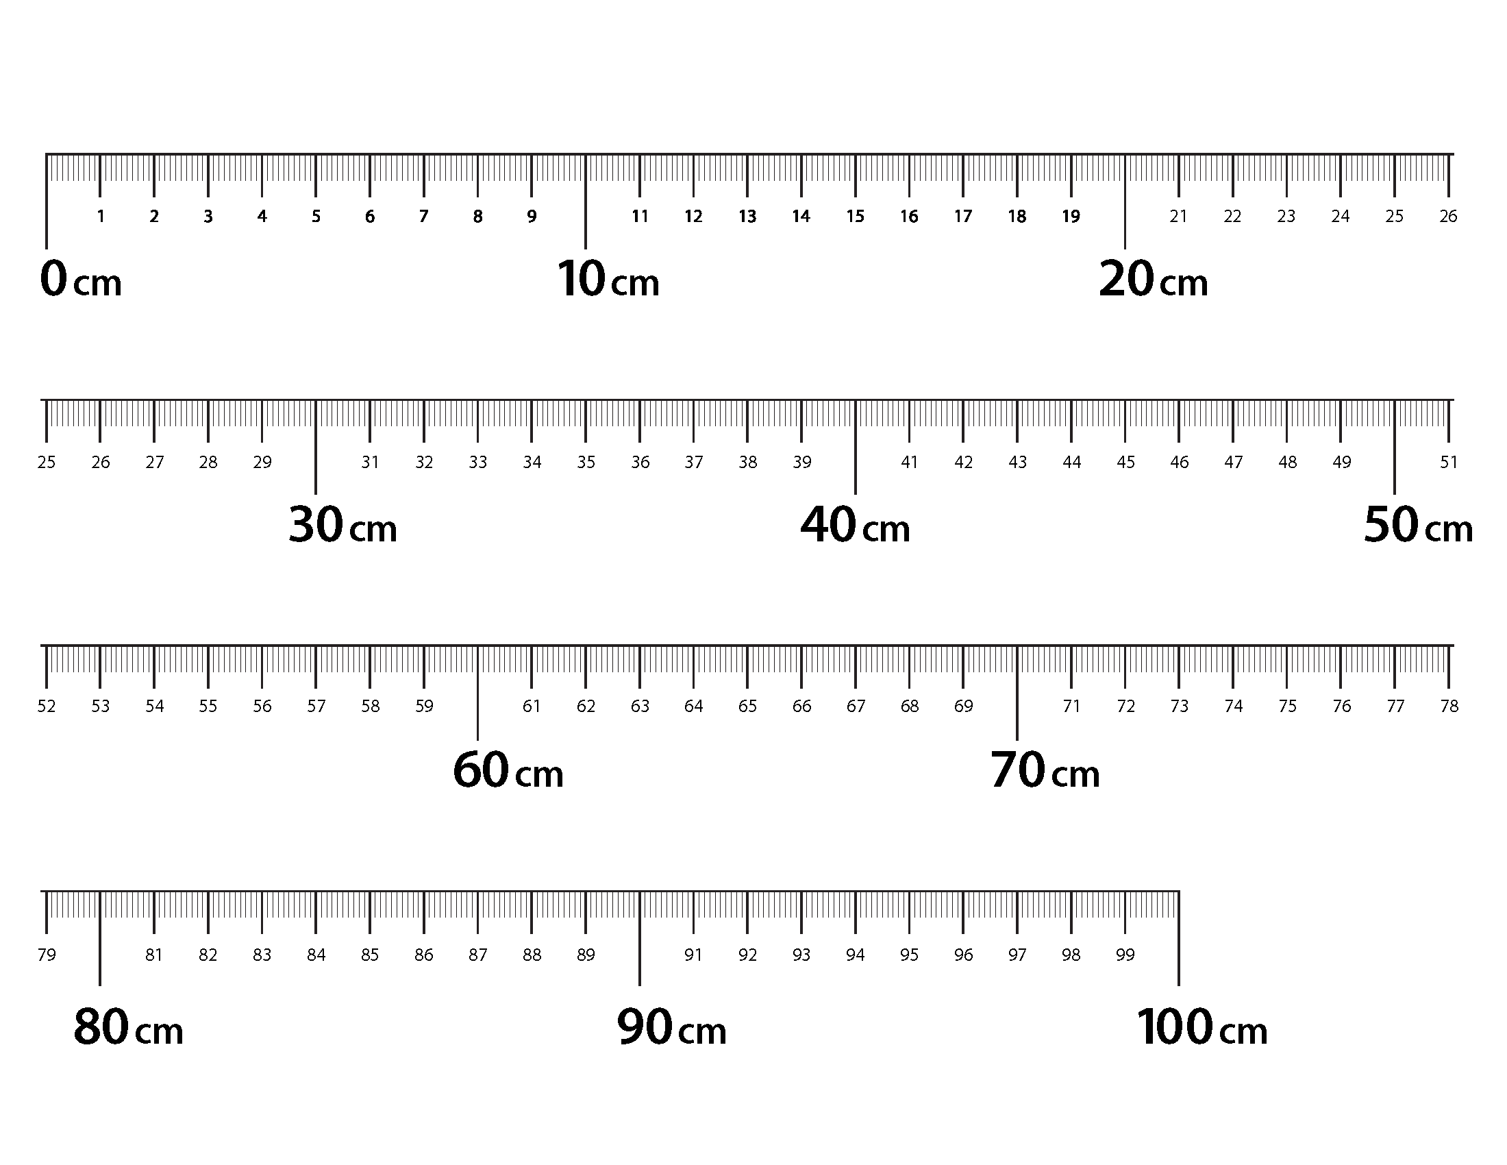
Terminology
Meter Strip
New or Recently Introduced Terms
- Benchmark (e.g., “round” numbers like multiples of 10)
- Endpoint (point where something begins or ends)
- Estimate (an approximation of a quantity or number)
- Hash mark (marks on a ruler or other measurement tool)
- Meter (standard unit of length in the metric system)
- Meter stick or strip (tool used to measure length)
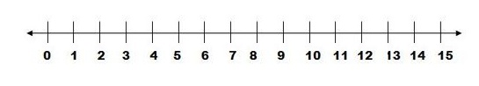
- Number line
Number Line
- Overlap (extend over, or cover partly)
- Ruler (tool used to measure length)
Familiar Terms and Symbols
- Centimeter (standard length unit within the metric system)
- Combine (join or put together)
- Compare (specifically using direct comparison)
- Difference (to find the difference between two numbers, subtract the smaller number from the greater number)
- Height (vertical distance measurement from bottom to top)
- Length (distance measurement from end to end; in a rectangular shape, length can be used to describe any of the four sides)Length unit (e.g., centimeters, inches)
Suggested Tools and Representations
- Centimeter cubes
- Centimeter rulers
- Large and small paper clips
- Meter stick
- Paper meter strips (Lesson 6 Template)
- Personal white boards
- Tape diagram

Scaffolds
The scaffolds integrated into A Story of Units give alternatives for how students access information as well as express and demonstrate their learning. Strategically placed margin notes are provided within each lesson elaborating on the use of specific scaffolds at applicable times. They address many needs presented by English language learners, students with disabilities, students performing above grade level, and students performing below grade level. Many of the suggestions are organized by Universal Design for Learning (UDL) principles and are applicable to more than one population. To read more about the approach to differentiated instruction in A Story of Units, please refer to “How to Implement A Story of Units.”
Assessment Summary
Type | Administered | Format | Standards Addressed
End-of-Module Assessment Task | After Topic D | Constructed response with rubric | 2.MD.1  2.MD.2  2.MD.3  2.MD.4  2.MD.5  2.MD.6

See the Progression Document “Geometric Measurement,” page 14.
Focus is on metric measurement in preparation for place value in Module 3. Customary measurement is addressed in Module 7.
These are terms and symbols students have used or seen previously.
Students with disabilities may require Braille, large print, audio, or special digital files. Please visit the website, www.p12.nysed.gov/specialed/aim, for specific information on how to obtain student materials that satisfy the National Instructional Materials Accessibility Standard (NIMAS) format.

