Table of Contents
GRADE 5 • MODULE 2
Multi-Digit Whole Number and Decimal Fraction Operations

Module Overview i

Topic A: Mental Strategies for Multi-Digit Whole Number Multiplication 2.A.1

Topic B: The Standard Algorithm for Multi-Digit Whole Number Multiplication 2.B.1

Topic C: Decimal Multi-Digit Multiplication 2.C.1

Topic D: Measurement Word Problems with Whole Number and Decimal
Multiplication 2.D.1

Topic E: Mental Strategies for Multi-Digit Whole Number Division 2.E.1

Topic F: Partial Quotients and Multi-Digit Whole Number Division 2.F.1

Topic G: Partial Quotients and Multi-Digit Decimal Division 2.G.1

Topic H: Measurement Word Problems with Multi-Digit Division 2.H.1

Module Assessments 2.S.1
NOTE: Student sheets should be printed at 100% scale to preserve the intended size of figures for accurate measurements. Adjust copier or printer settings to actual size and set page scaling to none.

NOTE: Student sheets should be printed at 100% scale to preserve the intended size of figures for accurate measurements. Adjust your copier or printer settings to actual size and set page scaling to none.

Grade 5 • Module 2
Multi-Digit Whole Number and Decimal Fraction Operations
OVERVIEW
In Module 1, students explored the relationships of adjacent units on the place value chart to generalize whole number algorithms to decimal fraction operations. In Module 2, students apply the patterns of the base ten system to mental strategies and the multiplication and division algorithms.
Topics A through D provide a sequential study of multiplication. To link to prior learning and set the foundation for understanding the standard multiplication algorithm, students begin at the concrete–pictorial level in Topic A. They use place value disks to model multi-digit multiplication of place value units, e.g., 42 × 10, 42 × 100, 42 × 1,000, leading to problems such as 42 × 30, 42 × 300 and 42 × 3,000 (5.NBT.1, 5.NBT.2). They then round factors in Lesson 2 and discuss the reasonableness of their products. Throughout Topic A, students evaluate and write simple expressions to record their calculations using the associative property and parentheses to record the relevant order of calculations (5.OA.1).
In Topic B, place value understanding moves toward understanding the distributive property via area models which are used to generate and record the partial products (5.OA.1, 5.OA.2) of the standard algorithm (5.NBT.5). Topic C moves students from whole numbers to multiplication with decimals, again using place value as a guide to reason and make estimations about products (5.NBT.7). In Topic D, students explore multiplication as a method for expressing equivalent measures. For example, they multiply to convert between meters and centimeters or ounces and cups with measurements in both whole number and decimal form (5.MD.1).
Topics E through H provide a similar sequence for division. Topic E begins concretely with place value disks as an introduction to division with multi-digit whole numbers (5.NBT.6).
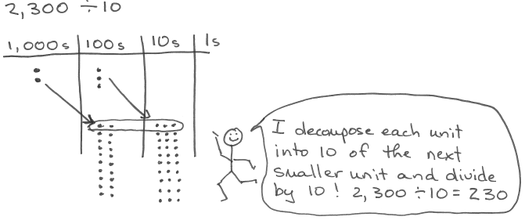
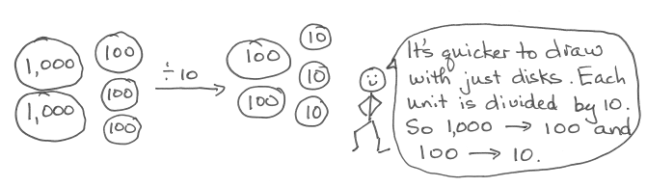

In the same lesson, 420 ÷ 60 is interpreted as 420 ÷ 10 ÷ 6. Next, students round dividends and two-digit divisors to nearby multiples of 10 in order to estimate single-digit quotients (e.g., 431 ÷ 58 ≈ 420 ÷ 60 = 7) and then multi-digit quotients. This work is done horizontally, outside the context of the written vertical method. The series of lessons in Topic F leads students to divide multi-digit dividends by two-digit divisors using the written vertical method. Each lesson moves to a new level of difficulty with a sequence beginning with divisors that are multiples of 10 to non-multiples of 10. Two instructional days are devoted to single-digit quotients with and without remainders before progressing to two- and three-digit quotients (5.NBT.6).
In Topic G, students use their understanding to divide decimals by two-digit divisors in a sequence similar to that of Topic F with whole numbers (5.NBT.7). In Topic H, students apply the work of the module to solve multi-step word problems using multi-digit division with unknowns representing either the group size or number of groups. In this topic, an emphasis on checking the reasonableness of their answers draws on skills learned throughout the module, including refining their knowledge of place value, rounding, and estimation.
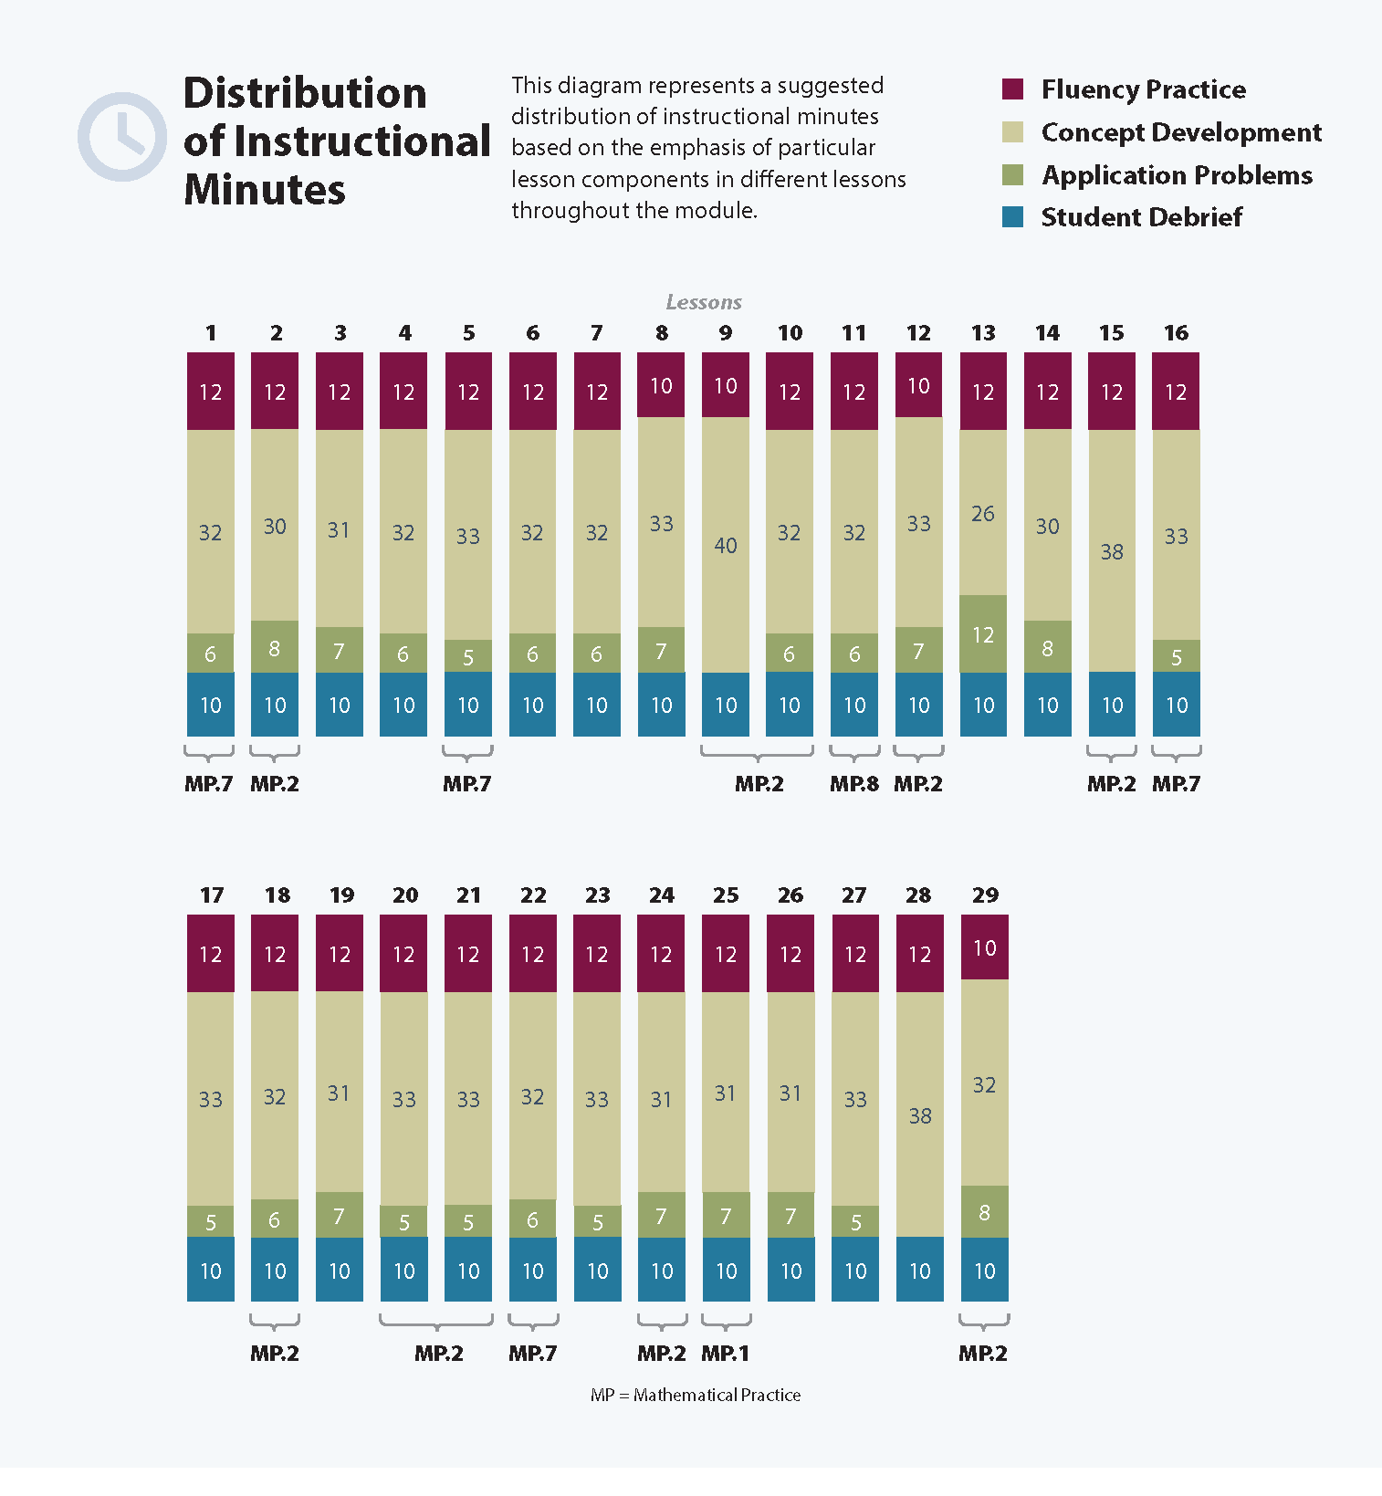
Focus Grade Level Standards
Write and interpret numerical expressions.
5.OA.1 Use parentheses, brackets, or braces in numerical expressions, and evaluate expressions with these symbols.
5.OA.2 Write simple expressions that record calculations with numbers, and interpret numerical expressions without evaluating them. For example, express the calculation “add 8 and 7, then multiply by 2” as 2 × (8 + 7). Recognize that 3 × (18932 + 921) is three times as large as 18932 + 921, without having to calculate the indicated sum or product.
Understand the place value system.
5.NBT.1 Recognize that in a multi-digit number, a digit in one place represents 10 times as much as it represents in the place to its right and 1/10 of what it represents in the place to its left.
5.NBT.2 Explain patterns in the number of zeros of the product when multiplying a number by powers of 10, and explain patterns in the placement of the decimal point when a decimal is multiplied or divided by a power of 10. Use whole-number exponents to denote power of 10.
Perform operations with multi-digit whole numbers and with decimals to hundredths.
5.NBT.5 Fluently multiply multi-digit whole numbers using the standard algorithm.
5.NBT.6 Find whole-number quotients of whole numbers with up to four-digit dividends and two-digit divisors, using strategies based on place value, the properties of operations, and/or the relationship between multiplication and division. Illustrate and explain the calculation by using equations, rectangular arrays, and/or area models.
5.NBT.7 Add, subtract, multiply, and divide decimals to hundredths, using concrete models or drawings and strategies based on place value, properties of operations, and/or the relationship between addition and subtraction; relate the strategy to a written method and explain the reasoning used.
Convert like measurement units within a given measurement system.
5.MD.1 Convert among different-sized standard measurement units within a given measurement system (e.g., convert 5 cm to 0.05 m), and use these conversions in solving multi-step, real world problems.
Foundational Standards
4.OA.1 Interpret a multiplication equation as a comparison, e.g., interpret 35 = 5 × 7 as a statement that 35 is 5 times as many as 7 and 7 times as many as 5. Represent verbal statements of multiplicative comparisons as multiplication equations.
4.OA.3 Solve multistep word problems posed with whole numbers and having whole-number answers using the four operations, including problems in which remainders must be interpreted. Represent these problems using equations with a letter standing for the unknown quantity. Assess the reasonableness of answers using mental computation and estimation strategies including rounding.
4.NBT.4 Fluently add and subtract multi-digit whole numbers using the standard algorithm.
4.NBT.5 Multiply a whole number of up to four digits by a one-digit whole number, and multiply two two-digit numbers, using strategies based on place value and the properties of operations. Illustrate and explain the calculation by using equations, rectangular arrays, and/or area models.
4.NBT.6 Find whole-number quotients and remainders with up to four-digit dividends and one-digit divisors, using strategies based on place value, the properties of operations, and/or the relationship between multiplication and division. Illustrate and explain the calculation by using equations, rectangular arrays, and/or area models.
Focus Standards for Mathematical Practice
MP.1 Make sense of problems and persevere in solving them. Students make sense of problems when they use place value disks and area models to conceptualize and solve multiplication and division problems.
MP.2 Reason abstractly and quantitatively. Students make sense of quantities and their relationships when they use both mental strategies and the standard algorithms to multiply and divide multi-digit whole numbers. Student also “decontextualize” when they represent problems symbolically and “contextualize” when they consider the value of the units used and understand the meaning of the quantities as they compute.
MP.7 Look for, and make use of, structure. Students apply the times 10, 100, 1,000 and the divide by 10 patterns of the base ten system to mental strategies and the multiplication and division algorithms as they multiply and divide whole numbers and decimals
MP.8 Look for, and express, regularity in repeated reasoning. Students express the regularity they notice in repeated reasoning when they apply the partial quotients algorithm to divide two-, three-, and four-digit dividends by two-digit divisors. Students also check the reasonableness of the intermediate results of their division algorithms as they solve multi-digit division word problems.
Overview of Module Topics and Lesson Objectives
Standards | Topics and Objectives |  | Days
5.NBT.1  5.NBT.2  5.OA.1 | A | Mental Strategies for Multi-Digit Whole Number Multiplication  Lesson 1: Multiply multi-digit whole numbers and multiples of 10 using place value patterns and the distributive and associative properties.  Lesson 2: Estimate multi-digit products by rounding factors to a basic fact and using place value patterns. | 2
5.OA.1  5.OA.2  5.NBT.5 | B | The Standard Algorithm for Multi-Digit Whole Number Multiplication  Lesson 3: Write and interpret numerical expressions and compare expressions using a visual model.  Lesson 4: Convert numerical expressions into unit form as a mental strategy for multi-digit multiplication.  Lesson 5: Connect visual models and the distributive property to partial products of the standard algorithm without renaming.  Lessons 6–7: Connect area models and the distributive property to partial products of the standard algorithm with renaming.  Lesson 8: Fluently multiply multi-digit whole numbers using the standard algorithm and using estimation to check for reasonableness of the product.  Lesson 9: Fluently multiply multi-digit whole numbers using the standard algorithm to solve multi-step word problems. | 7
5.NBT.7  5.OA.1  5.OA.2  5.NBT.1 | C | Decimal Multi-Digit Multiplication  Lesson 10: Multiply decimal fractions with tenths by multi-digit whole numbers using place value understanding to record partial products.  Lesson 11: Multiply decimal fractions by multi-digit whole numbers through conversion to a whole number problem and reasoning about the placement of the decimal.  Lesson 12: Reason about the product of a whole number and a decimal with hundredths using place value understanding and estimation. | 3

5.NBT.5  5.NBT.7  5.MD.1  5.NBT.1  5.NBT.2 | D | Measurement Word Problems with Whole Number and Decimal Multiplication  Lesson 13: Use whole number multiplication to express equivalent measurements.  Lesson 14: Use fraction and decimal multiplication to express equivalent measurements.  Lesson 15: Solve two-step word problems involving measurement conversions. | 3
 |  | Mid-Module Assessment: Topics A–D (assessment ½day, return ½ day, remediation or further applications 2 days) | 3
5.NBT.1  5.NBT.2  5.NBT.6 | E | Mental Strategies for Multi-Digit Whole Number Division  Lesson 16: Use divide by 10 patterns for multi-digit whole number division.  Lessons 17–18: Use basic facts to approximate quotients with two-digit divisors. | 3
5.NBT.6 | F | Partial Quotients and Multi-Digit Whole Number Division  Lesson 19: Divide two- and three-digit dividends by multiples of 10 with single-digit quotients and make connections to a written method.  Lessons 20–21: Divide two- and three-digit dividends by two-digit divisors with single-digit quotients and make connections to a written method.  Lessons 22–23: Divide three- and four-digit dividends by two-digit divisors resulting in two- and three-digit quotients, reasoning about the decomposition of successive remainders in each place value. | 5
5.NBT.2  5.NBT.7 | G | Partial Quotients and Multi-Digit Decimal Division  Lesson 24: Divide decimal dividends by multiples of 10, reasoning about the placement of the decimal point and making connections to a written method.  Lesson 25: Use basic facts to approximate decimal quotients with two-digit divisors, reasoning about the placement of the decimal point.  Lessons 26–27: Divide decimal dividends by two-digit divisors, estimating quotients, reasoning about the placement of the decimal point, and making connections to a written method. | 4
5.NBT.6  5.NBT.7 | H | Measurement Word Problems with Multi-Digit Division  Lessons 28–29: Solve division word problems involving multi-digit division with group size unknown and the number of groups unknown. | 2
 |  | End-of-Module Assessment: Topics A–H (assessment ½ day, return ½ day, remediation or further application 2 days) | 3
Total Number of Instructional Days |  |  | 35
Terminology
New or Recently Introduced Terms
- Conversion factor (the factor in a multiplication sentence that renames one measurement unit as another equivalent unit, e.g., 14 x (1 in) = 14 x ($\frac{1}{12}$ ft); 1 in and $\frac{1}{12}$ ft are the conversion factors.)
- Decimal Fraction (a proper fraction whose denominator is a power of 10)
- Multiplier (a quantity by which a given number—a multiplicand—is to be multiplied)
- Parentheses (the symbols used to relate order of operations)
Familiar Terms and Symbols
- Decimal (a fraction whose denominator is a power of ten and whose numerator is expressed by figures placed to the right of a decimal point)
- Digit (a symbol used to make numbers: 0, 1, 2, 3, 4, 5, 6, 7, 8, 9)
- Divisor (the number by which another number is divided)
- Equation (a statement that the values of two mathematical expressions are equal)
- Equivalence (a state of being equal or equivalent)
- Equivalent measures (e.g., 12 inches = 1 foot; 16 ounces = 1 pound)
- Estimate (approximation of the value of a quantity or number)
- Exponent (the number of times a number is to be used as a factor in a multiplication expression)
- Multiple (a number that can be divided by another number without a remainder like 15, 20, or any multiple of 5)
- Pattern (a systematically consistent and recurring trait within a sequence)
- Product (the result of multiplying numbers together)
- Quotient (the answer of dividing one quantity by another)
- Remainder (the number left over when one integer is divided by another)
- Renaming (decomposing or composing a number or units within a number)
- Rounding (approximating the value of a given number)
- Unit Form (place value counting, e.g., 34 stated as 3 tens 4 ones)

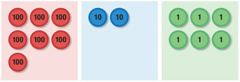Suggested Tools and Representations
10
8
2
Number bond
Unit form modeled with place value disks:
7 hundreds 2 tens 6 ones = 72 tens 6 ones = 726 ones
- Area models (e.g., an array)
- Number bond
- Place value disks

- Partial product (an algorithmic method that takes base ten decompositions of factors, makes products of all pairs, and adds all products together)
- Partial quotient (an algorithmic method using successive approximation)
Scaffolds
The scaffolds integrated into A Story of Units give alternatives for how students access information as well as express and demonstrate their learning. Strategically placed margin notes are provided within each lesson, elaborating on the use of specific scaffolds at applicable times. They address many needs presented by English language learners, students with disabilities, students performing above grade level, and students performing below grade level. Many of the suggestions are organized by Universal Design for Learning (UDL) principles and are applicable to more than one population. To read more about the approach to differentiated instruction in A Story of Units, please refer to “How to Implement A Story of Units.”

Assessment Summary
Type | Administered | Format | Standards Addressed
Mid-Module Assessment Task | After Topic D | Constructed response with rubric | 5.OA.1  5.OA.2  5.NBT.1  5.NBT.2  5.NBT.5  5.NBT.7  5.MD.1
End-of-Module Assessment Task | After Topic H | Constructed response with rubric | 5.OA.1  5.OA.2  5.NBT.1  5.NBT.2  5.NBT.5  5.NBT.6  5.NBT.7  5.MD.1

The balance of this cluster is addressed in Module 1.
Focus on decimal multiplication of a single-digit whole number factor times a multi-digit number with up to two decimal places (e.g., 3 × 64.98). Restrict decimal division to a single digit whole number divisor with a multi-digit dividend with up to two decimal places (e.g., 64.98 ÷ 3). The balance of the standard is taught in Module 4.
These are terms and symbols students have used or seen previously.
Students with disabilities may require Braille, large print, audio, or special digital files. Please visit the website, www.p12.nysed.gov/specialed/aim, for specific information on how to obtain student materials that satisfy the National Instructional Materials Accessibility Standard (NIMAS) format.

