Table of Contents
GRADE 1 • MODULE 6
Place Value, Comparison, Addition and Subtraction to 100

Module Overview i

Topic A: Comparison Word Problems 6.A.1

Topic B: Numbers to 120 6.B.1

Topic C: Addition to 100 Using Place Value Understanding 6.C.1

Topic D: Varied Place Value Strategies for Addition to 100 6.D.1

Topic E: Coins and Their Values 6.E.1

Topic F: Varied Problem Types Within 20 6.F.1

Topic G: Culminating Experiences 6.G.1

Module Assessments 6.S.1

Grade 1 • Module 6
Place Value, Comparison, Addition and Subtraction of Numbers to 100

OVERVIEW
In this final module of the Grade 1 curriculum, students bring together their learning from Module 1 through Module 5 to learn the most challenging Grade 1 standards and celebrate their progress.
In Topic A, students grapple with comparative word problem types (1.OA.1). While students have solved some comparative problem types during Module 3 and within the Application Problems in Module 5, this will be their first opportunity to name these types of problems and learn to represent comparisons using tape diagrams with two tapes.
Students extend their understanding of and skill with tens and ones to numbers to 100 in Topic B (1.NBT.2). For example, they mentally find 10 more, 10 less, 1 more, and 1 less (1.NBT.5) and compare numbers using the symbols >, =, and < (1.NBT.3). They then count and write numbers to 120 (1.NBT.1) using both standard numerals and the unit form.
In Topics C and D, students again extend their learning from Module 4 to the numbers to 100 to add and subtract (1.NBT.4, 1.NBT.6). They add pairs of two-digit numbers in which the ones digits sometimes have a sum greater than 10, recording their work using various methods based on place value (1.NBT.4). In Topic D, students focus on using drawings, numbers, and words to solve, highlighting the role of place value, the properties of addition, and related facts.
At the start of the second half of Module 6, students are introduced to nickels and quarters (1.MD.3), having already used pennies and dimes in the context of their work with numbers to 40 in Module 4. Students use their knowledge of tens and ones to explore decompositions of the values of coins. For example, they might represent 25 cents using 1 quarter, 25 pennies, 2 dimes and 1 nickel, or 1 dime and 15 pennies.
In Topic F, students really dig into MP.1 and MP.3. The topic includes the more challenging compare with bigger or smaller unknown word problem types wherein more or less suggest the incorrect operation (1.OA.1), thus giving a context for more in-depth discussions and critiques. On the final day of this topic, students work with varied problem types, sharing and explaining their strategies and reasoning. Peers ask each other questions and defend their choices. The End-of-Module Assessment follows Topic F.
The module and year close with Topic G, wherein students celebrate their year’s worth of learning with fun fluency festivities that equip them with games to maintain their fluency during the summer months prior to Grade 2. The final day is devoted to creating a math folder illustrating their learning in which to send home their year’s work.

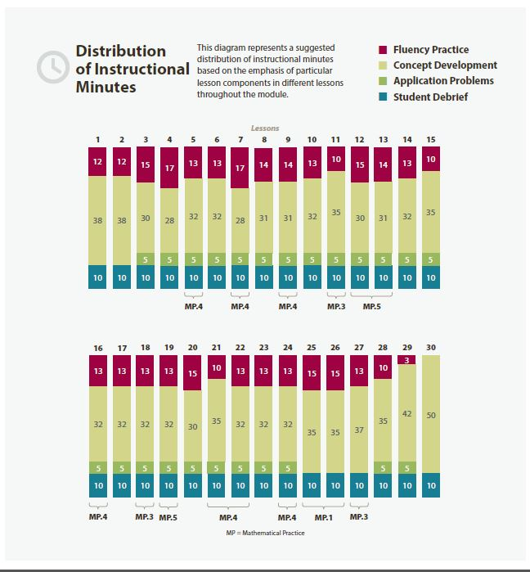
Focus Grade Level Standards
Represent and solve problems involving addition and subtraction.
1.OA.1 Use addition and subtraction within 20 to solve word problems involving situations of adding to, taking from, putting together, taking apart, and comparing, with unknowns in all positions, e.g., by using objects, drawings, and equations with a symbol for the unknown number to represent the problem. (See CCLS Glossary, Table 1.)
Extend the counting sequence.
1.NBT.1 Count to 120, starting at any number less than 120. In this range, read and write numerals and represent a number of objects with a written numeral.
Understand place value.
1.NBT.2 Understand that the two digits of a two-digit number represent amounts of tens and ones. Understand the following special cases:
a. 10 can be thought of as a bundle of ten ones—called a “ten.”
c. The numbers 10, 20, 30, 40, 50, 60, 70, 80, 90 refer to one, two, three, four, five, six, seven, eight, or nine tens (and 0 ones).
1.NBT.3 Compare two two-digit numbers based on meanings of the tens and ones digits, recording the results of comparisons with the symbols >, =, and <.
Use place value understanding and properties of operations to add and subtract.
1.NBT.4 Add within 100, including adding a two-digit number and a one-digit number, and adding a two-digit number and a multiple of 10, using concrete models or drawings and strategies based on place value, properties of operations, and/or the relationship between addition and subtraction; relate the strategy to a written method and explain the reasoning used. Understand that in adding two-digit numbers, one adds tens and tens, ones and ones; and sometimes it is necessary to compose a ten.
1.NBT.5 Given a two-digit number, mentally find 10 more or 10 less than the number, without having to count; explain the reasoning used.
1.NBT.6 Subtract multiples of 10 in the range 10–90 from multiples of 10 in the range 10–90 (positive or zero differences), using concrete models or drawings and strategies based on place value, properties of operations, and/or the relationship between addition and subtraction; relate the strategy to a written method and explain the reasoning used.
Tell and write time and money.
1.MD.3 Tell and write time in hours and half-hours using analog and digital clocks. Recognize and identify coins, their names, and their values.
Foundational Standards
K.OA.2 Solve addition and subtraction word problems, and add and subtract within 10, e.g., by using objects or drawings to represent the problem.
K.OA.3 Decompose numbers less than or equal to 10 into pairs in more than one way, e.g., by using objects or drawings, and record each decomposition by a drawing or equation (e.g., 5 = 2 + 3 and 5 = 4 + 1).
K.OA.4 For any number from 1 to 9, find the number that makes 10 when added to the given number, e.g., by using objects or drawings, and record the answer with a drawing or equation.
K.NBT.1 Compose and decompose numbers from 11 to 19 into ten ones and some further ones, e.g., by using objects or drawings, and record each composition or decomposition by a drawing or equation (e.g., 18 = 10 + 8); understand that these numbers are composed of ten ones and one, two, three, four, five, six, seven, eight, or nine ones.
Focus Standards for Mathematical Practice
MP.1 Make sense of problems and persevere in solving them. Throughout Topic A, students analyze given situations and determine whether they are compare, take away, or put together problem types. Students’ drawings, such as single and double tape diagrams, represent their planning towards a solution pathway. During Topic F, students initially work independently, supporting them in learning how to persevere and make sense of problems. As students share their strategies and solutions asking and answering peer questions, they demonstrate understanding of the approaches of their peers and identify corresponding elements between the approaches.
MP.3 Construct viable arguments and critique the reasoning of others. During Topic F, students share their strategies and reasoning as they explain their solutions to various problem types. They ask useful questions to help clarify or improve peers’ explanations, such as, “How does your drawing help demonstrate your thinking?” Students consider how a selected student’s work helped her solve the problem as well considering other pathways for at student to correctly solve the problem. As students share their thinking, they explain the mathematical reasoning that supports their argument.
MP.4 Model with mathematics. Throughout this module, students model their mathematics in various ways. While problem solving, students use tape diagrams and number sentences to model situations and solutions. When sharing various strategies for adding within 100, students use number bonds, number sentences, and sometimes drawings to solve for the sums and to demonstrate their understanding and use of place value, properties of addition, and the relationship between addition and subtraction as they decompose and recompose numbers.
MP.5 Use appropriate tools strategically. After learning varied representations and strategies for adding and subtracting pairs of two-digit numbers, students choose their preferred methods for representing and solving problems efficiently. As they share their strategies, students explain their choice of making ten, adding tens and then ones, or adding ones and then tens. They also demonstrate how their choice of written method (number bonds, vertical alignment, or arrow notation) expresses their strategy work.

Overview of Module Topics and Lesson Objectives
Standards | Topics and Objectives |  | Days
1.OA.1 | A | Comparison Word Problems  Lesson 1: Solve compare with difference unknown problem types.  Lesson 2: Solve compare with bigger or smaller unknown problem types. | 2
1.NBT.1  1.NBT.2a  1.NBT.2c  1.NBT.3  1.NBT.5 | B | Numbers to 120  Lesson 3: Use the place value chart to record and name tens and ones within a two-digit number up to 100.  Lesson 4: Write and interpret two-digit numbers to 100 as addition sentences that combine tens and ones.  Lesson 5: Identify 10 more, 10 less, 1 more, and 1 less than a two-digit number within 100.  Lesson 6: Use the symbols >, =, and < to compare quantities and numerals to 100.  Lesson 7: Count and write numbers to 120. Use Hide Zero cards to relate numbers 0 to 20 to 100 to 120.  Lesson 8: Count to 120 in unit form using only tens and ones. Represent numbers to 120 as tens and ones on the place value chart.  Lesson 9: Represent up to 120 objects with a written numeral. | 7
1.NBT.4  1.NBT.6 | C | Addition to 100 Using Place Value Understanding  Lesson 10: Add and subtract multiples of 10 from multiples of 10 to 100, including dimes.  Lesson 11: Add a multiple of 10 to any two-digit number within 100.  Lesson 12: Add a pair of two-digit numbers when the ones digits have a sum less than or equal to 10.  Lessons 13–14: Add a pair of two-digit numbers when the ones digits have a sum greater than 10 using decomposition.  Lesson 15: Add a pair of two-digit numbers when the ones digits have a sum greater than 10 with drawing. Record the total below.  Lessons 16–17: Add a pair of two-digit numbers when the ones digits have a sum greater than 10 with drawing. Record the new ten below. | 8
1.NBT.4 | D | Varied Place Value Strategies for Addition to 100  Lesson 18: Add a pair of two-digit numbers with varied sums in the ones, and compare results of different recording methods.  Lesson 19: Solve and share strategies for adding two-digit numbers with varied sums. | 2
 |  | Mid-Module Assessment: Topics A–D (assessment 1 day, return 1 day, remediation or further applications 1 day) | 3
1.MD.3 | E | Coins and Their Values  Lesson 20: Identify pennies, nickels, and dimes by their image, name, or value. Decompose the values of nickels and dimes using pennies and nickels.  Lesson 21: Identify quarters by their image, name, or value. Decompose the value of a quarter using pennies, nickels, and dimes.  Lesson 22: Identify varied coins by their image, name, or value. Add one cent to the value of any coin.  Lesson 23: Count on using pennies from any single coin.  Lesson 24: Use dimes and pennies as representations of numbers to 120. | 5
1.OA.1 | F | Varied Problem Types Within 20  Lessons 25–26: Solve compare with bigger or small unknown problem types.  Lesson 27: Share and critique peer strategies for solving problems of varied types. | 3
 |  | End-of-Module Assessment: Topics E–F (assessment 1 day, return ½ day, remediation or further applications ½ day) | 2
 | G | Culminating Experiences  Lessons 28–29: Celebrate progress in fluency with adding and subtracting within 10 (and 20). Organize engaging summer practice.  Lessons 30: Create folder covers for work to be taken home illustrating the year’s learning. | 3
Total Number of Instructional Days |  |  | 35

Terminology
New or Recently Introduced Terms
- Comparison problem type
- Dime
- Nickel
- Penny
- Quarter
Familiar Terms and Symbols
- <, >, = (less than, greater than, equal to)
Suggested Tools and Representations
- 100-bead Rekenrek
- Tape diagram
Scaffolds
The scaffolds integrated into A Story of Units give alternatives for how students access information as well as express and demonstrate their learning. Strategically placed margin notes are provided within each lesson elaborating on the use of specific scaffolds at applicable times. They address many needs presented by English language learners, students with disabilities, students performing above grade level, and students performing below grade level. Many of the suggestions are organized by Universal Design for Learning (UDL) principles and are applicable to more than one population. To read more about the approach to differentiated instruction in A Story of Units, please refer to “How to Implement A Story of Units.”

Assessment Summary
Type | Administered | Format | Standards Addressed
Mid-Module Assessment Task | After Topic D | Constructed response with rubric | 1.OA.1  1.NBT.1  1.NBT.2a  1.NBT.2c  1.NBT.3  1.NBT.4  1.NBT.5  1.NBT.6
End-of-Module Assessment Task | After Topic F | Constructed response with rubric | 1.OA.1  1.NBT.1  1.NBT.2a  1.NBT.2c  1.NBT.3  1.NBT.4  1.NBT.5  1.NBT.6  1.MD.3

Focus on money.
These are terms and symbols students have seen previously.
Students with disabilities may require Braille, large print, audio, or special digital files. Please visit the website, www.p12.nysed.gov/specialed/aim, for specific information on how to obtain student materials that satisfy the National Instructional Materials Accessibility Standard (NIMAS) format.
Focus on money.

