Name Date
- Use the RDW process to solve the following problems. Write the statement on the line.
- Tamra has 12 coins. Willie has 8 coins. How many more coins does Tamra have than Willie?

______________________________________________.
- 16 coins are on the table. 11 of them are pennies and the rest are dimes. How many dimes are there?

______________________________________________.

- Peter has 6 fewer coins than Nikil. Nikil has 9 coins. How many coins does Peter have?

______________________________________________.

- Fill in the missing numbers in each sequence:
- 115, 116, _____, _____, _____, 120 b. _____, 101, _____, 99, _____

- Use the word bank to write the number and value of each coin.
Coin Values
1 cent 5 cents
10 cents 25 cents

Coin Names
nickel dime
quarter penny

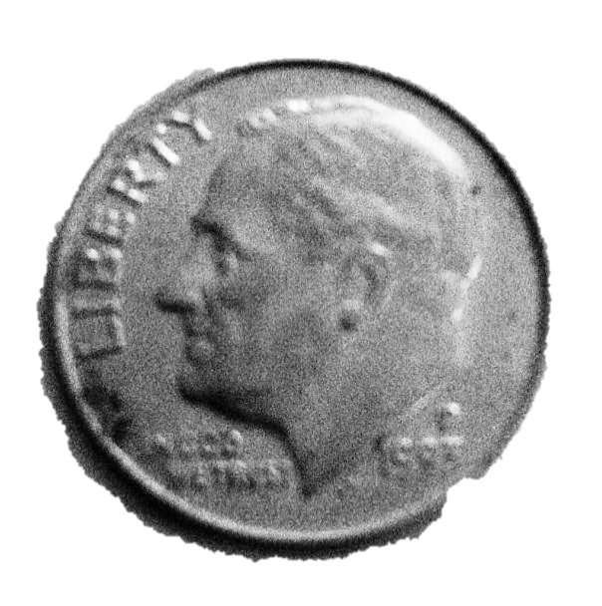
_______________________
_______________________
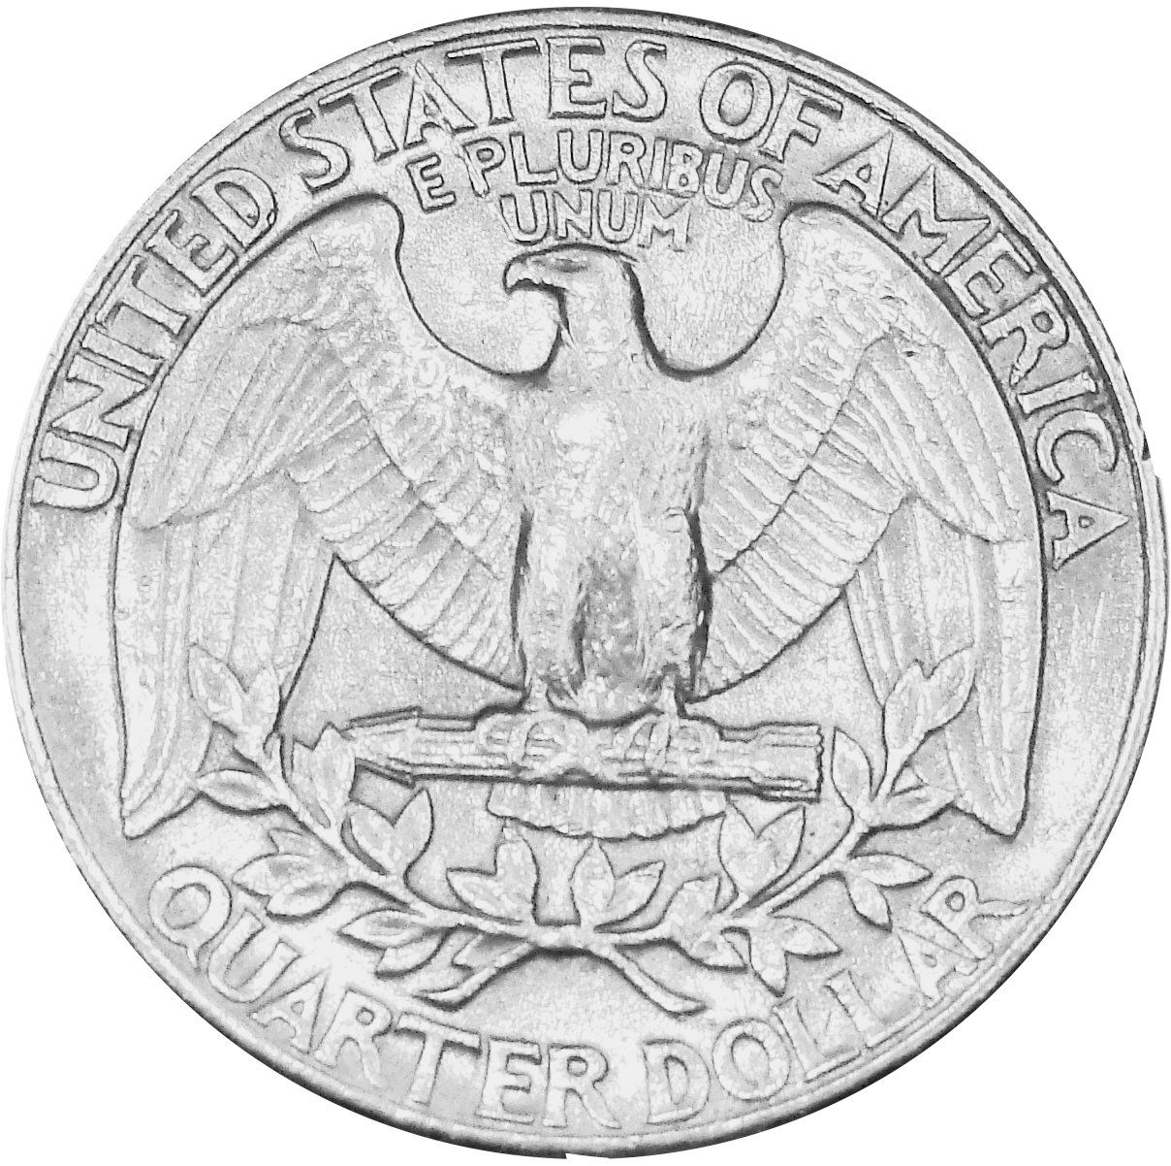
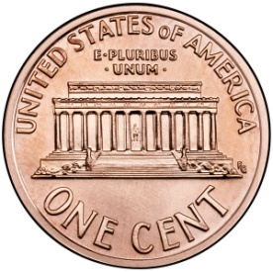
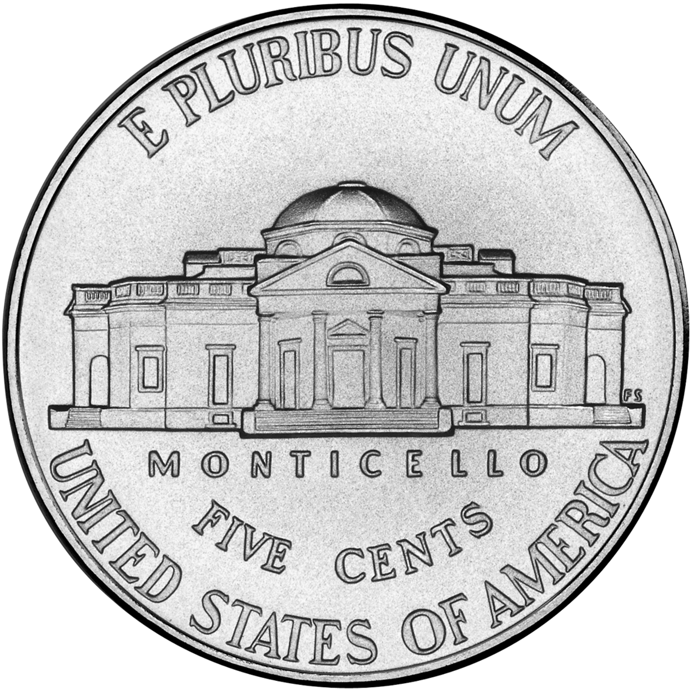
4. Mark says that 87 is the same as 7 tens 17 ones. Suki says that 87 is the same as 8
_______________________
_______________________
_______________________
_______________________
_______________________
_______________________
tens 7 ones. Are they correct? Explain your thinking.

5. Use <, =, or > to compare the pairs of numbers.
b. 69 75
a. 6 tens 42 ones
30 3

d. 8 tens 14 ones 7 tens 4 ones
c. 75 6 tens 15 ones

6. Find the mystery numbers. Explain how you know the answers.
b.
a.
10 less than 89 is ________
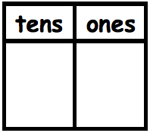

1 less than 89 is ________
10 more than 89 is _______

1 more than 89 is _______
8
9
8
9
8
9
8
9
d.
c.
- Solve for each unknown number. Use the space provided to draw quick tens, a number bond, or the arrow way to show your work. You may use your kit of ten-sticks if needed.

a. 90 + 3 = ____ | b. 50 + 40 = ____ |  | c. 80 - 30 = ____
d. 100 - ____ = 40 | e. 78 + 6 = ____ |  | f. 47 + 40 = ____
g. 65 + 34 = ____ | h. 75 + 25 = ____ |  | i. 47 + 36 = ____
End-of-Module Assessment Task  Standards Addressed |  | Topics A–G
Represent and solve problems involving addition and subtraction.
1.OA.1 Use addition and subtraction within 20 to solve word problems involving situations of adding to, taking from, putting together, taking apart, and comparing, with unknowns in all positions, e.g., by using objects, drawings, and equations with a symbol for the unknown number to represent the problem. (See CCLS Glossary, Table 1.)
Extend the counting sequence.
1.NBT.1 Count to 120, starting at any number less than 120. In this range, read and write numerals and represent a number of objects with a written numeral.
Understand place value.
1.NBT.2 Understand that the two digits of a two-digit number represent amounts of tens and ones. Understand the following special cases:
a. 10 can be thought of as a bundle of ten ones—called a “ten.”
c. The numbers 10, 20, 30, 40, 50, 60, 70, 80, 90 refer to one, two, three, four, five, six, seven, eight, or nine tens (and 0 ones).
1.NBT.3 Compare two-digit numbers based on meaning of the tens and ones digits, recording the results of comparisons with the symbols >, =, and <.
Use place value understanding and properties of operations to add and subtract.
1.NBT.4 Add within 100, including adding a two-digit number and a one-digit number, and adding a two-digit number and a multiple of 10, using concrete models or drawings and strategies based on place value, properties of operations, and/or the relationship between addition and subtraction; relate the strategy to a written method and explain the reasoning used. Understand that in adding two-digit numbers, one adds tens and tens, ones and ones; and sometimes it is necessary to compose a ten.
1.NBT.5 Given a two-digit number, mentally find 10 more or 10 less than the number, without having to count; explain the reasoning used.
1.NBT.6 Subtract multiples of 10 in the range 10–90 from multiples of 10 in the range 10–90 (positive or zero differences), using concrete modules or drawings and strategies based on place value, properties of operations, and/or relationship between addition and subtraction; relate the strategy to a written method and explain the reasoning used.
Tell and write time and money.
1.MD.3 Tell and write time in hours and half-hours using analog and digital clocks. Recognize and identify coins, their names, and their value.

Evaluating Student Learning Outcomes
A Progression Toward Mastery is provided to describe steps that illuminate the gradually increasing understandings that students develop on their way to proficiency. In this chart, this progress is presented from left (Step 1) to right (Step 4). The learning goal for each student is to achieve Step 4 mastery. These steps are meant to help teachers and students identify and celebrate what the student CAN do now, and what they need to work on next.

A Progression Toward Mastery
Assessment  Task Item | STEP 1  Little evidence of reasoning without a correct answer.  (1 Point) | STEP 2  Evidence of some reasoning without a correct answer.  (2 Points) | STEP 3  Evidence of some reasoning with a correct answer or evidence of solid reasoning with an incorrect answer.  (3 Points) | STEP 4  Evidence of solid reasoning with a correct answer.  (4 Points)
1  1.OA.1 | The student’s answers are incorrect, and there is no evidence of reasoning. | The student’s answers are incorrect, but there is evidence of reasoning. For example, the student is able to write a number sentence. | The student’s answers are correct, but the responses are incomplete (e.g., may be missing labels for the drawing, an addition sentence, or an explanation). The student’s work is essentially strong. | The student correctly:  - Solves each word problem.  - Tamra has 4 more coins than Willie.  - There are 5 dimes on the table.  - Peter has 3 coins.  - Demonstrates understanding of the problem situation through drawing/model.
2  1.NBT.1 | The student is unable to complete any sequence of numbers. | The student completes at least part of one sequence. | The student completes at least one sequence as well as at least one number in the additional sequence. | The student identifies all numbers in the sequences:  - 115, 116, 117, 118, 119, 120  - 102, 101, 100, 99, 98
3  1.MD.3 | The student is unable to match more than two coins with EITHER the proper name OR the proper value. | The student accurately matches at least three elements within the set, but mixes the value OR the names for more than one pair of coins. | The student accurately matches one set of coin information with another set, but mixes either the value OR the name of one pair of coins. | The student correctly matches image, name, and value of each coin:  - Dime, 10 cents  - Penny, 1 cent  - Nickel, 5 cents  - Quarter, 25 cents
4  1.NBT.2 | The student demonstrates little to no understanding of comparing numbers based on tens and ones, answering incorrectly. There is no evidence of reasoning. | The student uses drawings or words to accurately depict at least one of the two numbers, demonstrating limited understanding of the use of place value to compare numbers. | The student demonstrates some understanding of using place value to compare numbers and correctly identifies the greater number, but does not fully explain reasoning using place value.  OR  The student answers incorrectly due to error such as transcription, but demonstrates strong understanding of place value through drawing or words. | The student correctly uses drawings or words that depict place value to accurately explain that 87 is the same as both 7 tens 17 ones and 8 tens 7 ones.
5  1.NBT.2  1.NBT.3 | The student is unable to use symbols to compare numbers and is unable to correctly answer any of the four comparisons. | The student has limited ability to use symbols to compare numbers, correctly answering one of the four comparisons. | The student has some ability to use symbols to compare numbers, correctly answering two or three of the four comparisons. | The student answers:  - >  - <  - =  - >
6  1.NBT.5 | The student demonstrates little or no understanding of mentally adding or subtracting 10. Answers are incorrect and there is no evidence of reasoning. | The student demonstrates limited understanding of mentally adding or subtracting 10, identifying at least two correct mystery numbers, but does not complete any charts accurately. | The student demonstrates the ability to mentally add or subtract 10, correctly identifying four mystery numbers, but reasoning is unclear because no charts have been completed accurately.  OR  The student accurately completes charts, but makes an error in mental calculation on one or two of (a), (b), (c), or (d.) | The student identifies 99, 90, 79, and 88, and accurately completes the charts to depict the arrow way.
7  1.NBT.4  1.NBT.6 | The student answers two or fewer questions correctly. | The student answers at least three of nine correctly, and demonstrates misunderstandings of place value. | The student answers at least six of nine correctly, or uses sound process throughout with calculation errors. | The student correctly:  - Solves  - 93  - 90  - 50  - 60  - 84  - 87  - 99  - 100  - 83  - Represents process to accurately solve through drawings, number bonds, or the arrow way. The notation demonstrates use of a sound strategy for adding or subtracting.

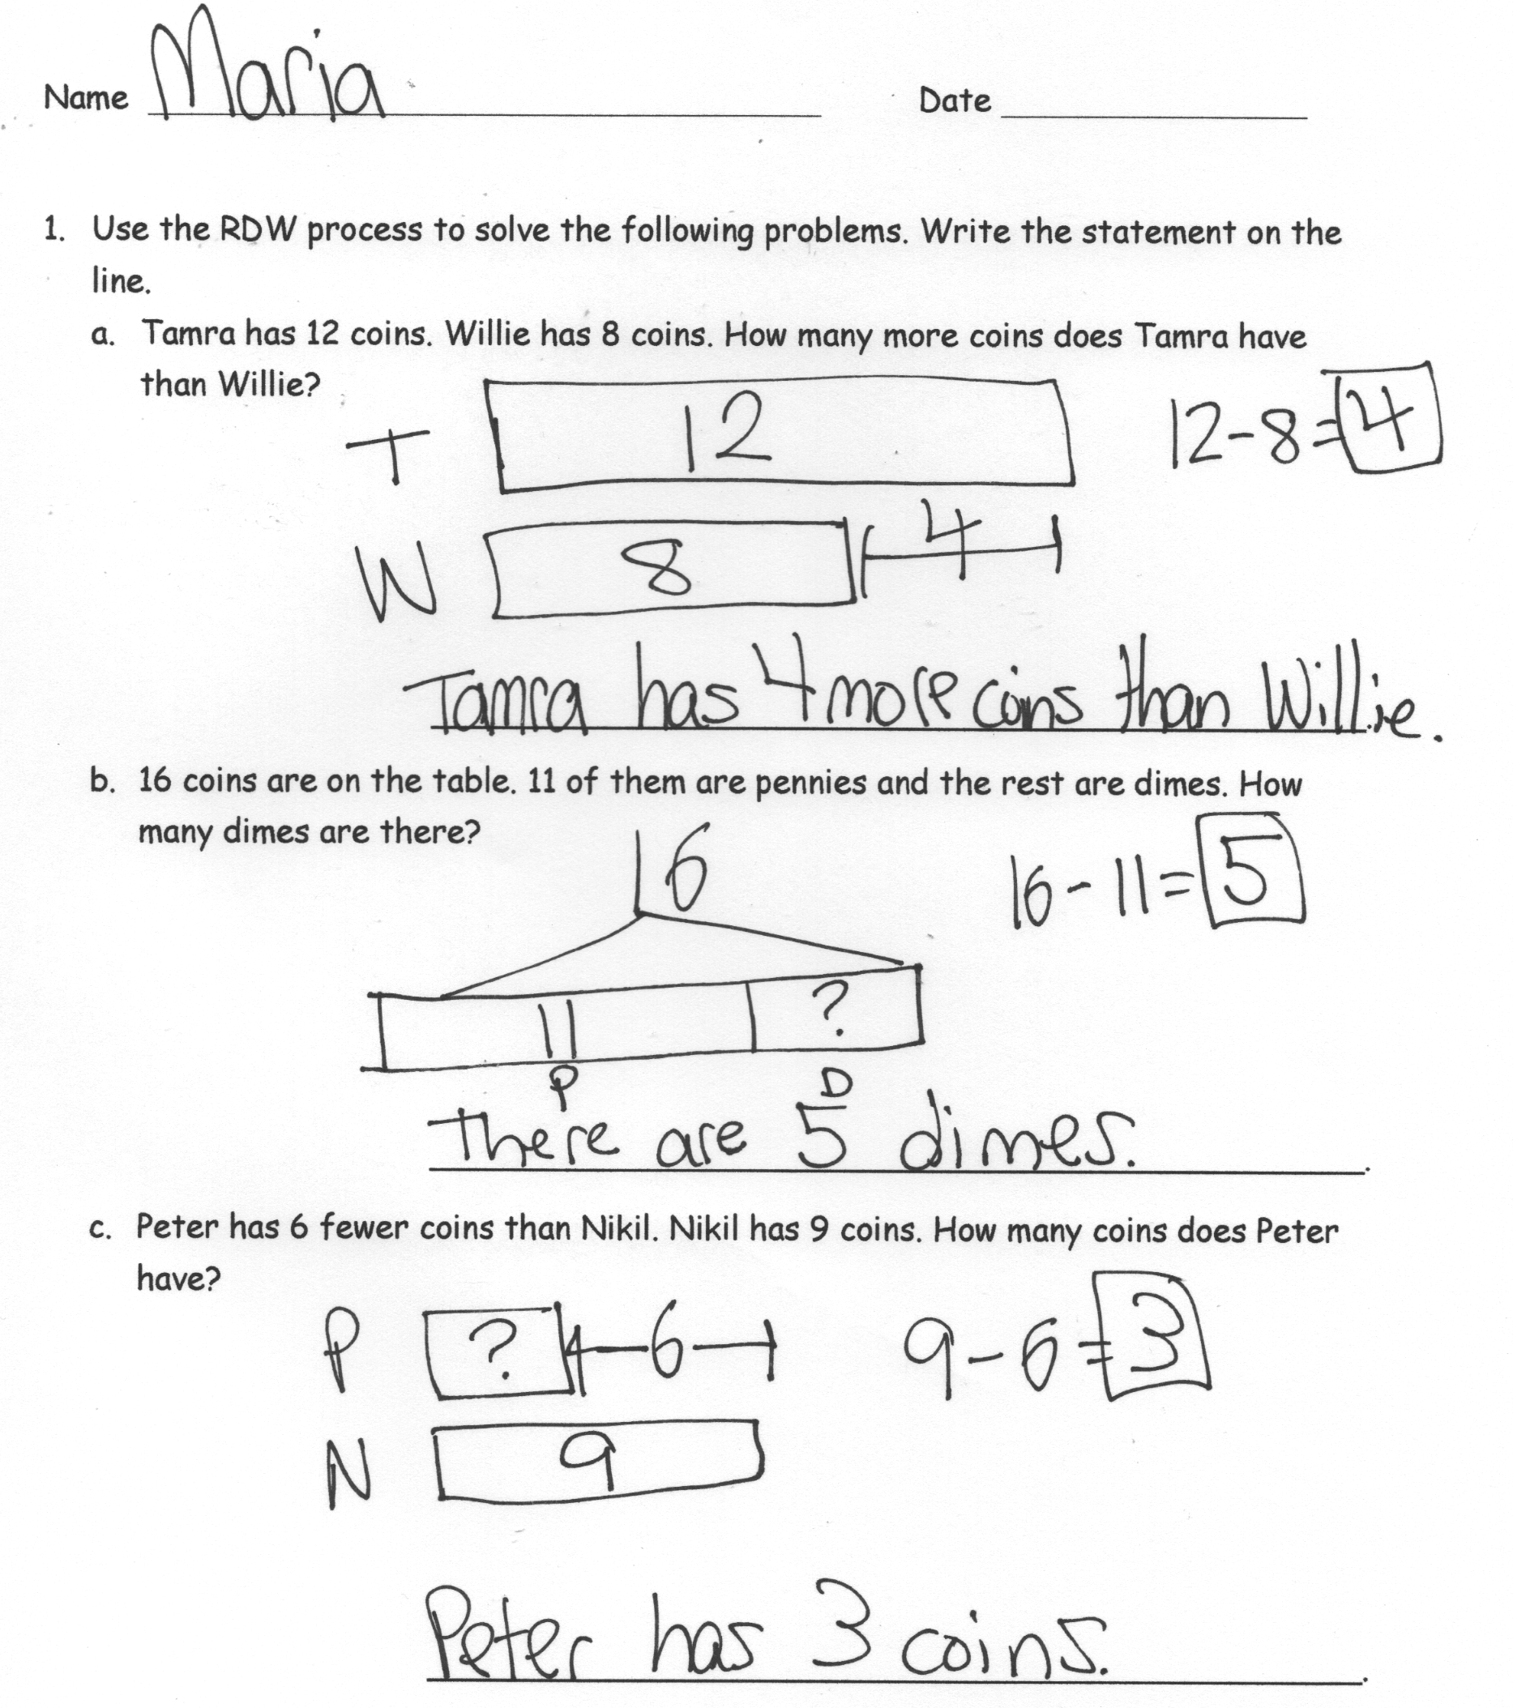
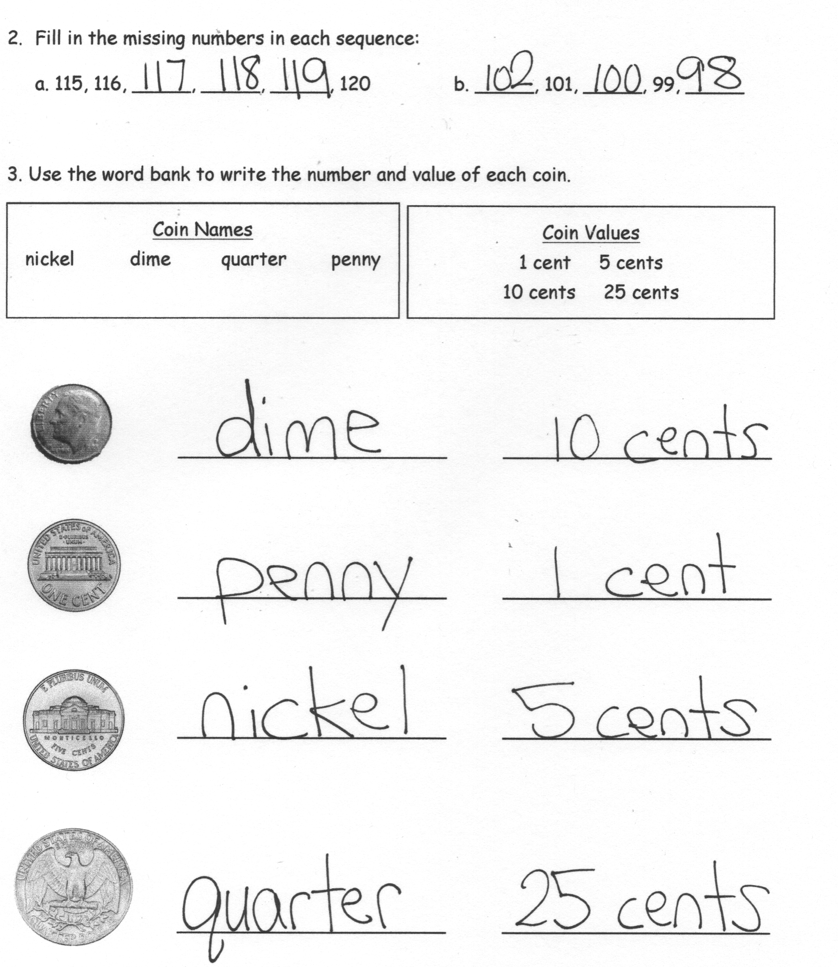
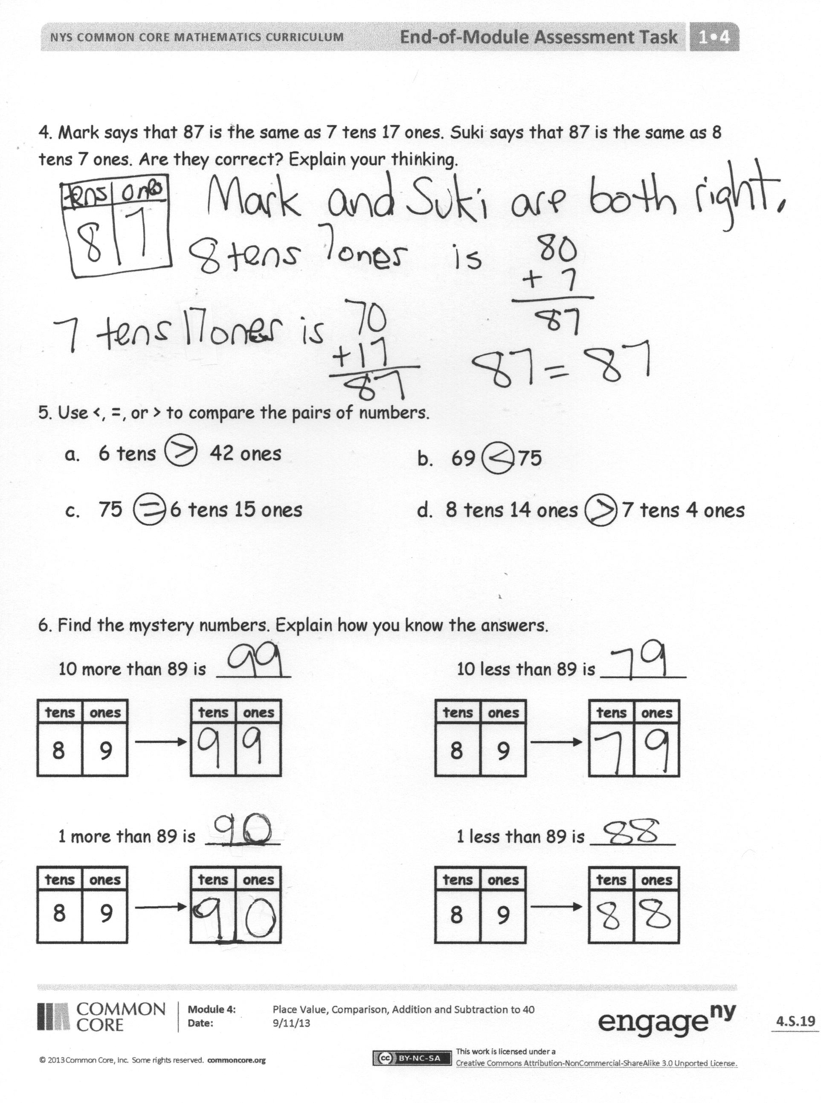
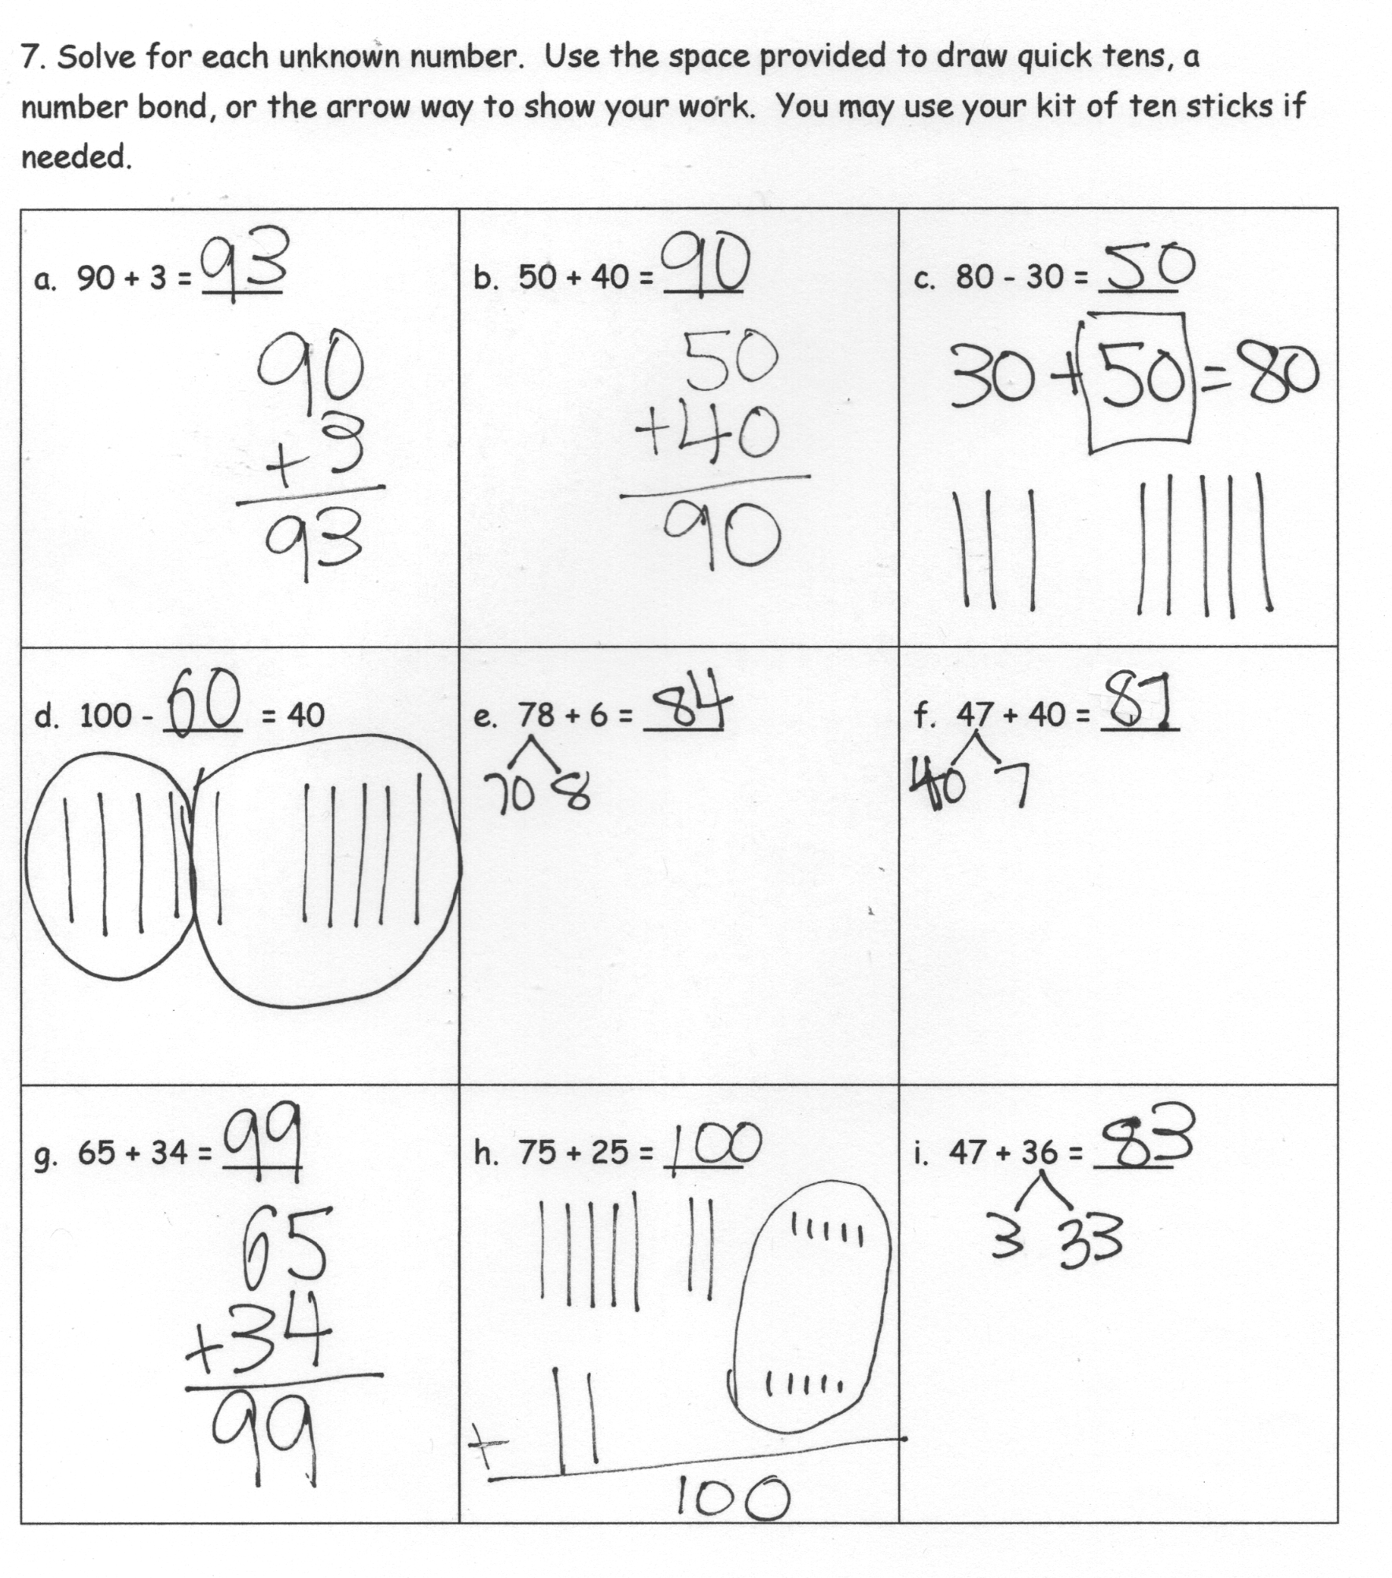

Focus on money.

