Table of Contents

GRADE 2 • MODULE 6

Foundations of Multiplication and Division

Module Overview i

Topic A: Formation of Equal Groups 6.A.1

Topic B: Arrays and Equal Groups 6.B.1

Topic C: Rectangular Arrays as a Foundation for Multiplication and Division 6.C.1

Topic D: The Meaning of Even and Odd Numbers 6.D.1

Module Assessments 6.S.1

Grade 2 • Module 6
Foundations of Multiplication and Division

OVERVIEW
Grade 2 Module 6 lays the conceptual foundation for multiplication and division in Grade 3 and for the idea that numbers other than 1, 10, and 100 can serve as units.
In Topic A, students begin by making equal groups using concrete materials, learning to manipulate a given number of objects to create equal groups (e.g., given 15 objects, they create 3 groups of 5 or 5 groups of 3), and progress to pictorial representations where they may begin by circling a group of 5 stars, adding 5 more, then adding 5 more. They determine the total and relate their drawings to the corresponding repeated addition equation (pictured below). Students calculate the repeated addition sums by adding on to the previous addends, step-by-step, or by grouping the addends into pairs and adding. By the end of Topic A, students draw abstract tape diagrams to represent the total and to show the number in each group as a new unit (pictured below). Hence, they begin their experience toward understanding that any unit may be counted, e.g., 3 dogs, 3 tens, or even 3 fives. This is the bridge between Grades 2 and 3. Grade 2 focuses on the manipulation of place value units, whereas Grade 3 focuses on the manipulation of numbers 1 through 10 as units.
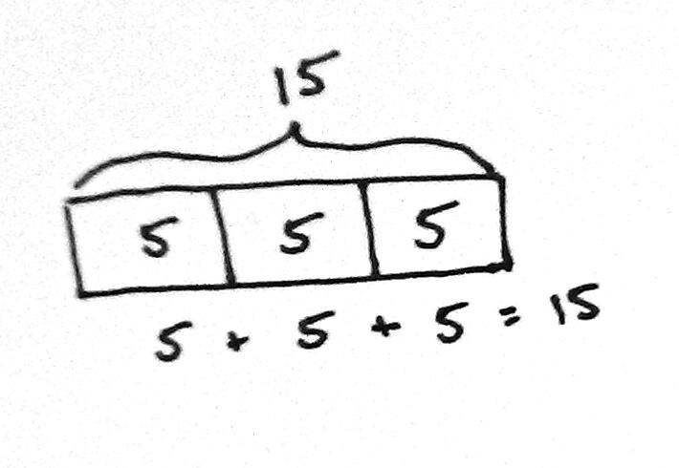
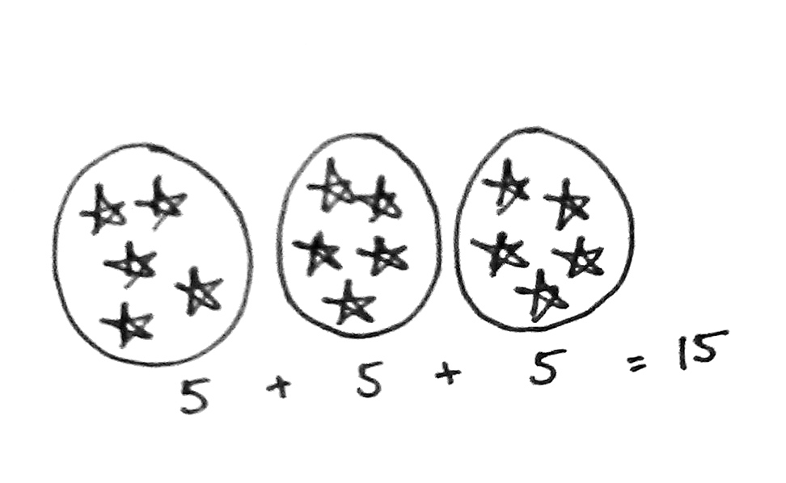
In Topic B, students organize the equal groups created in Topic A into arrays, wherein either a row or column is seen as the new unit being counted. They use manipulatives to compose up to 5 by 5 arrays one row or one column at a time and express the total via repeated addition equations (2.OA.4). For example, students might arrange one column of 5 counters, then another, and then another to compose an array of 3 columns of 5, or 15 counters. As they compose and decompose arrays, students create different number sentences yielding the same total (e.g., 5 + 5 + 5 = 15 and 3 + 3 + 3 + 3 + 3 = 15). They find the total number of objects in each array by counting on from left to right. “Three plus 3 is 6. Six plus 3 is 9. Nine plus 3 is 12." As Topic B progresses, students move to the pictorial level to represent arrays and to distinguish rows from columns by separating equal groups horizontally and vertically (e.g., 3 columns of 5 or 5 rows of 3). Then, they use same-size square tiles, moving them closer together in preparation for composing rectangles in Topic C. Topic B concludes with students using tape diagrams to represent array situations and the RDW process to solve word problems.
In Topic C, students build upon their work with arrays to develop the spatial reasoning skills they need in preparation for Grade 3’s area content. They use same-size squares to tile a rectangle with no gaps or overlaps, and then count to find the total number of squares that make up the rectangle (2.G.2).
After composing rectangles, students partition, or decompose, rectangles. First, they decompose rectangles made of square tiles. Next, they use scissors to cut apart paper rectangles. Finally, they draw and iterate a square unit. In doing so, students begin to see the row or the column as a composite of multiple squares or as a single entity, or unit, which is, in turn, part of the larger rectangle. Students further develop spatial structuring skills by copying and creating drawings on grid paper. Note that the concept of a square unit begins in Grade 3 and is not assessed in Grade 2. Throughout the topic, students relate repeated addition to the model. They are encouraged to think flexibly and to consider the many ways to construct or partition a given array. Students are not multiplying or dividing in Grade 2; rather, this topic lays the foundation for the relationship between the two operations. As equal parts can be composed to form a whole, likewise, a whole can be decomposed into equal parts.
Topic D focuses on doubles and even numbers (2.OA.3), thus setting the stage for the multiplication table of two in Grade 3. As students progress through the lessons, they learn the following interpretations of even numbers.
- A number that occurs as we skip-count by twos is even: 2, 4, 6, 8…
- When objects are paired up with none left unpaired, the number is even.
- A number that is twice a whole number (doubles) is even.
- A number whose last digit is 0, 2, 4, 6, or 8 is even.
Armed with an understanding of the term even, students learn that any whole number that is not even is called odd, and that when 1 is added to or subtracted from an even number, the resulting number is odd.
Initially, students arrange pairs into two rows and realize that an even number is the sum of two equal addends, or a repeated sum of twos. They then write number sentences to express the even number (e.g., 2 rows of 7 can be expressed as 7 + 7 or as 2 + 2 + 2 + 2 + 2 + 2 + 2) (2.OA.3). Next, students pair objects to make groups of two with none left over, thus discovering one means of determining whether a group of objects (up to 20) has an even or odd number of members. Finally, students learn that any number up to 20 whose last digit is 0, 2, 4, 6, or 8 is even. After gaining a firm understanding of even numbers, students learn that all other whole numbers are odd. They use the previously learned rules and patterns to identify larger numbers as even or odd and to defend their reasoning. The module concludes with an investigation of what happens when we add two even numbers, two odd numbers, or an odd number with an even number, and the relationship of these pairings to repeated addition (e.g., 3 + 3 is even, but 3 + 3 + 3 is odd).
The Mid-Module Assessment follows Topic B. The End-of-Module Assessment follows Topic D.

Focus Grade Level Standards

Work with equal groups of objects to gain foundations for multiplication.
2.OA.3 Determine whether a group of objects (up to 20) has an odd or even number of members, e.g., by pairing objects or counting them by 2s; write an equation to express an even number as a sum of two equal addends.
2.OA.4 Use addition to find the total number of objects arranged in rectangular arrays with up to 5 rows and up to 5 columns; write an equation to express the total as a sum of equal addends.

Reason with shapes and their attributes.
2.G.2 Partition a rectangle into rows and columns of same-size squares and count to find the total number of them.

Foundational Standards
1.OA.7 Understand the meaning of the equal sign, and determine if equations involving addition and subtraction are true or false. For example, which of the following equations are true and which are false? 6 = 6, 7 = 8 – 1, 5 + 2 = 2 + 5, 4 + 1 = 5 + 2.
2.NBT.2 Count within 1000; skip-count by 5s, 10s, and 100s.
2.NBT.6 Add up to four two-digit numbers using strategies based on place value and properties of operations.

Focus Standards for Mathematical Practice
MP.3 Construct viable arguments and critique the reasoning of others. Students explain their thinking using drawings, models, and equations to lay the conceptual foundation for multiplication and division. “If I build an array with 3 columns of 4 objects, then I must have twelve objects because 4 + 4 + 4 = 12. Likewise, if I partition my rectangle into twelve equally sized tiles, I can make 3 equal groups of 4 tiles, or I can make 4 equal groups of 3 tiles.” Students defend their reasoning as they prove that a number is even or odd, making connections to the previous concepts of counting by twos, adding on, equal groups, and doubles.
MP.4 Model with mathematics. Students learn to organize a set of objects into equal groups and then into rows and columns, or rectangular arrays. They use math drawings to analyze the relationship between rows and columns (e.g., 3 rows of 4 or 4 columns of 3) and to model the array as the sum of equal addends (e.g., 4 + 4 + 4 = 12).
MP.7 Look for and make use of structure. As students compose and decompose arrays, they recognize that the array structure is a collection of rows or columns and that either can be seen as a unit. Students match repeated addition to both the structure of the rows and columns (e.g., 5 + 5 + 5 can be 3 rows or columns of 5, or 3 fives).
MP.8 Look for and express regularity in repeated reasoning. As students create equal groups using objects, they recognize that they are repeatedly adding the same number; for example, 3 groups of 4 bears can be expressed as 4 + 4 + 4. Students also discover patterns in odd and even numbers, recognizing the repetition of 0, 2, 4, 6, and 8 in the ones place.

Overview of Module Topics and Lesson Objectives
Standards | Topics and Objectives |  | Days
2.OA.4  2.NBT.2  2.NBT.6 | A | Formation of Equal Groups  Lesson 1: Use manipulatives to create equal groups.  Lessons 2–3: Use math drawings to represent equal groups, and relate to repeated addition.  Lesson 4: Represent equal groups with tape diagrams, and relate to repeated addition. | 4
2.OA.4  2.NBT.2 | B | Arrays and Equal Groups  Lesson 5: Compose arrays from rows and columns, and count to find the total using objects.  Lesson 6: Decompose arrays into rows and columns, and relate to repeated addition.  Lesson 7: Represent arrays and distinguish rows and columns using math drawings.  Lesson 8: Create arrays using square tiles with gaps.  Lesson 9: Solve word problems involving addition of equal groups in rows and columns. | 5
 |  | Mid-Module Assessment: Topics A–B (assessment ½ day, return ½ day, remediation or further applications 1 day) | 2
2.OA.4  2.G.2 | C | Rectangular Arrays as a Foundation for Multiplication and Division  Lessons 10–11: Use square tiles to compose a rectangle, and relate to the array model.  Lesson 12: Use math drawings to compose a rectangle with square tiles.  Lesson 13: Use square tiles to decompose a rectangle.  Lesson 14: Use scissors to partition a rectangle into same-size squares, and compose arrays with the squares.  Lesson 15: Use math drawings to partition a rectangle with square tiles, and relate to repeated addition.  Lesson 16: Use grid paper to create designs to develop spatial structuring. | 7

Standards |  | Topics and Objectives | Days
2.OA.3 | D | The Meaning of Even and Odd Numbers  Lesson 17: Relate doubles to even numbers, and write number sentences to express the sums.  Lesson 18: Pair objects and skip-count to relate to even numbers.  Lesson 19: Investigate the pattern of even numbers: 0, 2, 4, 6, and 8 in the ones place, and relate to odd numbers.  Lesson 20: Use rectangular arrays to investigate odd and even numbers. | 4
 |  | End-of-Module Assessment: Topics A–D (assessment ½ day, return ½ day, remediation or further applications 1 day) | 2
Total Number of Instructional Days |  |  | 24

Terminology

New or Recently Introduced Terms
- Array (an arrangement of objects in rows and columns)
- Columns (the vertical groups in a rectangular array)
- Even number (a whole number whose last digit is 0, 2, 4, 6, or 8)
- Odd number (any number that is not even)
- Repeated addition (e.g., 2 + 2 + 2)
- Rows (the horizontal groups in a rectangular array)
- Tessellation (tiling of a plane using one or more geometric shapes with no overlaps and no gaps)
- Whole number (e.g., 0, 1, 2, 3…)

Familiar Terms and Symbols
- Addends
- Doubles
- Equation
- Number path
- Number sentence
- Pair
- Rectangle
- Skip-counting
- Square
- Sum
- Tape diagram
- Total
- Unit

Suggested Tools and Representations
- Counters
- Number bond
- Number path
- Personal white board
- Rectangular array
- Square tiles

Scaffolds
The scaffolds integrated into A Story of Units give alternatives for how students access information as well as express and demonstrate their learning. Strategically placed margin notes are provided within each lesson elaborating on the use of specific scaffolds at applicable times. They address many needs presented by English language learners, students with disabilities, students performing above grade level, and students performing below grade level. Many of the suggestions are organized by Universal Design for Learning (UDL) principles and are applicable to more than one population. To read more about the approach to differentiated instruction in A Story of Units, please refer to “How to Implement A Story of Units.”

Assessment Summary
Type | Administered | Format | Standards Addressed
Mid-Module Assessment Task | After Topic B | Constructed response with rubric | 2.OA.4
End-of-Module Assessment Task | After Topic D | Constructed response with rubric | 2.OA.3  2.OA.4  2.G.2

See Elementary Mathematics for Teachers by Scott Baldridge and Thomas Parker.
2.G.2 is included in this module because the array model is so important to the foundation for multiplication. The balance of this cluster is addressed in Module 8.
These are terms and symbols students have seen previously.
Students with disabilities may require Braille, large print, audio, or special digital files. Please visit the website www.p12.nysed.gov/specialed/aim for specific information on how to obtain student materials that satisfy the National Instructional Materials Accessibility Standard (NIMAS) format.

