Name Date
- Yasmine is having a birthday party with snacks and activities for her guests. At one table, five people are sharing three-quarters of a pizza. What equal-sized portion of the whole pizza will each of the five people receive?

- Use a model (e.g., picture, number line, or manipulative materials) to represent the quotient.

- Write a number sentence to represent the situation. Explain your reasoning.

- If three-quarters of the pizza provided $12$ pieces to the table, how many pieces were in the pizza when it was full? Support your answer with models.

- Yasmine needs to create invitations for the party. She has $\frac{3}{4}$ of an hour to make the invitations. It takes her $\frac{1}{12}$ of an hour to make each card. How many invitations can Yasmine create?

  - Use a number line to represent the quotient.

  - Draw a model to represent the quotient.

  - Compute the quotient without models. Show your work.

- Yasmine is serving ice cream with the birthday cake at her party. She has purchased $19\frac{1}{2}$ pints of ice cream. She will serve $\frac{3}{4}$ of a pint to each guest.

  - How many guests can be served ice cream?

  - Will there be any ice cream left? Justify your answer.

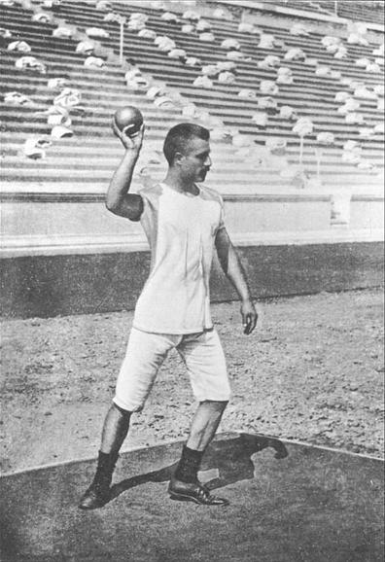
- L.B. Johnson Middle School held a track and field event during the school year. Miguel took part in a four-person shot put team. Shot put is a track and field event where athletes throw (or “put”) a heavy sphere, called a “shot,” as far as possible. To determine a team score, the distances of all team members are added. The team with the greatest score wins first place. The current winning team’s final score at the shot put is $52.08$ ft. Miguel’s teammates threw the shot put the following distances: $12.26$ ft., $12.82$ ft., and $13.75$ ft. Exactly how many feet will Miguel need to throw the shot put in order to tie the current first place score? Show your work.

- The sand pit for the long jump has a width of $2.75$ meters and a length of $9.54$meters. Just in case it rains, the principal wants to cover the sand pit with a piece of plastic the night before the event. How many square meters of plastic will the principal need to cover the sand pit?

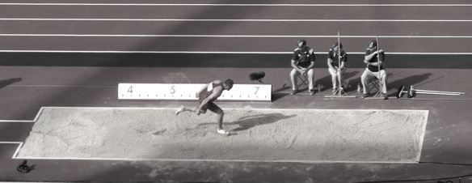

- The chess club is selling drinks during the track and field event. The club purchased water, juice boxes, and pouches of lemonade for the event. They spent $\$138.52$ on juice boxes and $\$75.00$ on lemonade. The club purchased three cases of water. Each case of water costs $\$6.80$. What is the total cost of the drinks?

A Progression Toward Mastery
Assessment  Task Item |  | STEP 1  Missing or incorrect answer and little evidence of reasoning or application of mathematics to solve the problem. | STEP 2  Missing or incorrect answer but evidence of some reasoning or application of mathematics to solve the problem. | STEP 3  A correct answer with some evidence of reasoning or application of mathematics to solve the problem, OR an incorrect answer with substantial evidence of solid reasoning or application of mathematics to solve the problem. | STEP 4  A correct answer supported by substantial evidence of solid reasoning or application of mathematics to solve the problem.
1 | a  6.NS.A.1 | Student response is incorrect and is not supported by a visual model.  OR  Student did not answer the question. | Student response is incorrect, but some evidence of reasoning is presented with a flawed visual model. | Student visual model is correct; however, the quotient of $\frac{3}{20}$ is not determined.  OR  Student response is correct, and the answer is supported with a visual model, but the model is inaccurate. | Student response is correct. The visual model is appropriate and supports the quotient of$\frac{3}{20}$. The student may have chosen to support the quotient with the use of more than one visual model.
 | b  6.NS.A.1 | Student response is incorrect.  OR  Student did not answer the question. | Student response is incorrect, but a portion of the equation has reasoning. For example, the student may have figured out to divide by five but did not multiply by $\frac{1}{5}$ to determine the quotient. | Student response is incorrect; however, the equation shows reasoning. The equation supports dividing by $5$ and makes connection to multiplying by $\frac{1}{5}$ to determine the quotient of $\frac{3}{20}$, but computation is incorrect. | Student response of $\frac{3}{20}$ is correct. The equation depicts the situation and makes connections between division and multiplication. All calculations are correct.
 | c  6.NS.A.1 | Student response is incorrect. Student found the product of  $\frac{3}{4}×12$ to arrive at $9$ as the solution.  OR  Student response is incorrect and is not supported with visual models. | Student response of $16$pieces is correct, but is not supported with visual models.  OR  Student response is incorrect with no support but shows general understanding of the equation. | Student response of $16$ is correct. Student arrived at the answer using an equation, but did not support reasoning with a model.  OR  Student calculation is incorrect, but visual models support reasoning. | Student response of $16$ is correct. Student supported the solution with appropriate visual models and determined the amount of each portion in order to determine the full amount.
2 | a  6.NS.A.1 | Student response is incorrect or missing.  OR  Student found the product of $\frac{3}{4}×\frac{1}{12}$ to reach the response of $\frac{1}{16}$. A number line diagram does not support the response. | Student response is incorrect, but depicts some reasoning in an incomplete number line diagram.  OR  Student response of $9$ invitations is correct without a supporting number line diagram. | Student response of $9$invitations is correct. Reasoning is evident through the use of a number line diagram, but the response is in terms of time, such as $\frac{9}{12}$ or $\frac{3}{4}$ of an hour, and not in the number of cards.  OR  Student response is correct through the use of calculation but is not supported by the number line diagram. | Student response of $9$invitations is correct. Reasoning is evident through the depiction of an accurately designed number line diagram.
 | b  6.NS.A.1 | Student response is incorrect or missing.  OR  Student computed the product of $\frac{3}{4}×\frac{1}{2}$ to reach the response of $\frac{3}{8}$. No visual representation supports the student response. | Student response is incorrect, but depicts some reasoning in an incomplete visual model.  OR  Student response is correct but reasoning is unclear through the misuse of a visual model. | Student response is correct. Reasoning is evident through the use of visual models, but the response is in terms of time, such as $\frac{9}{12}$ or $\frac{3}{4}$ of an hour, and not in the number of cards.  OR  Student response is correct through the use of calculation but is not supported by the visual model. | Student response of $9$ invitations is correct. Reasoning is evident through the depiction of an accurately designed visual model.
 | c  6.NS.A.1 | Student response is incorrect or missing.  OR  Student computed the product of the given fractions instead of determining the quotient. | Student response is correct but includes no computation to support reasoning. | Student response is correct. Student computed the quotient as $9$ invitations but showed minimal computation. | Student response of $9$ invitations is correct. Student demonstrated evidence of reasoning through concise application of an equation with accurate calculations.
3 | a  6.NS.A.1 | Student response is incorrect or missing.  OR  Student determined the product of $19$ $\frac{1}{2}$ and $\frac{3}{4}$. | Student response is correct but shows no computation or reasoning.  OR  Student response is incorrect, but reasoning is evident through calculations. | Student response of $26$ people is correct and represents some reasoning through calculation.  OR  Student response shows reasoning and application of mixed number conversion but includes errors in calculation. | Student response is correct. Reasoning is evident through correct mixed number conversion. The quotient of $26$ people is determined using apparent understanding of factors.
 | b  6.NS.A.1 | Student response is missing. | Student response is incorrect and does not depict understanding of whole and mixed numbers. | Student response correctly determines that there will be no leftover ice cream but is not supported with a clear understanding of whole and mixed numbers. | Student response is correct. Student explanation and reasoning include the understanding that a mixed number response will provide left over ice cream where a whole number response would not.
4 | 6.NS.B.3 | Student response is incorrect. Justification does not include adding the given throw distances and determining the difference of that sum and the distance needed to tie for first place. The student response may show only addition. | Student response is incorrect but attempts to determine the sum of the throw distances first and then the difference of the sum and the distance needed to tie first place. | Student response is incorrect due to slight miscalculations when adding or subtracting. It is evident that the student understands the process of adding the decimals first, then subtracting the sum from the other team’s final score. | Student response is correct. Student accurately determines the sum of the throw distances as $38.83$ feet and the differences between that sum and the score needed to tie as $13.25$ feet. It is evident that the student understands the process of adding the decimals first, then subtracting the sum from the other team’s final score.
5 | 6.NS.B.3 | Student response is incorrect or missing. The response depicts the use of an incorrect operation, such as addition or subtraction. | Student response is incorrect. The response shows understanding of multi-digit numbers but lacks precision in place value, resulting in a product less than $3$ or more than $262$. | Student response of $26.235$ square meters is correct but shows little to no reasoning that multiplication is the accurate operation to choose to find the area of plastic to cover the sand pit. | Student response is correct and shows complete understanding of place value. The response of $26.235$ square meters includes a picture that depicts finding the area through multiplication of the length and width of the sand pit.
6 | 6.NS.B.3 | Student response is incorrect or missing. The response disregards finding the total price of the water. | Student response is incorrect. Student finds the total price of the water only. | Student response is incorrect. Student finds the total price of the water and adds it to the price of the lemonade and juice but makes minor computation errors. | Student response is correct. The student finds the total price of the water to be $\$20.40$ and accurately adds it to the price of the lemonade and juice to determine a total cost of $\$233.92$.

Name Date
- Yasmine is having a birthday party with snacks and activities for her guests. At one table, five people are sharing three-quarters of a pizza. What equal-sized portion of the pizza will each of the five people receive?

- Use a model (e. g., picture, number line, or manipulative materials) to represent the quotient.
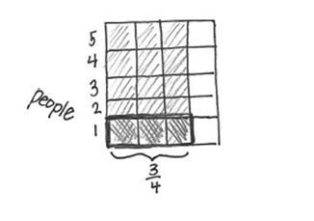

- Write a number sentence to represent the situation. Explain your reasoning.
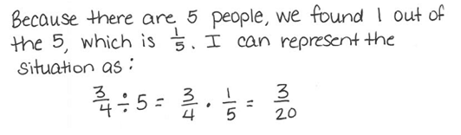

- If three-quarters of the pizza provided $12$ pieces to the table, how many pieces were in the pizza when it was full? Support your answer with models.

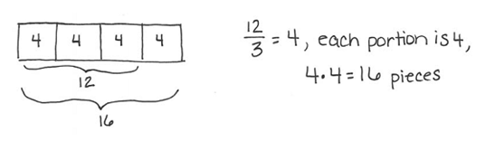

- Yasmine needs to create invitations for the party. She has $\frac{3}{4}$ of an hour to make the invitations. It takes her $\frac{1}{12}$ of an hour to make each card. How many invitations can Yasmine create?

  - Use a number line to represent the quotient.
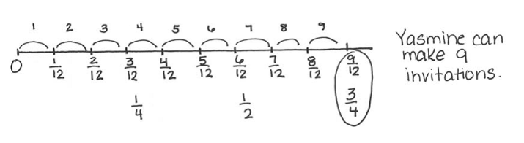

  - Draw a model to represent the quotient.

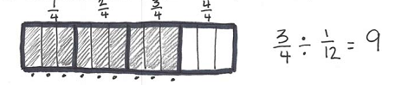

  - Compute the quotient without models. Show your work.

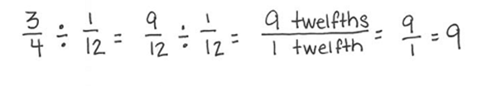

- Yasmine is serving ice cream with the birthday cake at her party. She has purchased $19\frac{1}{2}$ pints of ice cream. She will serve $\frac{3}{4}$ of a pint to each guest.

  - How many guests can be served ice cream?
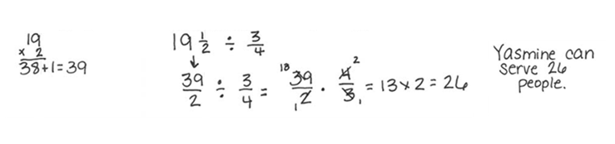

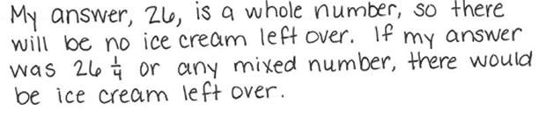
  - Will there be any ice cream left? Justify your answer.

- L.B. Johnson Middle School held a track and field event during the school year. Miguel took part in a four-person shot put team. Shot put is a track and field event where athletes throw (or “put”) a heavy sphere, called a “shot,” as far as possible. To determine a team score, the distances of all team members are added. The team with the greatest score wins first place. The current winning team’s final score at the shot put is $52.08$ ft. Miguel’s teammates threw the shot put the following distances: $12.26$ ft., $12.82$ ft., and $13.75$ ft. Exactly how many feet will Miguel need to throw the shot put in order to tie the current first place score? Show your work.

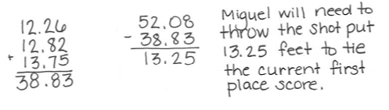

- The sand pit for the long jump has a width of $2.75$meters and a length of $9.54$ meters. Just in case it rains, the principal wants to cover the sand pit with a piece of plastic the night before the event. How many square meters of plastic will the principal need to cover the sand pit?

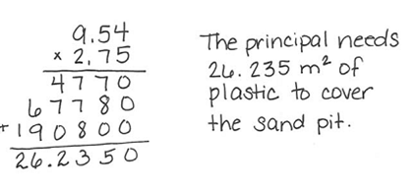
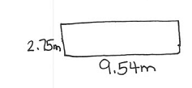
- The chess club is selling drinks during the track and field event. The club purchased water, juice boxes, and pouches of lemonade for the event. They spent $\$138.52$ on juice boxes and $\$75.00$ on lemonade. The club purchased three cases of water. Each case of water costs $\$6.80$. What is the total cost of the drinks?

