Name Date
- L.B. Johnson Middle School held a track and field event during the school year. The chess club sold various drink and snack items for the participants and the audience. All together, they sold $486$ items that totaled $\$2,673$.

- If the chess club sold each item for the same price, calculate the price of each item.

- Explain the value of each digit in your answer to 1(a) using place value terms.

- The long jump pit was recently rebuilt to make it level with the runway. Volunteers provided pieces of wood to frame the pit. Each piece of wood provided measures $6$ feet, which is approximately $1.8287$ meters.

$9.54$ meters
$2.75$ meters

- Determine the amount of wood, in meters, needed to rebuild the frame.

- How many boards did the volunteers supply? Round your calculations to the nearest hundredth and then provide the whole number of boards supplied.

- Andy runs $436.8$ meters in $62.08$ seconds.

- If Andy runs at a constant speed, how far does he run in one second? Give your answer to the nearest tenth of a second.

- Use place value, multiplication with powers of $10$, or equivalent fractions to explain what is happening mathematically to the decimal points in the divisor and dividend before dividing.

- In the following expression, place a decimal point in the divisor and the dividend to create a new problem with the same answer as in 3(a). Then, explain how you know the answer will be the same.

$4$ $3$ $6$ $8$ $÷$ $6$ $2$ $0$ $8$

- The PTA created a cross-country trail for the meet.

- The PTA placed a trail marker in the ground every four hundred yards. Every nine hundred yards the PTA set up a water station. What is the shortest distance a runner will have to run to see both a water station and trail marker at the same location?

Answer: hundred yards

- There are $1,760$ yards in one mile. About how many miles will a runner have to run before seeing both a water station and trail marker at the same location? Calculate the answer to the nearest hundredth of a mile.

- The PTA wants to cover the wet areas of the trail with wood chips. They find that one bag of wood chips covers a $3$ $\frac{1}{2}$ yards section of the trail. If there is a wet section of the trail that is approximately $50\frac{1}{4}$ yards long, how many bags of wood chips are needed to cover the wet section of the trail?

- The Art Club wants to paint a rectangle-shaped mural to celebrate the winners of the track and field meet. They design a checkerboard background for the mural where they will write the winners’ names. The rectangle measures $432$inches in length and $360$ inches in width. Apply Euclid’s Algorithm to determine the side length of the largest square they can use to fill the checkerboard pattern completely without overlap or gaps.

A Progression Toward Mastery
Assessment  Task Item |  | STEP 1  Missing or incorrect answer and little evidence of reasoning or application of mathematics to solve the problem. | STEP 2  Missing or incorrect answer but evidence of some reasoning or application of mathematics to solve the problem. | STEP 3  A correct answer with some evidence of reasoning or application of mathematics to solve the problem, OR an incorrect answer with substantial evidence of solid reasoning or application of mathematics to solve the problem. | STEP 4  A correct answer supported by substantial evidence of solid reasoning or application of mathematics to solve the problem.
1 | a  6.NS.B.2 | Student response is missing or depicts inaccurate operation choice. | Student response is inaccurate and does not represent the correct place value. | Student response is inaccurate through minor calculation errors; however, place value is represented accurately. | Student response is correct. The price of each item is determined as $\$5.50$, where place value is represented accurately.
 | b  6.NS.B.2 | Student response is incorrect or missing. Place value is not depicted in the response. | Student response depicts place value only in monetary denominations, such as dollars and cents. | Student response depicts place value accurately, but makes little to no correlation to monetary denominations. | Student response is accurate. Each place value is labeled accurately and shows correlation to the monetary denominations each place value represents. For example, $5$ dollars is labeled with $5$ ones and $5$ dollars,$50$ cents is labeled with $5$ tenths and $5$ dimes, and the zero in the hundredths place is labeled with zero hundredths and “no pennies.”
2 | a  6.NS.B.3 | Student response is incorrect or missing. Students merely included one length and one side in the calculation. | Student response is incorrect based on place value. | Student response depicts understanding of the addition algorithm, but minor calculation errors hinder the correct sum of $24.58$ meters. | Student calculations include all sides of the sand pit. Student applied the standard algorithm of addition of decimals to determine the correct sum of $24.58$ meters.
 | b  6.NS.B.3 | Student response is incorrect or missing. Calculations disregard place value. | Student response is incorrect and depicts inaccurate place value. | Student response is incorrect. Student rounded the decimal quotient to the nearest hundredth and determined the quotient to be $13.44$. The student does not provide the whole number of boards supplied. | Student response is correct. Reasoning is evident through the use of place value. The final response is in terms of a whole number. Student determines that from the calculation of $13.44$, the volunteers supplied $14$ boards.
3 | a  6.NS.B.3 | Student response is incorrect or missing. Calculations disregard place value. | Student response is incorrect. Response depicts inaccurate place value where the divisor is represented by a whole number, but the dividend remains a decimal. | Student response is correct, but the quotient of $7.03$ is not rounded to the nearest tenth.  OR  Student calculations are incorrect, but represent knowledge of place value. | Student response is correct, depicting accurate place value in order to generate a whole number dividend. Calculations are flawless, and the answer, $7.0$, is represented to the nearest tenth.
 | b  6.NS.B.3 | Student response either incorrectly depicts place value or is missing. | Student response depicts some place value knowledge, but not enough to sufficiently describe why and how a whole number divisor is generated. | Student response correctly includes accurate place value through the use of equivalent fractions to demonstrate how to generate a whole number divisor. | Student response is correct and includes multiplying by a power of ten to determine an equivalent fraction with a whole number denominator. Student determines that the quotient of the decimals is equivalent to the quotient of the whole numbers generated through the use of place value.
 | c  6.NS.B.3 | Student response is missing. | Student response is incorrect or indicates the same decimal placements from the previous problem. | Student response accurately places decimals in the divisor and dividend with no explanation or justification. | Student response accurately places decimals within the divisor ($6.208$) and dividend ($43.68$) to generate a quotient of $7.03$and justifies placement through the use of either place value, powers of ten, or equivalent fractions.
4 | a  6.NS.B.4 | Student response is incorrect or missing. Response is a result of finding the sum of or the difference between $9$ and $4$. | Student response is incorrect or is simply the product of $4$ and$9$with no justification. | Student response accurately finds the least common multiple of $4$ and $9$, but the response is determined as $36$, instead of $36$hundred or $3,600$ yards or the correct response reflects finding the LCM of $400$and $900$. | Student response is accurately determined through finding the least common multiple. The response represents an understanding of the unit “hundred” as a means of efficiently determining LCM using $4$and $9$, instead of $400$ and $900$.
 | b  6.NS.B.2 | Student response is missing.  OR  Student response utilizes incorrect operations, such as addition, subtraction, or multiplication. | Student response shows little reasoning through the use of division to determine the quotient.  Student response depicts division of $1,760$ yards by a divisor of $2$, derived from counting the two stations. Student response does not include values from the previous problem. | Student response is incorrect, but does include values from the previous problem. Instead of using $3,600$, however, the response chooses $36$ as the dividend, resulting in an incorrect quotient. | Student response is computed accurately and the solution is appropriately rounded to the hundredths place. The response reflects the correct divisor as $1,760$ and the correct dividend as $3,600$. The solution, $2.045$, is accurately rounded to $2.05$ miles.
 | c  6.NS.A.1 | Student response is incorrect or missing. Response includes inappropriate operations, such as addition, subtraction, or multiplication. | Student response is incorrect due to inaccurate calculations when converting mixed numbers or when finding the quotients of the fractions. | Student response is correctly determined through mixed number conversion and division of fractions, but is inaccurately left as a mixed number ($14\frac{5}{14}$). | Student response is accurately demonstrated through the use of visual models, such as a number line. The response is confirmed through precise mixed number conversion and division of fractions. The need for $15$ bags satisfies understanding that the quotient ($14\frac{5}{14}$) is not a whole number AND that $14$ bags is not sufficient.
5 | 6.NS.B.4 | Student response is incorrect or missing. Response includes inappropriate operations, such as addition, subtraction, or multiplication. | Student response is incorrect, but depicts reasoning leading to finding the greatest common factor.  OR  Student response incorrectly utilizes division to determine the quotient of $1\frac{5}{72}$. | Student response determines that the greatest common factor of$432$ and $360$ is $72$, through means other than the Euclidean Algorithm. | Student response efficiently utilizes the Euclidean Algorithm to determine the greatest common factor of $432$and $360$as $72$. Response correlates the GCF to the side length of the largest square.

Name Date
- L.B. Johnson Middle School held a track and field event during the school year. The chess club sold various drink and snack items for the participants and the audience. All together, they sold $486$ items that totaled $\$2,673$.

- If the chess club sold each item for the same price, calculate the price of each item.

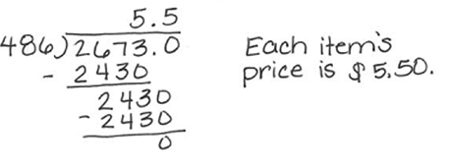

- Explain the value of each digit in your answer to 1(a) using place value terms.

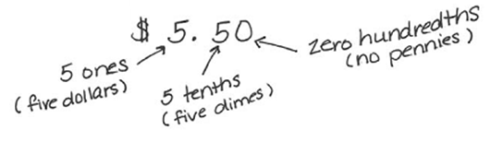

- The long jump pit was recently rebuilt to make it level with the runway. Volunteers provided pieces of wood to frame the pit. Each piece of wood provided measures $6$feet, which is approximately $1.8287$ meters.
$9.54$ meters
$2.75$ meters

- Determine the amount of wood, in meters, needed to rebuild the frame.
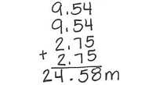

- How many boards did the volunteers supply? Round your calculations to the nearest hundredth and then provide the whole number of boards supplied.
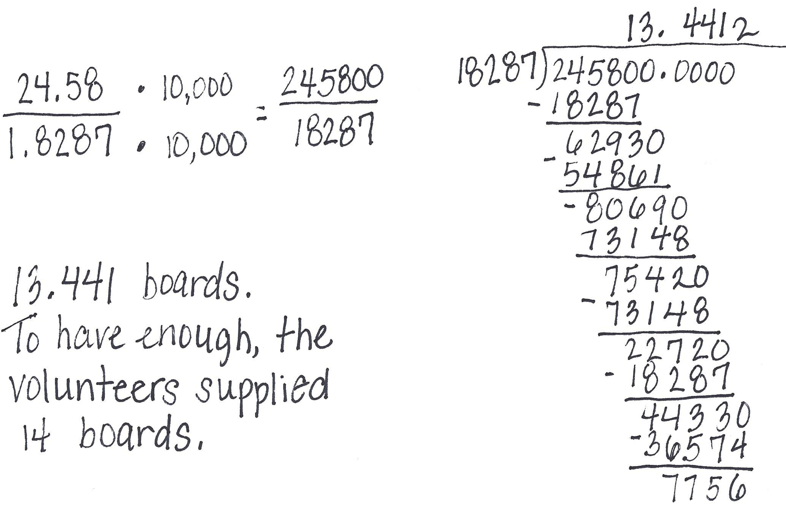

- Andy runs $436.8$ meters in $62.08$seconds.

- If Andy runs at a constant speed, how far does he run in one second? Give your answer to the nearest tenth of a second.

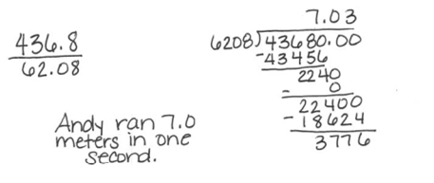

- Use place value, multiplication with powers of $10$, or equivalent fractions to explain what is happening mathematically to the decimal points in the divisor and dividend before dividing.

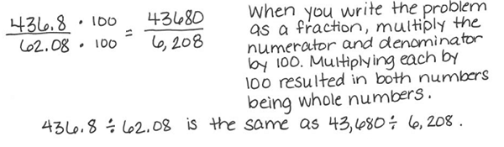

- In the following expression, place a decimal point in the divisor and the dividend to create a new problem with the same answer as in 3(a). Then, explain how you know the answer will be the same. (6.NS.3 – Lesson 15)

$4$ $3$ .$6$ $8$ $÷$ $6$ .$2$ $0$ $8$
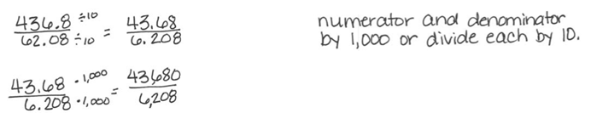

- The PTA created a cross-country trail for the meet.

- The PTA placed a trail marker in the ground every four hundred yards. Every nine hundred yards the PTA set up a water station. What is the shortest distance a runner will have to run to see both a water station and trail marker at the same location?
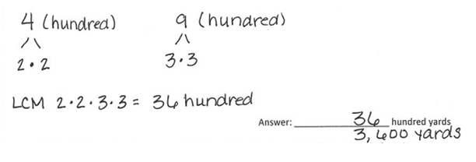

- There are $1,760$ yards in one mile. About how many miles will a runner have to run before seeing both a water station and trail marker at the same location? Calculate the answer to the nearest hundredth of a mile.
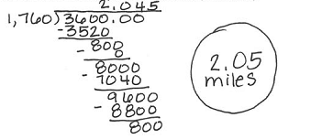

- The PTA wants to cover the wet areas of the trail with wood chips. They find that one bag of wood chips covers a $3\frac{1}{2}$ yards section of the trail . If there is a wet section of the trail that is approximately $50\frac{1}{4}$ yards long, how many bags of wood chips are needed to cover the wet section of the trail?
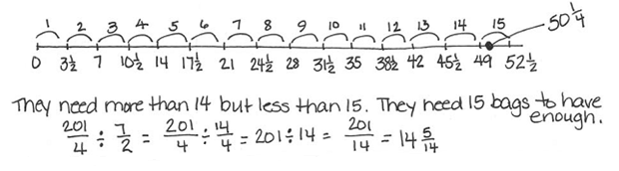

- The Art Club wants to paint a rectangle-shaped mural to celebrate the winners of the track and field meet. They design a checkerboard background for the mural where they will write the winners’ names. The rectangle measures $432$ inches in length and $360$ inches in width. Use Euclid’s Algorithm to determine the side length of the largest square they can use to fill the checkerboard pattern completely without overlap or gaps.
